GEF-6 REQUEST FOR PROJECT ENDORSEMENT/APPROVAL
Project Type: FULL-SIZED PROJECT
Type of Trust Fund:Gef Trust Fund
For more information about GEF, visit TheGEF.org

part i: project information
Project Title: Promoting Sustainable Cities in Brazil through integrated urban planning and innovative technologies investment
Country(ies): | Brazil | GEF Project ID: |  | 9142
GEF Agency(ies): | UNEP | GEF Agency Project ID: |  | 1355
Other Executing Partner(s): | Ministry of Science, Technology, Innovation and Communication (MCTIC), UNOPS | Resubmission Date: |  | November 28, 2016
GEF Focal Area (s): | IAP Sustainable Cities | Project Duration (Months) |  | 60
Integrated Approach Pilot | IAP-Cities IAP-Commodities IAP-Food Security |  | Corporate Program: SGP
Name of Parent Program | [if applicable] | Agency Fee ($) |  | 2,037,220
- Focal Area Strategy Framework and Other Program Strategies
Focal Area Objectives/Programs | Focal Area Outcomes | Trust Fund | (in $)
Focal Area Objectives/Programs | Focal Area Outcomes | Trust Fund | GEF Project Financing | Co-financing
BD-4 Mainstream biodiversity conservation and sustainable use into production landscapes and seascapes and production sectors.  Program 9 – Managing the Human-Biodiversity Interface. | Outcome 9.2 Sector policies and regulatory frameworks incorporate biodiversity considerations. | GEFTF | 3,669,725 | 25,500,000
CCM-2: Demonstrate Systemic Impacts of Mitigation Options  Program 3: Promote integrated low-emission urban systems | Outcome B. Policy, planning and regulatory frameworks foster  accelerated low GHG development and emissions mitigation | GEFTF | 14,378,899 | 135,400,658
IAP-Sustainable Cities: Harnessing Local Action for Global Commons | To promote integrated planning and investments related to urban sustainability that result in environmental, social and economic benefits at the local and global scale. | GEFTF | 4,587,156 | 34,750,000
Total project costs |  |  | 22,635,780 | 195,650,658

- Project description summary

Project Objective: To promote sustainability in Brazilian Cities through integrated urban planning and innovative technologies
Project Components/  Programs | Financing Type | Project Outcomes | Project Outputs | Trust Fund | (in $)
Project Components/  Programs |  |  |  |  | GEF Project Financing | Confirmed Co-financing
Integrated Planning Pilots | TA | A comprehensive evidence-based integrated and sustainable planning approach is adopted by Brasilia | 1.1.B. Environmental Information System (SISDIA) including EEZ guidelines and data is completed, online and available for FDG sustainable planning and public access. | GEFTF | 5,411,225 | 28,000,000
Integrated Planning Pilots | TA |  | 1.2.B. New data and studies to populate SISDIA are collected, developed and included in SISDIA. | GEFTF | 5,411,225 | 28,000,000
Integrated Planning Pilots | TA |  | 1.3.B. Climate risk assessment and scenarios are completed and 'climate bill' is drafted. | GEFTF | 5,411,225 | 28,000,000
Integrated Planning Pilots | TA |  | 1.4.B. Citizens' are engaged in FDG public policy making | GEFTF | 5,411,225 | 28,000,000
Integrated Planning Pilots | TA |  | 1.5.B. Lessons learned are collected and structured to feed the local and national platforms. | GEFTF | 5,411,225 | 28,000,000
Integrated Planning Pilots | TA | A comprehensive evidence-based integrated and sustainable planning approach is adopted by Recife | 1.1.R. Integrated and resilient Plans for Recife through enhanced popular participation, more evidence and live and open data | GEFTF | 5,411,225 | 28,000,000
Integrated Planning Pilots | TA |  | 1.2.R. Geo-referenced Integrated Management System (IMS) is tested | GEFTF | 5,411,225
Integrated Planning Pilots | TA |  | 1.3.R. Lessons learned collected and structured to serve as input to the national platform | GEFTF | 5,411,225
Integrated Investment Pilots | TA/Inv | Cities investments demonstrate the benefits resulting from integrated and sustainable planning in Brasilia | 2.1.B. Springs preservation completed, best practices implemented and open dumpsite monitored towards decommissioning. | GEFTF | 7,997,010 | 141,087,658
Integrated Investment Pilots | TA/Inv |  | 2.2.B. Solar energy pilots and promotion are completed | GEFTF | 7,997,010 | 141,087,658
Integrated Investment Pilots | TA/Inv |  | 2.3.B. Lessons learned are collected and structured to feed the local and national platforms. | GEFTF | 7,997,010 | 141,087,658
Integrated Investment Pilots | TA/Inv | Cities investments demonstrate the benefits resulting from integrated and sustainable planning in Recife | 2.1.R. The financial and technical viability of operating 2 Solar boats across the Capibaribe river is assessed | GEFTF | 7,997,010 | 141,087,658
Integrated Investment Pilots | TA/Inv |  | 2.2.R. Banks of the Capibaribe River urbanized in two sections. | GEFTF | 7,997,010 | 141,087,658
Integrated Investment Pilots | TA/Inv |  | 2.3.R. Filtering Garden cleaning the water through the use of vegetation. | GEFTF | 7,997,010 | 141,087,658
 | TA/Inv |  | 2.4.R. The City tracks and generates information and lessons on the experiences with the pilots for the national platform. | GEFTF | 7,997,010 | 141,087,658
Knowledge Platform | TA | The tested integrated and sustainable planning solutions are promoted by the National Platform for Sustainable Cities to up to 300 Brazilian cities as the reference for integrated urban planning | 3.1. An operational Knowledge Platform online | GEFTF | 7,877,545 | 19,000,000
Knowledge Platform | TA |  | 3.2. Operational modules for the Knowledge Platform portal online | GEFTF | 7,877,545 | 19,000,000
Knowledge Platform | TA |  | 3.3. Skills Development Training designed and delivered | GEFTF | 7,877,545 | 19,000,000
Knowledge Platform | TA |  | 3.4. Mayors and politicians mobilised to join the sustainable cities platform | GEFTF | 7,877,545 | 19,000,000
Knowledge Platform | TA |  | 3.5. Sustainable solutions to six urban planning and investment challenges identified and delivered to Brasilia, Recife and SCP | GEFTF | 7,877,545 | 19,000,000
Knowledge Platform | TA |  | 3.6. Solutions for urban planning and investments promoted to other cities. | GEFTF | 7,877,545 | 19,000,000
M&E |  |  |  | GEFTF | 100,000 | 63,000
Subtotal |  |  |  |  | 21,385,780 | 188,150,658
Project Management Cost (PMC) |  |  |  | GEF TF | 1,250,000 | 7,500,000
Total project costs |  |  |  | GEFTF | 22,635,780 | 195,650,658

- confirmed sources of Co-financing for the project by name and by type
Please include evidence for co-financing for the project with this form.

Sources of Co-financing | Name of Co-financier | Type of Cofinancing | Amount ($)
Federal Government | Ministry of Science, Technology and Innovation | In-kind | 57,500,000
Federal District | Government of Federal District (FDG) | Investment | 57,660,277
Municipal Government | Municipality of Recife | In-kind | 47,524
State Government | Compesa | Investment | 76,000,000
CSO | Sustainable Cities Programme | In-kind | 4,192,856
Int. Organization | UNEP | In-kind | 250,001
Total Co-financing |  |  | 195,650,658

- Trust Fund Resources Requested by Agency(ies), Country(ies) and the Programming of Funds
GEF Agency | Trust Fund | Country  Name/Global | Focal Area | Programming of Funds | (in $)
 |  |  |  |  | GEF Project Financing (a) | Agency Fee ^{a)} (b)² | Total  (c)=a+b
UNEP | GEFTF | Global Sustainable Cities Incentive (set aside) | IAP | IAP-Cities | 4,587,156 | 412,844 | 5,000,000
UNEP | GEFTF | Brazil | BD | BD-IAP Cities | 3,669,725 | 330,275 | 4,000,000
UNEP | GEFTF | Brazil | CCM | CCM-IAP Cities | 14,378,899 | 1,294,101 | 15,673,000
Total Grant Resources |  |  |  |  | 22,635,780 | 2,037,220 | 24,673,000

a ) Refer to the Fee Policy for GEF Partner Agencies

- Project’s Target Contributions to Global Environmental Benefits
Provide the expected project targets as appropriate.
Corporate Results | Replenishment Targets | Project Targets
- Maintain globally significant biodiversity and the ecosystem goods and services that it provides to society | Improved management of landscapes and seascapes covering 300 million hectares | 415 hectares
- Sustainable land management in production systems (agriculture, rangelands, and forest landscapes) | 120 million hectares under sustainable land management | 80 hectares
- Promotion of collective management of transboundary water systems and implementation of the full range of policy, legal, and institutional reforms and investments contributing to sustainable use and maintenance of ecosystem services | Water-food-ecosystems security and conjunctive management of surface and groundwater in at least 10 freshwater basins; | Number of freshwater basins
 | 20% of globally over-exploited fisheries (by volume) moved to more sustainable levels | Percent of fisheries, by volume
- 4. Support to transformational shifts towards a low-emission and resilient development path | 750 million tons of CO_{2e} mitigated (include both direct and indirect) | 3,802,710 metric tons
- Increase in phase-out, disposal and reduction of releases of POPs, ODS, mercury and other chemicals of global concern | Disposal of 80,000 tons of POPs (PCB, obsolete pesticides) | metric tons
 | Reduction of 1000 tons of Mercury | metric tons
 | Phase-out of 303.44 tons of ODP (HCFC) | ODP tons
- Enhance capacity of countries to implement MEAs (multilateral environmental agreements) and mainstream into national and sub-national policy, planning financial and legal frameworks | Development and sectoral planning frameworks integrate measurable targets drawn from the MEAs in at least 10 countries | Number of Countries:
 | Functional environmental information systems are established to support decision-making in at least 10 countries | Number of Countries:
- f. Does the project include a “non-grant” instrument?
(If non-grant instruments are used, provide an indicative calendar of expected reflows to your Agency and to the GEF/LDCF/SCCF Trust Fund) in Annex D.
N/A

part ii: project justification

A.0. Describe any changes in alignment with the project design with the original PIF

Approved Child Project framework |  | Project framework after consultation | Explanation of changes
Component 1 - Integrated planning pilots

A comprehensive evidence-based integrated and sustainable planning approach is adopted by Brasilia |  |  | The PIF did not include outputs, but it did include deliverables.  The proposed outputs have been developed in alignment with the PIF stated deliverables except for one and outcome 1 for Brasilia: cooperate institutionally with the municipal authorities of both Recife and Brasilia in the development of evidence based integrated planning focusing on the multidimensional aspects of sustainability in the preparation of strategic plans, land use plans, climate change plans, mobility plans and master plans.  The deliverable for Brasilia component 1 in the design stage has not included is “observatory of risk indicators and climatic risk management and alignment of indicators with the IAP cities global framework”. The global platform did not impose a set of indicators on the cities, and therefore the city has chosen indicators to reflect its own priorities.
City diagnosis to identify problems in an integrated way, through the following sectoral studies, modelling and surveys:  ₋ Conservation units climate and impacts risk assessment  ₋ Watershed climate and impacts risk assessment  ₋ Land use planning climate scenarios with identification of mitigation and adaptation options | 1.1.B. Environmental Information System (SISDIA) including EEZ guidelines and data is completed, online and available for FDG sustainable planning and public access.
. Observatory of risk indicators and climatic risk management and alignment of indicators with the IAP cities global framework  Evaluation of solar business models  GEO technologies and geo-sensing data as tools for integrated urban planning support | 1.2.B. New data and studies to populate SISDIA are collected, developed and included in SISDIA
Mainstreaming of climate scenarios, risk assessments and recommendations in FDG planning instruments  FDG climate change policy with the adoption of GHG mitigation actions, risk management actions and integration of mitigation and adaptation measures in FDG development policies  FDG Adaptation Plan elaborated in a participatory manner  Climate scenarios mainstreamed in all FDG public investments | 1.3.B. Climate risk assessment and scenarios are completed and 'climate bill' is drafted.
Institutionalization and functioning of District Council of climate change (CONCLIMA), and proposal for governance of climate risk in FDG 100% validated and draft bill published to be submitted to the CONCLIMA | 1.4.B. Citizens' are engaged in FDG public policy making
Knowledge sharing platform on climate risks deployed | 1.5.B. Lessons learned are collected and structured to feed the local and national platforms.
A comprehensive evidence-based integrated and sustainable planning approach is adopted by Recife
City diagnosis to identify problems in an integrated way  City expanded and updated observatory  Revised Strategic plan Recife 2037  A revised, integrated and comprehensive sustainable Urban Mobility Plan integrated in the City Master Plan  Climate change sectoral assessments and studies to provide inputs to the above plans (including a smart grid assessment, with spatial map and technical options)  Series of studies and assessments to support the development of an integrated and comprehensive sustainable Master Plan (Plano Diretor) 2019-2029  A sustainability target plan 2017-2020 (aligned with the 2037 strategic plan), which includes a set of indicators linked to the IAP cities global framework and ISO 37120 | 1.1.R. Integrated and resilient Plans for Recife through enhanced popular participation, more evidence and live and open data |  | Outputs from project design for Recife reflect only 4 of the 8 deliverables. Those no longer reflected in design are:  - city diagnosis to identify problems in an integrated way.  - a revised, integrated and comprehensive sustainable Urban Mobility Plan integrated in the City Master Plan;  - climate change sectoral assessments and studies to provide inputs to the above plans (including a smart grid assessment, with spatial map and technical options); and  - a sustainability target plan 2017-2020 (aligned with the 2037 strategic plan), which includes a set of indicators linked to the IAP cities global framework and ISO 37120.  After further discussion during design Recife concluded that it would be more useful for the project to support specific studies (social housing and resilience) to deepen their evidence based in areas of greatest need, rather than conducting a full city diagnosis, which they have done.  The social housing study is an important part of transport oriented development, but the project will no longer finance an urban mobility plan.  The social housing study and the resilience plans will contribute to the evidence base of the city master plan, however the project will no longer finance compilation of the city master plan. Instead there now more focus on the community driven long term vision of the city, Recife 500 Plan (Recife 2037 strategic plan), in line with the GEF programme objectives of promoting integrated sustainable planning.  The sectoral assessments have been replaced with the resilience plan, in line with the needs to city and the aim of the GEF programme of promoting resilience.  Finally, rather than linking the city’s sustainability target plan, 2017-2020 with IAP and ISO indicators, the city will now develop an information management system (IMS) for the implementation of the city’s sector plans, and track these against indicators for the city’s Recife 500 year plan.
Web-based Platform for integrated and sustainable planning in Recife developed and operational | 1.2.R. Geo-referenced Integrated Management System (IMS) is tested.
 | 1.3.R. Lessons learned collected and structured to serve as input to the national platform
Component 2 - Integrated Investment Pilots

Cities investments demonstrate the benefits resulting from integrated and sustainable planning in Brasilia
Planning and restoration in two watersheds in the urban periphery of Brasilia to manage the quality of drinking for Brasilia and for testing land use management including for agriculture.  Pilot remediation techniques of contaminated soil surrounding the dumpsite.  Education and social mobilization to create culture of responsibility and increase awareness of the population about existing environmental technologies for energy saving (enabling the partnership with educational institutions) |  | 2.1.B. Springs preservation completed, best practices implemented and open dumpsite monitored towards decommissioning. | All mentioned PIF deliverables are now included in this integrated output
Municipal solar and LED pilots to support larger scale uptake of these technologies in the public sector |  | 2.2.B. Solar energy pilots and promotion are completed | During the PPG phase, relevant solar energy interventions were selected through consultation with multiple stakeholders. LED implementation in parks was removed due to budget constraint.
MRV system |  | 2.3.B. Lessons learned are collected and structured to feed the local and national platforms. | This output was created to provide further material for MRV and feed in into the national platform
Cities investments demonstrate the benefits resulting from integrated and sustainable planning in Recife
Procurement and testing of two solar boats |  | 2.1.R. The financial and technical viability of operating 2 Solar boats across the Capibaribe river is assessed. | This output has been reworded to reflect the need to deepen its activities considering some requirements of the project itself and the city.  It was identified the need to define the best business model for operating the boat, especially in post-design stage, from 2021, as well as the current serious transport constraints. This output then covers 3 major products: the boat itself, the business model for the operation of these ships and deepening solutions for mobility in the hills.
Renovation and monitoring of 2 sustainable reconstructed buildings with green roofs |  | 2.2.R. Banks of the Capibaribe River urbanized in two sections. | During the phase of the PPG(Project Preparation Grant) problems were identified that would be crucial for the initial proposed reconstruction of these buildings sustainably.  This depends on a partnership to be held between the State Government and the Federal Government. However, given the delicate political and economic moment the country is, negotiations are, for now, suspended.  Therefore, it was decided to change the initial goal and carry out the construction of two smaller buildings associated with the urbanization of the banks of the river and solar boats. The buildings will be included as terminals for transfer between the ferry and bike paths/ buses and include toilets, and could be also used as exhibition site and classroom focused on environmental education, and they should receive the maximum infrastructure systems possible to be efficient buildings.
Construction and testing of filtering gardens |  | 2.3.R. Filtering Garden cleaning the water through the use of vegetation. | This output has been slightly reworded, compared to the original deliverable.
MRV system |  | 2.4.R. The City tracks and generates information and lessons on the experiences with the pilots for the national platform. | This output has been reworded to be more specific, from the original deliverable .
Procurement of bikes and electric cars |  | Removed. | After discussion with those responsible for the Bike-PE program, the viability of the two existing shared bike stations relocation was verified, which have very low use of content on the site where they are deployed. They will be relocated from low use areas in the bike network to the ferry terminals. As for cars, the company responsible for the project is conducting a partnership to develop a new vehicle solar powered, more efficient than the existing one. Thus, the process of acquiring the vehicle is temporarily suspended. However, the network can be expanded with the construction of new stations, allowing charging of both existing cars as new models under development.
Construction of inter-modal stations for bikes, electric cars and ferries |  | Merged with 2.1.R. | All mobility related products were grouped in output 2.1 due to increased scope of activities relating to the operation of the solar boat as a means of transport. The intention is to strengthen the transport solar powered, providing a specific area of intervention with charging stations for electric cars, possible mooring docks and loading of solar boats since the independence of their batteries over and bicycle station also fuelled by solar power.
Application for bike locations, ferry schedule and electric car user requests |  | Removed. | The application for access to electric cars and bikes shared already exists, and add the function of the solar boat can be an activity defined by the business model if considered relevant.
Microclimate application |  | Deepened and transferred to the component 1, deliverable 1.1.2 | To strengthen the Recife Observatory institution and consolidation of an evidence-based planning, the application of the product has been adapted to the microclimate of measuring stations make measurements associated with the indicators used by the Centre. Thus, this deliverable was transferred to the component 1.
Component 3 - Knowledge Platform

The tested integrated and sustainable planning solutions are promoted by the National Platform for Sustainable Cities to up to 300 Brazilian cities as the reference for integrated urban planning
Original component objectives:  i. support cities with integrated urban planning process and its indicators;  ii. test, adapt and provide proof of concept for innovative technologies that can be deployed to solve technological bottlenecks identified through the integrated urban planning process;  iii. disseminate good practices emerging sustainability work in support of the planning and design technologies;  iv. stimulate the engagement of more than 300 municipalities that voluntarily adopt sustainability goals in their local administrations;  v. promote the functionalities of the platform to support replication and scale gain and its evolution through collaborative action and tools for the revision of national urban policies and guidelines. |  | 3.1. An operational Knowledge Platform online. | The PIF did not detail specific deliverables for Outcome 3.  The current outputs are clearly aligned with the PIF stated objectives of component 3.
 |  | 3.2. Operational modules for the Knowledge Platform portal online.
 |  | 3.3. Skills Development Training designed and delivered.
 |  | 3.4. Mayors and politicians mobilised to join the sustainable cities platform.
 |  | 3.5. Sustainable solutions to six urban planning and investment challenges identified and delivered to Brasilia, Recife and SCP. | Outputs 3.5 and 3.6 are related to the Sustainable City Innovation Observatory (SCIO), which was not included in the PIF.  The Sustainable City Innovation Observatory (SCIO) has been included to support the National Knowledge Platform with more in-depth analysis of common problems that cities face, and to draw more scientific lessons from the investment pilots of this project.
 |  | 3.6. Solutions for urban planning and investments promoted to other cities.

The budget allocation for both the GEF funds and co-finance have been changed to reflect the project detailed design emerging from extensive consultations with partners and to take into account the actual figures for co-finance that the project will build upon.

A.1. Project description.

1) The global environmental and/or adaptation problems, root causes and barriers that need to be addressed

Environmental Problems arising from Urbanisation: Rapid urbanization led Brazil to an increase from only 30 percent in urban population in the 1940s, to more than 80 percent in urban population in 2010 and close to 85% in 2020. Within Brazil, major challenges in the rapid urbanization process are linked to urban sprawl and illegal settlements, poor coverage of basic sanitation systems (sewage and water supply), and urban transport and traffic jams amongst others. Climate change is a growing problem for cities in Brazil, both from a perspective of mitigation and adaptation and resilience. Brazil’s GHG emissions are fuelled in part, by the country’s rapid urbanization. Cities in Brazil contribute directly (e.g. through motor vehicles) and indirectly (e.g. production of goods and services that are consumed within urban boundaries) to GHG emissions (UNEP, 2013).

Brazilian Intended Nationally Determined Contributions (INDC) still needs to be ratified by Congress, but the National Policy on Climate Change (NPCC) in Art. 12, in effect, assumes that the country will adopt, as national voluntary commitment, actions to mitigate greenhouse gas emissions. The main goal is to reduce between 36.1 % and 38.9% of its projected emissions by 2020.

Drivers of urban land use: Over 50% of the world’s population now lives in urban areas, and it is estimated this figure will reach 60% by 2030. Brazil is one of the countries that have been following this global trend for more than five decades. In the early 1950s urbanization began taking off in Brazil due to the modernization of the interior (rural area) and industrial development in urban areas. By 1970 half of the country’s population was living in cities, a figure that has now risen to 86.53%. Over the course of this period two major processes determined the growth of cities and the overall population: the slow development of the interior, and industrialization around urban areas. Generally, the result is that the most of the population is located in medium-sized and large cities along the coast and up to 500 kilometres inland, which generates a huge demand for public services, natural resources, jobs and other needs, and accentuates the lack of planning and integrated management systems which are accessible to the public.
The slow development of Brazil’s interior regions led to a dramatic increase of rural-urban migration, although this has slowed in recent years. The reflects the many limitations found in the interior, such as: increased concentration of income in Brazil, primarily from 1960 to 1980; failure to broadly recognize the right to occupied land; lack of technical and financial support to small farmers; systematic harassment against indigenous and rural communities by private groups and public officials; and lack of employment and income in people’s interior’s hometowns. These components generate migrant populations that will continue contributing to the growth of poverty in cities, as large urban areas cannot give these people the institutional support that might mitigate their historical problems. This new urban population growth occurs primarily on the city outskirts, in very poor conditions, with little or no infrastructure or public services, and exposed to various illegal and informal markets. The most popular destinations for migrants are state capitals and other towns and cities which offer industrial development and the expansion of trade and service activities. Between 1960 and 2010 these cities often experienced growth rates of 300% or more: the population of São Paulo rose from 3.8 million to about 11 million people, an increase of close to 300%; while in Manaus (Amazonas) the number of residents grew from 175,000 to the current figure of 1.8 million people, an increase of close to 1,000%.
In urban areas a new yet similar process has arisen: high birth rates associated with social exclusion, lack of education and skills training, lack of income, and the failure of public agencies to meet the demand for public services. Combined, these circumstances have created a low income and unstable migrant population within and between cities, and have resulted in two new pressures associated with urban expansion: migration between cities and regions, and high birth rates. However, the development of urbanization is driven not only by migration and the growth of cities through the development of commerce, services and industry, but also by the construction industry, with its huge demand for raw materials and energy, and the establishment of mechanisms for property speculation.
Over the past 15 years population growth and internal migration rates have dropped, but there is still a continued demand for housing, infrastructure, and essential public services and facilities. The economic pressure resulting from growing property speculation has led to increased socio-spatial exclusion, whereby the poorest residents are forced to move from the cities’ central areas to the outskirts. In fact, what occurred in urban areas during this period (specifically 1960 to 2000) was the emergence of new, mostly illegal housing areas which were poorly designed and built, with no public services or facilities. Typically, these are found on the outskirts of cities and are often separated from more developed urban areas. If we consider the housing deficit, including replacing and increasing the supply, Brazil has a total deficit of approximately 4.7 million urban households and 800,000 rural households (João Pinheiro Foundation, 2015). To meet this demand typically requires a proportional creation of urban infrastructure and public facilities. In addition to insufficient utilities, housing, transportation and other daily needs, Brazil's current urban environment has created such a critical situation that in 2015 over 25% of the country’s cities declared a public emergency or calamity linked to extreme weather events or hazardous urbanization related to improper planning.
Progress in Brazilian Urban Planning: In the last 15 years, Brazil has advanced significantly in creating legislation that requires planning and management instruments for short, medium and long term; master plans, pluri-annual plans, mobility plans, sustainability plans, target plans and a national plan for climate change. While some cities have spontaneously adopted sustainable and integrated planning approaches, they are not wide spread in Brazil. Despite existing enabling legislation and some good examples, there is still an absence of a more prescriptive guidance/methodology for integrated urban planning and a lack of awareness and knowledge of urban planners of the benefits of comprehensive, integrated and sustainable urban planning. The urban planning process in Brazilian cities is described below.

Urban planning process: the federal government is responsible for defining policies, urban laws, programs and guidelines on housing, water supply and sanitation, and transportation in urban areas. It is also responsible for determining national and regional territorial plans. The federal urban development policy is written in the Article 182 and 183 of the Constitution (1988), which defends the social function of the city and property and the democratization of urban management. The 1988 Constitution also determines shared responsibility for health, education, economic development and infrastructure between the federal level and the states. State governments play a coordinating role in facilitating inter-municipal cooperation in large metropolitan areas and in supporting the creation of municipal consortia to address issues of capacity and scale for services in smaller municipalities. Hence, issues such as housing, traffic control, sewerage systems, rainwater collection among others may be a function of either the state or the municipality, depending on city scale and resources available. The state is also responsible for attracting large amount of investments from the Federal budget for urban sanitation, inter-municipal road systems and transportation, environmental management and tourism promotion.

Also according 1988 Constitution, the municipality is responsible for planning and implementing urban policy. The Statute of City confirmed and widened the fundamental legal-political role of municipalities in the formulation of guidelines for urban planning, as well as in conducting the process of urban development and management. The same Statute of City calls for municipalities with over 20,000 inhabitants, or located in strategic areas to develop a Master Plan (Plano Diretor). The Master Plan defines the municipal urban policy and should be based on studies and assessments and on an extensive public debate about the local reality of the city. The Master Plan must be reviewed no more than ten years after its adoption. Sectoral Plans and thematic plans are then derived from the Master Plan, such as the health plan, the educational plan, the transport plan, the housing plan and the urban macro zoning plan (Master Plan for Land Management (PDOT)). Environmental zoning is another key planning instrument at municipal level, that should be used to inform all the other plans but this link is not yet systematically being made.

In Brazil, the municipal term is 4 years and mayors are directly elected. Elected Mayors must prepare and submit a 4-year Pluri-annual Plan called PPA. The PPA draws priority activities from the Master and Sectoral Plans for budgetary allocation. The PPA is elaborated during the first year of newly elected government and its implementation takes place in the following 4 years, which means that it rolls over the first year of the subsequent government. The city operational budget is then set annually through the Directive Budget Plan (LDO) and the Annual Budget Law (LOA), and drawn from the Master and sectoral plans.

Mayors can also on a voluntary basis define Target Plans such as those promoted by the Sustainable Cities Programme (further explained below). The city Target Plan builds upon the Mayor’s government platform and translates its vision into goals and targets that can be tracked by a set of indicators in an open base web platform. Cities are beginning to consider long-term vision plans to provide strategic direction to the city planning as an important integrated planning tool. There are a number of Civil Society Organization (CSO) that are starting to promote this and support cities with long term strategic plans.
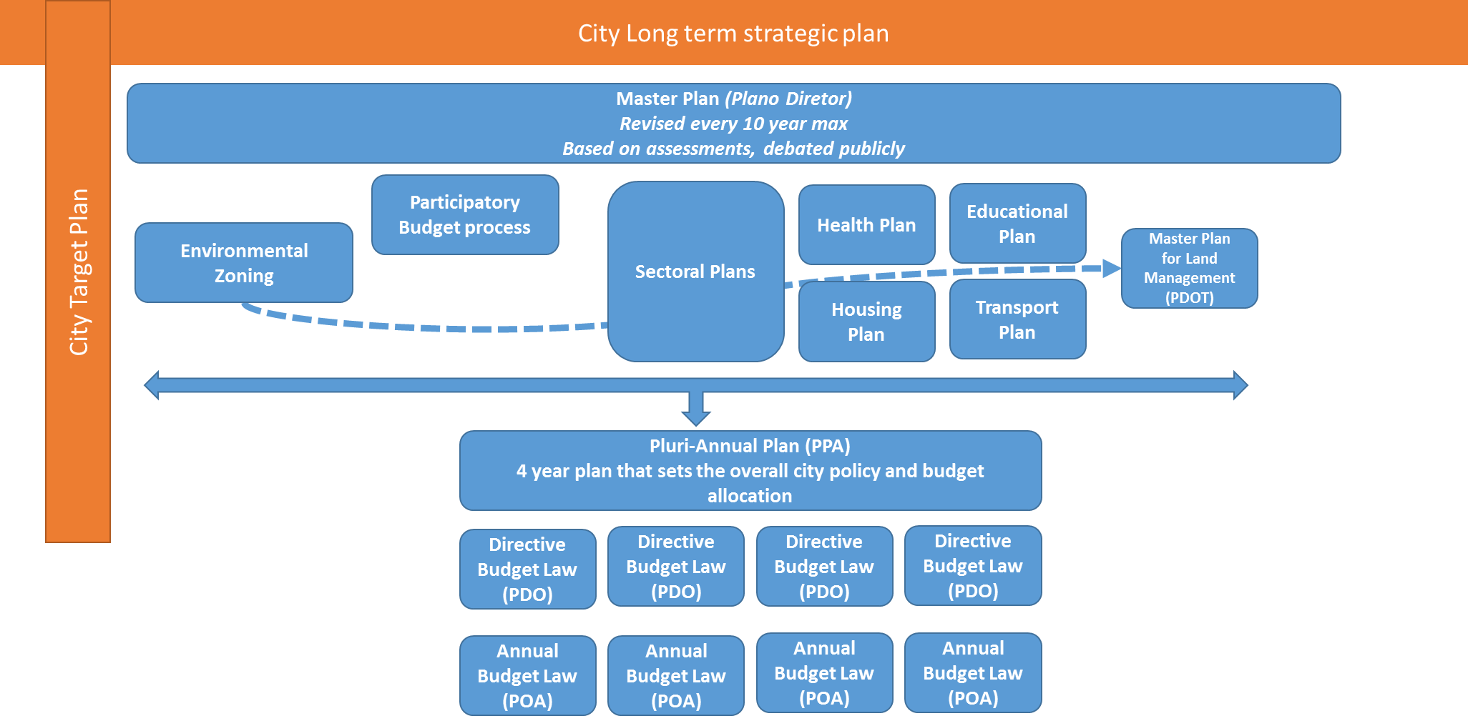

Recife and Brasilia will be the target cities for this project. Both cities are receptive to the concepts of sustainability and integration, and are in the process of reviewing a number of their urban plans. This project will help them to spread integrated urban planning more quickly than would be the case otherwise. The project will test integrated and sustainable urban planning approaches in these two cities, and foster uptake by other cities through the establishment of a Knowledge Platform to be hosted by the Sustainable Cities Programme.

2) The baseline scenario and any associated baseline projects

Component 1 - A comprehensive evidence-based integrated and sustainable planning approach is adopted by Brasilia

Brasilia, being a federal district, is not considered a municipality in Brazil, but a State, with an elected Governor (not a Mayor) and administrative regions. Brasilia is the federal capital of Brazil with an estimated population of 2,852,372 inhabitants in 2014. The metropolitan region (Região Metropolitana de Brasilia (RMBH) or Grande Brasilia), with almost 6 million people in 34 municipalities, is the 3rd most populated metropolitan area in Brazil. This project will work with all departments of the Federal District, including the Secretariat of Planning and Management (SEPLAG) and the Secretariat of Environment (SEMA) (hosting this project) who will take the lead in project implementation.

Major challenges on urbanisation: Brasília is currently facing increased risk of water and energy shortage, and the potential of economic and human losses from natural hazards is being exacerbated by the rate of unplanned urban expansion and influenced by the quality of urban management. Climate change brings additional challenges with a growing number and variety of impacts on the Federal District (FD), its critical ecosystems, and citizens livelihoods. Urban sprawl in peri-urban areas and informal settlements are particularly vulnerable to natural hazards due to their tendency of residing in high-risk areas and faulty shelters, having limited access to basic and emergency services, and a general lack of resilience. City management is often reactive to disasters, with little consideration given to reducing or managing risk in a comprehensive and preventive manner. In spite of the potential impacts that disasters have on the financial resources of city governments and the functionality of the city, the management of disaster risk remains ex-post, with little attention to preventing or mitigating measures.

Additionally, Brasilia’s population growth is high and the city faces much tougher challenges than do its counterparts in developed countries in adopting integrated policies and strategies, including watershed restoration practices and PV systems, as the city’s water and energy consumption is expected to outstrip supply in the next 3 years. The planning Company of the Federal District (CODEPLAN) estimates that in 2030 Brasilia will add 1 million inhabitants to the current population. This will not only create an increasing pressure on the surrounding land, but also on surrounding resources, energy and drinking water in particular ADASA (Federal District Water Agency) also highlights the increasing risk of water shortage: an average of 98% of local water supply is consumed during the dry season and almost 100% of Brasilia’s electricity demand comes from hydropower plant. Therefore, urban sprawl under water and energy scarcity is a significant challenge in rapid growth economies in Brazil, especially in Brasilia, where urban growth is putting at risk key watersheds. Brasília and its metropolitan region may have serious social and environmental problems in the light of land use, environmental degradation and climate change (floods, wildfire, water scarcity, loss of biodiversity and quality of life, etc.).

Climate Change impacts in Brasilia - the need for more information: The Federal District (FD) is located on an inland highland plateau at the headwaters of three major river basins in Brazil. According to the national assessments on Climate Change in the Report for National Assessment the inland and highlands will suffer changing patterns of precipitation (less rainfall during the wet season) and of higher temperatures. Climate change can exacerbate the risk of water resources and hydroelectricity supply shortage in major river basins, while increasing the risk of flooding in extreme events. Urban sprawling in peri-urban areas and informal settlements in Brasilia are particularly vulnerable to extreme natural events because they are often in high-risk areas and are poorly built, with limited access to basic and emergency services, and are vulnerable to floods. In addition, the Federal District Government (FDG) is often constrained by a lack of up-to-date, comprehensive and sufficiently detailed information about environmental hazards, especially local climate change impacts, and exposure in urban and peri-urban areas, particularly low-income settlements. FDG lacks an understanding of existing sources of risk and potential impact of climate change.

Including environmental carrying capacity in urban planning: Urban sustainability in the FD needs to encompass, therefore, two concepts in its territorial planning: the environmental carrying capacity of the territory and innovative social policies towards the economic and productive inclusion of the population, thus generating employment and income near the place of residence. These are critical otherwise Brasilia and its metropolitan region might suffer serious impacts from urban sprawl in the context of environmental degradation and climate change (such as flooding, wildfire, water scarcity, etc.). Therefore, urban sprawling under water and energy scarcity is a significant challenge in rapid growing economies in Brazil, especially in Brasilia, where urban growth is putting at risk key watersheds.

When data is available it is not organized to allow integration in the planning process: there is not of a tradition in consistent production, availability and systematic use of data produced in Brasilia. Historically, governmental institutions have tended to take a proprietary stance to data ownership, thus reducing the transparency and usefulness of linking different data, as well as social control and information sharing, both within the government and with the society at large. In addition, there is an absence of standard protocols for managing disaster risk and adapting to climate change, currently there are limited examples of cities that have standard procedures for incorporating/mainstreaming disaster risk planning and management and climate change adaptation in city planning.

Ecological-Economic Zoning (EEZ) and the planning process in Brasilia: The instrument that Brasilia is using to better inform environmental considerations of its zoning decisions is the Ecological-Economic Zoning (EEZ) tool. EEZ is defined by law and allows for an ecosystem-based territorial planning and organization. The EEZ prioritizes standards for environmental protection, including biodiversity, water resources and soil conservation, thus guaranteeing sustainable development and improvement of society’s living conditions. Even if the Ecological-Economic Zoning (EEZ) is inscribed in the Municipal organic law of Brasilia, the Federal District Government of Brasilia (FDG) has not yet been able to fully develop an EEZ for its territory and to use its results for fostering its sustainable integrated planning process.

As discussed above, one of the main issues in Brasilia is the tension between different land-uses and related zoning. Brasilia is a fast growing urban area that needs more land for real estate development and at the same time needs to preserve this same land for providing basic eco-system services to the expanding population, such as water. The Master Plan for Land Management (PDOT) of Brasilia, which is reviewed every 10 years, determines the strategies for land use and the major systems for integrated territorial planning. The PDOT is currently under review for approval in 2017. The PDOT presents the following issues:

- There is no real correlation with other sectoral plans, programmes and projects. Sectoral policies are defined from silo-based interests or points of view.
- The governance arrangement for territorial management is not well enough worked out and agreed between the different management levels and bodies, creating gaps and overlaps in decision making of the territory.
- There is no monitoring of this instrument, and territorial dynamics have historically been faster than the capacity of the FDG to regulate and supervise such dynamics, as well as establish control mechanisms.

There is an opportunity in Brasilia to use the EEZ to induce a clear strategy for monitoring these problems and incorporating carrying capacity focusing on resilience, land use, water resources, mobility, transportation, housing, sustainable drainage (runoff management), solid waste, among others in the planning process.

The EEZ’s main objective is to enhance the sustainability of the territory along four dimensions: social, economic, environmental and legal. The EEZ results can then feed the revisions of the Master Plan for Land Management and define land uses based on a sound scientific process of environmental/economic zoning. The EEZ will create a first set of integrated environmental tracking indicators aimed at full territorial management, based on a federal and district legal framework.

The key tracking indicators to included are:

To combine tracking indicators as part of an integrated planning and decision making process, Brasilia needs to parameterize the use and adoption of several of them, particularly through a Geographic Information System (GIS). Currently, spatial data is comprised of over 220 shape-files which are available through the FDG-NET. However, there is no standardization of data entry in the processes that involves environmental information, which makes the sharing and generation of maps, analysis and reports very difficult and time consuming.

One of the aims of Outcome 1 is to support Brasilia in developing an integrated environmental information and management system (SISDIA). SISDIA as a system is already in place but it is not geo-referenced and it is not populated with relevant data yet. SISDIA will be a GIS based system and will be populated with the results of the EEZ and several sectoral assessments and studies. It will be an important tool for integrated environmental management and territorial planning. It will include layers on risk scenarios, water and energy information, the outcomes of the EEZ, and basic infrastructure coverage. Some of these studies already exist. The project will develop missing studies assessments that are needed for a more integrated and sustainable planning and zoning process in Brasilia.

Climate change laws: the FDG Climate Law no. 4,797/2013 and Law No. 5,113 / 2013 established principles, guidelines, objectives, goals and strategies for Climate Change Policy in the Federal District. They also translated the national GHG emissions goals to the FDG. The climate law called for the establishment of a GHG inventory. The GHG offline inventory for 2005-2012 was done but needs validation. The adopted methodological approach for the compilation of this inventory in the Federal District was the 2006 Intergovernmental Panel on Climate Change Guidelines for National Greenhouse Gas Inventories (IPCC, 2006).

According to the 2005-2012 inventory, the total GHG emissions increased 2,091 kt CO2e in the period between 2005 and 2012 (absolute increase of 37%), and the total annual average emissions by category indicated a predominance of emissions from Transportation / Energy sector (49.05%), followed by Cement production / Industrial Processes and Product Use (IPPU) sector (16.51%) and Solid Waste Disposal/ Waste sector (14.26%), which altogether represent 79.82% of the emissions for the Federal District. (WayCarbon, 2014).

Brasilia is committed to reduce its emissions: Brasilia aims to reduce 40% of its GHG emission: from 7.36 Mt CO2e in 2011 level emissions to 4.4 Mt CO2e in 2020. An Inter-American Development Bank (IDB) GEF project is focusing on promoting non-motorised transport (NMT) and this project will support Brasilia in developing a solar strategy to diversify the energy matrix. The project will also support related work to close the existing dumpsite (Estrutural) which is a major source of emissions (more details about this below). Even if the current law sets ambitious targets, it does not have Adaptation and Mitigation Plans and does not allow the tracking of the sustainability level of public investment in climate change.

This project will support Brasilia in addressing these issues and elaborating an Adaptation and a Mitigation plan, defining parameters to track investment, validating the GHG inventory to consolidate its GHG emissions baseline and preparing for the revision of the Climate Bill to take all this new information into account. Given the current lack of public access and social control to information on climate related issues in the FDG, this project will support the establishment of a Climate council and forum where climate related information will be openly available to the public and where engaged citizens will have a platform for debate.

Component 1 - A comprehensive evidence-based integrated and sustainable planning approach is adopted by Recife

Recife is the sixth-largest metropolitan area in Brazil with 3,743,854 people, and with a population of 1,608,488 in 2014. The city is located at the confluence of the Beberibe and Capibaribe rivers before they flow into the Atlantic Ocean. Recife is a rapidly growing coastal city facing many of the same problems of both Brazil's and the world's other fast growing coastal cities including adaption to climate change, increasing journey times and the associated economic losses and pollution; water shortages and energy consumption. Recife’s rivers and small hills are natural barriers that unfortunately segregate the population. The rapid and irregular urbanization of the city has also led the city to an unstructured growth. As a result, a significant part of the population has been living in precarious conditions next to open sewers and are highly vulnerable to urban floods.

Major challenges in urbanisation: The urbanization of Recife involved significant environmental modification, including filling in mangrove swamps and building embankments to keep out flood-waters and provide dry foundations for construction and development. Political, social and economic factors also influenced the process of formation of the city, including (i) strong protection of private property over the collective interest; (ii) weak governance of urban and environmental management; (iii) unequal job opportunities including low pay and unstable work relations; and (iv) and unequal public investments in the territory. Thus, a significant portion of the population settled in environmentally fragile areas, notably banks of rivers and streams and hills, with low or no access to public services, such as mobility and sanitation, as well as housing quality. The housing shortage in the city is high, approximately 60,000 units and social housing solutions meet the needs of the population, with units in city outskirts with poor access to the city center. This urban sprawl is associated with an automobile culture guiding city planning and growth for many decades. This has generated an urban mobility crisis, characterized by one of the worst congestion indexes in the country, and results in the main sources of greenhouse gas emissions, for Recife in 2014. The main challenges in Recife are inequality of location infrastructure and opportunity.

Public participation in urban planning in Recife: Public participation in city planning is of fundamental importance for the legitimacy of the process. Despite existing participation channels, in Recife, the population is not involved in the development of the city plans. Priorities are still defined by the public administration. The city does not have a tracking tool that allows the "citizen oversight" and the most listened groups end up being the ones that have greater economic and political force. The result of this process is that the public administration prioritises actions to respond to shorter-term interests undermining a sustainable and long-term vision. In addition, the definition of projects and interventions actions is made in a political way, often pervaded by random choices which further fragments the process of urban planning as a whole.

Long term planning/ ARIES: it became clear to the mayors’ candidates in Recife during the last election that it was impossible to move forward as a city without a long term strategic plan to determine what the city wants and needs to be in the future. When elected, the current administration established ARIES – the Recife Agency for Innovation and Strategy (the lead partner of the project in Recife), as a response to this identified need for a participatory long term strategy plan. Once established, ARIES started the ‘construction’ of this visionary strategic long term plan for the City of Recife, with reference to the year of the 500th anniversary of the city in 2037. The current municipal administration embraced the concept and financed the development of the first version of the Plan Recife 500 Year. Comprehensive public hearings and workshops have been carried out in each of the city’s administrative regions and with specific thematic groups. The role of ARIES as a form of social pressure, is to seek that all city plans, including urbanistic instruments, are increasingly aligned with the Recife 500 Year Plan designed through this extensive popular and participatory approach, ensuring that the desire of the population is integrated and reflected in the government's policies and plans, such as the Master Plan.

Recife Master Plan and Mobility Plan: In 2009, the Institute of Recife Pelopidas Silveira City (ICPS) was created as a municipal administration agency to define a development model for the city. ICPS adopted the Transit Oriented Development (TOD) model for urban development. According to ICLEI – Local Governments for Sustainability, Recife is the third Brazilian Capital and the sixth city in the world where most time is lost in traffic. The TOD model leads to the establishment of sustainable urban communities where the use of the land and the infrastructure transport network and services are planned in an integrated way, bringing people closer to their main destinations and activities, promoting sustainable mobility and reducing travel time. The goal is to promote a complete urban life with proper access to the entire city, quality of housing, safe mobility, supply of basic needs, low-carbon emission, social integration and the generation of employment and culture.

In this context, the ICPS is currently involved in the formulation of two plans which are correlated, and that will change the direction of the urban actions in Recife. The first plan is the Land Use Management Plan (POT), which consists in the review of municipal planning legislation and regulation of urban instruments, including the review of the Master Plan and the second one is the Mobility Plan.

ICPS is aware of the need to integrate these plans and is developing a tool called Integrated Mobility Model and Land Use to achieve this. This ‘software’ tool which integrates layers of strategic transport axes and existing and planned infrastructure, enables the creation of scenarios, allowing the development of more effective plans with new forms of occupation or reorienting the current occupation, creating new nodes, higher density and mixed use neighbourhoods, more public spaces, etc.

Indicators and the Recife Observatory: The Recife 500 Year Plan has four structural axes: Inclusion and Human Development; Economic development; Urban Space and Mobility; and Environmental Sustainability. Targets for each of these dimensions are formulated but there are not yet indicators developed. The project will support the city to develop indicators for the Recife 500 Year Plan and align them with the indicators of the Sustainable Cities Programme (SCP), which Recife is a signatory. Another important agency that monitors indicators is the Recife Observatory. The observatory is an institution with recognized work and impact on the way the city targets are ‘monitored’ by the civil society. However it still has major institutional challenges due to the difficulty in obtaining the data needed to monitor indicators, given that most of the data should be provided by the public management and this is currently not being done. ARIES and the Recife Observatory will be partners in monitoring the evolution of city’s targets through tracking of indicators and improving data collection.

In addition, the public administration of the city also track their goals. The Secretariat of Planning and Management (SEPLAG), responsible for strategic planning and budget is also responsible for monitoring city priority goals but those are disconnected from the Recife 500 Year targets and SCP indicators. SEPLAG draws data manually from different departments since there is no automated system to do this. In fact, many of these departments use simple spreadsheets to monitor their actions. The project will support an improvement of this system situation through the development of an Integrated Management System (IMS).

Monitoring air/water quality: Some of the indicators that need to be tracked related to environmental issues such as air quality require equipment for sampling. The City of Recife, however, has no structure installed to monitor such information. The city has large climate measurement equipment, managed by the Water and Climate Agency (APAC) at its headquarters, but does not have a systematic process and decentralized equipment to measure air pollution and provide relevant information to the population. The project will support the acquisition of some stations that will monitor air quality. The Department of Environment and Sustainability after testing and validating the data collected by these stations, will incorporate these data into the official city information data system, directly feeding it into the (to be developed) Integrated Management System (IMS) (described further below). A partnership with the Recife Observatory has already been established to supervise the process of generating such data in order to ensure compatibility with the Sustainable Cities Programme indicators and systematic monitoring. Since the stations will produce data on particulate matter (PM), the public disclosure could directly influence public policies that will foster non-motorised transport in the city.

Social Housing Policy: to review the Master Plan with sound and up to date data, the municipality has already commissioned some key studies but some of them are missing such as a comprehensive housing policy and a resilience plan. The occupation of free areas, particularly environmentally sensitive or protected areas such as the floodplain areas of the Capibaribe river basin, constituted the only alternative to housing for a significant portion of the low income population. These population settled in environmentally fragile areas, notably banks of rivers and streams and hills, with low or no access to public services, such as mobility and sanitation, as well as to housing quality. The housing shortage in Recife is high, approximately 60,000 units and social housing solutions so far do not meet the needs of the population, with offers in locations distant from the urban center and without infrastructure and transport networks. The environmental impacts in these areas are significant. Hence the need to develop a social housing policy as a key part of the proposed TOD planning model - based on the integration of mobility and land use, focusing on the importance of effective access to housing for ensuring sustainable development and social and economic inclusion of lower income population and with a focus on gender issues. The TOD approach needs solid assessments of social housing needs and where to best locate them, possibly in resilient areas, along transport corridors and towards the center of the city. As part of this, the project will also undertake studies in city planning and infrastructure to identify sound locations for social housing. This will also allow for better planning of needed infrastructure services, once again, calling for an integrated planning approach.

Resilience Strategy: As mentioned above, one of the key missing pieces for the review of the Master Plan is a comprehensive resilience strategy for the city. Recife is one of the most vulnerable cities regarding sea level rise, precipitation and average temperature increase. Hence the need for a strategy that will support mitigation and adaptation actions for the city to cope with different climate scenarios. The project will support the strategy development. The strategy will allow the city to understand the main impacts on urban systems and land use allowing the prioritization of actions according to the risk, the development of heat maps and the identification of the most vulnerable social groups. By the end of the project, the strategy will have an implementation plan based on priority interventions with a focus on its transport network.

Climate Change: As regards the environment, Recife has sought in recent years to empower the municipal Secretariat of Environment and Sustainability (SMAS) to assume its leading role in the development of sustainable actions. In 2013, Recife was selected as the model city of the Low Carbon Urban Strategies Development Project (Urban LEDS), implemented by ICLEI in partnership with UN Habitat. Under this EC financed project, the city led by SMAS prepared its GHG emission inventory (the inventory shows that the main contributor to GHG emissions is the transport sector with 66%) and established its Sustainability Policy for Climate Change Mitigation. More recently, the city published through a decree its GHG emission reduction targets of 14.9 % by 2017 and 20.8 % by the year 2020.

Despite a number of good projects and initiatives in Recife which target the problems mentioned above, these projects are not carried out by the different city departments in a sustainable and integrated approach.

Component 2 – Investments demonstrate the benefits resulting from integrated and sustainable planning in Brasilia
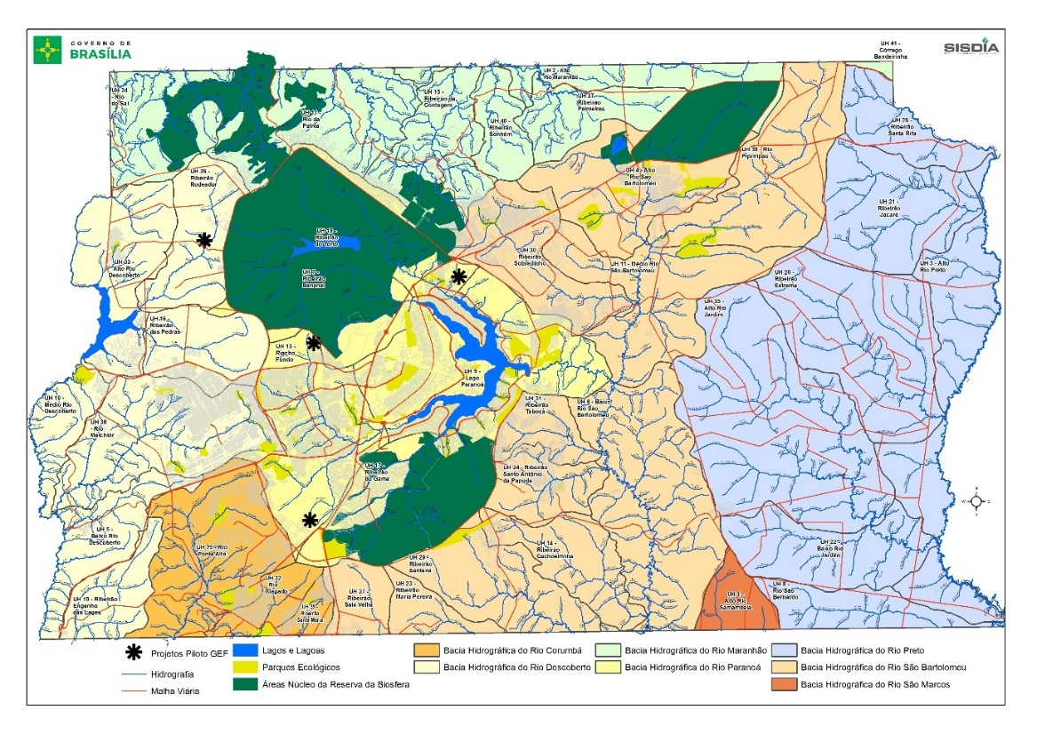

The Paranoá watershed: The Paranoá watershed comprises an area of 1,004 square kilometres and drains water to the Paranoá Lake, located downstream of the urban area of the Brasilia city. Unfortunately, the watershed has been suffering strong real estate pressure, even in the most preserved areas, impacting directly the tributaries and the Paranoá lake. The Paranoá Lake is the water body in the FD suffering the greatest human pressure. Soil sealing and disposal of sewage and untreated wastewater are threatening water quantity and quality in the Paranoá basin. Urban sprawl into city green belts can disconnect ecological corridors for Cerrado biodiversity and ecological services coming from the aquifers. For Example the groundwater in the Paranoá basin may already have been contaminated by the leachate plume from the dumpsite (Estrutural dumpsite), located in the basin.

The Descoberto watershed: another important water basin to secure water supply in Brasilia is the Descoberto, since it is currently responsible for supplying over 63% of drinking water to the FD and is also key for irrigated agriculture. The total area is 825 square kilometres of which 452 square kilometres in the FD. The area has been suffering land use change, and increasing use of pesticide in agriculture as well as real estate speculation. Water available in the basin has been decreasing over the last 30 years due to changes in land use, climate change and population increase.

Baseline in integrated environmental and water resources planning and management for the Descoberto and the Paranoá river basins: The project will restore and introduce water resource management techniques in the river basins of Descoberto and Paranoá. This will include implementing tested restoration techniques, developing and implementing a water resource plan, including agroforestry and agricultural practices consistent with the multi-use designation of the areas; and preparing the Estrutural dumpsite for closure, and testing soil restoration techniques in and around the dumpsite.

Area designations: The Environmental Protected Area of Descoberto River Basin is a mosaic of the following 4 Conservation units, a National Forest (FLONA), a Biological Reserve (REBIO), the Central Plateau EPA (UC Federal) and two parks, one at the Federal District Park and another at the Goiás State Park. The Federal Government Environmental Institution (ICMBIO) is discussing the idea of turning this mosaic into a federal protected area to promote integrated management. The single designation would cover the whole watershed and promote integrated watershed and biodiversity management, and would allow a single river and watershed management plan to be drafted.

Environmental Protected Area of Central Plateau covers 65% of the federal unit that houses the Brazilian federal capital and part of two municipalities in the State of Goiás, Padre Bernardo and Planaltina. Its aim is to preserve the sustainably use of the territory. Plans governing the EPA Central Plateau include the Territorial Master Plan of the Federal District, the master plans of Planaltina municipalities and Padre Bernardo, the zonings of EPA Cafuringa, EPA Gama and Cabeça de Veado Basin and EPA Paranoá reservoir, plus dozens of other protected areas managed by the Federal District Government. The units and plans within EPA Paranoá require integration as with the EPA Descoberto, and this is being done through a water resource management plan.

Water resource management: Preparation of the Water Resources Plan (WRP) for Paranoá reservoir started in 2015. Brazilian law requires basin plans to be developed in a participatory way, through a District System of Integrated Water Resources Management (SIDGRH) which is given this mandate. Both the WRP for Paranoá and Descoberto should build on other sectorial and regional planning instruments, to support integrated water resource and environmental planning at the watershed scale. Descoberto also established a watershed committee, although as yet no water resource plan; this is now under development.

Land restoration techniques and pilots: Project Descoberto was created by a working group formed of ICMBio, District government institutions (Secretary of Agriculture, Livestock and Supply - SEAPA, ADASA, IBRAM and CEBS), and the organized civil society through the Pro-Descoberto Association within rural communities. The first phase of the Descoberto Pilot starting in 2010, has been testing water resource management, forestry and land restoration techniques to restore and conserve a 125m strip around the Descoberto Reservoir and rehabilitate rural properties on the lakeshore. The aim has been to plant 500,000 saplings in 73 rural properties on the lakeshore and the riparian zones of the tributaries, by 2015. These techniques will now be implemented in the project as part of the water resource management plan.

The new Brazilian Forest Code obliges farmers to restore degraded lands on privately owned protected areas, known as Permanent Protected Areas and Legal Reserves. It allows them to do so through Agroforestry Systems (AFS), including short cycle crops and some exotic species intercropped with native species, provided they maintain basic ecological functions. The law does not specify, however, how such systems can and should be used in practice.

SEAGRI, EMBRAPA, EMATER, ICRAF-Brazil and Latin America, farmers, and policy makers organized an international workshop on Restoration of Permanent Protected Areas using Agroforestry Systems. The workshop learnt from a selection of innovative farmer experiences in two Brazilian eco-regions (known in Brazil as biomes), the Cerrado and Caatinga to inform FDG public policy on AFS restoration in PPAs using 15 different species of native Cerrado tree, under different conditions. Other pilots have also tested restoration techniques including using brushwood, soil transposition, artificial perches, selective weeding, ploughing, sowing, fertilizing, rain transposition seeds and litter, bagging plastics and pruning, among others. These experiences will inform restoration of the two watersheds in this project.

Organic farming: In 2005, 30 farmers already practiced organic farming in the Federal District, especially in the production of vegetables. Also in 2005, a Local Productive Arrangement (APL) for Organic Production FD was formed, and has become actively supported by users. The APL will be an important stakeholder for the project to work with. The project will assess the suitability of the techniques they are using for water resource management, and work with them and other stakeholders in the watershed to scale up suitable techniques.

Solid waste management and Estrutural open dumpsite: Urban Cleaning Service – SLU, is responsible for the collection, treatment and disposal of municipal solid waste in the Federal District. The Federal District is divided into twelve (12) regional centres to coordinate and supervise the cleaning services within their respective areas of coverage. The current waste infrastructure and operation of SLU’s waste collection, separation and treatment includes: 2 transfer stations, one in Sobradinho and one in Gaare; a central collection area for dry waste from south and north wings of the city; a pilot organic composting site in Brazilândia and a treatment plant in Ceilândia for separated waste. The remaining waste then goes to the 247 ha Estrutural open dumpsite, receiving 2,700 tons of municipal household and commercial waste per day and 3,500 – 6 000 tons / day recorded demolition waste per day.

The city’s water consumption is expected to outstrip supply in the next 3 years, so the City Administration aims to expand its water supply by adding lake Paranoá to the city's water supply network in the next three years. Brazil’s largest open and active dumpsite, Estrutural open dumpsite is located on the margins of Brasilia in an area of springs that feed into lake Paranoá. A plume of contamination from the dumpsite is going to the water table under the Estrutural landfill and adjacent areas, towards Lake Paranoá. The city believes this is causing a migration of heavy metals and through the unsaturated zone and into the saturated zone of the aquifer. This data comes from a desk study and needs to be validated with sampling and analysis, which the project will do. The city will close the Estrutural dumpsite because of these problems, and restore the surrounding area. Before it can do this, it must first open a new 30 ha site called West Landfill, and divert waste there.

As part of this overall strategy the project will sample and analyse the soil and ground water in and around the dumpsite to have more accurate data on the extent and nature of contamination from the dumpsite. This will help in choosing appropriate (phyto) remediation techniques for the project to test, and locate the pilots in optimal locations in and around the dumpsite.

Baseline on solar energy: The Ten-Year National Energy Plan (PDE) 2022 estimates that electricity consumption (excluding self-consumption) will grow from 466,5 TWh in 2013 to 672 TWh in 2022. Brazil currently generates around 70% of its power from hydro-electricity. It is therefore important the any growth strategy diversifies from this source to promote resilience, including renewable and non-renewable sources. In 2012, Brazil enacted a net metering program to allow small-scale power production generators of 1 MW or less to offset their electricity bills with credits from the energy they provide to the grid. This provides the basic conditions to encourage distributed energy and allows building owners to install and operate PV systems. However there has been little uptake or investment in PV distributed power generation. In part this maybe because of the high interest rates for loans, which do not make investment in PV systems in economic, unless the investor is using his or her own capital.

The aim of the project will be to promote federal investment in PV systems to generate experience and interest in distributed PV power generation. Based on the experience prepare a proposal to promote further uptake of PV distributed power generation in the federal district, starting with schools.

Component 2 – Investments demonstrate the benefits resulting from integrated and sustainable planning in Recife

In the 1980’s the city had a policy to promote private over public transport, and the current Land Use and Occupation Law (LUOS) still supports this, and the 4-lane Beira-Rio Avenue Project is an example of this, and which is still considered for licensing new projects. Under this policy, construction in the surrounding lots and the riverside track must still leave sufficient clearance for the implementation of the avenue to prioritize cars and parking, leaving room for dark sidewalks suffocated by a polluted and poorly maintained swamp.

Capibaribe Park is an example of a new approach. The transformation of public spaces in the Capibaribe Park introduces new approaches to urban development. The Park project will urbanize 30km the River’s banks, focusing on public spaces for people with bike lanes and installation of sidewalks, recreational and contemplation areas, for example. If it works, the Capibaribe Park project will be an example to gradually turn Recife into a park-town, with the aim of raising the rate of public green area, from 1.2 square meters per capita to 20 meters per capita by 2037. The concepts were unfolded in 4 lines of actions that involve the following objectives:

- Getting there: The streets offer pathways that prioritize pedestrians and cyclists with trees and generous sidewalks. A new system of relationship between streets, neighbourhoods and the park, which promotes the re-appropriation of the city;
- 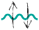Cross: with the construction of new bridges and pedestrian crossings and the consolidation of several boat crossing and several scenic overlooks on the banks, crossing the river, either on foot or by bicycle, will transform the daily life of Recife;
- Browse: a new humanized route offering a tour of more than 40 km without interruption where pedestrians and cyclists quietly move along the city, in the shades of the mangroves and in the river breeze;
- Embrace: new public spaces of permanence on the riverbanks of the Capibaribe River. Places dedicated to culture, sport and leisure. Innovative activities that will expand the imagination and expectation of people in relation to the river;

Implementation of the Capibaribe River Park project, when complete, should reach about 400,000 inhabitants in an area of ​​7,250 hectares. The first park related project provided financing for the neighbourhoods of Graças and Jardim do Baobá and implementation began in March 2016. Renovation will include leisure and contemplation areas, wide sidewalks and bike lanes.

Sewage system: Recife has currently only 35% of its territory covered by a sewage network, with the largest portion of the non-covered area occupied by the poor, in the suburban areas. A Public-Private Partnership formed in 2013 will implement a network sewage and treatment in Recife Metropolitan Region.

River transport: Recife has developed along its navigation axes, since the rivers were the only transport path for both people and goods. Over the centuries, the city has been modernized and prioritized motorized transport and the rivers have ceased to be used as a transport route for decades. The Capibaribe river Park project proposes the return of the river as a mode of transport that is integrated with the rest of the city’s transport network, allowing for intermodal connections.

An initiative between the Ministry of Cities and the State Government worth R$ 289 million (USD 82.5 million), will dredge the river, lift bridges and construct 5 boarding terminals along 11km of the Capibaribe River. The dredging and bridge lifting will allow the solar ferries - that the GEF project will finance - to operate.

Bike stations
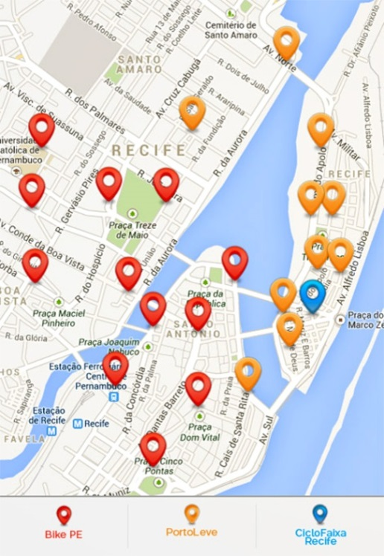

Bike Paths: in 2012 the State Government launched the Pedal -PE program, responding to the National Disability Policy and aimed to strengthen bike use as a means of sustainable transport. The program completed a Bike Plan and implemented Bike- PE. The plan sought to promote a safe cycling network, integrated with other modes, throughout the metropolitan area. The program built 70 bike-sharing stations with electronic ticketing for the Electronic Metropolitan Valley and currently carry 25,000 bike trips per month in the metropolitan area. The contract with the system management company was renewed recently, with the provision that under-used stations are relocated to other parts of the city. The GEF project will relocate two bike stations to the river crossing.

With the activities above, Recife is promoting integrated development, making use of the river once again as a recreation area and a mode of transport. The GEF project will support a plan that will connect public and non-motorized transport in an integrated network so passengers can reach their destinations, through a combination of buses, bikes, walking, electric cars, and now solar ferries to connect transport nodes more effectively. Recife must clean the Capibaribe river to make solar powered ferries an acceptable part of a passenger’s journey, and make the area attractive for people to walk and bike. This will be done by improving the city’s sewage system, and by testing biological water treatment systems to treat waste water going into the river. The banks along the river will then be urbanized and landscaped, to allow for an extension of walking and bike paths along the river to service ferry crossings and bus connections.

Component 3 – Knowledge Platform

Sustainable Cities Programme: The Sustainable Cities Program (PCS) was launched in 2011. It provides city mayors with the Sustainable Cities Platform – a full urban sustainability agenda that addresses different areas of public administration in 12 thematic axes and incorporates in an integrated manner the social, environmental, economic, political, and cultural dimensions, a set of indicators associated with this agenda (100 core indicators and 300 general indicators).

In 2012, the Sustainable Cities Program launched a large national mobilization to get commitments from mayor candidates that year. A letter of intent was presented to formalize the candidates’ commitment to sustainable development principles. Thereby, signatory mayors elected stated that they were willing to produce a diagnosis of the city from the one hundred core indicators, develop a Goals Plan (or Target Plan) for the four years of office, and account for actions taken and advances made through reports and public hearings, showing the evolution of the core indicators related to each axis.

The indicators also allow following the evolution of cities and towns over time and making comparative analyses between cities and towns. In addition, the indicators track city plans and actions and translate the results in measurable figures. Through them, it is possible to analyse the evolution in time of the different aspects of local life and formulate a set of strategies for a just, democratic and sustainable city. Raising indicators means disclosing public information, making it available to society, which is not only a right all citizens have but also a basic resource for public management and citizen participation.

After assessing the relevance of indicators, finding out how to develop them and diagnosing the city’s reality in an organized and transparent manner, the next step is formulating a goals plan.

The Goals Plan should consider criteria such as promotion of sustainable development, social inclusion and respect for human rights, and include the priorities, strategic actions, indicators and quantitative goals for each sector of the local public management, observing at least the guidelines of the electoral campaign and the objectives, guidelines, strategic actions and other regulations of the Strategic Master Plan Act. The Goals Plan enables good planning and budget execution, offering better predictability, establishment of priorities, elimination of waste and productivity gains. With a well-executed goals plan, the city will have administrative effectiveness, proposals and actions compatible with its budget, inclusion of civil society members as actors in the process, guidance for civil servants to perform their work and, above all, the continuity of public policy.

Nowadays, the Sustainable Cities Programme (SCP) (www.cidadessustentaveis.org.br) has 283 signatory cities and towns, out of which 22 are capital cities, showing the program’s reach among the main cities in the country. The project will build upon the existing SCP platform and develop a comprehensive national Knowledge Platform that will provide many more services to city managers with the aim to improve sustainable and integrated planning processes.

Innovation Observatory: In the national scenario, in terms of challenges to be addressed by cities and solutions able to ameliorate these, a number of global and national challenges associated to fostering more sustainable cities have been identified through a study conducted by CGEE (Centre for Strategic Studies) in 2015 for the Brazilian Ministry of Science, Technology and Innovation and Communication (MCTIC). These have been organised in twelve themes and sub-themes, according to table below. This was the departing point to select a number of solutions able to address identified general challenges linked to a long-term vision of what might constitute a future sustainable city.

THEMES AND SUB-THEMES FROM CGEE STUDY
Themes | Sub-themes
Natural resources and biodiversity | Air, land and water, including issues such as their use and degradation, as well as, particularly to water, its reuse, desalination, purification, filtering, treatment (including sewerage), respect to its natural cycle, conservation, depollution, efficient consumption, amongst others.  Overall life (e.g. animal, vegetal) in and across ecosystems (e.g. biome, watershed), including their variety and habitats as well as issues such as restoration, loss, etc.
Energy | Solar, wind and other clean or renewable sources (generation); efficiency (use and consumption); smart grids (distribution); transmission and storage; etc.
Built-in environment | Building; housing; infrastructure (e.g. green, blue, grey, etc.); access and social inclusion; sustainable materials and technologies; construction and demolition waste; etc.
Waste | Generation minimisation; collection systems; treatment and recovery; etc.
Mobility and transport | Individual; collective; goods and services; accessibility; security; apps and other technologies that enhance mobility and users experience; GHG emissions; etc.
Health | Food and nutrition (including diets); clean air and water; disease prevention, diagnosis, prognosis and prescription; leisure (including green spaces) and sports; access and adaptation to elderly, disable and other in special conditions; etc.
Agriculture | Urban production systems and technologies; sustainable techniques; climate adaptation; logistics and exports; etc.
Education | (Alternative and/or contextualised) learning models, both individual and collaborative; infrastructure; associated technologies; learning abilities; cultural values; literacy; etc.
Innovation and competitiveness | Manufacturing (transformative) technologies and (new) materials; infrastructure and environment for innovation; contemporary economic models; (future) jobs and required skills; sustainable consumption; inclusiveness; etc.
Governance and citizenship | Formal and informal structures and infrastructures for citizens’ participation in decision making processes; challenge-based rather than silo-based policy making; integrated and sustainable urban planning; access and ability to assess information; etc.
Security | Individual and collective; crime and violence prevention; use of territorial intelligence; diversity promotion and respect; incarceration vs. education; terrorism; physical and virtual infrastructure; etc.
Resilience | Prevention and mitigation of as well as response and adaptation to climate (e.g. climate change) and socio-environmental events; risk identification, monitoring and alert; supporting mechanisms and technologies; etc.

Based on the above findings, CGEE proposed an agenda for MCTIC, including a new line of action on top of four which are already run by the Programme of Technologies for Sustainable Cities in the MCTIC (where this project will be hosted and led – given that MCTIC is the executing agency), as well as new forms of investing both on technologies that can address specific problems at city region level and research able to develop better solutions. Currently, such an agenda is being connected to a joint project developed with the EU on innovative practices that may support the transition of cities towards sustainability. However, the need to contextualise all these findings according to city typologies to be developed remains critical to enable one to foster both innovation policies in general and specific technologies in particular that are fit for purpose.

The study validated as well that major obstacles to overall sustainability across the country are to identify contextualised challenges at the city or city region level as well as to find specific solutions able to ameliorate these. There is a lack of a clear understanding of both global and national challenges for urban sustainability and their relationship to international conventions and indicators (e.g. such as those associated to the UN SDGs and ISO 37120, amongst others). In addition, there is a lack of a clear understanding of which innovation policy design and implementation to foster in Brazil in order to promote relevant and contextualised solutions (i.e. innovative practices, technologies and integrated planning approaches) to support the transition of different Brazilian city typologies or regions in the direction of more sustainable pathways. Another critical aspect at national level is that in Brazil still prevails a short-term silo-based decision making system without much coordination. There is a clear need for better articulation at the national or federal level for developing a common vision of the future in order to design policies which are coordinated and integrated as well as to direct investments towards sustainability in different city typologies.

The World Bank (WB) is developing the Global Platform for Sustainable Cities (GPSC) which aims to put the world’s best knowledge and data in the hands of policy makers and practitioners in order to harness urban growth for better development outcomes. The Platform is organised around three components: (i) connections, which aims to match urban policy makers, decision makers and technical professionals to each other worldwide; (ii) knowledge, which aims to highlight important knowledge gaps and foster new collaborative research on policy-relevant questions; and (iii) city data, which aims to define common indicators to benchmark cities for international comparisons. The overall objectives of the World Bank Global Platform for Sustainable Cities are: (i) knowledge management – to create a flow of knowledge to where it is needed most; (ii) capacity building – to customize technical knowledge for practical use; and (iii) partnerships and global outreach – to connect policy makers and practitioners to knowledge and advisors, wherever and whenever needed.

In this context, the Sustainable City Innovation Observatory (SCIO) being proposed in the project to support the Knowledge Platform that will be hosted by the SCP - is aligned to the above-mentioned programmes and actions being developed by WB GPSC. Hence, it shall initially check which are the complementarities and lessons learned with regards to these and other existing initiatives as well as possible connections it can establish with one or more of these initiatives. This is key to enable the Innovation Observatory to become a service provider not only to the Brazilian and World Bank Global Platforms on Sustainable Cities and MCTIC, but also to other national and international organizations.

3) the proposed alternative scenario, GEF focal area strategies, with a brief description of expected outcomes and components of the project

The aim of this project is to promote integrated sustainable planning and investment in cities in Brazil. The project will test different integrated planning and management tools in Brasilia and Recife. In Brasilia, the project will help the city establish a geographical information system (GIS), with environmental and planning data to support the testing of an integrated planning approach that takes zoning decisions based on ecological and economic criteria. In Recife, the project will introduce a management system that brings departments together in a coordinated way to implement city plans and track progress for the public and city politicians to see. In both cities, the information systems to be developed will be key to support not only integrated planning but also, and perhaps most importantly, a more effective land use strategy for the future.

In Brasilia the project will support integrated investments in the restoration of a watershed while in Recife the project will promote integrated investments to model the concept of a city park along the river and an integrated public and non-motorised transport systems, including river solar ferry crossings.

Finally, the project will work with 2 partners; one to promote best practice planning approaches to other cities; and the other to use emerging big data analysis and artificial intelligence to help cities search for identified solutions to their planning problems.

Outcome 1 - A comprehensive, evidence-based integrated and sustainable planning approach is adopted by Brasilia

The outcome will help Brasilia to construct a sustainable and resilient planning approach that includes climate change mitigation and adaptation parameters, which will reflect on the ecological-economic zoning tools and territorial planning. Activity areas to improve Brasilia’s territorial planning include (i) conducting an EEZ assessment and integrating the results into a GIS information system that will allow planning in Brasilia by different departments to take into account the carrying capacity of the environment; and ii) developing mitigation and adaptation plans and assessing the use of alternative energy sources.

The project will more specifically support the following activities in Brasilia:

- Enhancement of the environmental information system (SISDIA), a virtual library that will be available for city administration, for planning, and for the public to observe and track city plans and progress. SISDIA will store, manage and analyse various information, indicators and metadata of different primary and secondary data sources, calibrated and validated by the teams responsible for data generated during the implementation of the GEF project. SISDIA will have the following modules: Climate Change, Integrated Environmental Permitting, Environmental Monitoring, Environmental Monitoring and Urban Surveillance and Geospatial Information Processing Protocol. The project will finance extensive training to all FDG system users.

- In setting up SISDIA, the project will create a governance structure for management, sharing and data use and protocols for data exchange and training for users and managers in the use of SISDIA; develop a standardised set of indicators with the SCP for use in SISDIA. The governance structure does not include new staff - and therefore will not have an additional cost burden for the city. SISDIA already exists in basic form. The aim of this project is to add the needed environmental layers to support EEZ, and the project will finance the staff and consultants time to do this. The governance structure however will control how new city data is generated in the future, how it is stored and used. Instead of departments creating their own GIS systems, they will be obliged to work with SISDIA and keep their own data current in the system. There will then be a decree with formal protocols and data integration about the use of SISDIA for planning (this is what we are calling the governance structure), and this will include an interdepartmental process to revise the city zoning using the EEZ concept.

- To populate SISDIA the project will finance over 20 different assessments on different environmental criteria including watershed management; energy and water; land use and occupancy; and conservation. These assessments will aim to regionalise climate models which will allow to build climate scenarios to which the GDF will be exposed in the following decades (temperature, rain, extreme events…). Currently public planning policies are only based on historical data and decision makers do not have evidence-base and sound scientific information to plan and invest in city infrastructure and management in a resilient and sustainable way. The results of the models will be fed into environmental and urban infrastructure layers for EEZ decision making. As SISDIA becomes functional the project will finance workshops on using SISDIA to support resilience planning.

- The creation of SISDIA will help the city to have the information they need to apply the concept of EEZ to its city zoning. Revised zoning is incorporated into Master Plans for land management, through an organic law decision. The Master Plan for Land Management (PDOT) of Brasilia determines the strategies for land use and the major systems for integrated territorial planning. The PDOT is currently under review for approval in 2017, and again every 10 years after. The EEZ and SISDIA will provide an important evidence base for the master plan in future years, as well as being used to enforce zoning policy and track progress towards city targets. In summary EEZ and SISDIA will be important to set zoning policy to inform planning decisions, and track and enforce city plans.

- Generating knowledge in climate change and integrating this knowledge in relevant climate change policies (including mitigation and adaptation plans and climate risk scenarios). This will include a Federal District Climate Forum, preparation of Environmental Conference and five small conferences for the World Water Forum.

- Creation of the Federal District Climate Forum and passing a revised Climate Bill. An important result of this action will be an increased participation of women in decision making, regarding mainstreaming of climate change risk management into territorial planning, ensuring that women will participate in the institutionalization of Brasilia’s climate change forum and Adaptation and Mitigation plans.

- Undertaking an assessment of remediation techniques for the contaminated soil/water around the Estrutural Dumpsite.

As mentioned in the baseline, the city will close the Estrutural dumpsite but it must first open a new 30 ha site called West Landfill, and divert waste there. The new landfill will be built next to the CAESB water treatment station in Samambaia. The landfill is currently in the process of environmental licensing and procurement for the works. 3 cells for waste are planned and each one will have an operating lifetime of 8 to 10 years, which can be extended if the separation at source and recycling are done. The landfill will have an impermeable floor and waste will be covered periodically as part of the standard management for the site. The new landfill will have the ability to receive an average of 2,200 tonnes per day according to the SLU, that amount will be considerably reduced with the segregated collection.

Part of this plan will also be to increase the recycling capabilities within the city as well. The aim will be to separate recyclables and organic waste at screening centres. The organic waste will go to the composing site, with an expectation that no organic content will go to the new landfill. Recycling and composting is expected to substantially reduce the levels of municipal and commercial waste going to the new landfill. The leachate from the organic waste being separated for composting, will be treated in a new wastewater treatment station that CAESB will build in Melchior.

The outputs and deliverables of this outcome 1 in Brasilia are as follows:

Output 1.1.B - Environmental Information System (SISDIA) including EEZ guidelines and data is completed, online and available for FDG sustainable planning and public access.

- Deliverable 1.1.1.B Needs and requirements for SISDIA defined and System structured.
- Deliverable 1.1.2.B Web based system designed, existing data included and equipment procured. System and modules handed out and situation room set-up.
Deliverable 1.1.3.B Training Programmes designed and delivered for internal users or FDG administrative body.

Output 1.2.B - New data and studies to populate SISDIA are collected, developed and included in SISDIA.

- Deliverable 1.2.1.B Sector climate scenarios for impact assessment and adaptation alternatives developed and included in SISDIA.
- Deliverable 1.2.2.B Updated GHG inventory and sinks for FDG.
- Deliverable 1.2.3.B Climate Management Regulatory Studies in FDG (carbon study).
- Deliverable 1.2.4.B Open dump contamination assessment completed to support the dumpsite closure plan

Output 1.3.B - Climate risk assessment and scenarios are completed and 'climate bill' is drafted.

- Deliverable 1.3.1.B Climate Act Regulation is drafted and presented for adoption.
- Deliverable 1.3.2.B Climate scenarios (1.2.1) internalized to evaluate public investments.

Output 1.4.B - Citizens' are engaged in FDG public policy making.

- Deliverable 1.4.1.B Climate Forum & Environmental Conferences established to engage citizens and policy makers in FDG sustainable policy making.
- Deliverable 1.4.2.B Indicators and monitoring data are made publicly available and citizens and policy makers are encouraged to participate in policy making.

Output 1.5.B - Lessons learned are collected and structured to feed the local and national platform.

- Deliverable 1.5.1.B Annual reports, mid-term and final report on a set of methodologies systematized and validated.
- Deliverable 1.5.2.B Annual reports, mid-term and final report, on governance arrangements for a sustainable planning approach.
- Deliverable 1.5.3.B Annual reports, mid-term and final report on positive and negative aspects from project implementation.

Outcome 1 - A comprehensive, evidence-based integrated and sustainable planning approach is adopted by Recife

This outcome will support Recife with improving its planning process. The Recife 500 Year Plan designed through this extensive popular and participatory approach will be revised to maintain the Plan consistent with the ever evolving citizens’ expectations. The revised Plan will also include an update of the portfolio of strategic projects for the city, as well as a translation of the targets in guidelines for the improvement and update of the master plan, the land use legislation. It will also widen its source base, allowing more hearings and workshops to take place in different locations and with different population segments.

The outcome will also deliver a resilience strategy and a social housing policy to support with evidence the planning process. Both studies are cornerstones of the TOD development model chosen by Recife to transform the city into a more resilient and compact city with an optimized and efficient transport system.

The project will support the selection of an indicators’ framework to guide evidence-based decisions by the municipal administration and enable the citizen to monitor them. Aries and the Recife Observatory will join hands to host the cities indicators framework aligned with the Sustainable Cities Programme to allow civil society to track progress towards the city’s goals.

Information Management System (IMS): This outcome will also respond to the coordination crisis that the city hall is facing. The different departments of Recife public management are not operating under a unified geo-referenced system that allows their actions, intervention and planning to overlay spatially. This causes a lack of coordination in the actions that place and lead to inefficiencies in the management of the city. The departments use their own sectoral plans to operate and are not yet connected to the vision that the Recife 500 Year plan brings, or respond to the Master Plan (under revision). To try to improve coordination and bring integration and sustainability to the management and planning process of Recife, the project will pilot test an Integrated Management System (IMS) in three city departments. The IMS system will allow all relevant data on projects and plans from these three departments to be standardized and migrated to this System. The Recife 500 Year plan, relevant laws, environmental studies, city targets and indicators and the revised Master Plan will also be inserted in the system. The IMS will have a public interface, where civil society can collect live data on municipal management indicators for citizen monitoring.

The targets from the Recife 500 Year plan will be included in the Implementation Management System (IMS) for implementation of the city’s plans. The 500 year plan includes a portfolio of projects and spatial plans for Recife to implement the people’s vision. The Mayor is supporting and financing the development of the Recife 500 year plan. As such, city officials will include this document along with other information and sector studies to inform the official planning process. The Mayor knows this is a popular vision of the city’s inhabitants and therefore it is good document to pick issues from, for his or her electoral platform. The Sustainable Cities Programme is also aware of the Recife 500 year plan, and can help the Mayor choose targets as part of his election platform.

Within the GEF investment, the first step on development of the IMS product will be to extract representative indicators from the plan, with support from the Sustainable Cities Programme. These representative indicators of Recife 500 year plan will be included in the system (IMS), enabling the monitoring of the city’s actions and projects, its compliance with the plan and finally measure the achievement of goals from the 500 year plan and the Mayor’s platform.

The outputs and deliverables of this outcome 1 in Recife are as follows:

Output 1.1.R - Integrated and resilient Plans for Recife through enhanced popular participation, more evidence and live and open data

- Deliverable 1.1.1.R: A more integrated and sustainable medium and long term Strategic Plan for Recife (Recife 500 Year Plan) resulting from a highly participatory process.
- Deliverable 1.1.2.R: Indicators identified and used to monitor the progress towards the long-term goals outlined in the Recife 500 Year Strategic Plan for, as the basis for evidence-based decisions.
- Deliverable 1.1.3.R: Air and water quality data and water is collected and used to support evidence-based planning.
- Deliverable 1.1.4.R: A Municipal Climate Resilience Strategy with an action plan adopted by the city
- Deliverable 1.1.5.R: Integrated social housing policy.

Output 1.2.R: Geo-referenced Integrated Management System (IMS) is tested.

- Deliverable 1.2.1.R: IMS is piloted in three municipal departments with standardised data.

Output 1.3.R: Lessons learned collected and structured to serve as input to the national platform

- Deliverable 1.3.1.R: Lessons learned and information from pilots are collected.
- Deliverable 1.3.2.R: Experiences transferred for uptake by the Global Platform for Sustainable Cities and the Sustainable Cities Programme.

Outcome 2: Investments demonstrate the benefits resulting from integrated and sustainable planning in Brasilia

This outcome will support ecosystem based adaptation (EbA) activities in pilot projects resulting from the integrated and sustainable planning for a resilient Brasilia. The local EbA strategies will focus on improving legal and institutional capacity of the Federal District and the local water and energy resource base, by increasing the use of renewable energy, providing water conservation and preservation measures, and the “willingness of policies” (OECD, 2011b). In this context, and in relation to investments for restoring and conserving both the Paranoá and Descoberto river basins, the main initiatives incorporating EbA concepts are: water resources planning; societal participation; rural development and organic agriculture; waste management and remediation of landfill; territorial planning; climate change planning; and conservation of ecological corridors and conservation units.

Spring Preservation, best practices and open dumpsite monitored: sample testing will be completed under component 1 on the dumpsite, in surround soil, in ground water aquifers and in streams in the area, to define the extent and nature of soil and aquifer contamination of structural dumpsite, and this will be used to identify technologies and phyto-treatment techniques to test on the types of contamination, and to identify locations where the tests should be conducted. The project will run remediation pilots on the dumpsite and soil and ground water around the dumpsite. Pilots will include soil and water phyto-remediation techniques. Treatment for the aquifer will also include installing a hydrologic barrier and pumps to channel, collect and treat leachate coming from the dumpsite to avoid further contamination of the aquifer. 10% of the dumpsite area will be tested, and by 2021, tested areas results are expected to inform the city on the best approaches to close the dumpsite. One result from the project will include an estimate of how long it will take, and what technologies are needed to decontaminate the area.

Waste coming to the dumpsite will be reduced by 75% through project co-financing. This will include activities to increase recycling; commissioning a new landfill, and diverting waste to the new landfill. This is explained more extensively in the baseline.

Watershed conservation and restoration: As discussed in the baseline, the Paranoá and the Descoberto basins are the main providers of water in the Federal District. More than 100 springs have been identified in the region of Serrinha Paranoá. These are key areas that need a participatory plan for conservation and preservation. In this outcome, the project will diagnose the current conditions of these springs and mobilize the local stakeholders (such as local farmers) in a number of ways to make them active participants in a sustainable and participatory approach to watershed management, including innovative techniques to conserve and restore these springs. The project targets to conserve and restore 60 ha of springs through the following initiatives:

- Work in 20 properties (50 hectares) in the Serrinha Paranoá on developing a baseline assessment of the status of the springs in this area, and on the identification and implementation of best approaches for conservation practices.
- Develop a proposal to create a 375-hectare Conservation Unit to establish an Ecological Corridor and draft a Conservation Unit Management Plan for public consultation.
- Raise awareness and work actively with the landowners in this area through a series of 16 workshops applying a “Cultivating Good Water (Cultivando Água Boa)” methodology and 6 workshops to apply the "Labyrinth of the Waters" methodology, targeting women as much as possible.
- Identify 15 new areas for agroforestry cultivation in catchments area targets and train 40 farmers.
- Establish 6 new distribution networks for organic products distribution through the CSA (Communities that Support Agriculture) in the target basin benefiting 120 consumer families (co-farmers) and support the cultivation of herbal medical plants;
- Identify 2 locations to pilot test different agriculture techniques to improve water quality and quantity using permaculture principles for watershed preservation and restoration;
- Develop a methodology to measure the "Sustainability Index of Watershed" and apply it to both Paranoá and Descoberto catchments area; and
- Collect lessons learned and publish a ‘best practice’ book, promote annual meetings for experience exchange and to track progress.

The project will also support the monitoring of the water quality of the restored springs and the evolution of the restoration of the pilot areas with aerial images, and the development of a recovery plan to scale up the pilot results in 700 ha of the Rodeador basin. The project will build on the co-finance civil works and equipment for the water production unit of CAESB.

Education and mobilization on watershed sustainability issues: It is very important that all the communities that live in the surroundings of both watersheds are aware of the benefits of watershed management and mobilized in participating actively in their conservation and restoration. The project will support existing networks and will expand initiatives to different stakeholder groups, such as schools, youth groups, organized committees, parks’ visitors, educators, etc. This active engagement and education effort will involve the following initiatives:

- Prepare for and establish a Sustainability Pact involving key stakeholders on the watershed area. The project will work through continued social mobilization of diverse number of key stakeholders in both basins, including private sector partners when relevant. No new committees will be created by the GEF project. The pacts will be based on best agriculture practices, from the project pilots existing water use, land use, urban planning and climate change mitigation targets, no regret climate change ecosystem based adaptation plans and targets. The pacts will establish clear rules, roles, targets for different parties and monitoring sustainability parameters and indicators will be based on sustainable development goals, Sustainable Cities indicators (World Bank, ISO, UN), FDG integrated water, land use, ZEE, climate change policies and plans and Good Water Methodology. SISDIA will be used to track change in areas covered by these pacts.
- Train and sensitize community groups, schools and parks, through 10 workshops using the Cultivating Good Water (Cultivando Água Boa) methodology and conduct 10 permaculture courses on best watershed management practices;
- Establish a Youth for the Environment committee in schools, and train school teachers to include the subject of watershed conservation importance in their environmental education classes.
- In FD parks, train park staff and visitors on environmental education and on the importance of watershed management including train-to-trainer’s seminars in the parks and roll out these seminars through the projects “Educator Park and Pilot Plan Parks”.
- Train active watershed community members in a series of events and actions and roll out activities in coordination with local schools on the project activities and on the importance of watershed management.

Photovoltaic panel pilot: The pilot will install a centralized PV system of 500Kw to 1MW to provide electricity to 10 schools. All excess power will be sold to the utility under the current net metering legislation, the proceeds for which will be shared among the schools. Part of the pilot will be to prepare a legal agreement between the schools on responsibilities for operation and maintenance of the PV system how the proceeds from the sales of the PV systems will be shared between the schools and what the proceeds can be used for. Primarily they will be used to cover the costs of electricity of the schools and energy savings measures to reduce power consumption in the schools (and maximize the sales of PV power to the utility). Thereafter they will be used for education and awareness, including on renewable energy. From the experience of the pilot the Federal District has committed to identify options to promote decentralized PV power operation in schools and other public buildings throughout the Federal District. This could include a legal framework, a mix of incentives, minimum energy efficiency standards in public buildings, and procurement regulations among other options. In preparing the framework, the federal district will complement the pilot experience with broader feasibility and data collection to support an expansion of PV in the energy mix in the federal district. The component will also include training for installers and maintainers to improve the service and quality of PV systems installed, and awareness creation in the public sector to promote action around the revised legislation and or incentives agreed to be the Federal District. Where possible the project will target women for the training on the installation and maintenance of PV panels, and in the results of the net metering business models for independent power generation. The project activities will be done in coordination with co-financed activities by the FDG on the Solar Brasilia Program, a strategy for decentralized photovoltaic power generation.

The outcome has an output to track and monitor the results from this outcome. This will include measuring power generation from the installed PV panels; generating lessons learned from the public decentralized PV model; measuring the effectiveness and generating recommendation from the soil and water decontamination pilots; measuring results on water quality and flow and making recommendation from the stream restoration, agro-forestry and agriculture pilots. Information and lessons from the outcome will be shared with SCIO and GPSC under outcome 3. A monitoring consultant will support the overall project in establishing the systems in both systems to measure the baseline and track progress of all pilots.

The project in Brasilia will hire consultants with gender expertise to promote various environmental education and social mobilization to support women and men in achieving the objectives of the project in their communities.

The outputs and deliverables of this outcome 2 in Brasilia are as follows:

Output 2.1.B - Springs preservation completed, best practices implemented and open dumpsite monitored towards decommissioning.

- Deliverable 2.1.1.B - Open Dumpsite surface soil, surface water and groundwater and gas remediation technologies are tested and validated.
- Deliverable 2.1.2.B - Descoberto and Paranoá watersheds pilot areas are restored and managed.
- Deliverable 2.1.3.B - Support for water conservation research and implementation of best practices in the pilot areas of Descoberto and Paranoá watersheds developed.
- Deliverable 2.1.4.B - Education and mobilization to enrol the FDG population on watershed recovery.

Output 2.2.B - Solar energy pilots and promotion are completed.

- Deliverable 2.2.1.B - Solar pilots installed, operating and changes measured.
- Deliverable 2.2.2.B - Enabling conditions created to promote the uptake of solar technologies in the FDG.
- Deliverable 2.2.3.B - Education and mobilization to enrol the FDG population on benefits of solar technologies.

Output 2.3.B - Lessons learned are collected and structured to feed the local and national platforms.

- Deliverable 2.3.1.B - Annual reports, mid-term and final report on a set of methodologies systematized and validated.
- Deliverable 2.3.2.B - Annual reports, mid-term and final report on governance arrangements for a sustainable planning approach.
- Deliverable 2.3.3.B - Annual reports, mid-term and final report on positive and negative aspects from project implementation.

Outcome 2: Investments demonstrate the benefits resulting from integrated and sustainable planning in Recife

This outcome will support the initiatives detailed below which derive from a portfolio of sustainable development projects identified in the city long-term vision plan. The intervention will entail land use transformation on the river banks and testing of innovative and sustainable technologies. The city plans to institutionalize through policy successful results.

Solar boats: The project will finance 2 PV solar powered boats (ferries) to connect passengers between the two banks of the Capibaribe river and the bike and bus networks on either side of the river. The figure below shows the two docks that will be directly financed by the project to ensure the connection between the riverbanks. The choice of the pilot location for the solar boats has been done in coordination with all the other pilots to allow all pilots to be located in one stretch of the river. This was done to be able to showcase at the end of the project the integrated nature of the Capibaribe Park with urbanized banks, bike lanes, walking paths, solar boats, and filtering gardens.

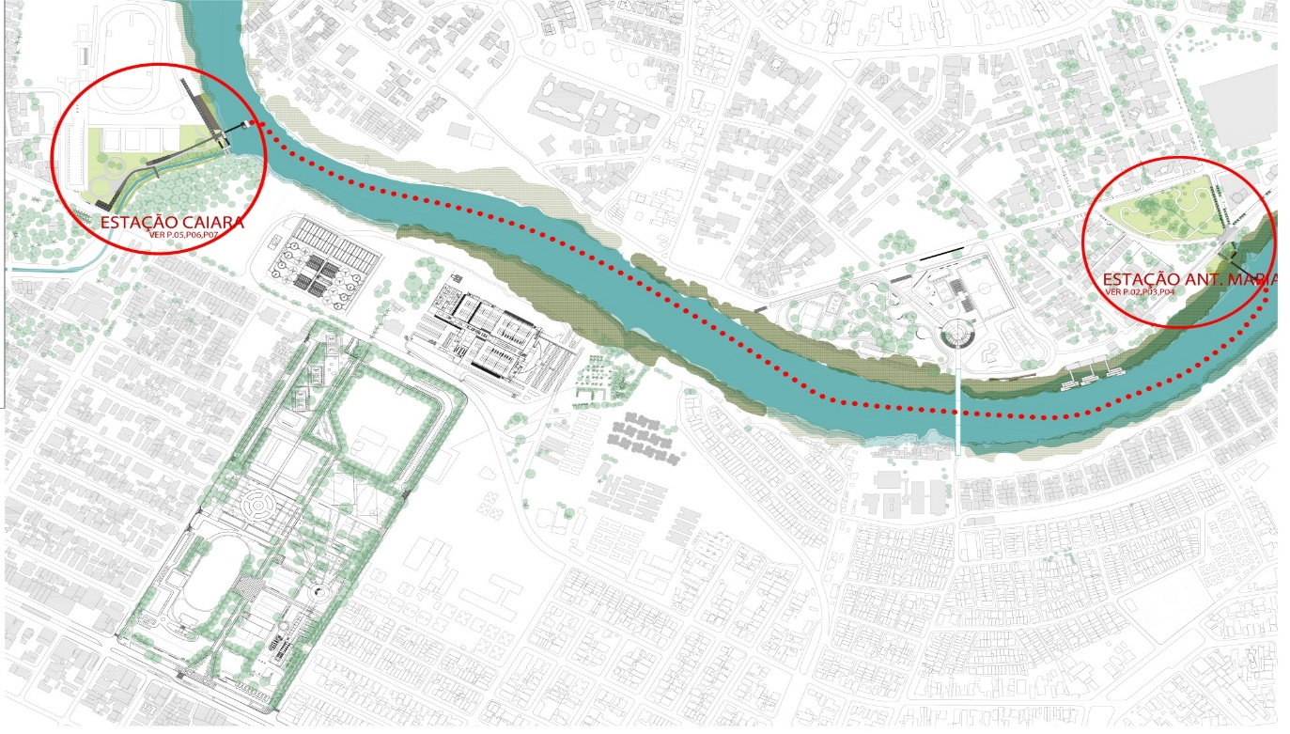

The figure below shows the 2 initial docks that will be built under the scope of this project, as well as 3 additional stations that could complement the system once this project has ended, if the system is proven to be successful.

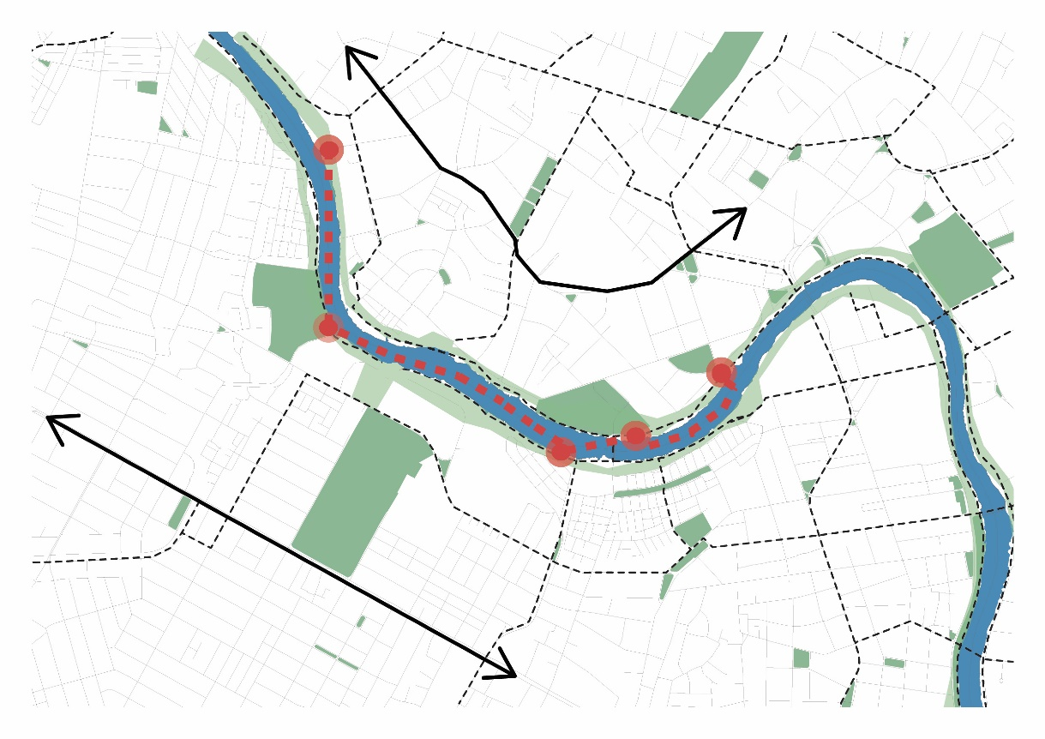

The PV technology is in part designed as publicity to attract interest among passengers in the river crossings and in part it will allow the city to test, refine and integrate this technology into their public transport system. There will be two PV boats; the first one will be tested as soon as possible after the start of the project, the second following later and building on the experience of the first. The vessels will be approximately 6 m (12m x 5m) long, with capacity for 20 passengers and 5 crew. The boats will have two battery banks, one set being charged on land by PV panels at one of the ferry stops, allowing uninterrupted operation of the boats. The boats themselves will have solar shelters for the passengers and to provide minimal charge to the battery banks in operation. There will be 23 docking stations with bike racks and an electric car sharing station will be located next to one of the terminals to charge the ferry batteries as well as an electric car. The ferry terminals will allow for modal shift between car, bikes, pedestrians and the ferry. More details of the infrastructure are provided below.

As part of the PV ferry boat pilot, the project will explore a suitable business model to have boats operated as part of the city’s public transport infrastructure. By locating the ferry terminals well, it will be more possible to develop a business model that is viable both economically and financially and that meets the real demand of the population, increasing the likelihood of the project to have long life. One possibility that has been considered in the planning stage is the turnkey system, in which a company would be hired to run the service, and the boat would be owned by the company, to serve the public transport. However, the definition of this model will occur early in project implementation.

The outcome will include a route survey (origin-destination survey) in the intervention area to identify the optimal route for the ferry and docking stations, to minimize travel time. This survey will be placed in the context of the city-wide origin destination survey to fully integrate the project pilot with the city public transport network. On top of that, the solar boats pilot will be implemented as part of a larger scheme to improve the navigability of the Capibaribe River and allow for an expansion of the ferry network. In the study area 1/3rd of population live in hilly areas of the city but mainly work in the plain area and therefore spend significant commute time travelling to and from work. These passengers could be prime beneficiaries of the river crossings. The pilot will be located on the river to reduce journey time for passengers and to unite parts of the city where income inequality is high. The final location of the terminals will also aim to link up with the network of public transport and to allow the passengers to connect their trip by short walking or bike.

The aim of the project is to also test the financial viability of the solar boats and develop a business model able to support the operation in a long term way. The project will include operators from the start of the project in the design of the solar boats and the design and location of the terminals. The city is committed to this service and will continue its operation even if it turns out not to be financially viable.

Capibaribe River bank Urbanization: This will include the landscaping of the above-mentioned areas around the two crossing river points. Urbanization will favor public spaces for pedestrians, paths and elevated crossings, as per the figure below.

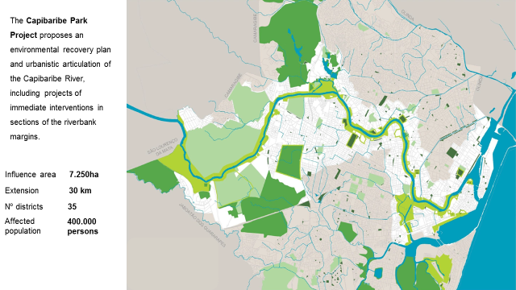

The navigable channel is nearly 40 meters from the bank and the river is tidal, so ferry terminals will need to be especially designed as per the figure below.

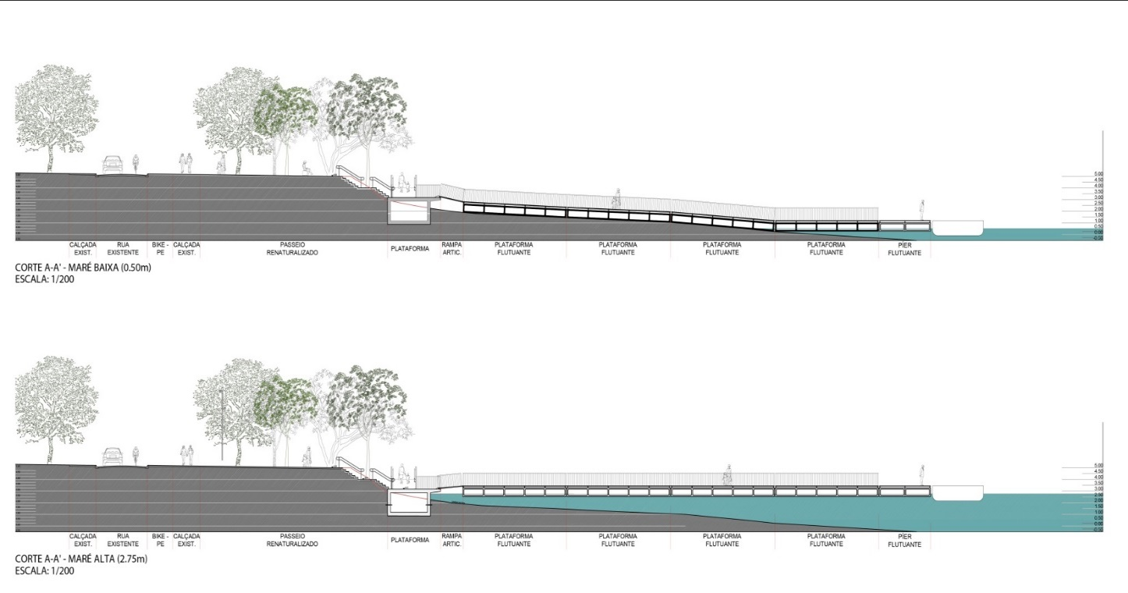

The terminal will have indoor and outdoor waiting areas and allow the docking of boats other than those provided for the project, such as boats of local boatmen, canoes and kayaks. The project will finance development, contracting and construction of these areas. Construction of the ferry terminals will test green materials and technologies as an experience for the city for application in other projects, as appropriate. Project infrastructure will be licensed with the Secretariat of Environment, the Secretariat of Mobility and Urban Control and the Port Authority, responsible for the navigable beds.

Filtering Gardens: The project will build on a Public-Private Partnership (PPP) co-finance of USD 76 Million (R$ 4.5 billion) to re-habilitate the sewage system in the city. The co-financing from COMPESA, which is a Pernambuco State Agency will reach approximately 3.7 million people in 14 municipalities in the Metropolitan Region of Recife. The project will test a filtering garden as a biological approach (see figure below) to treat sewage coming into the Capibaribe River. The filtering garden will be placed in channel next to the outlet of the river, and will be consistent with the park urbanization vision of the Capibaribe riverbanks. 14 channels have been identified along the river within the city, that will also have filtering gardens in the future if this example is successful. In order to assess performance of the pilot, river water will be collected and sampled. Sampling stations will be located before and after the treatment by gardens. This information will be of great importance for the decision on the up-scaling of the Project.

In addition to the technical activities, the gardens project will include communication activities for the involvement of the surrounding population, and will propose community gardens and engagement activities to promote ownership of the intervention. Finally, a maintenance plan will be established after 5 years of GEF project.

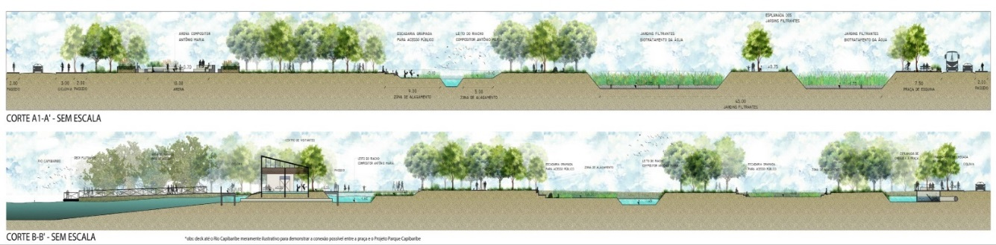

Lessons learned: The project will hire two companies: a communication company to develop and implement a social engagement strategy in the areas of intervention throughout the project; and an environmental consultancy to develop impact assessment parameters, and track project progress against these parameters. The consultancy will also provide lessons learned for the project knowledge platform. Two companies are needed since two different sets of expertise are required, which are not typically found in the same company in Brazil; these are the impact assessment capabilities and social engagement skills. Without them we will not be able to do the impact assessment and not be able to do the social engagement and understand what the population want and how to engage them.

The outputs and deliverables of this outcome 2 in Recife are as follows:

Output 2.1.R - The financial and technical viability of operating 2 Solar boats across the Capibaribe river is assessed.
- Deliverable 2.1.1.R Solar boats connect with bike and electric car stations, on both sides of the Capibaribe river.

Output 2.2.R - Banks of the Capibaribe River urbanized in two sections.

- Deliverable 2.2.1.R Banks of the Capibaribe River urbanized in two sections including: 2 docking areas; 2 waiting areas; 2 bike stations and 2 electric car terminals constructed; 5 resting areas; landscaping of 4.38 ha; repair of 0.3 km of bike lanes and walking paths.

Output 2.3.R - Filtering Garden cleaning the water through the use of vegetation.

- Deliverable 2.3.1.R 1 Filtering Garden installed, operational and results measured.
- Deliverable 2.3.1.R 1,010,000 meters of recovered or deployed sewage network (co-finance)

Output 2.4.R - The City tracks and generates information and lessons on the experiences with the pilots for the national platform.

- Deliverable 2.4.1: Information and lessons learned are collected for the national platform.

Outcome 3: The tested integrated and sustainable planning solutions are promoted by the National Platform for Sustainable Cities to up to 300 Brazilian cities as the reference for integrated urban planning.

The project will develop a National Knowledge Platform to replicate successful sustainable urban solutions in Brazil. The National Knowledge Platform (NKP) will be a joint undertaking of the Sustainable Cities Programme and the Center for Strategic Studies (CGEE). The NKP will link the websites of these two organisations and their associated services. Each organisation is responsible for discrete areas of work and knowledge development which once developed will be part of the NKP. Practitioners will be able to access the combined knowledge of the project through a single link. CGEE will participate in the NKP on behalf of the Ministry of Science, Technology, Innovation and Communication, the executing agency of the project. The Sustainable Cities Programme will be responsible for Guidance and Advisory activities with the other institutions that make up the Steering Committee. It also operates within the Project Management Unit, which together comprise the Executive Management Group.

This platform will build on the existing Sustainable Cities Programme Platform. It will include proven methodologies and integrated urban planning/development tools for Brazilian cities to use. To do this, the current SCP platform needs to be re-designed, restructured and populated with more features using project developed resources to improve their planning process and prepare more robust target plans.

In addition to the redesigned Platform, other data sources and links will also be included. Essentially this will include the Innovation Observatory (SCIO – described below), the Brazilian Institute of Geography and Statistics (IBGE), and the Global Platform for Sustainable Cities being created by the World Bank under the GEF cities IAP. This outcome will also focus on two strategic processes: mobilization of the key players, and their training.

The new modules of the platform will be:

Indicators: This section of the Platform consists of a local municipal data system which uses algorithms to filter and organize the structured data stored. Local governments feed the database (DB) using pre-established topics and indicators, within a system of 260 basic indicators offered by the SCP. The consolidation of these indicators will be conducted through a harmonization activity that will create data standards based on the UN’s Sustainable Development Goals (UN-SDG), SCP indicators (organized into 12 thematic axis), and the ISO 37120 standard. The data standardization process will seek to synthesize the topics covered in the three sources. The module provides several tools for data filtering and viewing, which provides a variety of activities, including indicator grouping, indicator historical analysis and integrated analysis. This module will work in conjunction with the integrated urban planning/development module to allow spatial viewing of data with the geoprocessing tools.

Integrated Urban Planning/Development: the module will allow users to choose local data on land features and associated problems the city aims to address. The following information layers (environment, health, transport, housing, land use, and education) will make up the local data system for cities, and city characteristics. The inclusion of this spatial data in the platform will provide transparency and connect city management, land use planning, and budgeting with planned results. Data processing tools - from the National Institute for Space Research (INPE) and the IBGE will provide free software for spatial data analysis (TerraView/Spring) and a detailed demographic database (Demographic Census spatialized by census sectors). This together with land use planning will allow different thematic layers to be overplayed, allowing city managers to see their city with different overlays, to support planning and decision-making.

Municipal financing and budget management: This module will allow city managers to see financial opportunities (such as loans and financings) and budget management, including domestic and international funding opportunities and to provide municipal budget management information to support municipal tax collection decisions and other financial decisions. This module is directly associated with GIS support and municipal indicators to allow integrated analysis for municipal plans.

Best practices database: This module will include a Best Practices (BP) database with successful public policies and plans from various countries, and methodologies for developing local best practices and comparing actions that have performed well in similar contexts. Together with the indicators module, users can analyze the components of each best practice and the results obtained. The module will be linked to the Innovation Observatory (SCIO).

Academic contributions: This module will enable municipalities and academic institutions to develop medium and long-term technical and scientific partnerships with each other to promote the uptake of new technologies and research to solve city problems. The module will be linked to the Innovation Observatory (SCIO).

Sustainable Cities Programme (City Goals Plan): The Sustainable Cities Programme allows public managers to define their urban sustainability agenda, with indicators to track progress and a best practices database on goal planning. The Sustainable Cities Program offers: tools: Database, Indicators, etc.; commitments: signed Letter of Commitment (for pre-candidates, candidates, mayors and parties) and commitment with municipal diagnosis, City Goals Plan. The plans and indicators will be publicly available for citizens to see. The module will include free access to indicator software, support to the City Goals Plan elaboration and capacity building. This module will support member cities to develop their City Goal Plans.

Social participation: The main goal of this module is to ensure social participation and involvement in the decision-making and development processes for municipal plans. Through the training of municipal managers and the transfer of technical, administrative and legal information, this module will build municipal capacity on social participation. Managers and civil society groups will have access to a range of information materials, as well as tools to develop and strengthen social participation in municipal management, such as discussion forums, online polls, chat rooms and methods for grouping and disseminating testimonials, plus examples for the establishment of municipal councils and other social participation media.

Collaboration with the private sector: Local and regional businesses play key roles in land use planning and development. Understanding the characteristics of the Local Productive Arrangement (LPA) and the Supply Chain (SP) allows local managers and civil society to articulate thematic plans. Cities can develop local strategies to achieve the Platform's goals and become more effective in the regional planning process, through dialogue with civil society and the productive sector. Local management can establish partnerships to obtain data and information, and access financial and material resources to enable greater effectiveness of local plans and actions. An example is the existing Business Forum to Municipalities Support.

Training and Capacity-building: This module is the repository of all training materials. SCP will use this module to support the training of at least 300 city managers and political parties’ foundations. The training will be delivered (under the Output on Skills Development Training) in presence, online, and through distance learning (DL) activities. The SCP will provide training to the cities. They already have a network of over 285 cities that they have been working with and providing training. The aim of the project will be to improve the quality and extent of the training that the SCP provides. The training will be provided to 300 city managers. City managers (municipal secretaries, directors, advisors and technicians) will be voluntarily selected by mayors on a voluntary basis, consistent with SCP agreements. Additionally, the SCP suggests that the managers chosen be employees from different departments and levels, and include the head of the Department of Planning, who will be tasked with coordinating the management of the Sustainable Cities Programme, given the need for dialogue between departments during the development of the strategic planning process. The training program will be adapted to incorporate the Sustainable Development Goals. The expectation is that by the end of the training, public managers taking part will have expanded their capacity to manage integrated programme within different areas of their city government. They will be able to use tools provided by the SCP to undertake short, medium and long-term assessments and planning. In addition to the training sessions, all training materials used will be available on this module, which will allow participants to independently develop their studies and engage in local discussions. Specific features of this module include an exclusive area for registered users (login) and tools for interaction between users (such as chatrooms and forums) which will allow the establishment of information and experience exchange flows among city managers who join the SCP.

Plans, laws and regulations: This module will include a list of existing regulations (such as national plans and state environmental zoning) as a reference for municipalities to be aware of national strategies and international guidelines.

Events: The module will include platform (such as scheduled international conferences); third parties an events organized by platform participants (city managers and civil society organizations). With tools for dissemination, calendars, and information sharing, users will have access to a wide range of activities related to the Platform and to current trends in social justice and sustainability.

To support the National Knowledge Platform with more in-depth analysis of common problems that cities face, and to draw more scientific lessons from the investment pilots of this project, this outcome will support the establishment of the Sustainable City Innovation Observatory (SCIO) to be hosted by CGEE (MCTIC).

Based on an in-depth continual understanding of key challenges which need to be addressed in different city contexts or typologies in Brazil, the proposed Observatory should then be better able to map, identify, select, contextualise, monitor, make sense and point to innovative technologies, practices or approaches that can leverage a city’s typology or region towards urban sustainability.

The Observatory of the Brazilian Sustainable Cities Knowledge Platform will involve the development of data mining and data processing tools that will use state-of-the-art software development solutions and will process huge amounts of available data to provide processed information customized through a large set of parameters offering a user friendly interface. The project requires sophisticated artificial intelligence programming and a whole period of trial and adjustments undertaken by very specialised and expensive expertise. The graphic below illustrates the process that the project plans to understand to develop this software, and collect, organise and make these data useful for cities.

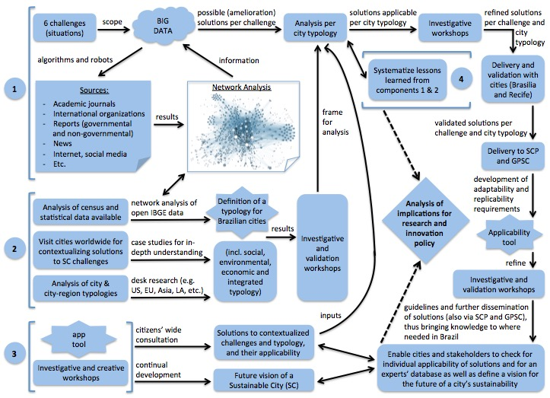

The Observatory will depart from six challenges identified in the consultation process of this proposal and that relate to the problems that knowledge platform or the investment pilots of the project cities will have to address:
- Net metering models for decentralised renewable energy production (Brasilia)
- Technologies and design options available to make low income housing climate resilient (Recife)
- Phytoremediation solutions for restoring ecosystem services in contaminated areas (Brasilia)
- Automated GIS data collection technologies for integrated planning and management software focused on zoning and mobility (Brasilia, Recife and KP integrated planning module)
- Best practices for long-term planning and integrated approaches for city visioning (Recife)
- Options for improving innovation policies based on resource flows and reverse logistics (Brasilia/Recife/ Observatory/UNEP)

To identify the solutions to the problems above, the Sustainable City Innovation Observatory (SCIO) will: (i) define a methodology for the contextualisation of cities (e.g. city typologies or city regions) in Brazil, according to specific challenges to be analysed; (ii) develop artificial intelligence mining tools (e.g. robots and algorithms) and big data analysis to undertake the identification/mapping and monitoring of likely solutions to the six challenges under analysis, thus supporting one to make sense of transition practices, innovative technologies and long-term integrated planning approaches able to ameliorate the challenges under analysis; (iii) identify the potential replicability or adaptability of findings into different city contexts (i.e. typologies or regions); and (iv) analyse the implications of findings for innovation policies in Brazil.

The proposed Sustainable City Innovation Observatory (SCIO) will provide policy for the development of a common vision for sustainable cities. In addition, it shall facilitate the dissemination and replication of lessons learned, including sharing of innovative practices through inter-alia and knowledge sharing mechanisms. In doing so, the Innovation Observatory shall raise awareness of and enhance capabilities for urban government leaders and officials, especially at the Ministry of Science, Technology, Innovation and Communication and other relevant Ministries in Brazil, to address global sustainability concerns in an integrated manner, with local action. This component through Output 3.6 will also develop policy briefs that will reflect successful lessons learned from the project. The policy briefs will be promoted to relevant ministries (Ministry of Cities and Ministry of Environment) to be adopted as part of the national framework for urban planning with the aim to scale up successful and impactful approaches that improve the sustainability of urban planning processes. The Observatory will also be able to provide national policy makers with tailor made policies taking into account city typologies, which will make urban policies more relevant to the level of development, profile and size of cities.

The Sustainable City Innovation Observatory (SCIO) products should also serve as input for both the Brazilian and the World Bank Platforms for Sustainable Cities. The connection between the proposed Observatory and the mentioned Platforms should enable one to monitor the evolution of a particular Brazilian city context or region in dealing with a specific challenge at hand and, therefore, to evolve towards sustainability or to transition in the direction of more sustainable pathways.

The outputs and deliverables of this outcome are as follows:

Output 3.1: An operational Knowledge Platform online

- Deliverable 3.1.1 – Improved functionality of the Knowledge Platform.
- Deliverable 3.1.2 - Knowledge Platform database interconnected with the Innovation Observatory database.

Output 3.2: Operational modules for the Knowledge Platform portal online.

- Deliverable 3.2.1 - Indicators module with data from up to 300 cities and with the following functions: progress tracking against city target plans, cities comparability, impact analysis, guidance for alignment with SDGs and ISO 37120.
- Deliverable 3.2.2 – Integrated geo-referenced urban planning tools operational and support to test tools delivered.
- Deliverable 3.2.3 – Funding opportunities on integrated urban planning listed and kept updated on the platform.
- Deliverable 3.2.4 – Best practice database on urban planning approaches kept updated on the platform.
- Deliverable 3.2.5 – Potential public and academic partnerships in integrated urban planning listed and kept updated.
- Deliverable 3.2.6 – Public participation in planning, consultations and hearings promoted through the platform.
- Deliverable 3.2.7 - Private sector partnerships enabled and promoted through the platform.
- Deliverable 3.2.8 - Training and skills development module operational.
- Deliverable 3.2.9 - Federal, state and municipal Plans, Laws, Regulations and Public Policies listed and kept updated.
- Deliverable 3.2.10 – Event list, kept updated and promoted through the platform.

Output 3.3: Skills Development Training designed and delivered.

- Deliverable 3.3.1 Inequality Map tools and data training delivered to Municipal managers.
- Deliverable 3.3.2 Integrated Urban planning tools and data training delivered to Municipal managers.
- Deliverable 3.3.3 Municipal Goals Plan preparation, implementation and development tools and data training delivered.
- Deliverable 3.3.4 Indicators module tools and data training delivered.
- Deliverable 3.3.5 National and international events on the Knowledge Platform organized, and training on the creation of similar local events delivered to municipal managers.
- Deliverable 3.3.6 Knowledge Platform training delivered to municipal managers and civil society.

Output 3.4: Mayors and politicians mobilised to join the sustainable cities platform.
- Deliverable 3.4.1 Mobilization campaigns for mayors to join the Sustainable Cities Program conducted.
- Deliverable 3.4.2 Mobilization campaigns for Brazilian political parties for the Sustainable Cities Program conducted.

Output 3.5 Sustainable solutions to six urban planning and investment challenges identified and delivered to Brasilia, Recife and SCP.

- Deliverable 3.1.1 Net metering models for decentralised renewable energy production.
- Deliverable 3.1.2 Technologies and design options available to make low income housing climate resilient.
- Deliverable 3.1.3 Phytoremediation solutions for restoring ecosystem services in contaminated areas.
- Deliverable 3.1.4 Automated GIS data collection technologies for integrated planning and management software focused on zoning and mobility.
- Deliverable 3.1.5 Best practices for long-term planning and integrated approaches for city visioning.
- Deliverable 3.1.6 Options for improving innovation policies based on resource flows and reverse logistics.

Output 3.6 Solutions for urban planning and investments promoted to other cities.
- Deliverable 3.2.1 A database of solutions is populated and available online.
- Deliverable 3.2.2 A search interface is functioning to allow search of solutions by challenge and city typology.
- Deliverable 3.2.3 Requirements for application of solutions by city typology are developed.
- Deliverable 3.2.4 Implications for innovation policy are developed.
- Deliverable 3.2.5 The uptake of solutions are actively promoted.

4) Incremental/additional cost reasoning and expected contributions from the baseline, the GEFTF, LDCF, SCCF, and co-financing;

The project aims to promote a more integrated and sustainable approach in cities in Brazil in municipal planning and investment.

This incremental cost analysis assumes that most if not all technical assistance and investment in the project will lead to city financial savings in the long run. Both the technical assistance and investment aim to pilot innovative investments which if they work will lead to further investments in the future which will make more savings for the city. Therefore, the incremental costs of this project are premised on barrier removal. In planning the project will make targeted interventions that incrementally improve the cities capability to plan in a more integrated, long term and sustainable way. Example of this intervention logic are summarized below:

Brasilia

- Brasilia needs to find additional municipal water supply to meet growing demand, and as such they plan to bring on-line water from a new watershed called Paranoá. However, there is an illegal dumpsite in the watershed, a degraded watershed, and land use activities in the watershed that are inconsistent with potable water abstraction. The city faces a choice of putting in a sophisticated and expensive water cleaning facility, or closing the dumpsite, remediating the surrounding area, rehabilitating degraded areas near water bodies and modifying land uses practices to those more conducive to the multi-use site. This cost of this alternative is expected to be cheaper for the city, together with other associated benefits of habitat restoration and improvement.

- Solar energy is rapidly becoming a least cost power generation alternative, and would improve the resilience of Brazil’s energy mix, from a very high reliance on hydro-power. Although Brazil has net-metering legislation, there has not been a significant uptake distributed solar power generation. The 2 main reported barriers to this uptake are poor installation and maintenance leading to a bad consumer experience, and a net metering business model that does not provide sufficient benefits for the consumer and or power distribution companies. Building on lines of thinking being developed primarily in the US to make sense of distribution costs in a distributed power generation model, the project aims to develop a business model that promotes the uptake of distributed solar taking into account the interests of distributed small generators and distribution companies. It will also seek to improve the quality of installation and maintenance which underpins the reliability and therefore cost effectiveness of distributed solar PV systems.

- In planning Brasilia is interested in using an ecological-economic approach to its zoning. This is an approach that aims to internalize environmental costs and benefits into local zoning decisions and investments. The project will support the city to test this EEZ approach, and if it works in future decisions in water supply and power generation will favour options such as those being tested in this project.

Recife

In Recife the focus of the project investment is to promote the concept of a park city with integrated transport systems to reduce the need for cars, reduce travel times, congestion, and air pollution. Underpinning this is the re-integration of the very polluted river Capibaribe into the landscape of the city and making an attractive place to use. As things stand the city does not currently have this view of how the city should be planned, and the pilots aims to put into practice in a micro-cosmos of the city this thinking. If successful there is an expectation that city officials will begin to adopt this type of thinking in in future city planning. As with Brasilia above the pilot aims to internalize environmental externalities in the city approach to planning, but in a less formalised way than Brasilia (i.e. without EEZ).

In planning the project aims to practical steps in helping municipal officials implement more effectively their sectoral plans, through an information management system that links different departments together and promotes coordination in the execution of city sectoral plans. However, there is an intrinsic link to environmental externalities through the public. The public faces the planning externalities of city planning on a daily basis, through a dirty river, polluted air, congestion and long travel times. The Recife 500 year plan reflects the environmental costs that citizens face on a daily basis, and as a result the plan seeks to address these environmental externalities. As such the Information management system being financed by the project will include indicators to track progress towards the Recife 500 year plan (as well as the formal City Master Plan), and be available on line to the city officials, politicians and the public. This is expected to bring public pressure to bear on the city to pursue actions that fulfil the goals and objectives of the citizen driven Recife 500 year plan.

Knowledge platform

The knowledge platforms and associated work being executed by CGEE, and the Sustainable Cities Programme simply seek to scale up successful planning and investment pilots to other cities in Brazil, and as such spread good practices on integrated sustainable urban planning.

5) global environmental benefits (GEFTF) and/or adaptation benefits (LDCF/SCCF)

The project is expected to have a direct emission reduction of almost 3,803 kilotons of CO_{2e} (ktCO_{2e}) mainly related to the policies and strategies developed under component 1. The estimated yearly reductions of 264ktCO_{2e} for Brasilia and 116ktCO_{2e} for Recife at the end of the project, have been cumulated for the period of influence after project closure of 10 years. The explanation of these estimations is detailed in Annex J2.
The cost effectiveness of the project considering only direct impacts is 5.95 USD/tCO_{2e}.
In addition, the project activities will also have adaptation benefits, mainly in Brasilia where the pilots that will be implemented by the GEF project are considered “no-regrets”. The project will improve the baseline conditions for targeted communities to the severity of anticipated climate change effects by decreasing energy and water insecurity. Solar energy and EbA demonstrations will be supported by local institutional and capacity strengthening – of the SEMA/SEPLAG/ CEB/ CAESB/ADASA/IBRAM – to reduce the vulnerability of local communities living in the Paranoá and Descoberto Basins to climate change. The direct environmental and adaptation benefits for local communities from EbA in the Paranoá and Descoberto basins will include improved natural capital and ecosystem services that underpin livelihoods such as agriculture and water production. Additionally, by testing monitoring and remediation systems to the open dumpsite, restoring the Cerrado forests and spring waters in the intervention sites, the GEFTF-financed project is expected to support science-based evidence climate change policies and institutional arrangement, help the implementation of best practices to improve water quality and quantity, avoid land degradation, and the creation of ecological corridors, increasing availability of natural habitat for plant and animal species that depend on these ecosystems.
6) innovativeness, sustainability and potential for scaling up.

Innovativeness
Cities have been developing specialized geographical information systems for some time now. However, it is very typical for these systems to separate, so for example a city may have a GIS for transport and another one for housing, neither system being able to interact with the other, for example to start making informed decisions about transport oriented development.

The project will support Brasilia to set up a GIS, SISDIA, which will begin to overlay zoning information with environmental data. This in itself is innovative. SISDIA is then designed to support the concept of economic-environmental zoning, which is also a novel approach to making zoning decisions. The aim of EEZ is to make informed decisions that balance much needed economic development with environmental trade-offs. Zoning decisions can therefore start to be made to internalize environmental externalities and being to reflect both the financial, economic and environmental costs to zoning decisions.

The Estrutural Dumpsite is causing contamination to surrounding land according to a desk study. Typically, this would be clean up using chemical solutions, or by removing the soil entirely. Phytoremediation techniques have been used successfully on other dumpsites but not so far in Brazil. The project will test phytoremediation for soil and waste water, and if they work these techniques will be used more widely. As with the phytoremediation techniques, the filtering garden are a biological technology designed to replace mechanical and or chemical processes. Filtering gardens are used elsewhere but not yet in Brazil, and the project is designed to test the efficacy in Recife, for scale-up all the river if successful.

Electric engines for boats are not new, but the connection with solar charging is a novel concept for Brazil. This project will test the concept as an application for small passenger ferry boats, and as such will be testing both the financial viability and the technology itself, as well as being a publicity to bring back interest by the population in the river for transport and recreation.

Recife city has set up Aries, among other things to tap the views, idea and opinion of the city’s population to build a long term vision for the city. This approach to planning and the long term nature of the plan is innovative. The challenge now is to link this long term vision with the cities formal master plan and annual operational plans. The project aims to do this by including tracking targets in an information management system that will be set up for coordination between departments and help them implement their plans in the most effective way.

GEFTF-financed project will support innovative EbA interventions in their design and granting methods, aiming at reducing exposure and vulnerability to current climate variability and land use change. The FDG Environment Bureau (SEMA/FD) and sub-secretariats will be innovating in synergistic measures to promote mitigation, adaptation and climate risk management, based on EbA measures, called of no-regret towards the Sustainable Brasilia agenda.

One example is to use Agroforest for these interventions on sensitive and/or degraded protected areas (e. g. springs floodplains) based on Cerrado forest species for selected sites in the Paranoá and Descoberto basins. These EbA intervention will co-fund local community’s preservation activities is an innovative and cost-effective method to sustain water resources conservation and environmental service benefits in the long-term. The innovation of using agroforest in protected areas will provide adaptation benefits – including availability of water and reduced soil erosion – in the short term. The adaptation benefits from EbA will also provide food and ecosystem value over a longer time and it be more sustainable than hard infrastructure, assuming that the ecosystems are managed effectively through time. Another example of innovative EbA is the Good Water Methodology applied in some of the rural areas where GEFTF supported restoration will take place, as this methodology will help to mobilize and educate the community to adopt best practices for more ecosystem-oriented and sustainable production.

Sustainability and Scaling up
Brasilia

One of the main aspects of sustainability in Brasilia is to ensure that SISDIA remains effective and operational after project closure. After SISDIA has shown to be a useful planning tool, sustainability will be promoted by engaging all relevant departments in the standardization of data and on agreeing on protocols for data entering, and decision making process. The project will also support the drafting and approval of a decree that will define SISDIA governance and data protocols for use. By doing so, budget allocations in the PPA will allow the data to be generated and the system to be maintained.

Findings of the mitigation and adaptation plans will be integrated in the revised Climate Bill. If the Bill is approved the project aims to have at least 30% of the PPA for 2020-2024 impacted by the mitigation and adaptation plans. This will ensure the integration of sustainability and resilience criteria in infrastructure investments.

During the five-year implementation of the project, a participatory approach will also be used to further promote stakeholder ownership and sustainability of project interventions. The mechanisms for stakeholders consultations will include: i) initial meetings with federal district and local government during the project inception workshop; ii) consultation meetings with the coordinators of the baseline projects and co-financing institutions; iii) consultation meetings with aligned projects; iv) policy making participatory working groups (Restaura Cerrado, Solar, Educação Ambiental) already in place holding consultation meetings with local NGOs and community members; and v) consultation meetings with beneficiaries. As a result, it is assumed that project interventions will be sustained beyond the project implementation period.

Additionally, social mobilization and training on planning and implementing tailored EbA in urban, peri urban and Cerrado forests in the Paranoá and Descoberto basins will be provided to local government, NGO and community involved in ongoing initiatives such as the Descoberto Coberto and Serrinha do Paranoá Water and Climate change adaptation Projects and CSA. This training – including technical details of selected species, planting protocols and monitoring and conservation plans – will promote replication and sustainability of solar technology (Escola Solar) and EbA through these initiatives. The long-term sustainability of the adaptation interventions will be promoted by establishing/strengthening local conservation groups (LCG) at intervention sites. In the Paranoá and Descoberto Basins, this activity will build on the LCGs that were established.

In Brasilia, project interventions are aligned with the National Adaptation Plan, the National Plans for Solid Waste and National Water Resources Plan, the Brazilian Forest Code, the Federal District protected areas plan and the Federal District Climate Change Bill priorities. This alignment increases the likelihood of the project interventions being up scaled to other areas. In addition, the cost-effectiveness of the proposed interventions as well as the buy-in of local communities will encourage the government to include solar technologies and EbA into national development planning. This will be further supported by project interventions in Component 3 through the National Platform.

Recife
As in Brasilia, a participatory approach is one the keys for long term sustainability and uptake of project results. This collegial and innovative approach process in Recife proposes to develop actions involving stakeholders at all stages, resulting in a more transparent relationship where the various views that permeate interventions are validated.
The IMS combined with the long term strategic plan (Recife 500 Year) will be a center piece of sustainability of project results in Recife and if successful will be up scaled to all municipal departments as the main system for management and related decision making. This will allow the city to include budget to allow the different departments to continually provide data to the system and to maintain it. The Recife 500 Year plan, the housing policy and resilience strategy will ensure that city vision and priorities are fully integrated in the planning process allowing infrastructure decisions to integrate sustainability and resilience aspects.
Finally, the interventions on the banks of the Capibaribe River are building upon the design of the Capibaribe Park project. They will be assessed on cost-effectiveness basis with the aim of being financially viable after project completion (solar boats and filtering gardens). It is expected that the GEF project will be able to showcase in a limited area the high transformative potential for the population allowing the municipal government to raise resources to continue to scale up investment for the construction of the whole Park.
Knowledge Platform
The SCP and CGEE are strategic to the scale up of the project. The SCP has been working with many cities in Brazil on their goal plans and city indicators. The project will build the capabilities of the SCP to deliver enhanced and integrated planning techniques to cities, through their website, planning tools, training programmes and awareness raising.

The CGEE, through the Sustainable City Innovation Observatory (SCIO), will develop solutions for city planning and investment problems. It will start with problems identified in Recife and Brasilia and then continue to search for other city related solutions beyond that. The CGEE will then create an online database which cities can search to find solutions to their problems, related to planning and investment.

The project in Component 3 will develop policy briefs that will reflect successful lessons learned from the project. The policy briefs will be promoted to relevant Ministries (i.e. Ministry of Cities and Ministry of Environment) to be adopted as part of the national framework for urban planning with the aim to scale up successful and impactful approaches that improve the sustainability of urban planning processes. The Observatory will also be able to provide national policy makers with tailor made policies taking into account city typologies, which will make urban policies more relevant to the level of development, profile and size of cities.

A.2. Child Project? If this is a child project under a program, describe how the components contribute to the overall program impact.

Brasilia

Indicator 1: Sustainability Planning
Indicator 1 | “City projects are designed to follow or complement existing or newly prepared sustainability or multi-sectoral plans.”
2 | 1 No links to sustainability or multi-sectoral plans;  2 Projects are designed with minimal links to several sectoral plans/approaches;  3 Projects are designed with a highly integrated multi-sectoral approach and usually links to a multi-sectoral plan (such as a transit-oriented development plan) or a sustainability plan

Indicator 2: Stakeholders
Indicator 2 | “Local authority has a formalized stakeholder engagement (with multiple levels of government, civil society, academia, private sector, etc.) process for sustainability planning and implementation of the projects supported by the IAP.”
3 | 1 Local authority has no formalized stakeholder engagement process for the projects supported by the IAP;  2 Local authority holds stakeholder consultations for the projects supported by the IAP, but they tend to be one-off or ad hoc, involving small number of local stakeholders or focused only on specific issues.  3 Local authority has an established process for stakeholder engagement for the projects supported by the IAP, involving multiple types of stakeholders, including civil society; satisfies two to three conditions of collective impact

Indicator 3: Resilience Planning
Indicator 3 | “Local authority improved its resilience planning and implementation capacities”
2 | 1 Local authority does not consider resilience or prepare for disaster management;  2 Local authority has a vulnerabilities map or has included some resilience/disaster management considerations in sectoral planning but does not consider the city’s vulnerabilities in the planning, decision-making, implementing or financing processes;  3 A vulnerabilities map exists, there is a resilience/disaster management action plan, and the city’s vulnerabilities influence the city’s planning, decision-making, implementing and financing processes.

Indicator 4: Measuring sustainability
Indicator 4 | “Local authority has in place improved tracking systems and enhanced capacity for measuring local and global sustainability indicators”
2 | 1 Local authority has no system in place for tracking urban sustainability;  2 Tracking system in place, but covers only one or two aspects/themes of urban sustainability (environmental, social or financial or cross-cutting themes); poorly resourced; little in-house capacity for reporting with ad hoc reporting;  3 Local authority has system in place to track wide range of sustainability indicators, covering environmental, social and financial sustainability; reporting is regular, backed by adequate resources; (Possibly: conducted in-house; lack of strong linkage with decision-making).

Indicator 5: GHG emission inventory
Indicator 5 | “Has the city completed a comprehensive GHG emissions inventory according to an internationally-accepted methodology?”
Yes | Yes  The GHG offline inventory for 2005-2012 was done but needs validation. The adopted methodological approach for the compilation of this inventory in the Federal District was the 2006 IPCC Guidelines for National Greenhouse Gas Inventories (IPCC, 2006).

Indicator 6: Finance
Indicator 6 | “Local authorities have learned about good practices for municipal financial management and financing options for urban sustainability.”
2 | 1 No participation in financial trainings and workshops;  2 Participation in at least one workshop, but no local authority representation from the appropriate/relevant agencies (mid-level officials related to budgeting, project planning or managing);  3 Participation in more than one workshop, with the relevant representation from the local authority (mid-level officials from the appropriate agencies related to budgeting, project planning or managing).

Indicator 7: Financing Sustainability
Indicator 7 | “Do city investment projects incorporate sustainability factors/considerations?”
Yes | Yes, but not in a systematic manner.

If yes, please provide details.

Indicator 8: Partnerships
Indicator 8 | “Please list all of the local, subnational, regional and global partners the city has been collaborating with”
 | SEMA; ADASA; SEPLAG; SLU; IBRAM; ZOO; BOTANICAL GARDEN OF BRASILIA; SEGETH; TERRACAP; CEBS; CEB; SINESP; CODEPLAN; SEAGRI; FD Secretaries of State, Affiliated Agencies and Public Utilities; INPE experts, SUPLAG, CEB, INPI, UNB/FINATEC, CÂMARA LEGISLATIVA, CONAM; SUPLAG; ISPN; CAESB; etc.

Recife

Indicator 1: Sustainability Planning
Indicator 1 | “City projects are designed to follow or complement existing or newly prepared sustainability or multi-sectoral plans.”
2 | 1 No links to sustainability or multi-sectoral plans;  2 Projects are designed with minimal links to several sectoral plans/approaches;  3 Projects are designed with a highly integrated multi-sectoral approach and usually links to a multi-sectoral plan (such as a transit-oriented development plan) or a sustainability plan

Indicator 2: Stakeholders
Indicator 2 | “Local authority has a formalized stakeholder engagement (with multiple levels of government, civil society, academia, private sector, etc.) process for sustainability planning and implementation of the projects supported by the IAP.”
2 | 1 Local authority has no formalized stakeholder engagement process for the projects supported by the IAP;  2 Local authority holds stakeholder consultations for the projects supported by the IAP, but they tend to be one-off or ad hoc, involving small number of local stakeholders or focused only on specific issues.  3 Local authority has an established process for stakeholder engagement for the projects supported by the IAP, involving multiple types of stakeholders, including civil society; satisfies two to three conditions of collective impact

Indicator 3: Resilience Planning
Indicator 3 | “Local authority improved its resilience planning and implementation capacities”
1 | 1 Local authority does not consider resilience or prepare for disaster management;  2 Local authority has a vulnerabilities map or has included some resilience/disaster management considerations in sectoral planning but does not consider the city’s vulnerabilities in the planning, decision-making, implementing or financing processes;  3 A vulnerabilities map exists, there is a resilience/disaster management action plan, and the city’s vulnerabilities influence the city’s planning, decision-making, implementing and financing processes.

Indicator 4: Measuring sustainability
Indicator 4 | “Local authority has in place improved tracking systems and enhanced capacity for measuring local and global sustainability indicators”
1 | 1 Local authority has no system in place for tracking urban sustainability;  2 Tracking system in place, but covers only one or two aspects/themes of urban sustainability (environmental, social or financial or cross-cutting themes); poorly resourced; little in-house capacity for reporting with ad hoc reporting;  3 Local authority has system in place to track wide range of sustainability indicators, covering environmental, social and financial sustainability; reporting is regular, backed by adequate resources; (Possibly: conducted in-house; lack of strong linkage with decision-making).

Indicator 5: GHG emission inventory
Indicator 5 | “Has the city completed a comprehensive GHG emissions inventory according to an internationally-accepted methodology?”
Yes | Yes  In 2013, Recife was selected as the model city of the Low Carbon Urban Strategies Development Project (Urban LEDS), implemented by ICLEI in partnership with UN Habitat. Under this EC financed project, the city led by SMAS prepared its GHG emission inventory (the inventory shows that the main contributor to GHG emissions is the transport sector with 66%) and established its Sustainability Policy for Climate Change Mitigation

Indicator 6: Finance
Indicator 6 | “Local authorities have learned about good practices for municipal financial management and financing options for urban sustainability.”
2 | 1 No participation in financial trainings and workshops;  2 Participation in at least one workshop, but no local authority representation from the appropriate/relevant agencies (mid-level officials related to budgeting, project planning or managing);  3 Participation in more than one workshop, with the relevant representation from the local authority (mid-level officials from the appropriate agencies related to budgeting, project planning or managing).

Indicator 7: Financing Sustainability
Indicator 7 | “Do city investment projects incorporate sustainability factors/considerations?”
Yes | Yes
Yes, but on an ad-hoc basis and not in systematic and clear way. This is not being tracked.

Indicator 8: Partnerships
Indicator 8 | “Please list all of the local, subnational, regional and global partners the city has been collaborating with”
National/subnational:
Recife Observatory, Porto Digital, Sustainable Cities Programme
International:
UN; ICLEI; World Bank.

A.3. Stakeholders. Identify key stakeholders and elaborate on how the key stakeholders engagement is incorporated in the preparation and implementation of the project. Do they include civil society organizations (yes /no)? and indigenous peoples (yes /no)?

Stakeholders Type | Name of Institution | Role in the Project
Government Agencies in Brasilia | SEMA – Secretariat of Environment | SEMA is the leading agency for the implementation of the project in Brasilia. SEMA will host the environmental information system SISDIA.
Government Agencies in Brasilia | SEPLAG - Secretariat of Planning and Management | SEPLAG will be active users of SISDIA and will work in close cooperation with SEMA on budget allocation for the PPA 2020-2024, to include actions emanating from the Mitigation and Adaptation Plans.
Government Agencies in Brasilia | ADASA – Water, Energy and Sanitation Regulatory Agency  SLU – Urban Cleaning Service  IBRAM – Brasilia Environmental Institute  SEGETH – Territorial Management and Housing State Secretary  TERRACAP – Brasilia Real State Company  CAESB – Federal District Sanitation Company  CEB – Brasilia Energy Company  SINESP – Public Safety National Secretary  CODEPLAN – Federal District Planning Company  SEAGRI – Agriculture and Rural Development Secretary  EMATER – State Extension Corporation  CERRADO ALLIANCE  Health Bureau  Department of Labour  SENAI – Industry National Service | All these agencies in Brasilia will be active members of SISDIA either as data providers or as data users or as both. The aim is that the data and information available in SISDIA will allow the agencies decision making process to be based in environmental data which is based on the EEZ.  CAESB will provide co-financing with water treatment to support the pilot in Component 2 on watershed management.  SLU will provide co-financing related to the landfill related activities in Component 1.  CEB, SENAI, Dept. of Labour will be involved in the solar energy activities and the net metering pilot in Component 2.  EMATER, CERRADO ALLIANCE, ADASA, IBRAM, CAESB, SEAGRI, Health Bureau, and SLU will be active partners in the watershed conservation and restoration pilot in their respective capacities, in Component 2.
Municipal Government Agencies in Recife | The Secretariat of Environment and Sustainability (SMAS) | The role of SMAS is central to the project. SMAS was actively involved in project formulation and is committed to integrate project results in the city planning processes (social housing policy, resilience plan, successful pilots related to the Capibaribe river Park). SMAS will review project products and will be actively consulted in their development. SMAS will join the Integrated Management System as one of the three pilot departments.
Municipal Government Agencies in Recife | Insituto da Cidade Pelópidas Silveira (ICPS) – urban planning Department | ICPS is currently mandated to develop the city’s Master Plan. Products such as the housing policy and the resilience strategy will feed in the Master Plan.
Municipal Government Agencies in Recife | Secretary of Housing | The Secretary of Housing will co-lead with ICPS the design and the development of the Social Housing Policy.
State Government of Recife | State of Pernambuco (COMPESA) | The state of Pernambuco is a co-financier of the project. They are investing USD 76 Million (R$ 4.5 billion) in co-finance to re-habilitate the sewage system in the city. The co-financing will reach approximately 3.7 million people in 14 municipalities in the Metropolitan Region of Recife.  The state will be involved in the dissemination of lessons learned. Training under component 3 will be organized in Recife, and will include the State of Pernambuco and other cities in the State.
CSO | Recife Observatory | The Recife Observatory collects and shares with the population city indicators. They get this data from the City Hall. They will cooperate with ARIES and will agree and track an indicators framework for the city.
Academia | The Federal University of Pernambuco - UFPE, through its group of Innovation Research and Research for Cities - INCITI | The INCITI is the research group responsible for developing the project Capibaribe Park. They have designed the re-urbanization pre-project during the PPG phase. During the project implementation phase, they will be responsible for the whole pilot related to the re-urbanization of the Capibaribe river stretches.
CSO | ARIES and Porto Digital (NGPD) | The NGPD is the lead partner for the project execution in Recife. ARIES is hosted by NGPD. ARIES will be lead project implementation under the auspices of NGPD and in close cooperation with Recife Secretary of Environment and Secretary of Planning.
CSO | CESAR - Centre for Advanced Systems and Studies in Recife | CESAR will be involved in the development of the IMS and will lead the development and implementation (including operation and maintenance) of the climate and pollution monitoring stations.
City Network Organization | ICLEI | The city of Recife, through its Department of Environment and Sustainability, already has a partnership with ICLEI through the Urban LEDS project. During PPG, ICLEI has been consulted and presented a plan of activities for the development of the Municipal Strategy Resilience to Climate Change. ICLEI will remain an active project stakeholder in Recife and in the overall project as well.
Public-Private enterprise | Emprel – IT municipal company | Emprel will be the IT hub that will co-design and host the Integrated Management System (IMS). Moreover, all databases to be connected to the IMS also work within the Emprel environment.
National Government | MCTIC – Ministry of Science, Technology, Innovation and Communications | MCTIC is the Executing Agency of the project. MCTIC has a Sustainable Cities portfolio where the leadership of this project will be hosted with an appointed project Director. MCTIC will actively contribute on project management activities and provide co-finance to all project components and more specifically to the National Knowledge Platform.
National Government | Ministry of Environment and  Ministry of Cities | Both Ministries will be invited to join all relevant project meetings in order to exchange on project successful pilots to guide the development or revision of urban policies that promote integrated and sustainable planning approaches.
CSO | CGEE - Management Centre and Strategic Studies | CGEE will lead the establishment of the Sustainable City Innovation Observatory, embedded in Component 3.
Non-Governmental | Sustainable City Programme SCP - (originally Our São Paulo Network Rede Nossa São Paulo – SCP) | The Knowledge Platform project requires coordination with partner institutions across the creation, preparation and implementation phases, as the Platform is designed to offer a wide range of subjects, specialties, practice areas and geographical operating areas. For this development to be effective, the various actions planned for the Platform must be linked to partners working in specific areas, such as those which are active with indigenous peoples, and civil society organizations acting at the local, regional and national levels.
Non-Governmental | National Mayors Association-NMA (Frente Nacional de Prefeitos-FNP)  Brazilian Association of Municipalities-BAM (Associação Brasileira de Municípios-ABM)  Local Governments for Sustainability (ICLEI)  ETHOS Institute  Arapyaú Institute | These organizations help the SCP to mobilise the municipalities involved and by helping to organize scheduled events.
Community Groups | Local committees and community groups in Brasilia and Recife | Local community groups and committees will be identified and will be invited to join all relevant project activities including design.

A.4. Gender Equality and Women's Empowerment. Elaborate on how gender equality and women’s empowerment issues are mainstreamed into the project implementation and monitoring, taking into account the differences, needs, roles and priorities of women and men. In addition, 1) did the project conduct a gender analysis during project preparation (yes /no)?; 2) did the project incorporate a gender responsive project results framework, including sex-disaggregated indicators (yes /no)?; and 3) what is the share of women and men direct beneficiaries (women %, men %)?

Overview of gender analysis
As stated in the OECD analysis "Closing the Gender Gap", inequality in Brazil is declining but gender gaps in labor market outcomes and political representation persist. Brazil's Civil code provides a strong legal framework to promote equality for women and men, and has also introduced comprehensive laws to address violence against women (the 'Maria da Penha' law).
The Word Economic Forum 2014 Gender gap report estimates that Brazil has closed 69% of the gap, ranked 71 out of 142. While it has fully closed the gap on both the health and education sub-indexes - Brazil recorded the greatest improvement in the region in “primary education enrollment” in the 2006-2014 period- it has not closed either the economic participation gap or the political empowerment gap.
According to the UNDP 2014 Gender inequality index, Brazil is ranked 97 out of 188 countries, behind most of the other countries in South America. This position is due to a high adolescent birth rate (70.8 birth per 1,000 women of ages between 15 and 19), a high gap on labor force participation (59% of women and 81% of men older than 15) and the lowest share of seats in parliament in South America (9.6%). This is similar to the proportion of women in ministerial positions which was only 15,4% in 2014 , according to World Bank Gender Portal Data.
Gender equality and women’s empowerment issues mainstreamed in the project
The project will first start identifying the gender implications of Brasilia and Recife’s integrated territorial and climate planning. The second step will be to understand why the promotion of gender equality is important for the achievement of territorial development objectives. Then, the third step will be to identify opportunities for introducing gender perspectives into the tasks being undertaken. These opportunities or entry points can be found in the following areas: consultations, research and analysis, policy development, use of statistics, training events, workshops/conferences, and the planning and implementing of projects. The final preparatory step is to identify an approach or methodology for successfully incorporating gender perspectives into these tasks, doing so in a manner that facilitates the influencing of goals, strategies, resource allocation, and outcomes. The project has employed a gender specialist to work with all project to ensure that these approaches are followed and to provide with technical support in these tasks.
Once a situational analysis or initial scoping to decide the major goals and entry point of the project has been completed, the next step is to offer to all stakeholders involved gender trainings and attend awareness-raising workshops on the intersecting issues of the project, such as gender-sensitive integrated territorial planning, gender dimensions in access to clean energy, water and environment.
It is important to build holistic partnerships to hold diverse local authorities and actors accountable for making Brasilia and Recife more gender sensitive, safe, and inclusive for women and girls. The project will include technical and women’s rights-based trainings for community and planners, service providers, and NGOs, and will offer interventions that empower women and girls with new skills, training, leadership roles, and on-going guidance and support, including women in decision-making processes, from the local communities at the Paranoá and Descoberto Watersheds and Capibaribe River Urbanisation to NGOs and state actors.
Component 1 will ensure that Brasilia and Recife’s women are given a political voice and are included in:
- Local government structures and decision-making, urban planning and design during the project;
- Decision making in community groups;
- Creating sustainable solutions for themselves, their community, watersheds and Capibaribe river.
- in the revisions of the Recife’s 500 Year plan, the indicators on civil society’s participation will be disaggregated by gender.
- The social housing policy will have a specific focus on gender issues.

Component 2 will provide equitable gender access to infrastructure and services and employment opportunities during the implementation of the EbA projects in Brasilia and the urbanisation of Capibaribe river:
- Women will have less exposure to contaminated environment and increased access to safe water and improved environment, which enhance women’s income-generating possibilities as they spend less time caring for sick family members;
- Women will have more access to capacity building and employment opportunity for higher incomes;
- The results framework will include gender-sensitive indicators that address the heart of the problem and measure progress on reaching the goals of the project. After the scoping study, it will be important to select a strong research institution or M&E consultant to conduct a baseline, midterm, and end-of-project study to measure the project’s impact in Brasilia.

Component 3 will introduce the topic of gender statistical indicators to be able to measure gender equality and women’s empowerment. Gender equality will be on the local managers’ agenda and will also be addressed through civil society capacity building.
The Gender Equality and Women’s Empowerment topic which is highlighted in SCP’s guidelines regarding SDG-5, in the thematic axis on equity, social justice and culture of peace (i.e. “Achieve gender equity and empower all women and girls”), will be addressed through capacity building activities and will be considered in the scope of the statistical database.
Indicators will be coined to measure the proportion of women in relevant administrative positions, in management and in middle-management positions, but also the level violence against women and women's participation in public life through local councils.
Therefore, the Knowledge Platform will focus on gender equity issues as a basic element to local civil society on capacity building and data publishing.
The proposed Observatory in Component 3 will develop a city typology methodology, including social, environmental and economic analyses. As part of the development of the methodology, the metrics or measurement scale and criteria for each of the variables (i.e. social, environmental and economic) will incorporate gender disaggregated and gender equality indicators, especially in the social and economic dimension. This means gender equality and woman’s empowerment will be part of the challenges and promising solutions to be addressed according to regional specificities.

A.5. Risk. Elaborate on indicated risks, including climate change, potential social and environmental risks that might prevent the project objectives from being achieved, and, if possible, the proposed measures that address these risks at the time of project implementation (table format acceptable):

Risk description | Mitigation Measure | Level of Risk
The project bears the full exchange rate risk:  - There are large exchange rate risks between the USD and Real because of political uncertainty in the country | - The Project Coordinator will keep a close eye on the exchange rate. If it becomes clear that the project cannot achieve all outputs and activities because of a decrease in the REAL, then the project will seek a major amendment to revise the scope of the project to meet the changing circumstances. | Probability is high and Impact is high
Information products of the project are not perceived as being useful by the users. In particular:  - SISDIA  - IMS  - The enhanced knowledge platform  - SCIO | - Brazil has a strong culture of consultation, so it is important that products are developed in very close consultation with the users.  - The project implementation arrangements put the users very much in control of project resources to develop products that are useful to them.  - In cases where the users are not developing their own products they will be developed by groups who are very familiar and who work closely with users to develop useful products. | Probability is low and Impact is high
Less than 300 cities join the Sustainable Cities Programme. | - The sustainable cities programme has a good track record in getting cities to sign up to their programme. There is an expectation that the project will help to improve the services that the SCP provide to cities, and continue to make them relevant and useful service providers.  - The Sustainable Cities Programme aims to engage political parties in the early stages when they form their electoral platform, to include sustainable cities issues. | Probability is low and Impact is medium
The investment pilots are not successful:  - Solar boats are not financially sustainable;  - Filtering gardens, and phyto-remediation technologies do not work  - The PV business model cannot find a satisfactory formula for distribution companies and distributed generators  - Land users do not buy-into the land pacts in Descoberto and Paranoá watersheds | - The solar boat operators will be involved in the design of the solar boat and stations from the on-set  - An origin destination survey will re-confirm travel demand and the ferry route will be design to cater for this demand.  - The filtering garden and phyto-remediation technologies are being drawn from other experiment where they have work. The risk in this project will be to adapt these technologies to prevailing conditions in Recife and Brasilia.  - Brasilia will work closely with the Rocky Mountain institute and other bodies who have been working on distributed power generation net-metering business models, so they will be able to evolve from the latest thinking on the subject.  - The users in Descoberto and Paranoá have already been mobilised by community programmes, are already pre-disposed to the multi-use objectives of the area. The challenge for the project is to find financially viable solutions for land users who typically do not own the land they are using. The project will draw upon successful land use models used elsewhere that have already proven successful in similar land ownership circumstances, including for agricultural and forestry practices, and which are consistent with the multi-use objectives of the project. | Probability is medium and Impact is medium
The project will not gain the level of expected scale up because political leaders do not agree with legal recommendations or make recommended budgetary decisions to support scale up of proven activities. | - It is expected that the climate forum in Brasilia will create electoral pressure to have the climate bill signed.  - The Recife 500 year plan is also expected generate a lot of citizen pressure to continue investing in an integrated transport system in Recife. | Probability is low and Impact is medium
Changes in political leadership weakens project support:  - Mayoral elections 2016  - Governor elections 2018  - Unstable federal political situation | - In Recife the project will work with Aries, an apolitical non-governmental agency, with very good connections with Recife’s political leaders, and we expect them connect well with all different parties.  - Many of the measures in Brasilia come from technical staff and are not politically motivated  - Political decision to create SISDIA, implement EEZ; close the dumpsite; manage watersheds have been taken and are unlikely to change. However further expansion or investment of project pilots will be subject to further political decisions.  - The project Director in MCTIC is not politically appointed, and therefore is expected to stay throughout the project. | Probability is medium and Impact is low

A.6. Institutional Arrangement and Coordination. Describe the institutional arrangement for project implementation. Elaborate on the planned coordination with other relevant GEF-financed projects and other initiatives.

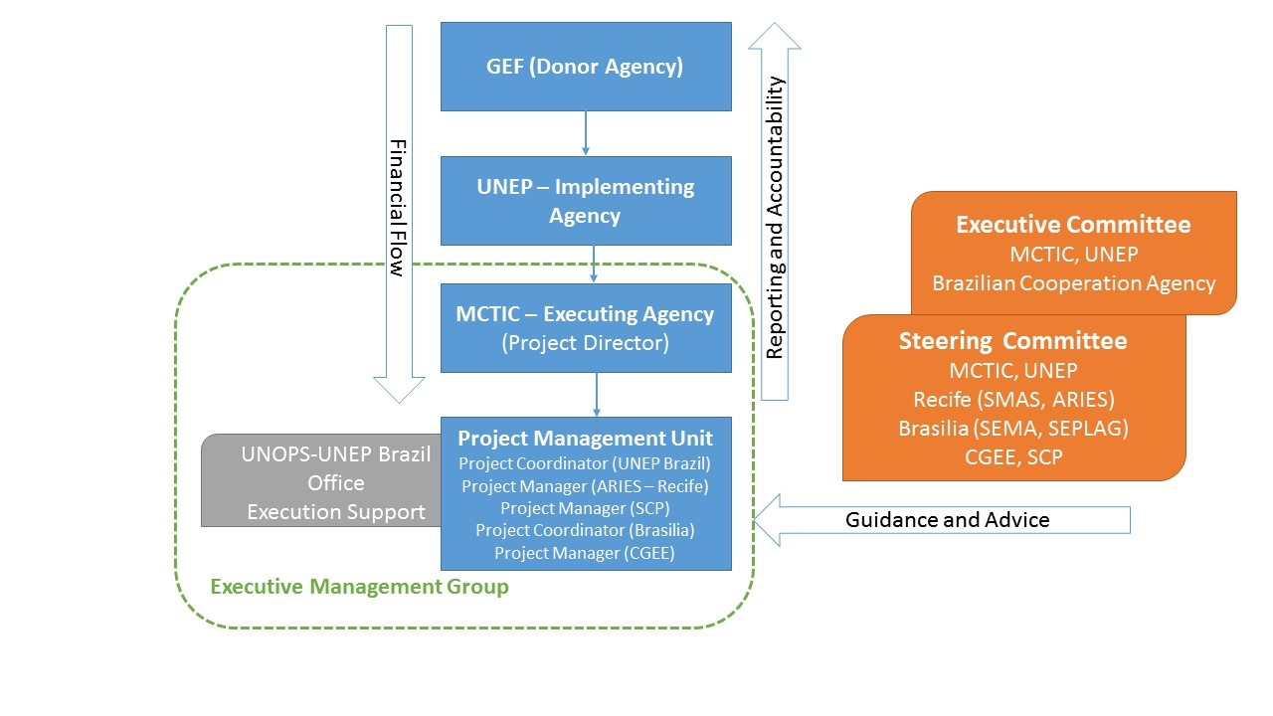

The details of the institutional arrangements above can be found in Annex H – Implementation Arrangements.

The project will coordinate with other relevant GEF-financed projects and other initiatives by inviting them to the kick-off meeting and annual technical meetings in order to share experiences and identify opportunities for synergies. In addition, we will add to the national platform a feature that provides information on existing bi-lateral and multi-lateral initiatives that are relevant to cities.

A particular coordination will be developed with IDB because it is the GEF implementing Agency for the Sustainable Cities project in Mexico and has many projects in Brazil. The IDB has a USD 6 million GEF project in Brazil on urban mobility, led by the Ministry of Cities. One of the cities in the project is Brasilia. It is not expected that project technical activities from this project will overlap with this proposed project, however formal channels of communication will be established between MCTIC and Ministry of Cities and if there is a need for coordination the IDB project manager will be invited as an observer to the project steering committee.

IDB also has an initiative in Brasilia, named PROCIDADES which aims to promote the economic development of the Federal District (FDG), with improvements in the conditions of the business environment, promotion of investment, infrastructure and promote the development of entrepreneurship in the FDG.

Finally, IDB has a non-reimbursable technical assistance programme, Emerging and Sustainable Cities Initiative, which provides direct support to national and subnational governments of Latin America and the Caribbean in the development and execution of city Action Plans. This includes support for GHG inventory development, risks and urban sprawl, mitigation and adaptation plans and adjustments in public policies. In 2016, 8 Brazilian cities participated in this programme of 71 cities. Even though Brasilia and Recife are not among these cities. The lessons learned from the other 8 Brazilian cities could be incorporated in the Brazil national knowledge platform and specific synergies with this programme will be sought through active engagement of IDB in relevant project meetings.

The World Bank launched in 2014 the project “Strengthening Public Management and Integrated Territorial Development” that will finish in 2017 and has been built under an integrated approach such as the one of the GEF project. It is a good opportunity for the project to look into lessons learned of this project and identify interest elements that can be incorporated. One of the World Bank’s main components “Strengthening metropolitan management through integration and coordination in urban development, housing, transport, environment and disaster risk management” can provide key contributions to the project.

Germany's International Climate Initiative has developed twenty-five projects within eight years in Brazil, with a total funding volume of EUR 101 million. This IAP project will link Brasilia to the focal point of this initiative and involve them in the climate groups. Some on-going projects financed by this initiative that have potential synergies with the Sustainable Cities project in Brazil in mitigation and adaptation to climate change are the following:
- Programme support for implementation of the National Policy on Climate Change (2016-2021, Brazil)
- Adapting public investment to climate change in Latin America (IPACC II) (2015-2019, Regional)
- Initial financing for renewable energy projects (2011-2017, regional).
- Energy recovery from sludge gases at a municipal sewage treatment plant (2009-2017, São Paulo)
- Mainstreaming ecosystem-based adaptation - strengthening eba in decision making processes (2015-2018, Global)
- Values: methods for integrating ecosystem services into policy, planning and practice (2013-2018, Global)

The GIZ finances many projects in Brazil, the focal points and the linkages between relevant projects will be identified once the project starts. The following projects have potential synergies with the project, mainly in renewable energy and energy efficiency but also in innovations for sustainable urban development:
- Renewable energy and energy efficiency in Brazil (2012-2018, Brazil)
- German Climate Technology Initiative: concentrating solar power in Brazil (2013-2018)
- Innovations for Sustainable Development - New Partnerships (NoPa) (2014-2017)
- Energy Efficiency for Sustainable Urban Development (2017-2019)

A.7. Benefits. Describe the socioeconomic benefits to be delivered by the project at the national and local levels. How do these benefits translate in supporting the achievement of global environment benefits (GEF Trust Fund) or adaptation benefits (LDCF/SCCF)?

Brasilia
In Brasilia the watershed management pilot and Sustainability Pact will improve water quality allowing cleaner and safer drinking water for the Brasilia city and for farming. The pilot will foster organic agriculture practices and will allow local producers to serve the local communities with improved quality and organic produce. The conservation and restoration practices will improve leisure benefits in the Cerrado area.

The planning process using EEA and SISDIA will internalise externalities, enabling decisions to factor in water, air and soil quality issues.

The solar pilots will help the city to diversify its power mix and improve energy security. Finally, activities related to the dumpsite closure and opening of the new landfill (co-finance) will impact directly the health conditions of the current pickers, create a potential for improved living and leisure and will allow for decontamination of the surrounding area.

Recife
Urbanisation of the Capibaribe river and creating a (electric engine) ferry link between the banks of the river and improving the intermodal links between modes of transport will: reduce travel times and distances; reduce noise and disturbance; create leisure opportunities; improve air and river water quality; and improve living conditions for those living close to the river. All of this will improve citizen health and productivity.
Benefits resulting from the IMS the resilience and social housing policy are expected to yield the following local benefits: reduced death, costs and economic disruption following extreme weather events and improved efficiency costs, and time in the implementation of city plans; and improved safety for low income groups living in social housing.
A.8. Knowledge Management. Elaborate on the knowledge management approach for the project, including, if any, plans for the project to learn from other relevant projects and initiatives (e.g. participate in trainings, conferences, stakeholder exchanges, virtual networks, project twinning) and plans for the project to assess and document in a user-friendly form (e.g. lessons learned briefs, engaging websites, guidebooks based on experience) and share these experiences and expertise (e.g. participate in community of practices, organize seminars, trainings and conferences) with relevant stakeholders.

Within all three components and implementation structure, the project will promote effective management of knowledge. A dedicated consultant will be appointed to work with the partners to establish a monitoring framework (MRV) and to collect project lessons learned and pack them for dissemination. The table below details how knowledge will be managed effectively:
Project aspect/component | Contribution to effective knowledge management
Brasilia  Component 1 | - Generating and recording information/knowledge:  - policy briefs, technical protocols and technical guidelines will be developed to support integration of climate change and GHG inventory into relevant territorial policies and plans, and their related budget.  - data will be stored and disseminated by SISDIA web platform and SEMA website/climate webpage  - Maintaining/sustaining knowledge: through training of district and local government staff on feeding in and using the SISDIA and climate webpage data base  - Improving knowledge: through validation workshops and conducting technical training on climate risks and carbon markets; staff in government and local communities will have enhanced knowledge to address climate risks as means of mitigating gee emissions and adapting to climate change
Component 2 | - Generating and recording information/knowledge:  - a set of detailed best practices manuals will be developed  - technical protocols for the reforestation in degraded protected areas of the Cerrado at the Paranoá and Descoberto basins, and for the restoration and maintenance of springs will be developed based on: i) site specific socio-economic, biodiversity and climate change assessments in the Paranoá and Descoberto basins; and ii) knowledge on ecosystem restoration using agroforestry in region  - research will be conducted on effective methods to mitigate site contamination of old dumpsite and information will be generated and stored at SISDIA.  - Maintaining/sustaining knowledge:  - local conservation groups will be involved in coordinating project activities, and monitoring the impacts of project interventions and sharing of lessons learned, and will sustain this knowledge in the area once the project has ended and a video and a book will be published based on their experiences  - through training of local authorities, communities, committees and user groups in the federal district, these stakeholders will have enhanced knowledge on climate change and EbA.
Recife  Component 1 | - Generating and recording information/knowledge:  - The knowledge gained from the experiences of the GEF project in Recife will be documented and recorded in activities related lessons learned from the project.  - Another key dimension to be recorded by the project will be the experience and the process of restoring the relationship between society and the Capibaribe river in the passages where the pilots will take place.  - Maintaining/sustaining knowledge: with registration, identification and traceability of information content and knowledge produced, project results can be replicated to other institutions, not originally contemplated by the pilots, as well as to other areas of Recife, or to other cities wishing to use the information generated to process continuous improvement. The IMS and ARIES will be the depositories of the information and responsible for sharing it with interested parties.
Component 2 | - Generating and recording information/knowledge:  - All project pilots will generate knowledge to allow them to be replicated if successful. All lessons learned will be packed and included in the SCIO and in the Knowledge Platform. The project has included a specific output and budget for this activity.
Component 3  Knowledge Platform | - Generating and recording information/knowledge:  - The Knowledge Platform will be the repository of lessons learned from components 1 and 2 the from the SCIO’s mapping and monitoring activity.  - Maintaining/sustaining knowledge:  - The on-going creation and feeding of the Good Practices Database with successful experiences conducted at the local level is one of the strategies to exchange experiences between sectors of civil society and between municipal managers. The goal is to guide new thinking and to effectively consolidate successful local management strategies.  - In addition to these proven strategies and actions there is a range of tools for users to interact with the platform so they can exchange experiences and develop discussions between stakeholders such as citizens, business people and municipal managers. The creation of thematic forums, training workshops and mobilization campaigns are strategies designed to combine user interaction with the Platform and its user community.  - Municipal managers will receive special attention by having access to the Platform through a user login that leads to various web pages with training tools (classroom and online courses), available materials (manuals, guides and reports), tools for interacting with other users (chat, forum, etc.), plus events schedules and a means to follow development plans.  - The User Map (Users Stories Map) prepared for each of the personas (user type) allows for step-by-step planning of the interaction with the Platform’s web system. The development of the system features simple visuals and efficient communication, and is structured by designing the interaction around each of the thematic modules in order to stimulate interactivity without loss of quality in the information transmitted.  - The app tool developed shall enable the consultation and engagement of stakeholders/citizens. The tool shall be operational both in mobiles and in the platforms (i.e. SCIO, SCP and GPSC) and shall also allow wide participation in the continual development and assessment of future visions and associated scenarios for sustainable cities.  - Regular events shall be organized for articulating different actors – these encounters shall bring together policy makers from different Brazilian ministries as well as city administration and exiting observatories in order to test developed guides and methodologies as well as to train these actors in designing long-term integrated and contextualised policies.
SCP | - Improving knowledge:  - The Knowledge Platform for the Sustainable Cities Program (Brazil) is based on the continuous and systematic exchange of knowledge and experiences in various industries related to sustainability and social justice.  - Additionally, the Innovation Observatory will be integrated into the Knowledge Platform so that the development of new technologies which are applied to local management can also be added to the collection of successful experiences.  - Platform development activities include carrying out various training activities (courses, training sessions, etc.) and exchanging experiences (conferences, seminars, etc.) between users so they can present their views, problems and strategies, plus future plans and actions and those already executed. This interactivity between users and those of the web system allows for the creation of a vehicle to exchange and store experiences. This will enhance all the other ways for citizens to interact with their managers and public and private participants, in the context of the shift to a development model which is guided by the exchange of knowledge and the creation of new understanding.

Regarding the coordination with other initiatives, the project will cooperate with UNEP global project 616.1 resources efficient cities and lifestyles to identify and pilot appropriate tools and methodologies in Brazil on the refinement and implementation of tools and mechanisms to integrate resource efficiency in city planning. This GEF-6 project will be supporting city planners with identification and implementation of reliable urban metrics and piloting of innovative approaches. This work in Component 3 (Knowledge Platform) will be further informed by UNEP's Resource Efficient Cities project (616.1), which globally will be refining the tools and mechanisms to integrate resource efficiency into city planning and management. The portfolio of knowledge products developed in 616.1 will be introduced to Brazilian cities, providing opportunities for mainstreaming UNEP developed tools in 300 municipalities in Brazil, as well as an institutional feedback loop to 616.1 from the GEF-6 project. Both projects will support the refinement of global indicators for sustainability in cities.

This cooperation will have an added benefit to GEF-6 project cities, as it will bring to city officials broader findings and lessons from 616.1 on the business case for resource efficiency and on resilience developed through the Resource Efficient Cities project. Staff from both projects will meet regularly to share lessons and identify possible joint activities or new areas for future research.

B. Description of the consistency of the project with:
B.1 Consistency with National Priorities. Describe the consistency of the project with national strategies and plans or reports and assessements under relevant conventions such as NAPAs, NAPs, ASGM NAPs, MIAs, NBSAPs, NCs, TNAs, NCSAs, NIPs, PRSPs, NPFE, BURs, etc.:

INDC
According to its Intended Nationally Determined Contributions (INDC), Brazil considers adaptation to be a fundamental element of the global effort to tackle climate change and its effects. The implementation of policies and measures to adapt to climate change contributes to building resilience of populations, ecosystems, infrastructure and production systems, by reducing vulnerability and through the provision of ecosystem services.

The NAP aims to implement knowledge management systems, to promote research and technology development for adaptation, to develop processes and tools in support of adaptation actions and strategies, at different levels of government. Brazil is a developing country that experienced a fast urbanization process. In this context, risk areas, housing, basic infrastructure, especially in the areas of health, sanitation and transportation, constitute key areas for adaptation policies. The Government of Brazil gives particular attention to the poorest populations, in terms of improving their housing and living conditions, bolstering their capacity to withstand the effects of severe climate events.

The INDC also highlights that Brazil seeks to enhance its national capacity in water security and conservation (National Water Security Plan) and sustainable use of biodiversity (National Strategic Plan for Protected Areas).

In addition, Brazil intends to adopt further measures that are consistent with GHG emission reductions in the energy sector, achieving 45% of renewables in the energy mix by 2030, including by raising the share of solar.

Finally, Brazil also plans to further promote efficiency measures in the transportation sector and improve infrastructure for transport and public transportation in urban areas.

National Communication (NC)

The 3rd “National Communication of Brazil to the UNFCCC emphasizes that the global importance of climate change in the context of sustainable development requires a continued application of scientific knowledge about the phenomenon as well as mitigation and adaptation technologies. On that point, important initiatives and contributions of bodies and entities related to the Ministry of Science, Technology and Innovation, ought to be recognized:

The Brazilian Network on Global Climate Change Research (Rede CLIMA) involves dozens of research groups in universities and institutes throughout the country. Its scientific focus covers all relevant issues on climate change, notably:
- impact, adaptation and vulnerability studies for relevant systems and sectors: agriculture and forestry, water resources, biodiversity and ecosystems, coastal zones, cities, economy, renewable energy, health;
- development of knowledge and technologies to mitigate climate change. It is currently addressing the integrative scientific themes such as climate change and food, water and energy safety; human health, cities and natural disasters.

National Emissions Registry System (SIRENE), which consists of a computer platform which aims to optimize information management processes related to the National Inventory of Anthropogenic Emissions by Sources and Removals by Sinks of Greenhouse Gases Not Controlled by the Montreal Protocol, conferring security and transparency to the Inventory’s preparation process, and providing support to decision-making processes within the scope of policies, plans, programs and projects in the area of climate change.

In addition, the main priorities of Brazilian urban development policies are housing, sanitation and urban mobility and transport. According to the Brazilian Plan for Urban Development, the theme of environmental sustainability was not singled out as ‘separate theme’ since it cuts across all the above priorities. This project is aligned with the national urban development policies of Brazil, especially as they call for an integrated approach to the key areas to address environmental sustainability. Furthermore, there is a call from the National Government for the establishment of Knowledge Platforms to address key strategic issues of national concern, such as urbanization (sustainable cities). Our proposal will establish a National Knowledge Platform responding to this national strategic policy. It will enable further integration of the three levels of government (national/state/city) for improved integrated city plans development, and will allow for further integration of sectoral plans (including sustainability plans).

In 2010, a thematic programme on sustainable technologies was launched by the MCTIC (Executing Agency) to support technologies for Sustainable Cities. This support to cities came in the form of innovative technologies in the areas of: sustainable buildings; sustainable transport and mobility; water and sanitation; and renewable energy and energy efficiency.

C. Describe the budgeted m &e plan:
UNEP will be responsible for managing the mid-term review/evaluation and the terminal evaluation. The Project Manager and partners will participate actively in the process.
The project will be reviewed or evaluated at mid-term (tentatively in mm/yy as indicated in the project milestones). The purpose of the Mid-Term Review (MTR) or Mid-Term Evaluation (MTE) is to provide an independent assessment of project performance at mid-term, to analyse whether the project is on track, what problems and challenges the project is encountering, and which corrective actions are required so that the project can achieve its intended outcomes by project completion in the most efficient and sustainable way. In addition, it will verify information gathered through the GEF tracking tools.
The project Steering Committee will participate in the MTR or MTE and develop a management response to the evaluation recommendations along with an implementation plan. It is the responsibility of the UNEP Task Manager to monitor whether the agreed recommendations are being implemented. An MTR is managed by the UNEP Task Manager. An MTE is managed by the Evaluation Office of UNEP (EOU). The EOU will determine whether an MTE is required or an MTR is sufficient.
In-line with UNEP Evaluation Policy and the GEF’s Monitoring and Evaluation Policy the project will be subject to a Terminal Evaluation. The Evaluation Office of UNEP will be responsible for the TE and liaise with the UNEP Task Manager and Executing Agency(ies) throughout the process. The TE will provide an independent assessment of project performance (in terms of relevance, effectiveness and efficiency), and determine the likelihood of impact and sustainability. It will have two primary purposes:
(i) to provide evidence of results to meet accountability requirements, and
(ii) to promote learning, feedback, and knowledge sharing through results and lessons learned among UNEP the GEF, executing partners and other stakeholders.
While a TE should review use of project funds against budget, it would be the role of a financial audit to assess probity (i.e. correctness, integrity etc.) of expenditure and transactions.
The direct costs of the evaluation will be charged against the project evaluation budget. The Terminal Evaluation will be initiated no earlier than six months prior to the operational completion of project activities and, if a follow-on phase of the project is envisaged, should be completed prior to completion of the project and the submission of the follow-on proposal. Terminal Evaluations must be initiated no later than six months after operational completion.
The draft TE report will be sent by the Evaluation Office to project stakeholders for comments. Formal comments on the report will be shared by the Evaluation Office of UNEP in an open and transparent manner. The project performance will be assessed against standard evaluation criteria using a six point rating scheme. The final determination of project ratings will be made by the Evaluation Office of UNEP when the report is finalised and further reviewed by the GEF Independent Evaluation Office of UNEP upon submission. The evaluation report will be publicly disclosed and may be followed by a recommendation compliance process.
A summary of M&E activities envisaged is provided in Annex G. When relevant, M&E activities will assess gender mainstreaming. The GEF contribution for M&E activities is USD 100,000.

PART iII: certification by gef partner agency(ies)
- GEF Agency(ies) certification
This request has been prepared in accordance with GEF policies and procedures and meets the GEF criteria for CEO endorsement under GEF-6.

Agency Coordinator, Agency Name | Signature | Date  (MM/dd/yyyy) | Project Contact Person | Telephone | Email Address
Brennan Van Dyke, GEF Coordination Office,  UNEP |  | November 28, 2016 | Ruth Coutto  UNEP/GEF Climate Change Mitigation Task Manager, Energy, Climate, and Technology Branch  Division of Technology, Industry and Economics (DTIE) | +33 1 44 37 16 34 | Ruth.Coutto@unep.org

ANNEX A: PROJECT RESULTS FRAMEWORK (either copy and paste here the framework from the Agency document, or provide reference to the page in the project document where the framework could be found).

Project Objective |  | Objective level Indicators | Baseline | Targets and Monitoring Milestones | Means of Verification | Assumptions & Risks | UNEP MTS reference*
Lasting and significant changes to which the project is expected to contribute |  | How contributions to the objective will be measured including quantity, quality, time | Initial Baseline for Objective indicator(s) | End of project Target  Mid-Point Target | How the information required to measure the indicator will be collected, when, and by whom | Assumptions and Risks that affect objective level | The Subprogramme under which the project objective can be fitted
To promote sustainability in Brazilian Cities through integrated urban planning and innovative technologies | O-1 | # of cities that join the Sustainable Cities Programme and adopt an enhanced goal plan with SDG indicators | 0 | EPT: 300 | Copies of signed SCP agreements and enhanced goal plans | Cities do not see goal plans as a useful planning or policy tool | UNEP MTS 2014-2017: Climate Change EA1 and EA2  UNEP MTS 2017-2021: Climate Change EA1 and EA2
Project Outcomes | N° | Outcome Indicators | Baseline | Targets and Monitoring Milestones | Means of Verification | Assumptions & Risks | MTS Expected Accomplishment
A comprehensive evidence-based integrated and sustainable planning approach is adopted by Brasilia | B-1 | # of secretaries out of the 10 that use SISDIA for at least 50% of their planning or zoning decisions | 0 | EPT: 5 | Surveys | The Secretariats do not see the full benefits of SISDIA and do not keep it up to date with data and information. | MTS 2014-2017: Climate Change EA2  MTS 2018-2021: Climate Change EA2
 | B-2 | Mitigation and adaptation plans and regulation of Climate Bill elaborated and approved with the incorporation of a revised target reduction of emissions | 0 | EPT: 1 | Climate Bill documents | The bill may not be adopted in its original form by the FDG.
 | B-3 | % of the 2020-2024 Pluri-Annual Plan - PPA (in R$) impacted by the adaptation and mitigation plans | 0 | EPT: 30% | Adaptation and mitigation plans, 2020-2024 PPA | City planner do not understand the impacts of the mitigation and adaptions plans, and reflecting them in the city PPA.  Budgetary constraints and short term problems take precedence in the PPA.
A comprehensive evidence-based integrated and sustainable planning approach is adopted by Recife | R-1 | % of decisions taken by the urban planning agency using the Integrated Management System (IMS) | 0  0 | MPT: 5%  EPT: 30% | Surveys | The platform is created with the relevant data, (projects, actions, laws, decrees, etc.) but does not have a control centre able to maintain the operation of the system.  The key data is not made available to be inserted in the platform. | MTS 2014-2017: Climate Change EA2  MTS 2018-2021: Climate Change EA2
 | R-2 | The city development plan uses the results of the Housing Policy and Resilience Strategy | 0 | EPT: 100% | Land Use Management Plan (POT) | The POT is not revised to reflect the project results during the implementation of the GEF project
Cities investments demonstrate the benefits resulting from integrated and sustainable planning in Brasilia | B-4 | % of the 179,660 hectares of the Descoberto and Paranoá watershed under the Sustainability Pact | 0 | EPT: 80% | Written Sustainability Pact agreements (the number of stakeholders signing the pact will be disaggregated by gender). | It is not possible to forge a Sustainability Pact with land users in the watersheds that meet planning targets and meet local needs. | MTS 2014-2017: Climate Change EA1 and EA2  MTS 2018-2021: Climate Change EA1 and EA2
 | B-5 | % of decrease in dumpsite activities | 6,200 – 8,700 ton/day (2010 and includes residential, commercial, construction waste) | EPT: 75% | Data records of SLU on incoming waste to the Estrutural Dumpsite | The new landfill is not completed and recycling activities have not started.
 | B-6 | # a legal framework to promote PV distributed power generation in public buildings ready for adoption | 0 | EPT: 1 | Draft legal framework | Pilots are successful and show benefits from distributed generation for public facilities
Cities investments demonstrate the benefits resulting from integrated and sustainable planning in Recife | R-3 | If the pilots prove successful, the city agrees to replicate them | 0 | Letter of intent covering any or all of the successful pilots (in addition to the ones funded by the project):  2 solar boats;  1 filtering garden;  4.38 ha of re-urbanization;  2 docking stations;  5 resting areas,  2 bikes stations  2 electric car park stations;  0.3 km of bike lanes and walking | Letter of intent from the Executive Secretary of the Secretariat of Environment and Sustainability of Recife. | Pilots are not successful.  The Secretary of planning does not allocate funding for scale up. | MTS 2014-2017: Climate Change EA1 and EA2  MTS 2018-2021: Climate Change EA1 and EA2
The tested integrated and sustainable planning solutions are promoted by the National Platform for Sustainable Cities to up to 300 Brazilian cities as the reference for integrated urban planning. | KP -1 | # of city policy recommendations found relevant by Federal Ministries | 0 | EPT: 5 | Letters of support for policy from Secretary of appropriate Federal Ministry | Policies are not found relevant by the Federal Ministries. | MTS 2014-2017: Climate Change EA2  MTS 2018-2021: Climate Change EA2
 | KP-2 | # of solutions identified by Sustainable City Innovation Observatory (SCIO), applied by Brasilia and Recife | 0 | EPT: 4 | Letters of confirmation from Secretaries of Environment/ Planning | Brasilia and Recife did not find the solutions appropriate.
 | KP-3 | # of cities looking in SCIO and National Platform for solutions to their planning and investment related problems | 0 | EPT: 100 cities find and apply solutions to their planning or investment problems | 50 active SCIO city accounts.  Survey to identify which cities have applied a solution from or used a service of the National Platform. | Cities do not find the services of the National Platform or SCIO as being relevant or useful to their work.

ANNEX B: RESPONSES TO PROJECT REVIEWS (from GEF Secretariat and GEF Agencies, and Responses to Comments from Council at work program inclusion and the Convention Secretariat and STAP at PIF).

STAP Scientific and Technical Screening of the Project Identification Form (P156504)
Matrix of Team’s Responses to STAP Comments (Date of STAP Screening: April 14, 2015)
Screener: Christine Wellington-Moore of GEF STAP prepared the comments

Comments | Team responses
- Collective Impact and Stakeholder Engagement
Acknowledging that in approaching complex environmental problems, stakeholder engagement and collective action is critical. The overarching objective of the PFD document speaks to broad inclusiveness in the pursuit of urban development planning and implementation, stressing a "network" approach to help pull the complex web of urban stakeholders onto a path of united vision and effort (see page 9 of PFD).  The strength of many GEF initiatives is typically in the technical and institutional components. Often social science components which can enhance performance of GEF interventions are lacking. It was also recognized that the link between local action and global impacts/benefits in this context must be supported with a clear conceptual framework, such that local intent and action is in step with national, regional and international actions. In addition, many governments marginalize informal settlements in their formal decision-making processes. As such, the IAP should attempt to address this challenge as it may undermine success in other areas.  One can compare and contrast the traditional isolated impact approach with the collective impact approach (Kania, J.; Kramer, M. 2011. "Collective Impact". Stanford Social Innovation Review. See also http://www.fsg.org/OurApproach/WhatIsCollectiveImpact.aspx)  Isolated Impacts:- Funders select individual grantees that offer the most promising solutions  Collective Impacts:- Funders and implementers understand that social problems, and their solutions, arise from the interaction of many organizations within a larger system  Isolated Impacts:- Non-profits work separately and compete to produce the greatest independent impact  Collective Impact:- Progress depends on working toward the same goal and measuring the same things  Isolated Impacts:- Evaluation attempts to isolate a particular organization's impact  Collective Impacts:- Large scale impact depends on increasing cross-sector alignment and learning among many organizations  Isolated Impacts:- Large scale change is assumed to depend on scaling a single organization  Collective Impacts:- Corporate and government sectors are essential partners  Isolated Impacts:- Corporate and government sectors are often disconnected from the efforts of foundations and nonprofits  Collective Impacts:- Organizations actively coordinate their action and shared lessons learned.  Over time the GEF has moved towards the collective approach, though it could be made more comprehensive and better embedded in GEF operations. Collective impacts provide a significant shift away from the traditional paradigm of "isolated impact," because the underlying premise of collective impact is that no single organization can create large-scale, lasting social change alone. This has been transposed to tackling environmental problems as well, since the social issues actually heavily influence success in tackling environmental problems at scale even where there are technological solutions available. Typically there is no "silver bullet" solution to systemic problems, and these problems cannot be solved by simply scaling or replicating one organization or program.  Collective impact is best employed for problems that are complex and systemic rather than technical in nature. Collective impact initiatives are currently being employed to address a wide variety of issues around the world, including education, healthcare, homelessness, the environment, and community development. Many of these initiatives are already showing concrete results, reinforcing the promise of collective impact in solving complex social problems.  This gradual change in thinking has been well researched, culminating in 2011 with the publishing of a critical article by Kania et. al (2011) , which, based on evidence of success and failure in tackling complex and systemic problems, was able to devolve five conditions of collective impact success.  Conditions of Collective Impact Success  Collective impact is more rigorous and specific than collaboration among organizations. There are five conditions that, together, lead to meaningful results from collective impact:  - Common Agenda: All participants share a vision for change that includes a common understanding of the problem and a joint approach to solving the problem through agreed-upon actions.  - Shared Measurement: All participating organizations agree on the ways success will be measured and reported, with a short list of common indicators identified and used for learning and improvement.  - Mutually Reinforcing Activities: A diverse set of stakeholders, typically across sectors, coordinate a set of differentiated activities through a mutually reinforcing plan of action.  - Continuous Communication: All players engage in frequent and structured open communication to build trust, assure mutual objectives, and create common motivation.  - Backbone Support: An independent, funded staff dedicated to the initiative provides ongoing support by guiding the initiative's vision and strategy, supporting aligned activities, establishing shared measurement practices, building public will, advancing policy, and mobilizing resources  The STAP has consulted with the US Department of Housing and Urban Development on their experience in applying this approach to their urban projects, and they reported significant improvements in accomplishment of project objectives that this model is endorsed by the White House council for Community Solutions. A follow-up study and updated guidance was also published in the Stanford Social Review in 2012 to highlight successes of the performance of initiatives by various municipalities as well as large private sector and CSO entities and foundations ( eg. UN GAIN, Communities That Care, Calgary Homeless Foundation, Bill and Melinda Gates Foundation, AVINA).  STAP has passed on information to the lead agency regarding experts in this area who could be consulted as the program document is further developed, along with the Global Knowledge Platform and other child projects. Indeed the Capacity Building subsection of the Global Platform document (see page 9 of the concept note) discusses how to overcome the cacophony of local city decisions that can threaten a united development path. Also in terms of the Global Knowledge platform, there can be support provided to all involved to show how they can be involved in the collective impact community (http://www.collectiveimpactforum.org/). This approach does seem to be emerging as the definitive way in which private and public entities (including funding bodies) are tackling complex social and environment problems, including leveraging and sourcing funding. Also in its favor is the fact that there has been high level, peer-reviewed research involved in devolving these principles for stakeholder engagement. | The GPSC acknowledges the important role that stakeholder engagement plays in urban change and has been designed in such a way to ensure that all relevant stakeholders will be involved in the GPSC’s design and implementation process. The Program-Level Results Framework measures stakeholder engagement in the design and implementation of IAP child projects (Indicator 3: Number of cities with meaningful engagement of multiple stakeholders in planning and implementation of the projects supported by the IAP).  To ensure that the GPSC achieves a lasting, collective impact, the GPSC will coordinate and collaborate with the relevant entities working in the larger web of urban sustainability. Working within this larger web, the GPSC will actively coordinate its actions to complement and build off of current work, actively seeking to communicate and align initiatives—as demonstrated by the Joint Deliverables section of the PCN. The GPSC, the implementing agencies, and the participating cities will deliver a set of joint activities at the city-level, focusing on geospatial data/tools, indicators, urban planning, and urban finance. To achieve this, the GPSC will have to actively partner with the implementing agencies, international organizations and networks, local governments, civil societies, and the private sector.  The design of the GPSC endeavors to encompass the right conditions for a successful collective impact:  - Common Agenda/Framework: The objectives of the GPSC are to (i) provide a platform for knowledge sharing and learning on an integrated approach to urban planning and management, (ii) create a space for networking and learning among cities and relevant organizations on issues related to urban sustainable development, and (iii) support the participating cities’ work on evidence-based urban planning with the aim of forging an agreed-upon common vision and approach to urban sustainability. The Joint Deliverables at the city-level attempt to co-align actions and approaches. The Joint Deliverables framework will focus on urban indicators and geospatial data/tools, urban planning, and urban finance at the city-level.  - Shared Measurement: All participating cities will share a common urban sustainability framework for selecting indicators and geospatial datasets that are relevant to the city’s contexts. In addition to this shared framework, participating cities will be encouraged to adopt core common indicators that reflects progress made towards UN SDG 11. The GEF Tracking Tool and Program-Level Results Framework will be tracked across all 11 child projects at the program-level to measure and report the progress of each child project.  - Mutually Reinforcing Activities: The PCN of the GPSC indicates the type of coordinated activities that will be offered through collaboration with urban think tanks, networks, and implementing agencies. Cities interested in participating in Joint Deliverables will develop a city-specific work program outlining a set of differentiated activities around the GPSC framework.  - Continuous Communication: The GPSC holds a monthly conference call with all implementing agencies to ensure frequent and structured open communication to build trust, assure mutual objectives, and create common motivation. In addition, GPSC will conduct active and inclusive city-level consultations with the implementing agencies to define a relevant city-level work program.  - Backbone Support: The GPSC will provide ongoing support by guiding the initiative's vision and strategy, supporting aligned activities, establishing shared measurement practices, building public will, advancing policy, and mobilizing resources.
- Results Framework
Looking at the PFD document, to measure a city's "increased scope and depth of integrated urban sustainability planning management policies" will be challenging against a baseline, as will the other proposed metrics. So the rating system alluded to in Component 1 will be a critical part of the M&E framework and methodology. Similarly for Component 2 the proposed core performance framework is difficult to understand without putting the concept into practice. A few details are provided in the M&E section on page 24 but there remain many uncertainties as to how this will be achieved in practice given the wide variations between cities as is evident from the section outlining the Child projects.  On the issue of process indicators, one might be included to measure the extent of stakeholder engagement as it is so critical to the IAP success. The aim of the IAP pilot to "ensure broad engagement with stakeholders across a city" is commendable, as is having a process-focused indicator to measure change over the life of the IAP program. Indeed the 5 conditions of success of the Collective impact model could be used as a ratings system based on increasingly comprehensive permutations of these criteria, with a 1 rating meaning perhaps only 1 condition is being met, and 5 meaning all have been met. This is also an important aspect of learning from, and ultimately capitalizing on, the IAP experience to determine best practices in stakeholder engagement, and other processes that may be identified as critical, foundational actions for Cities integrated projects.  STAP does not question the need for selected Cities to have some latitude in selecting indicators for their locally specific work. However, there should be an assessment process or preferably a common conceptual framework to ensure that the indicators selected are appropriate to measure the areas of performance critical to the specific interventions, relevant to the overall IAP knowledge needs, benchmarking, and comparability. Indeed the PFD and Global Knowledge Platform documents both cite a medium level risk of lack of alignment between child projects and overall program goals. A comprehensive, suite of locally specific indicators might be achieved through use of a common conceptual framework such that all projects would use similar criteria in determining if the suite of indicators selected covers all the critical areas to be monitored. STAP has developing a similar process for socio-ecological systems, and application of it under the Food Security IAP is already underway. This approach could also be used in the Cities IAP as the program develops.  STAP welcomes the opportunity for research on other urban sustainability indicators, and hopes that work for instance on urban metabolism indicators can be included going forward. In addition, in order to contribute to the GEF 2020 IAP strategic priority as relates to resilience and adaptation, open source indices for resilience such as the Notre Dame Global Adaptation Index (ND-GAIN) might be consulted as there exists a clear methodology that can assist with indicator selection, data sources, and rationale for indicator selection. | The GPSC aims to support cities in developing or adopting an evidence-based, integrated approach toward resilient and sustainable cities. As such, the GPSC will lead the development of a comprehensive framework that supports cities in choosing among a suite of locally-specific indicators based on common criteria. As part of the Joint Deliverables, cities wishing to enhance their capacity for measuring urban sustainability will receive guidance on selecting and implementing a set of locally relevant indicators. This work will be part of the GPSC’s work towards enhancing a city’s capacity for an evidence-based planning approach that is not tied to the duration of the program.  Separate from the city-level work on indicators, the GPSC, as a child project of the SC IAP, has developed a results framework to evaluate its progress as a knowledge platform during the duration of the program.  At the SC IAP program-level are two results frameworks that attempt to assess the results of all 11 child projects + GPSC: the GEF Tracking Tool and the Program-Level Results Framework.
- Knowledge Management
Knowledge Management is a key part of the IAP if the ambition is to widely disseminate information from lessons learned to other cities. STAP welcomes the Global Knowledge Platform as a key component of this effort. STAP looks forward to engaging with this component of the IAP going forward.  The PFD makes reference to the importance of comprehensive, evidence-based planning, and states that the IAP is "designed to function as proof of concept". The Global Knowledge Platform, however, emphasizes a construct that speaks to swapping of information between Cities, but reporting nothing back to the GEF and its donors to indicate whether investment was impactful or not. The difference between information gathering and knowledge generation is not clearly delimited, and there is no indication of any plans to develop overarching knowledge questions into a centralized Knowledge Management Strategy for the IAP and then the GEF. (For example: What are the overarching knowledge goals of the IAP? In what ways did the IAP contribute to the GEF 2020 strategic vision? Is the sum of the outputs of the child projects likely to contribute to overall outcomes and ultimately the overall objective of the IAP? What are the best conditions for successful investment? ). Developing a Knowledge Management strategy will help inform the Results Framework such that indicators utilized will need to be as objective as possible, and quantifiable where feasible. Without such an approach resulting in clear information flows back to the GEF partnership, including its donors, there will be no way for any objectively derived conclusions to be made about why an intervention succeeded or failed, nor to capture best practices for replication and scale-up. This is critical to any pilot activity, and the STAP wishes to re-emphasize this point because it was made during the consultations.  There should also be consultation between the authors of the upcoming STAP and GEF Sec papers on Knowledge Management in the GEF to help organize this area of the IAP. In addition, consultation with the Knowledge Management mechanisms as proposed in the other IAPs should be encouraged. | The GPSC fully acknowledges the wide range of ongoing initiatives and currently existing knowledge on urban sustainability and does not attempt to duplicate them. In addition to serving as a platform for knowledge sharing, it endeavors to compile lessons learned from the child projects and promote innovation through collaboration and knowledge exchange. Case studies on each city will be created at the end of the program to evaluate whether the knowledge positively affected the urban processes and systems. Given the limited budget and timeline, it is unlikely that the GPSC will be heavily engaged in knowledge creation activities but rather it will prioritize knowledge curation and sharing through its platform.
- Program Structure
- Number of Pilot Cities  - While STAP typically does not comment upon funding aspects of projects, it can raise questions related to incremental cost reasoning and expected contributions from the baseline. Based on the PFD child project descriptors, as well as Table C of the PFD, it is clear that agencies have wisely targeted cities with ongoing urban sustainability initiatives and investment, and the co-financing arrangements appear robust. However, with each country averaging around $2M per city from the IAP set-aside, even with the STAR country allocations it is uncertain if the GEF funding spread across 23 cities can trigger the incremental globally beneficial action of improving "the depth, breadth, and quality of local sustainability planning efforts and investment decisions,". For example, are resources sufficient to significantly develop resilience to future extreme events including climate change impacts?  The increase in number of pilots expected also further reconfirms the need for streamlined stakeholder engagement processes, indicator assessment and knowledge management.  - Link to other IAPs  - A review of child projects indicates potential opportunities for linkages with other IAPs (e.g. South Africa's Johannesburg project has a clear component for food (in)security). It would be useful to explore these possibilities for engagement in this case, as this could present interesting learning opportunities on urban-periurban-rural interactions. Other examples may exist in the portfolio. | Number of Pilot Cities:  - We agree that the funding is not enough to achieve the desired change and suggest tempering expectations. The funding is simply insufficient to achieve the long-lasting, in-depth change to which the Pilot Program professes to aspire. Taking a more realistic approach given the limited budget can help direct the limited budget to key priorities instead of trying to overcommit. The Joint Deliverables approach attempts to address this by dedicating resources to jointly-agreed upon actions at the city-level. The GPSC will also rely upon existing initiatives to leverage the knowledge and resources of entities currently working on the urban sustainability agenda.  Link to other IAPs:  - We will recommend to the South Africa child project that synergies with the IAP on Food Security be sought.
- Miscellaneous Comments
- Table C of PFD  - The Table C of the PFD makes it very difficult to assess the precise municipalities to be covered in each country, and therefore to align with the city names laid out in the text of the report. There are also several instances of acronyms used without explanations.  - Section E of PFD: “Program’s target contributions to GEBs”  - The only relevant target shown is the mitigation of 106,669,069 metric tons of GHG emission reductions. There should be some clarification as to how this figure was reached, especially given the various emission factors that differ widely between each city's energy and electricity sources. Direct and indirect emissions are included. Was this estimate made using the old GEF definition for "indirect" which is under review?  For cities to be able to track their own GHG emissions will require a standard method offered as detailed guidelines if there is to be any real benefit from benchmarking and having a common baseline. For example, accounting for road/rail/air traffic passing through a city requires a common boundary to be used. STAP realizes that there has been much good work already done on identifying indicators, but questions whether it will be possible to produce a set of practical guidelines in time for practical use by the pilot cities as they begin their programs.  - Program Challenges  - Under the "Global Coordination and Knowledge-Sharing Platform" section, there are many activities listed. Acknowledging the short time line that the agency has had to outline potential activities, there should be attention paid to the planning, timelines and quantification of the human and other resource issues needed for enabling a city/municipality to participate actively and make a useful contribution. It is a very ambitious program, covering 23 pilot cities, and as noted by the authors, continual turnover of local government officials (and of elected representatives) will make capacity building particularly challenging.  Further, the 23 pilot cities outlined in the PFD have very different issues to cope with. This will add challenges to the services to be provided using the various joint activities as planned. | Table C of PFD:  - We agree that there has been confusion about the precise municipalities to be covered in each country. Currently, we have identified 27 participating cities: Xalapa, La Paz (Mexico), Campeche, Recife, Brasilia, Johannesburg, Abidjan, Vijayawada, Guntur, Bhopal, Jaipur, Mysore, Melaka, Saint-Louis (Senegal), Greater Dakar (Diamniadio Industrial Park), Guiyang, Shenzhen, Ningbo, Nanchang, Beijing, Tianjin, Shijiazhuang, Lima, Asuncion, Hue, Ha Giang, and Vinh Yen.  Section E of PFD:  - Given that many cities use various GHG emissions methodologies, it was agreed at the first GPSC meeting in March 2016 that though there will not be a standard methodology, participating cities will be required to report their target contributions to GHG emissions according to internationally accepted methods and to disclose their methodology.  Program Challenges:  - We acknowledge that the SC IAP program poses many challenges and have tried to address the details of planning and timelines in our PCN. We are sensitive to resource constraints of cities and are in continued conversation with the implementing agencies to ensure that enough resources are allocated to ensure the successful participation of cities in GPSC activities throughout the duration of the program. The GPSC will focus on shared themes and common challenges of the participating cities in GPSC learning activities and products.

GEF Council Comments on “Global Platform for Sustainable Cities (GPSC) and
Knowledge Management and Coordination for Participating Cities (P156504; GEF ID 9077)”
Matrix of Team’s Responses to GEF Council Comments (June 2015)
Comments were received from:
- Canada
- France
- Germany
- USA
Comments | Team responses
- GPSC v. Existing Initiatives
The proposal has parallels to the very successful Cities Development Initiative Asia (CDIA, with parallel funding from BMZ and ADB), which supports medium sized Asian municipalities in infrastructure projects development and access to finance (from development banks and private sector). It needs to be ensured that this project can learn from CDIA’s experiences and success factors. [Germany]  The PFD provides too few details of the activities the program will support and how they will differ from those of other organizations that are developing similar sustainable cities-focused programs. We expect that the PFD will be modified to respond to STAP comments, and look forward to reviewing the child projects for this program prior to GEF CEO Endorsement. [USA] | We acknowledge the importance of learning from existing initiatives and will work closely with Cities Development Initiative Asia as well as other entities working on the urban sustainability agenda to avoid duplication of efforts and to leverage their knowledge and expertise in certain fields. The GPSC is unique among existing initiatives in that it works to operationalize the knowledge shared and learned in the fully-funded projects of the 27 pilot cities. The immediacy in impact is a rare opportunity for urban practitioners to translate the learned knowledge into a better designed and implemented project. In addition, as a knowledge platform, the GPSC is able to help cities navigate the overwhelming amount of initiatives and knowledge on urban sustainability. The GPSC can also serve as a global network for collaborative engagement on the urban agenda. In addition, the GPSC can contribute to the implementation of the SGD goals. The GPSC concept note outlines the types of activities the program will support.
- Common Framework & Scope
The project will contribute to promote among participating cities an approach to urban sustainability that is guided by evidence-based, multi-dimensional, and broadly inclusive planning processes that balance economic, social, and environmental resource considerations.  We globally support this proposal but we would like to underline the following points.  Indeed, regarding the aim of the project and its thematic and geographical (11 countries) scope, it seems that :  - the common methodological framework could be strengthened by systematically conducting vulnerability studies on hydrological, environmental and socio-economic aspects. These studies will notably allow to take into account resilience and adaptation to climate change;  - the common framework of knowledge capitalization must be more precise ;  - the issues of urban mobility, in particular in Abidjan, might benefit from the application of innovative planning tools based on analysis of Big Data that have already been tested in these contexts.  Opinion: Favorable provided the above comments are taken into account in the design phase.  [France]  While we recognize that multidimensionality is an aspect of the program, it may be useful to limit the variables for each city. This would make the information more comparable, make it easier to assess overall objectives of the program, and facilitate the exchange and dissemination of knowledge. [Canada] | We agree that a common framework is key, given the wide range of thematic and geographic scope of the program. As such, the GPSC proposes an integrated approach based on 4 components: (i) indicators for urban sustainability and geospatial data/tools, (ii) urban planning, (iii) urban finance, (iv) partnerships and engagement. Within this framework, each interested city will develop a roadmap to sustainability.  We agree that a systematic assessment of the cities will help given the vast thematic and geographical scope of the program—the GPSC will develop a common assessment framework that may include vulnerability studies. Through these assessments, a more tailored, city-specific action plan will be developed as one of the possible Joint Deliverables. The GPSC will serve as a knowledge repository as well as a collaborative forum where knowledge can be accessed and shared. Case studies of the participating cities will also be developed at the end of the program.  We agree with the suggestion of using Big Data in understanding urban mobility issues and look forward to investigating that modality with the Abidjan child project as part of the Joint Deliverables.  We agree to limiting the variables for each city for ease of implementation and evaluation and will endeavor to keep this in mind.
- Risks
The scope of this IAP will make it difficult to sufficiently finance and manage, and it is uncertain that funding and resources spread across 23 cities will result in the desired beneficial outcome for improving local sustainability planning efforts. Please strengthen the proposal to show how these risks will be mitigated. [Canada] | We agree that the funding is not enough to achieve the desired change and scope of the program. Taking a more realistic approach given the limited budget can help direct the limited budget to key priorities instead of trying to overcommit. The Joint Deliverables approach attempts to address this by dedicating resources to jointly-agreed upon actions at the city-level: the GPSC, the implementing agencies, and the participating cities will deliver a set of joint activities at the city-level, focusing on geospatial data/tools, indicators, urban planning, and urban finance. More details on this approach can be found in our Concept Note.  The GPSC will also rely upon existing initiatives to leverage the knowledge and resources of entities currently working on the urban sustainability agenda.  We acknowledge that the SC IAP program poses many challenges and have tried to address the details of planning and timelines in our Concept Note. The GPSC will also focus on shared themes and common challenges of the participating cities in GPSC learning activities and products.
- Miscellaneous
Please clearly outline the methodology for this IAP, including: the criteria used to choose cities; and, the criteria that will be used to measure the effectiveness, efficiency, budgetary cost, and level of stakeholder engagement involved within each child project. [Canada]  We note that sound management of harmful chemicals and wastes in urban environment is an expected outcome of the IAP. This link should be strengthened in the project proposal, as only two cities identified chemicals and wastes management as a dimension of their project. We propose that more emphasis be placed on the objective of developing “the enabling conditions, tools and environment for the sound management of harmful chemicals and wastes” within all pilot cities proposals, and more detail be included as to how this objective would be met. [Canada] | The Sustainable Cities Integrated Approach Pilot (SC IAP) is an integrated program consisting of two tracks: (a) City-level projects in 27 cities across 11 countries, with around US$140 million in GEF grant funding. Each country is supported by one or several implementing agencies to manage the various projects in the participating cities. (b) The Global Platform for Sustainable Cities (GPSC), led by the World Bank with US$10 million in GEF grant funding. The GPSC is a knowledge platform that ties all participating cities together and creates a collaborative space for cities aspiring towards sustainability to engage with entities already working in the urban realm.  Within this framework, it is important to clarify that the World Bank is the lead organization for the GPSC track. However, the World Bank did not play a major role in defining the “methodology for this IAP” (i.e. the criteria used to choose the cities, etc.) nor in defining the scope of each project in all pilot cities.

GEF-6 GEF Secretariat Review for Programmatic Framework Document
Comments on “Sustainable Cities Integrated Approach Pilot” (GEF ID 9077)”
Matrix of Team’s Responses to most recent GEF Secretariat Comments (March 30, 2015)
Comments | Team responses
- Program Design: Is the description of the baseline scenario reliable, and based on sound data and assumptions? Are the activities that will be financed using GEF/LDCF/SCCF funding based on incremental/additional reasoning?
XT, March 30, 2015:  a) Description added. Comment cleared.  b) Description added. Comment cleared.  c) At the PPG phase, please further elaborate on the coherency between the global component and 11 child projects.  d) At the PPG phase, please spell out how each child project can help city officials to implement integrated urban planning.  e) Indicators 3.1 and 3.2 are designed to capture the linkage between the integrated urban planning and investment catalyzed. Comment cleared. | - N/A  - N/A  - A description of the GPSC objectives has been added to the CEO Endorsement Document (p. 25), along with suggested strategies for collaboration between the project in Brazil and the platform. Knowledge management activities, some of which are directly related to the advancement of the GPSC, are included under Component 3 (also see section A.8- Knowledge Management of the CEO Endorsement Document, p.59). Project partners in Brazil are aware that elements of the GPSC project are still under development, and if necessary, will review and update knowledge management activities.  - The project in Brazil includes integrated urban planning trainings that target city managers of 300 cities under Component 3. Project city officials will be also trained in the use of the environmental information system (SISDIA) in Brasilia and in the use of the Information Management System (IMS) in Recife. City officials from Brazil have already participated in the GPSC coordination meeting in Singapore, and Italy and will be invited to take part in future platform meetings.  - N/A
- Program Design: Is the program framework (Table B) sound and sufficiently clear and appropriate to achieve program objectives and the GEBs?
XT, March 30, 2015:  k) The mitigation measures for the risk of failing to see results within the program lifetime need to be strengthened. Please consider this at the PPG phase.  m) How to better capture the GEF -6 PFD Review template -Feb2014 5 benefits of mutual learning is still missing in the M&E section. Please address the concern at the PPG phase. All other comments cleared. | k) This comment is targeted at the GPSC project, and not at the Brazil project specifically, so it is not applicable.  m) How the Brazil child project contributes to GSPC is presented in the CEO endorsement document in section A.2 (p.45-49) and the linkages are mentioned in: Component 3 baseline (p.25), Outcome 2 description (p.32) and Knowledge Management section (p.59).
- Program Design: Are socio-economic aspects, including relevant gender elements, indigenous people, and CSOs considered?
XT, March 30, 2015:  Description added. Comment cleared. | N/A
- Program Design: Does the program take into account potential major risks, including the consequences of climate change, and describes sufficient risk response measures? (e.g., measures to enhance climate resilience)
XT, March 30, 2015:  Risk analysis is strengthened. However, the mitigation measures for risk 3 need to be further developed. See comment k in box 3. | Please see above.
- Program Design: Is the program implementation/execution arrangement adequate?
XT, March 30, 2015:  The program implementation structure has been improved. More details will be provided at the PPG phase | This comment is targeted at the GPSC project, and not the Brazil project specifically, so it is not applicable.
- Program Design: Does the program include a budgeted M&E Plan that monitors and measures results with indicators and targets?
XT, March 30, 2015: Yes. | N/A

Annex C: status of implementation of project preparation activities and the use of funds

A. Provide detailed funding amount of the PPG activities financing status in the table below:

PPG Grant Approved at PIF: US$ 300,000 (Agency fee US$ 30,000)
Project Preparation Activities Implemented | GEF/LDCF/SCCF Amount ($)
Project Preparation Activities Implemented | Budgeted Amount | Amount Spent To date | Amount Committed
UNEP/Brazil | 90,000 | 60,000 | 30,000
SSFA ARIES | 60,000 | 25,000 | 35,000
SSFA CGEE | 80,000 | 25,000 | 55,000
SSFA SCP | 40,000 | 30,000 | 10,000
Total | 270,000 | 140,000 | 130,000

annex D: calendar of expected reflows (if non-grant instrument is used)

Provide a calendar of expected reflows to the GEF/LDCF/SCCF Trust Funds or to your Agency (and/or revolving fund that will be set up)

N/A
Annex E: CONSULTANTS TO BE HIRED FOR THE PROJECT USING GEF RESOURCES ²
(Attached separately)

ANNEX F1 – GEF GRANT BUDGET

ANNEX F2 – RECONCILIATION BETWEEN GEF GRANT AND CO-FINANCING

annex G: M&E BUDGET AND WORK PLAN

M&E Activity | Description | Responsible Parties | Timeframe | Indicative budget (USD)
Inception Workshop (IW) and Report | Report prepared immediately following the IW; it includes: | Execution: Project Coordinator  Support: MCTIC | Immediately following, within 2 months of project start-up | Co-fin: 3,000
Inception Workshop (IW) and Report | Detailed Work Plan and budget for the first year, as well as an overview of AWPs for subsequent years, divided per output and inputs (budget lines). | Execution: Project Coordinator  Support: MCTIC | Immediately following, within 2 months of project start-up
Inception Workshop (IW) and Report | A more detailed narrative of roles of UNEP, PMU and PSC: institutional responsibilities, coordinating actions and feedback mechanisms  Detailed Project Supervision and a M&E Plan | Execution: Project Coordinator  Support: MCTIC | Immediately following, within 2 months of project start-up
Half-yearly progress report; Quarterly financial reports; | Part of UNEP procedures for project monitoring.  Quarterly financial: Detailed financial reports (in Excel), with justification of any change; Bi-annual progress: | Execution: Project Coordinator  Support: MCTIC | Two (2) bi-annual reports for any given year (July 31 and January 31);  Quarterly financial reports  Last progress & financial Reports within 60 days of project closure of operations | Part of Project Coordinator and Project Managers tasks
 | Analyses project performance over the reporting period UNEP; Describes constraints experienced in the progress towards results and the reasons | Execution: Project Coordinator  Support: MCTIC |  | Part of Project Coordinator and Project Managers tasks
 | Describes Work Plan for the next period in an Annex and the detailed budget divided per output and inputs (budget lines) | Execution: Project Coordinator  Support: MCTIC |  | Part of Project Coordinator and Project Managers tasks
Technical and thematic Reports; Communication of lessons learnt | Technical and thematic periodic reports could also be prepared to focus on specific issues or areas of activity covered by the project, | Execution: Project execution partners (UNOPS-Brasilia, ARIES_Recife, CGEE and SCP)  Support: Project Coordinator | As necessary for the thematic reports | Part of Project Coordinator and Project Managers tasks
Project Implementation Review (PIR) | Analyses project performance over the reporting period UNEP; Describes constraints experienced in the progress towards results and the reasons | Execution: Project Coordinator  Support: All Project execution partners (UNOPS-Brasilia, ARIES_Recife, CGEE and SCP) and MCTIC | Yearly, by 31 July latest | Part of Project Coordinator and Project Managers tasks
Project Implementation Review (PIR) | Draws lessons and makes clear recommendations for future orientation in addressing the key problems in the lack of progress.  The PIR is discussed at PSC meetings |  | Yearly, by 31 July latest | Part of Project Coordinator and Project Managers tasks
Medium-Term Evaluation /Medium-Term Review | The purpose of the Mid-Term Evaluation (MTE) or Mid-Term Review (MTR) is to provide an independent assessment of project performance at mid-term, to analyse whether the project is on track, what problems and challenges the project is encountering, and which corrective actions are required so that the project can achieve its intended outcomes by project completion in the most efficient and sustainable way. In addition, it will verify information gathered through the GEF tracking tools. Since for a short duration project, PIR can serve as the project Mid-Term Review (MTR), the need of a MTE or MTR for this project will be assessed according to the progress of the project. | Execution: Independent Consultants  Support: Project Coordinator | One-three months prior to the end of the project | GEF: 50,000  Co-fin: 15,000
Final Report | The project team will draft and submit a Project Final Report, with other docs (such as last PIR) can serve as Project Final Report to the UNEP, at least two weeks before the PSC meeting for their review and comments; this meeting decides whether any action is needed to achieve the sustainability of project results; and draws lessons to be captured into other projects; | Execution: Project Coordinator  Support: MCTIC | Final report at least two-three months of the project completion date; | Co-fin: 30,000
Final Report | Comprehensive report summarizing all activities, achievements, lessons learned, objectives met or not achieved structures and systems implemented, etc. Lays out recommendations for any further steps that may need to be taken to ensure the sustainability and replication of project activities. | Execution: Project Coordinator  Support: MCTIC |  | Co-fin: 30,000
Terminal Evaluation | Looks at the impacts and sustainability of the results, including the contribution to capacity development and the achievement of global environmental goals. | Execution: Independent Consultants  Support: Project Coordinator | One-three months prior to the end of the project | GEF: 50,000  Co-fin: 15,000
Audits | Financial audits | Execution: External auditor – all project execution partners (UNOPS-Brasilia, ARIES_Recife, CGEE and SCP)  Support: Project Coordinator | Annually | GEF: 129,886
TOTAL indicative COST |  |  | GEF Grant for M&E: 100,000  GEF Grant for Audits: 129,886
(Excluding project team staff time and UNEP staff and travel expenses) |  |  | Co-financing: 63,000

annex H: Project Implementation Arrangements

Describe here the project implementation arrangements (Project Steering Committee, Project Management Unit and structure, stakeholders involved, workgroups, institutional setting, organization chart, workflow, etc.)

The Project Donors, are the GEF, UNEP, MCTIC, CGEE, Recife and Brasilia.

Implementing Agency: UNEP is the implementing Agency and is responsible to the GEF for the use of project resources as written in the CEO endorsement document, or any amendments agreed to it by all donors. The functions of UNEP as Implementing Agency are detailed below:

During project and programme development (PIF, PPG and project document):
- Provide guidance to EA on GEF and UNEP project cycle requirements, milestones and targets
- Advise on latest and correct GEF templates, guidelines, rules and regulations
- Assist EA to finalize the PIF and PPG documents
- Apply UNEP policy and criteria so as to strengthen executions arrangements
- Technically assess and assist EA with project design, RBM/logic, and other substantive elements (including applying lessons learnt from previous GEF and other projects)
- Verify whether idea incorporates latest science-based evidence and STAP guidance
- Check against quality insurance and appraisal rules, including social and environmental safeguards
- Ensure that all comments from UNEP peer review and appraisal processes are adequately addressed by EA
- Ensure that GEF OFP endorsement is obtained and is accurate
- Manage relations with the GEF council, including responding to comments and concerns
- Manage submission to UNEP Appraisal committees (PAG and PRC)
- Submit to GEF Sec, and negotiate approval
- Arrange transfer of funds to EA for PPG and/or project start-up (and report to Trustee)
- Review EA capacity (if new), or past performance (if used before, and based on terminal evaluations)
- Assist with EA to develop and finalize project document, including budget (GEF and co-financing)
- Lead in defining relevant UNEP legal instruments and preparing CEO Endorsement request
- Manage negotiations and relations with the GEF

Daily project execution and implementation oversight, and operational completion:
- Ensure timely disbursement/sub-allotment to executing agency, based on agreed legal document and in accordance with UNEP and GEF fiduciary standards
- Follow-up with Executing agency for progress, equipment, financial and audit reports
- Provide consistent and regular oversight on project execution and conduct project supervisory missions as per Supervision Plans and in doing so ensures that all UNEP and GEF criteria, rules and regulations are adhered to by project partners;
- Technically assess and oversee quality of project outputs, products and deliverables – including formal publications
- Provide on-objection to main TORs and subcontracts issued by the project, including selection of project manager or equivalent
- Attend and facilitate inception workshops, field visits where relevant, and selected steering committee meetings
- Asses project risks, and monitor and enforce a risk management plan
- Regularly monitors project progress and performance and rates progress towards meeting project objectives, project execution progress, quality of project monitoring and evaluation, and risk;
- Monitor reporting by project executing partners and provides prompt feedback on the contents of the report;
- Promptly informs management of any significant risks or project problems and takes action and follows up on decisions made;
- Apply adaptive management principles to the supervision of the project
- Review of reporting, checking for consistency between execution activities and expenditures, ensuring that it respects GEF rules,
- Clearance of cash requests, and authorization of disbursements once reporting found to be complete
- Approve budget revision, certify fund availability and transfer funds
- Ensure that GEF and UNEP quality standards are applied consistently to all projects, including branding and safeguards
- Certify project operational completion
- Link the project partners to any events organised by GEF and UNEP to disseminate information on project results and lessons
- Manage relations with GEF

During project monitoring and evaluation (PIR, MTE, TE):
- Review and finalize PIR
- Develop portfolio level consolidated report and submit to GEF (and contribute to all GEF-level report)
- The UNEP Evaluation Office ensures that independent evaluations are carried out according to GEF and UNEP requirements (dedicated budget, TOR, mission planning), and review evaluation reports
- Work with EA to develop management response to evaluation reports and Steering Committee recommendations
- Manage relations with the GEF Evaluation Office and GEF Secretariat on all M&E products
- Ensure OFPs obtain all M&E products and respond to information requests

During project financial closure:
- Lead project closure process using information provided by EA
- Inform Trustee and GEF Sec of closure
- Return any unspent GEF funds to Trustee
- Conduct post-facto evaluations or lessons learnt exercises

Executing Agency: MCTIC will be responsible to the Brazilian Cooperation Agency (ABC) for execution of the project, and approve all project expenditures. The project will work with 4 partners; 2 city partners; a national city network called the Sustainable Cities Programme (SCP), and a knowledge partner, called the CGEE. UNOPS will consolidate all financial and progress reporting at the project level and submit these documents and cash advanced requests to UNEP DTIE for approval and funds disbursement. The picture below summarizes these arrangements. The city of Brasilia will be the only partner not to receive project funds. Since they cannot receive funds UNOPS will provide transaction procure equipment, recruit staff and organize travel and meetings on their behalf and at their request. Aries (on behalf of Recife), the Sustainable Cities Programme and CGEE will receive their funds from UNOPS, and do their own funds management, procurement, recruitment, and travel etc.
A project Coordinator will be located in the UNEP office to coordinate between the different parts of the project, and respond to issues related to the project. S/he will be supported by a part time monitoring expert who will work with each of the partners to help set their project baselines and put in place a monitoring framework. This will allow the Project Coordinator to keep well updated on project progress and results and facilitate coordination between the different components.

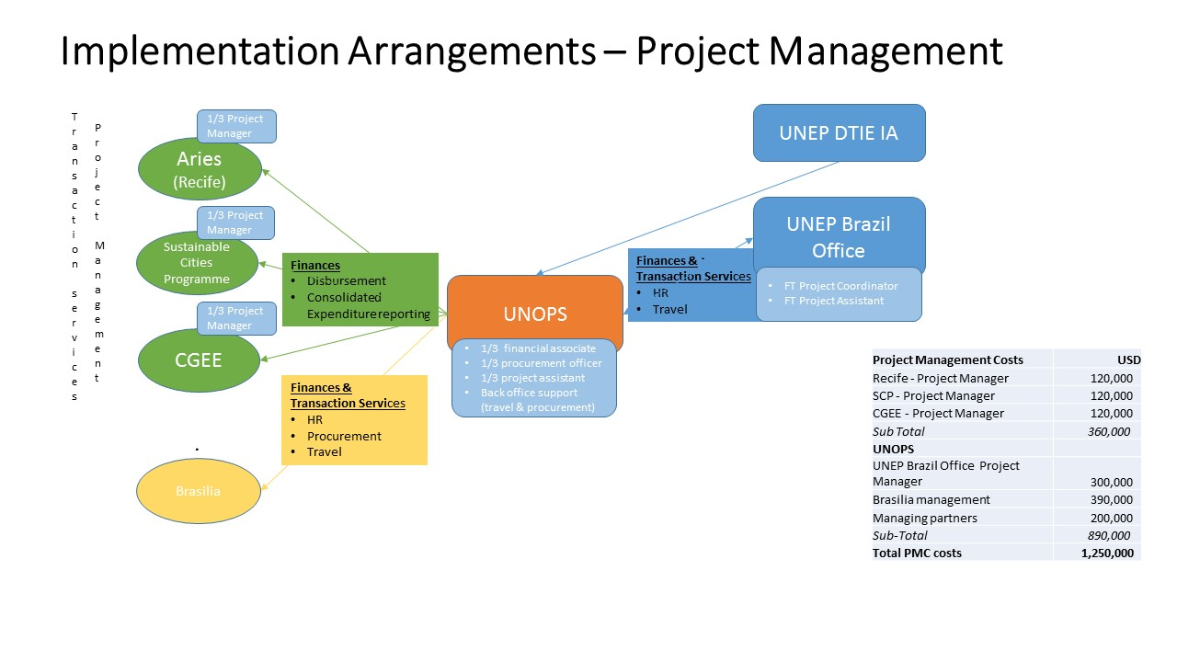

Project Management Unit
The project Management Unit will include:
- The Project Coordinator, UNEP Brazil
- The Project Managers for Recife, Sustainable Cities Programme, Brasilia and CGEE
- and assistants, and financial support of the above.
- UNOPS

Together this group will be responsible for day to day management of the project as a whole. The Project Managers for Recife, CGEE, SCP, Brasilia will be responsible for the day to day management of their parts of the project, while the Project Coordinator will be responsible for coordination between the project parts and representation of the project to MCTIC and ABC. The Project Coordinator will be supported by a part time Monitoring Coordinator, who will support Recife, Brasilia, CGEE and the SCP to develop their monitoring plans including data collection protocols. The Project Coordinator will call for Executive Management Group meetings monthly or as needed to ensure full coordination of the project. Executive Management Group Meetings will include the project management unit and MCTIC.

Project Steering Committee
Overseeing the entire project will be the Project Steering Committee (PSC). This will be chaired by the Project Director (PD) who (currently Ghilhereme Wiedman) and will include representatives from:

- MCTIC – Secretary
- UNEP Brazil office – Head of Office and Project Coordinator
- UNEP – Task Manager
- Recife (Secretary, Secretariat of Environment & Sustainability (SMAS), President, Recife City Institute of Planning (ICPS), Director, ARIES)
- Brasilia (Secretary, Secretariat of Environment (SEMA), Secretary, Secretariat of Planning and management (SEPLAG))
- Sustainable Cities Programme (Director)
- CGEE (Director)

This Committee will meet annually, unless one of the committee members call for ad hoc interim meeting. The main functions of the PSC will be to review project progress, approve annual workplans and budget and provide strategic guidance to the project, and approve management decisions to ensure timely delivery of quality outputs.
Other relevant stakeholders, such as the Ministry of Cities and the Ministry of Environment will be invited to join project technical meetings and the Steering Committee as observers.
Legal Arrangements
The project implementation protocols and legal agreements detailing the approval processes and documentation flow will be drafted and validated all partners at project inception. An executive programme who defines the roles of the Implementation Agency and Executive Agency is an obligatory document required by the Ministry of Foreign Affairs for Brazil to allow the project to be implemented in alignment with the Brazilian policy for international cooperation. The Executive Programme will be signed after project approval by the GEF between the Brazilian Cooperation Agency (representing the Ministry of Foreign Affairs, UNEP, and MCTIC).

UNEP DTIE, the project Implementing Agency, will sign a UN Letter of Agreement with UNOPS who will manage the financial transactions of the project.

annex I: Workplan and main deliverable

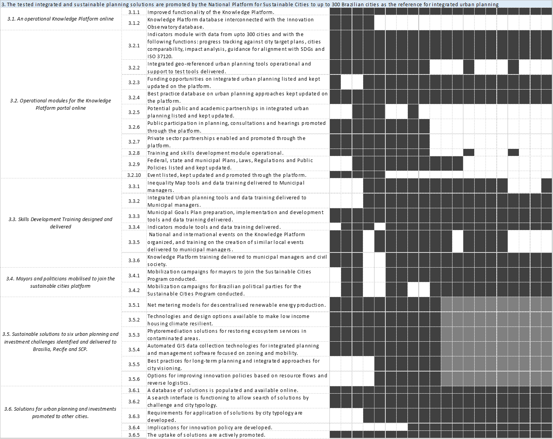

Annex J-2 - Estimates of Direct and Indirect GHG emission reduction

The impacts of the project have been estimated following the 2015 guidelines for greenhouse gas emissions accounting and reporting for GEF projects. The project will have direct emissions related to policies and investments in pilots, as well as consequential impacts related to scaling up. Since this project does not include a revolving fund, it will not have direct post-project impacts.

The project is considered to have a period of influence of 10 years after project closure. However, many of the activities such as the one related to reforestation, reduction of emissions from the dumpsite in Brasilia, as well as the efficient and resilient housing policy in Recife will have impacts that will last for two to four decades.

As stated in part II of the CEO endorsement request document, the project is expected to have a direct emission reduction of almost 3,803 kilotons of CO_{2e} (ktCO_{2e}) mainly related to the activities carried on in Brasilia and Recife (Components 1 and 2). The explanation of these estimations will be detailed in the following paragraphs for each city.

The cost effectiveness of the project considering only direct impacts is 5.95 USD/tCO2.

A) Direct GHG emission reductions

Brasilia

In Brasilia, the project is expected to have a direct emission reduction of 2,639 ktCO_{2e} obtained through policies developed under Component 1.

Component 1

Based on national targets, FDG has set an ambitious reduction target compared to the business as usual scenario by 2020. The project will draft and present for adoption a Climate Act Regulation as well as mitigation and adaptation plans that will strongly influence all sectors of the Federal District (Deliverable 1.3.1) to allow the District to achieve its reduction goals. The GEF project will then contribute through development of regulations and adoption to obtain a total cumulative direct GHG emission reductions of 2,111 ktCO_{2e}.
Inputs and results:
Federal target reductions by 2020 compared to 2020 | 38.9% |  | Current city target
Federal district emissions in 2012 | 7,739,830 | tCO2e/year | Latest city inventory
Annual population change | 2.85% |  | City data
Federal district emissions projection in 2020 | 9,690,937 | tCO2e/year | Calculated
Targeted reduction of yearly emissions by 2020 | 3,769,775 | tCO2e/year | Calculated
Percentage of activities implemented in the baseline | 30% |  | Assumption
Level of compliance/enforcement at the end of the project | 10% |  | Assumption
Climate act annual emission reductions at the end of the project | 263,884 | tCO2e/year | Calculated
Period of influence of the project | 10 | years | Assumption
Total direct emissions from policy | 2,638,842 | tCO2 | Calculated

- The percentage of activities of 30% reflects the current on-going initiatives such as renewable energy promotion and energy efficiency on public building as stated in the current climate bill.
- The percentage of level of compliance/enforcement at the end of the project of 10% reflects how much of the remaining reduction target (70%) will be met through the policies developed during the project at the end of the project. A conservative value has been assumed due to the fact that some of the policies developed during the project may only be applied and enforced after the project closure.

Component 2
Since the pilots under Component 2 will actually be part of the actions related to the Climate Act developed under Component 1, the estimations related to Component 2 are not added up to impacts estimated under Component 1 in order to avoid double counting. The calculations related to Component 2 impacts are only present in this document as an example of activities that will be promoted or enforced through the Climate Act. The global benefits related to investments realized under Component 2 in three main areas: sustainable land use, waste management and renewable energies have been calculated as explained in the following paragraphs.
Sustainable land use
The project will support the restoration of pilots and preservation in Permanent Preservation Areas springs in the Paranoá Basin and in the Descoberto basin (activities that will include agroforestry and best practices agriculture) and the study for the creation of ecological corridors. These activities will directly contribute to total cumulative GHG emission reductions of about 95ktCO_{2e}.
This figure has been estimated using the EX-Ante Carbon-balance Tool (EX-ACT) developed by FAO which provides estimates of the impact of agriculture and forestry development projects, programmes and policies on the carbon-balance based on the hectares of the area of impact.
Inputs and results:
Ecological corridors (REDD) | 375 | ha | Project target
Best practices agriculture (A/R) | 50 | ha | Project target
Agroforestry | 15 | ha | Project target
Watershed restoration | 45 | ha | Project target

Renewable energies

The project will promote the installation of centralised PV panels to feed 10 schools. The installation realized during the project will directly contribute to total cumulative GHG emission reductions of about 5.9 ktCO_{2e}.
Inputs and results:
Estimated CO2 emission reductions per year for 10 schools | 235 | tCO2e/year | WWF study in Brasilia value estimated for 8 schools
Photovoltaic solar panels lifetime | 25 | years | Assumption
Total CO2 emission reductions | 5,875 | tCO2e | Calculations

Justification of main assumptions:
- A WWF study estimated that 8 schools connected to the grid of a mini solar farm in Brasilia could avoid the emissions of 235 tCO_{2e}/year. The project aims to feed 10 schools with this system, but based on a conservative approach the same figure from the 8 schools WWF study is being used. Brasilia has the potential to replicate this to its 600 schools in which case it would allow to reduce a cumulative amount of more than 352ktCO_{2e}.

Waste management
The project will improve the waste management system of the city by developing a proposal of sustainable waste management (including source waste selection, waste selection and composting points). Moreover, it will test different restoration techniques and will develop the decommissioning plan of Brasilia’s dumpsite (the largest in South America).
The related activities realized during the project will directly contribute to reduce the waste being disposed of in the current dumpsite, getting a total cumulative GHG emission reductions of 5,905 ktCO_{2e}.
Inputs and results:
Federal district emissions in 2012 | 7,739,830 | tCO2e/year | Latest city inventory
% of the emissions related to waste | 17.94% |  | Latest city inventory
Emission of the dumpsite in 2012 | 1,388,526 | tCO2e/year | Calculation
Daily tonnage of waste going to dumpsite (residential+municipal) | 2,700 | t/day | City data
Annual tonnage of waste going to dumpsite (residential+municipal) | 729,000 | t/year | Calculation
Methane Correction Factor | 0.60 |  | IPCC Good Practice Guidelines 2000 default value
Degradable Organic Carbon (DOC) | 0.12 |  | Brazil value IPCC 1996
DOC_{f} | 0.5 |  | IPCC Good Practice Guidelines 2000
Fraction of methane in Biogas | 0.5 |  | IPCC Good Practice Guidelines 2000
Conversion Carbon to Methane | 1.33 |  | IPCC Good Practice Guidelines 2000
Methane recovery | - |  | Assumption
Oxidation Factor | 0.10 |  | Recife inventory
Annual methane emissions | 15,746 | tCH4/year | Calculation
Global warming potential | 25 | tCO2/tCH4 | IPCC
Emissions related to new waste each year | 393,660 | tCO2e/year | Calculation
% of reduction of dumpsite activities (= % of reduction of new waste in the dumpsite) | 75.00% |  | Project target
CO2 emission reductions per year | 295,245 | tCO2e/year | Calculation
Lifetime of investment | 20 | years | Assumption
Cumulative CO2 emission reductions | 5,904,900 | tCO2e | Calculation

The total direct emissions reductions from component 2 of Brasilia are estimated at 6,001 ktCO₂. This is significantly higher than the estimate given for Brasilia from policy reductions which proves that the estimate given is highly conservative.

Recife

In Recife the project is expected to have a direct emission reduction of 1,164 ktCO_{2e} obtained through policies developed under Component 1.

Component 1
The policies will be focused on sustainable (efficient and resilient) urban design based on transport oriented development and densification aiming to a significant transport modal shift (66% of GHG emissions are from transport in 2012), as well as increasing green areas in the city and making evidence-based decisions.

Recife target reductions by 2020 compared to BAU 2020 | 20.8% |  | City decree 2015
Total Recife emissions in 2012 | 3,120,426 | tCO2/year | Latest city inventory
Total Recife emissions projection in 2020 | 4,662,930 | tCO2/year | City decree 2015
Targeted reduction of yearly emissions by 2020 | 969,889 | tCO2/year | Calculated
Percentage of activities implemented in the baseline | 40% |  | Assumption
Level of compliance/enforcement at the end of the project | 20% |  | Assumption
Climate act annual emission reductions at the end of the project | 116,387 | tC02/year | Calculated
Period of influence of the project | 10 | years | Assumption
Total direct emissions from policy | 1,163,867 | tCO2 | Calculated

Justification of main assumptions:
- The percentage of activities of 40% reflects the current on-going initiatives such as the Capibaribe River Navigability Project (a planned project), the Green Roof Law (December 2014), among others further explained under part II, section A.1.2 of the CEO endorsement request document.
- The percentage of level of compliance/enforcement at the end of the project of 20% reflects how much of the remaining reduction target (60%) will be met through the policies developed during the project at the end of the project. A conservative value has been assumed due to the lack of enforcement power of the strategy. However, it is important to notice two important aspects of the global benefits of this project. First of all, the project will set the basis for future emission reductions (by conducting assessments that will set baselines for future projects, testing innovative pilots as well as targeting behavioural changes of citizens as well as decision makers). Secondly, the project will have a strong focus on resilience and adaptation to climate change which is considered as a top priority on the international development agenda.

B) Indirect/Consequential GHG emission reductions

The nature of the project implies a strong potential of consequential emission reductions. Indeed, the comprehensive evidence-based integrated and sustainable planning approach adopted by Recife and Brasilia under Component 1 will highly improve efficiency in the uses of resources, promote sustainable investments and optimize urban development leading to energy savings and GHG emission reductions. In addition, innovative pilots will be tested under Component 2 and plans for scaling up will be developed during the project. Finally, the consequential impacts will not be limited to Brasilia and Recife, the Knowledge Platform and Innovation Observatory implemented under Component 3 will provide tools and guidelines for sustainable planning for at least other 300 cities in Brazil.

Since this large potential of consequential GHG emission reductions is extremely complex to estimate, the calculations have been based only on the main elements: the ones where each city has the largest potential of impact and which is the most influenced by the GEF project.

Brasilia – Waste management
The project will set the basis of the decommissioning of the current dumpsite in order to replace it by a waste to energy facility which will then potentially reduce all the emissions coming from this dumpsite. Therefore, the consequential GHG emission reductions from Brasilia are estimated to be 11,108ktCO_{2e}.

Federal district emissions in 2012 | 7,739,830 | tCO_{2e}/year | Latest city inventory
% of the emissions related to waste | 17.94% |  | Latest city inventory
Emission of the dumpsite in 2012 | 1,388,526 | tCO_{2e}/year | Calculation
% of the emissions reduced | 100.00% |  | Total Potential
CO2 emission reductions per year | 1,388,526 | tCO_{2e}/year | Calculation
Lifetime of investment | 20 | years | Assumption
Cumulative CO2 emission reductions | 27,770,510 | tCO_{2e}/year | Calculation
Causality factor | 40% |  | Assumption
Consequential CO2 emission reductions from housing policy | 11,108,204 | tCO_{2e} | Calculations

Recife – Modal Shift and Housing policy
Following a top-down approach, the consequential GHG emission reductions are estimated to be 619 ktCO_{2e}.

As explained under the direct impact sections, the project will promote sustainable urban planning and investments in transit systems and non-motorised transport infrastructure. The project will be aligned and has the potential of boosting initiatives such as the Capibaribe River Park plan and the Capibaribe River Navigability Project. Therefore, one of the main consequential impacts of the project will be related to transport modal shift.

Emissions from Transport sector in 2012 | 2,038,873 | tCO2e/year | Calculated
Emissions from Ground Transport sector in 2012 | 1,413,617 | tCO2e/year | Inventory of Recife
Potential reduction from Modal shift | 10% |  | Assumption
Reduction of yearly emissions from transport sector | 141,362 | tCO2e/year | Calculated
Period of influence of the project | 10 | years | Assumption
Climate act annual emission reductions at the end of the project | 1,413,617 | tC02e | Calculated
Causality factor | 20% |  | Assumption
Total direct emissions from policy | 282,723 | tCO2e/year | Calculated

Justification of main assumption:
- The percentage of potential reductions in ground transport, 12%, has been estimated based on IEA 2009 transport publication that indicated that some policies such as urban planning and land-use changes can achieve up to 25% reductions on LDV travel in Non-OECD countries. It is also known that a city with a similar number of inhabitants, Madrid (around 3million) has the target of reducing the road transport emissions by 20% according to C40 2014 city targets.
- The activities under the GEF project scope will contribute to set the basis for behaviour change and will promote the modal shift but will have limited direct influence, so the causality factors assumed is only 20%.

In addition, the housing policy developed by the project will aim to influence any new construction in Recife. Taking into account the total housing deficit in Recife, there is an important potential of reductions related to this policy.

Housing deficit | 70,000 | units | City data
Area of one average building | 40 | m2 | City data
GHG emission reductions per unit | 30 | kg CO2e/ m2 year | Estimations from UNEP
Annual CO2 emission reductions per building | 1.20 | tCO2e/ building year | Calculations
Total Annual CO2 emission reductions | 84,000 | tCO2e/year | Calculations
Lifetime of investments | 20 | years | Assumption
Total potential CO2 emission reductions from housing policy | 1,680,000 | tCO2e | Calculations
Causality factor | 20% |  | Assumption
GEF consequential CO2 emission reductions from housing policy | 336,000 | tCO2e | Calculations

Justification of main assumption:
- Since the housing deficit is large, and the GEF project will be more focused on social housing, the level of influence of the project on the potential reductions taking into account all the housing deficit is considered low, the causality factor assumed is only 20%.

Annex J-3 - SC-IAP Draft GEF tracking tool
(2 documents Attached separately)
Annex K – OPERATIONAL FOCAL POINT ENDORSEMENT LETTER

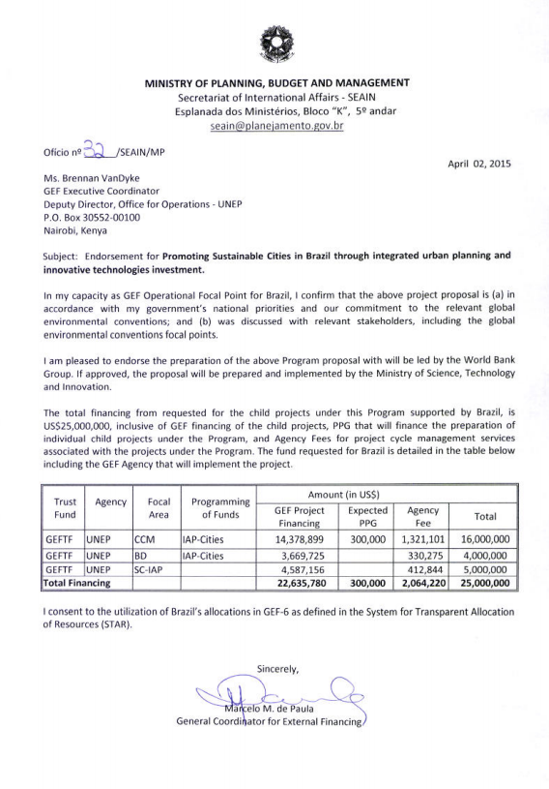
Annex L – Cofinance Letters
- Ministry of Science, Technology and Innovation (MCTIC)
- Government of Federal District (FDG)
- Municipality of Recife (PPA)
- Compesa
- Sustainable Cities Programme
- UNEP
MCTIC

Government of Federal District – SLU (Urban Cleaning Services)
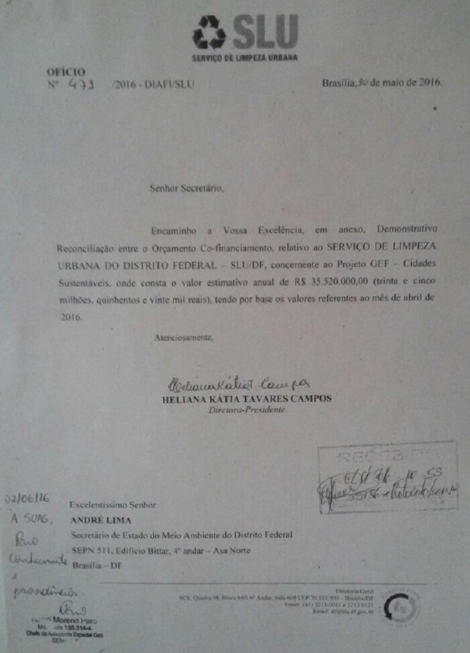
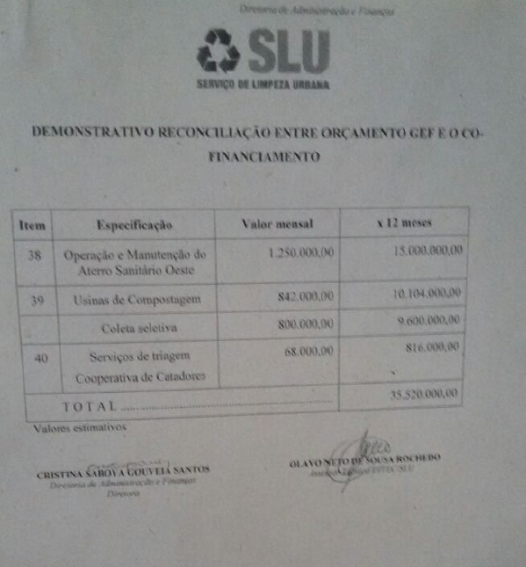

Government of Federal District – CAESB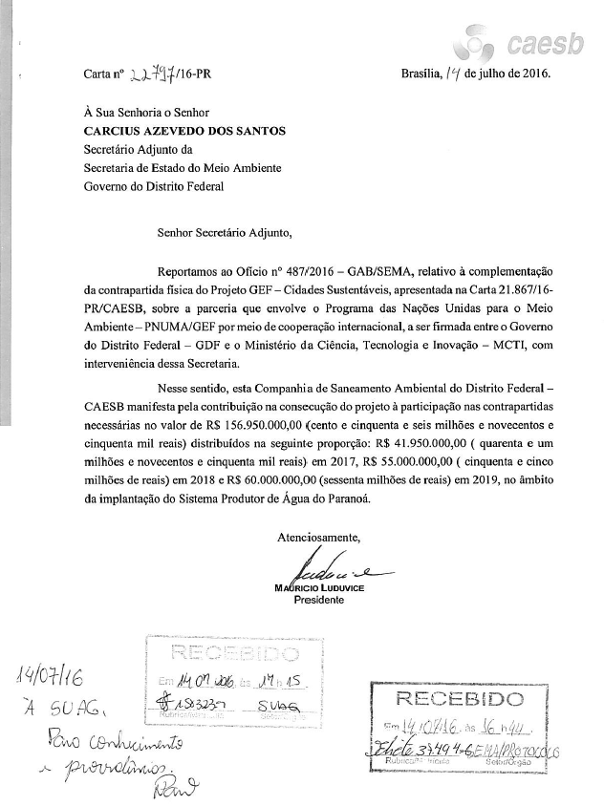
Municipality of Recife
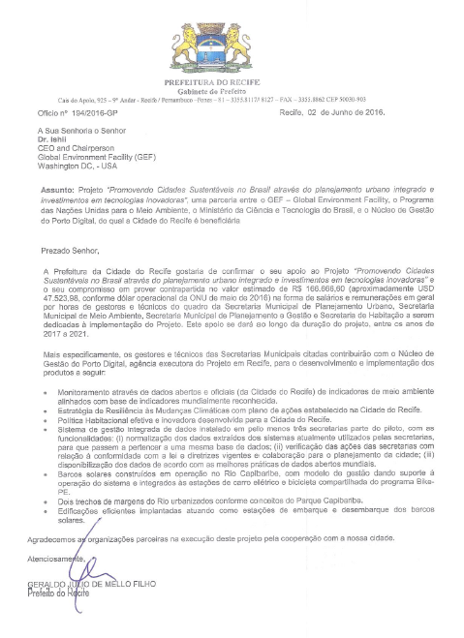
Compesa
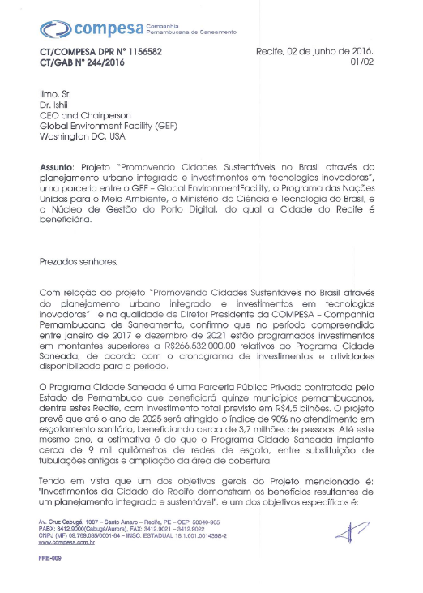

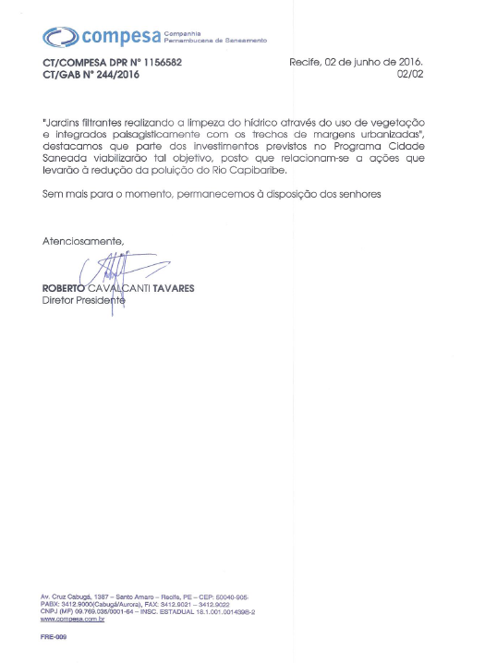

Sustainable Cities Programme
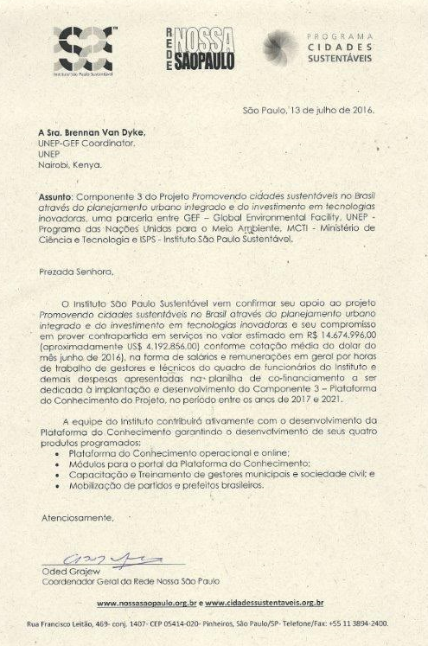
UNEP
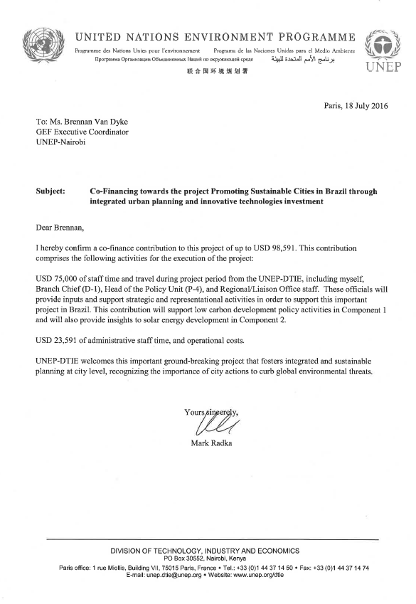

Annex M - Environmental and Social Safeguards Checklist
Project Title: | Promoting Sustainable Cities in Brazil through integrated urban planning and innovative technologies
GEF project ID and UNEP ID/IMIS Number |  | Version of checklist | 2
Project status (preparation, implementation, MTE/MTR, TE) | preparation | Date of this version: | 04 July 2016
Checklist prepared by (Name, Title, and Institution) | Eder Zanetti

In completing the checklist both short- and long-term impact shall be considered.

Section A: Project location:
If negative impact is identified or anticipated the Comment/Explanation field needs to include: Project stage for addressing the issue; Responsibility for addressing the issue; Budget implications, and other comments.

 | Yes/No/N.A. | Comment/explanation
- Is the project area in or close to -
- densely populated area | Yes | The project will be carried out in the Federal District (2.5 million people), pilots will be in the Paranoa and Descoberto watersheds which are both densely populated  The size of the population targeted by the project is at least 100000 people living in the Paranoá Watershed and 20000 people at the Descoberto Watershed. The project takes into account local livelihoods and communities living in the pilot areas. Capacity building, knowledge sharing resilience and community-based adaptation are all integrated into the project design.
- cultural heritage site | Yes | Brasilia city is part of the World Cultural and Historical Heritage Site.
- protected area | Yes | The project will implement EbA in the Paranoa and Descoberto watersheds. Both watersheds were designated by the Federal Government as an Environmental Protected Area (EPA)
- wetland | No
- mangrove | No
- estuarine | No
- buffer zone of protected area | Yes | The project intends to mainstream the EEZ into territorial planning, and build climate resilience through an Ecosystem-based approach to adaptation – including restoration of degraded springs – in the Paranoa watershed area near the Brasilia National Park.
- special area for protection of biodiversity | Yes | The project intends to mainstream the EEZ into territorial planning, and build climate resilience through an Ecosystem-based approach to adaptation – including restoration of degraded springs – in the Paranoa watershed area near the Brasilia National Park.
- Will project require temporary or permanent support facilities? | No
If the project is anticipated to impact any of the above areas an Environmental Survey will be needed to determine if the project is in conflict with the protection of the area or if it will cause significant disturbance to the area.

Section B: Environmental impacts, i.e.
If negative impact is identified or anticipated the Comment/Explanation field needs to include: Project stage for addressing the issue; Responsibility for addressing the issue; Budget implications, and other comments.

 | Yes/No/N.A. | Comment/explanation
- Are ecosystems related to project fragile or degraded? | Yes | The project will implement restoration and conservation actions in the Paranoa and Descoberto watersheds in the Federal District, to help restore these two watersheds.
- Will project cause any loss of precious ecology, ecological, and economic functions due to construction of infrastructure? | No | On the contrary, the project will restore ecological corridors, degraded habitat and protected areas, intends to build climate resilience through an Ecosystem-based approach to adaptation – in the Paranoa and Descoberto Watersheds
- Will project cause impairment of ecological opportunities? | Not anticipated | The project aims to increase the ecological opportunities and ecosystem services despite the negative impacts of climate change. Short-, medium- and long-term impacts will be beneficial for local ecosystems.
- Will project cause increase in peak and flood flows? (including from temporary or permanent waste waters) | Not anticipated | The project aims to restore spring water and increase water infiltration, despite increase of frequence and intensity of extreme rainfall events due to climate change in the region.
- Will project cause air, soil or water pollution? | No | The project will help to test technologies that will improve water, air and soil contamination coming from the open dumpsite.
- Will project cause soil erosion and siltation? | No | It is expected that project activities will increase water filtration in all priority project areas in watersheds and Cerrado, thereby reducing erosion and siltation. Furthermore, restored ecosystems will mitigate the effect of floods, further reducing erosion and siltation.
- Will project cause increased waste production? | No | The project will have environmental education and social mobilization activities to educate population about reducing waste production
- Will project cause Hazardous Waste production? | No
- Will project cause threat to local ecosystems due to invasive species? | No | The project will use Cerrado species to restore springs and ecosystems in the Paranoa and Descoberto Watersheds.
- Will project cause Greenhouse Gas Emissions? | No | Project activities are likely to reduce the emissions of greenhouse gases in identified priority sites through the restoration and re-establishment of degraded ecosystems, increasing soil and plant carbon sequestration, and using solar panels.
- Other environmental issues, e.g. noise and traffic | No
Only if it can be carefully justified that any negative impact from the project can be avoided or mitigated satisfactorily both in the short and long-term, can the project go ahead.

Section C: Social impacts
If negative impact is identified or anticipated the Comment/Explanation field needs to include: Project stage for addressing the issue; Responsibility for addressing the issue; Budget implications, and other comments.

 | Yes/No/N.A. | Comment/explanation
- Does the project respect internationally proclaimed human rights including dignity, cultural property and uniqueness and rights of indigenous people? | Yes | The project partners are either Brazilian government agencies or reputable NGO’s working with Government counterparts. As such the project designers assume that all project partners will uphold human rights. No indigenous people are involved in this project.
- Are property rights on resources such as land tenure recognized by the existing laws in affected countries? | Yes | The project facilitates participatory approaches for avoiding any conflicts.
- Will the project cause social problems and conflicts related to land tenure and access to resources? | No | The project will promote a community-based natural resources management approach. The project will adhere to national and local laws on land rights and land tenure.
- Does the project incorporate measures to allow affected stakeholders’ information and consultation? | Yes | On the ground activities are implemented by local NGOs and communities, and are preceded by and include stakeholder consultations together with training and information workshops. Technical briefs will be prepared to ensure that all stakeholders are fully informed.
- Will the project affect the state of the targeted country’s (-ies’) institutional context? | yes | The project will strengthen institutions within Federal District of Brazil and Brasilia in order to facilitate mainstreaming of environmental data system, ecological economic zoning and climate change adaptation and mitigation. In addition, Federal District government staff from SEMA and other bureaus will be trained on planning and implementing EbA interventions.
- Will the project cause change to beneficial uses of land or resources? (incl. loss of downstream beneficial uses (water supply or fisheries)? | yes | The project is designed to enhance beneficial land uses and access to resources, including improved water and soil quality in springs. Solar Energy systems will improve energy resilience in those public buildings.
- Will the project cause technology or land use modification that may change present social and economic activities? | yes | The project is designed to enhance resilient territorial land use and energy planning, access to resources and ecosystem services in both components and the projects sites.
- Will the project cause dislocation or involuntary resettlement of people? | No | No movement of populations is required for project activities: local populations are involved in all on-the-ground implementation.
- Will the project cause uncontrolled in-migration (short- and long-term) with opening of roads to areas and possible overloading of social infrastructure? | No | No new roads are to be built through project activities, and no population movement is anticipated. Local social infrastructure will be enhanced through the project community engagement and consultation process, and through local community training in adaptation techniques.
- Will the project cause increased local or regional unemployment? | No | No long-term change in employment as a result of project activities is anticipated. NGOs will insure that Community members will be also be employed for short periods to achieve specific project objectives where necessary. Livelihoods of communities in project sites will be enhanced in order to improve community resilience under conditions of climate change.
- Does the project include measures to avoid forced or child labour? | Yes | The project partners are either Brazilian government agencies or reputable NGO’s working with Government counterparts. As such the project designers assume that all project partners will avoid forced child labour.
- Does the project include measures to ensure a safe and healthy working environment for workers employed as part of the project? | Yes | The project partners are either Brazilian government agencies or reputable NGO’s working with Government counterparts. As such the project designers assume that all project partners will ensure safe and healthy working conditions for their staff and contractors.
- Will the project cause impairment of recreational opportunities? | No | No recreational opportunities will be impaired through project activities.
- Will the project cause impairment of indigenous people’s livelihoods or belief systems? | N A
- Will the project cause disproportionate impact to women or other disadvantaged or vulnerable groups? | No | Disproportionate negative impact to women or disadvantaged groups is not expected. However the project does target vulnerable groups in: social housing in Recife; Descoberto, Paranoa and along the Capiairibe river.  Restoration of the Capabiribe river may involve relocation of homeless people or informal settlements. If this is the case, the city of Recife will use its own checks and balances and ensure those relocated are provided with better conditions.
- Will the project involve and or be complicit in the alteration, damage or removal of any critical cultural heritage? | No | No cultural heritage will be impacted through project operations.
- Does the project include measures to avoid corruption? | yes | Corruption can be a problem. UNOPS will execute the project and validate all expenditures.
Only if it can be carefully justified that any negative impact from the project can be avoided or mitigated satisfactorily both in the short and long-term, can the project go ahead.

Section D: Other considerations
If negative impact is identified or anticipated the Comment/Explanation field needs to include: Project stage for addressing the issue; Responsibility for addressing the issue; Budget implications, and other comments.

 | Yes/No/N.A. | Comment/explanation
- Does national regulation in affected country (-ies) require EIA and/or ESIA for this type of activity? | No applied for the GEFTF activities and yes for the co-financed activities | The Brazilian Environmental Resolution 001 (BECA) (1986) creates an enabling environment that enforces all projects – related to the implementation of construction works, installations or schemes, or implying interventions into the natural and scenery environment – that may have a negative impact on the environment undergo an Environmental Impact Assessment (EIA). EIA were therefore undertaken within Component 2 of the Co-financed activities related to the SLU/new Dumpsite and CAESB /water works. In addition, feasibility and vulnerability assessments were undertaken to inform the design of project interventions.
- Is there national capacity to ensure a sound implementation of EIA and/or SIA requirements present in affected country (-ies)? | Yes | The Brazilian government and the Federal District government have both capacity and resources to ensure a sound implementation of EIAs.
- Is the project addressing issues, which are already addressed by other alternative approaches and projects? | No | No other projects have been identified that are currently mainstreaming environment and Climate change planning into territorial planning, nor undertaking Ecosystem based Adaptation activities in Brasilia. Project activities are complementary to the identified baseline projects, and will ensure that long-term adaptation benefits enhance the value of the baseline activities.
- Will the project components generate or contribute to cumulative or long-term environmental or social impacts? | No | The project will generate long-term environmental benefits by facilitating mitigation and adaptation restoration in degraded ecosystems, and positive social impacts through enhanced productivity. The project seeks to enhance the resilience of the Federal District population.
- Is it possible to isolate the impact from this project to monitor E&S impact? | yes | The project will generate long-term environmental benefits by facilitating adaptation restoration in Cerrado forests and and positive social impacts through enhanced ecosystems services and promoting additional livelihood options. By implementing distributed Solar Energy Systems the project will also enhance energy resilience in the Federal District.

Recife

Project Title: | Promoting Sustainable Cities in Brazil through integrated urban planning and investments in innovative technologies - RECIFE
GEF project ID and UNEP ID/IMIS Number |  | Version of checklist | 1
Project status (preparation, implementation, MTE/MTR, TE) |  | Date of this version: | June, 3rd /2016
Checklist prepared by (Name, Title, and Institution) | Ana Luiza Ferreira, Project Coordinator, ARIES/ NGPD

In completing the checklist both short- and long-term impact shall be considered.

Section A: Project location:
If negative impact is identified or anticipated the Comment/Explanation field needs to include: Project stage for addressing the issue; Responsibility for addressing the issue; Budget implications, and other comments.

 | Yes/No/N.A. | Comment/explanation
- Is the project area in or close to -
- densely populated area | Yes | The designed interventions are located close to high density residential areas. However, the scope of the interventions involve the urbanization of river banks, installing filtering gardens in the waters, and small solar boats for crossing the river, therefore no negative impact on the population is anticipated.
- cultural heritage site | No | -
- protected area | Yes | Interventions are located on the banks of the river, mangrove area, so environmentally protected areas. The Project and the whole concept of the Capibaribe Park aim to strengthen environmental protection in the surroundings of the project area.
- wetland | Yes | The intervention of the filtering garden is located in a river swamp, which acts as a natural regulator of the floods of the river, and therefore cannot be urbanized. The Project seeks to protect the area and enforce compliance with this determination/law.
- mangrove | Yes | Interventions are located on the banks of the river, mangrove area, so environmentally protected areas. The Project and the whole concept of the Capibaribe Park aim to strengthen environmental protection in the surroundings of the project area.
- estuarine | Yes | The area is an estuarine region. Negative impacts are not expected, but positive impacts of recovery and protection of the area.
- buffer zone of protected area | No | -
- special area for protection of biodiversity | No | -
- Will project require temporary or permanent support facilities? | Yes | the urbanization includes  1 filtering garden;  4.38 ha of re-urbanization;  2 docking stations;  5 resting areas,  2 bikes stations  2 car park stations;  0.3 km of bike lanes and walking  These are aligned with the Capibaribe Park design and the impacts are expected to be beneficial to the population and the environment.
If the project is anticipated to impact any of the above areas an Environmental Survey will be needed to determine if the project is in conflict with the protection of the area or if it will cause significant disturbance to the area.

Section B: Environmental impacts, i.e.
If negative impact is identified or anticipated the Comment/Explanation field needs to include: Project stage for addressing the issue; Responsibility for addressing the issue; Budget implications, and other comments.

 | Yes/No/N.A. | Comment/explanation
- Are ecosystems related to project fragile or degraded? | Yes | The Capibaribe River is highly polluted, mainly from untreated sewage. Co-financing for the Project involves the structuring of sewage, which will change this reality. The technology of filtering gardens to be tested as a pilot would contribute to the restoration of the river. Thus, there are expected only positive impacts, not negative.
- Will project cause any loss of precious ecology, ecological, and economic functions due to construction of infrastructure? | No | -
- Will project cause impairment of ecological opportunities? | No | -
- Will project cause increase in peak and flood flows? (including from temporary or permanent waste waters) | No | -
- Will project cause air, soil or water pollution? | No | -
- Will project cause soil erosion and siltation? | No | -
- Will project cause increased waste production? | No | -
- Will project cause Hazardous Waste production? | No | -
- Will project cause threat to local ecosystems due to invasive species? | No | -
- Will project cause Greenhouse Gas Emissions? | No | -
- Other environmental issues, e.g. noise and traffic | No | -
Only if it can be carefully justified that any negative impact from the project can be avoided or mitigated satisfactorily both in the short and long-term, can the project go ahead.

Section C: Social impacts
If negative impact is identified or anticipated the Comment/Explanation field needs to include: Project stage for addressing the issue; Responsibility for addressing the issue; Budget implications, and other comments.

 | Yes/No/N.A. | Comment/explanation
- Does the project respect internationally proclaimed human rights including dignity, cultural property and uniqueness and rights of indigenous people? | Yes | -
- Are property rights on resources such as land tenure recognized by the existing laws in affected countries? | Yes | -
- Will the project cause social problems and conflicts related to land tenure and access to resources? | No | -
- Does the project incorporate measures to allow affected stakeholders’ information and consultation? | Yes | The involvement of stakeholders is treated as a high priority for the project.
- Will the project affect the state of the targeted country’s (-ies’) institutional context? | No | -
- Will the project cause change to beneficial uses of land or resources? (incl. loss of downstream beneficial uses (water supply or fisheries)? | No | -
- Will the project cause technology or land use modification that may change present social and economic activities? | No | -
- Will the project cause dislocation or involuntary resettlement of people? | No | There are homeless people and informal settlements along the Capibaribe river and it is possible that some of these people will need to be moved. If so city will follow its own procedures and ensure resettled people are given better conditions than before.
- Will the project cause uncontrolled in-migration (short- and long-term) with opening of roads to areas and possible overloading of social infrastructure? | No | -
- Will the project cause increased local or regional unemployment? | No | -
- Does the project include measures to avoid forced or child labour? | N/A | -
- Does the project include measures to ensure a safe and healthy working environment for workers employed as part of the project? | N/A | -
- Will the project cause impairment of recreational opportunities? | No | -
- Will the project cause impairment of indigenous people’s livelihoods or belief systems? | No | -
- Will the project cause disproportionate impact to women or other disadvantaged or vulnerable groups? | No | -
- Will the project involve and or be complicit in the alteration, damage or removal of any critical cultural heritage? | No | -
- Does the project include measures to avoid corruption? | No | The project does not include specific measures, however all purchases and contracts related to the project will be made given the high quality standards to ensure free competition.
Only if it can be carefully justified that any negative impact from the project can be avoided or mitigated satisfactorily both in the short and long-term, can the project go ahead.

Section D: Other considerations
If negative impact is identified or anticipated the Comment/Explanation field needs to include: Project stage for addressing the issue; Responsibility for addressing the issue; Budget implications, and other comments.

 | Yes/No/N.A. | Comment/explanation
- Does national regulation in affected country (-ies) require EIA and/or ESIA for this type of activity? | yes | The Brazilian Environmental Resolution 001 (BECA) (1986) creates an enabling environment that enforces all projects – related to the implementation of construction works, installations or schemes, or implying interventions into the natural and scenery environment – that may have a negative impact on the environment undergo an Environmental Impact Assessment (EIA).
- Is there national capacity to ensure a sound implementation of EIA and/or SIA requirements present in affected country (-ies)? | Yes | -
- Is the project addressing issues, which are already addressed by other alternative approaches and projects? | Yes | The project aims primarily to reduce GHG emissions by improving the urban planning process and also the pilot of green technologies such as boats powered by solar energy and the implementation of urban parks stretches to encourage the use of NMT.
- Will the project components generate or contribute to cumulative or long-term environmental or social impacts? | Yes | -
- Is it possible to isolate the impact from this project to monitor E&S impact? | Yes | Isolating the impact of some components design is possible.

ANNEX N: ACRONYMS AND ABBREVIATIONS

ADASA - Federal District Water, Energy and Sanitation Regulatory Agency
AFS - Agroforestry SystemsAPARD - Descoberto River basin Protected Area
API - Applications Programming Interface
APL - Local Productive Arrangement
APP - Areas of Permanent Preservation
ARIES – Agência Recife para Inovação e Estratégia
BAM - Brazilian Association of Municipalities
BKP - Brazilian Knowledge Platform
BNDES – National Bank for development
CAESB - Water and Environmental Sanitation Company of the Federal District
CAR - Rural Environmental Registry
CEB - Brasilia Energy Company
CESAR - Centro de Estudos Avançados do Recife
CGEE - Centre for Strategic Studies and Management in Science, Technology and Innovation
CIRAT - International Reference Centre for Water and Transdisciplinary
CNRH - National Council of Water Resources
CODEPLAN - Planning Company of the Federal District
COMCLIMA - Sustainability Committee and Climate Change
CPRH - Agency of the State of Pernambuco
CRH-FD - Water Resources Board of the Federal District
CSA - Communities that Support Agriculture
CSO – Civil Society Organization
CTR - Screening and Recycling Centres
DATASUS - SUS Informatics Department
DB – Database
DL - Distance Learning
DOTS - Desenvolvimento Orientado ao Transporte Sustentável
E.g. – Example
EC - Economia Criativa
ECA - Adaptation Based Ecosystems
EEZ - Ecological-Economic Zoning
EMATER - Enterprise Technical Assistance and Rural Extension
EMBRAPA - Governmental Food Research Agency
EMPREL - Empresa Municipal de Informática
ENCTI - Estratégia Nacional de Ciência Tecnologia e Inovação
EPA - Environmental Protected Area
EPE - Energy Research Company
EPM - Environmental Planning and Management
Etc. - et cetera
FA - Focal Area
FAO - Food and Agricultural Organization of the United Nations
FAQ – Frequently Asked Questions
FD – Federal District
FDG - Government of Federal District
FDR - Rural Development Fund of the Federal District
FLONA - National Forest
FMHFIS - Fundo Municipal de Habitação de Interesse Social
FV – Photovoltaic
GAP - Good Agricultural Practices
GCC – Green Climate Cities
GDP - Gross Domestic Product
GECLIMA - Group Sustainability and Climate Change
GEF - Global Environment Facility
GEFTF - Project Templates for GEF Trust Fund
GGKP - Green Growth Knowledge Platform

GHG - Greenhouse Gas
GHG – Greenhouse Gases
GIS - Geographic Information System
GKP - Global Knowledge Platform

GPC - Global Protocol for Community
GPSC - Global Platform for Sustainable Cities

IAP - Integrated Approach Pilot
IBGE - Brazilian Institute of Geography and Statistics
IBRAM - Brasilia Environmental Institute
ICLEI - Local Governments for Sustainability
ICMBio – Institute of Biodiversity Conservancy
ICPS - Instituto da Cidade do Recife Pelópidas Silveira
ICRAF - World Agroforestry Centre
ICT - Information and communications technology
IDB – Inter-American Development Bank
IMS - Integrated Management System
INCITI - Grupo de pesquisa Inovação e Pesquisa Para Cidades da UFPE
INDC - Intended Nationally Determined Contributions
INPE - National Space Institute
IP – Instituto de Pesquisa
IPAV - Imóveis de Proteção de Áreas Verdes
IPCC - Fourth Intergovernmental Panel on Climate Change
IPPU - Industrial Processes and Product Use
IPTU - Imposto Predial Territorial Urbano
ISO - International Organization for Standardization
IT - Information Technology
KP - Knowledge Platform
LDCF - Least Developed Countries Fund
LDO –Directive Budget Plan (Lei de Diretrizes Orçamentárias)
LOA – Annual Budget Law (Lei do Orçamento Annual)
LPA - Local Productive Arrangement
LPT - Programme Light for All
LSCE - Laboratory on the Climate and Environmental Sciences
LUOS - Land Use and Occupation Law (Lei de Uso e Ocupação do Solo)
MCTIC - Ministry of Science, Technology, Innovation and Communication
MEA - Multilateral environmental agreements
MMA - Environment Ministry
MNP - National Mobility Policy
MPAs - Water source Protected Areas
MRV - Monitoring Reporting Verification
MTS – Medium-Term Strategy
M&E – Monitoring and Evaluation
NEP - National Environmental Policy
NGPD – Núcleo de Gestão do Porto Digital
NMA - National Mayors Association
NMT - Non-Motorised Transport (NMT)
NOVACAP – Urban Company of the Capital
NPCC - National Policy on Climate Change
NSSTI – National System of Science, Technology and Innovation
NST - National Science and Technology
ODIR - Outorga Onerosa do Direito de Construir
ODR – Observatório do Recife
OECD - Organization for Economic Co-operation and Development
OS - Organização Social
PCI – Projeto Contra Incendio
PDC – Plano Diretor Cicloviário
PDDU - Urban Drainage Master Plan
PDE - Ten-Year National Energy Plan
PDOT - Master Plan for Land Management
PE - Pernambuco
PEUC - Parcelamento, Edificação ou Utilização Compulsória
PGIRH - Integrated Management Plan for Water Resources
PIF - Project Identification Form
PLHIS - Plano Local de Habitação de Interesse Social
PNMC - National Policy on Climate Change
PNRH - National Plan for Water Resources
PM - particulate matter
PMC - Project Management Cost
POT - Plano de Ordenamento Territorial
PPA - Multi-Year Budget Plan
PPCUB - Urban Assembly Preservation Plan of Brasilia
PPG - Project Preparation Grant
PPP - Public-Private Partnership
PRAV - Projetos de Revitalização de Áreas Verdes
PROINFA - Programme for Electric Energy Alternatives
RA – Administrative Region
REBIO - Biological Reserve
REGIC - Regions of Cities Influence
RMR - Região Metropolitana do Recife
RMBH - Região Metropolitana de Brasilia
SC - Sustainable Cities
SCCF - Special Climate Change Fund
SCIO - Sustainable Cities Innovation Observatory
SCP - Sustainable Cities Programme
SDG – UN Sustainable Development Goals
SEAGRI - Secretary of Agriculture and Rural Development
SEBRAE - Brazilian Service to Support Small and Micro-enterprises
SEHAB – Secretaria de Habitação
SEMA - Secretariat of Environment
SENAI - National Service for Industrial learning
SEPLAG - Secretaria de Planejamento e Gestão
SETRAB – Secretary of Labour
SGIRS - Integrated management for Solid Waste System
SIDGRH - District System of Integrated Water Resources Management
SIGEPRO - Georeferencing Programs System
SINIMA - National System for Environmental Information
SISDIA - Integrated Environmental Management System
SISNAMA - Environment National System
SLU - Urban Waste Utility
SMAS – Secretariat of Environment and Sustainability of Recife (Secretaria de Meio Ambiente e Sustentábilidade)
SNHIS - Sistema Nacional de Habitação de Interesse Social
SPDA – Sistema de Proteção contra Descargas Atmosféricas
STI – Science, Technology and Innovation
STPs - Sewage Treatment Plants
SUS - Public Health System
TDC - Transferência do Direito de Construir
TIC - Tecnologia da Informação e Comunicação
TOD - Transit Oriented Development
ToR – Term of Reference
UCCN - Creative Cities Network
UCN - Unidades de Conservação da Natureza
UFPE - Universidade Federal de Pernambuco
UNDESA - United Nations Department of Economic and Social Affairs
UNEP - United Nations Environment Programme
UN-Habitat - United Nations Human Settlements Programme
UNOPS - United Nations Office for Project Services
URB – Empresa de Urbanização
URBAN LEDS - Urban Low Emissions Development Strategy
WRP - Water Resources Plan
ZEIS - Zona Especial de Interesse Social

ANNEX P: TABLE OF CONTENT
Part I – Project Information
Part II – Project Justification
A Project overview
A.0. Describe any changes in alignment with the project design with the original PIF.
A.1. Project Description.
A.2. Child Project
A.3. Stakeholders.
A.4. Gender Equality and Women's Empowerment.
A.5. Risk
A.6. Institutional Arrangement and Coordination.
A.7 Benefits.
A.8 Knowledge Management
B: Description of the consistency of the project with national priorities
C: Describe the budgeted M&E plan
Part III – Certification by GEF Partner Agency(ies)
A: GEF Agency(ies) certification
Annex A - Project Results Framework
Annex B - Responses to Project Reviews
Annex C - Status of implementation of project preparation activities and the use of funds
Annex D - Calendar of Expected Reflows
Annex E - Consultants to be hired •Annex F-1 - Detailed GEF budget template
Annex F-2 - Detailed Cofinance budget template
Annex G - M&E Budget and Work Plan
Annex H - Project Implementation Arrangements
Annex I - Project Workplan and Deliverables
Annex J-2 - Estimates of Direct and Indirect GHG emission reduction
Annex J-3 - SC-IAP Draft GEF tracking tool (Nov 2015)
Annex K - OFP Endorsement Letter template
Annex L - Co-financing commitment letters from project partners
Annex M - Environmental and Social Safeguards Checklist
Annex N - Acronyms and abbreviations

Project ID number remains the same as the assigned PIF number.
When completing Table A, refer to the excerpts on GEF 6 Results Frameworks for GETF, LDCF and SCCF.
Financing type can be either investment or technical assistance.
For GEF Project Financing up to $2 million, PMC could be up to10% of the subtotal; above $2 million, PMC could be up to 5% of the subtotal. PMC should be charged proportionately to focal areas based on focal area project financing amount in Table D below.
Update the applicable indicators provided at PIF stage. Progress in programming against these targets for the projects per the Corporate Results Framework in the GEF-6 Programming Directions, will be aggregated and reported during mid-term and at the conclusion of the replenishment period.
For biodiversity projects, in addition to explaining the project’s consistency with the biodiversity focal area strategy, objectives and programs, please also describe which Aichi Target(s) the project will directly contribute to achieving..
(1) Climate and Energy Assessment: Simulation Trend scenarios of the energy mix in the Federal District; (2) Climate and Water Multiple Uses Assessment: Methodology and systematization Database; (3) Climate and Land Use Assessment: Methodology and systematization Database; (4) Climate Models in High Resolution for GDF (20kmx20km); (5) Climate and Energy Assessment: Evaluation of projected impacts of climate change in the sector; (6) Climate and Water Multiple Uses Assessment: Water Balance 2010-2040; (7) Climate and Land Use Assessment: Simulation of the BAU scenario of land use and occupation; (8) Climate and Energy Assessment: decentralized generation alternative identification; (9) Climate and Water Multiple Uses Assessment: Integrated Modelling (Multiple Use); (10) Climate and Land Use Assessment: projected climate impacts of climate change; (11) Climate and Energy Assessment: Identifying adaptation and sectoral mitigation options; (12) Climate and Water Multiple Use Assessment: Recommendations on adaptive measures; (13) Climate and Land Use and Occupancy Assessment: Identification of adaptation options; (14) Climate Models Highest Resolution for GDF (5kmx5km); (15) Climate and Watershed Assessment: Methodology and systematization Database; (16) Climate and Conservation Units Assessment: Methodology and systematization Database; (17) Climate and Watershed Assessment: Vulnerability of the GDF Watershed; (18) Climate and Conservation Units Assessment: Vulnerability of the GDF Conservation Units; (19) Climate and Watershed Assessment: Simulation of the expected climate impacts; (20) Climate and Conservation Units Assessment: Simulation of the expected climate impacts; (21) Climate and Watershed Assessment: Identification of alternatives to adapt; and (22) Climate and Conservation Units Assessment: Identification of adaptation alternatives.
OECD. 2011b. Towards Green Growth. Paris: OECD
As per the GEF-6 Corporate Results Framework in the GEF Programming Directions and GEF-6 Gender Core Indicators in the Gender Equality Action Plan, provide information on these specific indicators on stakeholders (including civil society organization and indigenous peoples) and gender.
Same as footnote 7 above.
UNFCCC, Intended Nationally Determined Contributions (INDCs) submission portal <http://www4.unfccc.int/submissions/indc/Submission Pages/submissions.aspx>
UNFCCC, National Communication (NC) submission portal < http://unfccc.int/national_reports/non-annex_i_natcom/submitted_natcom/items/653.php>
GEF policies encompass all managed trust funds, namely: GEFTF, LDCF, and SCCF
UNEP Medium Term Strategy 2014-2017 Climate Change Expected Accomplishment (EA) 1: EA1 Climate resilience: Ecosystem-based and supporting adaptation approaches are implemented and integrated into key sectoral and national development strategies to reduce vulnerability and strengthen resilience to climate change impacts; Climate Change EA2 Low emission growth: Energy efficiency is improved and the use of renewable energy is increased in partner countries to help reduce greenhouse gas emissions and other pollutants as part of their low emission development pathways;
UNEP MTS 2018-2021 Climate Change EA1 Countries increasingly advance their national adaptation plans, which integrate ecosystem-based adaptation Climate Change EA2 Countries increasingly adopt and/or implement low greenhouse gas emission development strategies and invest in clean technologies
If at CEO Endorsement, the PPG activities have not been completed and there is a balance of unspent fund, Agencies can continue to undertake the activities up to one year of project start. No later than one year from start of project implementation, Agencies should report this table to the GEF Secretariat on the completion of PPG activities and the amount spent for the activities. Agencies should also report closing of PPG to Trustee in its Quarterly Report.

