
REQUEST FOR CEO ENDORSEMENT
PROJECT TYPE: FULL-SIZED PROJECT
TYPE OF TRUST FUND:GEF TRUST FUND

For more information about GEF, visit TheGEF.org

PART I: PROJECT INFORMATION

Project Title: SolarChill Development, Testing, and Technology Transfer Outreach
Country(ies): | Colombia, Kenya, Swaziland | GEF Project ID:1 | 4682
GEF Agency(ies): | UNEP | GEF Agency Project ID: | 00795
Other Executing Partner(s): | Gesellschaft für Technische Zusammenarbeit (GIZ), supported by, UNICEF, Program for  Appropriate Technologies in Health (PATH), Greenpeace International, Danish Technological Institute (DTI) | Submission Date:  Resubmission date: | 27/11/2013  19/12/2013
GEF Focal Area (s): | Climate change | Project Duration(Months) | 30
Name of Parent Program (if  applicable):  - For SFM/REDD+  - For SGP  - For PPP |  | Project Agency Fee ($): | 271,215

- FOCAL AREA STRATEGY FRAMEWORK2

Focal Area  Objectives | Expected FA Outcomes | Expected FA Outputs | Trust  Fund | Grant  Amount ($) | Cofinancing  ($)
CCM-1  (select) | Outcome 1.1: Technologies successfully demonstrated, deployed, and transferred | Innovative low-carbon  technologies demonstrated and deployed on the  ground | GEF TF | 2,712,150 | 8,033,500
(select)  (select) |  |  | (select)
(select)  (select) |  |  | (select)
(select)  (select) |  |  | (select)
(select)  (select) |  |  | (select)
(select)  (select) |  |  | (select)
(select)  (select) |  |  | (select)
(select)  (select) |  |  | (select)
Total project costs |  |  |  | 2,712,150 | 8,033,5000

1 Project ID number will be assigned by GEFSEC.
2 Refer to the Focal Area Results Framework and LDCF/SCCF Framework when completing Table A.

- PROJECT FRAMEWORK

Project Objective: To transfer and commercialize the SolarChill vaccine refrigerator (SolarChill A) and to begin the process of
Transferring and commercializing the SolarChill household and light commercial refrigerator (SolarChill B).
Project Component | Grant  Type | Expected Outcomes | Expected Outputs | Trust  Fund | Grant  Amount ($) | Confirmed  Cofinancing ($)
1. Procure, install | Inv | Procure and install 200 | Demonstration | GEF | 1,138,000 | 1,600,000
200 SolarChill A units | Inv | SolarChill A units in | experience and cross- | GEF | 1,138,000 | 350,000
in three countries (66 | Inv | three countries (66 per | comparison of currently | GEF | 1,138,000 | 675,0001
per country)* | Inv | country) | available SolarChill A | GEF | 1,138,000 | 230,000
per country)* | Inv | country) | products, under field | GEF | 1,138,000
per country)* | Inv | country) | conditions in | GEF | 1,138,000
per country)* | Inv | country) | representative health | GEF | 1,138,000
per country)* | Inv | country) | centers to ensure that safe | GEF | 1,138,000
per country)* | Inv | country) | vaccine storage conditions | GEF | 1,138,000
per country)* | Inv | country) | are met | GEF | 1,138,000
2. Laboratory testing  of prototypes, procurement, and field testing of 15 (total of  45) SolarChill B units in each of the three countries* | Inv+TA | Development by more  than one manufacturer of SolarChill B and first-hand experience with SolarChill B in practical applications | -Testing results of  SolarChill B under field conditions in a variety of small institutional and light commercial applications  - Brokerage activities to connect financing organizations (micro-financing and venture capitalists) for increased market penetration. | GEF | 547,650 | 1,820,000  40,000  6,000  175,000
3. Information  dissemination and technology transfer | TA | Information regarding  SolarChill more widely available; increased industry interest in SolarChill A and B production in Latin America and Africa | Marketing campaign,  business plans, increased awareness and interest in SolarChill, and updated SolarChill website  In cooperation with and contingent upon MLF and bilateral country program HCFC and HFC phase out activities, and contingent on manufacturers capacity to produce fluorocarbon- free refrigerators, facilitation of partnerships and licensing agreements, including assessment of potential partner companies by an unbiased engineer and business specialist.  Preparation of a technology transfer packet | GEF | 827,000 | 6,500  56,000  2,600,000
Subtotal |  |  |  | (select) | 2,512,650 | 7,558,500
Project Management Cost (PMC) |  |  |  |  | 199,500 | 475,000
Total project costs |  |  |  |  | 2,712,150 | 8,033,500

*Should countries choose to have more SolarChill B and fewer SolarChill A refrigerators, the project will accommodate this request.

3 PMC should be charged proportionately to focal areas based on focal area project grant amount in Table D below.
- SOURCES OF CONFIRMED CO-FINANCING FOR THE PROJECT BY SOURCE AND BY NAME ($)

Please include letters confirming cofinancing for the project with this form

Sources of Co-Financing |  |  | Name of Co-Financier (Source) | Type of Co-Financing | Co-Financing Amount ($)
Bilateral Aid Agency | GIZ |  |  | Cash | 1,820,000
National Government | Colombia, Kenya, Swaziland MOH |  |  | In-kind | 675,000
Bilateral Aid Agency | GIZ |  |  | In-kind | 40,000
Not profit organization | Greenpeace |  |  | In-kind | 6,000
Not profit organization | Greenpeace |  |  | cash | 6,500
Not profit organization | PATH |  |  | In-kind | 56,000
Bilateral Aid Agency | GIZ |  |  | Cash | 2,600,000
Bilateral Aid Agency | UNEP |  |  | In-kind | 230,000
Bilateral Aid Agency | GIZ |  |  | Cash | 650,000
Not profit organization, Bilateral Aid Agency | DTI,UNEP | PATH,Greenpeace( Combined exp. Jan 2000 to Nov 2009) |  | In-kind | 1,600,000
Not profit organization, Bilateral Aid Agency | DTI,UNEP | PATH,Greenpeace( Combined exp. Nov 2009 to Nov 2011) |  | In-kind | 350,000
Total Co-Financing |  |  |  |  | 8,033,500

The original submission took into account indicative co-financing of $1,600,000 in historical expenditures by the SolarChill Consortium from the inception of the SolarChill project in 2000 till November, 2009. Since November, 2009, the SolarChill Partners spent an additional $305,000 on various SolarChill development tasks, including activities related to the subsequently suspended GEF SolarChill Projects in Colombia and Kenya. The CEO endorsement submission, based on directions from GEF, includes historical expenditures as a component of co-financing.

- TRUST FUND RESOURCES REQUESTED BY AGENCY, FOCAL AREA AND COUNTRY1

GEF Agency | Type of Trust Fund | Focal Area | Country Name/ Global | (in $)
 |  |  |  | Grant Amount (a) | Agency Fee  (b)2 | Total  c=a+b
UNEP | GEF TF | Climate change | Colombia, Kenya, Swaziland | 2,712,150 | 271,215 | 2,983,365
Total Grant Resources |  |  |  | 2,712,150 | 271,215 | 2,983,365
- In case of a single focal area, single country, single GEF Agency project, and single trust fund project, no need to provide information for this table. PMC amount from Table B should be included proportionately to the focal area amount in this table.
- Indicate fees related to this project.

- CONSULTANTS WORKING FOR TECHNICAL ASSISTANCE COMPONENTS:

Component | Grant Amount ($) | Cofinancing ($) | Project Total ($)
International Consultants | 741,800 | 175,000 | 916,800
National/Local Consultants | 235,436 |  | 235,436

- DOES THE PROJECT INCLUDE A “NON-GRANT” INSTRUMENT? No
(If non-grant instruments are used, provide in Annex D an indicative calendar of expected reflows to your Agency and to the GEF/LDCF/SCCF/NPIF Trust Fund).

part ii: project justification

  - DESCRIBE ANY CHANGES IN ALIGNMENT WITH THE PROJECT DESIGN OF THE ORIGINAL PIF4

CEO letter | PIF | Reason for Amendment
- | 1. Development, and Testing of Solar Chill A & Evaluation | This component was a small activity ($40,000) which has been accomplished during the preparatory phase.
1. Procure, install 200 SolarChill A units in three countries (66 per country)* | 2. Procure and install 200 SolarChill A units in each of the three countries | This explanation has been added in order to clarify the numbers: It is 66 per country and 200 in total, not 200 per country.
2. Laboratory testing of prototypes, procurement and field testing of 15 (total of 45) Solar Chill B units in each of the three countries* and market introduction (micro-financing) | 3. Procurement and testing of 15 (total of 45) Solar Chill B units in each of the three countries | SolarChill B is a less developed model, so laboratory tests are foreseen before the field tests. The phrase has been added to mark this difference between the models and their corresponding work packages; Additional activities to support the market introduction through supporting micro-financing activities;
3. Information Dissemination and Technology Transfer | 4. Marketing and Information Dissemination | These two activities have been combined to allow for a greater flexibility during project implementation. The objectives of both packages are maintained.
3. Information Dissemination and Technology Transfer | 5. Technology Transfer activities

*Should countries choose to have more SolarChill B and fewer SolarChill A refrigerators the project will accommodate this request.

A.1. National strategies and plans or reports and assessments under relevant conventions, if applicable, i.e., NAPAS, NBSAPs, national communications, TNAs, NCSA, NIPs, PRSPs, NPFE, Biennial Update Reports, etc.

Swaziland: With an expected increase in GHG emissions to an estimated 2.42 million by 2030 under baseline conditions, Swaziland’s Second National Communication identifies the need for fuel-switching technologies to replace the high demand for fossil fuel. To affect this, Swaziland’s Implementation of the 2003 National Energy Policy supports and promotes efficient and environmentally friendly technologies, including solar-powered equipment. Moreover, the country’s technology needs assessment that was carried out in 2010 emphasized the need for renewable energy technologies in order to reduce consumption of petroleum products. The assessment identified opportunities for solar-powered technologies in the energy sector and the need for increasing its technology capacity and skilled labor available to operate and maintain these technologies. Swaziland has not completed a separate Technology Needs Assessment, but relies instead on its National Communication to identify technology mitigation priorities.

Kenya: The country’s first national communication noted the under-exploitation of solar systems in off-grid areas and emphasized the need for projects promoting solar-powered technologies in rural areas or regions with low grid power supply connectivity. One of the identified projects was the Kenya Renewable Energy Technology Development Programme that aimed at acquisition of solar PV systems for domestic utilization. Kenya’s 2012 draft national energy policy identifies challenges in the adoption of solar systems for domestic and commercial use, despite favorable tax incentives. This has been contributed to by substandard technologies, faulty installations, and a lack of skilled labor available to maintain the equipment. In addition, the lack of consumer awareness of solar technologies and their benefits has resulted in a low uptake. Some of the recommended policies and strategies include incentives to promote local production of solar systems, enforcing standards for technology, and providing tax rebates on solar equipment. One of the identified medium-term strategies of the draft national policy is to have 100 percent installation of public facilities in off-grid areas with solar PV systems. Kenya published its most recent Technology Needs Assessment (TNA) in 2013. The energy sector is one of their priorities for technology transfer, including demand side management. Solar power is listed as a demand side management measure at the building level, to help reduce the need for grid extension and demand for power.

Colombia: Colombia’s second national communication identifies the need for consumption of alternative sources of energy and fuel-switching technologies at the commercial and residential level. The country’s National Energy Plan (PEN) for 2003 to 2025 identifies some of the challenges in the utilization of alternative energy sources as lack of information dissemination, the high cost of technology, and the absence of implementation strategies. The report highlights one of its energy efficiency programmes in the Ministry of Environment that aims at promoting the use of energy saving equipment through replacement of inefficient refrigerators. Prioritization and promotion of solar technologies for generation of electricity in non-grid regions within the country is particularly emphasized. Colombia has not completed a separate Technology Needs Assessment, but has published ‘Colombia: Climate Change Enabling Activity Additional Financing for Capacity Building in Priority Areas’, which looks for additional capacity building support in the agricultural and transport sectors, but they have not completed a full TNA.

The United Nations Development Assistance Framework (UNDAFs) in all three countries list the improvement of health services as a goal. This project will support the objectives in all three countries by distributing and testing solar vaccine refrigerators for use and testing in remote health clinics.

A.2. GEF focal area and/or fund(s) strategies, eligibility criteria, and priorities.

The project responds to priorities under the GEF V Focal Area Objective I (CCM-1), “Technology Transfer: Promote the demonstration, deployment, and transfer of innovative low-carbon technologies.” The project also responds to Window 2 of the GEF Poznan strategic programme to scale up investment in environmentally sound technology, “piloting priority technology projects linked to TNAs.” Output 1.1 for CCM-1 is “innovative low-carbon technologies demonstrated and deployed on the ground.” This project will deploy 200 HFC-free and battery-free solar-powered vaccine refrigerators and 45 commercial refrigerators in 3 countries. Window 2 of the above strategic programme aims to “finance pilot projects that will support the deployment, diffusion, and transfer of technologies that have been identified and evaluated in the TNAs or national communications but have not yet been funded by the GEF.”

The project promotes these objectives by deploying solar-powered vaccine refrigerators (SolarChill A) and solar-powered commercial refrigerators in three countries, and monitoring their performance and user experience with a sample of these systems. The data will be used to develop calibrated promotional material, based on actual performance and user experience to promote market demand. The data, together with market data and information to support the business case, will be targeted at manufacturers to refine their production designs and interest new manufacturers in the production of solar-powered refrigerators. This will allow the project to initially promote the transfer and uptake of these products in the initial three countries.

SolarChill A vaccine refrigerators included in this project will require WHO Performance Quality and Safety (PQS) approval. PQS has estabilished an industry and country standard for refrigerator performance. Qualification of an appliance requires meeting a minimum set of specifications and independent laboratory tests. WHO PQS approval ensures a level of quality for refrigerators that are used to store temperature sensitive vaccines and essential medicines. By including only PQS approved refrigerators in the GEF project, immediate procurement from the UNICEF Supply Division can take place and countries will be assured of a level of quality set by UN authorities. Thus, adoption of these refrigerators and deployment can be rapidly executed.

A.3. The GEF Agency’s comparative advantage.
This project was initiated through UNEP’s Ozone Action Branch. As the unit responsible for phasing out ozone-depleting substances, the Ozone Action Branch saw an opportunity to introduce a new technology which would complement their work to develop HCHC phase out plans with governments. UNEP is working with the governments of Swaziland and Colombia to develop and implement their HCFC phase out management plans. In addition, the Energy Branch manages a number of projects on energy efficiency in refrigerators. This project builds on that experience, as well as complimenting the organization’s own programme of work goals and outputs. In particular, the project compliments UNEP’s POW output (b): “low carbon and clean energy sources and technology alternatives are increasingly adopted, inefficient technologies are phased out, and economic growth, pollution, and greenhouse gas emissions are decoupled by countries based on technical and economic assessments, cooperation, policy advice, legislative support, and catalytic financing mechanisms.” Finally, UNEP has its headquarters based in Kenya, which was chosen as one of the initial three countries.

  - The baseline,

A.4.1 Background: In regions of the world without reliable electricity, preservation of temperature-sensitive vaccines and food is problematic. Until recently, the market for vaccine refrigerators in remote areas without reliable electricity has been dominated by kerosene operated units. These refrigerators present a number of problems related to operating costs, effectiveness in maintaining appropriate temperatures, and environmental impact. In remote areas, obtaining kerosene on a timely and consistent basis has proven to be quite challenging and expensive.

In addition, fossil fuel (mostly kerosene but also propane gas or diesel) powered vaccine refrigerators result in greenhouse gas emissions through normal operation and emit toxic fumes that are dangerous to humans when in enclosed spaces. These refrigerators are also more susceptible to catching on fire as compared to electric and solar refrigerators. Finally, many solar vaccine refrigerators that are currently available on the market rely on lead acid batteries to store energy. These batteries are typically the weakest link in solar direct drive systems in developing countries because they break down frequently, especially in hot climates. Batteries are also vulnerable to theft and pose an environmental hazard upon disposal.

SolarChill is a technology- and product-centered initiative with the mission to create a refrigerator design that mitigates these problems. The SolarChill technology uses solar power to run a direct current (DC) hydrocarbon- based refrigerator compressor. Hydrocarbons, used as refrigerants, are safe for the ozone layer and for the climate. The compressor-driven refrigerant cycle freezes an ice bank in the walls of the SolarChill unit. The ice bank and thick insulation enables the unit to maintain the required temperature range for four to five days, even without any sunlight, thus batteries are not needed in the design.

SolarChill offers efficient use of limited solar energy and is free of emissions that may threaten human health or the environment. Finally, the SolarChill consortium has adapted a conventional, mass-produced cabinet to reduce the cost of these units compared to other solar vaccine refrigerators currently on the market, which are typically custom made. Following the creation of 30 – 100 liter vaccine refrigerator chest models called SolarChill A, a 100-liter upright refrigerator model intended for food storage, called SolarChill B, is in development using the same technology. SolarChill B is intended for food preservation in areas with unreliable or no electricity. This upright model will not need to undergo the same level of rigorous testing and certification standards as are required for WHO PQS vaccine refrigerators, and will target the potentially large household and light commercial market segments. Thus, the introduction and advancement of both SolarChill models represents a strong value proposition for manufacturers and investors to consider for multiple market segments.

Status in development of SolarChill technology: The first generation of SolarChill units was demonstrated at the World Summit on Sustainable Development in Johannesburg in 2002. Since then, second generation prototypes were built and tested in Cuba, India, Indonesia, and Senegal. The SolarChill vaccine cooler is now commercialized and approximately one thousand units have been installed in Southeast Asia, Africa, Latin America, and the Caribbean. They have been purchased for use in refugee camps in Chad and Uganda by Medicine Sans Frontier, as well as by aid agencies working in earthquake hit zones in Haiti.

Currently there are five factories producing SolarChill vaccine refrigerators (see Table 1 below).

Table 1: Solar Chill producers and products

Supplier | Model Number | Year of WHO PQS  Price | Category | Icepack Freezer | Vaccine Storage Capacity (Liters) | Holdover Time During Power Cut (Hours) |  | 2013 Price ($)*
 |  |  |  |  |  | 32°C | 43°C | 2013 Price ($)*
Dometic Sarl** | TCW 2000SDD TCW 3000SDD  HTC-60  BLF 100DC  MK S044  ECO-1 MC100 | 2012  2013  2013  2011  2010  2013  (pending) | SDD SDD  SDD anc. bat. SDD  SDD anc. bat.  SDD | Yes No No No No  Yes | 99.0  156.0  21.0  99.0  19.5  54 | 87.0  87.0  135.0  114.0 | 85.5  170.0  >70h | 8676  5125  1436  4238  1534  TBD
Dometic Sarl**
Haier

True Energy
Vestfrost

The Fridge Factory

*Pre-2013 prices are inflation-adjusted to reflect the 2013 price estimate.
**Dometic SDD units include the solar system in the listed price.
SDD = solar direct drive.
anc. bat. = ancillary battery to run a small fan for air circulation inside the cabinet.

There has not been a coordinated monitoring and evaluation program of these units. Solar Chill A and B units have not undergone so far a standardized field testing procedure, to clearly demonstrate across different countries and climate zones, and across different brands that the technology is working in a technical reliable way. The aim of the Solar Chill consortium is to bring this technology to a break through, that it finally reaches a much higher market penetration for the health market as well as for the domestic and small business market especially for off-grid areas. The proposed project will be a critical role to achieve these objectives and provide clear and transparent field test data, which then can be widely referenced. The aim will be foremost to demonstrate the feasibility in the target countries. Later, the reference data will be used by the Solar Chill consortium for outreach activities, primarily in developing countries, with the need for off-grid solutions mainly in the global sun-belt region. Further, the results from the field tests will be used to provide valuable feed back to Solar Chill producers both for enhancing the properties of Solar Chill A units and for the R&D and design of Solar Chill B units.

Therefore, there is still insufficient global awareness of the availability of the SolarChill technology.

Presently only one factory produces the SolarChill food refrigerator. However, several established refrigerator manufacturers with HC manufacturing facilities have expressed interest in producing a SolarChill food refrigerator. This product requires further testing and optimization but it is estimated that the potential global market for the SolarChill food refrigerator is much larger than that for the SolarChill vaccine cooler, as it has applicability for domestic, commercial, and light industry use.

A.4.2 Target country baseline and incremental activities

The following chapter describes the baseline and proposed incremental project activities which are taking place in the three target countries:

Colombia

Baseline activities: In Colombia, the National Training Organization (UTO), in a joint effort with the National Service Learning (SENA), has undertaken projects to build the capacities of cold chain and air conditioning technicians. This project has created best practices and technical certification in occupational competency standards, and maintenance of refrigeration and air conditioning systems. Technicians, who previously were not certified, can now be certified through this program.

On the manufacturing side, there are several manufacturers of refrigerators in Colombia (e.g., Haceb, Mabe, Challenger, Indusel, and Refrisur) with different levels of refrigeration specialization. Imbera (formerly Femsa) is seemingly the most specialized in both domestic and commercial refrigerators. This company also shows interest for green issues and has committed to produce 50 percent of its equipment based on environmentally friendly refrigerants by 2015. Thus, this manufacturer may be a well-suited potential partner for the development of a SolarChill model.

Legislation: There is currently a well-established legal framework that supports initiatives that contribute to the reduction of ozone-depleting substances in Colombia. Due to the implementation of these policies, all national manufacturers of domestic refrigerators have changed their manufacturing processes to technologies free of CFC. Thus, there has been no production of Colombian equipment with technologies CFC-11 and CFC-12 since 1997. Today, Colombia does not allow manufacturing or importation of equipment and products that contain or require use of ODS for production or use. In addition, importation of CFC has been prohibited since January 1, 2010. The SolarChill project is in line with the current policies and trends for reduction and elimination of ODS in Colombia.

SolarChill capabilities: Currently, SENA has 45 training centers in different municipalities. SENA provides training in new technologies related to using alternative refrigerants that do not damage the ozone layer and practices that prevent wastage and leakage of refrigerants during maintenance. It also offers supplementary courses for workers who want to continue learning or prepare for competency certification.

Both the UTO and SENA have already expressed an interest in participating in the SolarChill project. Technicians currently are not trained in installation or maintenance of SolarChill equipment, thus one of the outcomes of the project will be to increase the capacity of cold chain technicians in installation, maintenance, and repair of SolarChill equipment. This training will included activities not only on non-ozone depleting substances but also hydro-carbon natural refrigerants. Thus, the project activity will support to move not only to non-ozone but also climate friendly non-HFC refrigerants as an additional activity.

The project aims at identifying at least one Colombian refrigerator manufacture to engange on a technology partnership for manufacturing Solar Chill units. The pre-requisite for this would be the conversion of the production lines of such a manufacturer not only to non-ozone depleting refrigerants and foam blowing agents but also to climate friendly natural refrigerants and foam blowing agents. There are some manufacturers mentioned taking such efforts and to potentially qualify for a cooperation.

The UTO also has existing relations with the mentioned refrigerator manufacturers in Colombia. The UTO will continue engagement with these manufacturers as the SolarChill project is on-going. The SolarChill project will benefit from these existing relationships as the UTO has expressed interest in facilitating connections between SolarChill and refrigerator manufacturers.

Through the GEF project, the SolarChill partners to seeks to ensure that the SolarChill production capabilities are established in the participating countries in a sustainable way. The existing cooperation of GIZ with the The Fridge Factory as sole manufacturer in Swaziland will be strengthened. Additional partnerships with the manufacturers in Columbia will be sought. The Solar Chill partner GIZ will be ready to transfer its know how on the R&D and production of Solar Chill refrigerators from Swaziland to manufacturers in Columbia. The participating manufacturers will be supported to produce SolarChill A and B units building on their own capabilities. The target is for local production and to tailor the products to the specific needs and technical requirements in their specific country and region markets. It will be important for local production to achieve the targeted costs reductions and full competitiveness of SolarChill units especially with conventional fossil fuel powered fridges.

Table 2: SolarChill activities in Colombia (baseline and incremental)
Activities Colombia | Baseline Activities  Historic co-financing | Incremental Activities  Proposed GEF Project and  future co-financing
Training of technicians | UTO/ SENA training of technicians (cold chain) | - Training on Solar Chill units  - Training on using natural non-HFC refrigerants (used in Solar Chill units)
Colombian refrigerator manufacturers | - No locally produced Solar Chill Units | - Seek technology cooperation for the production of Solar Chill A and B with local manufacturers  - Technology transfer: Transfer the GIZ experiences from Solar Chill R&D and design from Swaziland to Colombia
International environmental agreements | - MLF conversion to non-ozone depleting substances as refrigerants and foam blowing agents  - Face out of ODS as refrigerants and foam blowing agents for local production and imports (also legislation) | - Ban also the use of F-Gases (HFCs) as refrigerants and foam blowing agents
Solar Chill Units | - No systematic field testing of Solar Chill units | - Systematic field testing  - Add additional brands of Solar Chill A and B units for the field testing in the market

Kenya

Institutional arrangements and baseline activities: In Kenya, the National Environment Management Authority (NEMA) is the government agency that is responsible for the management of the environment and environmental policy of Kenya. NEMA is legally obligated to promote the integration of environmental considerations into Kenya’s development policies, plans, programs, and projects to ensure proper management and rational utilization of environmental resources for improvement of the quality life in Kenya.

Kenya has a growing population and a very low electrification, meaning it has great potential for market uptake of off-grid solutions. Currently the off-grid market is mainly supplied with fossil fuel powered fridges.

The Kenya Division of Vaccination (DVI), under the ministry of health, procured and installed 298 Vestfrost units in 2011. The installation of the Vestfrost units has been an encouraging start for the introduction of Solar Chill A but will not provide the sufficient break through for this technology by itself. The reasons for this is that so far only one brand (Vestfrost) has been introduced to the market. The Vestfrost unit also only has a WHO certification up to 32°C ambient and cannot sustain high ambient temperatures (43°C WHO standard). The Vestfrost units have no functioning freezing compartment, whereas solar fridges with both cooling for the vaccines and freezing of the water packs are needed to generate frozen water packs for field workers to carry the vaccines into the field, without the vaccines spoiling.

SolarChill capabilities: With the support of the GEF project additional brands of both Solar Chill A and B will be introduced to the market for testing and to allow consumers to compare different brands and models.

DVI would like to expand the solar direct drive models in off-grid facilities needing new refrigerators. DVI has identified locations for the 66 SolarChill refrigerators to be installed through the GEF project, and they are interested in the long-term temperature monitoring data on different models for comparison and to ensure that the performance is acceptable for vaccine storage. In addition, they are enthusiastic about building staff technical knowledge of SolarChill site selection, installation, maintenance, and repair.

The opportunities for SolarChill are in the marketing of both the vaccine cooler and the food refrigerator, through Kenya-based wholesalers and distributors.

Also, especially Kenya will be the focus for the targeted cooperation with mico-financing organization to catalyze the deployment of Solar Chill Type B units in particlar (with supportive financing through which the upfront affordability of Solar Chill Units can be improved). With this, the project aims to support local small business initiatives. For example, The SolarChill consortium has received expression of interest from camel milk producers to store milk prior to distribution. Solar off-grid food storage refrigerators can allow here small business opportunities such as for reliable milk preservation in off-grid areas of Kenya where these producers operate.

As Kenya does not have a refrigerator manufacturing sector, it is not expected that SolarChill can be produced in the country in the near future.

Table 3: SolarChill activities in Kenya (baseline and incremental)
Activities Kenya | Baseline Activities  Historic sco-financing | Incremental Activities  Proposed GEF Project and  future co-financing
Off-grid refrigerators | - Large an growing off-grid market supplied with fossil fuel powered refrigerators | - Promote substitution of fossil fuel powered refrigerators for off-grid areas with Solar Chill units
Solar Chill Units | - DVI procured and installed 298 Solar Chill Vestfrost units  - Technology only with 32°C ambient, no freezing | - Add additional brands to the market (health facilities and for domestic / small commercial refrigerators)  - Add Solar Chill A and B units  - Add Solar Chill units with additional technology features
Micro-Financing | - No activities supporting financing of Solar Chill Units | - Brokerage services and contact establishment to micro-financing organisations to support the market introduction of Solar Chill units with approporiate financing schemes
International environmental agreements | - Face out of ODS as refrigerants and foam blowing agents | - Ban also the use of F-Gases (HFCs) as refrigerants and foam blowing agents

Swaziland
Baseline activities: In Swaziland, the only national manufacturer of refrigerators, The Fridge Factory (TFF/Palfridge), converted all production lines and foaming to HC within projects funded through GIZ (2009 to 2012) and MLF (2011 to 2013).
TFF converted the refrigerant cycle of their entire production line of cooling equipment (fridges and freezers) to hydrocarbons which was funded by GIZ together with their own investment by TFF. TFF has achieved ISO standards for their production, also deploying HC as refrigerants.
Training of production line staff was carried out with the support of GIZ and the suppliers of the production line equipment. Design engineers and technicians were provided with general HC safety training. Within two years, the conversion of the refrigerant to hydrocarbons was successfully completed for all products of TFF (some 65.000 units per year), showing that such a transition is possible, even in a challenging environment with comparatively low technological standards.
In a second step, TFF also converted their production line from HCFC to hydrocarbons as the insulation foam-blowing agent.

SolarChill capabilities: From 2009, GIZ and TFF, have initiated the development of Solar Chill Units. GIZ has supported the development with international experts. Both Solar Chill A and B units were developed. The units, however, had only limited autonomy (sustained operation period over several days without sunshine). The Solar Chill A prototype developed by TFF within their own R&D facilities could not yet qualify for WHO certification. During the development phase, several lessons had to be learned. Later, GIZ has stepped up R&D efforts and involved a German engineering office specialized in domestic refrigeration, which led to the design and development overhaul. The unit is undergoing WHO tests in 2013 with the aim to obtain the certification by Q4 2013 or Q1 2014. The design is innovative and shows some advantages to the design of other producers (low energy consumption, both freezing and refrigeration capabilities, no battery use, 72 hours autonomy, 43°C ambient) . GIZ has dedicated funds of 390,000 USD to initiate the new Solar Chill A Type.

This GEF project should serve the purpose of enabling TFF to produce the Solar Chill A Type with an increased local content. Further it is targeted that TFF can transfer the enhanced technology components from the Solar Chill A to the Solar Chill B unit, in particular with regard to low energy consumption, long autonomy, temperature controls. With this project TFF should then be enabled to produce Type A and B on a sustained basis in Swaziland.

Since the SolarChill development with The Fridge Factory and the German engineering office was paid for through GIZ funding, this technology is in the public domain. GIZ is free to pass on the technology to its partners in developing counties without additional license fees. GIZ is willing to pass on the technology know how and the experiences gained within the GEF project to potentially partnering manufacturers in Columbia.

The additional activities to be covered with the GEF project and not covered under current GIZ activities are the following

- Support TFF to produce Solar Chill A in series
- Support TFF to transfer Solar Chill A technology to Solar Chill B with critical and enhanced features (insulation, autonomy without battery, low energy consumption)
- Allow the transfer of product know how and support potential cooperation partners as manufacturers in Columbia to produce Solar Chill A and B
- Allow the Solar Chill A and B units to be fully field tested and allow the feedback from the field tests for the production of Solar Chill A and B in Swaziland, Columbia, and possibly in countries beyond the project scope.

Table 4: SolarChill activities in Swaziland (baseline and incremental)
Activities Swaziland | Baseline Activities  Historic sco-financing | Incremental Activities  Proposed GEF Project and  future co-financing
Off-grid refrigerators | - Large an growing off-grid market supplied with fossil fuel powered refrigerators | - Promote substitution of fossil fuel powered refrigerators for off-grid areas with Solar Chill units
Solar Chill Units | - TFF supported to develop new Solar Chill A unit (43C ambient, autonomy, freezing, low energy consumption)  - Unit currently tested for WHO criteria  - GIZ funding for manufacturing and distribution of initial demonstration units | - Support TFF to manufacture Solar Chill A in series, enhance production, lower sourcing and product costs over time;  - Support TFF to transfer Solar Chill A know to Solar Chill B and design & manufacture Solar Chill B  - TFF will be supported with marketing efforts to reach higher market penetration of Solar Chill A and B  - Add additional brands to the market (health facilities and for domestic / small commercial refrigerators)  - Add Solar Chill A and B units  - Add Solar Chill units with additional technology features
Micro-Financing | - No activities supporting financing of Solar Chill Units | - Brokerage services and contact establishment to micro-financing organisations to support the market introduction of Solar Chill units with approporiate financing schemes
International environmental agreements | - Face out of ODS as refrigerants and foam blowing agents | - Ban also the use of F-Gases (HFCs) as refrigerants and foam blowing agents

Each country will have a designated Country Program Manager to coordinate the various project activities, as well as a Country Program Committee that includes key stakeholders such as the MOH, MOF, MOE, MOI, relevant local NGOs, CSOs, and leaders of indigenous regions which may benefit most from these technologies. The Country Program Committee will provide input into ideal locations for deployment of SC-A and SC-B, as well as advocate for adoption of these units in remote, off-grid locations beyond the test sites.

A.4.3 Market potential in Columbia, Kenya, and Swaziland
Comparing the three project countries, Kenya has the lowest electrification and the strongest population growth. Columbia enjoys a high level of electrification. With the projected population growth in Kenya, the projected number of off-grid population will continue to grow despite an increasing rate of electrification.

Accordingly, Kenya will also have the highest number of off-grid households in the future and the highest potential among the three countries for the future.

Total demand is estimated to grow from currently some 30,000 units in all 3 countries to over 1.5 million units in 2050 (with over 90% of the demand coming from Kenya).

Tabl
 | 2010 | 2020 | 2030 | 2040 | 2050
Population (in millions)
Columbia | 46 | 52 | 57 | 60 | 62
Kenya | 40 | 53 | 66 | 81 | 97
Swaziland | 1,2 | 1,3 | 1,5 | 1,6 | 1,7
Electrification
Columbia | 0,86 | 0,95 | 0,95 | 0,95 | 0,95
Kenya | 0,14 | 0,15 | 0,17 | 0,19 | 0,2
Swaziland | 0,27 | 0,3 | 0,33 | 0,36 | 0,4
Population off-grid households
Columbia | 1.560.545 | 720.211 | 1.001.340 | 1.134.000 | 1.339.200
Kenya | 8.443.658 | 12.366.686 | 19.261.911 | 23.067.261 | 30.847.009
Swaziland | 209.040 | 263.269 | 355.391 | 358.753 | 411.191
e 5: Projection of off-grid households in Colombia, Kenya and Swaziland

Sources:
- People living in off-grid areas (IEA, 2010)
- United Nations, Department of Economic and Social Affairs, World Populations Prospects, esa.un.org
- Ironmonger, D., Jennings V., and Lloyd-Smith, B. (2000). Long Term Global Projections of Household Numbers and Size Distributions for LINK Countries and Regions. Paper presented at the World Project LINK Meeting, Oslo, Norway, 3-6 October 2000.
- Own calculation, GIZ Proklima/ Heat GmbH

To estimate the future demand for SolarChill units in the three project countries, we assume that fossil fuel powered refrigerators will increasingly be replaced with SolarChill units. We estimate that the replacement rate of fossil fuel powered units will increase to 50% (2020) and 85% (2050). The increased replacement rates are triggered by the lower costs of ownership (already realized now) and, further, potentially lower upfront costs of Solar Chill units compared to fossil fuel powered refrigerators. The cost reduction potential is further analyzed under chapter A.4.4 and illustrated for Solar Chill A units in Table 7.

In addition, an increasing number of off-grid households will acquire more affordable SolarChill units. Also through the use of solar electricity the energy supply of the units will be much easier. Tranportation and reliable supply of fossil fuels to off-grid areas is a major barrier for the operation of refrigerators in off-grid areas. We conservatively assume that penetration rate of households to increase from 0.3% (2010), to 1% (2020) and 5.0% (2050).
The assumptions are derived relevant research analysis such as Rue de Can (Rue de Can, 2009, Residential and Transport Energy Use in India: Past Trend and Future Outlook). Accordingly rural household refrigerator ownership is predicted to increase along an increasing electrification (and rising incomes) in rural areas from 10% to 30% from 2010 to 2020. It is assumed here that the Solar Chill household penetration will reach some 50% (2020) increasing to 85% (2050).

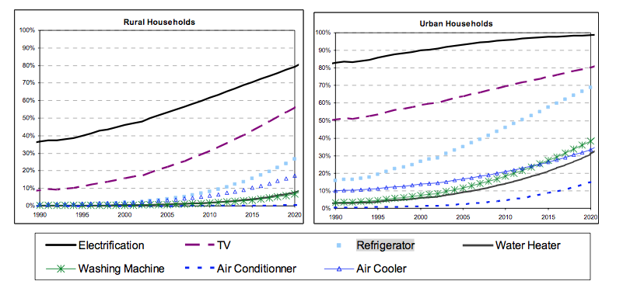
Figure 1: Increase of refrigeration household ownership in rural areas (Rue de Can, 2009)

Table 6 indicates the potential market size for SolarChill B units in the 3 countries. Total stock of Solar Chill units could potentially increase to 1 Mio. units (2020) up to 8 million units by 2050.

Table 6: Projected potential Solar Chill market size (stock of units) in the target countries
Type B: Vaccine coolers off-grid |  | 2020 | 2030 | 2040 | 2050
Offgrid households with fridges |  | 15% | 20% | 25% | 30%
Columbia |  | 108.032 | 200.268 | 283.500 | 401.760
Kenya |  | 1.855.003 | 3.852.382 | 5.766.815 | 9.254.103
Swaziland |  | 39.490 | 71.078 | 89.688 | 123.357
SC Type B market potential |  | 50% | 70% | 80% | 85%
Columbia |  | 54.016 | 140.188 | 226.800 | 341.496
Kenya |  | 927.501 | 2.696.668 | 4.613.452 | 7.865.987
Swaziland |  | 19.745 | 49.755 | 71.751 | 104.854

A.4.4 Technology transfer, unit cost reduction potential, affordability and economic competitiveness

The competitiveness of the Solar Chill units depends mainly on of the absolute price of SolarChill units and their price difference compared to fossil fuel powered refrigerators.

On the price competitiveness of Solar Chill units, both the price competitiveness of SolarChill versus the fossil fuel powered is relevant and the affordability of refrigerators for households in off-grid regions. It is expected that the project can fully prove that solar refrigerators can compete with fossil fuel powered refrigerators in both performance and price. The project test activities as suggested under Component 1 for Solar Chill A and Component 2 for Solar Chill B serve this purpose.

Figure 2 illustrates the comparative costs analysis of conventional versus Solar Chill refrigerators over their useful life (life time assumption of 10 years).

Conventional fossil fuel refrigerators (dark red line) have the lowest upfront costs with 1,500 USD but high operating costs of 250 USD per annum.

Solar refrigerators with battery (for energy storage) have still higher upfront costs with 2,000 USD, lower operating costs during initial years but need a replacement battery (assumed aftery year 5).

Solar Chill A units currently still have high upfront costs (most competitive product are assumed to have upfront costs now at around 2300 USD). Solar Chill units have the lowest running costs (only some maintenance work like cleaning of the condenser) will be required. Energy is stored through ice storage without battery reaching the same autonomy as battery solar refrigerators.

It is assumed (as outlined in Table 7) that during the duration of the project, the upfront costs of Solar Chill A units can further be decreased below 2,000 USD (light green line)

Perspectively, Solar Chill A units, can be expected to be sold below 1,000 USD (dashed light green line) and will be the most competitive products for off-grid refrigeration (both upfront and operating costs).

Solar Chill A units are mainly purchased through health care facilities (national and international) through public tendering process. While cost competitivess and affordability plays an important role for Solar Chill A, particularly, for a wider market penetration, technical performance aspects are still more important for the market introduction than supporting financing schemes.

As Solar Chill B units are much simpler than Solar Chill A units (no freezing department required, less stricter requirements on temperature control), it can be expected that Solar Chill B type with one compressor and without freezing function can be already developed, marketed and sold during the project duration at below 1,000 USD. The graph assumes here the same line as for “A potential” (dashed light green).

The Solar Chill B units are in direct competition with fossil fuel units for the domestic and small commercial market (like kiosk owners selling beverages). The upfront costs and the affordability play a major role for the wider market penetration. Here supporting financing schemes as outlined above can play a crucial role.

Accordingly, Solar Chill units are breaking even with conventional refrigerators between year 2 and 5. Solar Chill refrigerators have the lowest total costs of ownership over their lifetime (assumed to be 10 years). Solar Chill units operate entirely without batteries. Compared with solar refrigerators with batteries it is not required to replace the battery during the operational life time of the refrigerator. Compared to fossil fuel powered refrigerators it is not required to continuously buy the fuel to operate the units.

Figure 2: Comparative cumulative costs of conventional and Solar Chill refrigerators over lifetime

Table 7 analysis the costs components of Solar Chill refrigerators and their cost reduction potential.

Over time the upfront costs of Solar Chill units will decrease faster than refrigerators operated on fossil fuel or solar refrigerators operated with batteries (due to lowering costs for solar panels and no requirements for batteries and design enhancements and strong cost reduction potential of components for Solar Chill units).

Costs decreasing factors are mainly

- more efficient design and economies of scale through increased production;
- and newly deployed components will become mainstream with significant price reductions, especially with regard to bulk sourcing of
  - DC compressors
  - Vacuum Panel
  - PV Solar Panel (with generally decreasing price trend)

Solar refrigerators are benefitting from the global decrease in solar module price. Between 2008 and 2011, the average cost of solar modules, measured in price per Watt peak, decreased from approximately $5.50 (USD) per Watt to $2.30 (USD) per Watt,5 and have reduced further to currently less than $1.00 (USD) per Watt since then. It can be expected that the trend for decline costs for solar modules will continue and further benefit the cost economics for solar refrigerators.

Additional cost reduction is anticipated by increasing local manufacturing capacity of SolarChill units. Through this project, the consortium will inform manufacturers of the potential market for this product to stimulate local production and raise awareness with consumers of the benefits of this technology for off-grid uses.

The long-term aim of this project is to bring down costs of the technology, increase local manufacturing capacities, and stimulate consumer demand so the product can compete on price and performance with fossil fuel-driven refrigerators, even on the short-term horizon.

Table 7: Project cost reduction potential of Solar Chill A units
 | First batch  costs | Target price  within  project  period | Target price  after 5 to 10 years
Cabinet | 304 | 199 | 105
Insulation | 304 | 228 | 91
Refrigeration unit | 932 | 700 | 257
CE testing, manual etc. | 142 | 74 | 24
Solar Panel equipment | 270 | 216 | 130
Others | 230 | 124 | 98
Total hardware | 1,951 | 1,541 | 704
Sales Price | 2,341 | 1,850 | 845

A.4.5 Marketing and outreach activities in project countries and globally
The GEF SolarChill project will play an important role to support the promotion of SolarChill units (both A and B) in the market:
- Support partnering manufacturers in Swaziland and Columbia with their outreach campaigns (workshops at off- grid events and standard marketing material).
- Provide brokerage and connect manufacturers with supporting micro-financing facilities and provide brok (for small business owners of refrigeration kiosks). It is planned to engage with at least one micro-financing organization a pilot scheme for the distribution of Solar Chill B units. Micro-financing mainly functions catalyze the affordability of Solar Chill units with relatively higher upfront costs and lower running costs.
- Capacity building with government ministries and initiatives for rural development.
- Establish connections with NGOs (medical organizations for the promotion of SolarChill A units).
- Present the technology at off-grid events (with a focus on Kenya and Swaziland).

International outreach activities include opportunistic national and international meetings and conferences, direct outreach to potential manufacturers and purchasers, and internet-based marketing

The focus will be two-fold:

- Wake the interest of producers (especially in strategically important countries) and provide them with the necessary information (in the form of contacts, reference models, etc.) to step into the SolarChill technology with a particular focus to engage in the target countries (the outreach activities will also include initiating conduct to co-financing sources such as venture capital to provide additional funding for such activities;
- Promote the SolarChill technology and models among potential buyers, including:
  - Health ministries and likewise for SolarChill A (vaccine cooler).
  - NGOs and other entities working on rural (and off-grid) business creation for SolarChill B(commercial fridge).

For waking the interest of producers, fairs and conferences such as the ACREX, which occurs in the spring of every year in India, are suitable platforms. As for the activities, steps for providing information on the technology have been suggested by DTI in their proposal.

Ministries can either be contacted directly or via suitable platforms. NGOs and other global stakeholders can also be contacted via the network of the project participants or through suitable sector meetings, conferences, etc.

For any of these activities, it will be important to involve the suppliers of the units at some stage in order to make the discussion concrete and to focus on cost and performance; otherwise, there is a large chance that the technology as such will be given high credit by everyone and when it comes to decision making, the usual kerosene units may be given preference due to perceived reliability and costs.

A.5. Incremental /additional cost reasoning: Describe the incremental (GEF Trust Fund/NPIF) or additional (LDCF/SCCF) activities requested for GEF/LDCF/SCCF/NPIF financing and the associated global environmental benefits (GEF Trust Fund) or associated adaptation benefits (LDCF/SCCF) to be delivered by the project.

A.5.1 Incremental proposed project activities and removal of barriers

The objective of the submission is to transfer and commercialize the SolarChill vaccine refrigerator (SolarChill A) and to begin the process of transferring and commercializing the SolarChill household and light commercial refrigerator (SolarChill B).

By demonstrating SolarChill products in off-grid or unreliable grid regions in Colombia, Kenya, and Swaziland, the project seeks to enhance the cold chain for the preservation of vaccines and food with environmentally friendly, solar, and lead-free battery storage in vaccine coolers and food refrigerators.
The project aims to accomplish: (a) the demonstration of the SolarChill vaccine refrigerator technology in Colombia, Swaziland, and Kenya; (b) collection and interpretation of relevant, reference-able technical data to demonstrate reliable and viable technical and commerical performance and to show that user acceptability is achieved; (c) completion of the development and field testing of the SolarChill food refrigerator; (d) dissemination of information about the technology on a country and regional level to industry leaders and policy makers; (e) web-based information sharing (through SolarChill website redesign); and (f) support to individual manufacturers (particularly in the targeting countires) in their efforts to market Solar Chill units and decrease the cost of the units through technical support on design, R&D and production know how. (g) supporting participating manufacturers in Swaziland and Columbia to fully deploy and enhance the technology and lower the costs over time to allow a sustainable production of Solar Chill A and Solar Chill B refrigerators (f) brokerage activities to increase the market penetration potential of particularly Solar Chill B units though connecting Solar Chill manufacturers with supporting financing intermediaries, particular micro-financing organizations . The manufacturers will be supported deploying both Solar Chill A and B technologies. In particular, the project will support to transfer the technology know how gained with Solar Chill A refrigerators to Solar Chill B refrigerators with a potentially much larger market and deployment scope.

SolarChill is a breakthrough technology that provides solar-powered refrigeration and by-passes the need for lead acid-based storage batteries. The required stable operating conditions and long term autonomy (for cloudy days) will be reached through using innovative and state of the art technologies, such as:
- highly efficient insulation technologies (such as vacuum panels)
- low energy consuming refrigeration technologies (such a micro-channel evaporators)
- highly efficient direct current compressors
- effective ice storage solutions for storing excess energy supplied during highly sunny condition and with the use of the stored energy at night times or longer cloudy conditions.

The Solar Chill refrigerators use hydrocarbons instead of fluorocarbons for insulation and in the refrigerant cycle. They are therefore both ozone- and climate-friendly. The deployed technologies therefore show innovative ways for the use zero or close to zero emission technologies in the refrigeration and air conditioning sectors which otherwise have a high and fast growing carbon emission footprint (some 10% of global GHG emissions). The project thereby supports both the aims of the Montreal Protocol to use non-ozone depleting refrigerants and foam blowing agents and the
United Nations Framework Convention on Climate Change (UNFCCC) which seeks to lower GHG from the use of HFCs in refrigerants and foam blowing agents and energy to power the appliances.
The GEF support in this project is needed in order to
- introduce state of the art, reliable solar direct drive technologies in all three target markets (seek the deployment of several brands in each of the markets for the wider technology diversity)
- fully test Solar Chill A and B units in all three target countries to demonstrate the reliable and cost effective operation of the units under different climatic and operational conditions
- fully establish the technology with local manufacturers in the target countries
- allow the sustained and continuous development of the technology, through the support of local manufacturers to allow technology enhancements with the scale up of production, to lower product costs over time through improved R&D, design and sourcing of components, and to reach full commercial competitiveness of solar direct drive refrigerators
- allow the technology transfer from the Solar Chill A refrigerators to Solar Chill B refrigerators with participating manufacturers in Swaziland and Columbia
- support the increased market penetration of solar refrigerators in the target countries through supported marketing and financial brokering efforts
- demonstrate a successful, reliable and costs effective use of the technology in the target countries with reference-able test results

All above objectives and activities are additional and will not be possible without the support of the GEF project.

The GEF project will further accelerate the uptake of solar direct drive technology by removing or significantly contributing to lower existing barriers for the use of Solar Chill units (as outlined in Table 8) below:

Table 8: Barrier analysis for Solar Chill units
Barrier |  | Project activity to mitigate barrier
Market Information | Lack on transparent and reliable testing data on Solar Chill units | - Comprehensive and standardized test across several brands, countries and climate zones both for Solar Chill A and B proof that units can operate reliable and costs effective;
Market Information | Insufficient information on market data | - Provide manufacturers with transparent information on market data and sales channels (Solar Chill A: Health care facilities, sourcing information to international and local medical organizations; Solar Chill B: sales channels to domestic owners and small business owners)
Market Information | Product quality | - Introduce standardized type testing and labelling for Solar Chill B to allow for reliable quality standard in the market (already existing through WHO for Solar Chill A)  - Feedback results from field test to Solar Chill manufacturers
Product costs | Relatively higher upfront product costs | - Support manufactures to lower costs through  - Disseminating sourcing information (access to wider range of components)  - Transparency on available information on design, R&D, components and component costs to lower product costs (introduce producer coordination)
Financing/ Affordability | Relative higher upfront costs of Solar Chill units but lower running costs | - Connect manufacturers with financing organizations (micro-financing) to bridge between higher upfront and lower running costs
Product diversification | Few qualified products in target countries | - Introduce different brands per country  - Encourange manufactures to market in different countries  - Transfer technology (for Solar Chill A and B) to manufacturers in Colombia
Servicing | Insufficient servicing capabilities (both for installations and maintenance) | - Provide training to local service personal for qualified installation and maintenance (training on solar equipment, dealing with hydrocarbon refrigerants etc.)  - Ensure sufficient initial product warranties (2 years) through qualified manufacturers and link manufacturers to service networks
Outreach activities | - Insufficient information available on Solar Chill A product features (and field test results) to local and international sourcing organizations for Solar Chill A | - Marketing campaign with  - health care sourcing organizations which are in particular active in the target countries  - sales channels for domestic and small business refrigerators (whole sellers etc.)

With this a break through of the technology will be sought, so that it can spread rapidly within the target countries and other developing-country markets. Support from GEF will not only provide sufficient support and demonstration of the technology to be able to optimize SolarChill products for developing countries, but it will also foster product adoption and potentially stimulate additional country, donor, and manufacturer interest in the technology through local procurement and/or manufacturing. Without the GEF support, this technology would proceed at a very slow pace and the much needed demonstration of solar direct drive as viable technology option for both health (Solar Chill A), and solar direct drive refrigerators as the first choice for domestic and commercial application cannot be established. Major barriers as outlined in Table 8 will continue to existing and will not be addressed in systematic mannter. GEF funding will support to optimize the products with the results available from field tests to ensure optimal product performance and prove that the units can be used in a reliable and costs effective in the targeted markets (off-grid health areas, off-grid domestic purposes, off-grid commercial purposes). With the wider deployment of the technology significant environmental and climate benefits can be obtained.

A.5.2 Proposed project outcomes and outputs

The GEF project aims to have the the following specific outcomes and outputs.

Outcome 1: Procure and install 200 SolarChill A units and 45 SolarChill B units in the three target countries (with a balanced distribution among the three countries).
Output 1.1: Demonstration experience and cross-comparison of currently available SolarChill products (especially Solar Chill A units) under field conditions in representative health centers to ensure that safe vaccine storage conditions are met.
One of the project goals is to provide meaningful field test experience to position and advance this SolarChill technology in developing-country markets. Performance and user information obtained through field tests will be incorporated into a broad marketing, advocacy, and communication plans for SolarChill. So far a larger field test across several countries and deploying various leading solar direct drive brands has not taken place. This standardized field testing is much needed to have primary data to identify the weaknesses for improvement, and demonstrate the reliability and feasibility of the technology, as appropriate.
Output 1.2: Support participating manufacturers in the target countries in their efforts to market Solar Chill units and support their efforts to increase the costs competitiveness of the units
Participating manufacturers in Swaziland and Columbia, as well as other qualifying brands will be supported to improve the business case to sell solar fridges. This will include support through Solar Chill with market data and marketing support. Further the project aims to share information and support manufacturers to enhance their R&D and design features to lower costs. Similar, manufacturers will be supported to lower the sourcing costs of critical components (direct current compressors are currently two to three times more expensive than alternating current compressors, where as material costs for the direct current compressors are not different or lower). Manufacturers will also be supported through international expert advice to increase their ability to produce components locally, such as evaporators, and thereby further lower costs.

Outcome 2: Development by more than one manufacturer of SolarChill B and firsthand experience with SolarChill B in practical applications.
Output 2.1: Testing results of SolarChill B under field conditions in a variety of small institutional and light commercial applications.
Obtain performance and user feedback on the SolarChill B installed units to demonstrate the reliability and ease of use of this new category of refrigerators. Use the feedback from the field test to feed back to the participating Solar Chill B manufacturer to furher improve the technology and marketability of the units.

Output 2.2: Brokerage activity to connect financing organizations (micro-financing and venture capitalists) for increased market penetration. Link micro-financing organization with manufacturers and whole-sellers accelerate market penetration. Affordability will increase through micro-financing supported rental schemes to bridge relatively higher upfront and lower operational costs of Solar Chill B units. Linkage with VC type financing organization to bridge fund manufacturers (from target countries, other developing countries) to produce and market Solar Chill B primarily in the target markets.

Outcome 3: Information regarding SolarChill more widely available and increased industry interest in SolarChill A and B production in Latin America and Africa.
Output 3.1: Marketing campaign, business plan, increased awareness and interest in SolarChill, and updated SolarChill website.

The publishing and sharing plan will include: (a) a thorough revision and technical update of the SolarChill website; (b) the development of a business plan and technology transfer package, including critical technical issues that a manufacturer would face for manufacturing and servicing the units as well as for marketing the units especially in the target countries; (c) holding country-based technology trainings and/or technology sharing information workshops; (d) direct information outreach to country and regional manufacturers (mostly in Columbia) and direct engagement with interested parties; and (e) opportunistic exhibition of the technology at international events.

Output 3.2: In cooperation with and contingent upon MLF and bilateral country program HCFC and HFC phase out activities, and contingent on manufacturers capacity to produce fluorocarbon-free refrigerators, facilitation of partnerships and licensing agreements, including assessment of potential partner companies by an unbiased engineer and business specialist.
Recognizing the large upfront costs associated with this conversion, the SolarChill consortium aims to work with the MLF, governments, and manufacturers undergoing HCFC and HFC conversion to stimulate production of SolarChill units. This will start with sharing the SolarChill business case with governments and manufacturers. The GEF SolarChill project will build the case for companies to invest in SolarChill, sensitize country policy- makers of SolarChill opportunities, and support companies with their business and technical plans to produce SolarChill.
Output 3.3: Preparation of a technology transfer packet.
For the most part, SolarChill is an open-sourced technology. The current PIF is premised on the fact that refrigeration equipment manufacturers will first have to convert their fluorocarbon-based production facilities to work with hydrocarbons, that is to substitute HCFC or HFC refrigerants with hydrocarbons and substitute HCFCs with hydrocarbons in the insulation foam blowing. The project assumes that it only makes sense for a manufacture to produce SolarChill after this initial conversion to hydrocarbons. Advocacy surrounding SolarChill A has been driven by the SolarChill partners. GIZ has been instrumental in advancing the development of The Fridge Factory’s SolarChill A refrigerator. In addition, WHO and PATH have challenged industry to build and prequalify solar direct drive vaccine refrigerators over the last five years. As a result, several vaccine refrigerators are on the market, but adoption of these units by countries is slow and development of SolarChill B refrigerators has not materialized. The project aims to foster the technology transfer through providing technical support (technology transfer package):
- Technical know how on handling hydro-carbons in Solar Chill units (GIZ Handbook; Safe Handling of Hydrocarbons and providing access to technology experts) Guidance how to use hydro-carbons in Solar Fridge units safely (both for production and servicing)
- Access to R&D, design and production experiences from GIZ project with TFF (Solar Chill technology know how potentially available through GIZ) to manufacturers in Colombia Guidance for design, sourcing and production of solar chill units

The project deliverables include the following:
- To determine technical performance, user compliance, and potential market demand for SolarChill technology through field tests of the SolarChill vaccine refrigerators (SolarChill A) and pilot introduction of the SolarChill household and light commercial refrigerators (SolarChill B) in three developing countries.
- To support the modification and optimization of the SolarChill technology developed in Swaziland.
- To interest potential manufacturers globally, and more specifically in Africa and Latin America, in the SolarChill technology through: (a) a market analysis of the commercial potential of the technology; (b) preparation of a technology transfer package; and (c) outreach to local refrigerator manufacturers to communicate the benefits of adopting the SolarChill technology.
- To support governments in countries with refrigeration production capacity to develop and implement their HCFC Phase-out Management Plan (HPMP), by promoting the uptake of SolarChill production as an additional benefit of converting from fluorocarbons to hydrocarbons.

A.5.3 Incremental cost justification
SolarChill is an emerging technology, with a significant potential to reduce product costs, reach cost competitiveness with off-grid kerosene units and to prove accepted commercial viability especially in off-grid areas. The purpose of the project is to raise awareness among manufacturers of the potential market for this product, and stimulate production and raise awareness with consumers of the benefits of this technology for off-grid uses and as production prices drop, with on-grid costs as well. The long-term aim is to remove barriers to uptake of this technology by bring down costs and improve performance and consumer experience with the technology so it can compete on price and performance even with on-grid powered refrigerators.

The baseline and the incremental activities suggested through the project are shown in Table 9 for the three project components.

Component 1 aims to put units into the field and test and monitor 200 small solar refrigerators for vaccines.
Component 2 will put units into the field and test and monitor 45 larger refrigerators for food and other domestic and commercial users.

Component 3 aims at accelerating the technology transfer. Field testing data from both types of refrigerators on performance and user experience will be collected analyzed and technical recommendations will be made on how to improve system performance with manufactures. Information material will be generated and the SolarChill consortium will actively engange in linking the stakeholders to promote consumer uptake of the technology and expansion of production capabilities by manufacturers.

The baseline product is an off-grid fossil fuel powered refrigerator. Upfront costs of off-grid fossil fuel powered refrigerators are currently in most cases lower than solar powered refrigerators with comparable cooling and autonomy capabilities. However, fossil fuel powered refrigerators require high operating expenses for the continuous fuelling of the units. Fuelling costs will not occur for direct solar powered refrigerators. The proposed GEF projects, among others, aims to fully demonstrate (a) the lower life cycle costs of solar direct driven refrigerators (b) the reliable operation (c) the potential to further decrease upfront costs and to reach full commercial competitiveness with fossil fuel powered refrigerators also for upfront costs.

The reliable operation, is very critical for the safe handling of vaccines. As human health is a sensitive area, a thorough and transparent field testing under various climatic conditions is required. This has never undertaken to this point. With the targeted field testing the project aims to provide a field test which can be widely be referenced and used to reach the acceptance of international organization, countries and health organizations to adopt the Solar Chill A technology. The demonstration effect refers to both, the reliability of operations and the costs effectiveness.

Table 9: Baseline and incremental activities (including costs and co-funding)

A.5.4 Global environmental benefits

A.5.4.1 Direct GHG project benefits

The main GHG benefits of the project will be to establish the conditions under which Solar Chill A and B units can be deployed on a much wider scale. For these the project components Component 1 and Component 2 are critical which include the deployment, the standardized field testing and evaluation for both Solar Chill A and B in the three different countries, including the critical feedback of test results to manufacturers and the market. Component 3 promotes the dissemination of the technology through an accelerated technology transfer.
If only the GHG benefits of the deployed and tested 245 Solar Chill A and Solar Chill B units co-funded by the project will be considered, the climate impact will be 1,930 tons of CO2. This is calculated on the basis of an estimated lifetime of ten years and emission fuel savings of 8t of CO2 for one Solar Chill unit against the utilization of kerosene vaccine refrigerators. The direct GHG benefits are not representative for the wider induced indirect GHG benefits targeted through the project. Both direct and indirect GHG benefits of Solar Chill will not be realized without the proposed project activities.

A.5.4.2 Indirect GHG project benefits and marginal abatement costs

Based on the analysis in Annex O it can be estimated that in developing countries GHG emissions can be reduced by over 3 mt CO2 p.a. (2030) and over 9 mt CO2 p.a. (2050) through the substitution and use of Solar Units instead of fossile fuel powered units. This analysis is based on the use of Solar Chill units in off-grid areas only.

Additional benefits (not calculated) can be achieve when
- the use of Solar Chill units in grid areas is considered (the deployment of Solar Chill units can make sense here to bridge unstable grid conditions or to utilize day/ night differences of tariffs; Due to their nearly cost free energy storage capabilities Solar Chill units operate very efficient under these conditions). The calculation here is high dynamical (depending on assumptions of global grid conditions in relation to the costs of Solar Chill units) and due the inherent complexities not further analyzed here.
- the reduced deployment of high GWP refrigerants and foam blowing agents is accounted. Such high GWP F-Gases are are deployed under the baseline assumptions of conventional refrigerators but are not allowed in Solar Chill units. The additional benefits can be estimated in the range of additional 5-10% of above estimated indirect GHG benefits.

The above estimates on indirect GHG benefits are referring to the deployment of Solar Chill units in developing countries (see further Analysis O). Related to the share of estimated Solar Chill units in the three target countries Swaziland, Kenya and Columbia of estimated future Solar Chill units to the deployment of Solar Chill units in all developing countries the relative share of indirect GHG benefits to be realized in the target countries compared to the total in developing countries is about 15-20%.

The materialization of the estimated indirect GHG benefits is related to (among others)

  - Successful field testing of Solar Chill A and B units and information dissemination of results
  - Successful transfer of Solar Chill A technologies ot Solar Chill B
  - Realisation of the cost reduction potential for Solar Chill units
  - Increased production and marketing activities by Solar Chill manufactures
  - Increased product diversification in market
  - Positive consumer experience with Solar Chill units

Marginal Abatement Costs

The marginal abatement costs of Solar Chills units are projected to decrease from 105 USD / t CO2 currently to – 7 USD / t CO2 by 2030 compared to conventional fossil fuel powered refrigerators when only looking at upfront costs.

If the lower operational costs of Solar Chill units are considered, marginal abatement costs are already currently lower and negative for Solar Chill abatement costs (conservatively, it is not assumed here that fossil fuels might further increase in the future). Solar Chill units are not reaching a higher market penetration because of the existing obstructive market barriers which are critically addressed through the project. O

Table 10: Marignal abatement costs calculation for Solar Chill (exemplatory for Solar Chill A)
 |  | Now | 2017 | 2030
in USD
Fossil fuel unit
 | Upfront | 1.500 | 1.200 | 900
 | Lifetime operation expenses | 2.500 | 2.500 | 2.500
 | Total | 4.000 | 3.700 | 3.400
Solar Chill A
 | Unit costs | 2.341 | 1.850 | 845
 | Operating Costs | 100 | 100 | 100
 | Total | 2.441 | 1.950 | 945
Incremental upfront costs |  | 841 | 650 | -55
Inremental total costs |  | -1559 | -1750 | -2455
Lifetime CO2t reduced |  | 8 | 8 | 8

MACC (USD/ t CO2 reduced)
 |  | 105 | 81 | -7
 |  | -195 | -219 | -307

The basis of the marginal abatement costs calculation are:
- GHG emission reduction against the baseline kerosene refrigerator of 8 t CO2 per unit on an assumed lifetime of 10 years (see Annex O below)
- Investment costs differences between SC-A and a comparable fossil fuel powered unit are expected to come down from more than 900 USD to about 350 USD with the project term, whereas difference in lifetime costs would come down to below zero as fuel costs for the fossil fuel powered unit during 10 years sum up to about $ 2,500. Only comparing up-front marginal abatement costs
Marginal abatement costs for SC-B units will be significantly lower as the units will have much lower costs compared to Solar Chill A units (the technology is much simpler as temperature tolerances are higher; freezing compartment is not mandatory).

There are additional significant environmental benefits from the use of Solar Chill refrigerators not included in the calculation:

- Avoidance of emissions from ozone-depleting and high GWP F-gases such as HCFCs and HFC as as foam blowing agents for the insulation or refrigerants; F-gases are highly toxic; None of the three target countries, like the majority of developing country, do not have proper facilities for the collection and destruction of F-gases from appliances at the of the life of the appliances.
- Avoidance of GHG emissions from the transport and burning of fossil fuels now used to operate off-grid vaccine coolers and refrigerators.

A.6. Risks, including climate change, potential social and environmental risks that might prevent the project objectives from being achieved, and measures that address these risks.

Whilst this technology represents an opportunity in the form of mid- to long-term energy and cost savings for users (as well as governments who would see an overall long term reduction in energy demands, purchase of foreign oil, and lowering of foreign exchange reserves), a major risk could be that the market and potential technology adopters will not have the capital with which to support a switch from conventional fuel-driven technology and initial investment in the new technology, resulting in slow uptake of adoption and manufacture of product.
A significant challenge to the uptake of the SolarChill technology is the requirement to convert existing factories that currently use HCFCs and HFCs to hydrocarbons. Hydrocarbons are flammable and require specific safety procedures and equipment. However, their flammability is not an impediment. There are nearly 750 million hydrocarbon domestic refrigerators in the world today. Approximately 40% of annual global refrigerator production uses hydrocarbons and it is estimated that by 2020 75% of global refrigerator production will be using hydrocarbons.
However, the conversion of existing production facilities from fluorocarbons to hydrocarbons requires capital investment. The SolarChill project complements the HCFCs phase out schedule of the Montreal Protocol. SolarChill offers an additional product line opportunity to existing factories as they transition out of fluorocarbons to hydrocarbons.
In the course of the project, the Multilateral Fund of the Montreal Protocol and the National Ozone Units in Kenya, Colombia, and Swaziland will be contacted to explore opportunities arising from the implementation of the HCFC Phase Out and Management Planning (HPMP) program in each of these countries.

Table 11: Risk matrix

Risk factors | Description of risk | Ratinga  of risk | Mitigation measures
Technology | Several SolarChill models have received WHO prequalification in 2012 and therefore long-term performance is unknown. | Low | Given the rigor of WHO PQS specifications and testing protocol, there is low risk that SolarChill refrigerators will not perform in the field operation to the WHO testing criteria if appropriately matched to the climate zone, temperature, and radiation conditions of the installation site. Training and oversight will be provided in all countries on proper site qualification, PV panel sizing, and installation inspection. Long-term temperature monitoring will be undertaken on all units to ensure optimal performance of each installed refrigerator, and rigorous metrics will be tracked and reported back to countries and manufacturers. The field testing, will be very important to further mitigate the operational performance risk of Solar Chill units. The Solar Chill consortium will use the results of the field test to allow manufacturer to further improve and optimize their units and lower the operational performance risks.  GIZ will support TFF in an iterative process to obtain the WHO certification and qualification for the development of the Solar Chill A unit at DTI. Pre-testing of the units at independent test laboratories have shown encouraging results.
Insufficient market demand | Given the somewhat nascent stage of the solar direct drive technology, the market may be hesitant to adopt a more expensive refrigeration system for fear of product failure. | Moderate | The GEF SolarChill project will work to convey the technical, environmental, and cost-benefits of the SolarChill technology over all other refrigerator types via outreach and marketing communization.
Perception of technical hazard and lack of experience with HC refrigerants | Hydrocarbons are flammable and require specific safety procedures and equipment. | Low | The project involves training of technicians and health workers. An aspect of the training will explain that there are nearly 500 million hydrocarbon domestic refrigerators in the world today and it is estimated that by 2020, 75% of global refrigerator production will be using hydrocarbons. The small amount of refrigerant does not pose risk to users or maintenance personnel.

GEF5 CEO Endorsement Template-February 2013.doc
A.7. Coordination with other relevant GEF financed initiatives.

UNEP (DTIE) has been working with the SolarChill initiative since its inception and thus has a full understanding of the technology as well as its potential social, health, and environmental benefits. UNEP is working with the governments of Swaziland and Colombia to develop and implement their HCFC Phase Out Management Plans, which means companies have to phase out the use of HCFCs in all their production processes and is an important foundation for SolarChill production.

UNEP is working in Swaziland to assist with the implementation of a staged approach strategy of HCFC Phase Out Management Plan (HPMP). The first stage of the HPMP is aimed at phasing out the consumption of HCFCs in the country, as required by the Montreal Protocol by focusing on the establishment of safe hydrocarbon and natural refrigerant use practices to enable their safe general long-term use; conversion of The Fridge Factory, activities to curb the increase in HCFC-based refrigerant blends, and an incentive program to retrofit HCFC-based equipment to environmentally friendly alternatives. The goal is to ensure reduction of HCFC consumption by 35 percent by January 1, 2020. Stage two will aim at implementing activities to phase out remaining HCFC consumption based on the use of natural refrigerants. Stage two will allow for the total phase out of HCFCs in Swaziland by January 1, 2030, save for the service tail of 2.5 percent.

Kenya has also implemented an HPMP strategy. The National Ozone Unit of Kenya has introduced ODS regulations through the enforcement of licensing and quota system. In addition, the NOU began an awareness program, trained customs officers and refrigeration technicians, and implemented a methyl-bromide phase out project as well as terminal phase out management plans for CFCs.

ADDITIONAL INFORMATION NOT ADDRESSED AT PIF STAGE:

  - Describe how the stakeholders will be engaged in project implementation.
The SolarChill initiative was formed in 2000 by a consortium of organizations, including Greenpeace International, PATH, UNICEF, UNEP WHO, GIZ Proklima, and DTI.

Government stakeholders: In each country, the consortium members will liaise with the MOH, MOE, and MOI to align project objectives with those of the countries. For the SolarChill vaccine refrigerator, implementation sites will be determined by the MOH and staff or subcontractors will be trained on site validation, equipment installation, and repair. Government stakeholders will also assist in the monitoring of all refrigerators that are installed. Through this project, data will be collected from both types of refrigerators not only on performance but also on user experience.

Manufacturers: In addition, governments will assist in developing relationships with potential SolarChill refrigerator manufacturers and distributors. Stakeholders will assist in disseminating awareness materials developed to educate on the benefits of SolarChill and promote consumer uptake of the technology and expansion of production capabilities by manufacturers.

In Kenya, however, since there are no refrigerator manufacturers, we will reach out to potential local distribution partners to understand their interest in overseeing the sales of SolarChill locally and in the surrounding countries. In Colombia, several manufactures have been identified which have converted to HFC-free plants. We will engage with these manufacturers to share the lessons learned and promote solarchill production and distribution with them. We will work in Swaziland with The Fridge Factory to expand their marketing and distribution capabilities to sell solarchill products.

  - Describe the socioeconomic benefits to be delivered by the Project at the national and local levels, including consideration of gender dimensions, and how these will support the achievement of global environment benefits (GEF Trust Fund/NPIF) or adaptation benefits (LDCF/SCCF).

Health and social benefits of SolarChill include improved vaccine storage and reduced food spoilage, and offers obvious and substantial economic and health benefits to a community. Vaccines are a major focus of many donor programs to support development and improvements in the health of rural communities. SolarChill technology will be able to store vaccines while relieving the need to worry about fuel supply. This will be a considerable benefit in the promotion of rural community health. SolarChill technology also presents new commercial opportunities such as refrigeration in small commercial enterprises, agricultural vaccination, dairy farming, and fisheries.

SolarChill technology presents new commercial opportunities such as refrigeration in small commercial enterprises (grocery stores), agricultural vaccination, dairy farming, and fisheries. SolarChill technology eliminates the need for lead batteries, which are the major source of lead contamination in the environment and pose significant human and ecological hazards in both the industrialized and developing world. Tens of millions of lead batteries are disposed of in developing countries each year. Often these batteries end up in landfills or are haphazardly dismantled. Each battery contains approximately 27 pounds or 12.2 kilograms of lead (75% of global lead production goes into batteries). Lead poisoning can lead to central nervous system damage, deleterious impacts on central nervous system, kidneys, and blood diseases.

Gender and poverty benefits: The poor are often beset with health problems, since they often do not have access to clean water or solid waste management, making hygiene difficult. Vaccine programmes help make children and old people better able to withstand disease under poor hygene conditions. Women are typically the carers under these conditions, and sick family members take up considerable time women could be using for other tasks. By promoting solar power vaccine coolers this project helps government provide reliable health care in remote areas at lower cost, and so benefiting women and the poor.

B.3. Explain how cost-effectiveness is reflected in the project design.

The project will collect baseline data on current annual operating costs for fossil fuel powered refrigerators in the country. These costs include the price and transport logistics related to fuel, maintenance, and repair costs, and will be compared with the cost data collected following introduction of SolarChill refrigerators in each country. In addition, estimated carbon emission reductions will be quantified.

Emission reductions associated with outcomes induced by this project
(See annex on emissions projections at the end of the document for further details on assumptions and calculations.)

Emission reductions are estimated under A.4.5.2 and the methodology further outlined in Annex O.

DESCRIBE THE BUDGETED METRICS AND EVALUATION (M&E) PLAN:

The project will follow United Nations Environment Programme (UNEP) and Global Environment Facility (GEF) requirements for project monitoring, reporting, and evaluation processes and procedures. Substantive and financial project reporting requirements are an integral part of the UNEP legal instrument that will be signed by the executing agency and UNEP, as the Implementing Agency. The Monitoring and Evaluation (M&E) process will include an end of project assessment undertaken by independent review teams. The final reports will be submitted to the GEF M&E unit as well as other stakeholders involved in the implementation of this project. A report on the status of implementation of the project will be submitted to the regular meetings of the project steering committee (PSC). The project will be evaluated on the basis of execution performance, output delivery, and project impact. Evaluation of the project’s success in achieving its outcomes will be monitored continuously throughout the project through the bi-annual progress reports, annual summary progress reports, and the final evaluation. Details of M&E activities are provided in the table below.

Type of M&E activity | Responsible parties | Time frame | Budget (US$)
Project implementation review | Project manager, UNEP FMO | Yearly | Included in project  management
End of project evaluation | UNEP | End of project | Included in country  monitoring
Yearly monitoring reports  including on estimated global environmental benefits | Project manager | Yearly | Included in country  monitoring

PART III: APPROVAL/ENDORSEMENT BY GEF OPERATIONAL FOCAL POINT(S) AND GEF AGENCY(IES)

A. RECORD OF ENDORSEMENT OF GEF OPERATIONAL FOCAL POINT(S) ON BEHALF OF THE GOVERNMENT(S): ):
(Please attach the Operational Focal Point endorsement letter(s) with this form. For SGP, use this OFP endorsement
letter).

Name | Position | Ministry | Date
Mr. J. D. Vilkati | Chief Executive Director of  SEA and GEF National Focal Point | Swaziland Environmental  Authority (SEA) | September 2011
Carlos Castano Uribe | Vice Minister of MAVDT | Ministry of Health and  Social Protection (EPI) | September 2011
Dr. Ayub Macharia | Director General | NEMA/GEF  Operational Focal Point | August 2011

GEF AGENCY(IES) CERTIFICATION
This request has been prepared in accordance with GEF/LDCF/SCCF/NPIF policies and procedures and meets the GEF/LDCF/SCCF/NPIF criteria for CEO endorsement/approval of project.

Agency  coordinator, agency name | Signature | Date  (month, day, year) | Project  contact person | Telephone | Email address
Maryam Niamir-Fuller, Director, GEF Coordination Office, UNEP |  | 12/19/2013 | Geordie Colville, Task Manager | 254-762-3257 | geordie.colville@unep.org

ANNEX A: PROJECT RESULTS FRAMEWORK (either copy and paste here the framework from the Agency document, or provide reference to the page in the project document where the framework could be found). NOTE MID AND END TERM PROJECT TARGETS ARE SET OUT IN Annex G.

Description | Indicators | Source of verification | Assumptions
Promote, demonstrate, and deploy low-carbon technologies. | Greenhouse gas (GHG)  emissions reduction potential. | GHG emissions reduction estimates. | This project will project, not measure, GHG emissions reductions.
Reduce carbon emissions through off-grid  efficiency gains. | Addition or substitution of  SolarChill units for fuel-driven units. | SolarChill consortium. | Off-grid efficiencies gains using solar instead of fossil fuel powered.
Increased availability and use of WHO  PQS prequalified SolarChill refrigerators. | Number of WHO PQS  prequalified SolarChill A refrigerators and available brands. | WHO PQS. | Increased availability of WHO PQS SolarChill A  refrigerators will increase accessibility and introduction of SolarChill. Increasing introduction of off-grid  efficiency products will lead to reduction in carbon emissions.
Increased availability and use of  SolarChill B food refrigerators (for dometic and small scale businesses) | Number of marketed SolarChill  B refrigerators and available brands. | SolarChill consortium. | Increased availability of qualified SolarChill B  refrigerators will increase accessibility and introduction of SolarChill. Increasing introduction of off-grid efficiency products will lead to reduction in carbon emissions.
Increased awareness of benefits of  SolarChill technology from an environmental and health perspective. | Number of individuals  recognizing the benefits of SolarChill. | Number of views of  SolarChill website.  Questionnaire tracking | Recognition of benefits of SolarChill technology will  promote the use of SolarChill and reduce GHG emissions.  Annual Interviews will be carried out with all relevant stakeholders (ministries, health facilities, domestic manufacturers, distributors) with the same questionnaire. The interviews and questionnaire will be designed to appropriately monitor the progress of the project with regards to its objectives and also measuring the awareness.
Brokerage and linkage activities between manufacturers and whole sellers in the countries and financing organsitations (micro-financing) | Appropriate linking parties identified and contacts established; One partnership established; | Engagement from financing organization confirmed; | Existing financing (micro-financing) organization in at least one of the three target countries exists and shows interest to get engaged;
Deployment and testing of SolarChill units according to project components with resulting GHG emission reductions. | Number of units of SC-A and SC-B installed and being tested. | Monitoring of the local partners | Every unit installed avoids installation of a kerosene unit (GHG abatement) allows avoidance of corresponding additional fuel combustions. Therefore, every unit installed results in corresponding GHG abatement.
Accurate site selection for testing &  evaluating SolarChill A. | Site compliance to SolarChill  A requirements. | SolarChill consortium  technical experts. | Solar equipment site selection protocols have been  validated by industry experts.
SolarChill installation and monitoring  protocol and training program for local technicians. | Training protocols available. | SolarChill consortium  technical experts. | MOH will contribute to the appropriateness of the  training protocols and format for training.
Accurate site selection for testing and  evaluating SolarChill B. | Site compliance to SolarChill  B requirements. | SolarChill consortium  technical experts. | Solar equipment site selection protocols have been  validated by industry experts.
Consolidate SolarChill external  Communication. | Communication and marketing  materials available and accessible. | SolarChill consortium. | Obtaining buy-in of external communication messages  will strengthen the overall SolarChill category.
Engage in technology transfer discussions. | Number of companies engaged  in discussion about technology transfer. | SolarChill consortium,  Ministry of Industry (MOI) and Ministry of  Environment (MOE). | Given the timeframe and investment required for  conversion of a manufacturing line, it is anticipated that companies interested in technology transfer will not be able to fully adopt the technology within the scope of this project.
National institutional/sectoral and policy  compliance. | Number of national policies in  place to mitigate climate change through the introduction of solar  refrigeration or other means. | SolarChill consortium,  MOI, MOE, MOH. | Adoption of new policies or strengthening of existing  policies will help to encourage installation of additional SolarChill units and incent local or regional manufacturers to transition to CFC-free refrigerants and  insulation. Note that the policies to be followed are driven by the Montreal Protocol and HC conversions-HPMP strengthening enforcement is an extension of the work is driven by UNEP cofinancing. This activity therefore is not part of the project specific outputs or indicators and therefore does not appear in Annex G.

 | Foster project institutional arrangements. | Number of collaborating  institutions involved in the project. | SolarChill consortium,  MOI, MOE, MOH. | Aligning objectives of SolarChill with other  organizations will help to ensure the project goals are achieved and sustainable.
Activities | Dissemination of tools and training for  site selection evaluation and approval for SolarChill refrigerators. | Number of MOH staff trained. | SolarChill consortium  technical experts. | N/A.
Activities | Confirm potential SolarChill A sites in  each country. | Baseline information and  results from solar site assessment of facilities. | SolarChill consortium  technical experts. | N/A.
Activities | Prepare an overview of procurement  costs, including import and customs considerations for use in the  implementation phase. | Purchase orders available. | UNICEF Supply  Division. | SolarChill A units are all WHO PQS prequalified.  UNICEF tenders offer the lowest market price for refrigerators, PV panels, and installation equipment.
Activities | Procure and ship selected SolarChill A  units to Colombia, Kenya, and Swaziland. | Refrigerators purchased and  delivered to countries. | UNICEF Supply  Division. | N/A.
Activities | In collaboration with country MOH  and/or local contractors, distribute SolarChill A units. | SolarChill A units arrive to  designated sites. | MOH and country  coordinators. | If appropriate, MOH will distribute units to facilities,  contributing to in-kind co-financing.
Activities | Creation of tools and training for  installation of SolarChill refrigerators. | Number of MOH staff trained. | SolarChill consortium  technical experts. | Some countries prefer to have a private company install  and repair units. MOH training will ensure back-up experts are available. If SolarChill B units are installed by a different set of technicians, those individuals will be  included in this initial training.
Activities | Creation of tools and training for  maintenance and repair of SolarChill refrigerators. | Number of MOH staff trained. | SolarChill consortium  technical experts. | Some countries prefer to have a private company install  and repair units. MOH training will ensure back-up experts are available. If SolarChill B units are installed  by a different set of technicians, those individuals will be included in this initial training.
Activities | Creation of tools and training for  monitoring and reporting of SolarChill refrigerator performance. | Number of MOH staff trained. | SolarChill consortium  technical experts. | Some countries prefer to have a private company install  and repair units. MOH training will ensure back-up experts are available. If SolarChill B units are installed  by a different set of technicians, those individuals will be  included in this initial training.
Activities | Confirm potential SolarChill B sites in  each country. | Baseline information and  results from solar site assessment of facilities. | SolarChill consortium  technical experts. | The same solar assessment will be performed for  SolarChill B as that outlined for SolarChill A.
Activities | Document the criteria for how SolarChill  B units must perform in lab tests and during field testing. | Testing protocol available. | SolarChill consortium  technical experts. | Manufacturers that have expressed interest in developing  SolarChill B units will agree with these test specifications.

 | Collect design and test information from  SolarChill B candidate manufacturers (Liebherr, Bosch, The Fridge Factory,  Vestfrost). | Refrigerator specification and  test results available. | SolarChill consortium  (DTI). | SolarChill B units that meet test requirements will be  available for purchase.
 | Coordinate the procurement of SolarChill  B units to Colombia, Kenya, and Swaziland. | Refrigerators purchased and  delivered to countries. | SolarChill consortium  (DTI). | SolarChill B units meeting performance criteria will be  affordable and available for sale.
 | In collaboration with country MOH  and/or local contractor, distribute SolarChill B units. | SolarChill B units arrive to  designated sites. | MOH and country  coordinators. | Technicians trained upon the arrival of SolarChill A for  installation, repair, and monitoring, and will also be available to install SolarChill B units.
 | Complete optimization of The Fridge  Factory SolarChill A and obtain WHO prequalification. | WHO prequalification. | WHO PQS. | N/A.
 | Support R&D transfer from Solar Chill A to B (with enhanced critical features, in particular 72 hour autonomy without battery) with participating manufacturers in project countries | SolarChill B available for sale. | The Fridge Factory/GIZ.  Vestfrost, Bosch, True Energy.  Participating manufacturers in Columbia; | Partnership with local manufacturers in Columbia will be sought for the development of Solar Chill A and/ or B units. It is assumed that R&D and local manufacturing is required to tailor the products to local and regional needs (i.e. for technical specifications such as autonomy and ambient temperatures); lower production capabilities will allow to lower the costs of the units significantly over time.
 | Develop a SolarChill business case for manufacturing. Support partnering local manufacturers to assess regional sales markets including Kenya, Columbia and Southern Africa; support manufacturers to lower costs (design and sourcing); | Business case available. | SolarChill consortium  (GIZ).  Local | The business case will include information on markets, marketing; for manufacturing it will include a strategy on lowering costs for imported / externally sourced materials and lowering costs for improved designs;  It is assumed that costs for critical components for the solar units such as PV panels and vacuum panel (for insulation and autonomy at high ambient temperature), direct current compressor can be significantly reduced over time.
 | Contact refrigerator manufacturers to  assess their initial interest in SolarChill, and explore ways in which the project can support their interest in the implementation phase. | Identification of additional  technology transfer partners. | SolarChill consortium. | If a new manufacturer can deliver SolarChill B units for field testing within this project, this will be pursued.
 | In the context of each country, track the  national institutions related to and influencing this project and summarize their role, if any, in the GEF project. | Number of national policies in  place to mitigate climate change through the introduction of solar  refrigeration or other means. | SolarChill consortium,  MOI, MOE, MOH. | Adoption of new policies or strengthening of existing  policies will help to encourage installation of additional SolarChill units and incent local or regional manufacturers to transition to CFC-free refrigerants and  insulation.
 | In the global context (outside the context  of project countries) track the institutions related to and influencing this project and  summarize their role or effect on this  project. | Number of global policies in  place to mitigate climate change through the  introduction of solar  refrigeration or other means. | SolarChill consortium,  MOI, MOE, MOH. | Adoption of new policies or strengthening of existing  policies will help to encourage installation of additional SolarChill units and incent local or regional  manufacturers to transition to CFC-free refrigerants and  insulation.

 | Estimate the demand and supply potential  for SolarChill A and B refrigerators, globally and in the project’s three initial countries. | SolarChill market demand  estimates. | SolarChill consortium. | SolarChill A and B units will continue to be most  appropriate in areas of unreliable access to grid electricity.
 | Calculate potential indirect emissions  reductions from the project. | Baseline and end estimates of  direct and indirect emission reductions from the project. | SolarChill consortium. | Measurement of the emissions may not be feasible given  the small scale and short timeframe of this project.
 | Measure direct and indirect emission  reductions from the project. | Baseline and end estimates of  direct and indirect emission reductions from the project. | SolarChill consortium. | Measurement of the emissions may not be feasible given  the small scale and short timeframe of this project.
 | Update and advance the SolarChill  website and associated marketing materials. | Revised website and marketing  materials available. | SolarChill consortium. | N/A.
 | Create and execute a communication and  advocacy plan for SolarChill A and B. | Advocacy plan available. | SolarChill consortium. | N/A.
 | In collaboration with the project’s advisory  committee, identify, hire, and execute a contract, if needed, with a country program coordinator (CPC) and associated technical staff. The CPC may be a staff member from the MOH or may be an independent contractor capable of dedicating the time to oversee this project effectively. | Hired country program  coordinator. | SolarChill consortium. | Associated technical staff will be based on in-kind  government time commitments.
 | Summarize national- and donor-funded  activities contributing to the objectives of this project during project implementation. | Description of the activities,  how they supported the project, when they took place, and how  much they cost. | SolarChill consortium. | N/A.
 | Hold country program advisory  committee meetings in recipient countries. | Outline project activities and  timing, and develop an organogram and decision-making flow chart for the country. | SolarChill consortium. | Participants may include MOH, MOE, MOI, and interested NGOs.
 | Report in-kind contributions with each  country. | Document $225,000 (USD) per country, or agreed upon amount over 3 years. | SolarChill consortium. | N/A
 | Track co-financing of partners,  Governments, and existing and potential manufacturing partners. | Document SolarChill  consortium and government funding commitements. | SolarChill consortium  (GIZ). | Cash and in-kind contributions are included.
 | Carry out the administrative/executive agency functions, including financial reporting functions, as specified in the contract with UNEP. | Project funds disseminated and tracked. | SolarChill consortium (GIZ). | GIZ to provide international coordination amongst SolarChill partners
 | Manage and disburse the GEF funds by subcontracting SolarChill consortium member organization, country program executing agencies, and consultants. | Project funds disseminated and tracked. | SolarChill consortium (GIZ). | N/A

ANNEX B: RESPONSES TO PROJECT REVIEWS (from GEF Secretariat and GEF Agencies, and Responses to Comments from Council at work program inclusion and the Convention Secretariat and STAP at PIF).

GEF SECRETARIAT REVIEW FOR FULL/MEDIUM-SIZED PROJECTS*


THE GEF/LDCF/SCCF TRUST FUNDS

GEF ID: | 4682
Country/Region: | Global (Colombia, Kenya, Swaziland)
Project Title: | SolarChill Development, Testing and Technology Transfer Outreach
GEF Agency: | UNEP | GEF Agency Project ID:
Type of Trust Fund: | GEF Trust Fund | GEF Focal Area (s): | Climate Change
GEF-5 Focal Area/ LDCF/SCCF Objective (s): |  | CCM-6; CCM-6; Project Mana;
Anticipated Financing PPG: | $131,529 | Project Grant: | $2,712,150
Co-financing: | $8,033,500 | Total Project Cost: | $10,877,179
PIF Approval: | September 23, 2011 | Council Approval/Expected: | November 09, 2011
CEO Endorsement/Approval |  | Expected Project Start Date:
Program Manager: | Franck Jesus | Agency Contact Person:Agency Contact Person: | Geordie ColvilleManful
*Some questions here are to be answered only at PIF or CEO endorsement. No need to provide response in gray cells.
1 Work Program Inclusion (WPI) applies to FSPs only . Submission of FSP PIFs will simultaneously be considered for WPI.

Review Criteria | Questions | Secretariat Comment at PIF (PFD)/Work Program Inclusion 1 | Secretariat Comment At CEO Endorsement(FSP)/Approval (MSP) | UNEP/ GIZ Responses to Secretariat Comments
Eligibility | 1.Is the participating country eligible? | AL, 20 Sept: Yes | FJ - Sept 12, 2013:  Yes
Eligibility | 2.Has the operational focal point endorsed the project? | CA/AL, 20 Sept 2011: Endorsements  from Kenya and Swaziland are attached.  cancelled World Bank submission from  2009. A new endorsement for the UNEP re-submission is needed.
Colombia endorsement is for the cancelled World Bank submission from 2009. A new endorsement for the UNEP re-submission is needed.

AL, 23 Sept, 2011: A letter from
Colombia has been received by the GEFSEC. Comment addressed.
Agency’s Comparative Advantage | 3. Is the Agency's comparative  advantage for this project clearly described and supported? | AL, 20 Sept 2011: Yes. This project is a re-submission of an earlier project cancelled by the World Bank, which did not have a clear comparative advantage to carry it out. UNEP has a comparative advantage in this field. UNEP has been working with the SolarChill Consortium since its inception. UNEP is further working with the governments of Swaziland and Colombia to develop and implement their HCFC phase out management plans in the same sector. UNEP is well placed to implement regional projects and has taken notes of challenges experienced by the previous implementing agency. | FJ - Sept 12, 2013:  Yes
Agency’s Comparative Advantage | 4. If there is a non-grant instrument in the project, is the GEF Agency capable of managing it? | AL, 20 Sept: N/A | FJ - Sept 12, 2013:  The project is a grant
Agency’s Comparative Advantage | 5. Does the project fit into the Agency’s  program and staff capacity in the country? | AL, 20 Sept: Yes. Given the past 10 years of collaboration between UNEP and SolarChill partners substantial institutional memory will support the implementation of this project. | FJ - Sept 12, 2013:  Yes
Resource Availability | 6. Is the proposed Grant (including the  Agency fee) within the resources available from (mark all that apply):
Resource Availability | the STAR allocation?
Resource Availability | - the focal area allocation? | CA/AL, 20 Sept 2011: Yes. This is a resubmission of a cancelled project from  GEF-4, and the CEO has agreed to utilize the resources allocated to the cancelled PIF from the Poznan Strategic Programme on Technology Transfer.
Resource Availability | - the LDCF under the principle of equitable access
Resource Availability | - the SCCF Adaptation or Technology Transfer)?
Resource Availability | - Nagoya Protocol Investment Fund
Resource Availability | - focal area set-aside? | AL, 20 Sept 2011: From resources from the cancelled earlier submission by the World Bank | FJ - Sept 12, 2013:  Yes
Project Consistency | 7. Is the project aligned with the focal  /multifocal areas/ LDCF/SCCF/NPIF results framework? | AL, 20 Sept: Yes, please add CCM-1 in the "focal area objective" box in table A.  AL, 23 Sept, 2011: Comment addressed. | FJ - Sept 12, 2013:  While this project is with Poznan Strategic Program on Technology Transfer (GEF-4), for table A Part I, please consider using the outcome definition of the GEF CCM results framework available at:  http://www.thegef.org/gef/node/3624. | The Outcome statement for CCM 1 has now been added to row 1 in table A.
Project Consistency | 8. Are the relevant GEF 5 focal/  multifocal areas/LDCF/SCCF/NPIF objectives identified? | AL, 20 Sept: Yes. This project  contributes the transfer of innovative technology. | FJ - Sept 12, 2013:  Part I A.2, the second sentence of the first paragraph should mention the "Poznan Strategic Program" instead of the "strategic program". | The Word Poznan has been added to the third line of Part 1 A.2.
Project Consistency | 9. Is the project consistent with the  recipient country’s national strategies and plans or reports and  assessments under relevant  conventions, including NPFE, NAPA, NCSA, or NAP? | AL, 20 Sept: Yes | FJ - Sept 12, 2013:  Please address the project consistency with Kenya's and Colombia's TNA supported by UNEP. | Swaziland and Colombia have not done a technology needs assessment exercise, while Kenya has. Text now reflects this in section A.1
Project Consistency | 10. Does the proposal clearly articulate  how the capacities developed, if any, will contribute to the sustainability of project outcomes? | AL, 20 Sept 2011: Yes. At the CEO endorsement, please clarify further the project aims to ensure the sustainability of the SolarChill production capacity in the participating countries. | FJ - Sept 12, 2013:  Please address comments under Q14 below.
Project Design | 11. Is (are) the baseline project(s), including problem (s) that the baseline project(s) seek/s to address, sufficiently described and based on sound data and assumptions? | AL, 20 Sept: Yes | FJ - Sept 12, 2013:  a) Please clarify the source of data used in the table page 10 of the CEO endorsement request. The off-grid data presented seems to assume negative trends of electrification in in Kenya and Swaziland (in total number of persons connected). This seems to contradict the assumptions of annex O regarding GHG impact estimates.  b) Please clarify what are the current and planned activities of the Solarchill initiative. Please clarify in particular (i) the status of the initiative activities that  could be similar to the activities of the proposed project; whether the initiative started demonstration of SolarChill A and B; (iii) how the proposed project fits in the global initiative; (iv) what experience the initiative learned through previous activities, especially concerning the conditions for a successful deployment (and more specifically, on the economics and market barriers of SolarChill deployment).  c) Clarifications are especially expected on GIZ existing and planned activities and projects on Solarchill. | a) Number of off-grid households will overall increase along with increasing overall population and the number of households (people living in one household will decline); This is an overriding effect despite a increasing electrification rate; Sources for the calculations have been added below Table 5;  b) The Solar Chill Initiative has not yet started testing the units on a larger scale for Solar Chill A; Further analysis on the points raised are provided below Table 1 and the updated section on each of the 3 countries with now clearly demarking under A.4.2 baseline and incremental activities;  c) GIZ activities are concentrated on Swaziland so far; The GIZ baseline and proposed GEF incremental activities are outlined in Table 4 in particular and preceding paragraph on Swaziland.
Project Design | 12. Has the cost-effectiveness been sufficiently demonstrated, including the cost-effectiveness of the project design approach as compared to alternative approaches to achieve similar benefits? |  | FJ - Sept 12, 2013:  a) Please demonstrate the cost effectiveness of the project.  b) The cost per tCO2eq achieved by the project is very high, especially for its direct impact (above $1000/tCO2 eq). Please clarify the expected impact of the project on the reduction of the abatement cost associated with the use of SolarChill (in $/tCO2eq). | a) Table 7 outlines how the project effects units costs to decrease. Table 9 shows the benefits of the project from the incremental project activities.  b) Table 10 new calculation on marginal abatement costs USD/ tCO2 based on incremental unit costs (Fossil fuel powered refrigerator vs Solar Chill) both on upfront only costs and total costs of ownership
 | 13. Are the activities that will be financed using GEF/LDCF/SCCF funding based on incremental/ additional reasoning? | AL, 20 Sept: Yes | FJ - Sept 12, 2013:  a) The production and use of SolarChill A appears already partially developed: 1000 units have already been sold worldwide, 300 units have been installed in Kenya, Swaziland is already producing SolarChill A. Please clarify the added value of the project in supporting SolarChill A deployment. | - There are no reliable data available on a country basis, regional or global on field testing data for the operation of Solar Chill A units; Such data is required to support a good and growing consumer experience and demand; also such data will be very critical for health organisations, countries to deploy the units and for manufacturers to further enhance the quality and properties of the units (both for Solar Chill A and B) See also comment below Table 1 and comment on Solar Chill Units in Table 3 under Kenya baseline activities 298 Vestfrost units not meeting the full technical properties of best available Solar Chill units; Also the units are not fully tested;
 | 14. Is the project framework sound and sufficiently clear? | AL, 20 Sept: AL, 20 Sept 2011: Since this is a re-submission, please ensure that the project framework has similar objectives, components, outcomes, and outputs as the original version. If there are any improvements/changes, please summarize in the main text. Please consider the following specific comments:  The revised project objectives appear to be quite different from the objective specified in the original submission. As the original objective appears to be still valid, please revise the current version. If differentiation/further descriptions are needed, we suggest to do so primarily in the text.  Change the order of the activities so they are coherent with the previous PIF  (1.Development, evaluation and testing of solar chill A, 2. Procurement.. etc)  - Please re-name the two procurement components to be INV instead of TA  AL, 23 Sept, 2011: Changes have been done in line with GEFSEC suggestions. The log frame and project design is now very similar to the original submission.  Comment addressed. | FJ - Sept 12, 2013:  a) The explanations provided  concerning how the project will ensure the sustainability of the SolarChill production capacity in the participating countries are not clear. Please detail the project activities that will ensure this sustainability. If the sustainability of SolarChill production capacity is already acquired (e.g. with Palfridge in Swaziland), please clarify why supporting Solarchill with the project is still needed.  b) The project description seems to imply that most of the co-financing for component 1 and 2 will be in cash (investing in Solarchillers). However most of the co-financing presented in table C is labeled as in-kind. Please clarify.  c) Please clarify what the different co-financing sources will be used for.  d) Please clarify what are the technology transfer packets expected from component 3.  e) Please clarify what is meant by transformational financing page 11 of the CEO endorsement request.  f) Please clarify whether the cost comparisons presented in the figure page 16 take into account the investment costs or only the annual operation and maintenance costs?  Further comments may follow depending on the response.  g) Please clarify which type of user may afford to invest in SolarChill A or B and at what condition (in particular regarding the financial aspects).  h) Please explain why the proposed project mentions an objective of large scale demonstration when it only focuses on 200 SolarChill A, in a global market where 1000 units have already been deployed.  i) For output 1.1 (SolarChill A), please elaborate what is meant by "business plan". Does it include all due diligence activities to enable investments? Please also clarify if the project will involve potential financiers of SolarChill A to prepare for their supporting of SolarChill deployment during and beyond project implementation. If not, please consider doing so.  j) Please explain why GIZ did not document the research, development, and activities and costs undertaken by the Fridge Factory it supported. This seems unlikely.  k) For output 2.1 (SolarChill A Please articulate what is meant by "Leverage the feedback in the SolarChill business case. Does it include all due diligence activities to enable investments? Please also clarify if the project will involve potential financiers of SolarChill A to prepare for their supporting of SolarChill deployment during and beyond project implementation. If not, please consider doing so.  l) Please clarify how the project activities will enable to bring down the cost of the SolarChill technology and how this will be monitored.  m) Please describe the importance of the WHO PQS and how the project will contribute to it. Please also estimate the gain in pace of deployment (time saved) associated with project activities supporting WHO PQS.  n) Please explain why the project focuses on supporting the local production of SolarChill A and does not instead consider the importation of SolarChill to enable the development of bigger production facilities that may help bring costs down.  o) Please clarify what activities and mechanisms the project will put in place or initiate to ensure sustained training beyond project implementation.  p) Please clarify what financial mechanisms are considered to facilitate the deployment of SolarChill A & B. Clarifications are needed in particular concerning (i) the users' financial participation to SolarChill A and B investment, and (ii) the activities the project will include to improve the financial sustainability of solarchill deployment. Please consider in particular including activities to enable the project to support appropriate financial mechanisms for SolarChill deployment. | a) Production takes place in Swaziland and is targeted by the project to start in Colombia (Kenya is without production facilities);  See sections A.4.2 and Tables 2 and 4; Manufacturers in Colombia and Swaziland will be supported to manufacture Solar Chill and for larger scale production, to bring costs down, to market the units, to transfer the technology properties from Solar Chill A to B;  Table 7 showing target cost table for Solar Chill A for the project and longer term with outlining detailed project components;  b) For GIZ footnotes added on Table B: for co-funding 350,000 USD and 675,000USD so far unspent cash contributions; table C, improper categorization of GIZ co-financing; changed appropriate line items to cash.  c) Now outlined in Tables 2, 3 and 4.  d) TT package outlined now under Output 3.3.  e) Transformational financing: now added under Output 2.2.; Activity added under Annex A; Comment on STAP; Annex G updated; budget increased by 5% and allocated particularly to component 2  f) Figure 2 and preceding para graph outlining costing including operating and maintenance costs  g) see update and analysis under A.4.4.  h) The word ‘large scale’ has been removed from the text. However so far there was no larger scale field testing across countries, climate zones, brands; The project will enable this for the first time. Further the field testing will for the first time cover Solar Chill B;  i) additional explanations under Output 3.1 (b); also Annex A, fourth line from the bottom;  j) this has been documented;  k) wording changed  l) illustrated in Table 7  m) SC-A vaccine refrigerators included in this project will require WHO Performance Quality and Safety (PQS) approval. PQS has estabilished an industry and country standard for refrigerator performance. Qualification of an appliance requires meeting a minimum set of specifications and independent laboratory tests. WHO PQS approval ensures a level of quality for refrigerators that are used to store temperature sensitive vaccines and essential medicines. By including only PQS approved refrigerators in the GEF project, immediate procurement from the UNICEF Supply Division can take place and countries will be assured of a level of quality set by UN authorities. Thus, adoption of these refrigerators and deployment can be rapidly executed.  n) project supports both global Solar Chill brands and locally manufactured brands in Swaziland and Colombia. Local brands are closer to the local requirements and ready to test & deploy the Solar Chill technology; Large global manufacturers mainly focussing on conventional technology for grid connected markets;  o) training will focus on specifics of Solar Chill units (installation of Solar panels) and dealing with HC as flammable refrigerant; additional explanations added under Colombia (Table 2), Table 8 removal of barriers; see also STAP 5, also Annex H section on training;  p) see above e)
 | 15. Are the applied methodology and  assumptions for the description of the incremental/additional benefits  sound and appropriate? | AL, 20 Sept: Yes | FJ - Sept 12, 2013:  a) Please insert the table of Annex Q in part I A.5 of the CEO endorsement request.  b) Please clarify what is the basis of the 10-year deployment level estimation used to calculate project indirect GHG benefit. Assumptions regarding the penetration rates for SolarChill would in particular have to be clarified. Does it take into account the past trend of SolarChill deployment? Does it take into account users' ability to invest in SolarChill and expected cost evolution?  c) As indicated in the CEO endorsement request, the project expected impact is an acceleration of SolarChill deployment. This should be taken into account in GHG benefits estimation by estimating the difference between Solarchill deployment without GEF support and Solarchill deployment with GEF support. | a) done  b) 10 years is the useful operational life of a refrigerator; market penetration further explained see updated analysis under A.4.3 and Figure 1; Updated Table 6  c) see update section A.5.4.1
 | 16. Is there a clear description of: a) the socio-economic benefits, including gender dimensions, to be delivered by the project, and b) how will the delivery of such benefits support the achievement of incremental/ additional benefits? | AL, 20 Sept: Yes | FJ - Sept 12, 2013:  Yes.
 | 17. Is public participation, including CSOs and indigeneous people, taken into consideration, their role identified and addressed properly? | AL, 20 Sept: Yes | FJ - Sept 12, 2013:  Please clarify how the project takes into consideration public participation, including CSOs and indigenous people. | Each country will have a designated Country Program Manager to coordinate the various project activities, as well as a Country Program Committee that includes key stakeholders such as the MOH, MOF, MOE, MOI, relevant local NGOs, CSOs, and leaders of indigenous regions which may benefit most from these technologies. The Country Program Committee will provide input into ideal locations for deployment of SC-A and SC-B, as well as advocate for adoption of these units in remote, off-grid locations beyond the test sites.
 | 18. Does the project take into account potential major risks, including the consequences of climate change and provides sufficient risk mitigation measures? (i.e., climate resilience) | AL, 20 Sept: Yes. Please put a short summary to explain the challenges faced by the previous implementing agency and how this will be addressed by this re-submission.  AL, 23 Sept, 2011: Additional information is inserted under A.1.1 and we take note that the project proponents have learned from the challenges of previous submission. Comment is addressed. | FJ - Sept 12, 2013:  Please detail the risks associated with the WHO qualification for SolarChill A and how the project will mitigate these risks. | See update in Table 11
 | 19. Is the project consistent and properly coordinated with other related initiatives in the country or in the region? | CA/AL, 20 Sept 2011: Yes. Please further clarify linkages and coordination with other private sector-led and donor/MLF-supported initiatives by CEO endorsement.  AL, 23 Sept, 2011: The linkages and plans for ensuring coordination have been inserted in section B6. Comment is addressed. | FJ - Sept 12, 2013:  Please address Q11 b) and c).
 | 20. Is the project implementation/execution arrangement adequate? | AL, 20 Sept: Yes | FJ - Sept 12, 2013:  Please clarify why there does not seem to be any or only very limited local stakeholder involvement in the proposed implementation arrangement. | Each country will have a designated Country Program Manager to coordinate the various project activities, as well as a Country Program Committee that includes key stakeholders such as the MOH, MOF, MOE, MOI, relevant local NGOs, CSOs, and leaders of indigenous regions which may benefit most from these technologies. The Country Program Committee will provide input into ideal locations for deployment of SC-A and SC-B, as well as advocate for adoption of these units in remote, off-grid locations beyond the test sites.
 | 21. Is the project structure sufficiently close to what was presented at PIF, with clear justifications for changes? |  | FJ - Sept 12, 2013:  Please clarify why the CEO endorsement request includes almost no co-financing for component 2, when the PIF had identified $600,000 of cofinancing for the component. This may be interpreted as a low commitment from stakeholders to the objectives of component 2 and would question the justification for its inclusion in the project. | Co-financing has been re-allocated to the components. The adjusted allocation is more consistent with the actual co-financing for each component. The co-financing activities are support Solarchill A , B and component 3.
 | 22. If there is a non-grant instrument in the project, is there a reasonable calendar of reflows included? |  | FJ - Sept 12, 2013:  The project is a grant.
Project Financing | 23. Is funding level for project management cost appropriate? | AL, 20 Sept: Yes. | FJ - Sept 12, 2013:  Yes.
Project Financing | 24. Is the funding and co-financing per objective appropriate and adequate to achieve the expected outcomes and outputs? | CA/AL, 20 Sept 2011: Yes, the overall co-financing is approximately $500,000 higher than the cancelled World Bank submission.  The WB submission had $3,000,000 from private sector co-financing. Private sector engagement is a crucial component of successful technology transfer. Besides the Palfridge cofinancing (1.068M), please describe any other sources with private sector contributions. For instance, if Solar Chill Partners include private sector contributions, please indicate as such.  AL, 23 Sept, 2011: We note that funding and co-finance is allocated between the components reflecting the original submission and private sector involvement is highlighted. Comment addressed. | FJ - Sept 12, 2013:  See Q25.
 | 25. At PIF: comment on the indicated cofinancing; At CEO endorsement: indicate if confirmed co-financing is provided. | CA/AL, 20 Sept, 2011: amount of cofinancing appears to be adequate, the distribution among the project components needs improvement. Please address the following:  - Component 1: In the previous  submission, the procurement of Solar Chill A (component 2) had GEF financing of $1,073m, and co-financing of $0.25m. The current submission has a similar GEF financing level and significantly higher co-financing of 1.69m. While we note that the current version has 80 extra Solar Chill A installations, the co-financing increase by $1.44m seems extremely high. Please reduce the co-financing from this component, and increase the cofinancing for the procurement of SolarChill A (component 3) and technology transfer (component 5). | The GEF provides full cost for enabling activities.  FJ - Sept 12, 2013:  a) The co-financings from GIZ, Greenpeace and PATH include co-financing elements that have already been engaged before the beginning of the project and may therefore not be influenced by the project. Please explain the rationale.  b) The CEO endorsement does not include any co-financing for the technical assistance from consultants. Please revise to include some amount of co-financing. | - Text has been inserted under Table C in part 1 of the proposal, explaining that historical expenditures have been included as a source of co-financing.  - GIZ have now allocated USD 175,000 as co-financing for technical assistance.
- Component 5: The technology transfer activities used to have co-financing of 3m. Please consider increasing the cofinancing by at least 1.44m so that the original level of co-financing can be maintained.

- Component 6: The monitoring and evaluation should be a shared responsibility, not just for the GEF to bear. Please allocate some co-financing.

AL, 23 Sept, 2011: The distribution of
co-financing between the project components is reallocated in a adequate way. The co-financing reflects the original submission well. All comments addressed.
 | 26. Is the co-financing amount that the Agency is bringing to the project in line with its role? | CA/AL, 20 Sept 2011: Yes. The original WB submission had zero WB cofinancing. This re-submission includes $230,000 of UNEP co-financing. | The GEF provides full costs for  national communications, and the individual level countries will provide  cofinance.
Project Monitoring and Evaluation | 27. Have the appropriate Tracking Tools been included with information for all relevant indicators, as applicable? | The tracking tool has not been included. | FJ - Sept 12, 2013:  a) Please fill in row 18.  b) Row 39 should indicate 2 technologies instead of 1 to be consistent with the following rows 41 and 43. Please revise.  c) Rows 42 and 44: please specify the type of technology. d) Given the objectives of the project, row 47 should indicate "2: technologies have been demonstrated" instead of "1: technologies have been identified". | - Row 18 is now completed.  Row 39 now lists 2 technologies.  - Row 42 and 44 now list 2 technologies  c. Row 47 now reflects 2 technologies.
Project Monitoring and Evaluation | 28. Does the proposal include a budgeted M&E Plan that monitors and measures results with indicators and targets? | The proposal includes an M&E plan. | FJ - Sept 12, 2013:  a) The source of verification proposed for the GHG emission reductions would need to be clarified. It is expected that the project will monitor the number of SolarChill deployed, whether they replaced a fossil-fuel based alternative or not and derive GHG impact based on these elements.  b) Please review the source of verification for the indicator "number of individuals recognizing the solarchill benefits". The number of views of the SolarChill website does not seem appropriate.  c) Please clarify what are the requirement for site selection for testing SolarChill A and B mentioned in the M&E table of Annex G.  d) Please clarify what companies are considered for the discussions on technology transfer mentioned in the  M&E table of Annex G.  e) Please clarify why the number of national policies facilitating the introduction of solar refrigeration is identified in the results framework of annex A while no project activities or output seem focused on policy support.  f) The indicators proposed for the activities designed to "track the national institutions related to and influencing this project" do not seem to match with the activities title mentioned in the M&E table of Annex G, please verify, clarify and adjust.  g) Please clarify how the project will assess the financially viable demand for SolarChill equipment.  h) Please clarify what is the purpose of the activity "identify, hire, and execute a contract, if needed, with a country program coordinator" mentioned in the M&E table of Annex G.p27. | - See updates on Annex O  - this has been updated  - and f) Note that the policies to be followed are driven by the Montreal Protocol and HC conversions-HPMP strengthening enforcement is an extension of the work is driven by UNEP cofinancing. This activity therefore is not part of the project specific outputs or indicators and therefore does not appear in Annex G  - Engage in  technology transfer with refrigerator production companies in Colombia that have converted to HC production lines as well as those willing to do so.  g) see 14e and updates under A.4.4  h) country program coordinator (CPC) and associated technical staff. The CPC may be a staff member from the MOH or may be an independent contractor capable of dedicating the time to oversee this project effectively.
Agency Responsess | 29. Has the Agency responded  adequately to comments from:
Agency Responsess | - STAP? | FJ - Sept 12, 2013:  a) The comment 1 of the STAP has not been addressed. See Q15.  b) Comments 2 and 3 of the STAP have not been addressed. The figures presented as estimation of the market deployment seem solely based potential target users and do not seem to take into account the economics of SolarChill diffusion and do not clarify the market barriers (and how the project will address them).  c) With too few economic and market barrier analysis it is difficult to understand how the project may lead to global diffusion, especially since no specific activities seem devoted to the financing barrier.  d) Please clarify what are the specific risks associated with the maintenance of SolarChill equipment and how the project will address them. |  | STAP – answers updated as highlighted
Agency Responsess | - Convention Secretariat?
Agency Responsess | - Council comments? |  | FJ - Sept 12, 2013:  a) Please clarify what is the range of units from different manufacturers available for the targeted countries and how the project will enable the 3 countries to compare them.  b) Comment 2 from France has not been addressed. The information presented in sections A.4 and A.5 do not qualify as technical, economic and commercial (business plan), market analysis of the technology.  c) Comment 3 from France has not been addressed. Please see Q12.  d) Comment 4 from France has not been addressed. See comment d) in the  STAP comments row above. | See updated answers to Comments from France
Agency Responsess | - Other GEF Agencies?
Recommendation at PIF Stage | 30. Is PIF clearance/approval being recommended? | CA/AL, 20 Sept, 2011: Not yet.  AL, 23 Sept 2011: Yes, PIF is recommended.
 | 31. Items to consider at CEO  Endorsement / approval. | AL, 23 Sept, 2011: Please consider trying to increase the private sector involvement of the SolarChill partners and corresponding co-finance at CEO endorsement request.
Recommendation at CEO Endorsement/ Approval | 32. At endorsement/approval, did Agency include the progress of PPG with clear information of commitment status of the PPG? |  | FJ - Sept 12, 2013:  Yes.
Recommendation at CEO Endorsement/ Approval | 33. Is CEO endorsement/ approval being recommended? |  | FJ - Sept 12, 2013:  No. Please address the above comments. Please contact the GEF secretariat prior to re-submission.
Review Date (s) | First review* | September 20, 2011 | September 12, 2013
Review Date (s) | Additional review (as necessary) | September 23, 2011
Review Date (s) | Additional review (as necessary)
Review Date (s) | Additional review (as necessary)
Review Date (s) | Additional review (as necessary)

REQUEST FOR PPG APPROVAL

Review Criteria | Decision Points | Program Manager Comments
PPG Budget | 1. Are the proposed activities for project  preparation appropriate?
PPG Budget | 2.Is itemized budget justified? | CA 20 Sept 2011: Please reduce the GEF allocation to the PPG amount, including  agency fee, to be $145,000. Please significantly reduce the total amount allocated  to analysis on potential for cooperation with MLF and bi-lateral programs, and  also ensure that the reduced cost is shared with co-financing. Please significantly  increase the total co-financing for the PPG. Please provide co-financing for  activities 2 through 7.  AL, 23 Sept, 2011: Changes are made and funding and co-finance is adeqate.  Comments addressed.
Secretariat Recommendation | 3.Is PPG approval being recommended? | CA, 20 Sept, 2011: Not yet. Please address the above.  AL, 23 Spet, 2011: Yes, PPG is recommended.
Secretariat Recommendation | 4. Other comments
Review Date (s) | First review* | September 20, 2011
Review Date (s) | Additional review (as necessary) | September 23, 2011
- This is the first time the Program Manager provides full comments for the project. Subsequent follow-up reviews should be recorded. For specific comments for each section, please insert a date after comments.

GEF Secretariat Review Telecom [Janos Maté; Geordie Colville; Dietram Oppelt; Tobias
How do we reconnect with secretariat?
Schedule a call later this week with Frank Jesus
How we redraft?
What happens next? If Frank is to accept our responses, then we will redraft. There is a rare chance that this may go to Council. If we get a clean review, it will then go onto the GEF website for review; then the project becomes
Could Janos focus on the co-financing history review?
Pushing hard to evolve the legal agreement between UNEP and GIZ. Alvaro is leading this effort.
Project management costs – $190K is committed
Extended GIZ support – Euros 500K ~$630K
Concentrate on responding to French comments.

STAP Scientific and Technical Review

The project aims to commercialize and transfer the SolarChill vaccine refrigerator (SolarChill A) and to begin the process of commercializing and transferring the SolarChill and light commercial refrigerator (SolarChill B). STAP suggests that the following issues to be addressed during the full project development phase:

  - Rationale for selecting SolarChill technology: The social and health implications of SolarChill A systems are well recognized and commendable. However, the GHG implications are likely to be marginal given a very small-scale baseline activity requiring the technology.

The current estimated baseline emissions of kerosene-driven off-grid fridges globally in 2010 are 1.6 million tons of CO2 per year. The Solar Chill consortium reckons that the Solar Chill technology now has reached a stage where it can widely substitute the use of fossil fuel powered refrigerators especially in off-grid areas. The project will be critical to demonstrate the reliability and costs effectiveness of the Solar Chill refrigerators (both Solar Chill A and B units). With the successful demonstration of the technology it can be estimated that the technology can widely replace fossil fuel powered refrigerators. It is conservatively assumed that by 2050 a substitution of at least 80% will be achieved, triggering potential emissions reductions in least-developed countries with over 9 million tons CO2 per year by 2050. (Refer to Annex O for detailed emission calculations.)

Therefore, therefore installation of 200 vaccine coolers and 45 commercial fridges (all with the same average consumption) in the three target countries will be catalytic. The direct emissions reductions from the demonstration units are not representative for the indirect emission reduction impact strongly influenced by the results of the project. The direct emission reduction impact of the 245 units funded by the project for demonstration purposes will have an emission reduction impact from the replacement of fossil fuels, not considering the replacement of F-gases of 1,930 tons of CO2 over the lifetime of the units.

  - TT challenges to be faced by SolarChill B technology are different from a narrower vaccine storage market for SolarChill A. SolarChill B is to be used for general food storage in areas with unreliable electricity and targets residential and commercial markets. Analysis of supply/demand in these markets, of competing products and of specific market barriers are needed for successful promotion of this technology in selected countries. Globally, this technology might face even larger risks of non-uptake. Analysis of market barriers and how project aims to address them is recommended during project preparation.

An analysis of the market potential for SolarChill is included in Section A.4. Based on our assumptions that several manufacturers will be encouraged to enter this market and consumers will be incentivized and compelled to wean off of fuel-driven refrigeration units, the resulting total market potential for SolarChill B units is estimated to grow from currently some 2 million to 5 million units per year, to over 7 million by 2020 and over 10 million by 2030. Similarly, the annual new sales potential of SolarChill A units will grow from currently 20,000 units to 50,000 units in 2020 and 100,000 units in 2030.

As outlined the document, Solar Chill B units are technical less demanding (lower requirements on combined freezing and refrigeration, temperature control). The technical hurdles for developing Solar Chill B units are easier to achieve. The cost reduction potential for Solar Chill B units is higher (no requirements for freezing and refrigeration, units can be operated with a single compressor, etc.).

The costs competitiveness with fossil fuel powered units will be easier to establish with the strong potential that Solar Chill B units can replace conventional units. The barrier for higher upfront costs for Solar Chill B units will be address through testing financing schemes with micro-financing organisations which “rent” out the units. Through such rental scheme Solar Chill B units can reach lower costs both upfront and during operation. This will be attractive to both households and small shop owners. New sustainable market opportunities will be created.

  - Baseline scenario: It is not clear from the PIF what the scale of demand is for the SolarChill technology. The number of units in use currently and the projected demand for the same are necessary to estimate during project preparation.

The potential demand for SolarChill products is provided in Section A.4.

  - Selection of countries: The rationale and the advantages of combining Colombia with Kenya and Swaziland could be explored further, to maximize the synergies. Why, even if successful, transfer of SolarChillers will be taken up globally? What actions project proposes to assure appropriate dissemination and transfer of this technology to other developing countries?

Kenya is a primary consumer of SolarChill A systems; this will give you a sense of user. Kenya has installed approximately 300 Vestfrost units.

Kenya has expressed a strong interest to participate in the project in order to
- Allow for the introduction of a wider product range of Solar Chill units (installation of other brands)
- Widen the technical scope of installed units (current Vestfrost units are without freezing capabilities and only limited to ambient temperatures of 32°C)
- Have a standardized field test to both the Vestfrost units and other Solar Chill A units to field test and benchmark the performance.
- To introduce also the Solar Chill B market where Kenya has a vast and growing off-grid population.

Swaziland is the only developing country that is actively producing a vaccine refrigerator technology that qualifies as an environmentally friendly SolarChill unit.

The SolarChill technology has been transferred successfully to The Fridge Factory, based in Swaziland, through the cooperation of TFF and GIZ. The Solar Chill A unit is currently undertaking the WHO qualification process.

The GEF project aims to fully enable TFF to produce the Solar Chill A units in Swaziland and to transfer the technology from Solar Chill A to B. Further TFF will be supported in marketing the units in Swaziland and regionally. The experiences will be shared with the GEF project countires and through the Solar Chill Consortium through a wider audience.

Colombia has installed several hundred SolarChill A qualified refrigerators in the last few years. Their experience and available refrigerator manufacturing capacity offer potential for insight into user requirements and South American bases manufacturing. Furthermore, policies are in place in Colombia to eliminate fluorocarbons in all manufacturing sectors.

Thus, Swaziland provides valuable experience in technology transfer which may be leveraged by manufacturers in Colombia. And, Kenya and Colombia offer a rich off-grid environment for testing the performance of all SolarChill brands; experience that will feedback to manufacturers in order to optimize design and performance of SolarChill products.

  - Cost-effectiveness: Cost of the unit and maintenance: The cost implications of the Chiller A technology needs to be addressed. Further, the risks associated with the maintenance of the system in rural locations need to be addressed.

Solar Chill appliances have currently still higher up-front costs than conventional fossil fuel powered refrigerators. However, Solar Chill refrigerators are already more economic than fossil powered refrigerators in off-grid areas if the total costs of ownership of the lifetime of the units is considered. Solar Chill appliance are running on PV power and buying of fossil fuel for their continuous operation will not be required any more. The units are operating with components, which require low maintenance. The components are reliable and will normally require no replacement of the assumed life time of the appliances of 10 years. In addition the project aims to provide

and material to iniate the development of services sector with qualified technicians for proper maintenance and repairs associated with SolarChill refrigerators. Repair kits will be procured for each country to use going forward. Additional details of the cost benefit of SolarChill are illustrated in section A.5.

Comments from France on the work program submitted to the 41st GEF council

- The project aims to commercialize and transfer the SolarChill vaccine refrigerator and to begin the process of commercializing and transferring the SolarChill and light commercial refrigerator.

The main outcome of the project is the dissemination of 600 refrigerators in three countries, and supporting the development, certification, promotion of a particular technology, based on three producers. This note raises questions of principles on the use of public subsidy in favor of one specific equipment and three private companies.

Solar vaccine fridges will be procured as demonstrated in the field. However the aim of the project is to give the Ministries of Health in the 3 countries experience with a range of units from different manufacturers, so they could begin to make decisions about different unit, their performance and which units suit their needs best. As part of this package government counterparts will be taught to monitor performance and how to carry out repairs and maintenance of the equipment. The project developers firmly believe this is an effective way of promoting technology transfer, which is a goal of the UNFCCC.

All qualified Solar Chill Units in the market will be considered for the project. The project will consider for Solar Chill A all products which have reached the WHO pre-qualification stage for solar direct drive vaccine refrigerators without battery operation (see Table A.4. WHO qualified Solar Chill A manufacturers). For Solar Chill Type B the consortium has defined standard criteria, which would allow the reliable and sound operation of Solar Chill refrigerators without battery. For Solar Chill A refrigerators all units will have to undergo independent testing at WHO accredited testing facilities (including the facilities at DTI). For Solar Chill B refrigerator a testing protocol has been established by the Solar Chill consortium which has been adopted on the basis of the Solar Chill type a protocol on critical performance standards (such as sustained autonomy during cloudy days). No HFCs will be allowed for foaming or refrigerants as an additional qualification criteria (reference is taken here to the G20 declaration to phase down HFCs as potent GHG gas).

The Solar Chill units will be tested according to uniform testing criteria. No such uniform field testing exist today, has been published and is available to the countries’ health ministries (for Solar Chill A). The project will field test a diversity of brands for the first time in each of the countries and make such data available to the Ministries of Health and UN Solar Chill A sourcing bodies. Equally, for Solar Chill B such data will be published to support the increased marketing and market penetration of the Solar Chill B unit in the countries.

Further, in addition to the above criteria, the project will promote the manufacturing capabilities for manufacturers with qualified products in Swaziland and Columbia (Kenya has currently no manufacturer). Manufacturers in these countries will be supported by the project to enhance their production capabilities, lower the manufacturing costs and enhance the design of Solar Chill units. Their ability to market the products will be supported.
Swaziland has one manufacturer with two Solar Chill units. The manufacturer will be supported to enhance the design for its Solar Chill A unit for expanded production as well as transferring its Solar Chill A technology to Solar Chill B. Project aims to partner with at least one of the manufacturers in Columbia. Columbia has three manufacturers. The qualifying manufacturer(s) will be supported to design and produce Solar Chill A and/or Solar Chill B products.

Kenya’s Ministry of Health will be supported in their evaluation and deployment of a diversity of Solar Chill units. So far Kenya has only one Solar Chill type A in operation which is only tested at 32°C ambient (WHO criteria) instead of 43°C ambient as the preferred standard for this project. The project aims to increase the diversity of products available to Kenya. Reliable testing data will be established where upon Kenya can choose its products on a reliable basis.

- The document does not contain at all any analysis of technical, economic and commercial (business plan), market analysis, of this technology. This technology would be hyper-funded, under the justification of research and development.

The technical and commercial analysis of SolarChill A and B is presented in Sections A.4 and A.5. The risks associated with research and development are minimal given that several products have proven market success.

The Solar Chill consortium has established standard procedures and protocols for a uniform field testing of Solar Chill A and B units. Such a uniform field test of Solar Chill units has not yet taken place. The project will fund the first field test under uniform critieria. Such results are essential to demonstrate the technical and economic feasibility of the Solar Chill units and allow their higher market penetration (with the potential of Solar Chill units to widely replace all fossil fuel powered off-grid refrigerators mid to longer term).

For the Solar Chill B unit the consortium has for the first time developed a standardized testing protocol which will be used for the field testing of the Solar Chill B units and could become a market standard for high quality Solar Chill B units. High quality Solar Chill B units will help their reliable performance and market penetration.

Further the project will promote the wider market penetration of Solar Chill B units through demonstrating their dissemination in cooperation with micro-financing organisations. At least one cooperation with a micro-financing organization will be established to demonstrate the viability and the market potential of Solar Chill B units.

- From a strictly ecological point of view, as outlined in the STAP, the consequences in terms of reducing emissions of greenhouse gases are completely negligible. The cost per ton of CO2 avoided equals the amount outstanding of € 1453 per ton of CO2 avoided. GEF budget divided by emission reductions per ton.

This topic has been addressed with the reply to the first remark to the STAP Review:

The current estimated baseline emissions of kerosene-driven off-grid fridges globally in 2010 are 1.6 million tons of CO2 per year. The Solar Chill consortium reckons that the Solar Chill technology now has reached a stage where it can widely substitute the use of fossil fuel powered refrigerators especially in off-grid areas. The project will be critical to demonstrate the reliability and costs effectiveness of the Solar Chill refrigerators (both Solar Chill A and B units). With the successful demonstration of the technology it can be estimated that the technology can widely replace fossil fuel powered refrigerators. It is conservatively assumed that by 2050 a substitution of 80% will be achieved, triggering potential emissions reductions in least-developed countries by an estimated 7.3 million tons per year. (Refer to Annex O for detailed emission calculations.)

Therefore, therefore installation of 200 vaccine coolers and 45 commercial fridges (all with the same average consumption) in the three target countries will be catalytic. The direct emissions reductions from the 245 demonstration units with an emission reduction impact from the replacement of fossil fuels, not considering the replacement of F-gases, of 1,930 tons of CO2 over the lifetime of the unit, are NOT representative for the emission reduction impact of the project.

Assuming SolarChill penetration of 80 percent by 2050, this project will be catalytic for stimulating expansion of the SolarChill technology and triggering potential emissions reductions in least-developed countries of over 9 million tons per year-

Fruther as outlined in the document the marginal abatement costs per appliance unit will be much lower and further decrease over time.
The decrease of the marginal abatement costs is illustrated under A.4.5.2, Table 10.

If lifetime cost will be considered marginal abatement costs will be negative right away.
The project will support the wider penetration of Solar Chill A and B by addressing major barriers in the market and providing critical support to overcome these barriers:

Major barriers for Solar Chill A and ways to remove them:

- No reliable performance data (technical and economic available in the market) The project will do for the first time a wider field test in 3 countires across different continents and countries, climate zones. It will be possible to show the technical viability of Solar Chil A units. It will be demonstrated that Solar Chill A units will have low maintenance costs and negligible operating costs. Through lower operating costs, Solar Chill A units will have lower life time operating costs (total costs of ownership). The project will feed back the field test information to manufacturers and allow them to further improve and optimize their products. The results of the field tests will be published to establish benchmark data and standards which can be referenced. This will strongly support the uptake of Solar Chill A units to penetrate the market for vaccine refrigerators. This will be critical information to health care facility, Ministries of Health, sourcing departments of international organisations (UNICEF) and NGOs (Medecins sans frontiers, Red Cross etc). Solar Chill A should be able, eventually, to full replace kerosene vaccine refrigerators in off-grid areas.
- The field test results will also be applied for Solar Chill B units. Here the project for the first time will establish product standards for solar refrigerators to operate without batteries with a longer autonomy period. The deployed Solar Chill B units will be tested according to the established standards. The field test results will be used to show the reliable and economic operation of Solar Chill B units (lower total costs of ownership, low maintenance costs) and should support growing experience and recognition of Solar Chill B units in the market place. Eventually Solar Chill B units should be able to widely replace fossil fuel powered refrigerators in off-grid areas. The IEA (2010) predicts that by 2030 there will still 1,2 bn people living in off-grid areas (thereof 654 Mio in Africa). It can be assumed that the number of households in these areas and the ownership of refrigerators will further increase (along the world wide trend).
- Solar Chill A and B units still have higher upfront costs compared to conventional fossil fuel powered refrigerators. The project aims to be catalytic in lowering the upfront costs through the technical support of manufacturers, particular, partnering manufacturers in Swaziland and Columbia. The project will support these manufacturers with technical support for R&D, design, manufacturing and sourcing of critical components. As outlined in the section on “Market potential in Kenya, Colombia and Swaziland” it is estimated that with the project period the product costs can be reduced by some 20% with a long term cost reduction potential to over 50% (particularly lower costs of solar panels, compressors, insulation and evaporators)

- Finally, as underlined by the STAP, the issues of maintenance and service are absolutely not mentioned.

As referenced in the log frame and work plan, each project country will undertake a thorough training on maintenance, monitoring, and repair of units. Several solar direct drive refrigerator repair kits are also included in equipment procurement for each country.
The project will address several risk related to the maintenance and servicing and mitigate these risk

- Manufacturers warranty: Participating will requested to provide a two years product warranty and to provide replacement units or spare parts in the case of operating failures.
- Service networks: The project will support the establishment of adequate servicing networks in the countries
- Training: The project will provide for international technical technical experts to train local trainers for the installation and maintenance in the countries. Training material will be provided. The material will be educated and provided in workshops with local technicians and on the Solar Chill website. Local trainers and qualified servicing personal will be invited and selected with the support of the project’s national focal points.

GEF Secretariat Review

The GEF Secretariat only had 2 comments the project must address and CEO endorsement. These have been addressed in the matrix above.
ANNEX C: STATUS OF IMPLEMENTATION OF PROJECT PREPARATION ACTIVITIES AND THE USE OF FUNDS

Provide detailed funding amount of the PPG activities financing status in the table below:
PPG Grant Approval at PIF:
Project Preparation Activities Implemented | GEF/LDCF/SCCF/NPIF Amount ($)
 | Budgeted Amount | Amount Spent to date | Amount Committed
1101 Path Technical Experts | 65,928 | 70,489
1201 Consultant | 8,029 | 8,029
1601 PATH Travel | 14,073 | 9,511
2201 DTI | 10,000 | 10,000
2202 GIZ | 33,500 | 33,500
TOTAL | $131,529 | $131,529

If at CEO Endorsement the PPG activities have not been completed and there is a balance of unspent fund, Agencies can continue to undertake the activities up to one year of project start. No later than one year of project implementation. Agencies should report this table to the GEF Secretariat on the completion of PPG activities and the amount spent for the activities.

ANNEX E: TECHNICAL CONSULTANTS TO BE HIRED FOR THE PROJECT USING GEF/LDCF/SCCF RESOURCES

Position titles | $/ person week* | Estimated  person weeks** | Tasks to be performed
For technical assistance
Local
Technical country manager  Colombia | 1,183.91 | 43.5 | Technical coordinator in Colombia for all  aspects of the project. Visit facility sites for installation and monitoring.
Technical country manager Kenya | 1,183.91 | 43.5 | Technical coordinator in Kenya for all aspects  of the project. Visit facility sites for installation and monitoring.
Technical country manager  Swaziland | 1,183.91 | 43.5 | Technical coordinator in Swaziland for all  aspects of the project. Visit facility sites for installation and monitoring.
Technology transfer local consultant Swaziland | 1998.63 | 32 | Training, installation, and monitoring technical  Oversight.
Colombian translator | 3,396 | 5 | Colombian technical translator (=Spanish language).
International
Independent technical consultant (Terry Hart) | 4,966.67 | 7.5 | Training, installation, and monitoring technical  Oversight. Visit facility sites for installation and  monitoring.
Independent technical consultant (Steve McCarney, SELF) | 5,023.08 | 6.5 | Training, installation, and monitoring technical  oversight. Visit facility sites for installation and  monitoring.
Independent technical consultant (Janos Mate) | 5,000 | 11 | Project coordination, advocacy, and  communization.
Technology transfer international consultant Swaziland | 5402.7 | 56 | Manufacturing technical oversight.
Technical advisor (Dietram Oppelt) | 4867.5 | 20 | Assist GIZ in all project management tasks with regard to implementation of the programme in the countries and managing subcontractors
Techncial advisor (Tobias Maerz) | 4867.5 | 20 | Coordinate technology transfer from SolarChill to Swaziland and Colombia; and technology transfer from Type A to Type B
Financial Specialist | 2658.88 | 45 | Linking SolarChill manufacturers and distributors with Financing Institutions (Micro-financing), draft schemes for the implementation of financial schemes

ANNEX G - M&E BUDGET AND WORK PLAN

Costed M&E Work Plan Summary
Objective /  Outcome [1] | Outcome / objective  level indicator[2] | Baseline  Conditions[ 3] | Mid point  Target[4] | End of Project Target | Means of  Verificati on[5] | Monitoring /  sampling (frequency /  size) [6] | Location /  Group | Responsibility | Time  frame [7] | Budget  (Object of expenditur  e & cost)[8]
Procure, install  and monitor 200 SolarChill A units (=vaccine coolers) in three countries  Site selection for SolarChill A will follow project established and WHO endorsed guidelines. These guidelines stipulate that sites must meet the solar radiation, environmental conditions, clearance for solar panel installation, and healthcare catchment population size required by the solar direct drive refrigerator chosen.  Project review | Field demonstration  and cross-comparison of currently available SolarChill A products to ensure that safe vaccine storage conditions are met.  Mid-term and End of project evaluation (UNEP) | Vestfrost  units installed in Colombia and Kenya. | 200 SolarChill A  units installed and monitored across the three countries. (preferably from different suppliers). | Performance records of  at least 1 year from different brands of SolarChill A units.  Final report | SolarChill  consortiu m and MOH | Quarterly or  semi-annually (depending on equipment and existing protocols) | Colombia,  Kenya, Swaziland  Global | SolarChill  consortium technical experts | Q4Y1  Q1Y3  - Q2Y3 | 1,113,000  25,000
Procurement,  install and monitor of 45  SolarChill B units  in the 3 countries  Site selection for SolarChill B will follow project established guidelines. These guidelines stipulate that sites must meet the solar radiation, environmental conditions, clearance for solar panel installation, and demand utilization for a solar direct drive refrigerator.  Project review | Field demonstration  of SolarChill B in a variety of small  institutional and light  commercial applications.  Mid-term and end of Project evaluation (UNEP);  Linkage of manufacturers, wholesellers and financing (micro-financing organisations) | No available  SolarChill B units. | 45 SolarChill B  units installed and promotion of Solar Chill B marketing / finacing | First performance  records of SolarChill B units from different  suppliers.  Final report  Links between manufacturers, wholesellers and financing organisations established | SolarChill  consortiu m and  MOE | Quarterly or  semi-annually (depending on  equipment and  existing protocols) | Colombia,  Kenya, Swaziland  Global | SolarChill  consortium technical  experts | Q4Y2  Q1Y3  - Q2Y3 | 522,650  25,000
Increased  awareness of the availability of  SolarChill products and their technological, performance, cost  and environmental benefits.  benefits. | Advocacy campaign,  business plan, increase in global  demand for SolarChill units. | Minimal  visits to website and  demand of  ~1000 units per year; Low awareness among key stakehoders on the technology, availability, usage and access (including finance) of Solar Chill Units | Increase in visits  to website; Tracking of awareness, usage, knowledge of SolarChill technology, access, financing, sourcing | Annual Questionnaires/ Interviews with key stakeholders; Evaluation and tracking of progress.  information material available and shared with stakeholders worldwide | SolarChill  consortiu m and  manufactu rers | Semi-annually | Global | SolarChill  consortium | Q1Y1  - Q2Y3 | 807,000
Engage in  technology transfer with refrigerator production companies in Colombia that have converted to HC production lines as well as those willing to do so.  Project review | Preparation of a tech  transfer packet. Engage local manufacturers to adopt advanced Type B technology;  Mid-term and End of project evaluation (UNEP) | One  manufacture r | Discussions with  1-3 manufacturers | At least one additional  manufacturer from a development country adopts SolarChill Type- A technology. At least one manufacturer is enabled to adopt SC Type-B technology.  Final report | SolarChill  consortiu m | Semi-annually | Colombia,  Swaziland  Global | SolarChill  consortium, Ministry of Industry (MOI), of Environment (MOE) (mostly Colombia) | Q2Y1  - Q2Y3  Q1Y3  - Q2Y3 | 20,000
Project  management | Coordinate and track  finances and  administration of  grant. | Initial  project  budget | Expenses and co-  financing  commitments | Total expenses and co-  financing commitments | GEF | Quarterly  statements | Global | SolarChill  consortium,  MOI, MOE,  MOH | Q1Y1  to  Q2Y3 | 199,500

[1] All project outcomes should be included in this column. The objective here is to provide the means to monitor progress in achieving the results set for the life of the project. Goals and long term impact indicators should not be included in this section, but may be discussed in other sections of the project document and M&E plan.

[2] Only key indicators should be included (not more than 2 or 3 per outcome). Appropriate selection of outcome indicators is essential to assess progress in achieving project results.
[3] Please note that if no baseline information for a particular indicator exists it is difficult to justify the targets. Also, please note that baseline data should be collected during the project preparation phase (PPG). If essential baseline data is not complete at the time of Work Program entry (for FSP) or CEO approval (for MSPs) the end of the first year of project implementation is the deadline for collecting the necessary data. The plan for the collection of such baseline data should be added in the next section along with its associated cost.
[4] The mid point target will be reviewed at the Mid-Term Review along with validation of other focal area Tracking Tools. It is acknowledged that mid-point targets may not be relevant to all projects or all project outcomes. Flexibility will be applied.

[5] The means of verification is the source of data that the project team will use to track the indicator (e.g., if the indicator is “forest cover diversity”, the means of verification could be “field surveys data” and “satellite imagery). Reviewing of project reports alone is insufficient.

[6] This column should describe for each indicator the size (e.g., whether entire protected area or only a fraction, or, for example, in the case of a survey, how many people would be covered). The frequency (e.g., once in the lifetime of the project, quarterly during the first year, yearly, etc.)

[7] Expected date (month/year) in which the monitoring activity will take place
[8] For example, 15 satellite images @ $1,000 each = $15,000, or 4 field sampling trips by 2 staff @ $300 each= $1,200
- Cost of acquisition of essential baseline data during first year of project[1]:
- Cost of project inception workshop (please include proposed location, number of participants):
- Cost of Mid-Term Review/Evaluation:
- Cost of Terminal Evaluation:
- Any additional M&E costs [2]:
Total costs (this figure should be included in the consolidated project budget and in the Request for CEO endorsement/approval in the M&E budget line):
[1] Refer to detailed M&E work plan for additional information on what data will be collected and what activities will be undertaken. The data to be collected needs to be consistent with the indicators included in the table above.

[2] Please describe the activity and included the expected cost. Additional M&E costs could be related to the following: (i) Additional reviews and evaluation processes for phased and tranched projects; (ii) application & validation of tracking tools.

ANNEX H: PROJECT IMPLEMENTATION ARRANGEMENTS

The diagram below depicts the project implementation arrangements. The project is implemented by UNEP and executed by GIZ. Each country has a lead agent responsible for coordination and administration of activities (PATH in Colombia and Kenya and GIZ in Swaziland), as well an in-country focal point and technical coordinator to lead in- country activities.

A series of activities, together with the responsible execution parties are listed on the left as ‘overarching activities’. These are technical functions which will serve as inputs for work in all three countries.

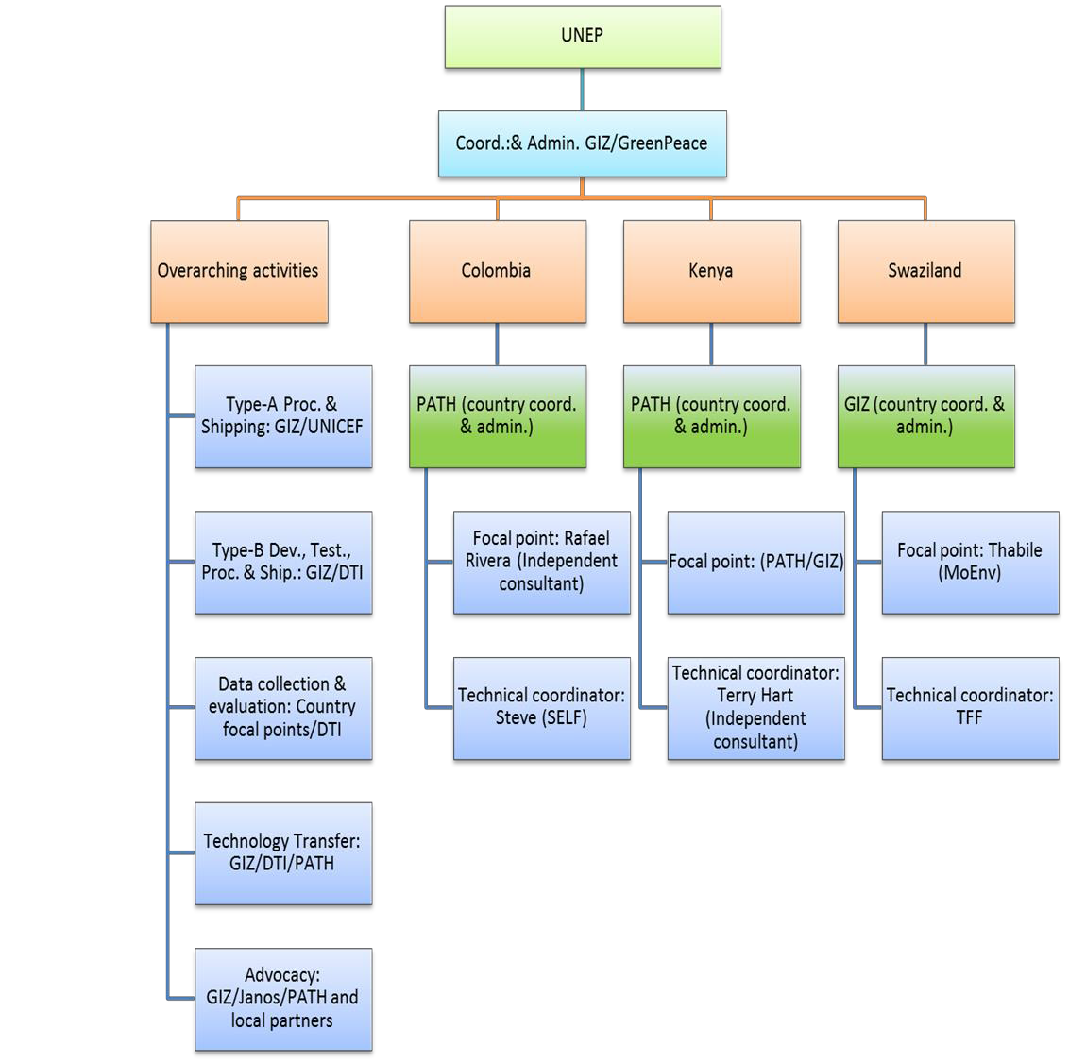
The project will hold a Project Steering Committee once a year, in each of the three project countries in rotation. The meeting will present project progress towards outcome in each of the three countries and a workplan and budget for the coming year. The steering Committee will approve the coming years work plan and budget and discuss and agree on project management issues and the need to coordinate with emerging in-country parallel activities. The PSC will be chaired by the host country, GIZ will be the Secretary of the meeting. The PSC will be represented by the Ministries of Health in each country, the lead member of the consortium in each country and refrigerator manufacturing representatives in each country (except Kenya).

ANNEX H: PROJECT IMPLEMENTATION ARRANGEMENTS

Component/Outcome | Activities | Responsible Party
Administer GEF project | Manage and disburse the GEF funds by subcontracting SolarChill consortium member organization, Country Program Executing Agencies and consultants. | GIZ
Administer GEF project | Carry out the administrative/executive agency functions, including financial reporting functions, as specified in the contract with UNEP. | GIZ
Administer GEF project | Provide international coordination amongst SolarChill partners | Janos
Project institutional arrangements | In collaboration with the Advisory Committee identify, hire and execute contract, if needed, with a Country Program Coordinator and associated technical staff. | GIZ, PATH
Project institutional arrangements | Summarize national and donor funded activities contributing to the objectives of this project during project implementation including: a description of the activities, how they supported the project, when they took place and how much they cost. | GIZ, PATH
Project institutional arrangements | Hold Country Program Advisory Committee meetings in recipient countries (semi-annual): participants may include Ministries of Health, Environment, Industry, and interested NGOs. Outline project activities and timing, develop and organigram and decision-making flow-chart for the country. | GIZ, PATH
Project institutional arrangements | Report in-kind contributions ($225K per country or agreed upon amount over 3 years) with each country. | GIZ, PATH
National institutional/ sectoral and policy context | In the context of each country, track the national institutions related to and influencing this project and summarize their role if any in the GEF project. | GIZ, UNEP, Janos, country coordinators
National institutional/ sectoral and policy context | In the global context (outside the context of project countries) track the institutions related to and influencing this project and summarize their role or effect on this project. | Janos, GIZ, UNEP
M&E | Follow UNEP and GEF requirements for project monitoring, reporting and evaluation processes and procedures, including continuous monitoring of outcomes throughout the project, communicated through regular meetings of the Project Steering Committee (PSC), bi-annual progress reports, annual summary progress reports and the final evaluation. | GIZ, UNEP, Janos, DTI, country coordinators
HPMP engagement | Collaborate with UNEP support to governments of Kenya, Colombia and Swaziland on the development and implementation of HPMP. | GIZ, UNEP, Janos, country coordinators
Develop training materials; including all the technical issues that a manufacturer would face for manufacturing and servicing the units. | Develop training materials for SolarChill monitoring and reporting of refrigerator performance | DTI
 | Develop training materials for site validation for SolarChill refrigerator placement using Solar Pathfinder, etc. | Technical specialists in the countries (S McCarney)
 | Develop training materials for installation of SolarChill refrigerators | Technical specialists in the countries ( T Hart)
 | Develop training materials for maintenance and repair of SolarChill refrigerators | Technical specialists in the countries (T Hart)
Demonstration of the SolarChill vaccine refrigerator technology in Colombia, Swaziland and Kenya | Prepare training and implementation plan with MOH, MOE, and MOI. Negotiate cost of in-country distribution, installation and maintenance with local contractor, if needed. | Technical specialists in the countries (S McCarney, T Hart, GIZ) and country coordinator
 | Training for site selection validation, installation, monitoring, maintenance and repair of SolarChill refrigerators | Technical specialists in the countries (S McCarney, T Hart, GIZ)
 | Training to confirm validation of SolarChill A sites in each country. Collect baseline information including: facility data on latitude, longitude, solar radiation, accessibility by road, elevation and environmental conditions, vaccine storage volume requirements, icepack freezing requirements, costs of existing equipment for cold storage, including performance (power utilization, operating costs, and temperature control), maintenance requirements, problems, acceptability, and ease of use.) | Technical specialists in the countries (S McCarney, T Hart, GIZ) and country coordinator and staff
 | Negotiate tender for SC-A procurement | UNICEF (GIZ)
 | Procure and ship selected SolarChill A units to Colombia, Kenya and Swaziland. | UNICEF (GIZ)
 | In collaboration with country MOH and/or local contractor, distribute SolarChill A units. | Technical specialists in the countries (S McCarney, T Hart, GIZ) and country coordinator
 | Install SC-A units | Technical specialists in the countries (S McCarney, T Hart, GIZ) and country contractor and/or MOH staff
Collection and interpretation of relevant technical data | Collect temperature and other refrigerator performance metrics using 3 month computer downloadable data loggers. Collect user feedback data as well (31 days total to visit 60 sites at 0, 6 and 12 month time points; thus, 33 days x 3 time points = 99 days). | Country coordinator and/or MOH staff
Collection and interpretation of relevant technical data | Analysis and interpretation of logged data and user questionnaires; elaboration of a report | DTI
Complete development and field testing of the SolarChill B refrigerator | Confirm SolarChill B sites in each country. Collect baseline information including: facility data on latitude, longitude, solar radiation, accessibility by road, elevation and environmental conditions, food storage volume requirements, icepack freezing requirements, costs of existing equipment for cold storage, including performance (power utilization, operating costs, and temperature control), maintenance requirements, problems, acceptability, and ease of use.) | Technical specialists in the countries (S McCarney, T Hart, GIZ) and country contractor and/or MOH staff
 | Document the criteria for how SolarChill-B units must perform in lab tests and during field testing. Collect and organize detailed information from SolarChill B candidate manufacturers (manufacturers in Colombia and Swaziland; qualifying international manufacturers ) | DTI
 | Perform lab tests on type-B prototypes from various manufacturers; report | DTI
 | Coordinate and implement the procurement of SolarChill B units to Colombia, Kenya and Swaziland. | GIZ with consultation from DTI
 | In collaboration with country MOE and/or local contractor, distribute and install SolarChill B units. | Country contractor and/or MOH staff (potential support from DTI, GIZ)
 | Collect temperature and other refrigerator performance metrics using 3 month computer downloadable data loggers. Collect user feedback data as well (6 days total to visit 12 sites at 0, 6 and 12 month time points; thus, 6 days x 3 time points = 18 days). | Country coordinator and/or MOH staff
 | Analysis and interpretation of logged data and user questionnaires; elaboration of a report. | DTI
Technology transfer | Complete optimization of SolarChill A and obtain WHO prequalification with The Fridge Factory. | GIZ
Technology transfer | Integration of SolarChill with other off-grid systems; development of a storage refrigerator for on-grid use; analysis of the cost reduction and localization potential. | GIZ through subcontract
Technology transfer | Complete the design and development of SolarChill B with The Fridge Factory. | GIZ
Technology transfer | Develop a business plan to convert their manufacturing processes to be HFC/HCFC free and bring a SolarChill A and B refrigerator to market. | GIZ/DTI
Technology transfer | Contact refrigerator manufacturers to assess their interest in SolarChill, explore ways in which the project may support their interest during the project period. | GIZ with support from DTI, PATH, Janos
Technology transfer | Share the business plan and technology transfer package with interested manufacturers, including all the technical issues that a manufacturer would face for manufacturing and servicing the units; | GIZ
Technology transfer | Support to individual manufacturers in preparing business plans and technical blue prints for SolarChill production. | GIZ
Perform market research to document the potential market for the SolarChill technology in various applications. | Collect baseline data on current annual operating costs for electric, gas and kerosene driven refrigerators in the country. These costs including the price and transport logistics related to fuel, maintenance and repair costs will be compared with the cost data collected following introduction of SolarChill refrigerators in each country. In addition, estimated carbon emission reductions will be quantified. Overall cost-effectiveness of implementing solar refrigeration will be calculated and extrapolated over the forecasted demand for solar units. | GIZ with country coordinators
Assess Greenhouse Gas emissions reduction potential | Estimate the demand and supply potential for SolarChill A&B refrigerators, globally and in the 3 project countries, and calculate potential indirect emissions reductions from the project. | GIZ / DTI
Assess Greenhouse Gas emissions reduction potential | Measure direct and indirect emission reductions from the project. | GIZ / DTI
SolarChill marketing and communication | Update and advance the SolarChill website and associated marketing materials. Create and execute a communication and advocacy plan for SolarChill A and B considering the obtained performance and user information. | Janos, PATH
SolarChill marketing and communication | Dissemination of information about the technology on a country and regional level to industry leaders and policy makers. | Janos, PATH, GIZ
SolarChill marketing and communication | Opportunistic exhibition of the technology at international events. | Janos, PATH, GIZ, DTI

ANNEX I: PROJECT WORKPLAN
Description of activities | Responsible party | Project month
Description of activities | Responsible party | 1 | 2 | 3 | 4 | 5 | 6 | 7 | 8 | 9 | 10 | 11 | 12 | 13 | 14 | 15 | 16 | 17 | 18 | 19 | 20 | 21 | 22 | 23 | 24 | 25 | 26 | 27 | 28 | 29 | 30
Dissemination of tools and training for site selection evaluation and approval for SolarChill refrigerators | SolarChill consortium technical experts
Confirm SolarChill A sites in each country. | SolarChill consortium technical experts
Prepare an overview of procurement costs, including import and customs considerations for use in the implementation phase. | UNICEF Supply Division
Procure and ship selected SolarChill A units to Colombia, Kenya and Swaziland. | UNICEF Supply Division
In collaboration with country MOH and/or local contractor, distribute and install SolarChill A units. | MOH and Country Coordinators.
Creation of tools and training for installation of SolarChill refrigerators | SolarChill consortium technical experts
Creation of tools and training for maintenance and repair of SolarChill refrigerators | SolarChill consortium technical experts
Creation of tools and training for monitoring and reporting of SolarChill refrigerator performance | SolarChill consortium technical experts
Collect performance data of installed SolarChill A and B refrigerators. Analze data and report results. | SolarChill consortium technical experts
Confirm SolarChill B sites in each country. | SolarChill consortium technical experts
Document the criteria for how SolarChill-B units must perform in lab tests and during field testing. | SolarChill consortium technical experts
Collect design and test information from SolarChillB candidate manufacturers (partnering manufacturers in Colombia and Swaziland; qualifying international manufacturers) | SolarChill consortium (DTI)
Coordinate the procurement of SolarChill B units to Colombia, Kenya and Swaziland. | SolarChill consortium (DTI)
In collaboration with country MOH and/or local contractor, distribute and install SolarChill B units. | MOH and Country Coordinators.
Complete optimization of The Fridge Factory SolarChill A and obtain WHO prequalification. | WHO PQS.
Complete the design and development of SolarChill B with The Fridge Factory. | The Fridge Factory/GIZ
Develop a SolarChill business case. | SolarChill consortium (GIZ)
Contact refrigerator manufacturers to assess their initial interest in SolarChill, explore ways in which the project may support their interest in the implementation phase. | SolarChill consortium
Broker to connect financing organizations (micro-financing and venture capitalists) for increased market penetration of solarchill B. | SolarChill consortium
In the context of each country, track the national institutions related to and influencing this project and summarize their role if any in the GEF project. | SolarChill consortium, MOI, MOE, MOH
In the global context (outside the context of project countries) track the institutions related to and influencing this project and summarize their role or effect on this project. | SolarChill consortium, MOI, MOE, MOH
Estimate the demand and supply potential for SolarChill A&B refrigerators, globally and in the 3 project countries. | SolarChill consortium
Calculate potential indirect emissions reductions from the project. | SolarChill consortium
Measure direct and indirect emission reductions from the project. | SolarChill consortium
Update and advance the SolarChill website and associated marketing materials. | SolarChill consortium
Create and execute a communication an advocacy plan for SolarChill A and B. | SolarChill consortium
In collaboration with the Advisory Committee identify, hire and execute contract, if needed, with a Country Program Coordinator and associated technical staff. | SolarChill consortium
Summarize national and donor funded activities contributing to the objectives of this project during project implementation | SolarChill consortium
Hold Country Program Advisory Committee meeting in recipient countries. | SolarChill consortium
Report in-kind contributions with each country. | SolarChill consortium
Track co-financing of partners, governments and existing and potential manufacturing partners. | SolarChill consortium (GIZ)
Carry out the administrative/executive agency functions, including financial reporting functions, as specified in the contract with UNEP. | SolarChill consortium (GIZ)
Manage and disburse the GEF funds by subcontracting SolarChill consortium member organization, Country Program Executing Agencies and consultants. | SolarChill consortium (GIZ)

ANNEX I – KEY DELIVERABLES AND BENCHMARKS

Component/Outcome/Outputs | Activities | Deliverables | Benchmarks | Responsible  Party
Administer GEF project | Manage and disburse the GEF funds by subcontracting  SolarChill consortium member organization, Country Program Executing Agencies and consultants. | Subcontracts and consultant contracts  executed.  Quarterly fund distribution to subcontractors and consultants. | Months 1-2 | GIZ
Administer GEF project | Carry out the administrative/executive agency functions,  including financial reporting functions, as specified in the contract with UNEP. | Quarterly financial reports. | Months 1-30 | GIZ
Project institutional  arrangements | Provide international coordination amongst SolarChill  partners. | Meeting minutes from monthly or  quarterlay conference calls. | Months 1-30 | Janos
Project institutional  arrangements | In collaboration with the Advisory Committee identify,  hire and execute contract, if needed, with a Country Program Coordinator and associated technical staff. | Country coordinator subcontracts  executed. | Months 1-2 | GIZ, PATH
Project institutional  arrangements | Summarize national and donor funded activities  contributing to the objectives of this project. | Midterm and final report describing the  country activities, how they support the project, when they took place and how much they cost. | Months 1-30 | GIZ, PATH
Project institutional  arrangements | Hold Country Program Advisory Committee meetings in  recipient countries (semi-annual): participants may include Ministries of Health, Environment, Industry, and interested NGOs. | Meeting reports that outline project  activities and timing, develop and organigram and decision-making flow- chart for the country. | Months 1-30 | GIZ, PATH
National institutional/ sectoral  and policy context | Report in-kind contributions ($225K per country or  agreed upon amount over 3 years) with each country. | Annual financial reports. | Months 15  and 30 | GIZ, PATH
National institutional/ sectoral  and policy context | In the context of each country, track the national  institutions related to and influencing this project and summarize their role if any in the GEF project. | Midterm and final institutional report. | Months 15  and 30 | GIZ, UNEP,  Janos, country coordinators
National institutional/ sectoral  and policy context | In the global context (outside the context of project  countries) track the institutions related to and influencing this project and summarize their role or effect on this project. | Midterm and final institutional report. | Months 15  and 30 | Janos, GIZ,  UNEP
M&E | Follow UNEP and GEF requirements for project  monitoring, reporting and evaluation processes and procedures, including continuous monitoring of outcomes throughout the project. | Minutes from Project Steering Committee  (PSC) meetings, bi-annual progress reports, annual summary progress reports and the final evaluation. | Months 1-30 | GIZ, UNEP,  Janos, DTI, country coordinators

HPMP engagement | Collaborate with UNEP support to governments of  Kenya, Colombia and Swaziland on the development and implementation of HPMP. | Final report on the collaboration activities  with UNEP in Kenya, Colombia and Swaziland on the development and implementation of HPMP. | Months 1-30 | GIZ, UNEP,  Janos, country coordinators
Develop training materials;  including all the technical issues that a manufacturer would face for manufacturing  and servicing the units. | Develop training materials for SolarChill monitoring and  reporting of refrigerator performance. | Final monitoring and reporting training  protocols and materials. | Months 1-4 | DTI
 | Develop training materials for site validation for  SolarChill refrigerator placement using Solar Pathfinder, etc. | Final site selection training protocols and  materials. | Months 1-4 | Technical  specialists in the countries (S McCarney)
 | Develop training materials for installation of SolarChill  refrigerators | Final installation training protocols and  materials. | Months 1-4 | Technical  specialists in the countries ( T Hart)
 | Develop training materials for maintenance and repair of  SolarChill refrigerators | Final maintenance and repair training  protocols and materials. | Months 1-4 | Technical  specialists in the countries (T Hart)
Demonstration of the SolarChill  vaccine refrigerator technology in Colombia, Swaziland and  Kenya | Prepare training and implementation plan with MOH,  MOE, and MOI. Negotiate cost of in-country distribution, installation and maintenance with local  contractor, if needed. | Training and installation plan summary. | Months 1-3 | Technical  specialists in the countries (S  McCarney, T  Hart, GIZ) and country coordinator
 | Training for site selection validation, installation,  monitoring, maintenance and repair of SolarChill refrigerators | Training seminars completed with MOH,  MOE and other technical staff in each country. | Months 3-6 | Technical  specialists in the countries (S McCarney, T Hart, GIZ)
 | Training to confirm validation of SolarChill A sites in  each country. | Report summarizing baseline information  including: facility data on latitude, longitude, solar radiation, accessibility by road, elevation and environmental  conditions, vaccine storage volume  requirements, icepack freezing requirements, costs of existing equipment for cold storage, including performance (power utilization, operating costs, and temperature control), maintenance requirements, problems, acceptability, and ease of use.) | Months 1-6 | Technical  specialists in the countries (S McCarney, T  Hart, GIZ) and  country coordinator and staff
 | Negotiate tender for SC-A procurement. | Finalize procurement plan report. | Months 2-6 | UNICEF (GIZ)
 | Procure and ship selected SolarChill A units to Colombia,  Kenya and Swaziland. | Arrival of SolarChill A refrigerators to  central stores in each country. | Months 2-6 | UNICEF (GIZ)

 | In collaboration with country MOH and/or local  contractor, distribute SolarChill A units. | Arrival of SolarChill A refrigerators to  designated facilities in each country. | Months 2-6 | Technical  specialists in the countries (S McCarney, T Hart, GIZ) and country coordinator
Collection and interpretation of  relevant technical data | Install SC-A units. | Installation of SolarChill A refrigerators to  designated facilities in each country. | Months 3-6 | Technical  specialists in the countries (S McCarney, T  Hart, GIZ) and  country contractor and/or MOH staff
Collection and interpretation of  relevant technical data | Collect temperature and other refrigerator performance  metrics using 3 month computer downloadable data loggers. Collect user feedback data as well (31 days total to visit 60 sites at 0, 6 and 12 month time points; thus, 33 days x 3 time points = 99 days). | Data collection completed, entered and  validated. | Post  installation at 0, 6 and 12 months | Country  coordinator and/or MOH staff
Collection and interpretation of  relevant technical data | Analysis and interpretation of logged data and user  questionnaires. | Refrigerator performance report. | Post  installation at 0, 6 and 12 months | DTI
Complete development and  field testing of the SolarChill B refrigerator | Confirm SolarChill B sites in each country. | Report on baseline information including:  facility data on latitude, longitude, solar radiation, accessibility by road, elevation and environmental conditions, food storage volume requirements, icepack freezing requirements, costs of existing equipment for cold storage, including performance (power utilization, operating costs, and temperature control), maintenance requirements, problems, acceptability, and ease of use.) | Months 6-12 | Technical  specialists in the countries (S McCarney, T Hart, GIZ) and country contractor and/or MOH staff
 | Document the criteria for how SolarChill-B units must  perform in lab tests and during field testing. Collect and organize detailed information from SolarChillB candidate manufacturers (partnering manufacturers in Swaziland, Columbia, qualifying international manufacturers) | Specifications document.  Database of potential SolarChill B manufacturers and development status. | Months 1-12 | DTI
 | Perform lab tests on type-B prototypes from various  manufacturers; report | Lab reports. | Months 1-12 | DTI

 | Coordinate and implement the procurement of SolarChill  B units to Colombia, Kenya and Swaziland. | Procurement plan and tender executed. | Months 6-12 | GIZ with  consultation from DTI
 | In collaboration with country MOE and/or local  contractor, distribute and install SolarChill B units. | Installation of SolarChill B refrigerators to  designated facilities in each country. | Months 6-12 | Country  contractor and/or MOH staff (potential support from DTI, GIZ)
 | Collect temperature and other refrigerator performance  metrics using 3 month computer downloadable data loggers. Collect user feedback data as well (6 days total to visit 12 sites at 0, 6 and 12 month time points; thus, 6 days x 3 time points = 18 days). | Data collection completed, entered and  validated. | Post  installation at 0, 6 and 12 months | Country  coordinator and/or MOH staff
 | Analysis and interpretation of logged data and user  questionnaires; elaboration of a report. | Refrigerator performance report. | Post  installation at 0, 6 and 12 months | DTI
 | Broker to connect financing organizations (micro-financing and venture capitalists) for increased market penetration of solarchill B | Meeting records with financiers | Months 12-30 | GIZ
Technology transfer | Complete optimization of SolarChill A and obtain WHO  prequalification with The Fridge Factory. | WHO prequalification. | Months 1-3 | GIZ
Technology transfer | Integration of SolarChill with other off-grid systems;  development of a storage refrigerator for on-grid use; analysis of the cost reduction and localization potential. | Summary report on integration. | Months 1-6 | GIZ through  subcontract
Technology transfer | Complete the design and development of SolarChill B  with The Fridge Factory. | Production scale refrigerator available. | Months 1-12 | GIZ
Technology transfer | Develop a business plan which documents the research,  development and commercialization activities and costs undertaken by The Fridge Factory to convert their manufacturing processes to be HFC/HCFC free and bring a SolarChill A and B refrigerator to market. | Business plan. | Months 1-8 | GIZ/DTI
Technology transfer | Contact refrigerator manufacturers to assess their interest  in SolarChill, explore ways in which the project may support their interest during the project period. | Database of potential manufacturers,  interest and development status. | Months 1-20 | GIZ with support  from DTI, PATH, Janos
Technology transfer | Share the business plan and technology transfer package  with interested manufacturers, including all the technical issues that a manufacturer would face for manufacturing and servicing the units; |  | Months 1-20 | GIZ

 | SolarChill technology transfer training to achievement  high quality (heat losses, tolerances) in RAC technology and condenser manufacturing. | Training report. | Months 6-25 | GIZ, partially  through subcontract
 | Preliminary testing of type B refrigerators. | Lab and field test reports. | Months 1-12 | GIZ, partially  through subcontract
 | Explore development of a local Type A model  (utilization of GIZ SC design) in Colombia | Hold meetings with manufacturers and  report on developments. | Months 6-25 | GIZ, partially  through subcontract
 | Explore development of a local Type B model (utilization  of GIZ SC design) in Colombia |  | Months 6-25 | DTI and GIZ,  partially through subcontract
 | Support to individual manufacturers in preparing  business plans and technical blue prints for SolarChill production. |  | Months 6-25 | GIZ
Perform market research to  document the potential market for the SolarChill technology in various applications. | Collect baseline data on current annual operating costs  for electric, gas and kerosene driven refrigerators in each country. | Summary report of costs including the  price and transport logistics related to fuel, maintenance and repair costs will be compared with the cost data collected following introduction of SolarChill refrigerators in each country. In addition, estimated carbon emission reductions will be quantified. Overall cost-effectiveness of implementing solar refrigeration will be calculated and extrapolated over the forecasted demand for solar units. | Months 1-6 | GIZ with  country coordinators
Assess Greenhouse Gas  emissions reduction potential | Estimate the demand and supply potential for SolarChill  A&B refrigerators, globally and in the 3 project countries, and calculate potential indirect emissions reductions from the project. | Summary emissions report. | Months 15  and 30 | GIZ / DTI
Assess Greenhouse Gas  emissions reduction potential | Measure direct and indirect emission reductions from the  project. | Summary emissions report. | Months 15  and 30 | GIZ / DTI
SolarChill marketing and  communication | Update and advance the SolarChill website and  associated marketing materials. Create and execute a communication and advocacy plan for SolarChill A and B considering the obtained performance and user information. | New website launched.  Advocacy plan finalized. | Months 6-20 | Janos, PATH
SolarChill marketing and  communication | Dissemination of information about the technology on a  country and regional level to industry leaders and policy makers. | Broad dissemination of marketing  materials. | Months 6-20 | Janos, PATH,  GIZ
SolarChill marketing and  communication | Opportunistic exhibition of the technology at  international events. | Midterm and final summary report of  conferences in which SolarChill technology was presented. | Months 15  and 30 | Janos, PATH,  GIZ, DTI

ANNEX K – OFP ENDORSEMENT LETTER
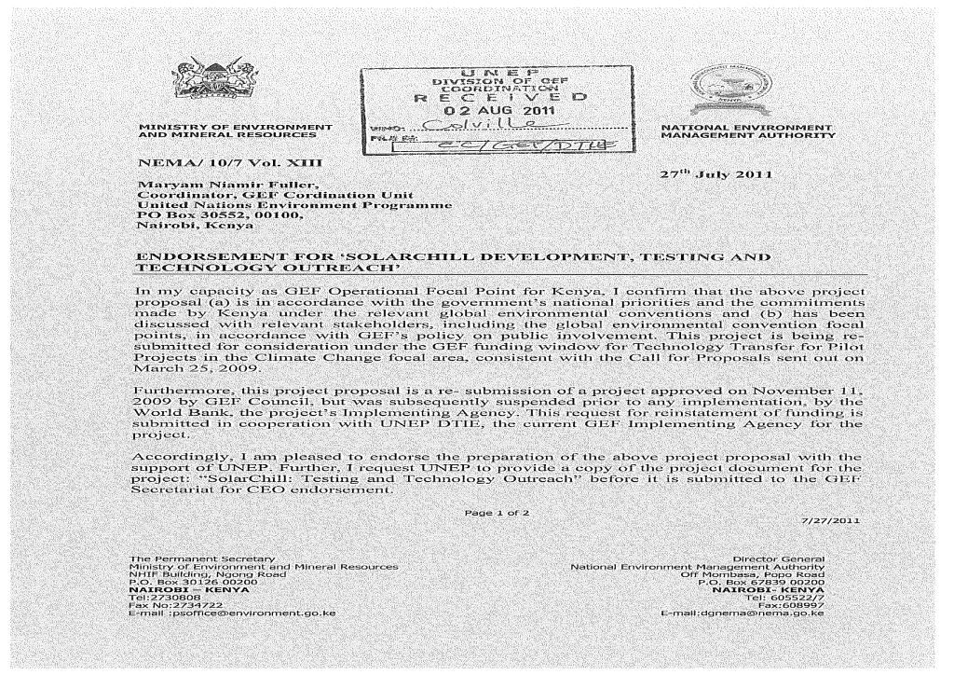

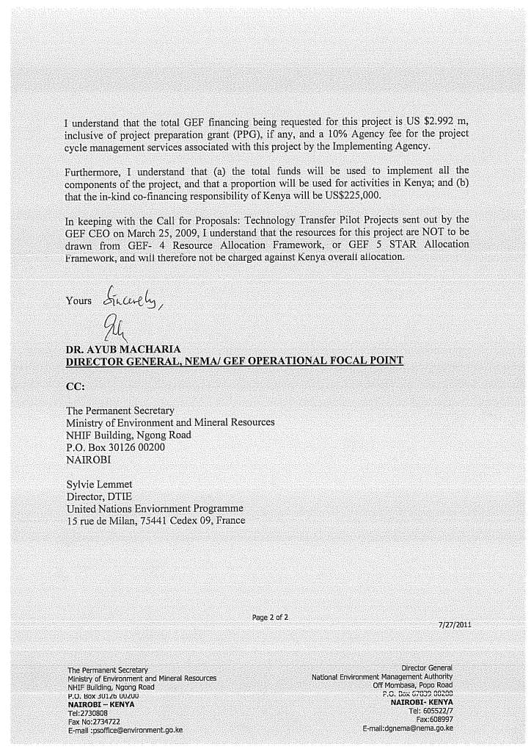

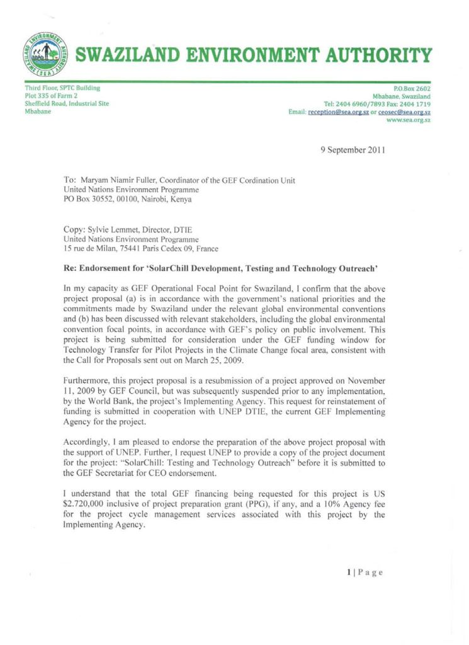

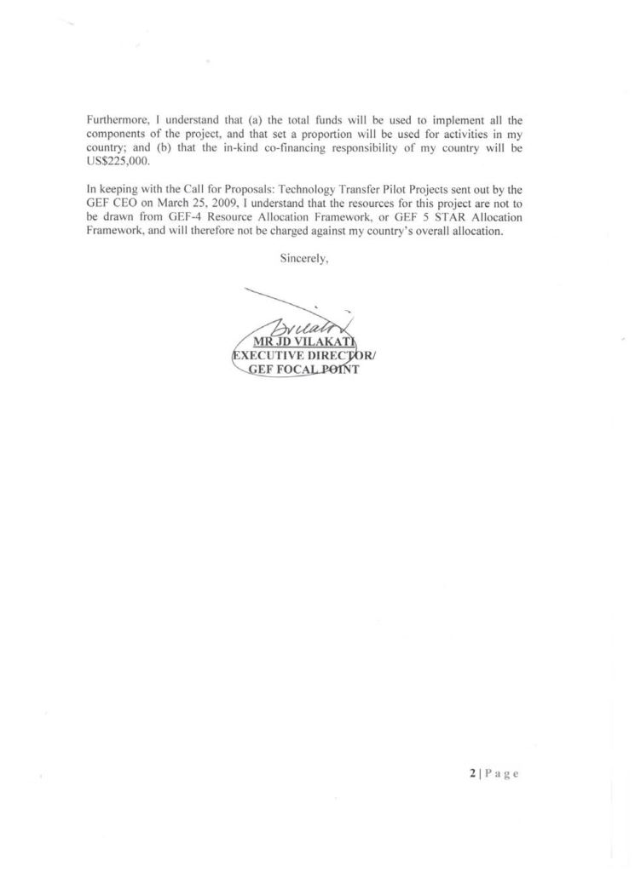

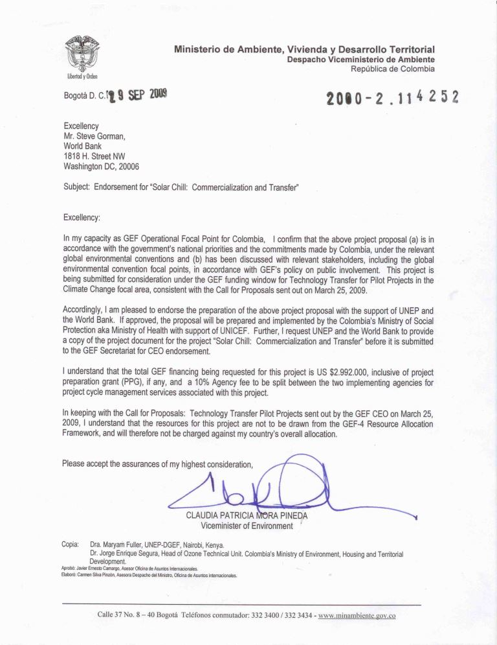

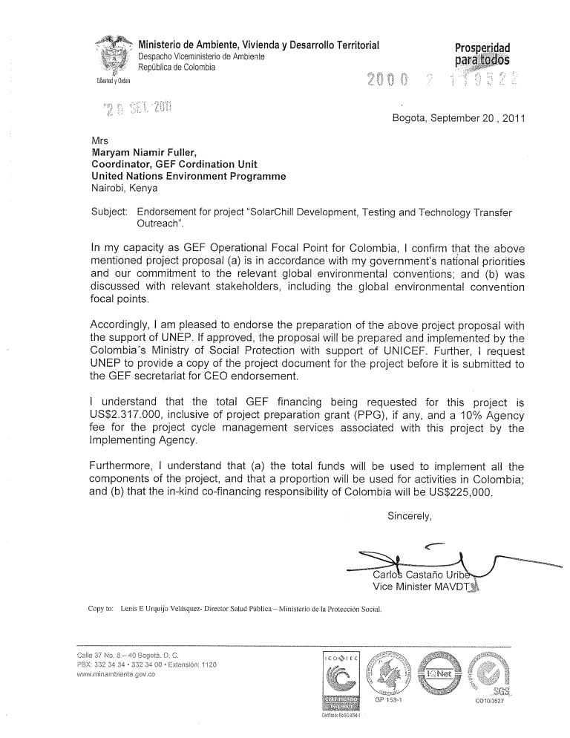

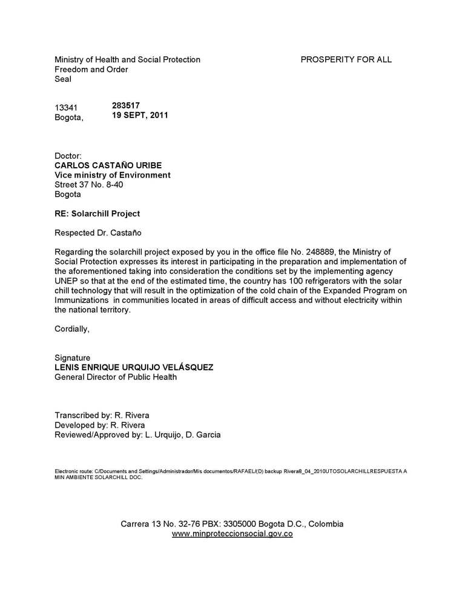

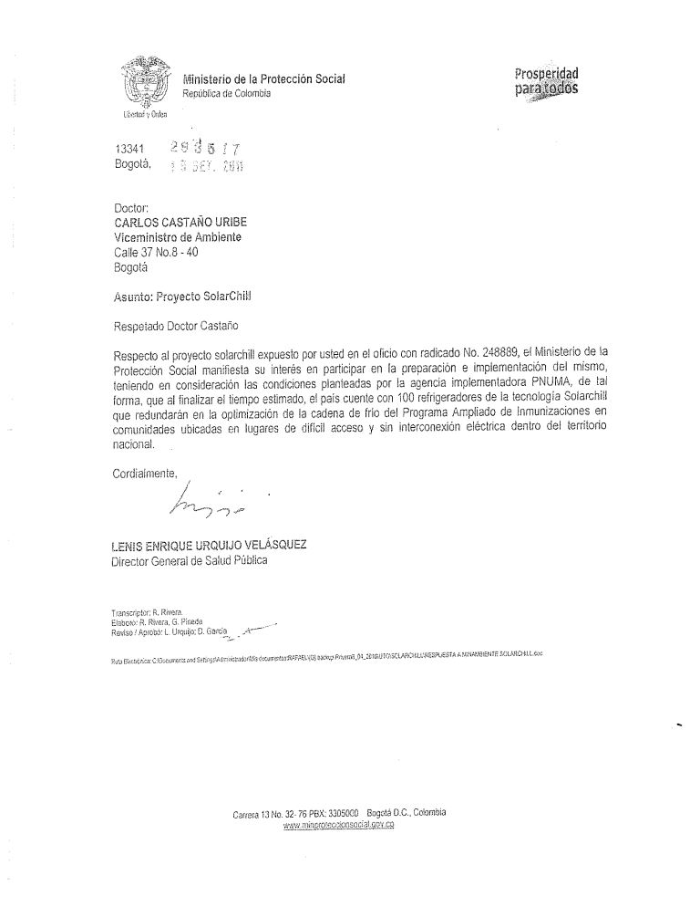

ANNEX L: CO-FINANCE LETTERS
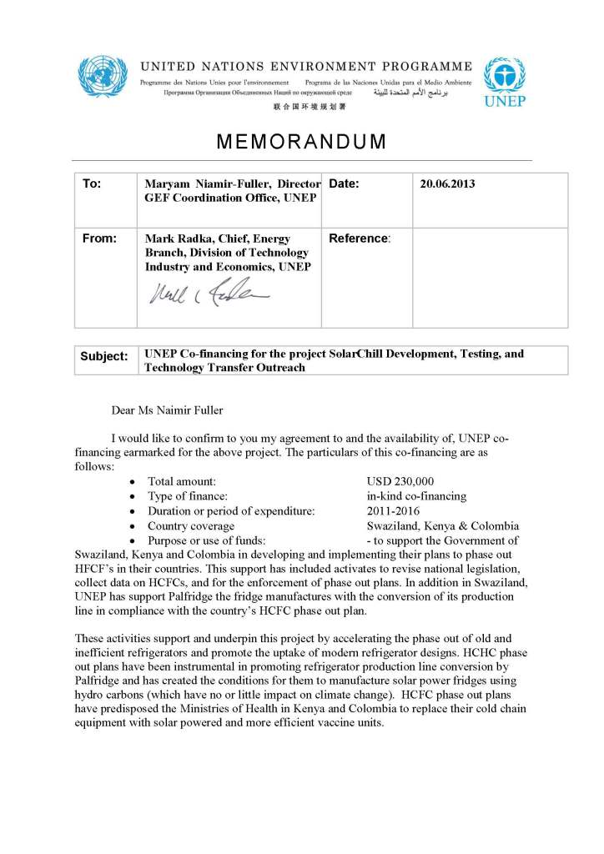

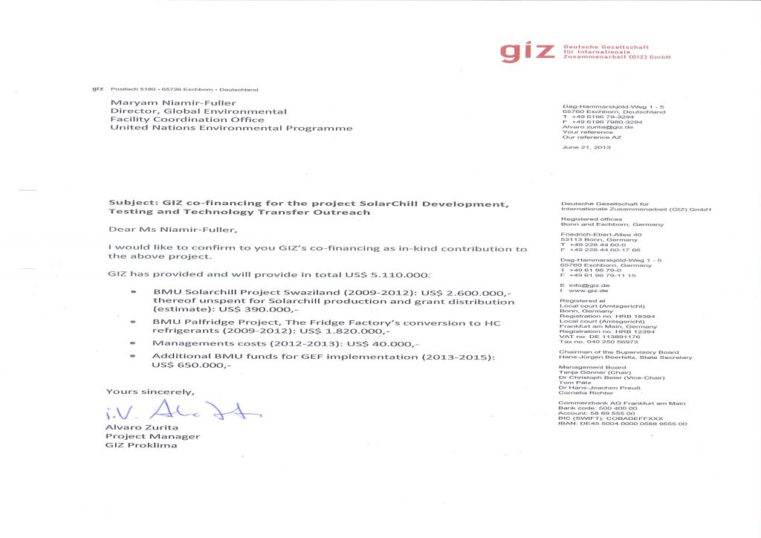

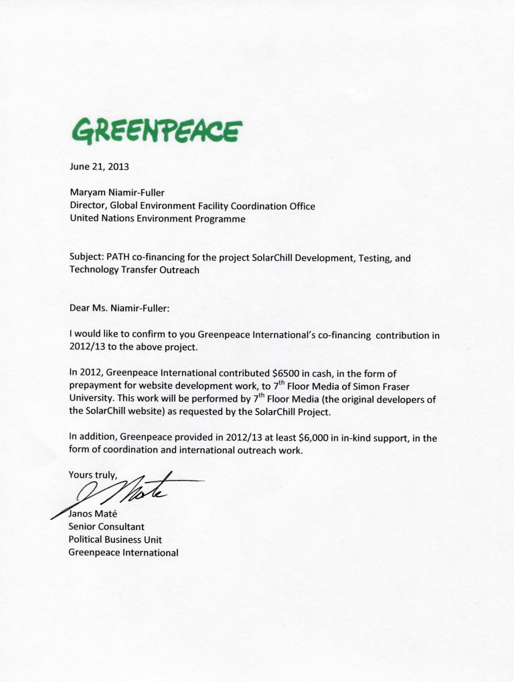

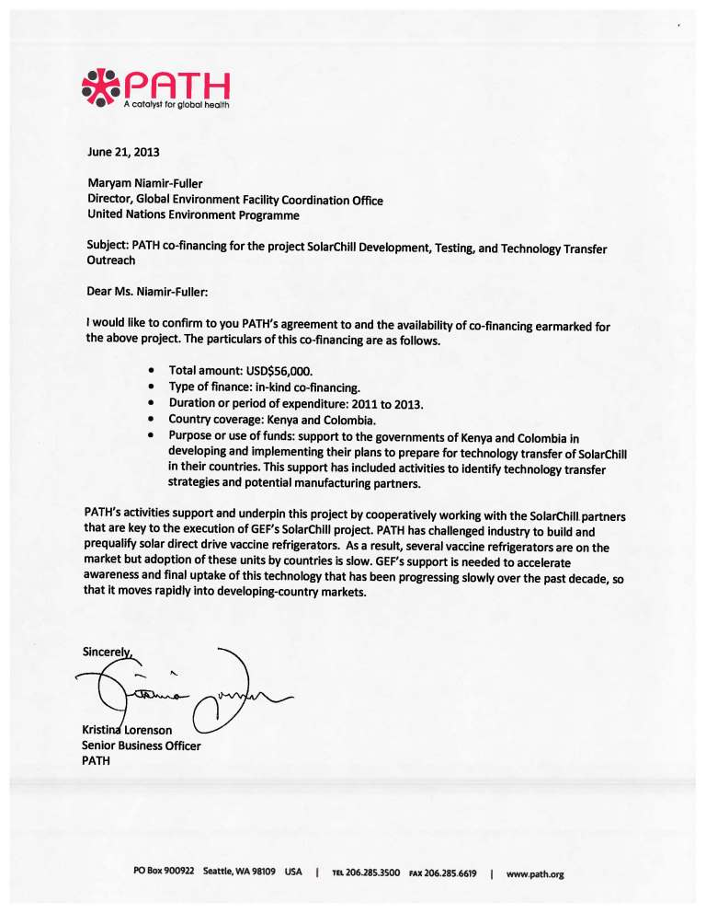

ANNEX M: ENVIRONMENTAL AND SOCIAL SAFEGUARDS CHECKLIST

As part of the GEFs evolving Fiduciary Standards that Implementing Agencies have to address ‘Environmental and Social Safeguards’. To fill this checklist:
  - STEP 1: Initially assess E&S Safeguards as part of PIF development. The checklist is to be submitted for the CRC.
  - STEP 2 : Check list is reviewed during PPG project preparation phase and updated as required
  - STEP 3 : Final check list submitted for PRC showing what activities are being undertaken to address issues identified

UNEP/GEF Environmental and Social Safeguards Checklist

Project Title: | SolarChill Development, Testing, and Technology Transfer Outreach
GEF project ID and UNEP ID/IMIS Number | 4682 | Version of checklist | 2
Project status (preparation,  implementation,  MTE/MTR, TE) | CEO  Endorsement | Date of this version: | 20.6.2013
Checklist prepared by (Name, Title, and Institution) | Geordie Colville, UNEP, Task Manager

In completing the checklist both short- and long-term impact shall be considered.

Section A: Project location

If negative impact is identified or anticipated the Comment/Explanation field needs to include: Project stage for addressing the issue; Responsibility for addressing the issue; Budget implications, and other comments.
 |  | Yes/No/N.A. |  | Comment/explanation
- Is the project area in or close to -
- densely populated area | No
- cultural heritage site | No
- protected area | No
- wetland | No
- mangrove | No
- estuarine | No
- buffer zone of protected area | No
- special area for protection of biodiversity | No
- Will project require temporary or permanent support  facilities? | No
If the project is anticipated to impact any of the above areas an Environmental Survey will be needed to determine if the project is in conflict
with the protection of the area or if it will cause significant disturbance to the area.

Section B: Environmental impacts

If negative impact is identified or anticipated the Comment/Explanation field needs to include: Project stage for addressing the issue; Responsibility for addressing the issue; Budget implications, and other comments.
 | Yes/  No/ N.A. | Comment/explanati  on
- Are ecosystems related to project fragile or degraded? | No
- Will project cause any loss of precious ecology, ecological, and economic functions  due to construction of infrastructure? | No
- Will project cause impairment of ecological opportunities? | No
- Will project cause increase in peak and flood flows? (including from temporary or  permanent waste waters) | No
- Will project cause air, soil or water pollution? | No
- Will project cause soil erosion and siltation? | No
- Will project cause increased waste production? | No
- Will project cause Hazardous Waste production? | No
- Will project cause threat to local ecosystems due to invasive species? | No
- Will project cause Greenhouse Gas Emissions? | No | Project will reduce GHG  emissions.
- Other environmental issues, e.g. noise and traffic | No
Only if it can be carefully justified that any negative impact from the project can be avoided or mitigated satisfactorily both in the
short and long-term, can the project go ahead.

Section C: Social impacts

If negative impact is identified or anticipated the Comment/Explanation field needs to include: Project stage for addressing the issue; Responsibility for addressing the issue; Budget implications, and other comments.
 | Yes/No/N.A. | Comment/explanation
- Does the project respect internationally proclaimed human rights including dignity,  cultural property and uniqueness and rights of indigenous people? | Yes
- Are property rights on resources such as land tenure recognized by the existing  laws in affected countries? | N/A
- Will the project cause social problems and conflicts related to land tenure and  access to resources? | No
- Does the project incorporate measures to allow affected stakeholders’ information  and consultation? | N/A
- Will the project affect the state of the targeted country’s (-ies’) institutional  context? | No
- Will the project cause change to beneficial uses of land or resources? (incl. loss of  downstream beneficial uses (water supply or fisheries)? | No
- Will the project cause technology or land use modification that may change present  social and economic activities? | No
- Will the project cause dislocation or involuntary resettlement of people? | No
- Will the project cause uncontrolled in-migration (short- and long-term) with  opening of roads to areas and possible overloading of social infrastructure? | No
- Will the project cause increased local or regional unemployment?
- Does the project include measures to avoid forced or child labour? | Yes | The project will work with  the Fridge Factory in Swaziland that respects Swazi Law.
- Does the project include measures to ensure a safe and healthy working  environment for workers employed as part of the project? | Yes | There will be training in  the use of hydro-carbons as a refrigerant.
- Will the project cause impairment of recreational opportunities? | No
- Will the project cause impairment of indigenous people’s livelihoods or belief  systems? | No
- Will the project cause disproportionate impact to women or other disadvantaged or | No

vulnerable groups?
- Will the project involve and or be complicit in the alteration, damage or removal of  any critical cultural heritage? | No
- Does the project include measures to avoid corruption? | No
Only if it can be carefully justified that any negative impact from the project can be avoided or mitigated satisfactorily both in the short and
long-term, can the project go ahead.

Section D: Other considerations

If negative impact is identified or anticipated the Comment/Explanation field needs to include: Project stage for addressing the issue; Responsibility for addressing the issue; Budget implications, and other comments.

 | Yes/N  o/N.A  . | Comment/explanatio  n
- Does national regulation in affected country (-ies) require EIA and/or ESIA for this type of  activity? | N/A
- Is there national capacity to ensure a sound implementation of EIA and/or SIA  requirements present in affected country (-ies)? | N/A
- Is the project addressing issues, which are already addressed by other alternative  approaches and projects? | N/A
- Will the project components generate or contribute to cumulative or long-term  environmental or social impacts? | Yes | The project should  improve health care coverage in remote areas
- Is it possible to isolate the impact from this project to monitor E&S impact? | Yes | Emissions  reductions will be monitored from the project

ANNEX N: ACRONYMS AND ABBREVIATIONS

DTI | Danish Technological Institute
DTIE | Division of Trade, Industry and Economics
DVI | Kenya Division of Vaccination
FMO | Fund Management Officer
GEF | Global Environment Facility
GHG | Green House Gas
GIZ | Gesellschaft für Technische Zusammenarbeit
GWP | Global Warming Potential
HC | Hydrocarbons
HCFC | Hydrochlorofluorocarbons
HFC | Hydrofluorocarbons
HPMP | HCFC Phase-out Management Plan
M&E | Monitoring and Evaluation
MLF | Multilateral Fund
MOE | Ministry of Environment
MOH | Ministry of Health
MOI | Ministry of Industry
NGO | Non-Governmental Organisation
NEMA | National Environment Management Authority
ODS | Ozone Depleting Substance
PATH | Programs for Appropriate Technologies in Health
PSC | Project Steering Committee
POW | Programme of Work
R&D | Research and Development
SEA | Swaziland Environmental Authority
SENA | Colombia National Service Learning
TFF | The Fridge Factory
SDD | Solar Direct Drive
UNDP | United Nations Development Programme
UNEP | United Nations Environment Programme
UNICEF | United Nations Childrens Fund
UNFCCC | United Nations Framework Convention on Climate Change
UTO | Colombia National Training Organisation
WHO | World Health Organisation

ANNEX O: METHODOLOGY AND DETAILS OF CO2 EMISSIONS REDUCTIONS ESTIMATES

The global environmental benefits of the SolarChill technology are significant, through the avoidance of emissions from
- ozone- depleting substances such as HCFCs in the insulation & foam blowing;
- potent high GWP refrigerants, such as HFCs;
- GHGs from burning of fossil fuels used to operate conventional off-grid vaccine coolers and refrigerators; additional emissions result from transportation emissions bringing the fossil fuels to remote areas.

The emission reductions that can potentially be achieved by an increased market penetration of the SolarChill vaccine coolers (Type A) and commercial fridges (Type B) throughout the next decades are significant. The increased market penetration will only take place if the reliability and costs effectiveness of the systems can be proven. Here the proposed GEF project has a critical role.

On that basis that the reliability and costs effectiveness of Solar Chill units can be proven and that the units compete with kerosene units, it can be assumed that Solar Chill units will widely replace kerosene units and reach a high penetration in off-grid markets.

The following calculations only consider the avoidance of emissions from the substitution of Kerosene.

Direct emissions are not regarded in the following calculations, as the kerosene fridges use ammonia as a refrigerant and thus imply very little direct emissions in terms of Global Warming Potential (GWP). The direct emissions stemming from the insulating foam are considered to be small and are also disregarded therefore.

For the three project countries the development of offgrid Type A Solar Chill units for medical use and Type B Solar Chill refrigerators for domestic / commercial use are estimated for the 3 project countries.

 | 2010 | 2020 | 2030 | 2040 | 2050
Population (in millions)
Columbia | 46 | 52 | 57 | 60 | 62
Kenya | 40 | 53 | 66 | 81 | 97
Swaziland | 1,2 | 1,3 | 1,5 | 1,6 | 1,7
Electrification
Columbia | 0,86 | 0,95 | 0,95 | 0,95 | 0,95
Kenya | 0,14 | 0,15 | 0,17 | 0,19 | 0,2
Swaziland | 0,27 | 0,3 | 0,33 | 0,36 | 0,4
Population off-grid
Columbia | 1.560.545 | 720.211 | 1.001.340 | 1.134.000 | 1.339.200
Kenya | 8.443.658 | 12.366.686 | 19.261.911 | 23.067.261 | 30.847.009
Swaziland | 209.040 | 263.269 | 355.391 | 358753 | 411191

It is estimated that without the project SolarChill units will develop grow with the market, however at a much slower pace and penetration. Through the efforts of the project Solar Chill units will a achieve a much wider penetration, and, consequently, emission reduction.

Emissions reductions on a wider global scale have not been calculated. However, it can be estimated that the project will have a significant impact in the region of the 3 countries (Africa and Latin America) and, global sun-belt countries in general.

Global estimation of emission reduction potential for SolarChill A

The following scenarios estimates the emission reduction potential of the SolarChill A technology.

It is expected that Solar Chill units will increasingly substitute type A fossil fuel powered refrigerators in off-grid areas. The project will demonstrate the reliable functioning of the units and that the total costs of ownership is lower for Solar Chill A than for type A conventional refrigerators.

In 2010, there were approximately 200.000 vaccine coolers in use globally, 30-50% of which were driven by kerosene (i.e. 60.000 – 100.000 units).

It is estimated that the 3 project countries will have some 6.000 type A refrigerators by 2020 growing to over 16.000 (2050). This growth is triggered by a strongly growing population and an improved penetration with health facilities.

It is estimated that the Solar Chill A market potential in the 3 project countries will be over 2.700 units (2020) and over 15.000 units (2050). With the increased spread of the technology the market penetration will increase form 50% to 85%.

It is further assumed that with the project there will be approximately 300 units (2020) and 1500 units (2050).

The emission reductions potential of the project is calculated as the result of

- Emissions of conventional offgrid units (assumed number of offgrid units x emissions per unit)
- LESS emission reductions through SolarChill units which will penetrated the market also without the project.

The emissions of conventional fossil fuel powered offgrid units are estimated on a per unit basis as the multiple of:

- Emission factor of kerosene of approximately 2.4 kgCO2/liter
- Fuel consumption of one unit at about .9 liter per day or 328 liter per year on an average.

The resulting emission reduction impact of SolarChill A will be an annual emission reduction growing from approx. 1,835 tCO2 (2020) to approx. 9,000 tCO2 (2050).

Type A: Vaccine coolers off-grid |  | 2020 | 2030 | 2040 | 2050
Vaccine-coolers per million of population (off-grid areas) |  | 120 | 150 | 180 | 210
Total Type A (all types)
Columbia |  | 312 | 428 | 540 | 651
Kenya |  | 5.406 | 8.217 | 11.810 | 16.296
Swaziland |  | 109 | 151 | 184 | 214
Penetration % (replacement of fossil fuel powered) |  | 50% | 70% | 80% | 1
Columbia |  | 156 | 299 | 432 | 553
Kenya |  | 2.703 | 5.752 | 9.448 | 13.852
Swaziland |  | 55 | 106 | 147 | 182
Type A SolarChill without GEF Project units
Columbia |  | 16 | 30 | 43 | 55
Kenya |  | 270 | 575 | 945 | 1.385
Swaziland |  | 5 | 11 | 15 | 18
Type A solarChill units through GEF Project
Columbia |  | 140 | 269 | 389 | 498
Kenya |  | 2.433 | 5.177 | 8.503 | 12.466
Swaziland |  | 49 | 95 | 133 | 164
Total |  | 2.622 | 5.541 | 9.025 | 13.128
Type B baseline CO2 Emission
Columbia |  | 246 | 337 | 425 | 512
Kenya |  | 4.256 | 6.468 | 9.297 | 12.828
Swaziland |  | 86 | 119 | 145 | 169
Total |  | 4.587 | 6.924 | 9.867 | 13.509
Type A emission reductions through GEF Project
Columbia |  | 98 | 188 | 272 | 348
Kenya |  | 1.702 | 3.622 | 5.950 | 8.723
Swaziland |  | 34 | 66 | 93 | 115
Total |  | 1.835 | 3.877 | 6.315 | 9.186

Global estimation of emission reduction potential for SolarChill B

The estimated emission reduction for Solar Chill B follows the same methodology.
While the absolute number of persons living in off-grid areas will decrease (with an increasing electrification), the number of refrigerators will increase with smaller household sizes and increasing ownership of refrigerators.

The number or Solar Chill units globall will will grow from currently some 1 million units to over 8 million (2050).

Without the project and the demonstration of Solar Chill B technology and its technical and economic feasibility, fossil fuel refrigerators will remain the dominant technology choice. Here the baseline emissions will grow from 1,6 million tons CO2 (2020) to 7,7 million tons CO2 (2050) annually.
With the project and the off-take of the Solar Chill B technology, by 2050 between 80% to 100% of conventional fossil fuel powered refrigerators can be replaced with resulting emission reductions of up to 0.6 million tons CO2 p.a. (2020) going up to 5,2 million tons CO2 p.a. by 2050.

Type B: Vaccine coolers off-grid |  | 2020 | 2030 | 2040 | 2050
Offgrid households with fridges |  | 15% | 20% | 25% | 30%
Columbia |  | 108.032 | 200.268 | 283.500 | 401.760
Kenya |  | 1.855.003 | 3.852.382 | 5.766.815 | 9.254.103
Swaziland |  | 39.490 | 71.078 | 89.688 | 123.357
SC Type B market potential |  | 50% | 70% | 80% | 85%
Columbia |  | 54.016 | 140.188 | 226.800 | 341.496
Kenya |  | 927.501 | 2.696.668 | 4.613.452 | 7.865.987
Swaziland |  | 19.745 | 49.755 | 71.751 | 104.854
Type B SolarChill without GEF Project [units]
Columbia |  | 5.402 | 14.019 | 22.680 | 34.150
Kenya |  | 92.750 | 269.667 | 461.345 | 786.599
Swaziland |  | 1.975 | 4.975 | 7.175 | 10.485
Type B solarChill through GEF Project [units]
Columbia |  | 48.614 | 126.169 | 204.120 | 307.346
Kenya |  | 834.751 | 2.427.001 | 4.152.107 | 7.079.389
Swaziland |  | 17.771 | 44.779 | 64.576 | 94.368
Total |  | 901.136 | 2.597.949 | 4.420.803 | 7.481.103
Type B baseline CO2 Emissions in t CO2
Columbia |  | 85.042 | 157.651 | 223.171 | 316.265
Kenya |  | 1.460.258 | 3.032.595 | 4.539.637 | 7.284.830
Swaziland |  | 31.087 | 55.953 | 70.603 | 97.107
Total |  | 1.576.388 | 3.246.199 | 4.833.411 | 7.698.202
Type B emission reductions in t CO2 through GEF Project
Columbia |  | 34.017 | 88.285 | 142.830 | 215.061
Kenya |  | 584.103 | 1.698.253 | 2.905.368 | 4.953.684
Swaziland |  | 12.435 | 31.334 | 45.186 | 66.033
Total |  | 630.555 | 1.817.871 | 3.093.383 | 5.234.777

Future GIZ cash contribution (unspent)
1 Future GIZ cash contribution (unspent)
Source: Solarbuzz [Internet]. Port Washington (NY): Solarbuzz; c2013. Module pricing page; 2012 Mar 01 [updated 2012 Mar 1; cited 2013 Feb 12]; [about 1 screen]. Available from: http://www.solarbuzz.com/facts-and-figures/retail-price-environment/module-; Futher data: Own analysis by GIZ Proklima / Heat GmbH; Fossil fuel powered refrigerators are representative of models from the WHO Product Information Sheets (PIS) that preceded the WHO PQS, established in 2009. For solar refrigerators, data are included for individual refrigerators prequalified under WHO PQS as of May 2013: Prices reflect 2013 WHO PQS price (or pre-2013 inflation-adjusted price estimates) per unit, photovoltaic panel (if appropriate), other installation equipment, freight, and installation charges. Maintenance and repair costs include estimated technician time, travel, and repair parts and equipment. Assumed LP gas price of $1.83 (USD) per kg and kerosene price of $0.85 (USD) per liter.
- The F-gas refrigerant HFC-134a has a GWP 1430 times greater than that of carbon dioxide.
The upper limit of the range was indicated by Greenpeace International

