UNEP GEF PIR Fiscal Year 2022
Reporting from 1 July 2021 to 30 June 2022

INSTRUCTIONS TO COMPLETE THIS PIR

- Instructions in blue are directed to Task Managers / Administrative Officers
- Instructions in red are directed to Project Managers and Executing Agencies
- When filling up the respective cells, use the Normal style from the template. The text will look like this.

1. PROJECT IDENTIFICATION

1.1. Project details
This entire table is to be prepared by Task Managers
1. IDENTIFICATION
Identification Table |  |  | GEF ID.: 9410 | Umoja no.: M99-32GFL-11207-14AC0003-SB-012551
Project Title |  |  | Strengthening national and regional capacities to reduce the impact of Invasive Alien Species on globally significant biodiversity in the Pacific
Duration months | Planned |  | 60 months
 | Extension(s) |  | N/A |  | N/A
Division(s) Implementing the project |  |  | Ecosystems Division, UNEP
Executing Agency(ies) |  |  | Secretariat of the Pacific Regional Environment Programme
Names of Other Project Partners |  |  | New Zealand Department of Conservation  Victoria University of Wellington  Manaaki Whenua – Landcare Research New Zealand Ltd  Island Conservation  Birdlife International  Pacific Community  Government of Kingdom of Tonga  Government of Republic of Marshall Islands  Government of Niue  Government of Tuvalu
Project Type |  |  | Full Size Project
Project Scope |  |  | Regional
Region |  |  | Asia Pacific
Countries |  |  | Marshall Islands, Niue, Tonga, Tuvalu
Programme of Work |  |  | SP3: Healthy and Productive Ecosystem  SP7: Environment under Review
GEF Focal Area(s) |  |  | Biodiversity
UNSDCF / UNDAF linkages |  |  | Outcome1: Climate Change, Disaster Resilience, and Environmental Protection – by 2022, people and ecosystems in the Pacific are more resilient to the impacts of climate change, climate variability and disasters; and environmental protection is strengthened
Link to relevant SDG target(s) and SDG indicator(s) |  |  | SDG 15 – Protect, restore and promote sustainable use of terrestrial ecosystems, sustainably mange forests, combat desertification, and halt and reverse land degradation and halt biodiversity loss.  Target 15.8  Indicator 15.8.1
GEF financing amount |  |  | USD 6,252,489
Co-financing amount |  |  | USD 22,177,157
Date of CEO Endorsement |  |  | 27 March 2019
Start of Implementation |  |  | 23 May 2019
Date of first disbursement |  |  | 31 July 2019
Total disbursement as of 30 June 2022 |  |  | USD 2,625,661
Total expenditure as of 30 June 2022 |  |  | USD 2,313,853 (As of 31 March 2022)
Expected Mid-Term Review Date |  |  | 3 May 2022 (Ongoing as of 29 July 2022)
Completion Date |  | Planned | 30 April 2024
 |  | Revised
Expected Terminal Evaluation Date |  |  | October 2024
Expected Financial Closure Date |  |  | 30 April 2025

1.2. Project description
Present a brief project description, stating objective, components, executing agency and main government/other partners involved. Summarize each component in one short paragraph:
The GEF 6 Regional Invasive Species Project: Strengthening national and regional capacities to reduce the impact of Invasive Alien Species on globally significant biodiversity in the Pacific is a full-sized regional project executed by the Secretariat of the Pacific Regional Environment Programme. Starting in May 2019, the project aims to reduce the threats from Invasive Alien Species (IAS) to terrestrial, fresh-water, and marine biodiversity in the Pacific by developing and implementing comprehensive national and regional IAS management frameworks. This project is composed of 4 components including 1) Strengthening institutional frameworks and capacities for IAS management; 2) Establishing national systems for prioritizing IAS management; 3) Implementing programmes for IAS risk reduction, Early Detection and Rapid Response (EDRR), eradication, control and restoration; and 4) Establishing a Pacific islands regional support framework for IAS management. By implementing all activities proposed, 4 key areas are expected to be delivered as project outcomes and those are 1) All participating countries have a comprehensive and effective administrative framework established and countries are enabled to manage invasive alien species; 2) Enhanced IAS surveillance and control strategies reduce introduction rates and contain populations below thresholds that endanger threatened and endemic species and their habitats in 4 countries: IAS surveillance and control strategies can be relied on to reduce the risk posed by the introduction of new IAS and contain established IAS populations below thresholds that endanger threatened and endemic species and their habitats in 4 countries; 3) Biosecurity risks are reduced for the highest risk pathways and IAS; and 4) Sustainable support service comprised of Council of Regional Organisations in the Pacific (CROP) agencies and partners established and enabling four countries to respond to existing and potential IAS threats, and is up-scalable to at least the Pacific region.

1.3. History of project revisions
To be completed by Task Managers
Version | Date | Main changes introduced in this revision
Rev0 (CEO ED) |  | N/A
:
:
RevN (latest version at the time of this PIF)

2. OVERVIEW OF PROJECT STATUS

To be completed by UNEP Task Manager

2.1. UNEP Subprogramme(s)
Insert the Subprogramme(s) and biennia of the PoW to which the project contributes  SP3: Healthy and Productive Ecosystems (2020-2021)  SP7: Environment under Review (2020-2021) | Specify the relevant Expected Accomplishment(s) & Indicator(s)  Insert the Subprogramme’s Expected Accomplishment(s) and Indicator(s) to which the project contributes  SP3 EA(a): The health and productivity of marine, freshwater and terrestrial ecosystems are institutionalized in education, monitoring and cross-sector and transboundary collaboration frameworks at the national and international levels  Indicator (i): The number of countries and transboundary collaboration frameworks that have made progress in monitoring and maintaining the health and productivity of marine and terrestrial ecosystems with the assistance of UNEP  SP7 EA: Governments and other stakeholders use quality open environmental data, analyses and participatory processes that strengthen the science-policy interface to generate evidence-based environmental assessments, identify emerging issues and foster policy action through UNEP  Indicator (ii): The number of countries reporting on the environmental dimension of sustainable development through shared environmental information systems with country-level data made discoverable through UNEP
Describe any progress made towards delivering the stated PoW Expected Accomplishments and Indicators. State key changes since previous reporting period. (maximum one paragraph)

Expected Accomplishment | Indicator | Progress
The health and productivity of marine, freshwater and terrestrial ecosystems are institutionalized in education, monitoring and cross-sector and transboundary collaboration frameworks at the national and international levels | The number of countries and transboundary collaboration frameworks that have made progress in monitoring and maintaining the health and productivity of marine and terrestrial ecosystems with the assistance of UNEP | The SPREP Pacific Invasive Species Regional Guidelines Reporting Database is used to assess the status for each Pacific Island Country and Territory (PICT) as well as the regional invasive species program and management. It is a monitoring tool for the Pacific Region and each PICT’s invasive species program and management. It has been used as a tool to define a baseline status; identify gaps within each PICT and across the region. The GEF6 RIP involves additional baseline monitoring, data collection during activity implementation, mobilization and outcome monitoring.
Governments and other stakeholders use quality open environmental data, analyses and participatory processes that strengthen the science-policy interface to generate evidence-based environmental assessments, identify emerging issues and foster policy action through UNEP | The number of countries reporting on the environmental dimension of sustainable development through shared environmental information systems with country-level data made discoverable through UNEP | Capacity has been developed for mobilizing Pacific data and using data for decision making. Tonga is one of the GEF6 RIP countries and was the consortium partner most engaged with GBIF activities. 19 Tongan datasets were published. Niue was also involved and published several datasets. Although Tuvalu was not directly involved, there were several datasets from there that were published. In the Project Document GBIF is identified as the primary means of mobilizing data collected during the delivery of project activities. There is a further BID funding round opening in September 2020. We intend to apply for funding to deliver a data mobilization and data use for decision making project that will align with and co finance GEF6RIP.

[Section to be shared with relevant Regional and Global SubProgramme Coordinators]

2.2. GEF Core Indicators (for all GEF 6 and later projects):
GEF Core Indicators | Indicative expected Results
Discuss GEF core indicators targeted by the project, as well as expected results. (maximum one paragraph)

Indicator | Expected values at
 | Mid-term | End-of-project
CI 1: Terrestrial protected areas created or under improved management for conservation and sustainable use | N/A | 22,418 hectares
CI 4: Area of landscapes under improved practices (hectares; excluding protected areas) | N/A | 7,550 hectares
CI 11: Number of direct beneficiaries disaggregated by gender as co-benefit of GEF investment | N/A | 124,000 (62,000 female and 62,000 male)

2.3. Implementation status and risk
[complete the fiscal year and select: 1st PIR; 2nd PIR; …. Final PIR; select HS; S; MS; MU; U; HU; unknown; not rated to rate the progress towards outcomes and outputs in third and fourth lines; select H; S; M; L; to rate risks for the fiscal year you are reporting in the fifth line. Add more columns if needed]
 | FY 2020 | FY 2021 | FY 2022 | FY 20__ | FY 20__
PIR # | 1st | 2nd | 3rd | 4th | ….
Rating towards outcomes (section 3.1) | S | S | S
Rating towards outputs (section 3.2) | S | HS | S
Risk rating (section 3.3) | M | M | L

Summary of status. Please structure as follows, highlighting progress, challenges and main achievements, as needed:
The project has made significant progress towards meeting expected results. Particularly under component 4, related to capacity building and sustainability, the progress has exceeded expectations. In addition, the GEF funding has been leveraged to secure multiple additional projects, which all contribute to the consolidation and extension of project outputs.

The Covid-19 pandemic as one of challenges in the project, and in particular the travel restrictions and border closures imposed by the Pacific countries, has caused delays to the delivery of project activities, and poses a risk to the timely deliverable of project outcomes. However, as of June 2022, there are plans for some countries to open their borders from 1 August. As a result, some project activities are affected more than others. Some activities were designed to be ongoing, and the delays with the start of these activities cannot be mitigated. Other activities have been delayed, but there is still time within the project to deliver them. Others have not been adversely affected and may be considered to have been prioritised due to delays to other activities. Risks related to Covid 19 are being closely monitored. Risks related to the project were thoroughly identified during the project development and continue to be assessed during implementation. Mitigation actions for each of the identified risks are being implemented. There have been no changes since the previous reporting period. Also, seasonable cyclones are the most relevant risk to the project. Therefore, to mitigate the potential effects of cyclones, certain project activities are planned in such a manner as to avoid the cyclone season, which takes place from November to April. Potential negative impacts and delays due to the movement of staff are mitigated by succession plans to ensure the recording and sharing of information within the project team.

Despite all challenges described above, the project has been implemented as planned in close collaboration with key stakeholders to meet the objective of the project. The Pacific Marine Biosecurity Tookit and its accompanying Battler Series Guide – Manage marine biosecurity in the Pacific, were launched by the Secretariat of the Pacific Regional Environment Programme (SPREP). A PRISMSS YouTube Channel featuring resources on courses for the PRISMSS programmes, including Predator Free Pacific, Protect our Islands, Natural Enemies Natural Solutions, Resilient Ecosystems Resilient Communities and Tools, is also established and populated. Additionally, there have been dedicated web pages set up for the GEF6 RIP and PRISMSS, which features a dedicated webpage for each PRISMSS Programme.

Rating towards outcomes: The rating is X because this, this, and this. This should be aligned with progress reported on section 3.1.
The rating is “S” because overall performance of implementation progress is highly satisfactory with some outcomes showing marginally satisfactory progress in others. This is attributed to travel restrictions caused by the COVID-19 pandemic.

Rating towards outputs: Aligned with progress reported on section 3.2.
Rating is “S”. Although the delivery of some activities has been delayed as a result of the pandemic, the timing, in relation to the project life cycle, means that there is still time for those activities to occur. There have been creative and lateral approaches taken to delivering activities, where possible, with excellent results.

Overall risk rating: justify consolidated project risk given on Table A in section 3.3.
Overall risk rating is “M”. Five of the nine identified risks are rated as “M”. The remainder are rated as “L”

[section will be uploaded into the GEF Portal]

2.4. Co-financing

Planned Co-finance  Total:  (total only)  Actual to date: Complete (in $ and %. State the date for which this value is valid) | Justify progress in terms of materialization of expected co-finance. State any relevant challenges.  The total reported co-finance up to 31 December 2021 is US$ 9,517690. This amount accounts for 43% of the total co-finance of the project, valued at US$ 22,177,157. The PMU continues to follow up with partners behind in co-finance reports. Therefore, we expect to have all partners' reports updated before the mid-term evaluation's commencement.  The co-finance shortfall to date is a result of the COVID 19 pandemic. Mainly due to travel restrictions causing a delay in activity implementation, partners have not been able to fully commit their support to in-country and regional implementation as identified in the co-finance agreements. We anticipate that this will change as travel resumes and project in-country implementation.

2.5. Stakeholder engagement
Stakeholder engagement | Describe progress, challenges and outcomes on stakeholder engagement (based on the description of the Stakeholder engagement plan included at CEO endorsement). For older projects that did not have a Stakeholder Engagement Plan in the CEO Endorsement Document, simply mention any kind of stakeholder engagement activities undertaken during the reporting period.  The project continues to make significant progress in engaging its diverse stakeholders during project management and implementation, despite the challenges of travel restrictions as a result of COVID – 19. For example, stakeholder engagement during Project Steering Committee, meetings between countries, and PRISMSS partners for activity planning have been successfully conducted virtually. During this period, the project continues to build good relationships with new and established stakeholders to sustain collaboration.  The project has taken proactive actions to increase the engagement of stakeholders in the various project activities. For example, we are exploring and supporting national stakeholders to use teleconferencing software programs and interactive presentation software to smooth capacity-building training and stakeholder consultations for national project activities. At regional and national governance levels, the GEF 6 RIP conducted various activities to engage relevant stakeholders involved in the governance and implementation of the project. These engagements involve representatives from the participating countries (Niue, RMI, Tonga, and Tuvalu), PRISMSS Partners, including Birdlife International, the New Zealand Department of Conservation, Island conservation, Manaaki Whenua Landcare Research, Pacific Biosecurity of Victoria University, Pacific Community (SPC) which form the GEF 6 RIP Steering Committee. The same partners are also involved in PRISMSS Meetings. At a national level, relevant stakeholders are engaged at the national level through the reforming of national Technical Advisory Groups (TAG) for IAS. This group provides support and advice for implementing IAS management for biodiversity, biosecurity activities, and outputs, including those related to the GEF6 RIP in-country. The TAGs involve vital stakeholders representing the Department of Environment, Department of Agriculture, Department of Custom and Port Services, Department of Local Government, Department of Youth, Department of Women, the Private Sector Organization, and local communities.  [section will be uploaded into the GEF Portal]

2.6. Gender
Gender mainstreaming | Describe progress, challenges and outcomes related to the gender-responsive measures documented at CEO Endorsement/ Approval in the gender action plan or equivalent. Older projects that were designed before gender mainstreaming should proactively report any possible gender benefits, as appropriate.  The project continues to collect sex desegregated data where applicable for all its project activities and is equally available to men and women. At the project management level, gender considerations have been considered when recruiting project personnel. In October 2020, the Project Steering Committee endorsed the GEF 6 RIP Gender Strategy. The Gender Strategy seeks to overcome challenges that prevent gender equality by promoting both men and women in GEF 6 RIP and the conservation of biodiversity. Since its endorsement, the strategy has supported National Coordinators to adopt gender considerations into their national TAG membership. In addition, the PMU continues to work with NISCs and the PRISMSS partners to integrate gender considerations in implementing the GEF 6 Project and promoting gender equity in achieving project objectives. Such activities have included community consultations for developing Tuvalu's NISSAP and reviewing NISSAPs in Niue, RMI, and Tonga, training opportunities, and restoration activities. Moreover, a guide, checklist, and reporting form for mainstreaming gender equality developed by SPREP is also part of an introduction package for all contractors the project works with to ensure communications products and services to ensure gender equality.  [section will be uploaded into the GEF Portal]

2.7. Environmental and social safeguards management
Environmental and social safeguards management | Describe progress, challenges and outcomes related to the environmental and social safeguard-responsive measures documented at CEO Endorsement/ Approval in social safeguard action plan or equivalent. Older projects that were designed before environmental and social safeguard mainstreaming should proactively report any possible social safeguard benefits, as appropriate.  Management of environmental and social safeguards is at an early stage of consideration in the four project countries. However, the legal infrastructure is lacking. Consideration of these safeguards is not part of the cultural landscape. There is a risk that the notion of environmental and social safeguards will be rejected outright as a “colonial idea.” Despite these challenges, we have engaged and are implementing a Health and Safety system for all project activities. This system is called Thinksafe and was designed in the Pacific by a New Zealander working in PNG. We remain hopeful that we can positively impact the health and safety of those participating in project activities by using the Thinksafe system. During the reporting period, there were no significant health and safety incidents reported.  We are trying to be proactive in our engagement with youth, women, and other groups in the communities where we work. We have developed a Gender and Youth Strategy to assist in this aspect.  [section will be uploaded into the GEF Portal]

2.8. Knowledge management
Knowledge activities and products | Provide a narrative of knowledge activities/ products (when applicable), as outlined in knowledge management approved at CEO Endorsement/ Approval  The development of knowledge products and their dissemination remains critical for addressing the limited capacity for management of invasive species in the Pacific. The project has published 6 New Battler Series titled: Build Resilient Ecosystems and Communities by Managing Invasive Species in High Priority Sites, Manage low-incidence priority weeds to conserve Pacific biodiversity, Use natural enemies to manage widespread weeds in the Pacific, Protect our islands with biosecurity, Creating Sustainable Financing for Invasive Species Management and Manage marine biosecurity in the Pacific  The project is working on other publications to be added to the Pacific Invasive Battler Series, including the Safe Use of Agrichemicals for Invasive Species Management in the Pacific.  A PRISMSS YouTube Channel featuring resources on courses for the PRISMSS programmes, including Predator Free Pacific, Protect our Islands, Natural Enemies Natural Solutions, Resilient Ecosystems Resilient Communities and Tools, is also established and populated. Additionally, there have been dedicated web pages set up for the GEF6 RIP and PRISMSS, which features a dedicated webpage for each PRISMSS Programme.  [section will be uploaded into the GEF Portal]

2.9. Stories to be shared
Stories to be shared | Optional for mature projects: Provide a brief summary of any especially interesting and impactful project results that are worth sharing with a larger audience, and/or investing communications time in, if any.  The Pacific’s battle against marine invasive species, has just been bolstered with the launch of new resources which will support marine biosecurity and invasive species management in the region.  The Pacific Marine Biosecurity Tookit and its accompanying Battler Series Guide – Manage marine biosecurity in the Pacific, were launched by the Secretariat of the Pacific Regional Environment Programme (SPREP), through the Global Environment Facility 6 Regional Invasive Species Project (GEF 6 RIP).  Introduced marine species are those that are introduced to an area or an environment from somewhere else. Once introduced, they may become invasive by establishing populations on their own, causing harm and severe impacts to biodiversity and ecosystem processes such as the production of clean water and removal of nutrients, which can negatively impact human health, the environment and economies.  According to Dr Graeme Inglis, Chief Science Advisor at the National Institute of Water and Atmospheric Research (NIWA), humans have introduced at least 2,000 marine species to a different part of the world’s oceans.  Unfortunately, many countries aren’t monitoring and recording these species which are introduced to their environment.  He identified three main pathways, by which invasive species enter a new area or spread within it, including ballast water from large shipping vessels, and vessel biofouling.  Ballast water is used by large vessels to maintain stability. When cargo is discharged from a large vessel, it takes on ballast water to make up the weight that is being removed. This water can take in millions of organisms, and becomes a pathway for marine species to spread to new areas and environments.  Vessel biofouling is the growth of plants, animals and other marine life on the surfaces of vessels. This has also been identified as another major pathway for invasive marine species to spread to new environments.  The Pacific Marine Biosecurity Toolkit is a set of six documents designed to help guide measures to control the movement of invasive marine species. It includes guides to biofouling assessments and ballast water management, management strategies and risk analysis, identification guides, and sampling guides for surveillance.  Manage Marine Biosecurity in the Pacific was developed as part of the Battler Series which is intended to share lessons learned about common invasive species issues in the Pacific region. Manage Marine Biosecurity in the Pacific’s two main purposes are to support the management of invasive marine species in the Pacific, and to be used as an accompaniment to the Pacific Marine Biosecurity Toolkit by explaining when and how to use the documents included in the Toolkit.  According to Mr Bradley Myer, GEF 6 RIP Project Manager, the Marine Biosecurity Toolkit is based on existing frameworks, and has been designed for use in small islands where officials are tasked with a range of responsibilities.  “The development of the Marine Biosecurity Toolkit was inspired by the one developed by the UK Non-Native Species Secretariat. We had a look at it and we felt that it could serve as a blueprint for something that would be of great benefit to the Pacific.”  “We were fortunate to work with the team at NIWA who were appointed to develop the Marine Biosecurity Toolkit, and who were also involved in the development of the UK version. They have a wealth of expertise and resources in this area and have been excellent to work with,” he added.  The documents can be easily accessed from the upgraded Battler Resource Base, a searchable knowledge resource to support Invasive Species management, available on the SPREP website.  The GEF 6 RIP is funded by the Global Environment Facility, implemented by the United Nations Environment Programme, and executed by the Secretariat of the Pacific Regional Environment Programme. The Project works primarily in the Marshall Islands, Niue, Tonga, and Tuvalu and has a regional component. Implementation of the GEF6RIP is supported by the Pacific Regional Invasive Species Management Support Service.  [section to be shared with communication division/ GEF communication]

3. PROJECT PERFORMANCE AND RISK

Based on inputs by the Project Manager, the UNEP Task Manager will make an overall assessment and provide ratings of:
- Progress towards achieving the project Results(s)- see section 3.1
- Implementation progress – see section 3.2

Section 3.3 on Risk should be first completed by the Project Manager. The UNEP Task Manager will subsequently enter his/her own ratings in the appropriate column.

Project objective and Outcomes | Indicator | Baseline level | Mid-term target | End-of-project target | Summary by the EA of attainment of the indicator & target as of 30 June 2022 | Progress rating
Objective:  Reduce the threats from Invasive Alien Species (IAS) to terrestrial, freshwater and marine biodiversity in the Pacific by developing and implementing comprehensive national and regional IAS management frameworks | - Area of forest and forest land restored | 30Ha | No midterm target | 22,418Ha | Operational project activities to manage invasive species have commenced in all four countries | S
 | - Area of landscapes under improved management to benefit biodiversity (qualitative assessment, not certified) | 0Ha | No midterm target | 7,550Ha | Operational project activities to manage invasive species have commenced in all four countries | S
 | - Enhanced capacity for IAS management and biosecurity improvement using NISSAP’s, TAG’s, EDRR protocols etc. as measured by score on GEF IAS Tracking Tool | 9 out of 27  (combined score for all countries) | 14 out of 27 averaged over the four participating countries | At least 20 out of 27 averaged over the four participating countries | Project activities to review and develop NISSAPs has commenced. All countries have now established TAGs. Project activities to develop EDRR protocols have started and are in endorsement stages for all of the 4 countries | S
 | - Four countries, four agencies, one project (current) | Seven countries and territories, five agencies, three projects | Nine countries and territories, six agencies, five projects | Memoranda of understanding between the PRISMSS and agencies or projects. Countries attending PRISMSS sponsored activities such as training etc. | The SPREP Invasives Team has leveraged the GEF6 RIP to develop multiple projects across the Pacific | HS
 | - Gender representation in government positions (environment sector) | 12 female staff out of 25 positions in the environment sector in the 4 countries’ governments | No midterm target | 14 female and 11 male staff | While the project has no direct impact on this indicator, gender law and policy have been assessed in each country and found to be compliant with SDGs and UNDAF | S
 | - Number of direct beneficiaries disaggregated by gender as co-benefit of GEF investment | Zero beneficiaries have access to IAS programs, and services, and protection of traditional livelihood | No midterm target | 62,000 men and 62,000 women in the communities where the project will be implemented will directly benefit from project activities that protect traditional livelihoods | Operational project activities have commenced in all 4 countries. These actions will have broad benefits for the community | S
Outcome 1.1:  All participating countries have a comprehensive and effective administrative framework established and countries are enabled to manage invasive alien species | Operational TAGs in all four countries | 0  (None of the countries have TAGs) | 4 TAGs are established in each country | 4 TAGs fully operational and are supervising IAS/biosecurity work programmes and rolling out project deliverables | 4 TAGs are operational. | HS
 | NISSAPs under implementation all four countries | 0  (Tuvalu has no NISSAP; Tonga, Niue, RMI have NISSAPs that need review and updating) | 1 new NISSAP for Tuvalu  3 revised NISSAPs for Tonga, Niue, RMI | 4 NISSAPs under implementation | Travel restrictions have resulted in the consultants and the Project PMU needing to redesign the NISSAP development process. This has been done successfully. The NISSAP for Tonga is ready for endorsement. All four will be completed by the end of 2022. This is 6 months ahead of the revised schedule. | S
Outcome 2.1: Enhanced IAS surveillance and control strategies reduce introduction rates and contain | IAS risk protocols established all four countries | All countries have some capacity for prevention of IAS, but none have reached standards that can be relied on for EDRR or rates of detection after incursion to minimize the threats of IAS to native biota | Baseline studies on the status of IAS in participating countries have been completed  Programmes for detecting changes in at-risk native communities designed | Detection regimes for IAS incursions in high-risk habitats are under implementation  Protocols for determining priorities used to identify species and sites of highest priority for IAS / biosecurity interventions for at least the medium term | PRISMSS partner Wellington Univentures has an agreement with SPREP for the delivery of these project activities. The review of priorities for EDRR has been completed. A Pacific Marine Biosecurity Toolkit was developed and launched at an online event | S
 | Species & site-specific IAS management plans on small islands completed within each participating country | Mechanisms are not fully developed to contain established IAS to levels which do not threaten native biota | Site and species-specific management plan needs are formally identified | Plans for these sites/species written/formulated | Species have been prioritized and the planning has been endorsed by 2 of the 4 countries to date. The remaining countries are expected to endorse any day now. Species specific management needs have been identified and plans will be developed over the next phase | S
Outcome 3.1: Biosecurity risks are reduced for the highest risk pathways and IAS | Stable or increased populations of key species threatened with extinction in the targeted sites | Species B/L pop. size Target pop. size  Ratak Imperial Pigeon 60 180  Friendly Ground Dove (VU) Not known 2 secure populations  Tongan Whistler (NT, endemic) Not known 2 secure populations  Boettger's Skink (EN, endemic) Not known 2 secure populations  Saw-tailed Gecko (EN, endemic) Not known 2 secure populations  Green and Hawksbill turtles Not known 3 secure breeding beaches |  |  | Surveys to identify rodent species on selected islands are complete. This is an important step towards eradication of predators for the protection of these species. Two islands in the Majuro Atoll were found to have no rats. An operation was delivered to eradicate rodents from one island. Pre eradication surveys revealed that rodents are not present on islands in the Funafuti Conservation Area (Tuvalu) A Pacific Marine Biosecurity Toolkit was developed and launched at an online event | S
 | Numbers of rodents in the targeted sites | Species B/L pop. size Target pop. size  Rattus rattus Not known 0  R. norvegicus Not known 0  Mus musculus Not known 0 |  |  | Surveys to identify rodent species on selected islands are complete | S
 | Number of weed control programmes in operation in Tonga, Niue, RMI, including biocontrol options | No weed control programs | Plan designed, resourcing identified, and all testing protocols completed | Program incorporating biocontrol options under implementation  M and E systems in place documenting impacts  Control programs fully integrated with restoration projects as appropriate | Travel restrictions continue to delay the delivery of vital training and assessment activities from 2020 to 2021. However, some progress has been made. The biocontrol facilities were upgraded in Tonga. A biocontrol agent for African Tulip Tree was imported into Tonga and is currently being bred in a contained facility prior to being released.  A plan for biocontrol of weeds in Niue has been developed. The programme has stalled in RMI and Tuvalu due to the travel restrictions | MS
 | Number of weed control programmes in operation in Tuvalu, including biocontrol options | No weed control programs on protected natural areas/conservation areas including those eligible for restoration (neither using standard weed control methods or classical biological control) | Priority weed species in areas of ecological importance identified, and rank ordered  Options for management identified including using herbicides and/or biological control options  Training in herbicide use undertaken by appropriate local staff  Arrangements for procurement of priority known biological control agents made and possible first introductions carried out | Priority weed control projects using herbicides demonstrated by staff who have received training in herbicide use and M and E for weed control  Biological control agents introduced and M and E underway for their efficacy  Restoration plans requiring weed management and/or eradication written  Planning for future weed control management using herbicides and biological control complete | Travel restrictions continue to delay the delivery of vital training and assessment activities from 2020 to 2021. However, some progress has been made. Training was delivered remotely for a survey for Castilla elastica in Tonga. The results were recorded and analysed in GIS by personnel in Tonga who were being coached using remote technology. An eradication programme for this species will commence once basic training is delivered in person in August. In Tuvalu and Niue, supplies of herbicides have been affected by global supply chain disruptions, but progress is being made.  The basic training for safe use of agrichemicals can not be delivered remotely so the War on Weeds programme has suffered resulting delays | MS
 | Control program underway for Yellow Crazy Ant in Tuvalu | YCA established and high risk of spreading further and compromising BD and the lifestyle of communities  Attempts at control have not been concerted, coordinated nor benefitted from professional advice from ant control experts. | YCA delimitation surveys completed and control plan written with M & E components  Deployment of bait started  Publicity and awareness programmes established and incorporate YCA message | Ongoing YCA control monitored and evaluated with adjustments to the control regime made based on the results of assessments of the efficacy of the control regime  M & E shows significant decline in distribution and abundance of YCA and no new incursions  Communities adjacent to YCA sites fully aware of YCA and management protocols. | YCA management is underway in Tuvalu | S
 | Restoration programs operational in each country | 0 | At least two restoration plans have been negotiated, written and approved per country and are linked to other IAS activities as appropriate | Restoration projects completed and assessed for their success  Further restoration sites short-listed | Restoration sites have been identified in the 4 countries. Restoration plans for 3 countries are in development. | S
Outcome 4.1: Sustainable support service comprised of Council of Regional Organizations in the Pacific (CROP) agencies and partners established and enabling four countries to respond to existing and potential IAS threats, and is up scalable to at least the Pacific region | Comprehensive technical support service directly supporting the national projects and other PICTs is in place | SPREP and its partners have been acting in the role of a support service since at least 1999  This role consolidated as EA for the GEF PAS IAS Pacific project which began in 2011  Continuity and further development of this role is now required to bring the PICTs closer to capacity | PRISMSS is fully operational  Offering services such as training to all other PICTS as requested  Significant additional demand for PRISMSS services from PICTs additional to the four countries originally party to this project | All training modules have been successfully delivered  Customisation process has been completed for each participating country and programmes (e.g., biocontrol, monitoring restoration etc.) have been completed or ongoing activities are mainstreamed into core business  PRISMSS has ongoing support past the term of the current project  Technical resource base (e.g. Battlers series) has a solid track record of uptake by end-users in-country | The PRISMSS Project Management Training went for 4 weeks in Oct/Nov 2019.  PRISMSS has fully achieved its Mid-term target | HS

3.2 Rating of progress implementation towards delivery of outputs

Outputs/Activities⁷ | Expected completion date⁸ | Implementation status as of 30 June 2021 (%) | Implementation status as of 30 June 2022 (%) | Progress rating justification, description of challenges faced and explanations for any delay | Progress rating¹²
1.1.1 National cross-sectoral and gender-balanced IAS technical advisory groups established and operational in all four participating countries | April 2024 | 100% | 100% | All four countries have established Technical Advisory Groups and regularly carry out TAG meetings. | HS
1.1.2 Expert input towards strengthened IAS legislation, regulations and policies in place in four countries | April 2024 | 50% | 80% | PRISMSS partner Wellington Univentures has aggregated the documents from the 4 countries and completed a legislative review | HS
1.1.3 One NISSAP written for Tuvalu; three NISSAPs reviewed and up-dated for the other countries | March 2022 | 50% | 80% | A contract has been signed to deliver the review of NISSAP for Tonga, RMI, and Niue and develop a NISSAP for Tuvalu.  Reviews are now underway, with consultations to follow. | S
1.1.4 Administrative systems and processes to implement NISSAPs are in place allowing their efficient implementation in all participating countries | April 2024 | 75% | 80% | National Invasive Species Coordinators and support staff are in place in the 4 countries | HS
1.1.5 Field based operational implementation teams are trained in best practice and standard operational procedures and mobilized in four countries | December 2022 | 50% | 60% | Successful delivery of the PRISMSS Project Management Course in 2019. Implementation teams have been established in the 4 countries. Some in country training has been affected by travel restrictions | S
2.1.1 Baseline studies of the distribution and status of invasive species, and programme for detecting change, completed in four countries | November 2021 | 25% | 50% | Although travel restrictions have affected some baseline studies others have been completed. Innovative remote training has been possible in some situations. A Ph.D. study has been commissioned to develop community-based monitoring tools. | S
2.1.2 Effective protocols for assessing risk and prioritizing IAS for management developed and implemented in four countries | April 2024 | 75% | 80% | PRISMSS partner Wellington Univentures has aggregated the documents from the 4 countries and completed a review of priorities for EDRR. A Pacific Marine Biosecurity Toolkit was developed and launched at an online event | HS
3.1.1 Priority risk mitigation measures are identified, and necessary actions taken to reduce or eliminate risks in the four countries | April 2024 | 50% | 80% | PRISMSS partner Wellington Univentures has an agreement with SPREP for the delivery of these project activities. The review of priorities for EDRR has been completed. | S
3.1.2 EDRR protocols operational in four participating countries (including surveillance) | April 2024 | 50% | 60% | Species have been prioritized and the planning has been endorsed by 2 of the 4 countries to date. The remaining countries are expected to endorse any day now. Species specific management needs have been identified and plans will be developed over the next phase | S
3.2.1 At least two sustainable IAS control programmes are established in each of at least three participating countries | April 2024 | 5% | 30% | Rodent eradications have commenced in RMI. A weed survey was completed in Tonga and the resulting eradication programme will commence in August. A biocontrol agent has been introduced into Tonga for the African Tulip tree | S
3.2.2 Successful eradications of priority species are completed on islands or island groups in at least two countries | April 2024 | 15% | 20% | Rodent eradications have commenced in RMI. Pre eradication surveys have been completed in Tonga, RMI and Tuvalu. Islands in RMI and Tuvalu were proven to have no rats | S
3.2.3 At least two sites demonstrate measurable restoration outputs as described in restoration plans | April 2024 | 15% | 20% | Two restoration sites have been identified in Niue and Tonga. The Funafuti Conservation Islands have been identified for restoration and activities have commenced | S
4.1.1 Support Service supporting the three other components for the four countries and the region, including providing advice on NISSAP development and implementation as required, is operationalized | Nov 2021 | 85% | 90% | PRISMSS is operational delivering project activities to the 4 countries and others. The NISSAP development is in process | S
4.1.2 Sustainable financing mechanisms in place to support the establishment of a long-term Regional Support Service and national IAS management programs | April 2024 | 35% | 80% | The Sustainable Finance study was completed. A new Battler Series publication was published and launched during an online capacity building event | HS
4.1.3 Capacity developed in to systematically measure the success of IAS management objectives as described in national, regional and international instruments | April 2024 | 5% | 100% | The Regional Guidelines Reporting database was redesigned and has shifted online | HS
4.1.4 Regionally capable information system in place delivering case studies, guidelines, standard operating procedures and tools generated by components one to three; plus, sex disaggregated data on women and youth participation in IAS/ biosecurity activities / outputs | April 2024 | 60% | 90% | The Battler Resource Base has been developed significantly, with a major upgrade. The new BRB was launched at an online event last week. Further customisations including the translation of the site into French are being considered | HS
4.1.5 Based on project outputs, new version of the “Guidelines” for Invasive Species Management in the Pacific (Guidelines) is produced and formally approved | April 2024 | 15% | 60% | The review and update of the Guidelines for Invasive Species Management in the Pacific has commenced. The first draft has been received and will be circulated for consultation soon. This activity was brought forward into the work plan so that we are ready to capitalize on meetings and events planned through the life of the project (subject to restrictions). | S
Add rows as needed to reflect the project structure

3.3. Risk Rating

Table A. Risk-log
Insert ALL the risks identified either at CEO endorsement (inc. safeguards screening), previous/current PIRs, and MTRs. Use the last line to propose a suggested consolidated rating.

Risk | Risk affecting: | Risk Rating |  |  |  |  |  |  | Variation respect to last rating
 | Outcome / outputs | CEO ED | PIR 1 | PIR 2 | MTR | PIR 3 (this PIR) | PIR 4 | PIR 5 | Δ | Justification
1. Extreme weather events may severely disrupt operational plans and hence project delivery | Components 2-3 | M | M | M |  | M |  |  | = | This explanation should focus on what changed respect to the previous rating.
2. Changes in internal conditions such as movement of staff; shifting national local implementing partner to another Ministry. Movement of staff due to promotions etc. may lead to the delays in some components. | Components 2-3 | M | M | M |  | M |  |  | =
3. Unsustainable Financing (non-materialization of co-finance because project partners or Governments do not honour MOU’s and/or insufficient project funds due to unexpected changes in economies, availability of external technical support professionals) | Components 2-3 | M | L | L |  | L |  |  | =
4. Climate change related habitat shifts, and destruction create conditions for spread of Invasive Species | Components 2-3 |  | L | L |  | L |  |  | =
5. Limited buy in from national community | Components 2-3 |  | M | M |  | M |  |  | =
6. Changing government priorities through change in governments or ministers in charge | Components 2-3 |  | L | L |  | L |  |  | =
7. NISSAP TAG effectiveness – TAG’s are empowered to act effectively in their role implementing the national projects | Components 2-3 |  | L | L |  | L |  |  | =
8. Lack of regional Buy-in – countries and territories apart from the four participating countries do not take advantage of the PRISMSS, training courses etc. | Component 4 |  | M | M |  | M |  |  | =
9. The introduction of environmental and social safeguards are interpreted as colonial concepts and are met with resistance or apathy | Components 2-3 |  | M | M |  | M |  |  | =
Consolidated project risk |  | n.a | M | M |  | M |  |  | = | This section focuses on the variation. The overall rating is discussed in section 2.3.

Table B. Outstanding medium & high risks
List here only risks from Table A above that have a risk rating of M or worse in the current PIR
Risk | Actions decided during the previous reporting instance (PIR_{t-1}, MTR, etc.) | Actions effectively undertaken this reporting period | Additional mitigation measures for the next periods
 |  |  | What | When | By whom
1. Extreme weather events may severely disrupt operational plans and hence project delivery | Early warning systems, contingency planning, PRISMSS support to change plans to accommodate new circumstances. | Timing activities to avoid cyclone season | Timing activities to avoid cyclone season | Cyclone season is November to March | Countries and partners
2. Changes in internal conditions such as movement of staff; shifting national local implementing partner to another Ministry. Movement of staff due to promotions etc. may lead to the delays in some components. | Institute a project communication strategy that allows for documentation and systematic filing system of all decisions and actions taken to permit quick resumption of activities by any new staff. | We have been propagating ideas around succession planning in our partner institutions. In some cases, this has been very successful. We are working hard to reduce this risk | Further developing a culture of succession planning | Through the next reporting period | PMU
5. Limited buy in from national community | To mitigate this risk, the project will take advantage of its communication strategy which targets key stakeholders and will use the right media to reach them. The project will work closely with local partners and Governmental institutions will be participating in the roll out of the project and therefore will feel ownership and thus less likely to withhold support. | We have developed a simple but robust communications strategy. Key personnel were trained in its implementation during the PRISMSS Project Management Course. In addition, we are working hard on gender mainstreaming and have developed a Youth Engagement Strategy | Utilize the tools that we have developed ie Communications Strategy, Gender Strategy and Youth Strategy to help build consensus for invasive species management. The MISCAP Project is developing an Invasive Species Mainstreaming Strategy that will benefit the 4 project countries | Through the next reporting period | MISCAP Team  PMU  National Invasive Species Coordinators
8. Lack of regional Buy-in – countries and territories apart from the four participating countries do not take advantage of the PRISMSS, training courses etc. | To mitigate this risk, the project will take advantage of its communication strategy which targets key stakeholders and will use the right media to reach them. In addition, the project will not be working in isolation; it will work closely with regional partners and institutions to secure their support.  Key partners will also be invited to project meetings | Support for the PRISMSS suggests that momentum for increased focus on invasive species management and biosecurity is building generally. The project will continue to work together with broader initiatives to tackle invasive alien species, including a robust communications strategy. | GEF6 RIP has provided leverage for the development of 2 adjacent projects that are working on invasive species in different countries in the Pacific. This provides funds to enable the PRISMSS to establish working relationships across the region | Through the next reporting period | PMU along with the SPREP Invasives Team
9. The introduction of environmental and social safeguards are interpreted as colonial concepts and are met with resistance or apathy |  | Safeguard actions should be integrated with project activities and streamlined to minimise the burden on project management. The benefits should be clearly explained to justify the necessary safeguard measures and increase buy-in. | Gender Strategy and Youth Strategy to help build consensus and sustainability for invasive species management. The MISCAP Project is developing an Invasive Species Mainstreaming Strategy that will benefit the 4 project countries | Through the next reporting period | MISCAP Team  PMU  National Invasive Species Coordinators

High Risk (H): There is a probability of greater than 75% that assumptions may fail to hold or materialize, and/or the project may face high risks.
Significant Risk (S): There is a probability of between 51% and 75% that assumptions may fail to hold and/or the project may face substantial risks.
Medium Risk (M): There is a probability of between 26% and 50% that assumptions may fail to hold or materialize, and/or the project may face only modest risks.
Low Risk (L): There is a probability of up to 25% that assumptions may fail to hold or materialize, and/or the project may face only modest risks.

Project Minor Amendments
Minor amendments are changes to the project design or implementation that do not have significant impact on the project objectives or scope, or an increase of the GEF project financing up to 5% as described in Annex 9 of the Project and Program Cycle Policy Guidelines.

Please tick each category for which a change occurred in the fiscal year of reporting and provide a description of the change that occurred in the textbox. You may attach supporting document as appropriate.

Results framework
Components and cost
Institutional and implementation arrangements
Financial management
Implementation schedule
Executing Entity
Executing Entity Category
Minor project objective change
Safeguards
Risk analysis
Increase of GEF project financing up to 5%
Co-financing
Location of project activity
Other

[Annex document linked to reported minor amendment]
Minor amendments | [Provide a description of the change that occurred in the fiscal year of reporting]

GEO Location Information:
The Location Name, Latitude and Longitude are required fields insofar as an Agency chooses to enter a project location under the set format. The Geo Name ID is required in instances where the location is not exact, such as in the case of a city, as opposed to the exact site of a physical infrastructure. The Location & Activity Description fields are optional. Project longitude and latitude must follow the Decimal Degrees WGS84 format and Agencies are encouraged to use at least four decimal points for greater accuracy. Users may add as many locations as appropriate. Web mapping applications such as OpenStreetMap or GeoNames use this format. Consider using a conversion tool as needed, such as: https://coordinates-converter.com Please see the Geocoding User Guide by clicking here
Location Name  Required field | Latitude  Required field | Longitude  Required field | Geo Name ID  Required field if the location is not an exact site | Location Description  Optional text field | Activity Description  Optional text field
Apia, Samoa | 13.7590° S | 172.1046° W | Secretariat of the Pacific Regional Environment Programme | Samoa is based in the Pacific Region. The project is being housed at SPREP, a regional environmental organisation in Apia. The project is being implemented in 14 Pacific Island countries. | The project supports ratification of Nagoya Protocol, capacity building, development of compliance measures and general awareness raising on access and benefit sharing in th Pacific.

Please provide any further geo-referenced information and map where the project interventions is taking place as appropriate. *
[Annex any linked geospatial file]
[Please provide any further geo-referenced information and map where the project interventions is taking place as appropriate]

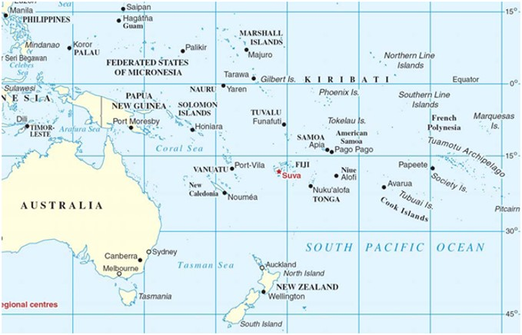
Project activities are taking place in Tonga, Niue, Tuvalu and the Marshall Islands

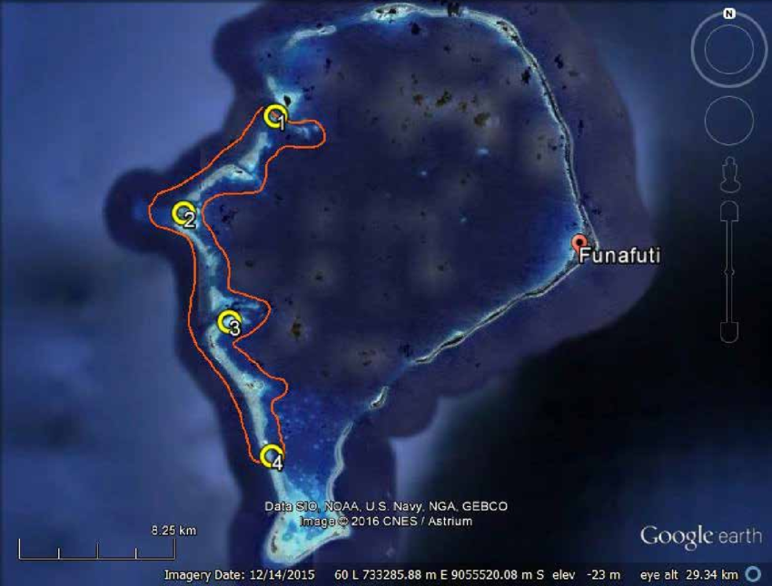

Funafuti Atoll, Tuvalu: Islands in the Funafuti Conservation Area in Tuvalu have been survey and assessed to be free of rodents. Neighbouring islands are currently being surveyed for eradication operations in 2023.
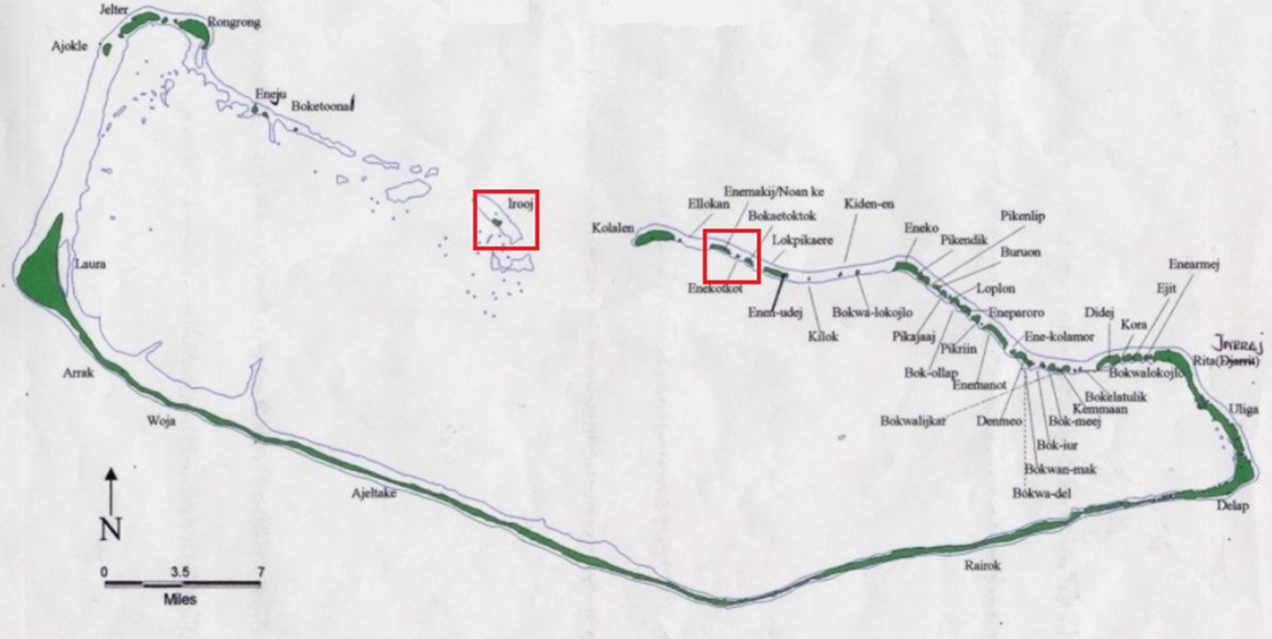Majuro Atoll, Republic of Marshall Islands
Irooj Island had a successful rodent eradication operation in March 2022. The operation was managed and delivered by a local team with remote support provided by Island Conservation. Eneja and Boketoonal were surveyed and assessed as rodent free. Enemak, Enekotkot and Bokaetoktok are being assessed for eradication operations in 2023. All rodent free islands have an interisland biosecurity protocol established to ensure they remain rodent free

confirmed sources of Co-financing for the project by name and by type
Please complete for all projects at MTR and TE Stages
Please include evidence for co-financing for the project with this form (please add rows as necessary)
Sources of Co-financing | Name of Co-financier | Type of Cofinancing | Investment  Mobilized | Amount ($)
Recepient Country Government | Republic of Marshall Islands | Inkind |  | 105930
Recepient Country Government | Niue | In kind |  | 789231
Recepient Country Government | Kingdom of Tonga | Inkind |  | 441423
Recepient Country Government | Tuvalu | Inkind |  | 250409
Civil Society Organisation | Island Conservation | Cash |  | 2122726
Civil Society Organisation | Island Conservation | Inkind |  | 287754
Other | Manaaki Whenua Landcare Research |  |  | 2008904
Other | Victoria Link |  |  | 160731
Other | SPREP | Cash |  | 2798698
Other | SPREP | Inkind |  | 551884
Total Co-financing |  |  |  | 9,517,690
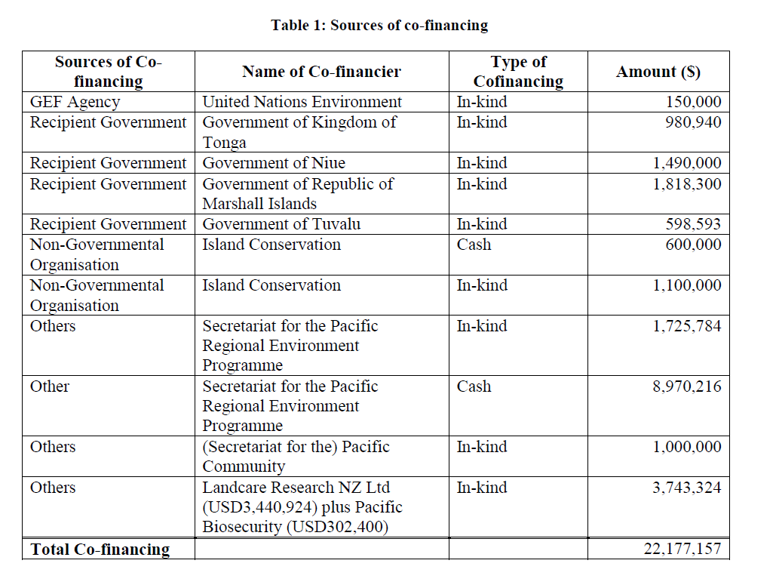

For joint projects and where applicable ratings should also be discussed with the Task Manager of co-implementing agency.
Use GEF Secretariat required six-point scale system: Highly Satisfactory (HS), Satisfactory (S), Marginally Satisfactory (MS), Marginally Unsatisfactory (MU), Unsatisfactory (U), and Highly Unsatisfactory (HU).
Apart from Ratak Imperial Pigeon for which there is an estimate, there are no estimates possible for the other species albeit they are recognised as threatened. Indeed, estimating population size of even common species of herpetofauna is technically virtually impossible. Capture indices are usually the best that can be possible and these are fraught with technical problems and certainly have never been corroborated with independent population counts. The number of secure populations indicated is also an estimate because the exact distribution of these species is not known. However with post IAS control/eradication monitoring a better handle on the quantitative benefits to these species should be possible. Green and Hawksbill turtles have a regional distribution including many countries and territorial waters so predictions of benefits to population size are not feasible. Hence it is more practical to signal the number of beaches used by breeding females which will benefit from reduced predation from introduced species.
Population size of the various rodent species is not known before eradication but the successful removal/eradication of these species can be determined using established protocols and techniques and this will be done. Eradication of these predatory species will be evidence of successfully removing the risk of extinction of the threatened endemic species identified above.
As much as possible, describe in terms of immediate gains to target groups, e.g. access to project deliverables, participation in receiving services; gains in knowledge, etc.

