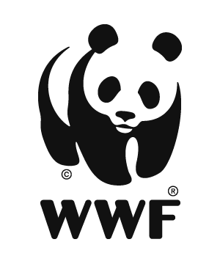
WWF GEF Agency
Project Implementation Report

Title: Coral Reef Rescue: Resilient Coral Reefs, Resilient Communities (GEF ID: 10575)
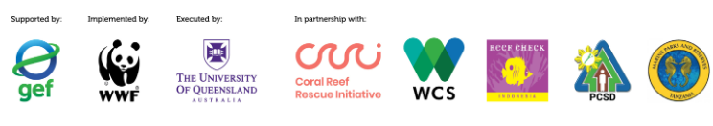

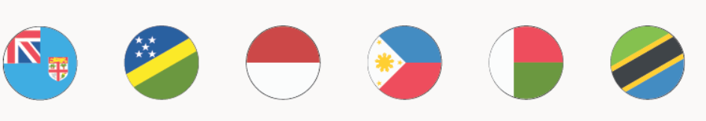
Project Report information:
Report Author(s) | Jacquelyn Beattie
Report Completion Date | 8/25/2025

1. General  Information | PIR Submission Date | 15 September 2025
1. General  Information | Agency Approval Date | 11 November 2022
1. General  Information | Fiscal Year | 2024/2025
1. General  Information | Implementation Status (1st PIR, 2nd PIR, Final PIR) | 2nd PIR
2. Current Year Ratings | Overall Development Objective rating | MS
2. Current Year Ratings | Overall Implementation Progress rating | MS
2. Current Year Ratings | Overall Risk rating | L
3. Key dates | Implementation Start Date | 8 March 2023
3. Key dates | Expected Mid-Term Review Date | September 30 2025
3. Key dates | Expected Completion Date | 31 March 2027
3. Key dates | Expected Financial Closure | 31 October 2027
4. Budget | Total Project Budget in USD (please distinguish GEF trust fund from LDCF, GBFF and SCCF funding) | USD 6,925,000 GEFTF
4. Budget | Total GEF disbursement (USD) through June 30 of the FY for project that has been in implementation for at least 1 FY | USD 1,699,596 GEFTF
4. Budget | Co-finance identified at project CEO Endorsement | USD 71,338,533
4. Budget | Materialized Co-finance to Date in USD (per annual partner co-finance reporting letters) | USD 8,560,401.32

PMU Contact information:
Project Position | Name | E-mail
Project Manager | Jennifer Dunn | jennifer.dunn@uq.edu.au
Management and Administrative Support | Benjamin Breen | benjamin.breen@uq.edu.au
Project Coordinator | Matthew Glue | m.glue@uq.edu.au
Finance Contact | Sarah Bradley (Contract and Grants Accounting) | fbs.research.central@uq.edu.au

WWF GEF Contact information:
Project Position | Name | E-mail
Project Manager | Jacquelyn Beattie | jacquelyn.beattie@wwfus.org
Safeguards Specialist | Adrienne McKeehan | adrienne.mckeehan@wwfus.org
Project Advisor | Isabel Filiberto | Isabel.Filiberto@wwfus.org
Gender Specialist | Edmond Odaba | edmond.odaba@wwfus.org
Results Based Management Specialist | Amelia Kissick | Amelia.kissick@wwfus.org
Finance and Operations | Tracey Smith | Tracey.smith@wwfus.org

Instructions:
The WWF GEF Project Manager is responsible for completing the PIR in coordination with the Project Management Unit. It may be necessary to consult with other experts for current data (e.g. Safeguards, Gender, RBM, etc). Please include the following annexed documents:
- Completed Tracking Tool with Results Framework and Annual Work Plan and Budget Tracking (for project year)
- Tracking tools (eg. METT), if applicable
- Knowledge Management products (if links were not provided in the section directly)
- Other supporting documents: meeting minutes, stakeholder consultation, photos, maps, reports, etc.

Ratings

 | Year 1 | Year 2 | Year 3 | Year 4 | Year 5 | Year 6 | Year X
Development Objective | MS | MS
Implementation Progress | U | MU
Risk | L-M | L

Justification for Current Year Ratings:
Development Objective Rating:
Moderately Satisfactory
While the achievement rating of 62% is calculated against the results framework for Year 2, there was a significant amount of progress made across 5 of the 6 project countries – with many of the Year 2 targets exceeded.

The WWF GEF Agency notes the complexity of implementing a Global project across six countries, each with its own institutional context and coordination challenges. Despite this complexity, there has been substantial progress made to date against the workplan, particularly the success of UQID in building awareness and educational material for Coral Reefs, fostering strong partnerships, and maintaining momentum despite initial delays. The project's latest achievement is the final signed execution agreements with sub-executing entities in all 6 countries, with Philippines joining implementation in June, 2025.

Targets fell short in GEF Core Indicator 11 due to several of the activities identified to be contributors to this indicator being pushed into project Year 3. These included the additional learning events and communities of practice from Component 1 so that countries had the opportunity to engage in consultations with the Component 1 global team as to the topics of these events to best suit their needs. Additionally, at the country level in Component 2, community visioning meetings in country priority areas continue into Year 3 as does the delivery of the capacities and conditions strengthening program. As discussed below, Component 3 activities were limited in Year 2, but will advance as Year 3 takes shape.

The PMU contracted Terranomics as the global consultant to support work under Component 3 in November of 2024 (Project Year 2 Q3). Given the onboarding process and the initial introductions to the National Technical Facilities (NTFs), Terranomics focused appropriately on laying the groundwork for Component 3 by producing a well-researched Benchmarking Study which will act as a resource guide for countries moving forward and engaging NTFs in the sectoral analysis for lead contributors to coral reef degradation. Component 3 did not progress beyond this in Year 2, and did not meet the Indicator 3.1a target. However, relationships are well established, many countries are onboarding a national sustainable blue economy consultant, and the project is well placed to make strong advances into Component 3 in Year 3.

Implementation Progress (IP) – Moderately Unsatisfactory
The project received a moderately unsatisfactory Implementation Progress rating, as 46% (104/234) of the work plan indicator targets for Y2 in the AWPB were achieved. This score resulted from several different factors including: Activity 1.2. becoming an optional activity as Outcome 1.2 was altered to better reflect what was achievable with both time and money across this outcome (6 countries were targeted to complete this activity in Year 2 - Indonesia completed this activity in Year 2 and other countries are working towards this); despite a huge amount of work accomplished in Year 2 including significant catch-up from Year 1, NTFs goals were lofty when creating workplans for Year 2 and several activities are being pushed out into Year 3 across all NTFs.

Action Plan to Address MU rating
Action 1: Improving the effectiveness of workplan mobilization and NTF level review of project activities. This will be achieved by combining multiple activities into single events, to reduce administrative costs, event/hosting and traveling logistics and the burden ons takeholders. Additionally, some consultancies have been combined into one TOR to cover multiple activities, s (for example one consultancy to conduct the costs/benefits analysis and threats/opportunities analysis) and the PMU will continue to suggest that NTF’s utilize this method for planning their activities, when applicable. Adaptive management has been seen across the workplans in the countries. For example; in Madagascar, the recruitment of multiple consultants will significantly increase the mobilization of the project workplan, supporting the project to achieve project targets. For Fiji, the workplan has been assessed and following consultation with the PMU and the WWF-GEF team, revisions have been made to the project outputs. The revised outputs include changes from a cost benefit analysis (several of which have already been completed by partnering agencies) to a policy gap analysis, which will be more beneficial and will further bolster the National Action Plan for Coral Reefs.
Additionally, the project has learned from creating too great a workload for completion in one year and therefore will scale back the intended activities for Year 3. Some of the activities that were originally planned will no longer be relevant to delivering the project objectives and therefore will be removed from the project. Changes in the project strategy have been explained in the adaptive management section.

Risk Rating- Low
There are a few factors that contribute to the Low risk rating, entered as Low in this PIR, most notably there are only two risks identified as moderate residual risks after project implementation. The NTF in the Philippines will need time and support in developing capacity for implementation as they join project activity implementation at the start of Y3. This may cause a delay in the anticipated workplan. Additionally, political instability and conflict remain a risk in the project countries but are considered a moderate risk to project outcomes. The project risks and mitigation methods are detailed in the risk section.

Progress, Challenges, and Outcomes on Project Implementation
(Based on Outcomes, Challenges, and Safeguards sections of the Progress Report)

In Year 2, the project achieved significant progress across the five implementing countries and the global component team. Key structures such as National Hubs and technical working groups were effectively established and strengthened, enabling inclusive multi-stakeholder engagement and integration of traditional knowledge. Community visioning exercises and gender-sensitive capacity building advanced equitable participation. Critical threat and opportunity analyses informed the development of national action plans. Government agencies and local partners demonstrated increased commitment and alignment with national priorities. While some delays in formal approvals and agreements impacted certain activities, adaptive management and workplan adjustments ensured continued momentum. In Year 2, the global team demonstrated strong adaptability and progress. University of Queensland’s shift to a new online course hosting platform improved accessibility and engagement, with positive feedback on country-specific course content. The team successfully pivoted from the 2024 discontinuation of the National Oceanic and Atmospheric Administration (NOAA) Coral Reef Watch (CRW) program for data support, to develop a multi-source decision support tool through key partnerships and stakeholder input. Key learning courses were launched and well-received (as noted in post-course surveys and testimonials) while needs assessments informed national knowledge strategies. Progress on near-real-time monitoring tools and data management training also advanced. In Year 2, progress was made under Component 3 and 4 in advancing financial solutions and knowledge management components. Engagement with national teams laid the groundwork for developing sustainable finance strategies, supported by sectoral analyses and stakeholder consultations. The global communications strategy was further developed through workshops and increased visibility at key events. Monitoring and evaluation systems (the Coral Huddle) were strengthened, with improved data collection and an upcoming reporting dashboard (completion expected in early May 2025) to enhance transparency and tracking of project progress. Overall, Year 2 results reflect strong advancement toward project objectives and lay a solid foundation for Year 3 implementation.

- The project has demonstrated considerable strengths and adaptability, making up for delays in the first year of project implementation. Key Achievements and Outcomes the past calendar year have included;Positive recognition from the GEF Secretariat and on
- The project was able to officially begin implementation in all six countries this year. In the Philippines, the Department of Natural Resources (DENR), together with the National Technical Facility (Palawan Council for Sustainable Development), convened meetings with the Project Management Unit (PMU) and the WWF GEF Agency. These government-led discussions culminated in the signing of the execution grant agreement between the NTF in the Philippines and the lead executing agency.
- the global stage through active engagement with the IW:LEARN News letter and IW:LEARN website, including recognition as a “best case example” project from the past 30 years of the GEF International Waters portfolio.
- The project played a dynamic role at the 10th International Waters Conference (IWC10), held from September 21 to 26, 2024, in Uruguay. It co-hosted an engaging interactive booth within the “Innovation Marketplace,” where project management staff and government partners connected with participants for three days to share insights about coral reefs and the Coral Reef Rescue project. Additionally, with project sponsored government representatives from project countries, the project led a well-received clinic session on “How to Increase Coral Reef Resilience,” fostering knowledge exchange and practical solutions.
- Strong adaptive management was demonstrated through the project’s ability to a) adjust the hosting platform for the online learning courses when the University online learning platform was no longer available, and to b) adjust the work plan to address the loss of NOAA Coral Reef Watch data support, which disrupted the original tool development strategy under Component 1.

Products created during Y2 include;

- Outcome Yr 2 Evaluation
- Global Needs Assessment Results Outcome
- GEF CRR Benchmarking Study_FINAL
- Indonesia - Training Needs Assessment
- Indonesia - Monitoring and Reporting Needs Assessment
- Solomon Islands – Threat & Opportunities Analysis
- Solomon Islands – Cost Benefit Analysis
- Solomon Islands – GEDSI Analysis Report
- Fiji – GESI Action Plan
- Fiji – Coral Reefs Threats and Opportunities Analysis
- Terranomics - Methodology and Outline of Sectoral Analysis
- Sectoral Analyses of Main Drivers of Coral Reef Degradation and Short Tech Report/Summary for Each Country
- CRR GEF Communications Strategy_Final
- CRRI_MultiDonorAnnualReport_FY24
- IWC Summary
- Needs Assessment Results Outcome
- Outcome Knowledge Proposal
- Outcome Follow-Up Survey Results
- Project Inception and National Vision_Fiji
- Proposal for Decision Support Resource Tool

Component 1: Capacity Strengthening for Coral Reef Management
Strengths:
The global team demonstrated strong flexibility, including a smooth transition from the edX platform to the more accessible Extend platform, which better serves country-level participants. Online courses were enhanced with country-specific case studies, improving relevance and resonance with national stakeholders, and stakeholder feedback has been consistently positive regarding usability and responsiveness to user needs. In response to setbacks with the National Oceanic and Atmospheric Administration Coral Reef Watch (NOAA CRW), the team pivoted to develop a multi-source decision support tool integrating satellite data, supported by partnerships with Truii and the Natural Capital Impact Project. The team’s active engagement in a NOAA-facilitated working group with ReefCloud, the Marine Ecosystem Resource Monitoring and Assessment for Improved Decision-making (MERMAID), and CoralNet has also opened opportunities for standardized data sharing. A proposal was submitted to secure additional funding to further expand the tool’s capabilities.
Key Outcome Achievements:
Outcome 1.1 Global network of knowledge practitioners
• CRRI101x Coral Reefs: Introduction to Challenges and Solutions continues to run with a total enrolment of just under 1,000 participants as of March 28, 2025. The Indonesian translated material was launched in August 2024, with 43 learners from Indonesia utilizing the Bahasa Indonesia version.
• A new course, CRRI103x Coral Reefs: Sustainable Blue Economy, was launched March 31, 2025, in English and Indonesian and continues to be promoted by the PMU.
• Needs assessment findings were circulated to countries and informed the knowledge proposal development. Subsequently, the vision, framework, and proposal were approved by national hubs.
• A learning strategy evaluation workshop on March 27, 2025, reviewed Year 2 progress and engaged country partners to plan for Year 3, with a draft evaluation report circulated.
Outcome 1.2 Near-real time monitoring data and information
• A contract with Truii, a Brisbane-based IT consultancy, is in place for the development of an interactive decision support tool linking CRR stakeholders to global and local coral reef resources specific to their needs. Feedback from NTFs on the resource list has been incorporated.
• UQ signed a Letter of Understanding with Truii for the Natural Capital Impact Project, using the CRR project as a case study, which includes the development of a free report card valued at approximately $500,000.
• UQ Component 1 team participated in an AI and Coral Reef Monitoring working group led by the Australian Institute of Marine Science and NOAA Federal, receiving valuable feedback for the CRR project.
• Two virtual design workshops in August 2024 gathered feedback on the decision support tool from six countries and stakeholders, followed by surveys for refinement.
• Strong progress on the CRRI102x online course, developed in collaboration with AIMS ReefCloud and WCS, addresses data collection and management training for Outcome 1.2.

Challenges:

The project has faced several challenges across both its online learning and decision support tool components. Developing universally relevant course content for a diverse global audience has required extensive tailoring and the creation of localized guidance for facilitators, which has been resource-intensive. Country teams, already stretched across multiple project components, have had limited capacity to co-develop online course materials, limiting deeper collaboration. In some countries, delays in establishing National Hubs have slowed the planning and delivery of locally relevant learning events. Additionally, the loss of NOAA Coral Reef Watch data support—due to shifting U.S. priorities and the departure of a key partner—caused uncertainty and disrupted the original tool development strategy under Outcome 1.2. Progress was further hindered by internal contracting delays and difficulties in accessing key external datasets such as those from Coral Research & Development Accelerator Platform (CORDAP).

Funding Disbursement and Co-Financing;

Project disbursement has been lower than anticipated due to delays and low spend during the start up year. The Year 3 workplan and anticipated disbursement is expected to increase in rate during Year 3. Materialized cofinance is lower than expected at Year 2, in part due to delays in the anticipated GCF project that will contribute to the objective of this GEF project.

Country-Level Strengths, Outcomes and Challenges;

Fiji
Overall Implementation: With a realistic workplan in place this project year, most targets were successfully met.
Strengths and Outcomes During Implementation:
- A community visioning workshop in September 2024 gathered 60 participants (30 male,30 female, 10% youth) to integrate Traditional Ecological Knowledge (TEK) and develop a shared vision for reef ecosystems. Gender-sensitive capacity building activities informed a program to address community gaps, planned for Year 3. A Video product from the workshop was created by WCS and shared with project partners (attached to this report)
- Strong grassroots enthusiasm and engagement from communities, stakeholders, and the Department of Environment were evident.
- Visibility of the project has grown through consistent communications and international bulletins.
- Positioned under the National Ocean Policy Steering Committee, The National Hub for Coral Reef Conservation (NHCRC) has a membership of 27 individuals (17 male, 11 female) spans multiple sectors and was formalized in January 2025.
- Threat and opportunity analyses of Fiji’s coral reefs led by the WCS team, presented to NHCRC, emphasized drivers of coral reef health and identified opportunities/solutions to address these drivers. The outcomes from the NHCRC workshop were used to finalise the threat/ opportunity analysis approach and will inform the National Action Plan for Coral Reef Conservation.
- Three technical working groups (TWGs) were established to focus on knowledge, finance, and conservation planning, becoming active in April 2025.
- Initial collaboration with Terranomics on Component 3 began.

Challenges:
- Delayed formal endorsement of the NHCRC and its Terms of Reference due to staff turnover and government travel schedules.
- Slow stakeholder feedback for Component 1 activities due to competing priorities (e.g., COP16 preparations).
- Challenges arose due to delays in establishing the national hub and the extended recruitment process for the Marine Technical Advisor.
- Postponed Activities: Certain planned actions were affected, including the finalization of the threat/opportunity analysis (draft completed but pending national hub review), the development of the national communication strategy and full implementation of the community capacity strengthening program.

Indonesia

Overall Implementation: Some activities were not integrated into the schedule and have been carried over to Year 3.

Strengths and Outcomes During Implementation:
- All terms of reference (TOR) for hiring consultants to lead community representation in national hubs, threats and opportunity analysis and cost/benefit analysis in component 2 have been developed and are awaiting approval at the next National Hub meeting (Year 3 Q1).
- Several meetings/workshops have been held to consolidate and write up the National Action Plan for Coral Reefs (outline has been developed) and for the conservation of climate refuge reefs.
- Engagement from government and Reef Check (the NTF) was strong at the IWC 10, with both partners presenting on the project during a learning session.
- National Hub formalization includes multi-stakeholder representation, with plans for clarified roles and institutional integration in Q3–Q4.
- Steering Committee member from the Directorate of Ecosystem Conservation ensures alignment with national KPIs and blue economy priorities.
- Several meetings and workshops have been held to consolidate and draft the National Action Plan for Coral Reefs (outline has been developed) and for the conservation of climate refuge reefs.
Challenges:
- Year 2 focused on establishing foundational structures (working group, task force, and national hub).
- The Ministry of Marine Affairs and Fisheries (MMAF) was heavily engaged with other initiatives (e.g., USAID projects), limiting availability for GEF7 CRR engagement.
- Reef Check (NTF) gradually improved coordination by adjusting staff portfolios and refining event planning and reporting. Additionally, MMAF is expected to have greater availability for GEF7 project engagement in Q1–Q2 of Year 3.
- A sub-grant agreement between Reef Check and UQID has been signed, however, government registration of the project with MMAF remains pending while clarity is sought on the requirements under the Ministerial Regulation of Marine and Fisheries, No. 4, 2024 about foreign grants. The project is operating some activities, while the lack of registration limits other activities, such as public communication and campaign efforts.
- Plans are in place to finalize registration of the project in coordination with the PMU, WWF GEF Agency, and other partners within the current year.

Madagascar

Overall Implementation: workplan activities such as the initial formation of National and Regional Hubs and synergizing these with existing networks have progressed successfully through Y2

Strengths and Outcomes During Implementation:
- The project was launched with two key meetings to establish the National Hub (Plateforme Nationale de Concertation et de Coordination des Récifs Coralliens – PNCCRC), during which WCS provided participants with a clear understanding of the project’s objectives, components, and the structure of the National Hub.
- Around 65% of identified National Hub entities attended the meetings, contributing to the validation process both in-person and online.
- March 2025 meeting advanced consultant ToR validation and engagement with the reef network, with plans to integrate them into thematic groups.
- Hiring of a dedicated Marine Science Advisor was successful in Y2.
- Key workplan activities such as the initial formation of National and Regional Hubs and synergizing these with existing networks have progressed successfully through Y2.
- The NTF is currently processing multiple TORs for national consultants to support with project implementation such as the cost/benefit analysis, Threats/ opportunities analysis, gender analysis, and economic sectoral analysis, with all TOR’s validated by national hub participants.

Challenges:
- Postponed Activities: Due to the delays in staff recruitment, Y2 activities were postponed including community visioning meetings, threats and opportunity analysis and the cost benefit analysis.
- Budget Adjustments: Underspending caused by delays in implementation has been reallocated to the Y3 budget.
- Difficulty organizing meetings for the small core committee and national hub, due to last minute changes, mis aligned schedules and competing priorities resulting in frequent rescheduling of planned meetings.
- Limited collaboration with the reef network during the second year.

Philippines
Overall Implementation: Delayed implementation and therefore limited delivery of the workplan due to lack of operational agreement between country partners and the executing agency.

Strengths and Outcomes Made to Progress Towards Implementation:
- A meeting with the Department of Environment and Natural Resources (DENR), the Palawan Council for Sustainable Development (PCSD), the UQID Project Management Unit (PMU), and the WWF GEF Agency focused on reviewing project achievements, clarifying roles of in-country subgrantees, and finalizing the draft grant agreement between DENR and UQID. The following months saw the signing of the operational agreement and official beginning of project implementation.
- A workshop with the NTF, PCSD, was held to revise the Year 3 workplan. Activities were adjusted to reflect the remaining timeline, with emphasis on gender inclusion, clarification of partner roles, national hub progress, and ultimately identifying a total funding amount needed. This amount aligns with UQID and WWF projections, ensuring sufficient support for the Philippines to project close, while allowing surplus funds to be reinvested in global project implementation.
- PCSD is working with government to ensure strategy alignment with the Coral Triangle Initiative on Coral Reefs, Fisheries, and Food Security (CTI-CFF) and the National Coral Reef Conservation Strategy (NCRCS).
- PCSD Participated in knowledge proposal reviews; and their feedback was incorporated.
- The Philippines CTI National Coordinating Committee has accepted to be the National Hub.
- The inception workshop is planned in Sept/Oct 2025.
Challenges:
- Delay in the operational agreement between UQ and DENR delayed any funding to be allocated to activities in the first two project years, even while the NTF contributed time and effort to provide project feedback and inputs;
- A revised workplan (assuming two years of project implementation in the Philippines) identified a number of activities, primarily within Component 3 and 4, as unachievable in the 2-year time frame remaining, and these activities have been removed from the workplan.
- The PMU is now beginning to build reporting capacity of the NTF and troubleshoot fund administration which requires additional time.

Solomon Islands
Overall Implementation: Most planned activities were successfully executed, achieving the majority of workplan targets.

Strengths and Outcomes During Implementation:
- Technical Working Groups were created to support hub formation, stakeholder analysis, cost-benefit work, and finance solutions.
- A gender-sensitive stakeholder analysis was conducted to strengthen engagement strategies and inform capacity-building efforts.
- Work has begun on the National Action Plan for Coral Reefs and a dedicated communication strategy for coral reef conservation in Solomon Islands.
- The government and key stakeholders have been actively integrated into the National Hub through the development of workplans and budgets aligned with the Ministry of Environment, Climate Change, Disaster Management, and Meteorology (MECDM).
- Threat/opportunity and cost/benefit analyses were finalized and presented to National Hub members to achieve consensus.
- Continued strong engagement with local communities and integration with provincial government stakeholders, ensuring consistency and alignment.
- Use of provincial government officers to effectively support activities in remote, geographically scattered areas.
- Community visioning was completed in Central, Malaita, and Isabel Provinces, with 265 participants (65% male, 35% female; 62% youth)—exceeding gender and youth inclusion targets.
- Face-to-face surveys were completed and used to complete the Component 1 needs assessment, overcoming participation challenges.
- Meetings with senior government officials have raised awareness of the project’s importance.
Challenges:
- Delays occurred in key areas, including community visioning, consultant report submissions, and the recruitment of the Marine Technical Advisor.
- Postponed Activities: Some planned actions were impacted, including the development of the national communication strategy (rescheduled post-global communication strategy workshop) and the implementation of the community capacity strengthening program (affected by community visioning delays).
- Delays led to underspending, with unspent funds reallocated to the Year 3 workplan.
- Limited engagement from stakeholders due to time constraints, lack of awareness, and unstable internet connectivity. Solomon Islands NTF also noted the need to socialize the project to enhance the visibility of the project at a national level.
- Inconsistent attendance at National Hub and TWG meetings, and logistical difficulties in reaching remote case study areas.

Tanzania
Overall Implementation: The workplan followed the schedule, with some delays impacting key milestones.

Strengths and Outcomes During Implementation;
- Conducted a gender-differentiated analysis to identify gaps in capacities and conditions for effective community representation in the National Coral Reef Hub and Tanzania's National Action Plan for Conservation of Resilient Coral Reefs (NAPCRC).
- The NTF, Tanzania’s Marine Parks and Reserves Unit (MPRU), established a TWG, facilitated by an expert, to develop and implement a gender-sensitive capacity strengthening program addressing the identified gaps. This program was delivered to project communities, ensuring inclusion of all suggested groups, and support of ongoing implementation throughout the project duration. A comprehensive stakeholder analysis was conducted to identify key stakeholders to join National Hub meetings, with these groups then invited to all National Hub meetings.
- Established a TWG to integrate traditional knowledge and community visions into national strategies.
- Conducted multistakeholder workshops in project areas (e.g., Tanga Sea Scape, Mafia, Lindi, Pemba Channel Sea Scape) to support inclusive participation and to aid the development of shared visions for coral reef conservation, governance, and decision-making.
- Consolidated community visions into an overarching plan for resilient coral reefs and inclusive governance.
- Using insights from multistakeholder meetings and community visions, a draft National Action Plan for Conservation of Resilient Coral Reefs (NAPCRCR) was developed (Activities 2.2.3.1, 2.2.3.2, 2.2.3.5) with its early versions undergoing review.
- The threat/opportunity analysis is well underway and will be publicized and included as a chapter in the National Coral Reef Status Report and NAPCRCR.
- Implementation demonstrated strong cooperation from the Ministry of Livestock and Fisheries (MLF), with active involvement from its Permanent Secretary and Director of Fisheries, also the CRRI National Steering Committee Chair.
- Marine Parks and Reserves Unit (MPRU) longstanding relationships with stakeholders, NGOs, and community groups interested in conservation, was reinforced through active involvement and partnerships this year.
Challenges:
- Delay in finalizing the cost-benefit and threats analysis affected the timeline for official endorsement and completion of critical project documents.
- Delayed fund transfers due to stringent international banking requirements and the National Microfinance Bank system sensitivities.
- Some project deviations occurred due to implementation challenges but were approved by the PMU.

Component 3: Financial solutions for resilient coral reef rescue
- A benchmarking study was completed by the consultant group Terranomics, where 12 blue economy technical assistance programs were assessed. The study will be a resource guide for NTFs moving forward.
- Engagement was initiated by Terranomics, all active NTFs during Y2 to begin progress on Component 3 activities.
- Two webinars were delivered with NTFs on the findings of the benchmarking study and to receive their feedback.
- The draft outline and methodology for the Sectoral Analysis was prepared by Terranomics and NTFs were engaged to provide input and on-the-ground knowledge – continuing into Year 3 Q1.

Component 4: Knowledge management and Monitoring & Evaluation
- UQ’s Centre for Communication and Social Change (CfCSC), was contracted by the PMU to provide global support to design a communications strategy, identify key narratives and audiences, build basic capacity, and develop and implement a work plan. They conducted an in-country workshop with nine participants in Bogor, Indonesia in February 2025. Two additional workshops in Fiji (w/Solomon Islands) and Tanzania (with Madagascar) are planned for project year 3.
- The PMU, WCS Fiji, jointly with the Department of Environment, and Reef Check Indonesia, along with Ministry of Marine Affairs and Fisheries, presented at the GEF International Waters Conference (IWC10) in September 2024.
- The IW:Learn project webpage continues to be populated with recent news stories from NTFs and global partners and is also now the landing page for all online courses developed by the Component 1 global team.
- Year 3 AWPBs were received from all countries and global teams.
- National Hub Reflection meetings were held by most countries, notably Solomon Islands, Fiji, Tanzania. Indonesia to hold theirs in early/mid-April due to holidays in March.
- The Coral Huddle (Project M&E Portal) continues to receive inputs from all NTFs regarding their activity progress and submission of evidence and data for review by the PMU. The final stage, delayed due to web development issues, is to activate the dashboard with support from Palo IT. The reporting dashboard will allow NTFs, global teams, G-PSC, and the public to track progress against the workplan and results framework indicators. This is expected to be fully functional by end of May 2025.

Safeguards Progress and Outcomes:
The project Communications Strategy outlines the process for lodging any grievances raised amongst stakeholders including guidance for NTFs to establish GRM processes in each project country. The grievance redress mechanism is available via the UQ Project website https://global-partnerships.uq.edu.au/coral-reef-rescue-project and the Project website via IW:Learn https://coralreefrescue.iwlearn.net/about/grievanceredressmechanism A QR code has also been provided to countries to include in stakeholder presentations and on banners displayed at workshops. No grievances were reported in Year 2.
Fiji: The NHCRC includes stakeholders from government, NGOs/CSOs, academia, private sector, and communities, identified through consultations with the Department of Environment. A plan is being developed by the knowledge unit TWG to better engage non-indigenous Fijian ethnic groups reliant on marine resources. Stakeholders are informed of the grievance mechanism during workshops, with space for discussions; no grievances raised.
Indonesia: Inclusive communication includes Bahasa translations and a “buddy system” for vulnerable stakeholders. Project updates are shared via Reef Check Indonesia’s website and social media in collaboration with MMAF, with ongoing improvements to engagement.
Madagascar: Safeguarding efforts focus on strengthening environmental and social management in the North-West landscape, developing a landscape-specific safeguarding manual, updating PGES to align with the PAG, and recruiting a dedicated safeguarding officer. The complaints mechanism is being enhanced based on early feedback; no issues reported. A field mission to Nosy Be in April 2025 will further refine strategies.
Philippines: No Activities have begun yet
Solomon Islands: The grievance process follows the global communication strategy, with awareness-raising during workshops and opportunities for discussion; no grievances raised in Year 2.
Tanzania: MPRU implements the grievance mechanism per the global strategy, with contact details shared at presentations and drop boxes placed in regional offices. Stakeholders are regularly refreshed on the process during meetings; no grievances lodged this year.

Progress, Challenges, and Outcomes of Stakeholder Engagement

(Based on Stakeholder Engagement Plan (SEP) or equivalent included in the ProDoc)
Major Progress and Outcomes:

Government Engagement & Steering Committee Meetings
The project has maintained strong coordination and engagement with governments of each project country. The Global Project Steering Committee (G-PSC), composed of government representatives from all project countries, convened virtually in October 2024 to review progress, share key learnings, assess the Annual Work Plan and Budget (AWPB) at the mid-point of Year 2 implementation, and facilitate dialogue between global and national teams. The meeting was well attended and productive. Additionally, a GEF Coral Reef Rescue (CRR) collective virtual meeting in July 2024 brought together five of the six participating countries to exchange updates and discuss challenges, with another session planned for Year 3. Government representatives from Fiji and Indonesia also participated in the 10th International Waters Conference (IWC10) in Uruguay, joining the Project Management Unit (PMU) and GEF Agency to highlight the national hub model and the project’s inclusive, country-led approach.

Private Sector and Other Organization Engagement
The project has fostered strong private sector and organizational collaboration to support key technical components. Global partnerships with organizations such as NOAA, the Australian Institute of Marine Science (AIMS), Allen Coral Atlas, Wildlife Conservation Society (WCS), CARE, CSIRO, Ocean Fox Advisory, and the University of Tasmania have been instrumental in developing both the online courses and the Decision Support Tool (DST). Truii, an Australian data consultancy, is leading the design of the DST and a beta version of a reef health report card, with translations underway in Bahasa Indonesia and French, and plans to expand into Fijian, Pijin, Tagalog, and Swahili to broaden accessibility. Additionally, Palo IT continues to support the development of the Coral Huddle monitoring and evaluation (M&E) platform, enhancing project tracking and learning

Component 1 (Global Stakeholder Engagement)
The University of Queensland’s School of the Environment (UQ SEnv) collaborated with country teams to establish goals for the needs assessment survey. A total of 96 responses were collected (45% female, 53% male) with broad representation across countries, age groups, and stakeholder types. Courses are being co-designed based on participant input, with tailored content to address specific needs. The gender and inclusion expert (Pranati Mohanraj, CARE) is embedded throughout the process to ensure inclusive course development and responsive feedback loops.

Project Management Unit (PMU) Coordination
- Monthly coordination meetings continue between PMU and national/global teams to discuss implementation, troubleshoot issues, and celebrate achievements.
- WhatsApp channels were created for informal cross-country exchanges. While initial uptake during IWC10 was positive, follow-up use has been limited.
- A collective virtual meeting in July 2024 brought together five of the six project countries to share experiences and reinforce inter-country communication. A similar Year 3 session is planned with greater emphasis on dialogue and learning.

Country Level Progress and Outcomes of Stakeholder Engagement

Fiji – Progress and Outcomes
- The National Hub for Coral Reef Conservation (NHCRC) includes civil society, academia, government, indigenous groups, private sector, and international partners.
- NHCRC Inception Workshop: 54 participants (23 male, 31 female; 17 youth), ensuring cross-sectoral and gender-inclusive representation.
- Community Visioning Workshop: 60 participants (equal gender balance; indigenous, elder, and youth voices included).
- The NHCRC was established collaboratively by MECC, WWF Pacific, and NTF.
- Regular monthly project meetings are held among in-country partners and the PMU.
- Challenges include scheduling conflicts for stakeholders and transport logistics for community participants.
Indonesia – Progress and Outcomes
- Strong national-level engagement with MMAF, BRIN, NGOs, local governments, universities, and coral reef experts during National Hub dialogues, workshops, and virtual meetings.
- Active participation from diverse organizations and institutions has positively impacted the project.
- The “buddy system” was implemented in project target areas to support grassroots stakeholders (local communities, indigenous peoples), fostering trust, confidence, and inclusivity, and addressing language barriers.
- A Reef Check Indonesia representative and a sponsored Indonesian government member played a key role at the IWC10 conference by hosting a session connecting community groups, government agencies, civil society, and GEF representatives, enabling cross-sector dialogue and highlighting the value of in-person engagement.
- Challenges: While gender-balance among government delegates is not possible due to appointment processes, the project is using participatory approaches such as sticky note activities to encourage gender balanced input in meetings
Madagascar – Progress and Outcomes
- WWF Madagascar, WCS, and the Ministry of Environment have worked closely since April 2024 to advance the project, integrating the CRR initiative into the Blue Economy Cluster—a national platform of ministries, NGOs, CSOs (including MIHARI), and private sector actors.
- In May 2024, the cluster endorsed the inclusion of the National Hub.
- A regional hub in Diana Region is being supported through local engagement and participation, including during the Nosy Be launch event.
- Nosy Be Launch: 38 stakeholders (37% women) including ministerial representatives, NGOs, community groups, and researchers.
- Stakeholder mapping and involvement ensure ownership by target stakeholders and alignment with national and local context.
- Representation has included the Ministries of Environment, Fisheries, Tourism, and Territorial Planning; NGOs (WWF, WCS, Madagascar National Parks); research institutions (IH.SM); and the MIHARI platform of Locally Managed Marine Areas.
- Across two national hub platform setup meetings, around 65% of involved sectors participated actively.
Philippines – Progress and Outcomes
- Meeting with DENR, PCSD, and the UQID PMU reviewed project achievements, clarified roles of in-country subgrantees, and finalized the draft grant agreement between DENR and UQID.
- Workshops with PCSD and DENR representatives were held to draft the Year 3 Annual Work Plan and Budget (AWPB).
Solomon Islands – Progress and Outcomes
- Stakeholder engagement across ministries (Environment, Fisheries, Planning, Tourism, Culture & Tourism, National Planning & Development, Foreign Affairs & Trade), NGOs (WWF, TNC, WorldFish, Live and Learn), academia (SINU), and communities in Malaita, Isabel, and Central Provinces.
- Involvement from the Solomon Islands Marine Authority, provincial governments, and ecological/economic consultants in various events.
- Engagement with CBOs, including the Solomon Island Rangers Network.
- National Hub and Technical Working Groups (TWGs) established with Terms of Reference for meaningful engagement.
- Workshops, community visioning, and reflection activities prioritized inclusive participation.
- Challenge: Inconsistent engagement across sectors and individuals.
Tanzania – Progress and Outcomes
- Multi-stakeholder workshops held in key local areas with participants including district officials, ward representatives, council members, parliamentarians, law enforcers, religious leaders, elders, BMUs, CBOs, and private sector actors (e.g., hotels, diving centers).
- Regional-level participation included Regional Commissioners, Administrative Secretaries, Fisheries Officers, and security body representatives (police, immigration, navy, defense).
- National-level collaboration with universities (IMS, UDSM, Sokoine), NGOs (WWF, TNC, Sea Sense, MWAMBAO), and donor partners (IUCN, USAID Heshimu Bahari, EACOP).
- Strong involvement from BMUs during training in Kilwa, with media and local radio used for broader awareness.
- Importance of BMUs and Village Liaison Committees (VLCs) is being assessed for coral reef governance.

Key Challenges for the Project Stakeholder Engagement:
Across the GEF CRR countries, several common challenges to stakeholder engagement have emerged. Scheduling conflicts have affected participation in meetings and workshops, particularly in Fiji and Solomon Islands, where key stakeholders were often unavailable or dispersed. Transportation and logistical costs have hindered community involvement, especially from remote areas. Government representation creates a challenge to receiving gender-balanced participation in meetings, particularly in Indonesia. In Solomon Islands and Tanzania, inconsistent engagement across sectors and individuals was noted, and in Solomon Islands and Madagascar, geographic isolation has limited outreach to local communities. Additionally, language and trust barriers require tailored approaches ), and the long-term success of participatory structures depends on sustained coordination and resource availability.

A key lesson learned to date across the entire project is the need to enhance project visibility at both the national and global level through diverse stakeholder engagement. Attendance at the IWC10 provided an opportunity to share approaches and outcomes with fellow IW practitioners, with an increase in online learning course enrolments in the week after the event showcasing the importance of sharing such outcomes at different national and global fora. At the global level, with exception of attendance at such events, there are no project funds within the existing budget to enable travel (for the PMU and project team members from different countries to meet in person). The value of building relationships through personal connections is important to enrich sharing and networking, thus enhancing project outcomes.

Information on Progress on Gender-Responsive Measures

(As documented in the ProDoc, Results Framework, the Gender Action Plan or Equivalent)
Please provide the completion dates for: the gender assessment or analysis and gender mainstreaming strategy/action plan (GEF-7) 12/07/2021
Component 1 – UQ-Led Course Development (Global)
- A gender and inclusion specialist has been engaged throughout the development of the needs assessment and knowledge proposal, and continues to provide feedback and support in course planning.
- A gender-sensitive approach is integrated across all courses. This includes both explicit content on gender and inclusion theory and practice, and implicit efforts to ensure the experiences and needs of all groups are reflected in course materials.
- Course design and development involves a diverse team of contributors—men and women from various socio-cultural and academic backgrounds. Learning activities encourage consideration of multiple perspectives, particularly from underrepresented or marginalized groups.
- Online delivery supports greater accessibility, especially for women, by addressing traditional barriers to participation in professional development. To overcome limitations in remote areas, downloadable and printable course materials have been developed. A future ‘cascade model’ is also being explored, enabling participants to share learning within their own communities.
- Gender and social inclusion expert Pranati Mohanraj (CARE US) continues to provide technical guidance throughout the course development process.

Country-Level GEDSI Integration
Fiji
- WCS Fiji uses the Capacity and Gaps Analysis for Strengthening Community Representation on Fiji CRR National Hub – 10/01/2024 GEDSI guidelines.
- A socially inclusive and gender/age-balanced approach guides workshop planning and invitations.
- Inception Workshop (NHCRC launch & national visioning): 54 participants (23 male, 31 female, 17 youth), including indigenous elders.
- Community Visioning Workshop (TEK for coral reef conservation): 60 participants (30 male, 30 female, 6 youth).
- The WCS Gender Officer led in-depth discussions on gender equality, diversity, and social inclusion, encouraging sharing of personal experiences of inequality before transitioning to group work, aligning with the Gender Action Plan (GAP).
Indonesia
- All stakeholder meetings have consistently reached 25–40% female participation, with strong engagement in discussions.
- A female consultant was hired to lead the country-level needs assessment (Component 4), with gender balance experience prioritized in consultant TORs.
- A plan is being developed to mainstream and disseminate coral reef conservation information to diverse stakeholder groups, supporting inclusive learning. This remains an ongoing agenda item in working group meetings.
Madagascar
- At the project launch in Nosy Be, 36% of participants were women, many considered potential National Hub members.
- The ToR for recruiting a gender analysis consultant was reviewed and validated by stakeholders; recruitment is underway.
- Gender-responsive strategies have been integrated since project inception.
- Second National Hub Meeting: 46% women, 20% youth.

Philippines
- During meetings and consultations with the Palawan Council for Sustainable Development and DENR, there was representation from approximately 30% female representatives.
- The project has not begun project activities as of yet therefore there has been no other progress on the gender action plan.
Solomon Islands
- The Gender TWG reviewed the national gender-sensitive institutional governance analysis, identifying persistent gender imbalance in conservation/environmental institutions.
- The report recommends gender-responsive actions aligned with the GAP to amplify voices of women, men, and youth.
- Although a gender specialist in environmental conservation is lacking, WSC sought technical support from a sister organization.
- Workshops and consultations emphasize social inclusion, enabling vocal participation by women in the male-dominated fisheries/environment sector.
- Women are engaged as focal points at the community level; schools identified as important partners in the communication strategy.
Tanzania
- Gender Assessment: 12/07/2021 (GEF-7)
- GEDSI Analysis & Workshop: 01/11/2024
- A gender-differentiated analysis identified capacity and condition gaps for effective community representation in the National Coral Reef Hub and NAPCRC.
- A TWG, facilitated by an expert, developed and delivered a gender-sensitive capacity strengthening program in project areas, with ongoing implementation planned.
- Multi-stakeholder workshops in Tanga Seascape, Mafia, Lindi, and Pemba Channel Seascape ensured inclusive participation and shared visions for coral reef conservation and governance.
- The gender desk officer from the Ministry of Livestock and Fisheries contributes actively to training design, gap analysis, and community visioning, advocating for women in leadership in the male-dominated fisheries sector.
- Workshop invitations ensured a 40–60% gender balance, with intentional outreach to women in sectors like fish retail and processing.

Knowledge Activities / Products

(When Applicable, as Outlined in Knowledge Management Approach in the ProDoc)
The Project been developing products, documenting best practices and utilizing an integrated knowledge management platform to track its achievements. For the International Waters Conference 10 in Uruguay, materials had to be for the GEF packaged to highlight the project’s recognition as a “best case” from 30 years of the GEF International Waters portfolio and demonstrate lessons learned during project start up and how techniques for some countries are being replicated in others.
The Project has also strengthened relationships among NTFs, Coral Reef Rescue Initiative focal points and global partners and the UQ School of Environment (global). These strong working relationships have facilitated knowledge sharing and cross-country learning. For example, knowledge exchange across the six country NTFs—coordinated by the PMU—has included WhatsApp channels, regular meetings and shared templates/examples between countries, increasing the NTF’s ability to report back timely to the PMU and reducing heavy administrative workloads. Key Achievements and activities towards enhancing Knowledge Management and producing products to capture knowledge from the project were made in the past year. These included;
- Through the the development and distribution of the Communication Strategy to country teams, the project has documented how to engage in cross-country sharing and learning, with ideas for replication of best practices. One example of this is the Philippines sharing “small reef-dependent businesses” as a category of stakeholders that NTFs could coordinate with to promote engagement with the online learning course. This was then replicated by other countries.
- A project specific website has been developed (using the IW:Learn platform) as a mechanism to enhance visibility of the project and an informal WhatsApp group has been established to enable informal sharing between countries.https://coralreefrescue.iwlearn.net/
- The project team (PMU, NTFs and Government focal Ministry representatives from Fiji and Indonesia and WWF GEF Agency) represented the GEF CRR project at the IWC10. This provided an opportunity to share the national hub approach with fellow IW colleagues and also gather information and techniques for increased stakeholder engagement from other IWC Representatives.
- Participants in the IWC10 were able to interact with the PMU and take a short quiz on coral reef science to further engagement with the project in a CRR booth that was designed and run by PMU.
- The GEF Coral Reef Rescue project was selected as one of 30 projects to highlight the 30 year anniversary of the GEF International Waters program Discover GEF International Waters' interactive globe.
- The Component 1 global team (UQ X) launched the Indonesian translation of CRRI101x and the IWC10 provided an opportunity to promote the course amongst Indonesian representatives (with an increase in Indonesian participants noted in the week following IWC10).
- The Component 1 team (UQ X) developed promotional and marketing materials for online courses

Products
- Collective knowledge is power when tackling the challenges faced by our climate - resilient coral reefs – IW:Learn Portfolio Bulletin (IW:LEARN | News -> Collective knowledge is power when tackling the challenge... (iwlearn.net)
- Global Development at UQ Update Report 2023-2024, Digital_GlobalDevelopmentatUQ_23-24.pdf
- Coral Reefs at Risk – Social Posts through LinkedIn, Facebook, and X
- Launch of Fiji National Hub – Media News Report, Fiji One News on Facebook
- Coral Reef Rescue Project Website - https://coralreefrescue.iwlearn.net/
- Fiji's commitment to coral reef conservation: Ensuring resilient reefs with launch of new national hub – IW:Learn Portfolio Bulletin (Fiji’s commitment to coral reef conservation by IW:LEARN - Exposure (iwlearn.net)
- Indonesian translation CRRI101x Coral Reef LinkedIn
- WCS-Fiji led workshop aimed at strengthening community voices for coral reef conservation – Facebook
- The GEF International Waters Conference was a powerful reminder of the global collaboration needed to protect our oceans – Socials Post through LinkedIn, Facebook, and X
- UQ-led Coral Reef Rescue project contributes to the Global Environment Facility International Waters Conference - UQ Global Partnerships Website – https://global-partnerships.uq.edu.au/article/2024/09/uq-led-coral-reef-rescue-project-contributes-global-environment-facility-international-waters-conference
- Fiji’s LinkedIn Post: 10th GEF Biennial International Waters Conference (IWC10) in Uruguay
- CRRI Multi-Donor Annual Report 2023-2024 (Appendix 4.3)
- Coral Reef Rescue Initiative Newsletter – September 2024 - 🪸CRRI Newsletter September 2024 (mailchi.mp)
- Empowering Communities, Strengthening Reefs: Uniting voices for coral conservation in Fiji Coral Reef Rescue | News -> Empowering Communities, Strengthening Reefs: Uniting voic... (iwlearn.net)
- Coral Reef Rescue: Ensuring Resilience for Solomon Islands’ Vital Coral Reefs and Communities – My SIG Services Portal
- Premier of Malaita Province Supports Coral Reef Rescue Initiative – My SIG Services Portal
- Government announces Coral Reef Rescue project | Theislandsun
- Coral Reef Rescue Initiative: 2024 Highlights Report
- Strengthening Coral Reef Conservation: A Global Collaborative Effort in the Face of Climate Challenges – IW Learn
- #FijiOneNews (Facebook Video)| Fiji hosts a diverse range of coral reefs - including fringing, barrier, patch, and atoll reefs, which are critical to the nation's marine biodiversity, and the livelihoods of local communities
- Fiji Village - Fiji’s coral reefs under threat, urgent action needed
- University of Queensland - Build your capacity in coral reef conservation with free online courses
- UQ Global Partnerships Website – Component 1 Course Promotion
- Tanzania - World Oceans Day Preparations - 06/06/2023
- Tanzania – Blue Economy Potential 20/04/2025
- Tanzania – Marine Reserves a tourist attraction 25/01/2025
- Tanzania - MATUMBAWE IS A MAJOR TOURIST ATTRACTION - DC KILWA 29/01/2025

Reflows (for NGIs only)
Note: This field is not publicly disclosed.
N/A

Adaptive Management
Please check all applicable modifications made to the project during this reporting period noting a description of the change, justification for the change and the date of No-Objection given by the WWF GEF Agency. If not applicable, please leave blank. Please see guidance on definitions and procedures for Major and Minor Amendments. Note: it is recommended that all changes be discussed in advance with the GEF Program Manager.

Category of change | Description of the change | Justification | Date of No-Objection by WWF GEF
Major Amendments
☐Project Scope
☐ Project Objective
☐>5% Increase in financing
Minor Amendments
☒Results framework | Indicator 1.2a: remove ‘registered’ users and just measure user visitations. | The purpose of outcome 1.2 is to increase the use of data in decision making. The team discovered that many community members do not have an email address (e.g. fishermen in Indonesia often have phones but no email). Requiring users to register for the website or report card is unnecessary for the tools being developed and will be a barrier to the use of these tools and reduce their reach and effectiveness. The decision support system should be open-access and easily accessible to everyone. In addition, requiring users to register, and collecting personal information, has privacy concerns and will be more challenging to achieve under UQ policy. | 11/05/2024
☒ Components and cost | Activity 1.2.1.2 was made ‘optional’ to all NTFs  Updated allocation of budget to the Philippines, reduction in original budget funding to Philippines in alignment with project implementation time frame. | This activity was made optional as it is no longer relevant to the success of Outcome 1.2 given the discontinuation of NOAA’s coral reef watch program.  Total Philippines country-allocated budget was reduced by approximately 1/2 to reflect the activities that the sub-executing partner believe can be executed within the remaining 2 project years, given the 2-year delay in project implementation. Government partners, PMU and NTF agreed to new total allocated budget. Reallocation of remaining funding from the original budget was approved by the GPSC to cover; a) the cost of an in-person mission to the Philippines to resolve operational agreement delays and b) coordinator and communications staff members to support the PMU and global NTFs. | 9/25/2024  05/31/2025
☐Institutional and implementation arrangements
☐Financial management
☒Implementation schedule | Activities under Component 3, lead by the PMU and a global consultant (Terranomics) remain delayed and most Comp 3 activities to be moved into Year 3.  Philippines project delayed in implementation stage – signed agreement end of Y2. Prior to the signature, the Philippines NTF (PCSD) had adapted their workplan and budget to reflect the remaining project implementation period. Activities that other countries completed in Project Years 1 and 2 were prioritized first, with the remainder categorized as “achievable,” “completed” (including some activities within Component 1), or “forgo – no longer achievable.” Much of the Component 3 / Sustainable Blue Economy work was removed from the workplan, as laying the groundwork for stakeholder participation and creating the national hub in the Philippines had been prioritized. Work towards component 3 outcomes will be considered in future if there is funding and time available. | Terranomics not onboarded until November 2024 and countries not yet equipped with in-country consultants to assist with this Component. Strong advances to be made in Year 3.  Support mission to Manila and Puerto Princesa City strengthened relationships in Feb 2025. A revised workplan and budget was co-designed and fully executed agreement was signed May of 2025. Activities will begin officially in Y3.  Demonstrating adaptive management, and through regular coordination and communication with the PMU, the GEF Agency and Global Project Steering Committee provided no objection to these changes in project implementation. | 11/05/2024  1/13/2025  &  05/31/2025
☐ Executing Entity
☐Executing Entity Category
☐Minor project objective change
☐ Safeguards
☐ Risk analysis
☐ Increase of GEF project financing up to 5%
☐ Co-financing
☐ Location of project activity
☐ Other: <fill in>

For any proposed or anticipated changes to the project this coming year, please describe in below section what those changes would and provide justification. Where possible, please align these changes according to the same categories in the table above. Note: It may be helpful to reference project lessons, challenges, strengths and/or the project theory of change.

The Operational Partner Agreement (OPA) between UQ and DENR was signed in May 2025 for a funding amount commensurate with the remaining half of the project implementation period. A portion of the unused budget was planned to be reallocated to global activities and agreed upon. There is remaining funding (altering Components and Cost) that has not yet been reallocated but will likely support global project stakeholder engagement and in-person workshops bringing together all 6 countries as in-person gatherings have proven to be an area of strength in the project.

Geolocation Information
Location Name | Latitude |  | Longitude | Geo Name ID | Location & Activity Description (Optional)
MECC, Fiji | -18.139164 |  | 178.432702 | 2205218  -18, 178 | Hub structure/setup meeting
WCS, Fiji | -18.146104 |  | 178.432951 | 2205218  -18, 178 | Meeting with SPREP
Peninsula Int. Hotel, Fiji | -18.146878 |  | 178.429940 | 2205218  -18, 178 | Project Inception, NHCRC launch, National Vision workshop
Labasa FC, Fiji | - 16.427134 |  | 179.374609 | 2205218  -18, 178 | Conference room for Community visioning/TEK workshop
Suva, Grand Pacific Hotel, Fiji | -18.1469 |  | 178.4225 | 2205218  -18, 178 | Inaugural meeting of the NHCRC
Mercure Hotel, Sabang – Jakarta, Indonesia | -6.182265 |  | 106.825033 | 9956232  -6.21172, 106.84479 | Meeting to Overview and Discuss AWPB Year-2 of GEF7 CRR Project (3-4 April 2024)
Akmani Hotel, Jakarta, Indonesia | -6.187291 |  | 106.825640 | 6301224  -6.26612, 106.89225 | Meeting to Establish Knowledge Unit Working Group (16-17 May 2024)
Novotel Jakarta Cikini, Indonesia | -6.195319 |  | 106.840590 | 6301224  -6.26612, 106.89225 | Meeting to Establish Capacity Building Working Group and its Task Force (25-26 June 2024)
Mina Bahari 3rd Building, Ministry of Marine and Fisheries, Indonesia | -6.179180 |  | 106.835059 | 6301224  -6.26612, 106.89225 | Meeting to develop Knowledge Unit’s Work Plan (11 July 2024; 13 August 2024)  Meeting to discuss Indonesia's position regarding International Coral Reef Initiative General Meeting 38th (4 September 2024)
Erian Hotel, Jakarta, Indonesia | -6.187245 |  | 106.829160 | 6301224  -6.26612, 106.89225 | Meeting to coordinate and prepare the draft of the National Action Plan for Coral Conservation of the 2025-2029 Period (9 September 2024)  Meeting to follow up on formulating the National Action Plan for Coral Conservation of the 2025-2029 period (14 October 2024)
Hotel Permata, Bogor, Indonesia | -6.597366 |  | 106.804814 | 1639525  -6.57083, 106.81944 | Meeting to consolidate the National Action Plan for Coral Conservation of the 2025-2029 period (01-02 Oktober 2024)  2nd Focus Group Discussion to formulate National Action Plan for Coral Conservation of the 2025-2029 period (14-15 November 2024)
Swiss Bel Hotel, Bogor, Indonesia | -6.588508 |  | 106.804185 | 1639525  -6.57083, 106.81944 | 1st Focus Group Discussion to formulate National Action Plan for Coral Conservation of the 2025-2029 period (29-30 Oktober 2024)  Meeting to develop (04-05 February 25)
Mercure Hotel, Bandung, Indonesia | -6.923588 |  | 107.611298 | 6559695  -6.91667, 107.63333 | Meeting to consolidate and present the progress of implementing GEF7 CRR to MMAF (16-17 December 2024)
Hotel Aston Inn, Pandanaran – Semarang, Indonesia | -6.985839 |  | 110.413761 | 1961855  -7.0133, 110.3923 | Meeting to consolidate Indonesia’s MPA Vision and its potential of GEF7 CRR to support (24 December 2024)
Salak Boutique Hotel, Bogor, Indonesia | -6.588865 |  | 106.804685 | 1639525  -6.57083, 106.81944 | Meeting with Global Consultant and HUB Member to co-design an Indonesia-specific engagement and communication strategy
Nosy Be_Bel Hotel, Madagascar | -13.31421 |  | 48.25899 | 1058090, | Launch of the GEF CRR project
Ankivonjy_Nosy Iranja_Iranja kely, Madagascar | -13.59498 |  | 47.81701 | 1064035, | Field visit
Ministère de l’Environnement et du Développement Durable Nanisana, Madagascar | -18.88985 |  | 47.54785 | 11944318, | First set up meeting of National Hub
Hotel Panorama Antananarivo, Madagascar | -18.91368 |  | 47.53613 | 10709040, | Second set up meeting of National Hub
Tanga Sea Scape, Tanzania. | -5.0692615 |  | 39.0975844 | 150737  -5.16667, 39.8 | Tanga City, Muheza, Pangani, and Mkinga community visioning meetings and operationalization of the Tanga Sea Scape.
Pemba Channel Sea Scape | -6.16394 |  | 39.19793 | 150737  -6.16394, 39.19793 | Zanzibar Community visioning and operationalization of the Zanzibar Hub.
Mafia | -7.85378 |  | 39.78041 | 155410  -7.85378, | Mafia Community visioning and operationalization of the Mafia Hub.
Lindi | -9.99709 |  | 39.71649 | 879281, | Operationalization of the LINDI Regional Hub.
Morogoro, PH Hotel | -6.82102 |  | 37.66122 | 153220, | NTF Annual Budget and Activity Plan preparations.
Dar Es Salaam, Tiffany Diamond Hotel | -6.83523 |  | 39.19597 | 16020, | NH Workshop for data needs assessments
KIBAHA District, Destiny Hall. | -6.76273 |  | 39.00312 | 11006103, | NH Workshop for the analysis of community gaps and development of the training program.
Kilwa Local Hub | -8.98173 |  | 39.51722 | 157380, | NTF Execution of the training Program
Tanga Sea Scape, Tanzania. | -5.0692615 |  | 39.0975844 | 150737, | Tanga City, Muheza, Pangani, and Mkinga community visioning meetings and operationalization of the Tanga Sea Scape.
MECDM, Honiara, Solomon Islands | -9.43333 |  | 159.95 | 2108502, | Meetings with focal government, TWG meeting
MFMR, Honiara, Solomon Islands | -9.43333 |  | 159.95 | 2108502, | Meetings with MFMR
Nggela, Solomon Islands | -9.0895 |  | 160.2646 | 2105067, | Community Visioning
Malaita, Solomon Islands | -9.01748 |  | 160.95392 | 2106553, | Community Visioning
Isabel, Solomon Islands | -8.05379 |  | 159.13696 | 2108262  -, | Community Visioning
Point Cruz, Honiara, Solomon Islands | -9.43333 |  | 159.95 | 2108502, | TWG Meeting (CBA, T/O)
Heritage Park Conference Room, Honiara, Solomon Islands | -9.43333 |  | 159.95 | 2108502, | Inception, Reflection workshops
Honiara Hotel, Solomon Islands | -9.43333 |  | 159.95 | 2108502, | Validation workshop

Risks
Examine whether the project faces substantial risks in terms of the achievement and sustainability of project results. First identify the individual risks (internal and external) that the project is facing and rate those according to the rating scale (you may take both probability and impact into consideration). These are the inherent risks (or baseline risks). All of the risks will have mitigation actions to either manage or reduce the risk. After reviewing the mitigation plan for the individual risk, please project what the resulting risk would be, the residual risk – and rate according to the same scale. After assessing all individual residual risks, please determine the overall risk by averaging the individual risk ratings. In this example, the overall rating is identified as Modest given that one risk is substantial, one is modest and one is low. This rating is subjective and considered the best estimate for the average risk the project is facing in terms of achievement of outcomes. The risk rating should take into account the country setting and ambition of the project. See additional details here.

Type of Risk | Baseline /Inherent Risk Rating  (L – M - S – H) | Mitigation Plan (if “Substantial” or “High” risk) Please indicate person responsible/timeline. | Residual Risk  Rating  (L – M - S – H)
High turnover of personnel in executing agencies | M | The project requires each sub executing entity to create a video at the end of each project year explaining what the project has accomplished that year. They also create a video with plans for the following year. These are stored in a database managed by the executing entity and can be shared with any new staff. The executing agency has been recording all progress for each NTF that would be useful for new or future staff and there is no concern that those materials will be inaccessible to future users. | L
Lack of engagement from in country stakeholders | L | This would only be relevant for NTFs and has not been an issue thus far. | L
Insufficient financial resources limit the implementation of investments on the ground needed to ensure coral reef conservation measures and sustainable livelihood activities. | L | Project countries in year 2 are starting to catch up with projected spending, there is not a request for increased budget and looking back at spending, the project will not face a lack of funding. Delay in implemenation from Philippines allowed reallocation of funding from the first 2 years to other project priorities. | L
Low participation and support from key stakeholders due to competing personal priorities, inappropriate project activities, or a limited understanding of the value and importance for coral reef conservation | L | To mitigate this threat to the project, there are many stakeholder who hold others accountable. Long term plans for coral reef conservation enable guidelines for consistent engagement after the end of the project. | L
Capacity constraints of local and national institutions to undertake the required project interventions. | L | For sub executing partners that require more regular and involved guidance on how to execute the activities and distribute funding within their country there is potential for needing more support after the project ends. For these project countries, consistent implementation training tailored to each country is required and is being documented. | M
Political instability and conflict | M | NTFs work with leads at the Ministries and government authorities to monitor the situation; in the event of personnel changes NTFs continue the promotion of the project with new government staff. The PMU and WWF GEF Agency are supportive and in consistent communication with the NTFs to monitor potential instability and conflict, and troubleshoot as needed. | M
Priority site access (no access due to cyclone etc) | M | The project activities are conducted through technical assistance and are adjusted if communtiies or stakeholders are unable to be reached. Adjustments include online meetings/consultations; and shifting activity priorities if and as required. | L
Residual Risk Rating (take average of above risks) |  |  | L

Photos from the past project year:

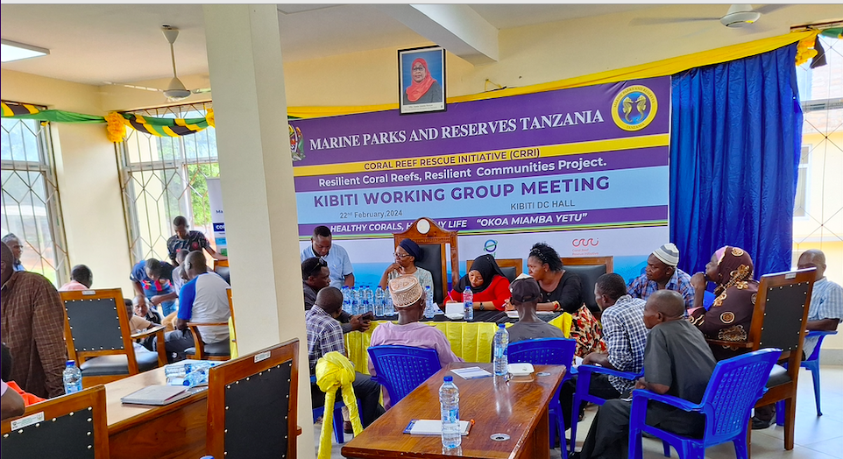
Tanzania Planning Workshop in Kibiti Site

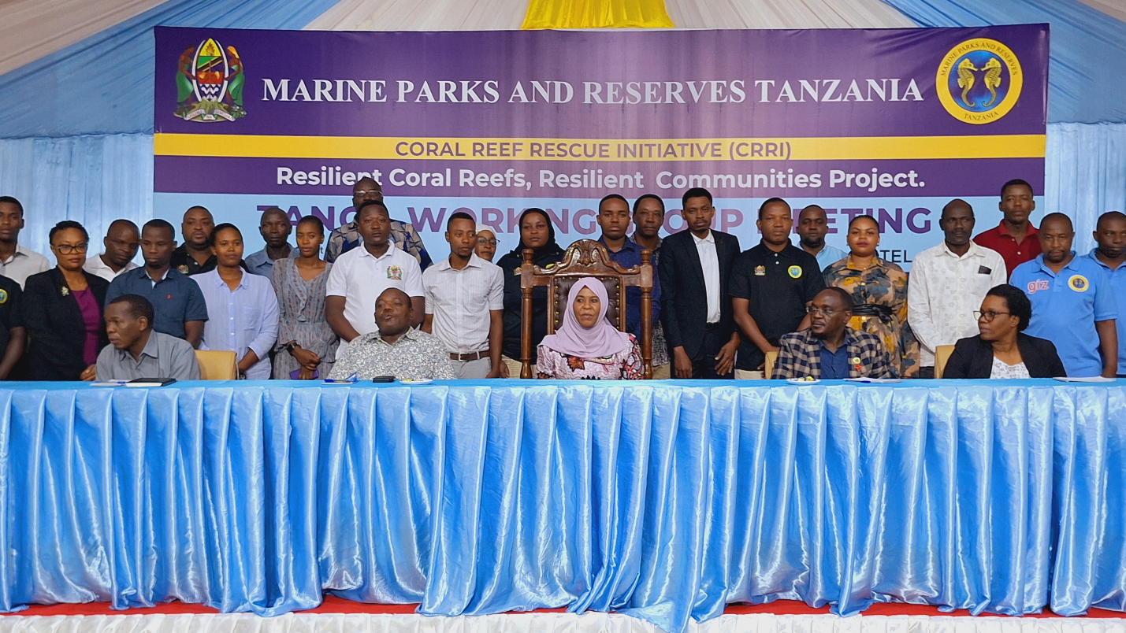
Tanzania Site Planning in Tanga Coelacanth Marine Park

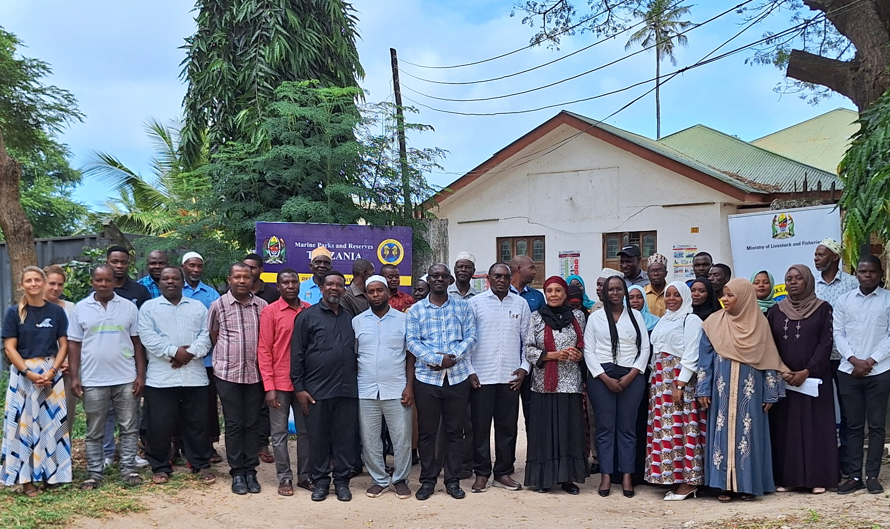
Tanzania Site Planning Zanzibar

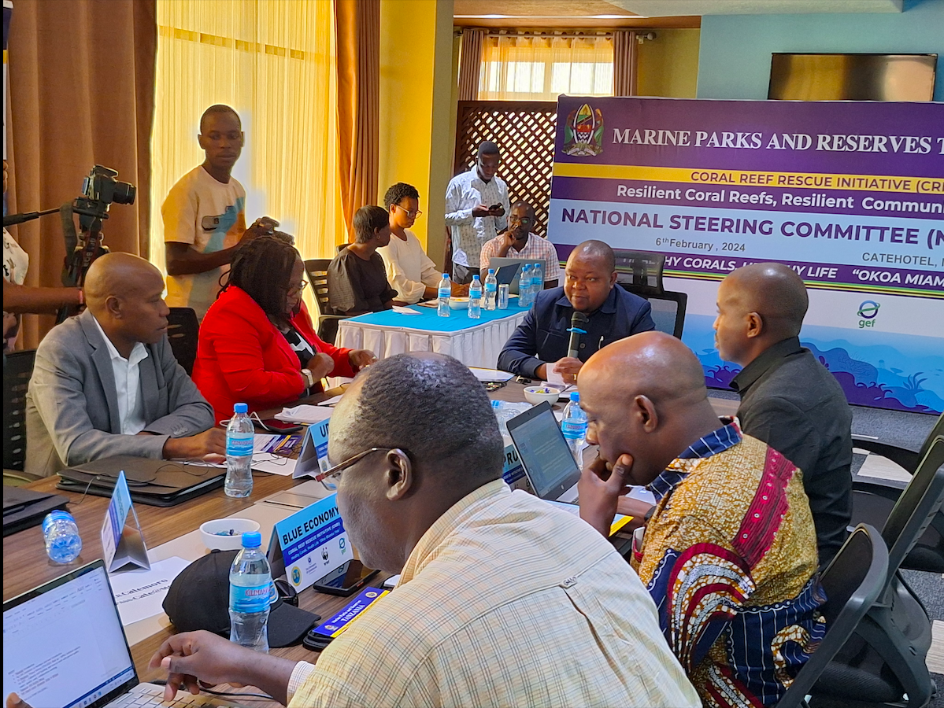
Tanzania National Project Steering Committee

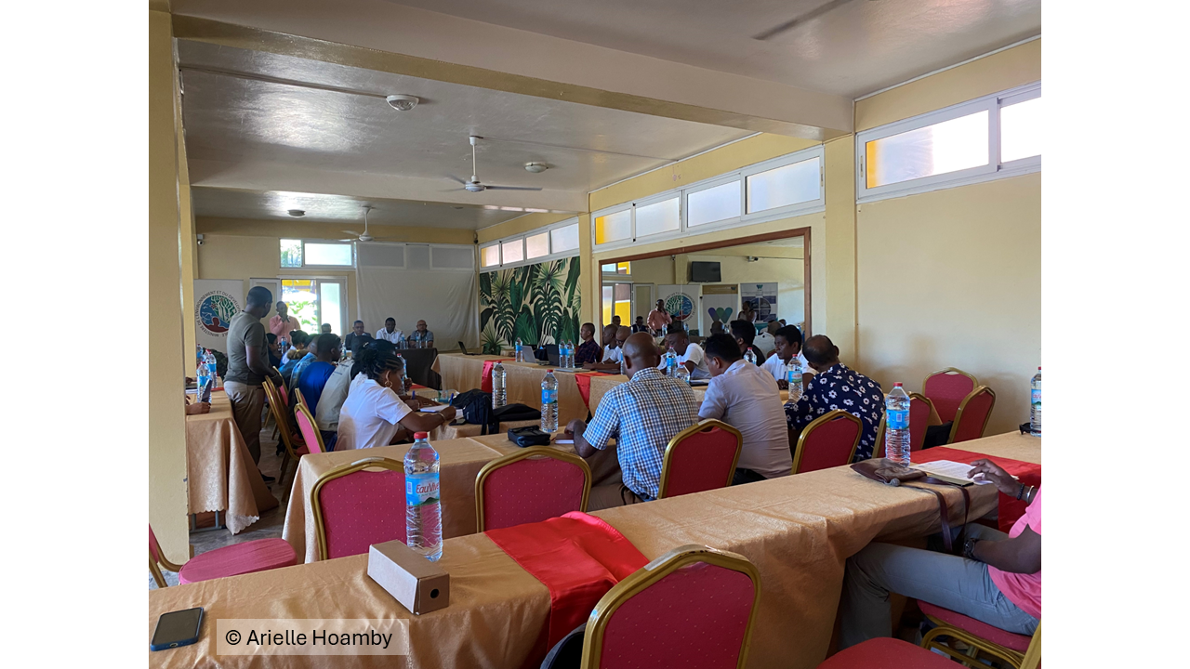
Madagascar National Hub Launch
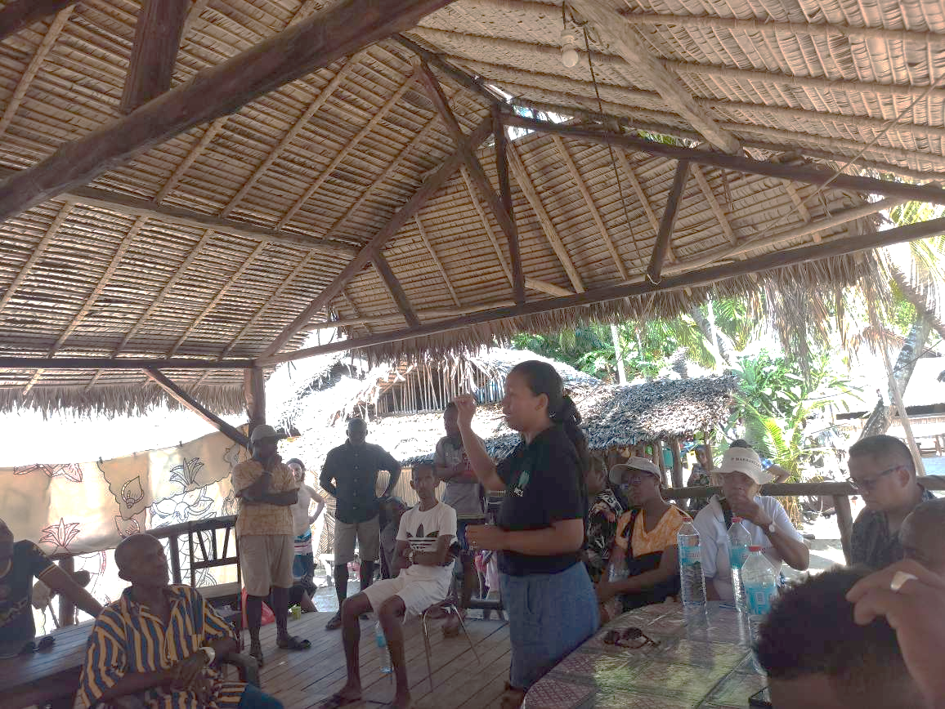
Madagascar National Hub Site Visit: Nosy Iranja

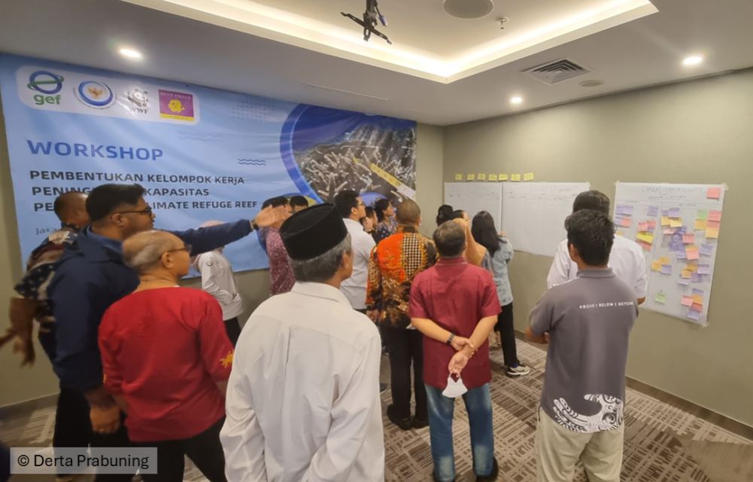

Indonesia Technical Working Group Workshop
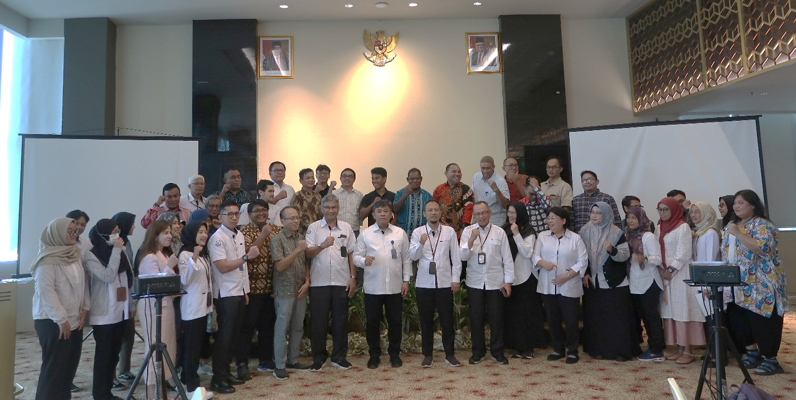
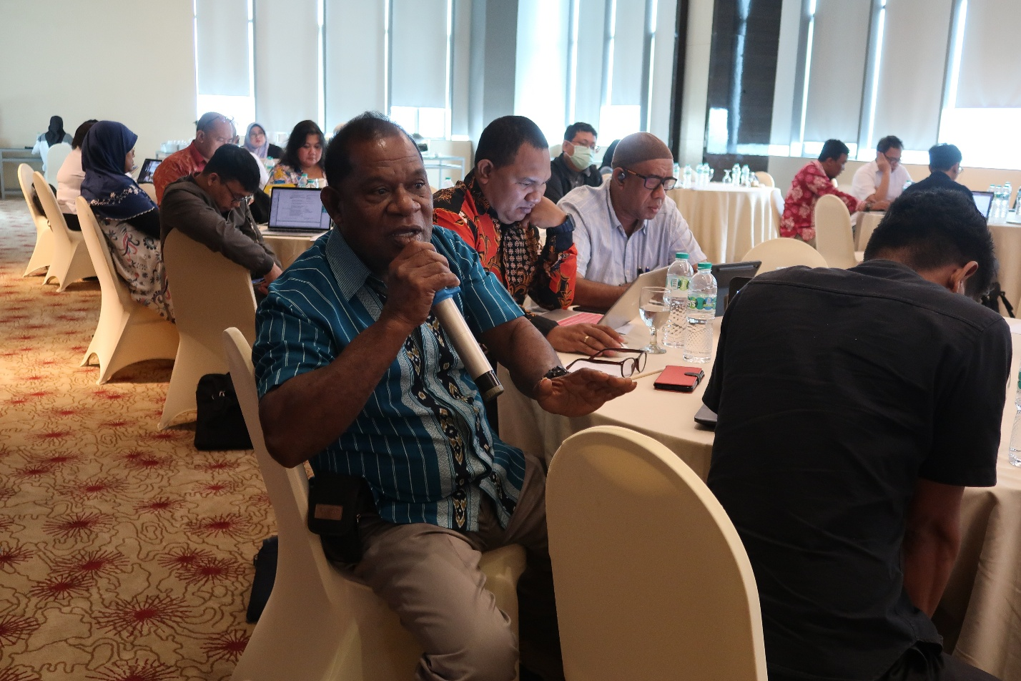
Multi-stakeholder Workshop to Develop Shared National Vision Attended by Director General of Marine Spatial Management of MMAF, and Indigenous Community Representatives
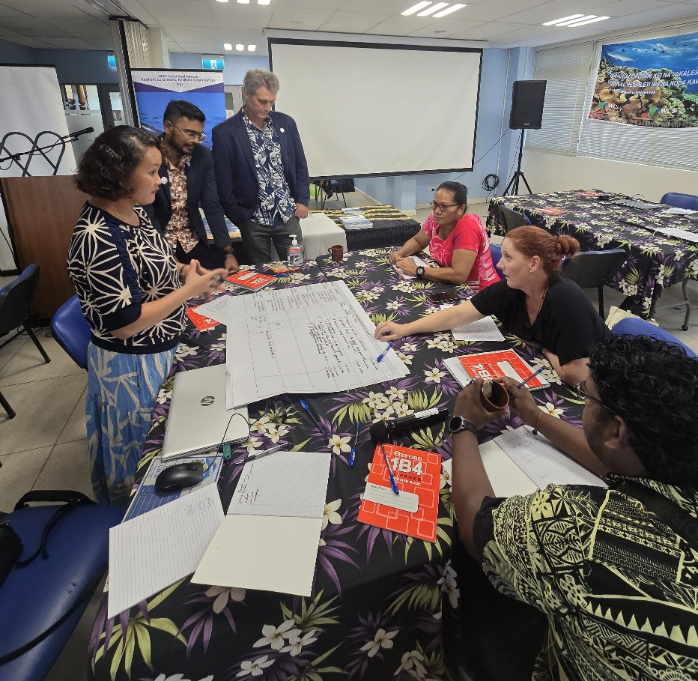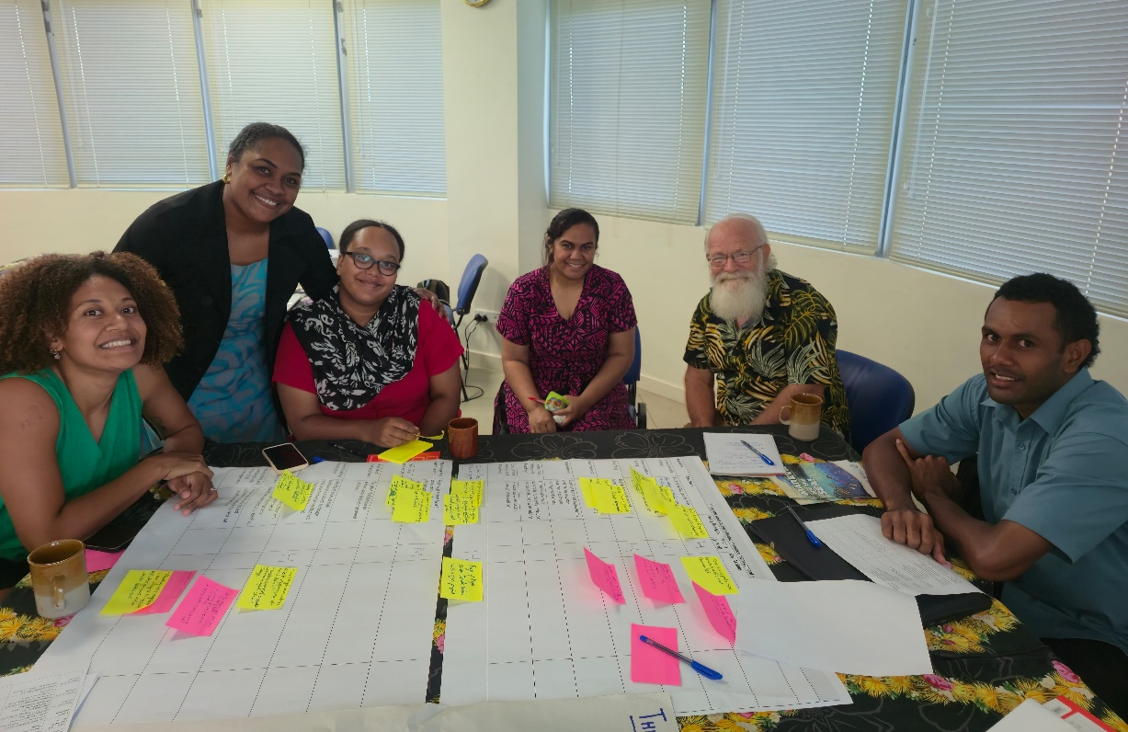
Fiji Multi-Stakeholder Dialogues and Planning

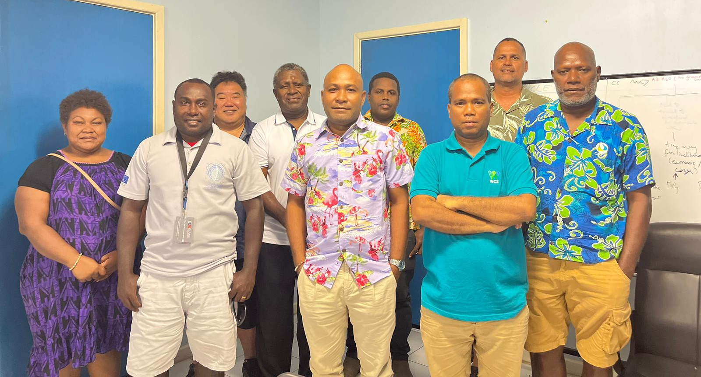
Solomon Islands Technical Working Group for Threats/Opportunity Analysis

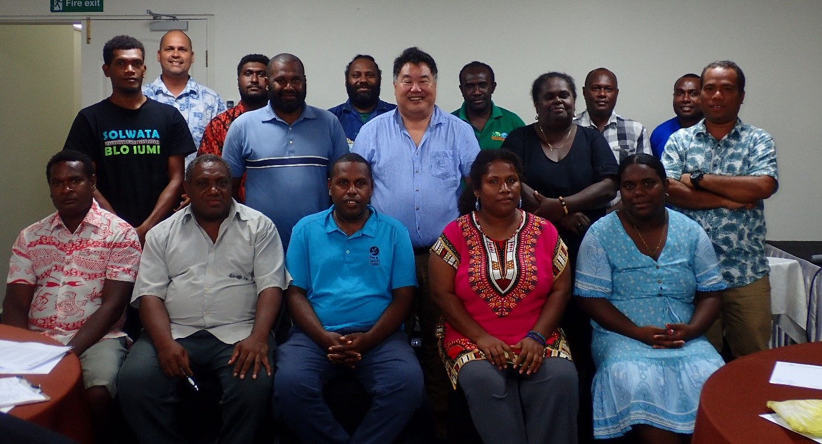
Solomon Islands National Hub inception

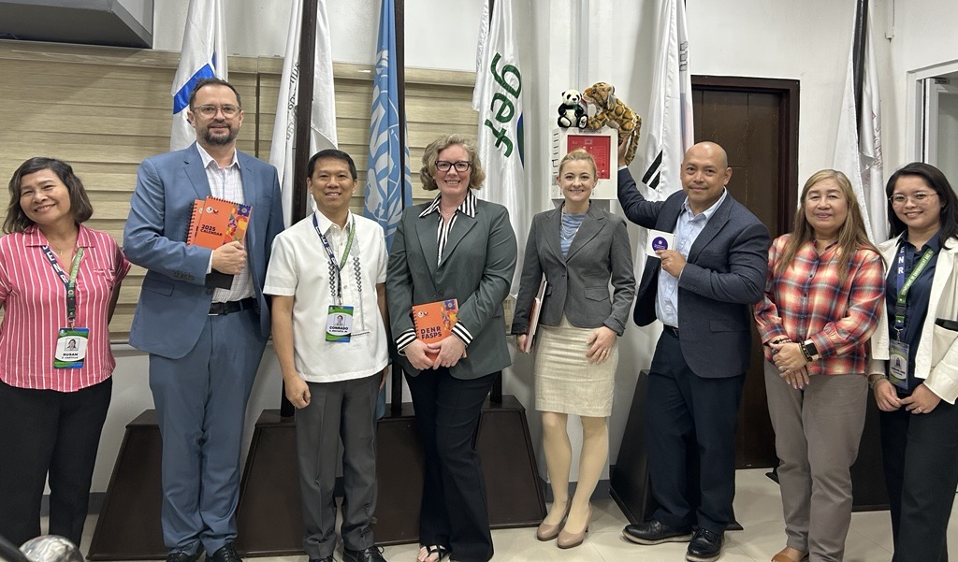
Philippines DENR and PCSD Planning Meeting

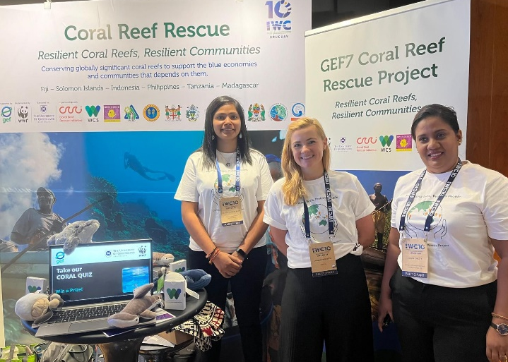
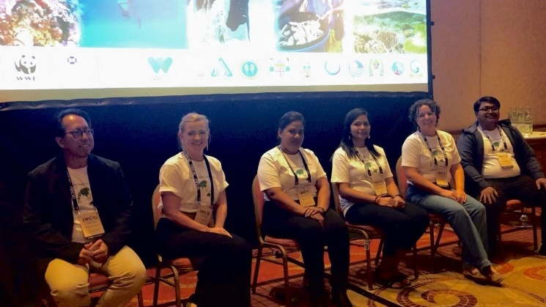
IWC 10 Conference

Reference Section M
Grant Agreement Signature
Midpoint projected from Grant Agreement signature
As specified in the CEO Approval/ Endorsement or subsequent revision.
Should be no more than 12 Months after the expected closing date. Please keep current.
Total GEF disbursement defined as amount of project budget spent by the Executing Agency, as a total from project start until June 30 of reporting FY.

