FAO GEF PROJECT DOCUMENT ANNOTATED TEMPLATE
Project Title: | Strengthening capacity for monitoring environmental emissions under the Paris Agreement in Bangladesh
Project symbol: | GCP/BGD/627/CBT
Recipient Country(ies): | Bangladesh
Executing Entity (ies)/Operational Partner (s): | Department of Environment (DoE) under Ministry of Environment, Forest and Climate Change (MoEFCC)
Implementing Agency | Food and Agriculture Organization of the United Nations (FAO)
Expected EOD (Starting Date): | 01 December 2019
Expected NTE (End Date): | 30 November 2022
Contribution to FAO’s Strategic Framework:  (Indicate as appropriate) | - Strategic Objective 2: Increase and improve provision of goods and services from agriculture, forestry, and fisheries in a sustainable manner  - Country Outcome 204: Stakeholders make evidence-based decisions in the planning and management of the agricultural sectors and natural resources to support the transition to sustainable agricultural sector production systems through monitoring, statistics, assessment, and analysis  - Regional Initiative/Priority Area: Regional Rice Initiative, Climate Change, One Health, Blue Growth
Contribution to GEF TF Focal Area Strategic Objectives and Programs: | OI3: MRV systems for emissions reductions in place and reporting verified data  OI7: Number of countries meeting convention reporting requirements and including mitigation contributions
Environmental and Social Risk Classification | low risk √ moderate risk € high risk €
Gender Marker | G0 € G1 √ G2a € G2b €
Financing Plan: GEF allocation:  Co-financing (in-kind): | USD 863,242 GEF Trust Fund  USD 1,000,000 Department of Environment
Total Budget: | USD 1,863,242
Executive Summary
This project will strengthen national capacities for measurement, reporting, and verification (MRV) in the agricultural and land-use sub-sector (AFOLU), energy, industrial processes and product use (IPPU) and waste sectors in order to help Bangladesh meet its commitments associated with the Enhanced Transparency Framework (ETF) of the Paris Agreement under the United Nations Framework Convention on Climate Change (UNFCCC).
As a Non-Annex I party to the Paris Agreement under the UNFCCC, Bangladesh has submitted Nationally Determined Contributions (NDC) to help keep climate change below a global rise of two degrees Celsius. As part of the ETF, Bangladesh has committed to certain protocols for MRV regarding progress toward its NDC targets. However, Bangladesh’s AFOLU and other sectors’ MRV systems have some capacity gaps, such as (i) establishment of nationally specific emissions factors and activity data (for IPCC Tier 2 reporting for key categories), (ii) full determination of key sub-categories, (iii) uncertainty estimates, (iv) establishment of metadata and quality-control protocols, (v) reliable measurement of activity data, in particular for key IPCC AFOLU categories, (vi) feasibility studies for adaptation-related interventions, (vii) prioritization and specification of adaptation-related metrics, and (viii) ensuring the financial and operational sustainability of MRV initiatives.
Closing these gaps requires strengthening in the following aspects:
- institutional arrangements to support the transition to ETF;
- technical capacities for mitigation-related MRV; and
- technical capacities for adaptation-related M&R.
This project is structured into three components to address these barriers.
Component 1. Strengthened national institutional arrangements and capacities to enhance MRV transparency in line with NDC activities.
Outcome 1.1. Institutional arrangements for data collection and sharing, archiving and reporting strengthened focusing on AFOLU, Energy, IPPU and Waste sectors.

Outcome 1.2. Best practice ETF reporting process, information gathering, system infrastructure and module sharing for the priority sectors of NDC, and regional Capacity-building Initiative for Transparency (CBIT) ETF program.
Component 2. Strengthened technical capacity to assess the emissions and removals, and monitor mitigation activities of NDC.

Outcome 2.1. Reporting on inventories of emissions sources and sinks with a particular focus on AFOLU, Energy, IPPU and Waste sectors, and monitoring of mitigation activities strengthened.
Component 3. Strengthened capacity to monitor and report adaptation activities in support of the NDC.

Outcome 3.1. Monitoring and reporting progress of the adaptation actions.
FAO will be the implementing agency of this project and national executing agency will be the Department of Environment (DoE) under Ministry of Environment, Forest and Climate Change (MoEFCC). Several other executing agencies will deliver substantial portions of the project’s outputs, with the aim of transitioning to sustainable, scalable, long-term operational arrangements for climate-related MRV in the relevant sectors.

GEF-7 REQUEST FOR PROJECT ENDORSEMENT/APPROVAL
Project Type: Medium-sized Project
Type of Trust Fund: Capacity-Building Initiative for Transparency


part i: project information
Project Title: Strengthening capacity for monitoring environmental emissions under the Paris Agreement in Bangladesh
Country(ies): | Bangladesh | GEF Project ID: | 9986
GEF Agency(ies): | Food and Agriculture Organization of the United Nations | GEF Agency Project ID: | 648280
Project Executing Entity(s): | Department of Environment under Ministry of Environment, Forest and Climate Change | Submission Date: | 30 May 2019
GEF Focal Area (s): | Climate Change | Expected Implementation Start | 01 Dec 2019
 |  | Expected Completion Date | 30 Nov 2022
Name of Parent Program | If applicable | Parent Program ID:
- Focal/Non-Focal Area Elements
Programming Directions | Focal Area Outcomes | Trust Fund | (in $)
Programming Directions | Focal Area Outcomes | Trust Fund | GEF Project Financing | Confirmed Co-financing
CBIT | OI 3: MRV systems for emissions reductions in place and reporting verified data. | CBIT | 431,621 | 500,000
CBIT | OI 7: Number of countries meeting Convention reporting requirements and including mitigation contributions. | CBIT | 431,621 | 500,000
Total project costs |  |  | 863,242 | 1,000,000
- Project description summary

Project Objective: Strengthened institutional and human capacities in Bangladesh to meet the Enhanced Transparency Framework (ETF) of Paris Agreement, and track the progress against priority mitigations and adaptations actions identified in the NDC focusing on agriculture, forestry and land use (AFOLU), Energy, Industrial Processes and Product Use (IPPU) and Waste sectors.
Project Components/  Programs | Component Type | Project Outcomes | Project Outputs | Trust Fund | (in $)
 |  |  |  |  | GEF Project Financing | Confirmed Co-financing
1. Strengthened national  institutional arrangements and capacities to  enhance MRV transparency in line with NDC activities. | Technical Assistance | 1.1 Institutional arrangements for data collection and sharing, archiving and reporting strengthened focusing on AFOLU, Energy, IPPU and Waste sectors.  1.2 Best practice ETF reporting process, information gathering, system infrastructure and module sharing for the priority sectors of NDC, and regional CBIT ETF program. | 1.1.1 Capacity gaps and needs of DoE for meeting the requirements of the ETF identified focusing on AFOLU, Energy, IPPU and Waste sectors.  Indicators: Capacity gap assessment report outlining the gap, and action plan to meet the ETF requirement.  1.1.2. Systematic and updated documentation and archiving system established in DoE with a focus on ETF requirements for the AFOLU, Energy, IPPU and Waste sectors.  Indicators: (i) A fully  functional platform for documentation, referencing and archiving. (ii) Number of GHG dataset focusing on AFOLU, Energy IPPU and Waste sector archived.  1.1.3 National ETF monitoring and reporting roadmaps prepared and adopted involving AFOLU, Energy, IPPU and Waste sectors.  Indicator: National ETF monitoring roadmap prepared and adopted.  1.2.1 Strengthened multi-sectoral collaboration and coordination mechanism focusing on AFOLU, Energy, IPPU and Waste sectors for national and international reporting.  Indicators: (i) Arrangement for inter-ministerial coordination of GHG data collection and sharing officially established and working. (ii) Number  of staff from inter-ministerial agencies (number of men and number of women. Not less than 40% of the  trainees to be women) trained in domestic MRV systems, and ETF reporting for GHG emission and removal. (iii) Number of collaborating inter-ministerial agencies  with formally  established focal points. (iv) The number of MoUs/Contracts have  been established in between DoE and inter-ministerial agencies for data collection,  and sharing & archiving.  1.2.2 AFOLU and Waste sector lessons learned and best practices scaled out through exchange  programs for relevant stakeholders of Energy and IPPU sector.  Indicators: (i) Number of collaborating inter-ministerial agencies relevant to other GHG inventory sectors, with formally established focal points. (ii) The number of MoUs/Contracts have  been established in between DoE and division level agencies like city corporation and City agencies for data collection and sharing and archiving. (iii) Number of documents prepared on sharing of sectoral lessons.(iv) Number. of exchange program organized | CBIT | 203,649 | 150,000
2. Strengthened technical capacity to assess the emissions and removals, and monitor mitigation activities of NDC. | Technical Assistance/  Investment | 2.1 Reporting on inventories of emissions sources and sinks with a particular focus on AFOLU, Energy, IPPU and Waste sectors, and monitoring of mitigation activities strengthened. | 2.1.1 Enhanced technical capacity of DoE through specific training program on institutional source software on GIS using OpenForis/Collect Earth tool for land use change analysis, data collection, management, and statistical analysis and reporting related with greenhouse gas (GHG) emissions and removals.  Indicators: (i) Number of trainings organized, (ii) Number  of staff from DoE and other relevant inter-ministerial agencies  (number of men and  number of women. Not less than 40% of the  trainees to be women)  trained and applying the knowledge. (iii) Number of training materials and training proceedings.  2.1.2 Strengthened GIS unit at DoE with necessary hardware, institutional source software and network in DoE for land use change analysis.  Indicators: (i) Strengthened GIS unit with AFOLU analysis capability, (ii) Number  of staff from DoE (number of men and  number of women. Not less than 40% of the  trainees to be women)  trained and applying the GIS knowledge for land use change analysis. (iii) Number of training materials and training proceedings.  2.1.3 Established national environment database in DoE with comprehensive datasets for transparent monitoring and reporting different environmental aspects including pollutions and GHG emissions.  Indicators: (i) A fully functional environmental database, (ii) Number and type of data included in the database.  2.1.4 Established interoperable national environmental monitoring system equipped with GHG information monitoring system under DoE.  Indicators: (i) A fully functional interoperable national environmental monitoring system in place and publicly  available the environmental data, (ii) Number and type of environmental data monitored. | CBIT | 470,900 | 650,000
3. Strengthened capacity to monitor and report adaptation activities in support of the NDC. | Technical Assistance | 3.1 Monitoring and reporting progress of the adaptation actions. | 3.1.1 Assessment prepared for good practice methodologies and frameworks for transparent monitoring and reporting of adaptation measures.  Indicators: (i) guidelines and tracking tools developed for monitoring of support received and adaptation measures identified in NDC.  3.1.2 Nationally appropriate indicators, monitoring and reporting framework developed for NDC priority adaptation activities.  Indicators: (i) Nationally appropriate metrics and indicators in place for NDC priority adaptation activities. (ii) Nationally appropriate  reporting framework with climate change adaptation support and  finance received and expensed in place.  3.1.3 Existing Information systems upgraded to integrate and analyze adaptation support-related data.  Indicators: (i) Number of collaborating inter-ministerial agencies with formally  established focal points providing data and information on adaptation support and finance received and expensed. (ii)Arrangement for inter-ministerial coordination of adaptation support and finance data collection and sharing officially established and working. (iii) Operational web-based system with publicly available data and information on adaptation support and finance received and expensed.  3.1.4 Enhanced capacity of relevant national entities through the training program at different levels on monitoring and reporting processes for NDC priority adaptation activities.  Indicators: (i) Number of staff from DoE and other relevant inter-ministerial agencies  (number of men and  number of women. Not less than 40% of the  trainees to be women)  trained and applying the Guidelines and tools  Developed. (ii) Number of training materials and training proceedings on guidelines, frameworks, tools for monitoring of support received on adaptation measures.  3.1.5 National reports prepared and submitted on priority adaptation activities consistent with latest UNFCCC guidance.  Indicators: (i)Reliable, accurate and  credible reports  available and used for  tracking NDC priority actions and decision making. | CBIT | 110,693 | 200,000
Subtotal |  |  |  |  | 785,242 | 1,000,000
Project Management Cost (PMC) |  |  |  | CBIT | 78,000
Total project costs |  |  |  |  | 863,242 | 1,000,000
For multi-trust fund projects, provide the total amount of PMC in Table B, and indicate the split of PMC among the different trust funds here: ( )
- confirmed sources of Co-financing for the project by name and by type
Please include evidence for co-financing for the project with this form.
Sources of Co-financing | Name of Co-financier | Type of Cofinancing | Investment  Mobilized | Amount ($)
Recipient Country Government | Department of Environment (DoE) under the Ministry of Environment, Forest and Climate Change (MoEFCC) | In-kind | Recurrent expenditures | 1,000,000
Total Co-financing |  |  |  | 1,000,000
Describe how any “Investment Mobilized” was identified.
Trust Fund Resources Requested by Agency(ies), Country(ies), Focal Area and the Programming of Funds
GEF Agency | Trust Fund | Country  Name/Global | Focal Area | Programming of Funds | (in $)
 |  |  |  |  | GEF Project Financing (a) | Agency Fee (b) | Total  (c)=a+b
FAO | CBIT | Bangladesh | Climate Change |  | 863,242 | 82,008 | 945,250
Total GEF Resources |  |  |  |  | 863,242 | 82,008 | 945,250

- Does the project include a “non-grant” instrument? No
(If non-grant instruments are used, provide in Annex D an indicative calendar of expected reflows to your Agency and to the GEF/LDCF/SCCF Trust Fund).

- Project’s Target Contributions to GEF 7 Core Indicators
Update the relevant sub-indicator values for this project using the methodologies indicated in the Core Indicator Worksheet provided in Annex F and aggregating them in the table below. Progress in programming against these targets is updated at mid-term evaluation and at terminal evaluation. Achieved targets will be aggregated and reported any time during the replenishment period. There is no need to complete this table for climate adaptation projects financed solely through LDCF and SCCCF.
Project Core Indicators |  | Expected at CEO Endorsement
1 | Terrestrial protected areas created or under improved management for conservation and sustainable use (Hectares)
2 | Marine protected areas created or under improved management for conservation and sustainable use (Hectares)
3 | Area of land restored (Hectares)
4 | Area of landscapes under improved practices (excluding protected areas)(Hectares)
5 | Area of marine habitat under improved practices (excluding protected areas) (Hectares)
 | Total area under improved management (Hectares)
6 | Greenhouse Gas Emissions Mitigated (metric tons of CO2e)
7 | Number of shared water ecosystems (fresh or marine) under new or improved cooperative management
8 | Globally over-exploited marine fisheries moved to more sustainable levels (metric tons)
9 | Reduction, disposal/destruction, phase out, elimination and avoidance of chemicals of global concern and their waste in the environment and in processes, materials and products (metric tons of toxic chemicals reduced)
10 | Reduction, avoidance of emissions of POPs to air from point and non-point sources (grams of toxic equivalent gTEQ)
11 | Number of direct beneficiaries disaggregated by gender as co-benefit of GEF investment | 30 (12 female, 18 male)
Provide additional explanation on targets, other methodologies used, and other focal area specifics (i.e., Aichi targets in BD) including justification where core indicator targets are not provided.
- Project Taxonomy
Please update the table below for the taxonomic information provided at PIF stage. Use the GEF Taxonomy Worksheet provided in Annex G to find the most relevant keywords/topics/themes that best describe the project.
Level 1 | Level 2 | Level 3 | Level 4
Influencing Models | Strengthen institutional capacity and decision-making
Stakeholders | Type of Engagement | Partnership
Capacity, Knowledge and Research | Capacity Development
Capacity, Knowledge and Research | Knowledge and Learning | Knowledge Management
Gender Equality | Gender Mainstreaming | Sex-disaggregated indicators
Focal Area/Theme | Climate Change | Climate Change Adaptation | Climate Finance
Focal Area/Theme | Climate Change | Climate Change Mitigation | Financing
Focal Area/Theme | Climate Change | United Nations Framework on Climate Change | Nationally Determined Contribution
Rio Marker | Climate Change Mitigation 2
Rio Marker | Climate Change Adaptation 1

part ii: project justification

describe any changes in alignment with the project design with the original pif
1a. Project Description. Elaborate on: 1) the global environmental and/or adaptation problems, root causes and barriers that need to be addressed (systems description); 2) the baseline scenario and any associated baseline projects; 3) the proposed alternative scenario with a brief description of expected outcomes and components of the project; 4) alignment with GEF focal area and/or Impact Program strategies; 5) incremental/additional cost reasoning and expected contributions from the baseline, the GEFTF, LDCF, SCCF, and co-financing; 6) global environmental benefits (GEFTF) and/or adaptation benefits (LDCF/SCCF); and 7) innovativeness, sustainability and potential for scaling up.

A.0 Describe any changes in alignment with the project design with the original PIF

A.0.1 Changes in the project design have been made as compared to the original Project Identification Form (PIF). Two sectors, AFOLU and Waste, were included during the PIF stage under Component 1. However, during the inception workshop a significant number of stakeholders, including the representatives from the Department of Environment (DoE) and Ministry of Environment, Forests and Climate Change recommended to include Energy and IPPU sectors because the focus of NDC quantified mitigation contributions is on energy and IPPU sectors. Robust data was not readily available for the other sectors to set quantified targets. As a result, the project has been adjusted to focus on the four following sectors: AFOLU, Waste, Energy and IPPU. As there is no additional funding available to support the process for Energy and IPPU sectors, coordination with other projects will be important. The GEF Biennial Update Report (BUR) project can contribute to the process of involvement of national stakeholders for the four sectors under the Component 1. DoE under MoEFCC is also prioritizing use of GCF funds to support other activities.

In addition, there have been some minor adjustments to the wording of the project objective and logical framework as mentioned below in order to articulate more precisely some of the conceptual distinctions between the components. The wording has been adjusted to reflect the following theme by component: Component 1- coordination and GHG reporting issues to meet the Transparency, Accuracy, Consistency, Comparability and Completeness (TACCC) principle of GHG reporting, which will eventually help to achieve the ETF requirement of Paris agreement; Component 2- technical capacity building of DoE for MRV of climate-change mitigation activities; Component 3- measurement and tracking capacity development of DoE for the support received on NDC prioritized climate-change adaptation activities. In addition, to streamline the government’s requirements, one output (previously 1.1.3 Established collaboration and coordination mechanism among national entities involved in AFOLU, Energy, IPPU and Waste sectors for data sharing) has been integrated into Output 1.2.1 Strengthened multi-sectoral collaboration and coordination mechanism focusing on AFOLU, Energy, IPPU and Waste sectors for national and international reporting. Indicators have been added for each project output.

Approved PIF | Current CEO Endorsement document
Objective: Strengthened institutional and human capacities to meet the Enhanced Transparency Framework (ETF) requirement and track the progress against priority actions identified in Bangladesh’s Nationally Determined Contribution (NDC) for agriculture, forestry and land use (AFOLU) and waste sectors. | Objective: Strengthened institutional and human capacities in Bangladesh to meet the Enhanced Transparency Framework (ETF) of Paris Agreement, and track the progress against priority mitigations and adaptations actions identified in the NDC focusing on agriculture, forestry and land use (AFOLU), energy, industrial processes and product use (IPPU) and waste sectors.
Component 1: Institutional arrangements to meet the Enhanced Transparency Framework and monitoring of NDC activities. | Component 1: Strengthened national  institutional arrangements and capacities to enhance MRV transparency in line with NDC activities.
Project Outcome 1.1 Institutional arrangements to integrate Agriculture, Forestry and Other Land Use (AFOLU) and waste sectors information and data to comply with ETF processes and reports enhanced. | Project Outcome 1.1 Institutional arrangements for data  collection and sharing, archiving and reporting strengthened focusing on AFOLU, Energy, IPPU and Waste sectors.
Project output 1.1.1 Capacity gaps and needs of DoE for meeting the requirements of the ETF identified with particular focus on AFOLU and waste sectors. | Project output 1.1.1 Capacity gaps and needs of DoE for meeting the requirements of the ETF identified focusing on AFOLU, Energy, IPPU and Waste sectors.
Project output 1.1.2 Systematic and updated documentation and archiving system established in DoE with particular focus on ETF requirements for the AFOLU and waste sectors. | Project output 1.1.2. Systematic and updated documentation and archiving system established in DoE with a particular focus on ETF requirements for the AFOLU, Energy, IPPU and Waste sectors.
Project output 1.1.3 National ETF monitoring and reporting road maps prepared and adopted involving AFOLU and waste sectors. | Project output 1.1.3 National ETF monitoring and reporting roadmaps prepared and adopted involving AFOLU, Energy, IPPU and Waste sectors.
Project output 1.2.1 Strengthened multi-sectoral collaboration and coordination mechanism focusing on AFOLU and waste sector for national and international reporting. | Project output 1.2.1 Strengthened multi-sectoral coordination mechanism focusing on AFOLU, Energy, IPPU and Waste sector for national and international reporting.
Project output 1.2.2 AFOLU and waste sectors lessons learned at the national level are replicated at the division level. | Project output 1.2.2 AFOLU and Waste sector lessons learned and best practices scaled out through exchange  programme for relevant stakeholders of Energy and IPPU sector.
Project outcome 2.1 Reporting on inventories of emissions sources and sinks and emissions reduction activities with particular focus on AFOLU and waste sector, and monitoring of mitigation activities strengthened. | Project outcome 2.1 Reporting on inventories of emissions sources and sinks with a particular focus on AFOLU, Energy, IPPU and Waste sectors, and monitoring of mitigation activities strengthened.
Project output 2.1.2 Established GIS unit at DoE with necessary hardware, institutional source software and network in DoE. | Project output 2.1.2 Strengthened GIS unit at DoE with necessary hardware, institutional source software and network in DoE for land use change analysis.
Project output 3.1.2 Nationally appropriate indicators, monitoring and reporting framework developed for NDC priority adaptation activities in the AFOLU sectors. | 3.1.2 Nationally appropriate indicators, monitoring and reporting framework developed for NDC priority adaptation activities.
Project output 3.1.3 Established adaptation information management system (AIMS). | Project output 3.1.3 Information systems upgraded to integrate and analyze adaptation support-related data.
Project output 3.1.4 Enhanced capacity of relevant national entities through training programme at different levels on monitoring and reporting processes for NDC priority adaptation activities in the AFOLU sectors. | Project output 3.1.4 Enhanced capacity of relevant national entities through the training programme at different levels on monitoring and reporting processes for NDC priority adaptation activities.
Project output 3.1.5 National reports prepared and submitted on priority adaptation activities in the AFOLU sectors consistent with latest UNFCC guidance. | Project output 3.1.5 National reports prepared and submitted on priority adaptation activities consistent with the latest UNFCCC guidance.

A.1. Global environmental and/or adaptation problems, root causes and barriers that need to be addressed

A.1.1 The international community as stated in the Paris Agreement in 2015 agreed on global efforts to keep global warming below 2°C with an extended desire to keep warming closer to 1.5°C. Subsequent to this global effort, regardless of the level of economic development and technical capacity, countries across the world committed to contributing towards Greenhouse Gas (GHG) emissions reduction and adaptation as mentioned in their Nationally Determined Contribution (NDC). Article 4 of the Paris Agreement calls for a robust domestic measuring, reporting, and verification (MRV) systems to assess and track the domestic climate change actions and policies impacts on the implementation of NDC. According to this article, every country (except for least developed countries), shall report the progress of NDC mitigation commitment implementation as well as adaptation efforts and international support received on a biennial basis.

A.1.2 Article 13 of the Paris Agreement calls for an enhanced transparency framework (ETF) aiming to build mutual trust and confidence and promote the effective implementation of the actions identified under the NDCs. The ETF demands extensive and immediate progress in the countries’ domestic MRV systems to track the achievement of the de-carbonization strategies mentioned in the NDC. ETF requirement demands the countries move from existing disintegrated GHG inventory data management to integrated and robust data management system, because the success of the Paris Agreement centers on enhanced transparency of action and support received by the individual country, as well as building mutual trust and confidence amongst the Parties. Hence to fulfill the ETF requirement, Parties should develop new transparent GHG inventory data management structures, adopt consistent GHG measurement and reporting methodologies, and integrated data and information flows of mitigation and adaptation actions. Such a transition towards integrated and robust data and information sourcing and management system presents a significant barrier for a country like Bangladesh, where preparation of previous national communications was project-based ,.

A.1.3 Bangladesh’s NDC set quantified target only for Power, Transport, and Industry. But, it is explicitly mentioned that “quantified mitigation target is more challenging and not included in the NDC for other sectors as robust data-set is not readily available. Yet, Bangladesh will carry out more work in the future, under the umbrella of the Bangladesh Climate Change Strategy and Action Plan (BCCSAP) 2009, to improve analysis in other sectors. Bangladesh will also continue to consider mitigation actions in these sectors, despite their contribution currently not being quantified in the NDC”. This project aims to enhance the efficiency of tracking the national actions on climate change mitigation and adaptation actions focusing on AFOLU, Energy, IPPU and Waste sector. This project originally focused on AFOLU sector because this is the most complex sector with high uncertainty for estimating removal and emission of GHG, and most extensive data is required to track the mitigation and adaptation actions. Besides, as mentioned in the NDC, robust data set as well as data management system is absent for AFOLU. On the other hand, the Waste sector is also considered for this project because GHG emission from this sector is steadily increasing due to an increase of wastes generation as reflected in the initial and second national communication,. Besides, there is a lack of waste generation data collection and management system. Similar issues such as limited accessibility and documentation of data, the absence of integrated and robust data management system for all sectors are major barriers to fulfill the ETF requirements. That is why during the inception workshop all the participants suggested to include four sectors: AFOLU, Energy, IPPU, and Waste for this CBIT project. The justification for inclusion of the two additional sectors and associated resources support is provided in the section A.0.1, which in the long run will contribute to integral, climate resilient and low-carbon development in the country through capacity development of DoE for tracking the climate mitigation activities and adaptation support received in the country.

A.1.4 To date, Bangladesh has not prepared any Biennial Update Report (BUR) to monitor, report, and verify their mitigation and adaptation actions, as well as policies and corresponding finance in a concise and robust manner. The current processes of policy and action formulation to track the progress of mitigation and adaptation actions are not based on the integrated and robust data management system. This is seen as the key barrier in ensuring that Bangladesh meets its NDC actions. Other root causes and barriers are: (i) limited institutional and technical capacity to face new transparency framework under the Paris Agreement; (ii) inadequate permanent institutional structure for data sharing, data archiving and update on regular basis of GHG emission data involving relevant ministries, (iii) limited coordination system amongst relevant Ministries for collecting data and information needed to report progress against NDC migration and adaptation actions, and (iv) limited experience with MRV systems for emissions from the AFOLU and wastes sectors. Besides the above-mentioned root causes, the NDC roadmap and action plan identified some of the existing challenges to track the mitigation actions, which are- (i) lack of consistent archiving of data on mitigation, e.g. from national communication and other reports, and (ii) inadequate robust data, and most of the cases reliance on extrapolation and interpolation instead of IPCC guideline followed GHG inventory data. More detail root causes and barriers have been mentioned in the PIF, which have not changed so much during the preparation of this document.

During the inception workshop, participants point out the capacity gap of DoE related to ETF requirements like- completeness, uncertainty measurement, accuracy, and standardization etc., which currently affecting the data-sharing, analyses, reporting, and verification. Therefore, this project activities has increased focus on building technological and technical capacities to close those gaps, as reflected in significant portions of the budget allocation towards ETF-related requirements like establishing national environment database, interoperability national environmental monitoring system, GIS unit etc., and training (including training of trainers, training materials on land use change analysis, GHG inventory preparation, statistical analysis, etc.). As a developing country, and one of the next eleven emerging market middle income economies with a constant GDP growth rate of over 6.5 for the last seven year; the country wants to ensure the growth of the economy in a sustainable way, to bring opportunities towards a more equitable society development, giving special attention to the most vulnerable. Hence, the country is focusing on low GHG emissions economic development, but at the same time wants to build and enhance resiliency against the adverse effects of climate change and variability,, which are aligned to the Paris Agreement, SDG 10 (reduced inequality), SDG 11 (sustainable cities and communities), SDG 12 (responsible consumption and production), and SDG 13 (climate actions).

A.2. The baseline scenario and baseline projects

A.2.1 Bangladesh has prominently placed climate change mitigation and adaptation in its current National Development Planning documents, making it the foundation of every strategic action to be performed. To better address the climate change mitigation and adaptation activities on May 14, 2018 cabinet changed the name of the ‘Ministry of Environment and Forest (MoEF)’ to ‘Ministry of Environment, Forest and Climate Change (MoEFCC)’. ‘Climate Changes and The Protection of The Environment’ is one of the key priority areas as mentioned in the election manifesto 2018 of the newly elected government. Under the section 3.23 with ‘Climate Changes and The Protection of The Environment’ heading, the election manifesto mentioned about some mitigation activities covering AFOLU sector like: (i) increasing the area of productive forest to 20% against 13.22% of 2015, and (ii) growing 500-metre wide green belts along the coastal lines. The proposed GEF-CBIT project will develop the capacity of DoE to monitor such climate change mitigation activities of the AFOLU sector. Besides, the Country’s commitment to contribute to climate change mitigation and adaptation is reflected in its four-climate change-related key national documents as mentioned below:
- Bangladesh Climate Change Strategy and Action Plan (BCCSAP) 2009: The BCCSAP aims to address a range of climate change issues including adaptation, GHG mitigation, and low-carbon development. The BCCSAP has 6 pillars covering (1) food security, social protection, health, (2) comprehensive disaster management, (3) infrastructures, (4) research and knowledge management, (5) mitigation and low carbon development, and (6) capacity building and institutional strengthening. The proposed CBIT project will contribute to BCCSP activities covering pillars 4, 5 and 6 to operationalize a monitoring and evaluation system for climate change mitigation and adaptation activities.
- Nationally Determined Contribution (NDC) 2015: The NDC committed unconditional 5% emission reduction (12 million tonnes CO_{2eq}) from industry, transport and energy consumption. While the AFOLU and wastes sector is a major source of emission (together around 70% in total national emission reported in the second national commission) and a key category for GHG emission reduction, because of lack of relevant robust GHG data and data management system the country not quantified emission reduction target for the AFOLU and wastes sector in the NDC. It is anticipated that with improved capacity for monitoring and reporting that quantified emission reductions measures or targets might also be able to be considered for the AFOLU and waste sectors in the future .
- Bangladesh Country Investment Plan for Environment, Forestry and Climate Change (2016-2021) (EFCC CIP) 2017: The EFCC CIP is a strategic tool of the country to translate the policies into investment programmes link to measurable results. The EFCC CIP also reflects the measures and targets submitted by the country to the UNFCCC, as well as 10 of the UN’s 17 SDGs. Among the four pillars identified by EFCC CIP, pillar 3- Adaptation and resilience to, and mitigation of, Climate Change as well as pillar 4-Environmental governance, Gender, and Human & Institutional Capacity Development are directly related with this project. Under pillar 3, the two programme areas out of four, are mitigation and low carbon development (Programme 3.3), and increased resilience at the community level (Programme 3.4). On the other hand, one of the key programmes of pillar 4 is improving organization capacity and processes for evidence-based decision making (programme 4.3). This project is expected to contribute to this programme by developing the technical and human capacity of DoE related to tracking the climate change mitigation and adaptation actions.
- Roadmap and Action Plan for Implementing Bangladesh NDC, 2018: The NDC roadmap and action plan also mention about the mitigation action identified by the BCCSAP taking place in other sectors in addition to the quantified GHG target in the NDC. Such mitigation actions cover the AFOLU and waste sector like-(i) reduce emissions in the agriculture sector through energy efficiency, water and fertilizer management, (ii) capture methane emissions from landfill sites of waste disposal, and (iii) scale up afforestation and reforestation. The NDC roadmap and action plan clearly mention about the challenges like lack of archiving of GHG data, the absence of a system of regular updating the GHG emission data, and robust data to track such mitigation action. To overcome such challenges, the NDC roadmap and action plan recommended (i) setting up institutional arrangement, (ii) initiation of a system of electronic data archiving in MoEFCC and DoE to keep all the mitigation related data in one place GHG inventory data collection, (iii) comprehensive review of data across all sectors by MoEFCC to identify the gaps and develop more robust data, and (iv) seeking international support by MoEFCC for a capacity building project to develop the capacity of its agencies on GHG inventory methodologies and mitigation modeling . The proposed CBIT project will contribute towards above mentioned four recommendation of NDC roadmap and action plan, 2018.
- Bangladesh Climate Change Trust Fund (BCCTF): The Bangladesh Climate Change Trust Fund (BCCTF) is the first-ever national climate fund established by a Least Developed Country (LDC) and is an example to other countries for institutionalizing national climate finance. The BCCTF funds programmes and projects from the national budget to help communities recover and become resilient to climate change impacts and contributed to climate change mitigation. Operational since 2010, the fund is currently managed by the Bangladesh Climate Change Trust (BCCT) and the government and has allocated $400 million. To manage this trust fund, the government has also enacted the Climate Change Trust Act 2010. One of the key objectives of the BCCT is contributing towards national efforts of climate change adaptation, mitigation, technology transfer, as well as finance & investment. BCCT considers projects that fit with the priority actions and programmes of BCCSAP 2009. Establishing BCCT and developing its institutional arrangements demonstrate the commitment of the Bangladesh government to the issues of climate change. Institutionalizing climate finance at the national level has led to organizational capacity and experience required for effective fund management. It is time now to move it forward, for which this GEF-CBIT project will support extensively.
A.2.2 A number of baseline projects have been identified that can address climate change mitigation and adaptation activities mentioned in the NDC. The identified projects can support NDC’s priority activities to be operationalized, including forest cover change monitoring and emissions factors development of the forest sector. Please see the appendix 13 of this document for a detailed list of relevant projects pertaining to this CBIT project. The baseline scenario has been updated in this document as well as in the project document to reflect changing circumstances and nationally prioritizing the climate change issue. The baseline situation will be updated again during the project’s inception, and throughout the project’s implementation as part of the process of institutional coordination, formal inter-ministerial collaboration, and stakeholder engagement.

A. 3. Proposed alternative scenario with a brief description of expected outcomes and components of the project

A. 3.1 This project will target strengthening capacity building activities under three components, and in three key areas. The overarching theme of the three components are: Component 1- coordination and GHG reporting issues to meet the TACCC principles for GHG reporting, which will eventually help to achieve the ETF requirements of Paris agreement; Component 2- technical capacity building of DoE for MRV of climate-change mitigation activities; Component 3- measurement and tracking capacity development of DoE for the finance received and expensed for NDC prioritized climate-change adaptation activities. The targeted outputs of the first two components for a permanent GHG data platform and reporting capacity focusing on AFOLU, Energy, IPPU and waste sectors will directly help the preparation of national GHG inventory by providing updated activity and emission factors data with a permanent archiving system, through regular update of GHG database, bringing all the relevant stakeholders on a single platform for data collection, analysis and interpretation. Besides, the outputs of component three will ensure the enhanced capacity of data and information collection on support received related adaptation to be reported in the national communication. Technical support for the preparation of data sharing and accessibility infrastructure involving the national entities is fundamental for building as well as to ensure the sustainability of the overall GHG inventory system and monitoring climate change mitigation aspects at national and sub-national levels. Besides FAO in collaboration with different GoB agencies is implementing a number of the project as mentioned in the baseline project list, which will benefit from this platform to monitor their GHG mitigation performances.

A.3.2 Component 1. Strengthened national institutional arrangements and capacities to enhance MRV transparency in line with NDC activities: Activities under this component will address barriers associated with institutional coordination and awareness to ensure that information and data from the AFOLU, IPPU, Energy and Waste sectors is coordinated and integrated into national ETF processes and reports.
Outcome 1.1. will support coordination, education and capacity building activities that include: capacity gaps and needs identified for ETF reporting in the AFOLU, Energy, Industrial processes, and waste sectors (Output 1.1.1); establishment of systematic and updated documentation, archiving system (Output 1.1.2); national ETF monitoring and reporting road map will be prepared and adopted (Output 1.1.3). Under this Outcome, support will also be provided to relevant agencies from MoEF, and other relevant agencies of different ministries to engage in global capacity building efforts in the lead up to the Paris Agreement commitment period. With Outcome 1.2, the proposed project will ensure the best practices for ETF reporting process, information gathering, and the implementation of the system infrastructure in the country. Activities under the Outcome 1.2 specifically targets Strengthened coordination mechanism of relevant stakeholders with DoE for the UNFCCC reporting (Outputs 1.2.1.) and replication of the experiences learned from AFOLU and Waste sectors to the Energy and IPPU sectors (Outputs 1.2.2).

A.3.3. Component 2: Strengthened technical capacity to assess the emissions and removals, and monitor mitigation activities of NDC: Under this component, activities will be designed to address barriers for improved reporting of GHG emissions and removals from the AFOLU and waste sectors and establish more advanced measurement, monitoring and reporting systems for emissions reduction actions as specified in the NDC and BCCSAP. Activities implemented under this component will draw upon baseline projects and initiatives, for example, GHG inventory data used for “Third National Communication (TNC) to the UNFCCC" and forest reference emission level (FREL) will be archived in common data sharing platform. Country-specific emission factors developed under the TNC and FREL will be archived. Moreover, the data collection channel used for the TNC will be used as a baseline to develop a permanent institutional arrangement.
Under Outcome 2.1, the project will work towards regular, reliable and systematic archiving processes, including quality assurance and control for data and information produced and reported for sector-specific inventories of GHG source and sinks. Several datasets exit for the AFOLU and waste sectors with different national entities with limited accessibility. Technical capacity on GHG reporting will be enhanced through land use change analysis and using open source geospatial tools such as Open Foris, Collect Earth, SEPAL, and interoperable platform can be developed using already existing spatial geodatabase system using Geonode. Technology transfer to enhance measurement, monitoring and reporting of mitigation activities in the AFOLU. Energy, IPPU and Waste sectors, will also be a core element of capacity building activities under this output including collaborations to link FAO international partners with local research institutions and universities offering emissions measurement services and environmental science education (Output 2.1.1 to Output 2.1.4).
A dedicated, interoperable national environmental monitoring system involving investment in basic, but critical IT hardware and system infrastructure to store, manage and make accessible existing and projected GHG and other environmental emissions data and information requirements and drawing together data and information from relevant agencies and projects will be established. These investments will be supplemented with training and capacity building activities for the DoE officials and other relevant agency officials to adhere to reporting protocols and data standards (Output 2.1.2 to Output 2.1.4).

A.3.4. Component 3. Strengthened capacity to monitor and report adaptation activities in support of the NDC: Under this component, activities will be designed to establish the basic frameworks and infrastructure for enhanced monitoring and reporting of support received for adaptation activities. Activities under this component will be linked to the National Adaptation Plan of Action (NAPA) and supporting improved integration of the AFOLU, Energy, IPPU and Waste sectors into national adaptation planning processes. This component will be designed to focus largely on the policy and institutional capacity building priorities identified in the NDC as well as specific activities to link adaptation in the AFOLU, Energy, IPPU, and Waste sector with particular focus on the ecosystem-based adaptation and forestry co-management adaptation priorities identified in the NDC.
Activities under Outcome 3.1 will be designed to address barriers to monitoring and reporting of priority NDC adaptation action. Based on a review of the NDC priority on policy and institutional capacity building, and relevant planning documents including the BCCSAP 2009, 7th five-year plan, and NDC implementation plan; sector-specific indicators, methodologies, frameworks, and interventions will be identified (Outputs 3.1.1 and 3.1.2). The information system will be upgraded to integrate and analyze adaptation related data involving relevant agencies and involving training programme (Outputs 3.1.3 and 3.1.4). The final output under this Outcome will be support provided to the national reporting on adaptation information (Output 3.1.5). The budgetary allocation for this component is based upon projected costs associated with stocktaking existing, relevant M&E systems, setting up adaptation information system, and knowledge management systems and building country-specific capacity to monitor, report and aggregate information from numerous relevant adaptation programmes at a national level. These activities involve investments in capacity building for indicator development, knowledge management system development, and coordination as well as investments in hardware for database management and connectivity.
A.3.6. As the implementing entity of the proposed CBIT project, FAO will draw upon its deep technical expertise in data management, analysis in the context of climate change in particular where it is the most needed i.e the AFOLU sector. The wide range of tools, methods and guidelines developed for emissions inventories, measuring and monitoring emissions, quality assurance protocols and adaptation planning and monitoring will contribute to enhance the adaptation and mitigation priority on individual and institutional capacity building.

A.4. Alignment with GEF focal area and Impact Program strategies

A. 4.1 The project will support Bangladesh to establish an overarching structure for MRV of GHG mitigation focusing on AFOLU and waste sectors at first, and gradually across all sectors to ensure transparency according to the ETF requirement of Paris Agreement. Such contribution of this project is in line with the Objective 3 (Foster enabling conditions for mainstreaming mitigation concerns into sustainable development strategies) of GEF-7 Climate Change Focal Area. CBIT is one of the key entry points of Objective 3 of GEF-7 Climate Change Focal Area. The proposed project will contribute towards the three aims of the CBIT under GEF-7 Climate Change Focal Area, i.e, (i) strengthening national institutions for transparency-related activities in line with national priorities; (ii) providing relevant tools, training and assistance for meeting the provisions stipulated in Article 13 of the Agreement; and (iii) providing assistance to improve transparency over time.

A.4.2 The proposed project’s most important contribution will be the strengthen of capacities and formal collaboration at an inter-sectoral and inter-ministerial levels. This cross-sectoral work is fundamental to the country due to the mitigation activities mentioned for the different sectors in the BCCSAP, NDC implementation road plan, and NDC, which seeks to ensure low carbon economy development approach. These outcomes are directly supportive of the first and second aim of the GEF-7 CBIT initiative mentioned in the preceding section. Besides, the objectives of the proposed project will strongly foster Bangladesh’s capacity in complying with its obligations under the Paris Agreement. In line with the need for low carbon economy development ambition as mentioned in the pillar 5 of BCCSAP, CBIT support will ensure the country’s long-term climate policy planning and implementation tracking capacity building, needed to sustain its low carbon national development goal. It will give the country the opportunity to report with clarity and transparency on the progress towards its NDC goals in line with the Paris Agreement Article 13. This outcome is directly supportive of the third aim of the GEF-7 CBIT initiative mentioned in the preceding section. Finally, the Paris Agreement reassures the need for knowledge sharing, which has recognized in the country as ‘research and knowledge management (4th pillar of BCCSAP)’ pillar to ensure low carbon development and building climate resiliency. Proposed GEF-CBIT project will also support this pillar through the sharing of sectoral lessons learned.

A.5. Incremental/additional cost reasoning and expected contributions from the baseline, the GEFTF, LDCF, SCCF, and co-financing
A.5.1 Incremental/ additional cost reasoning remains unchanged from the PIF. DoE under the MoEFCC will provide the needed co-finance in kind.

A.6. Global environmental benefits (GEFTF) and/or adaptation benefits (LDCF/SCCF)

A.6.1 No substantial change from the PIF.

A.7. innovativeness, sustainability and potential for scaling up

A.7.1 Innovativeness: The project aims to develop structures, processes, tools, as well as the necessary technical and human capacities with regard to national climate change related activities covering mitigation and adaptation. Hence, the results of these CBIT project in the long-term will be used to satisfy the need of enabling compliance of the NDC, and NDC implementation road plan. This CBIT project will enable the collection and assessment of relevant robust data, data archiving, inter-ministerial data sharing platform, national environment database, and interoperable national environmental monitoring system, thus enabling well-informed policy decision making. Which will be completely new and innovative for the country focusing on climate change issue. The processes and tools designed under this project will be innovative in the country and in the region; and will help to set the position of Bangladesh in the negotiations regarding transparency regarding mitigation and adaptation support received. The inter-ministerial data sharing as well as interoperable environmental monitoring platform will make knowledge broadly available in the public sector through the provision of an easy-access, easy-to-navigate digital platform. Besides, the platform will contribute to the consistency of information used for reaching national and international reporting requirements as well as to contribute to monitor climate change mitigation and adaptation performances. The platform will centralize all relevant data, methodologies, documentation, and tools with regard to GHG data generation and processing, gradually phasing-out the project based national communication preparation by a hired consultant. Thereby, the loss in capacity and financial resources through hiring an external consultant will be avoided and, moreover, widen the range of public officials’ knowledge with the relevant capacities for tracking the success of national climate change mitigation activities and adaptation support received.
A.7.2 Sustainability: In May 14, 2018 the Cabinet Division, Bangladesh changed the name of the ‘Ministry of Environment and Forest (MoEFF)’ to ‘Ministry of Environment, Forest and Climate Change (MoEFCC)’, which is reflecting the importance of climate change issue into the national agenda and consequently strengthening the institutional capacities related to climate change under the former MoEF. This will certainly lead in strong and dedicated commitments and involvement from different sectors which can assure the sustainability of this project in future, because this project is designed to help Bangladesh to track the mitigation actions, and adaptation support received. The sustainability of the proposed GEF-CBIT project will mainly depend on two aspects: (i) available national funding; and (ii) the retention of capacities created by the project. As to the available national funding and retention of the capacities, the BCCTF is the first-ever national climate fund established by a LDC and is an example to other countries for institutionalizing national climate finance. The BCCTF funds programmes and projects from the national budget to help communities recover and become resilient to climate change impacts, and contributed to climate change mitigation. Operational since 2010, the fund is currently managed by the BCCT and the government and has allocated $400 million. To manage this trust fund, the government has also enacted the Climate Change Trust Act 2010. One of the key objectives of the BCCT is contributing towards national of efforts of climate change adaptation, mitigation, technology transfer, as well as finance & investment. Such national commitment facilitates earmarking of the national budget to ensure the sustainability of climate change oriented initiatives. Moreover, the development of a legal mandate like Climate Change Trust Act 2010 is expected as a consequence of other transparency initiatives and Bangladesh´s commitment.

A.7.3 Potential for scaling up: The activities addressed with this GEF-CBIT project have an inordinate potential of replicability since this kind of preparation and analysis should be carried out by every signatory country of the Paris Agreement in the coming years. The data sharing platform, national environmental database, interoperable environmental monitoring digital platform will be scaled-up after the initial case under this project and will be eventually included and provide information on all GHG sectors. Sharing experience with regard to the data generation and processing and data-driven policymaking efforts related to climate change supported by CBIT will also help Bangladesh to replicate such lessons for tracking the SDG’s success in the country.

1b. Project Map and Geo-Coordinates. Please provide geo-referenced information and map where the project interventions will take place. N/A

2. Stakeholders. Please provide the Stakeholder Engagement Plan or equivalent assessment. In addition, provide a summary on how stakeholders will be consulted in project execution, the means, and timing of engagement, how information will be disseminated, and an explanation of any resource requirements throughout the project/ programs cycle to ensure proper and meaningful stakeholder engagement.
2.1 The project will require the support and contribution of key stakeholders in order to make the implementation of the project a success. The following have been identified as key stakeholders in the project:
(i) The government of Bangladesh through its relevant agencies under different ministries, like Department of Agricultural Extension, Bangladesh Agricultural Research Council, Planning Commission, Bangladesh, Bangladesh Rice Research Institute, Bangladesh Forest Research Institute, Soil Resource Development Institute, Land Record and Survey Department, Space Research and Remote Sensing Organization, Bangladesh Livestock Research Institute, and Department of Livestock Services.
(ii) Bangladesh Climate Change Trust (BCCT).
(iii) Bangladesh Forest Department.
(iv) Research organisations and university, as sources of new data and information.
(v) Private sector and civil society organizations as followers of climate action in the country, and sources of data.
The above stakeholders (for more details of stakeholders engagement plan please see the appendix 9 of this document) have been consulted during the preparation of the CEO endorsement document through inception workshop and validation workshop. Besides, they will be involved in various project activities like training, as well as institutional collaboration and strengthening. They will also be involved in data sharing arrangements, data collection, and analysis. Their views on how to share the data will be incorporated during project implementation through regular consultation. They will be also asked to identify a focal person in each of their other organizations, who will be included for setting the institutional arrangement. This GEF-CBIT project will strengthen the preparation of the national greenhouse gas inventory system, aiming to eventually engage other stakeholders with a relevant participation role in transparency related needs. Such participation could be in the form of contributions to the development of country-specific emission factors, or activity data sets needed to improve the accuracy and completeness of GHG emissions estimations from AFOLU and other sectors.
2.2 Nation-wide associations and civil society involvement with the project documents, outcome, and access to the knowledge generated by the project will be ensured through the use of the user-friendly interactive web-based platform, and through workshops or meetings. Also, the web-based platform that will be implemented under this project as the interoperable system will be fed with the knowledge products generated by this project, as appropriate, serving as another way to engage and receive feedback from these stakeholders. On the other hand, the project will share the best practices and lessons learned to all the stakeholders, including regional peers. For more details on stakeholder engagement please see the appendix 9 (stakeholder engagement) and 12 (Project institutional framework) of this CEO document.
Select what role civil society will play in the project:
Consulted only;
Member of Advisory Body; contractor;
Co-financier;
Member of project steering committee or equivalent decision-making body;
Executor or co-executor;
Other (Please explain)
3. Gender Equality and Women's Empowerment. Provide the gender analysis or equivalent socio-economic assessment.
Does the project expect to include any gender-responsive measures to address gender gaps or promote gender equality and women’s empowerment? (yes /no) If yes, please upload gender action plan or equivalent here.

The project’s beneficiaries are estimated to be about 60% men and 40% women. As reflected in the project logical framework, for all the training under this project not less than 40% women participation will be ensured. The project for all stakeholder group meeting will ensure 30% women participation, seeking considerable representation in project activities or—at a minimum—proportional representation. Such proportional representation is also in agreement with the election manifesto 2018 of the newly elected government. As per the election manifesto 2018, representation of women in Parliament will be increased to 30% (currently 16.7), and 33% of local government members to be women, elected directly. For more details please see the appendix 7 (gender analysis) and 8 (Gender action plan) of the project document.

If possible, indicate in which results area(s) the project is expected to contribute to gender equality:
closing gender gaps in access to and control over natural resources;
improving women’s participation and decision making; and or
generating socio-economic benefits or services for women.
Does the project's results framework or logical framework include gender-sensitive indicators? (yes /no)

4. Private Sector Engagement. Elaborate on the private sector’s engagement in the project, if any. Not applicable.

5. Risks. Elaborate on indicated risks, including climate change, potential social and environmental risks that might prevent the project objectives from being achieved, and, if possible, the proposed measures that address these risks at the time of project implementation (table format acceptable):

Please see the appendix 5 of this CEO endorsement document.

6. Institutional Arrangement and Coordination. Describe the institutional arrangement for project implementation. Elaborate on the planned coordination with other relevant GEF-financed projects and other initiatives.

Please see Appendix 12 of this CEO endorsement for the institutional arrangement, and Appendix 13 for coordination with other relevant projects and initiatives.

7. Consistency with National Priorities. Describe the consistency of the project with national strategies and plans or reports and assessments under relevant conventions from below:
- National Action Plan for Adaptation (NAPA) under LDCF/UNFCCC
- National Action programme (NAP) under UNCCD
- ASGM NAP (Artisanal and Small-scale Gold Mining) under Mercury
- Minamata Initial Assessment (MIA) under Minamata Convention
- National Biodiversity Strategies and Action Plan (NBSAP) under UNCBD
- National Communications (NC) under UNFCCC
- Technology Needs Assessment (TNA) under UNFCCC
- National Capacity Self-Assessment (NCSA) under UNCBD, UNFCCC, UNCCD
- National Implementation Plan (NIP) under POPs
- Poverty Reduction Strategy Paper (PRSP)
- National Portfolio Formulation Exercise (NPFE) under GEFSEC
- Biennial Update Report (BUR) under UNFCCC
- Others
7.1 This project directly assists Bangladesh in fulfilling its commitments under the Paris Agreement, and UNFCCC through the future support for the preparation of National Communications (NC) and Biennial Update Report (BUR). Besides, this project’s objective and outcomes will eventually also directly support several domestic priorities and initiatives, including:
- Bangladesh Country Investment Plan for Environment, Forestry and Climate Change (2016-2021) (EFCC CIP) 2017.
- Bangladesh Climate Change Strategy and Action Plan (BCCSAP) 2009.
- Nationally Determined Contribution (NDC) 2015.
- Roadmap and Action Plan for Implementing Bangladesh NDC, 2018.
- Bangladesh Climate Change Trust Fund (BCCTF).
- 7th Five Year Plan (2016-2020).
- Bangladesh National Adaptation programme of Action (NAPA) 2005.
- Bangladesh National Adaptation programme of Action (NAPA) 2009.
- Bangladesh National Conservation Strategy (NCS) (2016-2031).
- National 3R Strategy for Waste Management.
- National Sustainable Development Strategy 2010-21 (NSDS).
- Perspective Plan of Bangladesh 2010-2021: Making Vision 2021 A Reality.
- Bangladesh National Conservation Strategy (2016-2031).
- The Election Manifesto 2018 of the newly elected government.

8. Knowledge Management. Elaborate the “Knowledge Management Approach” for the project, including a budget, key deliverables and a timeline, and explain how it will contribute to the project’s overall impact.

8.1 The GEF-CBIT project plans to learn from other relevant projects and initiatives, mainly through participation in CBIT capacity building global network. In addition, the project will explore regional and international methodologies and experience to assess mitigation and adaptation measures. Besides, different means such as webinars, on-site training and peer exchanges to learn the application methodologies and experience to assess mitigation and adaptation measures will be integrated during the project implementation phase.

8.2 As highlighted in the project logical framework, outreach activities including the documentation of the results in a user-friendly digital platform, providing online access to the knowledge generated by the project, and through training and workshops will be used to communicate mitigation and adaptation measures policies and their effects. As mentioned, appropriate knowledge management products will be shared on web-based platforms with public access, as well as global CBIT platform to share best practices and lessons learned.

9. Monitoring and Evaluation. Describe the budgeted M & E plan.

M&E activity | Responsible party(ies) | Schedule or Deadline | Budget
Inception Workshop & Report | PMU in consultation with the PIC and PSC | Within one month following project start-up | USD 10,000
Results-based Annual Work Plan and Budget (AWP/B) | PMU in consultation with the PIC | Within one month of project start-up and on an annual basis thereafter covering the July to June reporting period | USD 2,100
Updated baseline information | PMU | Inception and end of each project year | USD 5,500  (PMU staff time)
Supervision visits | PIC | Annual | FAO visits via GEF Agency fees  (others via project’s travel budget as needed)
Project Progress Reports (PPRs) | PMU | No later than one month after each biannual reporting period (Jan-Jun and Jul-Dec) | USD 10,000  (PMU staff time)
Project Implementation Review (PIR) | FAO, in its role as implementation agency via the BH | 1 August of each reporting year | GEF Agency fees
Co-financing Reports | PMU | Annual together with PIR | USD 5,300  (PMU staff time)
GEF Tracking Tools | LTO | Mid-point and end-of-project | GEF Agency fees
Technical Reports | PMU (staff or LOAs); reviewed by LTO, | As appropriate | PMU staff time and corresponding LOAs  USD 20,000
Final workshop | PMU and BH | At the end of the project | USD 10,000
Independent Terminal Evaluation (TE) | BH | Six months prior to the actual project completion date | USD 15,000
Processing of Terminal Report | PMU, BH, LTO, GEF Coordination Unit, TCS Report Group | At the end of project implementation | USD 5,000
Total Project Budget for M&E |  |  | USD 82,900

10. Benefits. Describe the socioeconomic benefits to be delivered by the project at the national and local levels, as appropriate. How do these benefits translate in supporting the achievement of global environmental benefits (GEF Trust Fund) or adaptation benefits (LDCF/SCCF)?
As a signatory of Paris agreement, Bangladesh is committed to carry out both adaptation and mitigation by maintaining ETF with a view to advancing climate action in the country. In line with the aspiration of durable and beneficial climate action as well as robust adaptation and mitigation, the CBIT project will advance efficient tracking, monitoring, reporting of the national climate change adaptation and mitigation in the AFOLU, energy, IPPU, and Waste sector. Currently, Bangladesh has no reliable database as well as data management system for the AFOLU, Energy, IPPU and waste sectors, and has the limited technical capacity to assess GHG removals and emissions for the complex sectors like AFOLU. Hence, it is anticipated the GEF-CBIT project will benefit the social and environmental sectors of the country by playing a specific role in building the capacity of DoE, Govt. officials, and track the progress against NDC priority mitigations and adaptations in Bangladesh. Apart from NDC, the project will also ease the goals and targets of the national plans and policies such as NDC implementation road plan, CIP, BCCSAP and SDG action plan. Further, the fifth pillar of BCCSAP is mitigation and the sixth pillar are capacity building and institutional strengthening. Hence, the major goals and activities of the GEF-CBIT project are highly pertinent to the environment and climate change related national interest and action plans of Bangladesh. The outcome of this CBIT project will also provide access to data and information used for GHG inventory which are multi-sectoral, and will contribute to climate change mitigation and adaptation. Besides, in the long rung it will ensure the transition from a brown to a greener economy. National stakeholders will have access to the data used for national and sub-national GHG monitoring, and have the possibility to monitor their performances depending on available data and information. Interoperability of the platform with other national platforms will enhance the consistency of the data used for different purpose and contributes to integrated approaches and solution to complex national social and environmental issues.

PART IV: ANNEXES

Annex A: Project Results Framework (either copy and paste here the framework from the Agency document, or provide reference to the page in the project document where the framework could be found).

Please see the Appendix 1: Project Results Framework of this CEO Endorsement Document.

Annex B: Response to Project Reviews (from GEF Secretariat and GEF Agencies, and Responses to Comments from Council at work programme inclusion, and responses to comments from the Convention Secretariat and STAP at PIF).
Please see the Appendix 16 of this CEO Endorsement Document.

Annex C: Status of Utilization of Project Preparation Grant (PPG) (Provide detailed funding amount of the PPG activities financing status in the table below:
PPG Grant Approved at PIF: 50,000
Project Preparation Activities Implemented | GETF/LDCF/SCCF Amount ($)
Project Preparation Activities Implemented | Budgeted Amount | Amount Spent Todate | Amount Committed
Project management (BL5011) | 2,381 | 0 | 0
Consultants for preparation of project submission documents (BL5013) | 36,550 | 19,008 | 3,612
Travel | 6,069 | 0 | 0
Training (PPG consultation and validation workshops), stationary | 5,000 | 2,949 | 2,051
Expendable procurement for office small equipment | 0 | 80 | 0
General operating expenses | 0 | 100 | 0
Total | 50,000 | 22,137 | 5,663
If at CEO Endorsement, the PPG activities have not been completed and there is a balance of unspent fund, Agencies can continue to undertake exclusively preparation activities up to one year of CEO Endorsement/approval date. No later than one year from CEO endorsement/approval date. Agencies should report closing of PPG to Trustee in its Quarterly Report.
Annex D: Calendar of Expected Reflows (if non-grant instrument is used)
Provide a calendar of expected reflows to the GEF/LDCF/SCCF Trust Funds or to your Agency (and/or revolving fund that will be set up)

Not applicable

Annex E: Project Map(s) and Coordinates
Please attach the geographical location of the project area, if possible.

Not applicable

Annex F: GEF 7 Core Indicator Worksheet
Use this Worksheet to compute those indicator values as required in Part I, Table F to the extent applicable to your proposed project. Progress in programming against these targets for the programme will be aggregated and reported at anytime during the replenishment period. There is no need to complete this table for climate adaptation projects financed solely through LDCF and SCCF.

Annex G: GEF Project Taxonomy Worksheet
Use this Worksheet to list down the taxonomic information required under Part I, item G by ticking the most relevant keywords/ topics/themes that best describe this project.
Please see the Appendix 2: Project taxonomic information of this CEO Endorsement Document.

Appendix 1: Project Results Framework

Result | Indicator | Baseline | Mid-term Target | Final Target | Means of Verification | Assumptions
Objective: Strengthened institutional and human capacities in Bangladesh to meet the Enhanced Transparency Framework (ETF) of Paris Agreement, and track the progress against priority mitigations and adaptations actions identified in the NDC focusing on agriculture, forestry and land use (AFOLU), Energy, Industrial Processes and Product Use (IPPU) and Waste sectors.
Component 1: Strengthened national institutional arrangements and capacities to enhance MRV transparency in line with NDC activities.
Outcome 1.1: Institutional arrangements for data collection and sharing, archiving and reporting strengthened focusing on AFOLU, Energy, IPPU and Waste sectors. | A: Capacity gap assessment report outlining the gap, and action plan to meet the ETF requirement. | Low level of readiness and awareness on expected ETF requirements and capacity needed to cope with such requirements. | ETF relevant data, information, and analyses requirement focusing on AFOLU, Energy, IPPU and Waste sectors established; readiness assessed; key gaps, opportunities and mechanisms to overcome the gaps identified. | ETF-relevant data, information, and analyses focusing on the AFOLU, Energy, IPPU and Waste sectors compiled and protocols developed, readiness assessed; and accordingly, key gaps are identified, recommendations such as for data sharing mechanisms are provided and a roadmap to overcome the gaps is prepared. | Status of the ETF requirements capacity gap assessment report. | Sufficient political and institutional support to prepare the report.
 | B: A fully  Functional platform for documentation, referencing and archiving. | Absence of platform for climate change mitigation data and documenting and referencing system in DoE. | Platform is designed and documentation, referencing, and archiving system established, training provided on the developed system, GHG data/information of SNC and TNC documented, archived and referenced. | The platform is operational, the documentation, referencing, and archiving system is operational, DoE staff capacitated to maintain and update the platform. | Information made accessible through the platform. | Sufficient political and institutional support to access GHG data/information of SNC and TNC, as well as to develop the documentation, referencing, and archiving system.
 | C: Number of GHG data focusing on AFOLU, Energy, IPPU and Waste sectors archived and documented. | No archiving system and hence previous GHG data is not archived. | Data and metadata related to GHG inventory of AFOLU, Energy, IPPU and Waste sectors identified and documented. | Measurable increases of archived data and metadata of the AFOLU, Energy, IPPU and Waste sectors (Note: Quantitative targets to be defined based on updated AFOLU, Energy, IPPU and Waste sectors readiness assessment and finalized ETF requirements). | Status and number of data and metadata of AFOLU, Energy, IPPU and Waste sector archived, reported (final report) and made accessible. | Stakeholders have sufficient intrinsic and extrinsic motivations to archive the existing data and metadata related to GHG inventory of AFOLU, Energy, IPPU and Waste sector.
 | D: The number of MoUs/Contracts have been established between DoE and inter-ministerial agencies for data collection,  and sharing & archiving. | No formal MoUs between DoE’s and existing 27 interministerial agency for data collection,  and sharing & archiving. Each time data request letter sent to each relevant government agencies. | Inter-ministerial agencies for MoUs/Contract for the purpose of data collection, sharing & archiving  are identified. | Measurable increases of number of MoUs/Contracts between DoE’s and existing 27 ministerial agency for data collection,  and sharing & archiving of GHG data and metadata focusing on AFOLU, Energy, IPPU and Waste sector (Note: Quantitative targets to be defined based on updated AFOLU, Energy, IPPU and Waste sector readiness assessment and finalized ETF requirements). | Status and number of MoUs/Contracts between DoE and inter-ministerial agencies. | Stakeholders have sufficient intrinsic and extrinsic motivations to engage.
 | E: National ETF monitoring roadmap prepared and adopted. | No national ETF monitoring roadmap. | National ETF monitoring roadmap drafted and shared for consultation with stakeholders. | National ETF monitoring roadmap prepared, publicly available, and adopted. | Status of ETF monitoring roadmap preparation and adoption. | Sufficient political and institutional support to prepare and adopt national ETF monitoring roadmap.
Outcome 1.2: Best practice ETF reporting process, information gathering, system infrastructure and module sharing for the priority sectors of NDC, and regional CBIT ETF programme. | A: Arrangement for inter-ministerial coordination of GHG data collection and sharing officially established and working. | Limited engagement of agricultural and land-use sub-sector stakeholders, including government agencies, academia and natural resources management related research organization. | Sub-sector (e.g. Agriculture, Forestry and land use change, Energy, IPPU, Waste) coordination mechanisms established. | Broad engagement of stakeholders focusing on the identified sub-sectors via established coordination mechanisms. | Number of inter-ministerial agencies and academia engage via the established data sharing platform. | Stakeholders have sufficient intrinsic and extrinsic motivations to engage.
 | B: Number  of staff from inter-ministerial agencies (number of men and number of women. Not less than 40% of the  trainees to be women) trained in domestic MRV systems, and ETF reporting for GHG emission and removal. | Weak knowledge background on domestic MRV systems, and ETF requirement of GHG emission and removal reporting. | Increased number of staffs of inter-ministerial agencies trained with the domestic MRV knowledge, and ETF reporting process. | AFOLU, Energy, IPPU and Waste sub-sectors agencies engaging with, benefitting from, and contributing to ETF capacities in other sectors. | Number  of staffs trained on domestic MRV knowledge, and ETF reporting process. | Stakeholders have sufficient intrinsic and extrinsic motivations to engage and deploy the knowledge earned from the training.
 | C: The number of MoUs/Contracts have been established between DoE and division level agencies like city corporation and City agencies for data collection  and sharing and archiving. | No MoUs/Contracts between DoE and Division level City agencies. | Increased number of MoUs/Contracts between DoE and Division level City agencies. | Division level key AFOLU, Energy, IPPU and Waste sectors stakeholders engaging with DoE. | Number of MoUs/Contracts; meeting records; reports submitted through collaboration. | MoEFCC facilitates engagement with counterparts of AFOLU, Energy, IPPU and Waste sector.
 | D: Number  of documents prepared on sharing of sectoral lessons. | No knowledge sharing of the GHG inventory lessons learned. | At least 1 formal document of best practices and lessons learned shared; | At least 2 specific summaries/ case studies of lessons learned circulated; regular publication of the GHG inventory knowledge documents on the established collaborating platform. | Number of documents prepared and shared. | Stakeholders have sufficient intrinsic and extrinsic motivations to engage.
Component 2: Strengthened technical capacity to assess the emissions and removals, and monitor mitigation activities of NDC.
Outcome 2.1: Reporting on inventories of emissions sources and sinks with a particular focus on AFOLU, Energy, IPPU and Waste sectors, and monitoring of mitigation activities strengthened. | A:  Number of trainings organized. | Limited capacitated DoE staff supported by few trainings from UN-REDD and US EPA. | At least 4 trainings on land use change analysis (1 trainings), GHG inventory (1 training), statistical analysis and reporting related with greenhouse gas inventory reporting (1 training), and database management (1 training). | At least total 10 training on land use change analysis (3 training), GHG inventory (3 training), statistical analysis and reporting related with greenhouse gas inventory reporting (2 training), and database management (2 training). | Number of trainings organized. | Stakeholders have sufficient intrinsic and extrinsic motivations to engage.
 | B: Number  of staff from DoE and other relevant inter-ministerial agencies  (number of men and  number of women. Not less than 40% of the  trainees to be women)  trained and applying the  knowledge. | A few staff from DoE trained on GHG inventory through UN-REDD National Programme and US EPA. | At least 15 staff from DoE and inter-ministerial agencies. | At least 30 staff from DoE and inter-ministerial agencies. | Number of staff trained. | Stakeholders assured of sufficient, reliable support for the training.
 | C: Number of training materials and training proceedings. | A few training materials on GHG inventory of AFOLU sector through UN-REDD National Programme and US EPA. | At least 4 training proceedings on land use change analysis (1 training proceedings), GHG inventory (1 training proceedings), statistical analysis and reporting related with greenhouse gas inventory reporting (1 training proceedings), and database management (1 training proceedings). | At least 10 training proceedings on land use change analysis (3 training proceedings), GHG inventory (3 training proceedings), statistical analysis and reporting related with greenhouse gas inventory reporting (2 training proceedings), and database management (2 training proceedings). | Training records; participants evaluation, training proceedings and exercise booklet with country-specific data. | Staff turnover will not undercut capacity development; post-project funding will support further training of new staff, and replication of the training after the project period.
 | D: Strengthened GIS unit with land use change analysis capability. | Exiting GIS unit with limited human skills, hardware and software capacity on land use change analysis. Existing GIS lab has 4 computers installed with software without license. There is no archiving and storage system. | The procurement process of Hardware and software for the GIS unit initiated. | Hardware and software for the GIS unit procured and strengthened GIS unit in DoE to manage GIS related data for ETF requirements with existing manpower. This includes the management of info for mitigation and adaptation | Strengthened GIS unit to manage GIS related data for ETF requirements. | Staff turnover will not undercut capacity development; post-project funding will support further training of new staff, and replication of the GIS training after the project period.
 | E: Number  of staff from DoE (number of men and number of women. Not less than 40% of the  trainees to be women) trained and applying the  GIS knowledge for land use change analysis. | 2 staff from DoE trained on GIS through UN-REDD National Programme. 12 staff from DoE trained on GIS under climate finance governance project. | At least 12 staff from DoE participated in 1 training on land use change analysis. | At least 12 staff (assuming same person will continue the training) from DoE participated in 4 training on land use change analysis, and applying the GIS knowledge for land use change analysis. | Number of staffs trained and number of training on land use change analysis. | Staff turnover will not undercut capacity development; post-project funding will support further training of new staff, and replication of the training after the project period.
 | F: Number of training materials and training proceedings. | A few training proceedings on land use change analysis through UN-REDD National Programme. | 2 training proceedings and exercise booklet developed with country related data on land use change analysis. | 4 training proceedings and exercise booklet developed with country related data on land use change analysis. | Training records; participants’ evaluation, training proceedings and exercise booklet with country-specific data.
 | G: A fully functional environmental database. | There exists an Internal database on climate change and GHG emission. Non-relational database for climate change and GHG emission with limited number of data and information scattered in different computers and in different format. Only TNC data has been added to the database. | The procurement process of Hardware and software needed for the database initiated. | A fully functional environmental database established with the operational server, storage capacity, data backup, with 24-hour power backup. | Operational environmental database. | Staff turnover will not undercut capacity development; post-project funding will support the maintenance of the resources procured during the project, and operation after the project period.
 | H. Number and type of data included in the database. | GHG inventory data of the TNC. | Already existing data in DoE are referenced and properly archived with the metadata. New list of data along with their source organization covering AFOLU, Waste, Energy and IPPU processes are listed. | All the previous national communications data covering AFOLU, Waste, Energy and IPPU are stored in the database. | Data needed to prepare the GHG inventory following the IPCC inventory guideline. | Staff turnover will not undercut capacity development; post-project funding will support the maintenance of the resources procured during the project, and operation after the project period.
 | I: A fully functional interoperable national environmental monitoring system in place and publicly make available the environmental data. | None | The procurement process of Hardware and software needed for the interoperable national environmental monitoring system initiated. | Interoperable national environmental monitoring system in place and environmental data are publicly available. | Operational Interoperable national environmental monitoring system. | Staff turnover will not undercut capacity development; post-project funding will support the maintenance of the resources procured during the project, and operation after the project period.
 | J: Number and type of environmental data monitored. | Air quality data monitoring: 11 continuous air quality monitoring systems (CAMS) covering the divisional cities. Monitoring data are regularly published in the CASE project website http://case.doe.gov.bd/.  Industrial pollution monitoring: DoE through its divisional offices regularly monitor the industrial pollution level of red category industry.  River water quality: DoE regularly monitors river water quality in 63 permanent sample location of 27 rivers across the country. River water quality report 2016 was published, and the publication of 2017 report is ongoing.  Marine pollution monitoring: DoE regularly monitors the marine pollution level in 4 permanent sample location in the estuary of Bay of Bengal.  Noise pollution: DoE regularly monitors the noise pollution level in different location of divisional cities and regularly publish the outcome of the measurement in the annual report. | All the available existing historical monitored environmental data with their spatial location will be archived. | Monitored data with their spatial location are publicly available in the Interoperable national environmental monitoring system and regularly updated. | Number and type of monitored environmental data hosted in the Interoperable national environmental monitoring system. | Staff turnover will not undercut capacity development; post-project funding will support the maintenance of the resources procured during the project, and operation after the project period.
 | K: Number of focal points for the inter-ministerial agencies appointed and operational. | None | Increased number of focal points engage with DoE for the establishment of inter-ministerial collaboration mechanism for AFOLU, Energy, IPPU and Waste sector. | AFOLU, Energy, IPPU and Waste sectors stakeholders engaging with, benefitting from, and contributing to ETF national capacities. | Number of collaborating inter-ministerial agencies; meeting records; reports submitted through collaboration. | MoEFCC facilitate engagement with counterparts of AFOLU, Energy, IPPU and Waste sector.
 | L: The number of MoUs/Contracts have  been established between DoE and inter-ministerial agencies for data collection,  and sharing & archiving. | None | Increased number of MoUs/Contracts between DoE and inter-ministerial agencies for data collection,  and sharing & archiving for AFOLU, Energy, IPPU and Waste sector. | AFOLU, Energy, IPPU and Waste sectors stakeholders engaging with, benefitting from, and contributing to ETF national capacities. | Number of MoUs/Contracts and its monitoring of deliverables. | MoEFCC facilitate engagement with counterparts of AFOLU, Energy, IPPU and Waste sector.
Component 3: Strengthened capacity to monitor and report adaptation activities in support of the NDC.
Outcome 3.1: Monitoring and reporting progress of the adaptation actions. | A: Guidelines and tracking tools  developed for monitoring of support received and adaptation measures identified in NDC. | None | Drafted by the project staff with the support from MoEFCC and involving other relevant ministries. | Endorsed and adopted by relevant stakeholders. | Publication of tracking tools; formal endorsements of MoEFCC and other relevant stakeholders. | Stakeholders assured of sufficient, reliable support for to develop the tracking tools.
 | B: Nationally appropriate metrics and indicators in place for NDC priority adaptation activities. | None | Inter-ministerial and inter-agency data needs to be determined based on drafted metrics and indicators; materials developed for data collection protocols in line with developed metrics and indicators. | Endorsed and adopted by relevant stakeholders. | Drafted metrics and indicators; formal endorsements of MoEFCC and other relevant stakeholders. | Stakeholders assured of sufficient, reliable support to develop the metrics and indicators.
 | C: Nationally appropriate  reporting framework with climate change adaptation support and  finance received and expensed in place. | None | Drafted by the project staff with the support from MoEFCC and involving other relevant ministries. | Endorsed and adopted by relevant stakeholders. | Publication of protocols and framework for the reporting; formal endorsements of relevant stakeholders | Stakeholders assured of sufficient, reliable support to develop the reporting framework.
 | D: Number of collaborating inter-ministerial agencies with formally  established focal points providing data and information on adaptation support and finance received and expended. | None | Increased number of focal points engage with DoE for the establishment of inter-ministerial collaboration mechanism focusing on data and information on adaptation support received and expended. | All the relevant stakeholders engaging with, benefitting from, and contributing to national capacities to collect and inter-agency share of data and information on adaptation support received and expended. | Number of collaborating inter-ministerial agencies; data and information source identified on adaptation support and finance received and expended. | Staff turnover will not undercut capacity development; post-project funding will support operation and maintenance
 | E: Arrangement for inter-ministerial coordination of adaptation support and finance data collection and sharing officially established and working. | None | Inter-ministerial agencies for the adaptation support and finance data collection identified. | Broad engagement of stakeholders focusing on the identified Inter- ministerial agencies via coordination mechanism like MoU and letter of agreement. | Number of inter-ministerial agencies engaged, number of MoU and letter of agreement. | Staff turnover will not undercut capacity development; post-project funding will support operation and maintenance
 | F: Operational web-based system with publicly available data and information on adaptation support and finance received and expended. | None | Prototype designed and the operational web-based system is developed. | The web-based system is operational. | Operational web-based platform; archived data and information on adaptation support and finance received and expended. | Staff turnover will not undercut capacity development; post-project funding will support operation and maintenance
 | G: Number of staffs from DoE and other relevant inter-ministerial agencies  (number of men and number of women. Not less than 40% of the  trainees to be women) trained and applying the  Guidelines and tools Developed. | None | Number of staff of inter-ministerial agencies trained with the guidelines and tools developed for monitoring of support received and adaptation measures. | Inter-ministerial agencies engaging with, benefitting from, and contributing to monitoring of support received and adaptation measures. | Number of training summaries. | Stakeholders have sufficient intrinsic and extrinsic motivations to engage, and deploy the knowledge earned from the training.
 | H: Number of training materials and training proceedings on guidelines, frameworks, tools for monitoring of support received on adaptation measures. | None | At least 2 training on guidelines, frameworks, tools for monitoring of support received on adaptation measures. | At least 4 training on guidelines, frameworks, tools for monitoring of support received on adaptation measures. | Number of staffs trained and training materials/proceedings. | Stakeholders assured of sufficient, reliable support for the training.
 | I: Reliable, accurate and  credible reports  available and used for tracking NDC priority actions and decision making. | None | Report on national adaptation support received drafted in line with UNFCCC guideline and shared for consultation with stakeholders. | National adaptation support received endorsed, and regularly updated. | Drafted and endorsed the report. | Sufficient political and institutional support to prepare and adopt national ETF monitoring roadmap.

Appendix 2: Gef 7 Project Taxonomy

Please identify the taxonomic information required in Part I, Item G by ticking the most relevant keywords/ topics/themes that best describe the project.
Level 1 | Level 2 | Level 3 | Level 4
Influencing models
 | Transform policy and regulatory environments
 | Strengthen institutional capacity and decision-making
 | Convene multi-stakeholder alliances
 | Demonstrate innovative approaches
 | Deploy innovative financial instruments
Stakeholders
 | Indigenous Peoples
 | Private Sector
 |  | Capital providers
 |  | Financial intermediaries and market facilitators
 |  | Large corporations
 |  | SMEs
 |  | Individuals/Entrepreneurs
 |  | Non-Grant Pilot
 |  | Project Reflow
 | Beneficiaries
 | Local Communities
 | Civil Society
 |  | Community Based Organization
 |  | Non-Governmental Organization
 |  | Academia
 |  | Trade Unions and Workers Unions
 | Type of Engagement
 |  | Information Dissemination
 |  | Partnership
 |  | Consultation
 |  | Participation
 | Communications
 |  | Awareness Raising
 |  | Education
 |  | Public Campaigns
 |  | Behavior Change
Capacity, Knowledge and Research
 | Enabling Activities
 | Capacity Development
 | Knowledge Generation and Exchange
 | Targeted Research
 | Learning
 |  | Theory of Change
 |  | Adaptive Management
 |  | Indicators to Measure Change
 | Innovation
 | Knowledge and Learning
 |  | Knowledge Management
 |  | Innovation
 |  | Capacity Development
 |  | Learning
 | Stakeholder Engagement Plan
Gender Equality
 | Gender Mainstreaming
 |  | Beneficiaries
 |  | Women groups
 |  | Sex-disaggregated indicators
 |  | Gender-sensitive indicators
 | Gender results areas
 |  | Access and control over natural resources
 |  | Participation and leadership
 |  | Access to benefits and services
 |  | Capacity development
 |  | Awareness raising
 |  | Knowledge generation
Focal Areas/Theme
 | Integrated Programs
 |  | Commodity Supply Chains (Good Growth Partnership)
 |  |  | Sustainable Commodities Production
 |  |  | Deforestation-free Sourcing
 |  |  | Financial Screening Tools
 |  |  | High Conservation Value Forests
 |  |  | High Carbon Stocks Forests
 |  |  | Soybean Supply Chain
 |  |  | Oil Palm Supply Chain
 |  |  | Beef Supply Chain
 |  |  | Smallholder Farmers
 |  |  | Adaptive Management
 |  | Food Security in Sub-Sahara Africa
 |  |  | Resilience (climate and shocks)
 |  |  | Sustainable Production Systems
 |  |  | Agroecosystems
 |  |  | Land and Soil Health
 |  |  | Diversified Farming
 |  |  | Integrated Land and Water Management
 |  |  | Smallholder Farming
 |  |  | Small and Medium Enterprises
 |  |  | Crop Genetic Diversity
 |  |  | Food Value Chains
 |  |  | Gender Dimensions
 |  |  | Multi-stakeholder Platforms
 |  | Food Systems, Land Use and Restoration
 |  |  | Sustainable Food Systems
 |  |  | Landscape Restoration
 |  |  | Sustainable Commodity Production
 |  |  | Comprehensive Land Use Planning
 |  |  | Integrated Landscapes
 |  |  | Food Value Chains
 |  |  | Deforestation-free Sourcing
 |  |  | Smallholder Farmers
 |  | Sustainable Cities
 |  |  | Integrated urban planning
 |  |  | Urban sustainability framework
 |  |  | Transport and Mobility
 |  |  | Buildings
 |  |  | Municipal waste management
 |  |  | Green space
 |  |  | Urban Biodiversity
 |  |  | Urban Food Systems
 |  |  | Energy efficiency
 |  |  | Municipal Financing
 |  |  | Global Platform for Sustainable Cities
 |  |  | Urban Resilience
 | Biodiversity
 |  | Protected Areas and Landscapes
 |  |  | Terrestrial Protected Areas
 |  |  | Coastal and Marine Protected Areas
 |  |  | Productive Landscapes
 |  |  | Productive Seascapes
 |  |  | Community Based Natural Resource Management
 |  | Mainstreaming
 |  |  | Extractive Industries (oil, gas, mining)
 |  |  | Forestry (Including HCVF and REDD+)
 |  |  | Tourism
 |  |  | Agriculture & agrobiodiversity
 |  |  | Fisheries
 |  |  | Infrastructure
 |  |  | Certification (National Standards)
 |  |  | Certification (International Standards)
 |  | Species
 |  |  | Illegal Wildlife Trade
 |  |  | Threatened Species
 |  |  | Wildlife for Sustainable Development
 |  |  | Crop Wild Relatives
 |  |  | Plant Genetic Resources
 |  |  | Animal Genetic Resources
 |  |  | Livestock Wild Relatives
 |  |  | Invasive Alien Species (IAS)
 |  | Biomes
 |  |  | Mangroves
 |  |  | Coral Reefs
 |  |  | Sea Grasses
 |  |  | Wetlands
 |  |  | Rivers
 |  |  | Lakes
 |  |  | Tropical Rain Forests
 |  |  | Tropical Dry Forests
 |  |  | Temperate Forests
 |  |  | Grasslands
 |  |  | Paramo
 |  |  | Desert
 |  | Financial and Accounting
 |  |  | Payment for Ecosystem Services
 |  |  | Natural Capital Assessment and Accounting
 |  |  | Conservation Trust Funds
 |  |  | Conservation Finance
 |  | Supplementary Protocol to the CBD
 |  |  | Biosafety
 |  |  | Access to Genetic Resources Benefit Sharing
 | Forests
 |  | Forest and Landscape Restoration
 |  |  | REDD/REDD+
 |  | Forest
 |  |  | Amazon
 |  |  | Congo
 |  |  | Drylands
 | Land Degradation
 |  | Sustainable Land Management
 |  |  | Restoration and Rehabilitation of Degraded Lands
 |  |  | Ecosystem Approach
 |  |  | Integrated and Cross-sectoral approach
 |  |  | Community-Based NRM
 |  |  | Sustainable Livelihoods
 |  |  | Income Generating Activities
 |  |  | Sustainable Agriculture
 |  |  | Sustainable Pasture Management
 |  |  | Sustainable Forest/Woodland Management
 |  |  | Improved Soil and Water Management Techniques
 |  |  | Sustainable Fire Management
 |  |  | Drought Mitigation/Early Warning
 |  | Land Degradation Neutrality
 |  |  | Land Productivity
 |  |  | Land Cover and Land cover change
 |  |  | Carbon stocks above or below ground
 |  | Food Security
 | International Waters
 |  | Ship
 |  | Coastal
 |  | Freshwater
 |  |  | Aquifer
 |  |  | River Basin
 |  |  | Lake Basin
 |  | Learning
 |  | Fisheries
 |  | Persistent toxic substances
 |  | SIDS : Small Island Dev States
 |  | Targeted Research
 |  | Pollution
 |  |  | Persistent toxic substances
 |  |  | Plastics
 |  |  | Nutrient pollution from all sectors except wastewater
 |  |  | Nutrient pollution from Wastewater
 |  | Transboundary Diagnostic Analysis and Strategic Action Plan preparation
 |  | Strategic Action Plan Implementation
 |  | Areas Beyond National Jurisdiction
 |  | Large Marine Ecosystems
 |  | Private Sector
 |  | Aquaculture
 |  | Marine Protected Area
 |  | Biomes
 |  |  | Mangrove
 |  |  | Coral Reefs
 |  |  | Seagrasses
 |  |  | Polar Ecosystems
 |  |  | Constructed Wetlands
 | Chemicals and Waste
 |  | Mercury
 |  | Artisanal and Scale Gold Mining
 |  | Coal Fired Power Plants
 |  | Coal Fired Industrial Boilers
 |  | Cement
 |  | Non-Ferrous Metals Production
 |  | Ozone
 |  | Persistent Organic Pollutants
 |  | Unintentional Persistent Organic Pollutants
 |  | Sound Management of chemicals and Waste
 |  | Waste Management
 |  |  | Hazardous Waste Management
 |  |  | Industrial Waste
 |  |  | e-Waste
 |  | Emissions
 |  | Disposal
 |  | New Persistent Organic Pollutants
 |  | Polychlorinated Biphenyls
 |  | Plastics
 |  | Eco-Efficiency
 |  | Pesticides
 |  | DDT - Vector Management
 |  | DDT - Other
 |  | Industrial Emissions
 |  | Open Burning
 |  | Best Available Technology / Best Environmental Practices
 |  | Green Chemistry
 | Climate Change
 |  | Climate Change Adaptation
 |  |  | Climate Finance
 |  |  | Least Developed Countries
 |  |  | Small Island Developing States
 |  |  | Disaster Risk Management
 |  |  | Sea-level rise
 |  |  | Climate Resilience
 |  |  | Climate information
 |  |  | Ecosystem-based Adaptation
 |  |  | Adaptation Tech Transfer
 |  |  | National Adaptation Programme of Action
 |  |  | National Adaptation Plan
 |  |  | Mainstreaming Adaptation
 |  |  | Private Sector
 |  |  | Innovation
 |  |  | Complementarity
 |  |  | Community-based Adaptation
 |  |  | Livelihoods
 |  | Climate Change Mitigation
 |  |  | Agriculture, Forestry, and other Land Use
 |  |  | Energy Efficiency
 |  |  | Sustainable Urban Systems and Transport
 |  |  | Technology Transfer
 |  |  | Renewable Energy
 |  |  | Financing
 |  |  | Enabling Activities
 |  | Technology Transfer
 |  |  | Poznan Strategic Programme on Technology Transfer
 |  |  | Climate Technology Centre & Network (CTCN)
 |  |  | Endogenous technology
 |  |  | Technology Needs Assessment
 |  |  | Adaptation Tech Transfer
 |  | United Nations Framework on Climate Change
 |  |  | Nationally Determined Contribution
 |  |  | Paris Agreement
 |  |  | Sustainable Development Goals
 |  | Climate Finance (Rio Markers)
 |  |  | Climate Change Mitigation 1
 |  |  | Climate Change Mitigation 2
 |  |  | Climate Change Adaptation 1
 |  |  | Climate Change Adaptation 2

Appendix 3: Budget

FAO-GEF CBIT for Bangladesh
Description | Unit | No. of units | Unit cost | Total |  | Component 1: |  | Component 2: |  | Component 3: |  | PMC |  | TOTAL GEF |  | Year 1 |  | Year 2 |  | Year 3 |  | TOTAL GEF
5300 Salaries professional
Programme Assistant/national professional | months | 12 | 1300 | 15,600 |  | 0 |  | 0 |  | 0 |  | 15,600 |  | 15,600 |  | 5,200 |  | 5,200 |  | 5,200 |  | 15,600
Sub-total professional salaries |  |  |  | 15,600 | 0 |  | 0 |  | 0 |  | 15,600 |  | 15,600 |  | 5,200 |  | 5,200 |  | 5,200 |  | 15,600
5570 International Consultants & National Consultants
International Environmental Expert | days | 180 | 350 | 63,000 |  | 16,096 |  | 24,788 |  | 12,116 |  | 10,000 |  | 63,000 |  | 21,000 |  | 21,000 |  | 21,000 |  | 63,000
Sub-total international Consultants |  |  |  | 63,000 | 16,096 |  | 24,788 |  | 12,116 |  | 10,000 |  | 63,000 |  | 21,000 |  | 21,000 |  | 21,000 |  | 63,000
National consultants
Senior Environmental Advisor | days | 126 | 225 | 28,350 |  | 7,243 |  | 15,655 |  | 5,452 |  | 0 |  | 28,350 |  | 9,450 |  | 9,450 |  | 9,450 |  | 28,350
Climate Change MRV Expert | months | 16 | 2000 | 32,000 |  | 8,176 |  | 17,670 |  | 6,154 |  | 0 |  | 32,000 |  | 10,667 |  | 10,667 |  | 10,666 |  | 32,000
National Data Management Associates | months | 20 | 1800 | 36,000 |  | 9,198 |  | 19,879 |  | 6,923 |  | 0 |  | 36,000 |  | 12,000 |  | 12,000 |  | 12,000 |  | 36,000
National Legal / Policy expert | months | 2 | 2000 | 4,000 |  | 1,022 |  | 2,209 |  | 769 |  | 0 |  | 4,000 |  | 4,000 |  | 0 |  | 0 |  | 4,000
National M&E and Reporting Associate | months | 12 | 1600 | 19,200 |  | 0 |  | 0 |  | 0 |  | 19,200 |  | 19,200 |  | 6,400 |  | 6,400 |  | 6,400 |  | 19,200
Office Assistant/ Messenger | months | 24 | 500 | 12,000 |  | 0 |  | 0 |  | 0 |  | 12,000 |  | 12,000 |  | 4,000 |  | 4,000 |  | 4,000 |  | 12,000
Finance/Admin/ Operations Assistant | months | 12 | 1000 | 12,000 |  | 0 |  | 0 |  | 0 |  | 12,000 |  | 12,000 |  | 4,000 |  | 4,000 |  | 4,000 |  | 12,000
Sub-total national Consultants |  |  |  | 143,550 | 25,639 |  | 55,413 |  | 19,298 |  | 43,200 |  | 143,550 |  | 50,517 |  | 46,517 |  | 46,516 |  | 143,550
5570 Total consultants |  |  |  | 222,150 | 41,735 |  | 80,201 |  | 31,414 |  | 53,200 |  | 206,550 |  | 71,517 |  | 67,517 |  | 67,516 |  | 206,550
5650 Contracts
Service Contract for Platform Development | LS | 1 | 69,000 | 69,000 |  | 0 |  | 69,000 |  | 0 |  |  |  | 69,000 |  | 69,000 |  |  |  |  |  | 69,000
Contract: training sessions, meetings/ workshops /communication materials; other activities | LS | 1 | 201,800 | 201,800 |  | 73,000 |  | 49,000 |  | 79,800 |  | 0 |  | 201,800 |  | 67,267 |  | 67,267 |  | 67,267 |  | 201,800
Contract with stakeholders | LS | 1 | 12,000 | 12,000 |  | 3,066 |  | 6,626 |  | 2,308 |  | 0 |  | 12,000 |  | 0 |  | 12,000 |  | 0 |  | 12,000
Mid-term review (MTR) and Terminal Evaluation (TE) | LS | 2 | 20,000 | 40,000 |  | 10,220 |  | 22,087 |  | 7,693 |  | 0 |  | 40,000 |  | 0 |  | 20,000 |  | 20,000 |  | 40,000
Terminal Report | LS | 1 | 6,500 | 6,500 |  | 1,661 |  | 3,589 |  | 1,250 |  | 0 |  | 6,500 |  | 0 |  | 0 |  | 6,500 |  | 6,500
5650 Sub-total Contracts |  |  |  | 329,300 | 87,947 |  | 150,302 |  | 91,051 |  | 0 |  | 329,300 |  | 136,267 |  | 99,267 |  | 93,767 |  | 329,300
5900 Travel
International travel | trip | 8 | 3,000 | 24,000 |  | 6,132 |  | 13,252 |  | 4,616 |  | 0 |  | 24,000 |  | 8,000 |  | 8,000 |  | 8,000 |  | 24,000
National Travel | trip | 36 | 1,250 | 45,000 |  | 11,498 |  | 24,848 |  | 8,654 |  | 0 |  | 45,000 |  | 15,000 |  | 15,000 |  | 15,000 |  | 45,000
5900 Sub-total travel |  |  |  | 69,000 | 17,630 |  | 38,100 |  | 13,270 |  | 0 |  | 69,000 |  | 23,000 |  | 23,000 |  | 23,000 |  | 69,000
5023 Training and workshops
Training on emission inventory | lumpsum | 3 | 5,000 | 15,000 |  | 0 |  | 15,000 |  | 0 |  | 0 |  | 15,000 |  | 7,500 |  | 7,500 |  | 0 |  | 15,000
Description | Unit | No. of units | Unit cost | Total |  | Component 1: |  | Component 2: |  | Component 3: |  | PMC |  | TOTAL GEF |  | Year 1 |  | Year 2 |  | Year 3 |  | TOTAL GEF
Training on Statistical analysis analysis and reporting related to GHG inventory. | lumpsum | 2 | 5,000 | 10,000 |  | 0 |  | 10,000 |  | 0 |  | 0 |  | 10,000 |  | 5,000 |  | 5,000 |  | 0 |  | 10,000
Training on AFOLU, waste and other sectors analysis | lumpsum | 3 | 5,000 | 15,000 |  | 0 |  | 15,000 |  | 0 |  | 0 |  | 15,000 |  | 7,500 |  | 7,500 |  | 0 |  | 15,000
Training on data management | lumpsum | 2 | 5,000 | 10,000 |  | 0 |  | 10,000 |  | 0 |  | 0 |  | 10,000 |  | 5,000 |  | 5,000 |  | 0 |  | 10,000
Training on ETF and international reporting and UNFCCC | lumpsum | 6 | 5,000 | 30,000 |  | 30,000 |  | 0 |  | 0 |  | 0 |  | 30,000 |  | 15,000 |  | 15,000 |  | 0 |  | 30,000
5023 Sub-total training |  |  |  | 80,000 | 30,000 |  | 50,000 |  | 0 |  | 0 |  | 80,000 |  | 40,000 |  | 40,000 |  | 0 |  | 80,000
6000 Expendable procurement
IT equipment/Software for data sharing platform, interoperable national environmental monitoring system, and environmental database, GIS unit | lumpsum | 1 | 70,000 | 70,000 |  | 0 |  | 70,000 |  | 0 |  | 0 |  | 70,000 |  | 23,333 |  | 23,333 |  | 23,333 |  | 70,000
Communication and awareness raising materials | lumpsum | 1 | 15,000 | 15,000 |  | 3,833 |  | 8,283 |  | 2,884 |  | 0 |  | 15,000 |  | 0 |  | 15,000 |  | 0 |  | 15,000
6000 Sub-total expendable procurement |  |  |  | 85,000 | 3,833 |  | 78,283 |  | 2,884 |  | 0 |  | 85,000 |  | 23,333 |  | 38,333 |  | 23,333 |  | 85,000
6100 Non-expendable procurement
Office furniture and IT accessories | lumpsum | 1 | 8,792 | 8,792 |  | 2,246 |  | 4,855 |  | 1,691 |  | 0 |  | 8,792 |  | 4,396 |  | 4,396 |  | 0 |  | 8,792
Communication equipment (Cameras, palmtops, etc ) | lumpsum | 1 | 11,000 | 11,000 |  | 2,811 |  | 6,074 |  | 2,115 |  | 0 |  | 11,000 |  | 5,500 |  | 5,500 |  | 0 |  | 11,000
Air Conditioners for field office | Pcs | 2 | 1,300 | 2,600 |  | 664 |  | 1,436 |  | 500 |  | 0 |  | 2,600 |  | 2,600 |  | 0 |  | 0 |  | 2,600
Printers | lumpsum | 2 | 2,500 | 5,000 |  | 1,278 |  | 2,761 |  | 961 |  | 0 |  | 5,000 |  | 5,000 |  | 0 |  | 0 |  | 5,000
Laptops | Pcs | 10 | 1,600 | 16,000 |  | 4,088 |  | 8,835 |  | 3,077 |  |  |  | 16,000 |  | 8,000 |  | 8,000 |  | 0 |  | 16,000
6100 Sub-total non-expendable procurement |  |  |  | 43,392 | 11,087 |  | 23,961 |  | 8,344 |  | 0 |  | 43,392 |  | 25,496 |  | 17,896 |  | 0 |  | 43,392
6300 GOE budget
Leasing of vehicles | months | 20 | 920 | 18,400 |  | 3,700 |  | 4,700 |  | 1,540 |  | 8,460 |  | 18,400 |  | 6,133 |  | 6,133 |  | 6,134 |  | 18,400
Security Costs for the field office | months | 20 | 300 | 6,000 |  | 1,533 |  | 3,313 |  | 1,154 |  | 0 |  | 6,000 |  | 2,000 |  | 2,000 |  | 2,000 |  | 6,000
Office operation (Stationeries & other utilities) | months | 20 | 500 | 10,000 |  | 2,555 |  | 5,522 |  | 706 |  | 1,217 |  | 10,000 |  | 3,333 |  | 3,333 |  | 3,334 |  | 10,000
6300 Sub-total GOE budget |  |  |  | 34,400 | 7,788 |  | 13,535 |  | 3,400 |  | 9,677 |  | 34,400 |  | 11,466 |  | 11,466 |  | 11,468 |  | 34,400
TOTAL |  |  |  | 863,242 |  | 200,020 |  | 434,382 |  | 150,363 |  | 78,477 |  | 863,242 |  | 336,279 |  | 302,679 |  | 224,284 |  | 863,242

 | USD | % | PIF | %
SUBTOTAL Comp 1 | 200,020 | 23% | 200,000 | 23%
SUBTOTAL Comp 2 | 434,382 | 50% | 434,765 | 50%
SUBTOTAL Comp 3 | 150,363 | 17% | 150,000 | 17%
Project Management Cost | 78,477 | 9% | 78,477 | 9%
TOTAL GEF | 863,242 | 100% | 863,242 | 100%

Appendix 4: Tentative workplan
Component | Outcome |  |  |  | Budgeted Work Plan for GCP/BAN/628/CBT  " Strengthening capacity for monitoring environmental emissions under the Paris Agreement in Bangladesh " | Year 1 |  |  |  | Year 2 |  |  |  | Year 3
Component | Outcome |  |  |  | Output | Q1 | Q2 | Q3 | Q4 | Q1 | Q2 | Q3 | Q4 | Q1 | Q2 | Q3 | Q4
 |  |  | 1. Strengthened national institutional arrangements and capacities to enhance MRV transparency in line with NDC activities.
 |  |  |  | 1.1. Institutional arrangements for data collection and sharing, archiving and reporting strengthened focusing on AFOLU, Energy, IPPU and Waste sectors.
 |  |  |  |  | 1.1.1. Capacity gaps and needs of DoE for meeting the requirements of the ETF identified focusing on AFOLU, Energy, IPPU and Waste sectors.
 |  |  |  |  | 1.1.2. Systematic and updated documentation and archiving system established in DoE with focus on ETF requirements for the AFOLU, Energy, IPPU and Waste sectors.
 |  |  |  |  | 1.1.3 National ETF monitoring and reporting roadmaps prepared and adopted involving AFOLU, Energy, IPPU and Waste sectors.
 |  |  |  | 1.2. Best practice ETF reporting process, information gathering, system infrastructure and module sharing for the priority sectors of NDC, and regional CBIT ETF programme.
 |  |  |  |  | 1.2.1. Strengthened multi-sectoral collaboration and coordination mechanism focusing on AFOLU, Energy, IPPU and Waste sector for national and international reporting.
 |  |  |  |  | 1.2.2. AFOLU and Waste sector lessons learned and best practices scaled out through exchange programme for relevant stakeholders of Energy and IPPU sector.
 |  |  | 2. Strengthened technical capacity to assess the emissions and removals, and monitor mitigation activities of NDC.
 |  |  |  | 2.1. Reporting on inventories of emissions sources and sinks with a particular focus on AFOLU and waste sector and monitoring of mitigation activities strengthened.
 |  |  |  |  | 2.1.1. Enhanced technical capacity of DoE through specific training programme on institutional source software on GIS using Open Foris/Collect Earth tool for land use change analysis, data collection, management, and statistical analysis and reporting related with greenhouse gas (GHG) emissions and removals.
 |  |  |  |  | 2.1.2. Strengthened GIS unit at DoE with necessary hardware, institutional source software and network in DoE for land use change analysis.
 |  |  |  |  | 2.1.3. Established national environment database in DoE with comprehensive datasets for transparent monitoring and reporting different environmental aspects including pollutions and GHG emissions.
 |  |  |  |  | 2.1.1.4. Established interoperable national environmental monitoring system equipped with GHG information monitoring system under DoE.
 |  |  | 3. Strengthened capacity to monitor and report adaptation activities in support of the NDC.
 |  |  |  | 3.1. Monitoring and reporting progress of the adaptation actions.
 |  |  |  |  | 3.1.1. Assessment prepared for good practice methodologies and frameworks for transparent monitoring and reporting of adaptation measures.
 |  |  |  |  | 3.1.2. Nationally appropriate indicators, monitoring and reporting framework developed for NDC priority adaptation activities.
 |  |  |  |  | 3.1.3. Information systems upgraded to integrate and analyse adaptation support-related data.
 |  |  |  |  | 3.1.4 Enhanced capacity of relevant national entities through the training programme at different levels on monitoring and reporting processes for NDC priority adaptation activities
 |  |  |  |  | 3.1.5. National reports prepared and submitted on priority adaptation activities consistent with latest UNFCCC guidance.

Appendix 5: Environmental and Social screening, & Environmental and Social Risk Mitigation Plan

- Climate change, potential social and environmental risks identification
Risk | Yes | No | Mitigation mechanism | Yes | No
Environmental and Climate change impact |  | × | Environmental Impact assessment |  | ×
Justification: No significant adverse environmental impacts that are sensitive, diverse, or unprecedented is anticipated
Social impact |  | × | Social Impact assessment |  | ×
Justification: No significant adverse social impacts that are sensitive, diverse, or unprecedented is anticipated.
Natural Habitats impacts |  | × | Environmental Impact assessment |  | ×
Justification: The project is not proposing to alter natural habitats.
Involuntary Resettlement impacts |  | × | Social Impact assessment |  | ×
Justification: The project is not proposing involuntary resettlement or restriction of access/use of natural resources.
Impacts on indigenous Peoples |  | × | Social Impact assessment |  | ×
Justification: The project is not planning to work in lands or territories traditionally owned, customarily used, or occupied by indigenous peoples.
Pest Management |  | × | Environmental Impact assessment |  | ×
Justification: There are no proposed activities related to pest management.
Physical & Cultural Resources |  | × | Social Impact assessment |  | ×
Justification: There are no proposed activities related to physical and cultural resources.
Stakeholder Engagement | × |  | Stakeholder engagement plan. | ×
Justification: The project is required to engage stakeholders.
Gender mainstreaming | × |  | Gender Action Plan | ×
Justification: The project is required to mainstream gender at all levels.
Accountability and Grievance Mechanisms | × |  | Grievance mechanism and disclosure | ×
Justification: As a publicly funded GEF project, a Grievance Mechanism is required.

- Potential risk and their mitigation plan
From information provided in the above table, this project has potential to trigger risk covering their aspects. These are:
- Stakeholder Engagement: The Stakeholder Engagement Plan is developed and presented in the appendix 9. The GEF Project Agency will responsible for the implementation of this plan throughout the duration of the project.
- Gender Mainstreaming: A Gender Mainstreaming Plan is developed to ensure the mainstreaming of gender issues throughout the project, and presented in the appendix 8. The GEF Project Agency will provide a gender mainstreaming guideline, and will implement the Gender Mainstreaming Plan throughout the duration of the project.
- Grievance Mechanism: An accountability and grievance mechanism are developed and presented in the appendix 6, which will ensure people affected by the project are able to bring their grievances to the Executing Agency for consideration and redress. The mechanism must be in place before the start of project activities, and also disclosed to all stakeholders in a language, manner and means that best suits the local context.

Appendix 6: Grievance mechanism and disclosure
6. 1. Grievance mechanism
FAO as an implementing agency facilitates the resolution of concerns of beneficiaries/stakeholders of the projects and programmes regarding alleged or potential violations of FAO’s social and environmental commitments and safeguards. For this purpose, concerns may be communicated in accordance with the eligibility criteria, which apply to all FAO programmes and projects. Furthermore, these programmes and projects are required to publicize the mechanism for the receipt and handling of grievances at the local level.
6.2. Disclosure
6.2.1. The disclosure of relevant project information helps stakeholders participate effectively and ensures transparency, which enables the project to remain responsive and relevant. FAO will disclose information in a timely manner, before appraisal formally begins. The information disclosed will be accessible and culturally appropriate, placing due attention to the specific needs of the stakeholders that may be affected by project implementation, such as gender, differences in language, and accessibility of technical information or connectivity.
6.2.2 An inception workshop for the project’s design phase was held on 10 February 2019 in Dhaka, Bangladesh; and a validation workshop for the project’s design was held on 18 May 2019 in Dhaka, Bangladesh. Governmental and non-governmental representatives contributed extensively to the project’s design, including via the inception and validation workshops. Throughout the project’s design phase, the project’s formulation team consulted extensively with potentially relevant stakeholders.

Appendix 7: Gender Analysis and Socio-economic analysis

Bangladesh has made considerable progress in women’s empowerment in the past decade and experiencing a positive change in the society because of its efforts in gender inclusion and equality. The Gender Gap Index of 2017 spotted Bangladesh first in South Asia in gender equality. Women’s progression through access to education, health care, employment, and social protection have been prioritized in FY 2018-19 budget for which around 30% of the total budget is allocated. It is mentionable that gender sensitivity has been well addressed in the policies and policy instruments as well as the existing legal and institutional framework of the country. The constitution of Bangladesh pledges equal rights and opportunities for women, and marginal and indigenous people in the Articles 19, 27, 28, and 29.
Despite the remarkable progress in women’s economic empowerment, women are still lagging behind in some key areas including economic participation, social empowerment, gender rights and equality, climate resilience, social security, and access to education and health services. In Bangladesh, the Ministry of Women and Children Affairs (MoWCA) is responsible to promote the integration of gender rights and equality into the policies and programmes of public institutions, civil society, and the private sector and acts as a coordinator and facilitator for gender mainstreaming across government. The proposed GEF-CBIT project will establish close cooperation with the MoWCA for the integration of project activities with women’s affairs and the Gender Mainstreaming Policy and Strategy with a view to advancing the rights and participation of women of Bangladesh throughout the project period.

National plans/policies | Issues covered related to gender
National Perspective Plan (2010-2021) | i. Assurance of the gender equality and the rights of the ethnic populations  ii. Promotion of gender balance, ensure gender sensitive good governance  iii. Increase the participation rate of women in the labor force from 29 per cent to at least 40 per cent by 2021  iv. Promote gender equitable learning system
Delta Plan 2100 | i. Adopted gender sensitive approach and made clear commitment to the gender equity
National Adaptation Programme of Action (NAPA) | i. Urged for gender equality  ii. Considered gender perspective as one of the important criteria for prioritization of adaptation needs and activities.
Perspective Plan of MoEFCC (2021-2030) | i. Policies and strategies for gender mainstreaming
Bangladesh Climate Change Strategy and Action Plan (BCCSAP) 2009 | i. Increase the resilience of vulnerable group including women  ii. The needs of women has been prioritized in all the activities under BCCSAP
7th Five Year Plan (7FYP) | i. Gender empowerment through gender equality, inclusion and social protection
Nationally Determined Contributions (NDC) | i. Capacity building on gender mainstreaming
Country Investment Plan for Environment, Forestry and Climate Change (2016-2021) | i. Gender inclusiveness
National Women Development Policy 2011 | i. Establish gender equality in politics, administration, and other areas of activity  ii. Elimination of all forms of discriminatory treatment  iii. Produce gender-disaggregated database  iv. Inclusion of gender perspective in the respective work plans of all the ministries/divisions/departments/organizations

The project will include gender sensitive and disaggregated data and information in all document and publications. Gender concepts and equity will be mainstreamed during the implementation of the project which will confirm better and effective participation of women in the project activities such as workshop, training. To ensure the effective participation of the women in the project formulation and implementation process, the voice of women from different project events will be considered sincerely and address appropriately. Through cooperation with the government partners, the project intervention will be aligned with the GEF Gender Equality Action Plan and the existing policy and strategy in the National Women Development Policy 2011 for the advancement of women.

Appendix 8: Gender Action Plan

8.1 Gender mainstreaming: The project will provide gender-disaggregated reporting for capacity-development activities, such as training. The project will also report on gender-related issues as followed by FAO. The project itself has benefitted to date from extensive engagement from various stakeholders, including substantial representation by women. Gender-specific indicator has mentioned in the project output of the project description in section B of this CEO endorsement document. FAO, the PSC, and the PMU will ensure that the project addresses any gender-specific needs, that women have equal access to the project’s governance and activities, and that women benefit equitably from the project.
8.2. Gender Action plan:
Component | Activity/Strategy | Performance/Target  Indicators | Responsibility
Component 1: Strengthened national institutional arrangements and capacities to enhance MRV transparency in line with NDC activities.
Increase  awareness of  women on  project design  and implementation and empower them to Participate during project Implementation. | Development of a stakeholders list and participation plan at the beginning of the Project.  Ensure appropriate social inclusion in decision-making at all levels.  Staff involved in the project should be provided with awareness on gender equality to improve their understanding of gender concerns and increase  their capacity to implement the  Project’s gender action plan.  Ensure that payment terms for all staff involved in the project are  not discriminated based on their  gender.  The PMU is given the responsibility of monitoring and reviewing the  gender action plan targets  regularly and produce progress  reports | Developed stakeholder list &  participation plan at the  beginning of the project.  Number of women’s groups and representatives consulted during project implementation and data collection.  Target to have at least 60:40 male and female ratio in all decision-making forums.  Conduct training on gender  mainstreaming to all staff involved in the project.  Number of women and  men involved in the project  implementation team as per the FAO recruitment policy. | PMU is responsible for producing report on implementation of activities and outcomes of M&E.
The PMU will be staffed by
qualified staff and who
have knowledge in
Transparency and Paris
Agreement and whose
composition should not
have not more than 2/3 of
single gender.
Component 2: Strengthened technical capacity to assess the emissions and removals, and monitor mitigation activities of NDC.
Training | Make deliberate efforts to train women on data capture and reporting.  Assign more women in land use change and GHG inventory data analysis and reporting. | Establish a network and gender focal points in all relevant organisations.  Produce training packages for all trainers  Participant ratio male and female (60:40) will be maintained for all the training. | PMU – national M&E, gender and communications specialist
Awareness | Both women and men benefit equally and have equal participation and involvement in engagement and monitoring  Process. | At least 30% women represented in general meetings and decision making. | PMU
Component 3: Strengthened capacity to monitor and report adaptation activities in support of the NDC.
Reporting | Ensuring women are given more roles in coordination  Establishing capacity through training on data sharing, project management, monitoring and evaluation.  Ensuring there is constant liaison between various government  entities. | Number of women in leadership roles and decision making.  Tanning needs identified and number of people trained on coordination desegregated by sex. | PMU
Adaptation decision making using data collected | Ensuring that selection of reporting gives preference to projects that specifically bring improvement of women’s livelihoods through adaptation support. | Reporting tool segregates on adaptation support received which initiated development/increased of women’s livelihoods. | PMU

Appendix 9: Stakeholder Engagement Plan

9.1 Various stakeholders—including governmental agencies, academic and research institutions, international organizations, and CSOs/ NGOs—have been extensively consulted during this project’s development. For example, Appendix 14 presents the summary report for the workshop conducted at the inception of the project-preparation phase. The final design of this project was also validated at a workshop in April 2019. Appendix 14 and 15 provide the participant list and agenda for the inception and validation workshop.
9.2 The existing stakeholder list of DoE from whom DoE collect the GHG inventory data through data request letter is presented below. A number of stakeholders as mentioned below as well as newly identified during the project implementation phase will be extensively involved in the delivery of this project via MoU, LoA, data sharing contract, co-financed activities, representation on the project’s steering committee, knowledge-sharing, project workshops, training etc. The institutional arrangement describes in details how different stakeholder will be involved with this project (Appendix 12).
Sector | Stakeholders
Agriculture and Livestock | - Ministry of Agriculture  - Department of Agricultural Extension.  - Bangladesh Bureau of Statistics  - Bangladesh Livestock Research Institute  - Department of Fisheries  - Soil Research Development Institute
Industry | 1. Bangladesh Chemical Manufacturing Association
Power and Energy | 1. Bangladesh Petroleum Corporation  2. Power Cell  3. Bangladesh Power Development Board  4. Rural Power Company Ltd  5. North West Power Generation Company Ltd  6. Electricity Generation Company of Bangladesh  7. Ashuganj Power Station Company Ltd  8. Petrobangla  9. Bapex  10. Titas Gas
Waste sector | 1. Dhaka North City Corporation  2. Dhaka South City Corporation  3. Rajshahi City Corporation  4. Barisal City Corporation  5. Khulna City Corporation  6. Rangpur City Corporation  7. Sylhet City Corporation

Appendix 10. Terms of Reference (ToR)

Job Title: | International Environmental Expert
Division/Department: |  |  | FAO- Bangladesh
Programme/Project Number:
Location: | Dhaka, Bangladesh
Expected Start Date of Assignment: |  |  |  |  |  |  | Duration: |  | 180 days
Reports to: |  |  |  |  |  |  | Title: | FAO Representative in Bangladesh

General Description of task(s) and objectives to be achieved
Under the overall supervision of the FAO Representative in Bangladesh, guidance provided by the Lead Technical Officer (LTO), the technical backstopping of the Climate and Environment Division and FAO experts, in collaboration with the National Project Director (NPD), the international environmental expert will support in carrying out the technical activities of the project and ensure the delivery of quality technical outputs. Additionally, the international environmental expert will provide the lead technical assistance in organizing training for national teams in specific areas such as international reporting requirements, measurement, reporting and verification, data management and analysis, land use change analysis, information system and support to project executing agencies. The international environmental expert will be responsible to carry out the following specific tasks:
- Ensure all technical soundness of the project on “Strengthening capacity for monitoring environmental emissions under the Paris Agreement in Bangladesh”;
- Supervise all GHG Measurement, Reporting, and Verification (MRV) related activities;
- Supervise the development of monitoring and reporting framework for NDC priority adaptation;
- Provide necessury support in preparing Annual and Quarterly Progress Reports (APR, QPR) and Annual and Quarterly Workplans (AWP, QWP), budget, 6-month Project Progress Reports and GEF annual Project Implementation Review reports (PIR), ensure the standard quality of FAO-GEF reporting documents and submission deadlines, and verify the content of standard project reporting documents prior to internal clearance and submisison with PIC recommendations to the PSC for clearance;
- Manage the project monitoring system tracking output and outcome indicators as established in the project's results matrix;
- Facilitate and support/participate in the regular FAO’s project supervision/oversight mission and Mid-Term Review and Terminal Evaluation of the project in close cooperation with Monitoring and Evaluation expert;
- Attend and contribute in the project meetings and workshops, including inception and validation workshop, Project Steering Committee meetings, consultation meetings with project stakeholders;
- Assist in the recruitment of the national and international consultant/staff, their deployment within the project, oversee their activities and the procurement of services and equipment in compliance with FAO-GEF rules and guidelines and work plan and budget;
- Work closely and at frequent time intervals with the NPD, project executing agencies and other national counterpart personnel to implement the project activities as planned;
- Assist the NPD and the other national counterpart personnel in elaborating a training programme to the national staff assigned for the implementation of the project activities;
- Provide technical support to PMU on the supervision of all the technical activities related to all components of the project;
- Develop technical capacities of the Govt. officials and national stakeholders;
- Support the FAO Representative in strengthening effective working relationships with national, regional and international partners, including appropriate liaison and synergies with GEF Operational Focal Point, Ministries, UN agencies, International Financial Institutions in the country, and other local institutions;
- Assist in any other tasks under the project at the instruction/advice of the FAOR/Project Steering Committee;
- Perform any other task required.
Selection criteria
The International Environmental Expert shall have as a minimum the following qualifications:
- Advanced degree (Master of Science as a minimum) in Environmental Science or Natural Resources Management related subjects;
- Sound experience on reporting mechanisms and United Nations Framework Convention on Climate Change UNFCCC;
- At least 7 years working experience in the field of natural resources management, climate change, GHG emission, or in projects related to climate change and the implementation of mechanisms under the UNFCCC;
- Previous experience in the implementation or supervision of projects related to environmental protection/emission mitigation;
- Sound knowledge on GIS and statistical analysis through appropriate software;
- Relevant publications in the international peer reviewed journals;
- Possess previous working experience in Bangladesh or countries with similar nature; and
- Proven Knowledge on local context including Bangla language

key performance indicators
Expected outputs:  - Updated project progress reports;  - Deliverables as per the project document;  - Training materials;  - Operational online platform for data sharing  - Technical recommendations and policy briefs;  - Mission Reports (as required). | Required completion dates:  - NNNN 2021

Job Title: | Senior Environmental Advisor
Division/Department: |  |  | FAO- Bangladesh
Programme/Project Number:
Location: | Dhaka, Bangladesh
Expected Start Date of Assignment: |  |  |  |  |  |  | Duration: |  | 126 days
Reports to: |  |  |  |  |  |  | Title: | International Environmental Expert/AFAOR (Programme)

General Description of task(s) and objectives to be achieved
Under the overall supervision of the FAO Representative in Bangladesh, direct supervision of the International Environmental Expert, guidance provided by the Lead Technical Officer (LTO), and in coordination with the National Project Director (NPD), the Senior Environmental Advisor will:
Ensure the proper implementation of the project as approved document;
- Lead the development of outputs under Component 3;
- Maintain collaboration with NPD and PMU members, coordinate and ensure the progress of the project in regularly and properly communicated with the relevant agencies in various aspects of the project activities and ensure timely mobilization to the Project Steering Committee (PSC) for clearance;
- Advise the team for project implementation on “Strengthening capacity for monitoring environmental emissions under Paris Agreement in Bangladesh”;
- Coordinate the liaison with related stakeholders i.e. line ministries, departments and research organization and provide support to develop and implement different project management arrangement i. e. Project Steering Committee, focal point from related organization;
- Liaise with the government authorities and national stakeholders and ensure proper communication and information sharing with the different national stakeholders involved in the different projects;
- Provide support for the identification of social and environmental risks and risk mitigation strategies;
- Review national sector strategies, plans, programmes, policies and projects and other relevant baseline projects;
- Facilitate meetings, discussions, consultations and workshops of the project;
- Facilitate the stakeholder engagement processes, arrange and conduct meetings with relevant stakeholders and ensure their engagement in the project implementation;
- Provide recommendations and review the national documents to ensure recommendations well reflects the needs, gaps and projects objectives;
- Facilitate the preparation of the necessary documentation during the project implementation phase and the process with relevant government ministries and departments;
- Support identifying the monitoring, evaluation, implementation modalities, financial management, and reporting for the project implementation, considering FAO, GEF and government requirements;
- Review national arrangements and provide recommendations for the preparation of the greenhouse gas inventory for AFOLU and waste sectors;
- Support the preparation of the stakeholder engagement plan and ensure the smooth implementation of stakeholder consultations according to the workplan;
- Provide support to international consultants for the proper achievement of their deliverables;
- Assists to develop periodic reports as per requirements; and
- Assist NPD in implementation of the project activities;
- Perform other related duties in the assigned areas when required.
Selection criteria
- Post-graduate degree in Environment NRM and other related discipline;
- A minimum of ten years of demonstrated, relevant experience;
- Extensive working knowledge on climate change mitigation related issues in Bangladesh;
- Prior experience to work with Ministry of Environment, Forest and Climate Change, and Department of Environment will be advantage;
- Excellent English and Bangla communication skill;
- Ability to use standard office software such as MS-Office
Proven analytical capacity and ability to maintain good relations with relevant stakeholders

key performance indicators
Expected outputs:  - Reports of the workshop and consultations;  - Recommendations and review the concept notes provided;  - Review of national sector strategies, plans, programmes, policies and projects and other relevant baseline projects provided;  - Operational institutional arrangements for data sharing;  - Mission Reports (as required). | Required completion dates:  - NNNN 2021

Job Title: | National Climate Change MRV Expert
Division/Department: |  |  | FAO Bangladesh
Programme/Project Number: |  |  |  | Strengthening capacity for monitoring environmental emissions under the Paris Agreement in Bangladesh
Location: | Dhaka
Expected Start Date of Assignment: |  |  |  |  |  |  | Duration: |  | 16 months
Reports to: |  |  |  |  |  |  | Title: | International Environmental Expert/AFAOR (Programme)

General Description of task(s) and objectives to be achieved
Under the overall supervision of the FAO Representative in Bangladesh, direct supervision of the International Environment Expert, with the technical backstopping of the Lead Technical Officer (LTO), and in collaboration with the National Project Director, the National Climate Change MRV Expert will:

- Provide technical support for the implementation project activities ;
- Provide guidance in all Greenhouse Gas (GHG), Measurement, Reporting, and Verification (MRV) related activities under each project component;
- Provide necessary support for designing the information management system in DoE for climate change mitigation and adaptation;
- Develop training materials and provide training to Government Officials on greenhouse gas inventory and international reporting frameworks;
- Conduct a thorough review of NDC implementation process, with a particular focus on the agriculture and land-use sectors as well as available materials available for the preparation of GHG inventory, Biennial Updated Report and National Communication;
- Gather baseline information necessary for the implementation of full GEF project documents, and supplementary documentation;
- Review existing capacities to conduct the GHG inventory, collect, analyze and archive GHG related data for AFOLU, Waste, Energy and IPPU sectors;
- Using available data and information, perform all necessary tasks for assessing greenhouse gas mitigation impacts for the different projects using EXACT and other relevant tools for GHG mitigation calculation;
- Support project inception/validation missions and lead follow-up consultations with key project stakeholders;
- Coordinate workshops, seminars, training and regular meeting with the MRV working group;
- Contribute to the implementation and use of the data from national GHG inventory, BUR and NDC and strengthening national arrangements for the GHG inventory process;
- Assess the needs and gaps related to GHG inventory preparation for AFOLU and Waste sectors;
- Collect, archive and analyse data for emission factor and activity data and prepare an emission factor database for the AFOLU and waste sectors;
- Support dialogue and implementation of joint activities between the different institutions involved in the preparation of the GHG inventory for the AFOLU and waste sectors;
- Prepare calculation of potential emission reductions from the different projects following the IPCC guidance and guidelines and when necessary using EXACT;
- Quantify expected climate change specific outcomes in terms of anticipated reduction in GHG emissions/carbon sequestered and the basis and assumptions;
- Assist NPD in implementation of the project activities;
- Perform any other task required.
Selection criteria:
- Post-graduate degree in forestry, environmental sciences, soil sciences, agriculture and other related discipline;
- A minimum of five years of demonstrated, relevant experience;
- Extensive working knowledge in greenhouse gas inventory software, the Ex-Ante Carbon-balance Tool (EX-ACT), climate change, MRV carbon mitigation projects, AFOLU, energy, IPPU and waste sectors;
- Working knowledge in English and Bangla;
- Ability to use standard office software such as MS-Office;
- Proven analytical capacity; and
- Excellent communication and workshop facilitation skills and ability to maintain good relations with relevant stakeholders.

key performance indicators
Expected outputs:  - consultation organized and proceedings of workshops prepared;  - List of documents archived and referenced;  - Draft sections of the project documents;  - Draft communication materials provided;  - Report on databases for AFOLU and wastes sectors;  - Baseline and potential emission reduction scenarios for the different projects provided;  - Detailed methodology of the calculations prepared;  - Review of existing capacities prepared;  - GHG inventory calculation for the different project under formulation;  - Inputs on project documents relevant to GHG inventory preparation capacities, needs and gaps provided. | Required completion dates:  - NNN 2021

Job Title: | National Legal / Policy Officer
Division/Department: |  |  | FAO- Bangladesh
Programme/Project Number:
Location: | Dhaka, Bangladesh
Expected Start Date of Assignment: |  |  |  |  |  |  | Duration: |  | 2 months
Reports to: |  |  |  |  |  |  | Title: | International Environmental Expert/AFAOR (programme)

General Description of task(s) and objectives to be achieved
Under the overall supervision of the FAO Representative in Bangladesh, direct supervision of the International Environmental Expert, guidance provided by the Lead Technical Officer (LTO), in Collaboration with the National Project Director (NPD), the Legal, Policy and Institutional Officer will be responsible for the following:
- Collect all relevant sources all the legal documents related to intellectual property and data sharing between national Government entities and national stakeholders in general;
- Identify gaps and needs to strengthen data sharing between national entities of existing national legislation;
- Provide recommendations in close consultation with Government Officials through consultations, meetings and workshops;
- Draft data sharing policies and Memorandum of Understanding to facilitate data sharing between national entities;
- In close collaboration with the senior environmental advisor, prepare policy briefs highlighting the necessary legislative recommendations to strengthen data sharing;
- Assist the PMU in preparing the appropriate instruments for working with national stakeholders and facilitate data sharing with the project activities;
- Organise consultations and meetings to ensure the national ownership and the necessary actions for the considerations of the recommendations to be considered to revise the relevant national legislations or data sharing mechanisms and procedures;
- Assist NPD in implementation of the project activities; and
- Perform any other task required.
Selection criteria
- Post Graduate degree on law preferably environmental law;
- Minimum of five years demonstrated experience in drafting legislation/reviewing laws and policies related to emission;
- Good knowledge of intellectual property and data sharing;
- Very good knowledge of data sharing mechanisms;
- Excellent English communication skills (speaking and writing);
- Excellent communication and community facilitation skills; and
- Multi-disciplinary team work spirit.

key performance indicators
Expected outputs:  - Report on gaps and needs to strengthen data sharing between national entities  - Draft data sharing policies  - Draft memorandum of understanding  - Terms and conditions for the information system  - Minutes of meetings, workshop and consultations;  - Policy brief on intellectual property and data sharing in the context of Bangladesh;  - Training materials and communication materials on data sharing and accessibility;  - One policy brief;  - Mission Reports (as required). | Required completion dates:  - NNNN 2020

Job Title: | National M&E and Reporting Associate
Division/Department: |  |  | FAO- Bangladesh
Programme/Project Number:
Location: | Dhaka, Bangladesh
Expected Start Date of Assignment: |  |  |  |  |  |  | Duration: |  | 12 months
Reports to: |  |  |  |  |  |  | Title: | International Environnemental Expert /AFAOR (Programme)

General Description of task(s) and objectives to be achieved
Under the overall supervision of the FAO Representative in Bangladesh, direct supervision of the International Environmental Expert, guidance provided by the Lead Technical Officer (LTO), in collaboration with the National Project Director (NPD), the National M&E and Reporting Associate will support the project by performing the following tasks:

- Implement the M&E plan as per FAO requirements, provide support in evaluating the compliance of project outputs with the relevant indicators;
- Monitor and review the status of project implementation to ensure that activities are carried out in line with the work plan and the approved project document; when necessary, propose corrective measures to overcome operational constraints.
- Prepare reports following the requirement of the GEF and PMU;
- Ensures adherence to procedures and work requirements and accuracy and diligence of the work provided;
- Plans, organizes and participates in capacity development plans and activities involving the provision of technical advice and assistance, and oversees the development of related materials;
- Ensures the relevant sections of the Field Programme Management Information System (FPMIS) is up to date at all times (logical framework and work plan, etc.)
- Assists PMU in drafting various reports of the project, with specific reference to the review of project results matrix and indicators, and the preparation of annual work plan;
- Monitor and evaluate the progress of activities, assess the quarterly performance of the project activities in term of Efficiency, Effectiveness and relevance, based on the findings, drafts the Project Implementation Reports, and Quarterly Project Reports and Annual Project reports;
- Implement the M&E plan as per FAO requirements, provide support in evaluating the compliance of project outputs with the relevant indicators;
- Ensure the collection of the necessary information to complete monitoring baselines and design the evaluation framework;

- Anticipate and report any issue which may hinder the achievement of the relevant project indicators and discuss and propose solutions;
- Assist NPD in implementation of the project activities;
- Perform other related duties as required.
Selection criteria
- Post-graduation degree (Master of Science as a minimum) in statistics, demographics, public policy, international development, economics, or any other related field;
- Five years of experience on the evaluation and management of projects;
- Previous experience as Programme Specialist or M&E expert in projects related to environmental protection or hazardous waste management;
- Knowledge on United Nations Framework Convention on Climate Change is an asset;
- Excellent written and spoken command of English.

key performance indicators
Expected outputs:  - M&E plan developed  - Updated database of national consultants  - Evaluation of trainings and workshops  - Proceedings reports and meetings on support to DoE on M&E for ETF requirements;  - Quarterly and annual workplan regularly updated;  - Updated semi-annual and annual reports;  - Mid-term and final termination and closure reports;  - Mission Reports (as required). | Required completion dates:  - NNNN 2020

Job Title: | National IT & Data Management Associate
Division/Department: |  |  | FAO- Bangladesh
Programme/Project Number:
Location: | Dhaka, Bangladesh
Expected Start Date of Assignment: |  |  |  |  |  |  | Duration: |  | 20 months
Reports to: |  |  |  |  |  |  | Title: | International Environnemental Expert / AFAOR (Programme)

General Description of task(s) and objectives to be achieved
Under the overall supervision of the FAO Representative in Bangladesh, direct supervision of the International Environmental Expert, guidance provided by the Lead Technical Officer (LTO), in collaboration with the National Project Director (NPD), the National IT &Data Management Associate contributes development of the data management platform of the Department of Environment, capacity development of the PMU officials and the smooth and effective running of the IT equipment, will interact with the project team, exchange the routine information and provide the standard IT support services, performing the following tasks:
• Provide a full range of technical and functional support for data management, computer information systems, including Application Support, Server/data Center Administration, Network Administration, IT Service support, and ICT Security;
• Provide direct technical assistance to all project related activities by acting as the first point of contact for computer and data management users including support for the procurement of appropriate system and equipment for DoE;
• Collect the necessary data from the different national stakeholders and archive them in a structural relational database, including metadata, documentation, reference other needed information;
• In close collaboration with the Government counterpart, provide leadership in designing the database management system for the different sectors and the development of the online data sharing platform to allow the accessibility of the necessary data to the different stakeholders;
• When developing the platform (1) consider both back-end organisation of data and front-end accessibility for end-users, (2) refine the logical design so that it can be translated into a specific data model, (3) further refining the physical design to meet system storage requirements, (4) install and test new versions of the database management system (DBMS), (5) maintain data standards, including adherence to the Data Protection Act, (5) control access permissions and privileges and (6) develop, manage and test back-up and recovery plans.
• Provide regular support to strengthen DoE capacities in managing the different data and the system by (1) communicating regularly with technical, applications and operational staff to ensure database integrity and security, (2) commission and install new applications and customise existing applications in order to make them fit for purpose, (3) manage the security and disaster recovery aspects of a database, (4) provide trainings on multi-user database development, data management, data sharing and data processing, and related open source software (5) development and maintenance of the website and webportal, and (6) ensure the maintenance of Server and Network in DOE;
• Report any technical problems related to the data, database and web portal to the NPD and liaise with external technical support companies following up on users problems;
• Perform any other tasks required.
Selection criteria
- University degree in Computer Science/ System Administration/ Database Administration/ Service Operations/, System Analysis/ Software Development,/ or other related IT field is required.
- A minimum of five years of relevant and progressively responsible experience in the data management and maintenance on the data base/ big data;
- Appropriate English language skills, both spoken and written; and
- Good knowledge of the MS Office applications, Internet and office technology equipment.

key performance indicators
Expected outputs:  - Functional IT system in PMU and GIS unit;  - Information system and database management system designed;  - Technical specification with service provider(s);  - Data management and information system operationalised;  - Proceedings reports and meetings on data management, analysis, and use of the information system;  - Mission Reports (as required). | Required completion dates:  - NNNN 2021

Job Title: | Finance and Admin/Operations Assistant
Division/Department: |  |  | FAO- Bangladesh
Programme/Project Number:
Location: | Dhaka, Bangladesh
Expected Start Date of Assignment: |  |  |  |  |  |  | Duration: |  | 12 months
Reports to: |  |  |  |  |  |  | Title: | International Environnemental Expert /AFAOR (programme)

General Description of task(s) and objectives to be achieved
Under the overall supervision of the FAO Representative in Bangladesh, direct supervision of the International Environmental Expert, guidance provided by the Lead Technical Officer (LTO) at, in collaboration with the National Project Director (NPD), the Finance and Admin/Operations assistant will have two roles: as an Administrative Assistant and as an Accountant with the following duties:
As a Project Administrator:
- Provide assistance in the operational management of the project;
- Provide assistance in handling day to day project administrative work, preparing draft note for file for arranging different activities, keeping documents in appropriate forms of filling;
- Provide assistance for the logistic arrangement for national and international consultants, prepare all official domestic and international travel of project staff, Government Officers and other relevant parties, which include transportation arrangement, hotel reservations, air ticket and preparation of Travel Authorisation;
- Undertake all preparation work for procurement of office equipment, stationeries and support facilities as required;
- Liaise with the Operations Unit in the FAO Representation, for the reporting, planning, and provision of goods and services;
- Provide support in preparing project events, including workshops, meetings (monthly, quarterly and annual) and study tours, training, as required.
- Accountable for project telephone, fax and email system;
- Maintain all the HR records of project office staff (leave records, service contract copy, staff details);
- Support in new recruitments, (printing the CVs, completing the required forms, updates in TALEO) induction and human resource services to project personnel;
- Create routine office reports including petty cash reports, staff attendance forms, correspondence reports, security approvals, and other forms as required;
- Perform other duties (such as general correspondence, attendance at meetings, minutes of meetings, reports, follow-up, etc.) as required;
- Assist in other tasks for maintaining the smooth running of the office;
- Assist NPD in implementation of the project activities;
- Overseeing the office storage and ensuring proper control and
- Perform any other tasks required.

As a Project Accountant:
- Assist the Finance and Admin/Operations Officer in project budget monitoring and project budget revision, including submitting monthly financial progress report and any other relevant report to Government;
- Prepare project financial reports and submit to Finance and Admin/Operations Officer for clearance and furnish to FAO as required;
- Set up accounting system, including reporting forms and filling system for the project, in accordance with the project document and the DEX / LOA procedures;
- Prepare budget estimates and list of needed supplies for project activities, such as trainings, workshops, seminars, meetings and adjustment of those programme with proper supporting document in a timely manner;
- Reconcile all balance sheet accounts and keep a file of all completed reconciliation;
- Check budget lines to ensure that all transactions are booked to the correct budget lines;
- Request and manage cash advance/petty cash for purchasing small item necessary for the project and follow up their adjustments in a timely manner
- Ensure documentation relating to payments are duly approved by the FAO Bangladesh;
- Bring any actual or potential problems to the attention of the Finance and Admin/Operations Officer and NPD;
- To continuously improve system and procedures to enhance internal controls to satisfy audit requirements;
- Undertake other relevant matters assigned by the Finance and Admin/Operations Officer; and
- Perform other related duties as required.
Selection criteria
- University degree in accounting, finance or related fields;
- Five years of experience in budgeting, planning and reporting on projects funded by the international development organizations; and experience with international auditing requirements;
- Good secretarial skills and good organizational capacity;
- Knowledge in administrative and accounting procedures of the Government;
- Good computer skills in common word processing (MS Word), spreadsheet (MS Excel), and accounting software;
- Appropriate English language skills, both spoken and written.

key performance indicators
Expected outputs:  - Regularly updated administrative and financial information and reports;  - Budget and administrative documents for training, workshop, meetings and consultations prepared;  - HR, BTOR and other project document records and archived;  - Information on FAO FPMIS regularly updated;  - Mission Reports (as required). | Required completion dates:  - NNNN 2021

ToR of the National Project Director (NPD)

This position is not under the project's pay roll. The position of the National Project Director (NPD) will be nominated by the MoEFCC. The major roles of the NPD are to

- Oversee the project activities and report to the Project Steering Committee (PSC) which will be chaired by the Secretary of the MoEFCC with members from other Ministries and key stakeholders;
- Ensure the project will receive the political support beyond the government for smooth execution of the project activities;
- Ensure the timely operation of the project based in the work plan;
- Ensure proper utilization of the budget and resources;
- Oversee day to day project activities;
- Ensure the quality of the project outputs;
- Liaise with other stakeholders to monitor the co-financing commitment activities;
- Prepare and follow detailed implementation plan of the project; and
- Supervise and monitor all the activities of the project including deliverables of the consultants;

Project Steering Committee (PSC)’s ToR and Provisional Membership

Purpose and Duties
The PSC will provide guidance and decision-making to ensure that the project’s execution leads efficiently to the project’s objective, and that the project continually accords with national policies. The PSC will oversee the project’s execution and ensure that all activities are executed in accordance with the project document, inception report, and updates or amendments approved by the PSC. It will follow the planning procedure of the Govt. The PSC will be responsible:

- To oversee the overall execution of the project, M&E and resolution of conflicts/problems, if any;
- To review the recommendation of the Project implementation committee and provide necessary guidelines for successful project implementation;
- To provide institutional support for the project’s goals and activities;
- To provide overall guidance to the Project Management Unit (PMU) in the implementation of the project;
- To ensure all project outputs accord with the project document, inception report, and updates or amendments approved by the PSC;
- To proactively identify and discuss related initiatives and policies, and their potential implications for the project;
- To provide inputs to project reviews and the terminal evaluation, review findings, and provide comments for the response;
- To facilitate relevant inter-ministerial discussion and knowledge-sharing;
- To identify, propose, and support efforts to strengthen post-project sustainability
- To oversee and coordinate strategic aspects of the project’s execution;
- To endorse the activities and outcomes of the project;
- To review, revise (as needed), and approve the annual work-plan and budget, including any requested amendments or changes;
- The committee will meet at least twice in a year or according to project’s needs;
- The committee may co-opt members from other stakeholders in AFOLU, Energy, IPPU and Waste sector, if necessary.
- The Project Director, in co-operation with Planning Section under Development Wing of the Ministry of Environment, Forest and Climate Change will provide all secretarial service to the committee.
- Any other matter related to project implementation.

The PSC committee will meet twice a year or according to project’s needs. The committee may co-opt members from other stakeholders in AFOLU, Energy, IPPU and Waste sector, if necessary. The project will ensure necessary logistics and resources to conduct PSC meeting.

Membership
PSC membership is held ex officio (i.e., by office or official capacity), such that turnover does not affect membership. The PSC’s chair and members will be confirmed during the project’s inception phase. The Project Steering Committee (PSC) chaired by the Secretary, Ministry of Environment, Forest and Climate Change will be constituted as follows, covering wide range of experts, decision and policy makers related to the project:
 | Secretary, Ministry of Environment, Forest and Climate Change | Chairman
 | FAO Representative in Bangladesh | Member
 | Additional Secretary (Development), Ministry of Environment, Forest and Climate Change | Member
 | Additional Secretary (Climate Change), Ministry of Environment, Forest and Climate Change | Member
 | Representative, Ministry of Agriculture | Member
 | Representative, Agriculture, Water Resources and Rural Institutions, Bangladesh Planning Commission | Member
 | Representative, Economic Relations Division (ERD, Ministry of Finance | Member
 | Representative, IMED, Planning Commission | Member
 | Representative, Ministry of Land | Member
 | Chief Conservator of Forests, Bangladesh Forest Department | Member
 | Director General, Department of Environment | Member
 | Director General, Bangladesh Bureau of Statistics | Member
 | Executive Chairman, Bangladesh Agricultural Research Council | Member
 | Director General, Department of Agricultural Extension | Member
 | Director General, Bangladesh Agricultural Research Institute | Member
 | Director, Soil Resource Development Institute (SRDI) | Member
 | Director, Bangladesh Forest Research Institute | Member
 | Representative, City Corporations (Dhaka North City Corporation/ Dhaka South City Corporation/ Chattogram City Corporation/ Khulna City Corporation | Member
 | Executive Director, Arannayk Foundation | Member
 | Deputy Secretary (Development), Ministry of Environment, Forest and Climate Change | Member
 | Deputy Chief, Ministry of Environment, Forest and Climate Change | Member
 | Concerned Senior Assistant Chief/Assistant Chief, Ministry of Environment, Forest and Climate Change ---- | Member
 | Project Director | Member Secretary

Project implementation Committee’s ToR and proposed Membership

Purpose and Duties
The Project Implementation Committee (PIC) by and large is a technical group composed of focal points of all stakeholders. The specific functions and responsibilities of the Project Implementation Committee are as follows:

- Oversee Quality Control (QC) related works;
- Oversee technical and budgetary activities;
- Advise on piloting of QC protocols and remediation of operational and technical difficulties;
- Review technical materials related to the project, such as training materials;
- Advise the Project Management Unit (PMU) on technical matters related to climate change and GHG mitigation in AFOLU, energy, waste and IPPU;
- Project technical and operational challenges during and after the project, and propose options to (i) improve the project’s efficient achievement of its objective and (ii) ensure post-project sustainability; and
- Oversee all project actions, necessary logistics, account project’s progress and provide necessary suggestion/guidance for implementing project activities;
- Finalize Annual Work Plan and Annual Procurement Plan;
- Identify innovations and promote good practices to achieve compliance and strengthen activities;
- Provide necessary decision for solution to any problem that arises during the project implementation;
- Ensure performance of roles and responsibilities of stakeholder organizations in the implementation of the project;
- Monitor the quality of all kinds of reporting;
- Oversee other matter related to project implementation;

The committee will meet at least three times in a year or according to project’s needs. The committee may co-opt members from other stakeholders in AFOLU, Energy, IPPU and Waste sector, if necessary. The project will ensure necessary logistics and resources to conduct PIC meeting.
Members of PIC are nominated and serve in an ex-officio capacity, representing their official positions, agencies, and constituents rather than their personal interests or views. Membership in the PIC is completely voluntary and does not affect or prejudice decisions regarding awards of contracts or LOAs to members’ respective organizations.

The initial nominees for membership in the PIC will be approved by the PSC. Subsequently, the chair of the PIC may add or change members to the PIC with concurrence of the PMU. Duties of the Chairperson
The chairperson shall exercise the functions conferred on him/ her as indicated in this document, and in particular shall:
- Ensure the implementation of the decision of PSC;
- Finalize Annual Work Plan and Annual Procurement Plan in consultation with the PIC members
- Review and endorse all publications
- Present to or advise the PMU and PSC on relevant technical matters
- Declare the opening and closing of each PIC meeting;
- Rule on points of order;
- Control the proceedings of the PIC in accord with these rules;
- Ensure that the PIC’s membership continues to represent relevant technical areas;
- Ensure circulation of all relevant documents by the secretariat to PIC members;
- Review all publications materials of the project;
- Resolve the conflict of interest in consultation with the PIC members;

Secretariat
The PMU will act as secretariat to the PIC and be responsible for providing PIC members with all required documents in advance of meetings, including agendas and any documents to be discussed during the meeting. The secretariat will ensure timely and appropriate logistical arrangements for meetings, including translation services as requested. The secretariat will prepare a written report summarizing the main points of discussion, guidance, and decisions of the PIC, as well as any issues directed to the PMU and PSC. The secretariat will circulate minutes to the PIC members for review and clarification prior to finalization, and will archive the meeting minutes. The secretariat will facilitate the relevant inter-sessional collaboration of PIC members. The PMU provides financial support to the PIC in accordance with the project’s approved work-plan and budget.

Constitution of the Project Implementation Committee
Sl. | Organization/position | Role in PIC
 | Director General, Department of Environment | Chairman
 | Representative from the Development Wing, MoEFCC | Member
 | Representative from the Ministry of Agriculture | Member
 | Representative from Agriculture, Water Resources and Rural Institutions, Bangladesh Planning Commission | Member
 | Project Director | Member
 | Representative from Forest Department | Member
 | Representative from Bangladesh Climate Change Trust | Member
 | Representative from Department of Agricultural Extension | Member
 | Representative from Department of Livestock | Member
 | Representative from Soil Resource Development Institute (SRDI) | Member
 | Representative from Land Record and Survey Department | Member
 | Representative, Bangladesh Bureau of Statistics | Member
 | Representative from Bangladesh Agricultural Research Council | Member
 | Representatives from Institute of Forestry and Environmental Science, Chittagong University / Department of Forestry and Environmental Science, Shahjalal University of Science and Technology, Sylhet/ Forestry and Wood technology Discipline, Khulna University | Member
 | Representatives from Research Organizations (Bangladesh Forest Research Institute/ Bangladesh Rice Research Institute/ Bangladesh Agricultural Research Institute/ Bangladesh Livestock Research Institute | Member
 | Representative from City Corporations (Dhaka North City Corporation/ Dhaka South City Corporation/ Chattogram City Corporation/ Khulna City Corporation | Member
 | Representative from Arannayk Foundation | Member
 | Gender Focal Point, Department of Environment | Member
 | Representative from NGOs | Member
 | Representative from Civil Society | Member
 | Project Director | Member Secretary

Appendix 11: FAO’s Role in the project Organization

11. 1 FAO’s Technical role
- This project focuses primarily on the AFOLU sector, along with other sector like Waste, Energy, and Industrial processes. Among other areas, FAO has extensive expertise and experience in technical areas that are highly relevant to this project, including: climate-change mitigation in agriculture and forestry, climate-change adaptation for agriculture, integrated production systems, land use change analysis, forest resources assessment, GHG inventory, natural resources management data sharing and institutionalization, stakeholder engagement, and sustainable forest management.
- FAO has developed and maintains the FAOSTAT database, a global inventory of GHG emissions from the AFOLU sector. FAOSTAT provides Tier 1 default estimates in accordance with IPCC’s 2006 Guidelines using data from the Global Forest Resource Assessment (FRA) and countries’ official reports on agriculture and land-use changes. Additionally, as a technical agency, FAO has specific expertise, tools, and training materials for measurement, reporting and verification (MRV) of climate change mitigation, and greenhouse gas inventory (GHG-I), as mentioned below:
- “Building a sustainable national greenhouse gas inventory for Agriculture, Forestry and Other Land Use”, which is FAO’s new e-learning series to guide users in estimating AFOLU emissions following IPCC’s 2006 Guidelines using Tier 1 methods, with practical exercises to apply the acquired knowledge and information in order to transition from the 1996 to the 2006 IPCC Guidelines; and
- the system for earth observations, data access, processing, and analysis for land-monitoring (SEPAL), which allows users to access powerful cloud-computing resources to query, access, and process satellite data quickly and efficiently for advanced analyses without heavy investment in information technology infrastructure;
- OpenForis’s CollectEarth tool, developed initially in the context of REDD+ and adapted through experience under the UN-REDD Programme for application in wider land-use contexts;
- the suite of tools available through FAO’s programme on Mitigation of Climate Change in Agriculture (MICCA) ;
- FAO’s Estimating Greenhouse Gas Emissions in Agriculture: A Manual to Address Data Requirements for Developing Countries (2015);
- FAO’s Ex-Ante Carbon-balance Tool (Ex-ACT), which is an appraisal system that provides estimates of the impact of AFOLU projects, programmes, and policies on the carbon-balance.
- FAO’s overall capacity in this area is globally recognized, for example, as a service provider through the World Bank’s Forest Carbon Partnership Facility (FCPF). Technical contributions from the NFM/ REDD+ team within FAO will therefore comprise an important part of the implementation approach of this project not only to maintain consistency with progress made on Forest/REDD+ MRV, but also to expand that progress to a wider land-use context.
- FAO will use its long experience of stakeholder engagement and institutional arrangement development to involve the stakeholders related to Waste, Energy and Industrial sectors as well as AFOLU sector for GHG-I data collection, sharing, referencing and archiving through a common platform.
- Besides, the FAO Representation in Bangladesh is capable to:
- fulfil its fiduciary obligations in the financial, administrative, and operational aspects of the project’s implementation and execution;
- act as a neutral platform and honest knowledge broker for national partners to share, discuss, and evaluate viewpoints, helping to find common ground based on evidence, common goals, and shared principles; and
- deploy its networking capacity within FAO, the executive partners, and other stakeholders nationally and internationally in order to ensure the project’s success and sustainability.
11. 2 Financial Management
1. GEF resources: FAO will be the GEF Implementing Agency for this project. The Department of Environment (DoE) under Ministry of Environment, Forest, and Climate Change (MoEFCC) will act as the main executing entity of the project with the support of national, and district level government offices. A Project Steering Committee (PSC) chaired by Secretary, MoEFCC will be established to ensure coordination and provide guidance to the project. The GEF resources will support the following: i) hiring full time and part-time consultants that will form the PMU; ii) transfers of resources that will be made through Letters of Agreements (LoAs) and/or service contracting; iii) procurements; iv) communications; v) training; vi) travel and vii) activities related to project monitoring and evaluation.
2. Financial records: FAO shall maintain a separate account in United States dollars for the project’s GEF resources showing all income and expenditures. Expenditures incurred in a currency other than United States dollars shall be converted into United States dollars at the United Nations operational rate of exchange on the date of the transaction. FAO shall administer the project in accordance with its regulations, rules and directives. FAO, recipient of the GEF resources shall maintain a separate account in USD for the Project.
3. Financial Reports: The FAO country office shall prepare six-monthly project expenditure accounts and final accounts for the Project, showing amount budgeted for the year, amount expended since the beginning of the year, and separately, the un-liquidated obligations as follows:
- Annually: Details of project expenditures on a component-by-component and output-by-output basis, reported in line with project budget codes, as at 30 June and 31 December each year.
- Final report: Final accounts on completion of the Project on a component-by-component and output-by-output basis, reported in line with project budget codes.
- Final statement of account in line with FAO Oracle Project budget codes, reflecting actual final expenditures under the Project, when all obligations have been liquidated.
Financial reports for submission to the donor (GEF) will be prepared in accordance with the provisions in the GEF Financial Procedures Agreement and submitted by the FAO Finance Division. FAO will also send all financial and physical progress report to Project Director who will communicate necessary report as per requirement of IMED and Ministry.
4. Budget Revisions: The PMU will prepare the draft budget revision in accordance with FAO standard guidelines and procedure and also consult NPD and approved work plan.
5. Audit: The Project shall be subject to the internal and external auditing procedures provided for in FAO financial regulations, rules, and directives and in keeping with the Financial Procedures Agreement between the GEF Trustee and FAO. The audit regime at FAO consists of an external audit provided by the Auditor-General (or persons exercising an equivalent function) of a member nation appointed by the Governing Bodies of the Organization and reporting directly to them, and an internal audit function headed by the FAO Inspector-General who reports directly to the Director-General. This function operates as an integral part of the Organization under policies established by senior management, and furthermore has a reporting line to the governing bodies. Both functions are required under the Basic Texts of FAO, which establish a framework for the terms of reference of each. Internal audits of accounts, records, bank reconciliation, and asset verification take place at FAO field and liaison offices on a cyclical basis.
6. Procurement: Careful procurement planning is necessary for securing goods, services and works in a timely manner, on a “Best Value for Money” basis. It requires analysis of needs and constraints, including forecast of the reasonable timeframe required to execute the procurement process. Procurement and delivery of inputs in technical cooperation projects will follow FAO’s rules and regulations for the procurement of supplies, equipment and services (i.e. Manual Sections 502 and 507). Manual Section 502: “Procurement of Goods, Works and Services” establishes the principles and procedures that apply to procurement of all goods, works and services on behalf of the Organization, in all offices and in all locations, with the exception of the procurement actions described in Procurement Not Governed by Manual Section 502. Manual Section 507 establishes the principles and rules that govern the use of Letters of Agreement (LoA) by FAO for the timely acquisition of services from eligible entities in a transparent and impartial manner, taking into consideration economy and efficiency to achieve an optimum combination of expected whole life costs and benefits.
To enhance the technical capacity of DoE the following tentative goods and services will be procured during the project implementation period.
- Interactive online platform for sectoral GHG emission, natural resource, and climate change related data collection and sharing, and adaptation monitoring and reporting
- ArcGIS software for land use change and environmental analysis (unit: 6 pcs. with 3-year license period)
- Endnote license for referencing and archiving (unit: 6 pcs. with 3-year license period)
- Security software (unit: 10 pcs. with 3-year license)
- STATA application for statistical analysis (unit: 4 pcs.)
- External hard drive (unit: 4 pcs.)
The PMU shall draft the 12-month procurement plan each year and will submit it to the FAO representation and LTO for clearance prior to submitting to the PSC for review and endorsement together with the annual work plan, budget, and annual financial statement of expenditures report for the next instalment of funds. The procurement plan is reviewed and updated (if necessary) every six months.
Letters of Agreement (LoAs) will be signed between FAO and service providers for the implementation of proposed project activities. The Terms of References for LoAs will be prepared by the PMU in consultation with NPD. The PMU, together with the LTO, will be responsible for setting up all necessary LoAs to be defined at the inception phase of project implementation. The LoAs will be administratively managed by the FAO representation. The funds received by the service providers will be used to carry out proposed project activities ensuring alignment and conforming to the rules and procedures of FAO.
7. The DoE’s financial contribution will be in kind and will consist of the following: i) government officials’ time assigned to the CBIT project; ii) office space and consumables; and iii) existing infrastructural support. DoE will provide co-finance from its following projects.

I. Development of institution infrastructure, setting up laboratories and enhance capacity of DoE;
II. Projection of sea level rise and assessment of its sectoral impacts; and
III. Mainstreaming climate change issues and adaptive practices in the coastal communities of Bangladesh.

11.3 Risks and risk management

The identified risk and potential measures to address them are mentioned here:

No. | Description of risks | Types of risks | Probability and Impact (Scale 1-5) | Measures to address the risks
1 | Inadequate coordination among concerned ministries and local government authorities | Organizational | P=2  I=4 | Clear project institutional arrangements that specify roles and responsibilities of relevant organization.
2 | Limited cooperation on data and information sharing among stakeholders | Organizational | P=3  I=5 | Clear agreement and developing data sharing policy of the stakeholders to collect and hand over required data and information.
3 | Inability for the government to fund the ETF related activities beyond the project cycle | Financial | P=4  I=4 | The proposed CBIT project will include measures to mainstream ETF activities into government budgetary and extra-budgetary processes, as well as international finance.
4 | Gender mainstreaming hindered by resistance from local and national stakeholders | Cultural | P=3  I=3 | Clear initial communication on gender equality as one of the key monitoring element for tracking progress of the project focusing on adaptation monitoring and co-benefits.
5 | Transparency related work loses momentum as the Paris Agreement is not advanced as planned. | Political | P=1  I=4 | Potential mitigation measures associated with improved data collection, monitoring and reporting of agriculture, forestry and land-use sector mitigation and adaptation activities as priority need of the country. This approach will go beyond the lifetime of the Paris Agreement.

Appendix 12: Project Governance and Institutional arrangement

Project Governance
Project Steering Committee (PSC): The PSC will be put in place to oversee project coordination, implementation, approve the Annual Work Plans, provide broad guidelines for administrative procedures, address matters or problems requiring inter-ministerial decisions and review the progress of these aspects of the Project. PSC will be chaired by the Secretary of MoEFCC. The PSC will include key stakeholders of the project including MoEFCC, DAE, FD, Planning Commission, Economic Relations Division and Implementation Monitoring and Evaluation Division and others as required by the scope of the project. The FAO Representative is a member while National Project Director (DoE) will serve as member secretary.
The PSC will meet annually with the provision for calling an extraordinary meeting at the request of GoB or FAO and will receive reports from the Project Implementation Committee (PIC) and provide guidance to the Project Management Unit (PMU). The PSC will ensure:
- To review the recommendation of the PIC for addressing challenges that arises during project implementation and provide broad guidelines to be followed for implementation of the project and address and resolve problems;
- Review progress of the project implementation and provide guidance and administrative support if needed;
- To provide oversight of and coordinate the planning of project implementation;
- To endorse the guidelines or policies which are required for implementing project activities;
- Address the issues requiring inter-ministerial decisions and coordination;
- Review and approve the Project Annual Work Plan;
- Any other issues for smooth functioning of the project implementation.
    - Project Implementation Committee (PIC): PIC is the central technical advisory body for the project and PSC. PIC will be chaired by Director General of the DoE. PIC will meet on a quarterly basis to direct the activities, discuss the outputs, and to formulate recommendations to PSC on how the performance of the project might be improved. The PIC will include the members as mentioned in Annex 10. Other members can be included, such as representatives from academia, research organizations, civil society organizations and private sector, as deemed necessary.
The PIC will ensure:
- Technical quality of outputs;
- Close linkages between the project and other ongoing projects and programmes relevant to the project;
- Timely availability and effectiveness of co-financing support;
- Sustainability of key project outcomes, including up-scaling and replication;
- Effective coordination of government partners’ work under this project;
    - Project Management Unit (PMU). The Project Management Unit (PMU) will coordinate the daily execution of the project’s activities. The PMU will be housed in the DoE office, Dhaka.
PMU will be responsible for establishment for the strategic, technical and operational coordination of the project and will meet on a regular basis. The PMU will be led by National Project Director and consist of national and international consultants who will be recruited prior to and during project implementation as deemed necessary. The PMU will be responsible for the day-to-day management of the project. Key functions of the PMU are:
- Technically identify, plan, design and support all activities;
- Liaise with government agencies and regularly advocate on behalf of the project;
- Prepare the Annual Work Plan and Budget (AWP/B) and monitoring plan;
- Be responsible for day-to-day implementation of the project in line with the AWP;
- Ensure a results-based approach to project implementation, including maintaining a focus on project results and impacts as defined by the results framework indicators;
- Coordinate project interventions with other ongoing activities;
- Monitor project progress;
- Be responsible for the elaboration of FAO Project Progress Reports (PPR) and the annual Project Implementation Review (PIR); and
- Facilitate and support the mid-term evaluation/review and final evaluation of the project;
- Ensure strong communication and visibility of project activities.
PMU will be supported by national and international consultants who will be recruited prior to and during project implementation as deemed necessary.

    - GEF Agency: As requested by the MoEFCC, and Bangladesh’s GEF Operational Focal Point (OFP), FAO will act as the implementing agency for this project. As the GEF implementing agency, FAO will act as a trustee of GEF resources, applying a fiduciary standard to ensure efficient delivery of global environmental benefits. FAO will disburse funds and provide technical, operational, and financial oversight throughout the project cycle, and will fulfil annual reporting obligations to GEF Secretariat on the project’s status. FAO shall in its role as GEF Implementing Agency, provide project oversight to ensure that GEF policies and criteria are adhered to and that the project meets its objectives and achieves expected outcomes in an efficient and effective manner. It shall also in partnership with DoE, and other key project partners engage in promoting the project with a view to mobilizing resources and partnership. Project supervision will be entrusted to FAO who will discharge this responsibility through the assigned Task Manager who represents the FAO on the Project Steering Committee. Project supervision missions by the Task Manager shall constitute part of the project supervision plan. FAO will perform the liaison function between DoE and the GEF Secretariat and report on the progress against milestones outlined in the CEO approval letter to the GEF Secretariat. FAO shall inform the GEF Secretariat whenever there is a potentially substantive co-financing change (i.e.one affecting the project objectives, the underlying concept, scale, scope, strategic priority, conformity with GEF criteria, likelihood of project success, or outcome of the project). It shall rate, on an annual basis, progress in meeting project objectives, project implementation progress, risk, and quality of project monitoring and evaluation, and report to the GEF Secretariat through the Project Implementation Review (PIR) report prepared by the National Executing Agency (NEA) and ensure that the Evaluation and Oversight Unit of FAO arranges for an independent terminal evaluation and submits its report to the GEF Evaluation Office.
    - Project Executing Entity: Department of Environment (DoE) under Ministry of Environment, Forest, and Climate Change (MoEFCC) is the executing entity of the project. DoE, as Executing Agency, will work closely with GEF Implementing Agency, FAO that administers the project. The roles of DoE will include:
- Designate a National Project Director (NPD) to lead the PMU.
- Designate a number of officials/pool of official to be part of the PMU team and project implementation;
- Ensure liaison with all stakeholders to delineate a relevant area of responsibility for the project’s activities for the components 1, 2 and 3;
- Ensure planning, promotion, coordination and overseeing the project implementation and coordination of overall project activities to achieve the intended objectives;
- Assistance in the execution of project activities with necessary engagement of stakeholders;
- Establish collaboration and coordination mechanism among national entities involved in AFOLU, IPPU, Energy, and Waste sector for data sharing (MoU, formally established focal points);
- Strengthened multi-sectoral collaboration for data sharing (operational MoU and focal points to upload GHG data on national platform);
- Established national environment database (pollution, GHG emission etc.);
- Assistance in the organization of relevant workshops and meetings, facilitation of policy and regulatory approvals, and any other support to best implement the project;
- Support to the Mid-Term Review (MTR) and Terminal Evaluation (MTE) and audit of the project; and
- Arrange PSC and PIC meetings and also take lead in organizing inception, midterm, closing workshops;

Apart from the above-mentioned initiatives organize training programmes on GIS, statistical analysis, reporting and other relevant subject-matters. DOE will take necessary initiatives to contribute to the capacity development of its officials designated to PMU on monitoring environmental emissions. On the last year of the project period—Designated officials of DOE (PMU staff)will take up activities from the project consultants and roll out the monitoring and reporting initiatives. This will be part of the exit strategy of the project.
    - Project Support Services. Based on a governmental request, FAO’s country office will provide direct operation and administrative support services to the project, including procurement and contracting services, with costs to be recovered from the project management costs (PMC). FAO’s country office will assist the PMU in providing six-monthly financial reports including a statement of project expenditures to the PSC. FAO will also assist the PMU in the preparation of budget revisions and in tracking the project’s finances via FAO’s financial management system.

  - Institutional framework

The project’s institutional arrangement is presented in the Figure 12.1. The terms of reference and provisional membership of the PSC, and PMU is presented in the Appendix 10.

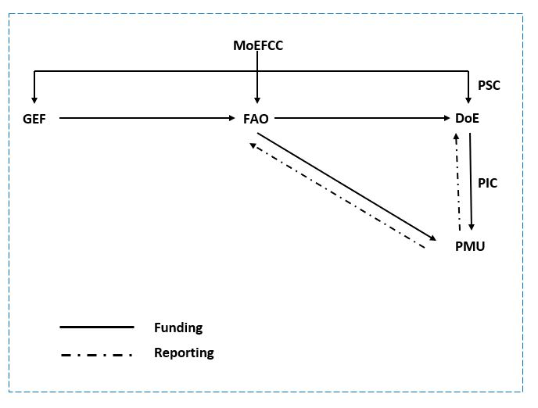

Figure 12.1 Overview of the Project’s Institutional Arrangements

Project inception priority actions
The first six months after the project has become operationally active will be considered as the inception phase of the project. The PMU will perform the following priority actions during the inception phase.
- Recruit the PMU staff;
- Establish the PSC;
- Review and, as needed, refine the stakeholder-coordination mapping with needed mechanism like LoA, MoU, data sharing contract etc;
- Review of the project’s logical framework and results matrix (e.g., baselines) and draft any refinements for the PSC’s review and endorsement in order to reflect any circumstantial changes since the GEF CEO’s endorsement. In particular, indicators (and related baseline and targets) will be finalized;
- Refine the M&E plan as needed to reflect specific requirements for each indicator (e.g., data collection methods, frequency, responsibilities for data collection and analysis and budget). Any missing baseline data will also be collected during this time;
- Draft 1st year annual work-plan and budget for PTF clearance and further approval by the PSC;
- Conduct an inception workshop;
- Hold the first PSC meeting; and
- Prepare an inception report and submit its outcome to the PSC

Appendix 13: Baseline Project and coordination with existing/completed project.

13.1 Baseline projects

Project Title | National implementing entity and Executing partner | Brief description | Funding source and Project time period | Status
UN-REDD Bangladesh National Programme | Bangladesh Forest Department, Ministry of Environment, Forest and Climate Change in partnership with FAO and UNDP. | - The key outcome of this project are:  - National Forest Monitoring System (NFMS).  - Forest Reference Emissions Level (FREL). | Time period: 2016-2019 | (1) Collected and archived the activity data for the period of 2000-2015, and emission factors data of the forests sector.  (2) Drafted the first FREL of Bangladesh.  (3) The activity and emission factors data are integrated with the NFMS, and launched in 2018.
Third National Communication to the United Nations Framework Convention on Climate Change (UNFCCC) | Department of Environment, ministry of Environment, Forest and Climate Change in partnership with UNDP. | The key components of this project are:  (1) national circumstances,  (2) inventories of greenhouse gases for 2006 - 2010,  (3) programmes containing measures to mitigate GHG emission,  (4) studies on vulnerability and impacts and formulate programmes containing measures to facilitate adequate adaptation to climate change,  (5) programmes and plans that are considered relevant towards achieving the objectives of the UNFCCC, and  (6) constraints and gaps, and related financial, technical and capacity needs. | GEF financing.  Time period: 2013-2016 | (1) All available national and sectoral strategies, plans, programmes and studies relevant to the formulation of the TNC, including national development blueprints and poverty reduction strategy papers and strategies are being analyzed.  (2) Draft GHG inventory section of the national communication has been prepared based on the collected activity data and emission factors.  (3) Damages and losses caused by past weather events like floods, cyclones, storm surges, river bank erosion, droughts and waterlogging etc are being estimated.  (4) Needs for research to adapt to and mitigate climate change and arrangement for sufficient training and education programmes for raising awareness among general public, professionals, member of non-governmental organizations, policy makers and students on climate change issues are being identified.
Strengthening National Forest Inventory and Satellite Land Monitoring in Support of REDD+ in Bangladesh | Bangladesh Forest Department, Ministry of Environment, Forest and Climate Change in partnership with FAO. | The key contribution of this project are:  - A robust forest monitoring system.  - An updated forest inventory contributing to country-specific emission factors.  - Updated land use map of 2000 and 2015. | Time period: 2015-2019 | - Socio-economic survey of 6400 households and 100 communities  - Biophysical survey in 1858 plots  - Land cover map of 2015  - National Land Representation System (NLRS) of Bangladesh
Bangladesh Environmental Institutional Strengthening Project | Department of Environment, Ministry of Environment, Forest and Climate Change in partnership with CIDA. | The overall objective of the project is to increase the capacity for sustainable development in Bangladesh.  The overall objective leads to two specific project level objectives:  a) Strengthened capacity of the Department of Environment to implement their Strategic plan; and  b) Strengthened capacity of civil society (including the private sector) for environmental management. | CIDA/GoB  Time period: 2006-2010 | Completed
Strengthening the Environment, Forestry and Climate Change Capacities of the Ministry of Environment and Forests and its Agencies | Ministry of Environment, Forest and Climate Change in partnership with FAO. | The project aims at developing and strengthening the skills, abilities, processes and resources that the MoEFCC and its agencies can improve their effectiveness, efficiency and relevance in the context of changing needs, priorities and challenges so that they become more enabled to lead, intervene, coordinate and monitor national programmes in the mandated areas of environmental and natural resources management leading to a more effective and synergetic approach and to deal with climate change and associated issues through smooth and efficient organizational performances at the local, regional and international levels.  One of the key outcomes of the project is the Country Investment Plan for Environment, Forestry and Climate Change (EFCC CIP) | USAID  Time period: 2014-2018 | (1)The EFCC CIP lays out priority investment areas organized into four pillars (Sustainable Development and Management of Natural Resources, Environmental Pollution Reduction and Control, Adaptation, Mitigation and Resilience to Climate Change and Environmental Governance, Gender, and Human & Institutional Capacity Development), 14 programmes, and 43 sub-programmes. At least 77 Government of Bangladesh (GoB) agencies (ministries/ divisions/departments) will implement various EFCC investment programmes.  (2) It is estimated that approximately USD 11.7 billion will be required to implement the EFCC investment programmes, as described in the CIP. Presently, the GoB is funding approximately USD 4.7 billion of EFCC programmes through the GoB’s Annual Development Plans, leaving an investment gap of around USD 7 billion over the next five years for internal and external development partners to begin to address.  (3) The First CIP monitoring report covering 2016-17 and 2017-18 financial years has been prepared and shared with the MOEFCC. The overarching objective of CIP monitoring is to support the MOEFCC , other relevant ministries and agencies and Development Partners in identifying new investment priorities and evaluating existing ones. The CIP will be monitored on an annual basis to track the impact of investments, identify success stories and challenges, and provide recommendations for improvements.
Climate Resilient Participatory Afforestation and Reforestation Project | Bangladesh Forest Department, Ministry of Environment, Forest and Climate Change. | The objective of the Climate Resilient Participatory Afforestation and Reforestation Project for Bangladesh is to reduce forest degradation and increase forest coverage through participatory planning and monitoring and to contribute in building the long-term resilience of selected communities in coastal and hilly areas to climate change. | World Bank  Time period: 2013-2016 | The project made substantial contribution to the forestry sector of Bangladesh by increasing climate resilience through improving hill natural forest, establishing plantations, adopting indigenous plant species for plantations at increasing rate instead of exotic species and development of socio-economic conditions of forest dependent communities by creating employment opportunities. Raising awareness among the mass people living adjacent to the forests through communication tools, consultation and training. By handing over Participatory Benefit Sharing Agreements (PBSA) to the beneficiaries will ensure their future economic benefit & attaining sustainability of the afforestation programmes. Moreover, strengthening FD (Forest Department) through developing National Forestry Policy, Monitoring Guidelines, Updating  Forestry Master Plan, training of FD staff, procurement of logistics for RIMS (Resource Information Management System), construction of forest field offices would increase forest management efficiency.  The project achieved it's target to establish 17,500 ha block and 2,000 km strip plantations in the 10 target Forest Divisions during the project implementation period (July 2012 to April 2017). Out of 17500 ha block plantations, 10015 ha. have been established in the hills of Chittagong and Cox's Bazar (57% of total block plantation) and 7485 ha (43%) has been established in the coastal areas. Out of 2000 km strip plantations, 1057 km has been established in marginal land (in the slope of Roads, Rails and Embankment), and 943 km Golpata (Nipa fruticans) plantations have been established in the muddy slopes of tidal canals in mangrove plantations. Depending on the local site, conditions/biophysical features and socioeconomic conditions nine (09) types of plantations have been established under CRPAR Project.  Such increase of afforestation will be helpful achieving the proposed greenbelt with varying width covering a total of 126,748 ha of land within 37 upazilas of 9 coastal districts extending from eastern boundary of the Sunderbans to the southwest tip of Teknaf. The plantations would also have impact on the issues for maximizing the utilization of greenbelt area for income generating activities by allowing space for fishery, vegetable and spice cultivation. The afforestation will also provide protective benefits of saving crops and infrastructures and sequestering carbon.  To reduce forest dependency and enhance resilience of selected communities, alternative livelihood programme was jointly implemented by Arannayk Foundation (AF) and its partner NGOs. 200 communities-based Forest Dependent Groups (FDG) were formed with 6000 beneficiaries to demonstrate alternative livelihood options. Major activities of livelihoods programme include community mobilization and formation of 200 community groups (FDG), train different AIGA, formation and strengthening 55 Union Federations, train federation leaders in financial and management functions, establishment of 55 Mutual Rotating Savings and Loan Fund (MRSLF) at union federation level with a monthly saving of BDT 100 by each FDG member, providing improved vegetables seeds, fruit and timber saplings, poultry (chick/duck), scaling up value chain interventions, demonstration of climate resilient and improved technologies, promotion of improved cooking stoves(ICS), and water and sanitary support (deep and shallow tubewells, and sanitary latrines), etc.  For capacity building 51 officials from Forest Department and 5 officials from the Ministry of Environment, Forest and Climate Change participated in 5 overseas certificate courses, 26 exposure visits and 25 training programme. Besides, 445 officers and staff of Forest Department participated in different trainings(74% local and 26% foreign trainings) . Moreover, FADS trained 17000 beneficiaries and 380 FD officials at local and field level.
Formulating the National Strategy on Waste Reduce, Reuse and Recycle (3R) for Bangladesh | Department of Environment, Ministry of Environment, Forest and Climate Change | The overall objective of the project is to formulate a National Strategy on the 3Rs (Waste Reduce, Reuse, and Recycle) for Bangladesh to build a " Second Material Recycle Society ". | IGES/UNCRD  Time period: 2008-2010 | Formulation of the National 3R (Reduce, Reuse, Recycle) Strategy in 2010 for Waste Management for implementation by the City Corporations and the Municipalities. The 3R strategy sets the goal of waste reduction, reuse and recycling and minimizing waste disposal in open dumps, rivers, floodplains, and landfills by 2015. It also promotes recycling of waste through mandatory segregation of waste at source as well as creates a market for recycled products and provides incentives for recycling of wastes.
Establishing National Land Use and Land degradation profile towards mainstreaming SLM practice in sector policies | Department of Environment, Ministry of Environment, Forest and Climate Change in partnership with UNEP. | The project objective is to establish knowledge base and enabling policy and institutional environment for SLM consideration in the country development agenda. | GEF  Project duration: 3 years | Project Approved for Implementation  Under GEF-5 in May 2016.
Bangladesh: First Biennial Update Report (BUR1) to the UNFCCC | Department of Environment, Ministry of Environment, Forest and Climate Change in partnership with UNDP. | To assist Bangladesh in the preparation of its First Biennial Update Report (BUR1) for the fulfillment of the obligations under the United Nation Framework Convention for Climate Change. | GEF | Project Approved for implementation under GEF 6 trust fund in February 2018.
Promoting Low Carbon Urban Development in Bangladesh | Ministry of Power, Energy and Mineral Resource (MoPEMR) in partnership with UNDP. | To reduce GHG emissions by enabling investments in renewable energy, energy efficiency, and waste-to-energy applications to support urban development in Bangladesh. | GEF  Project duration: 5 years | Project Concept approved under GEF - 6 in November 2017.
Integrating Climate Change Adaptation into Sustainable Development Pathways of Bangladesh | The Department of Environment under the Ministry of Environment and Forests will be the lead national executing agency which will implement the project in collaboration with relevant ministries and line agencies (e.g. Planning Commission, Department of Agricultural Extension) in partnership with UNDP. | To support Bangladesh in addressing urgent, medium and long-term climate change risks in selected agro-ecological zones. | GEF  Project duration: 4 years | Project Concept approved under GEF - 6 in March 2017.
Community-Based Adaptation to Climate Change through Coastal Afforestation | Bangladesh Forest Department, Ministry of Environment, Forest and Climate Change in partnership with UNDP. | To reduce the vulnerability of coastal communities to the impacts of climate change-induced risks in four upazilas in the coastal districts of Barguna and Patuakhali (Western Region), Bhola (Central Region), Noakhali (Central Region), and Chittagong (Eastern Region). | GEF  Project duration: 2008-2016 | Achievement of the project includes : Development of 12 Community-Based Adaptation (CBA) Plans on coastal Afforestation, livelihood diversification and extreme climate warning communications for all project sites, Establishment of 9000 ha coastal Afforestation with mangrove species, Establishment of 112 ha Non-mangrove plantation with dyke including FFF Model, Establishment of 332 ha Non-mangrove mound plantation, Establishment of 680 km Strip Plantation, Model demonstration in 200 ha by introducing 10 commercially important mangrove species, 2,700 coastal people trained on mangrove nursery establishment and community-based forest management, Participation of 5,876 local people in the management and protection of new plantation, Alternate livelihood options for 2,860 households and skill development training for 4,000 coastal people 4 assessments of early warning needs for sustainability of climate-resilient alternative livelihood options completed in 4 Upazilas, Excavation of 4.07 km single dyke structure and 4 fresh water reservoirs to enhance resilience of coastal communities through improved water management. Excavation of 4 fresh water reservoirs to enhance resilience of coastal communities through improved water management, Livelihood services to 640 households through water management, Publication of 5 briefing notes, 5 fact sheets, and 1 knowledge product on climate change adaptation actions in Bangladesh, 12 climate change seminars, Formation of 4 Co-management Committees, Training of 500 Upazila officials (GoB and NGO) in promoting and facilitating local climate risk resilience for integration in the upazila development plans, Training of 1300 GoB, CBO, NGO officials including union parishad chairman and women members from the 4 coastal districts, Establishment of 4 Climate Clubs for networking, Comprehensive review of 4 National Policies—national forest policy, national environment policy, national land use policy, coastal zone management policy and incorporation of Climate Resilient Policy Recommendations into these national policies, Conduct of 12 climate resilient policy workshops and dissemination of policy recommendations on climate resilient livelihoods, Review of existing land use policies and recommendations for climate Resilient Policy for the sustainability of a protective greenbelt structure. Preparation of 2 coastal zoning regulations including Coastal Zone (Declaration, Protection and Management) Act and Long Term Transfer of Newly Accreted Land to sustain protective ecosystems, Preparation of Agreement Document for long-term transfer of newly accreted lands from Ministry of Land to Forest Department for the sustainability of protective ecosystems, Conduct of 33 Lesson Sharing Dialogue and preparation of 4 Video Documentary films and Conduct of 2 national workshops on coastal afforestation and diversified climate-resilient livelihoods with participation of more than 100 national policymakers in each workshop.
Integrating Community-based Adaptation into Afforestation and Reforestation Programmes in Bangladesh | Bangladesh Forest Department, Ministry of Environment, Forest and Climate Change in partnership with UNDP. | The key objective is to reduce the vulnerability of communities to the adverse impacts of climate change through participative design, community-based management, and diversification of afforestation and reforestation programmes. | GEF  Project duration: 2016-2020 | The project is currently under implementation in 8 Upazilas under 5 coastal districts. So far, about 5000 beneficiaries have been provided with climate resilient alternative livelihood support in agriculture, fisheries and livestock sectors to reduce their vulnerability. Forest-Fruit-Fish (3F) model has been successfully applied in 17 ha of land involving 85 beneficiaries (5 beneficiaries per hectare of land). About 200 ha of degraded mangrove areas have been reforested. Under civil works, 20 sluice gates have been repaired to improve drainage system and to reduce water logging. Upazila Co-management Committees have been constituted in 8 coastal Upazilas.
Environmentally-sound Development of the Power Sector with the Final Disposal of PCBs | Department of Environment, Ministry of Environment, Forest and Climate Change in partnership with UNDP | The major objective of this project is to assist the power sector of Bangladesh in fulfilling its obligations under the Stockholm Convention by reducing the release of PCBs to the environment and disposing of 500tons of PCB-containing equipment, oil, and waste in an environmentally sound manner | GEF  Project duration: 2016-2020 | Project Approved for Implementation  Under GEF-5 in May 2016.
Greater Dhaka Sustainable Urban Transport Corridor Project | Roads Division, Ministry of Communications in partnership with ADB | The project intends to promote energy efficient, low-carbon transport and urban systems in the Gazipur area of north Greater Dhaka, through the delivery of a 20 kilometer Bus Rapid Transit (BRT) corridor and associated infrastructure, systems and capacity building. | GEF  Project duration: 2012-2017 | Completed
Development of Sustainable Renewable Energy Power Generation (SREPGen) | Sustainable Energy Development Authority (SEDA), Ministry of Power, Energy and Mineral Resources in partnership with UNDP | The major objective of the project is to reduce the annual growth rate of GHG emissions from fossil fuel-fired power generation through the exploitation of Bangladesh's renewable energy resources for electricity generation | GEF  Project duration: 2013-2019 | Project Approved for Implementation  Under GEF-5 in August 2013
Pesticide Risk Reduction in Bangladesh | Department of Environment, Ministry of Environment, Forest and Climate Change in partnership with FAO | The project aims to reduce risks to human and animal health and the environment from stockpiles of POPs and other obsolete pesticides and from ongoing excessive use of new POPs and other Highly Hazardous Pesticides | GEF  Project duration: 2013-2019 | Concept approved  Under GEF-6 in August 2017
Preparation of the POPs National Implementation Plan under the Stockholm Convention | Ministry of Environment, Forest and Climate Change in partnership with UNDP | The objective of the project is to create sustainable capacity and ownership in Bangladesh to meet its obligations under the Stockholm Convention, including preparation of a POPs National Implementation Plan, and broader issues of chemicals safety and management as articulated in Chapter 19 of Agenda 21 | GEF  Project duration: 2002-2007 | Completed
Rural Electrification and Renewable Energy Development | Rural Electrification Board (REB) and Infrastructure Development Company (IDCOL) in partnership with World Bank | This project intends to promote solar energy in rural Bangladesh by increasing awareness of SHS among consumers and providers, building technical and management capacity, and providing technical and business development support to implementing institutions | GEF  Project duration: 2002-2009 | Completed

13.2 Coordination with other project

Other initiatives that will be coordinated with the CBIT project are as follows:
Other Ongoing and Pipeline Initiatives | Areas of complementarity with the proposed CBIT Project
Strengthening National Forest Inventory and Satellite Land Monitoring System in Support of REDD+ in Bangladesh (Bangladesh Forest Inventory Project), USAID. FAO, Silva Carbon USD 6.5M (2015-2018)  This project aims to build a robust forest monitoring system will be implemented for the Forest Department - supporting forest policy and critical decision making processes, and supporting actions for climate change adaptation and mitigation in forestry.. | The proposed CBIT project will ensure coordination to ensure contributing to enhance transparency-related processes; and vice versa by learning from strengthening adaptive capacity and resilience of forest-dependent communities, reduced green-house gas emissions from forestry sector, collaborative activity and value chain development, and community-based sustainable natural resource management.
UN-REDD Bangladesh National Programme, FAO, UNDP (2015-2018)  As part of the country’s progressive measures, the UN-REDD Bangladesh National Programme has brought together the United Nations specialized agencies – the Food and Agriculture Organization of the United Nation (FAO), and the United Nations Development Programme (UNDP) with the GoB’s nodal ministry, i.e. the Ministry of Environment and Forests (MoEF), to build the capacities required to formulate and implement Bangladesh’s national REDD+ strategy, develop FREL/FRL, safe guard information system and forest monitoring system. | The project will support better capacity and enabling environment for Forest and Landscape Restoration activities in Bangladesh, resource mobilization and implementation to replicate the successful experiences and modality to restore Forest Landscape and reduce forest degradation and deforestation.  The proposed CBIT project will ensure smooth institutional coordination and capacity development on new initiatives and systems to be developed by the UN-REDD national project as well as will complement for a better data collection and reporting.
'Country Investment Plan (CIP) for Environment, Forestry and Climate Change(2016-2021)’, under USAID-funded (USD 4.5 million) project ‘Strengthening the Environment, Forestry and Climate Change Capacities of the Ministry of Environment and Forests and its Agencies’  The main Goal of the project is to strengthen human and organizational capacity in the country to deliver more effective, coordinated, sustainable and country-driven investment programmes in environmental protection, sustainable forest management and climate change adaptation and mitigation. The project also aims at addressing the crosscutting role of gender, and at promoting inclusive participation from the private sector and the civil society. | This project aims to build national capacity for investment under four pillars namely sustainable development and management of natural resources; environmental pollution reduction and control; adaptation, mitigation and resilience to climate change and environmental governance, gender, and human and institutional capacity development  The proposed CBIT will directly benefit and ensure coordination and capacity development on data collection and production, and data availability and transparency as well as the monitoring.
Bangladesh: First Biennial Update Report (BUR1) to the UNFCCC | For the preparation of First Biennial Update Report (BUR1) to the UNFCCC, Technical Assistance Project Proposal (2019 -2021) has been prepared by  the Department of Environment It is now ready for submission to the MoEFCC for approval.
Third National Communication to the United Nations Framework Convention on Climate Change (UNFCCC) | The Government of Bangladesh (GoB), represented by the Ministry of Environment, Forest and Climate Change (MoEFCC), and its operational arm, the Department of Environment (DoE) prepared its Third National Communication (TNC) in June 2018. It provides an overview of climate change issues in the country and their implications for the key stakeholders at local, national, regional and global levels. It explains national circumstances, details greenhouse gas (GHG) inventory, and highlights programmes of measures for adaptation to climate change and mitigation actions. Towards the fulfillment of its obligation under the Convention, Bangladesh has already submitted 3rd National Communication to the UNFCCC Secretariat. Bangladesh’s Third National Communication Project, the preparation of which has been funded by the Global Environment Facility (GEF) through UNDP Bangladesh, has been able to create a solid foundation for further work on scientific and policy issues. It has also been able to clearly define the concerns relevant within the national context and has identified potential areas for further action. This document alerts policy makers and other key stakeholders of the urgency of mainstream climate issues in the national development policy and agenda as well as within a legal framework.

Appendix 14: Inception workshop report

The inception workshop of the GEF-CBIT project was organized with a view to sharing the objectives and deliverables of the proposed project with stakeholders, take opinion on the project activities, and improve awareness about the importance of climate change related data sharing, archiving and management.

Agenda of the inception workshop
Time | Event
09.30 – 10.00 | Registration
10.00 – 10.20 | Welcome Remarks and  Presentation on “National Greenhouse Gas Inventory Preparation in Bangladesh “ & “Paris Agreement and NDC in Bangladesh”  Mr. Mirza Shawkat Ali, Director (Climate Change & International Convention), DoE
10.20-10.30 | Presentation on “An Overview of GEF-CBIT Programme”.  Ms. Yurie Naito, Programme Officer, FAO-GEF Unit
10.30 – 10.40 | Presentation on “Project Objectives, Expected Deliverables and Activities”  Dr. Matieu Henry, Chief Technical Advisor, FAO
10.40 – 10.45 | Address by Special Guest  Mr. Robert Simpson, FAO Representative in Bangladesh
10.45 – 10.50 | Address by Special Guest  Md. Mozahed Hossain, Additional Secretary, MoEFCC
10.50 – 10.55 | Address by Special Guest  Mr. Mohammed Shafiul Alam Chowdhury  Chief Conservator of Forests, Bangladesh Forest Department
10.55 – 11.05 | Address by Chief Guest  Mr. Abdullah Al Mohsin Chowdhury, Secretary, MoEFCC
11.05 – 11.15 | Address by Chairperson  Dr. Nurul Quadir, Additional Secretary, MoEFCC
11.15 – 11.30 | Tea break
11.30– 11.45 | Data Sharing in the context of Sustainable Development in Bangladesh  Md. Shaheduzzaman, Senior Environmental Advisor, FAO Bangladesh
11.45– 15.00 | Group Exercise:  Topics:  1. Existing Institutional Data Sharing Mechanism  2. Problems of Institutional Data Sharing and possible solutions  3.Identification of Institution-wise data to share with DoE  4. Opinions on Project Components and Proposed Project Activities  Facilitator: Mr. Ben Vickers, Regional Programme Officer, FAO RAP, Bangkok
15.00-15.10 | - Closing Remarks  Mr. Mohmmed Solaiman Haider, Director (Planning), Department of Environment, Agargaon, Dhaka
15.10 | Lunch and Closing of Inception Workshop

Summary of the speech and presentation session

Mr. Mirza Shawkat Ali, Director (Climate Change & International Convention) of DoE stated in his opening speech that, as a signatory of UNFCCC, Bangladesh has to submit biannual report on GHG inventory and national communication every five years where the CBIT project will play an imperative role through the technical capacity building of DoE. He further mentioned, to develop well referenced and documented as well as consistent UNFCCC reporting documents and for natural resource management in general, it requires a common and user-friendly platform for data sharing and institutional arrangement among the national entities. The CBIT project will fill this gap by strengthening the institutional arrangement for data sharing and create modern system for documentation and archiving. The aim of the inception workshop is to receive suggestions and inputs on the key elements of the project proposal. These recommendations can help effective formulation of the project to be submitted to the GEF, he added.
Ms. Yurie Naito, Programme Officer of FAO-GEF unit highlighted the key issues of Paris agreement and the capacity building initiative for transparency (CBT) with the audience. She remarked strengthen national institution, provide appropriate tools, training and assistance and support in the enhancement of transparency are the major goals of CBIT programme. As of 6 January 2019, total 41 projects/concepts have been approved under CBIT, she mentioned.
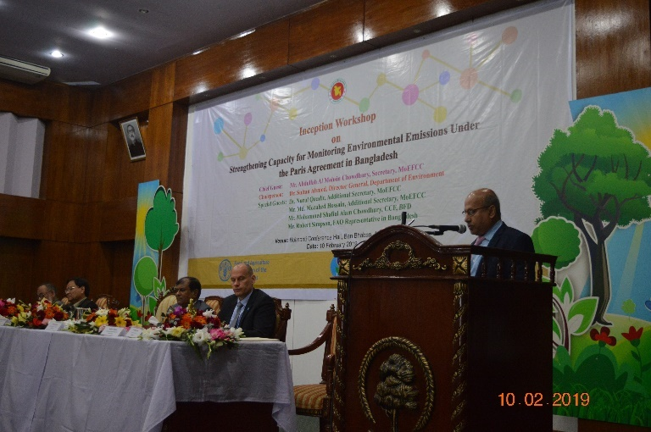 | 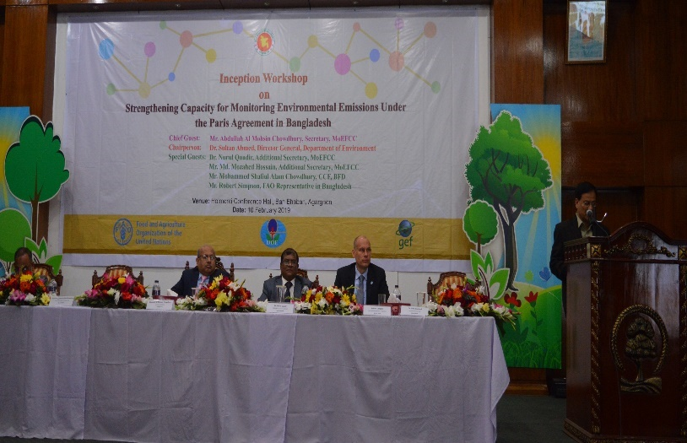
Dr. Henry Matieu, Chief Technical Advisor of FAO has provided a brief overview of the CBIT project of Bangladesh including its objective, component and expected deliverables. He describe the project under the framework of Theory of Change which comprises capacity building, stakeholder engagement, gender responsiveness, data and knowledge sharing, addressing national priorities, and communication and strategic partnership.
Mr. Robert Simpson, FAO Representative in Bangladesh gratefully appreciated the commitment from Government, partners and the representation from all the stakeholders in the workshop. He praised, In close consultation with our national stakeholders we will finalize the project proposal, which also happens to be the first capacity building initiative in GHG emission measurement, reporting, and verification and NDC priority adaptation monitoring and reporting to-date in Bangladesh. He urged for continued cooperation from the MoFECC, DoE and all national level stakeholders for the effective formulation of this important capacity building project.
Mr. Md. Mozahed Hossain, Additional Secretary (Development) of MoEFCC remarked in this speech that, national reporting under the Paris Agreement requires enhanced institutional arrangements to support the data collection, data analysis and data reporting. The absence of the institutional arrangement encompassing the procedural, legal and institutional set-up is a major constraint for national entities to sustainably fulfill the requirement of data management and reporting system, including measurement, reporting and verification processes (MRV), preparation of national greenhouse gas inventory (GHGI), biennial update report (BUR), national communication (NC), nationally determined contribution (NDC) under United Nations Framework Convention on Climate Change (UNFCCC), he opined. He expressed that, as we don’t have any good database related to the emission of AFOLU and waste sectors, the CBIT project will strengthen the institutional and individual capacities in Bangladesh to meet the Enhanced Transparency Framework (ETF) of Paris Agreement focusing on AFOLU and waste sectors and track the progress against the NDC priority actions.
Mr. Mohammed Shafiul Alam Chowdhury, Chief Conservator of Forests expected that there are several challenges related to the collection of data produced by various national entities. These challenges are attributed to the lack of data and awareness on issues related to AFOLU GHG inventory. Many a National entity lack in sound data management system, and lack of proper institutional arrangements data sharing. He opined, development of common format for data collection and systematic archiving of data is highly essential. He expected that CBIT project will advance the integration of adaptation and mitigation activities at the operational level which will help meeting its overarching goal of NDC. He mentioned that, considering the climate risk factor, the outcomes of the CBIT project will help to increase the reporting and monitoring capacity of adaptation and to work more clearly in the mitigation sectors. The proposed project will mainstream the gender equality with a view to advancing the rights and participation of women, marginal people of Bangladesh throughout the project period, he added.
Dr. Nurul Quadir, Additional Secretary, MoEFCC uttered in his speech that transparency, monitoring and capacity are very important for Bangladesh where the CBIT project is based upon. He stressed for successful development of the CBIT project that would eventually lead to the initiation of the required technical capacity for effective monitoring of GHG data of all sector, reporting adaptation measures and the sharing of benefits. He further requested to the Department of Environment as well as to all relevant stakeholders to engage and contribute in the formulation of this capacity building project of high importance.
Mr. Abdullah Al Mohsin Chowdhury, Secretary, Ministry of Environment, Forest and Climate Change uttered that strengthening individual and institutional capacities in Bangladesh is highly essential at present time to meet the Enhanced Transparency Framework (ETF) of Paris Agreement focusing on agriculture, forestry and land use (AFOLU) and waste sectors and track the progress against priority actions identified in the NDC. It is also important to stress on transport, power and industry sectors as highlighted in the Road Map and Action Plan for implementing Bangladesh NDC. He anticipated that CBIT project will advance to integrate the adaptation and mitigation activities at the operational level which will foster the climate action in Bangladesh as well as meet its overarching goal of NDC. He further added that, currently we have huge data deficit in the environment and natural resource sector. One of the major outputs of the project is to establish a national environment database to generate in-depth knowledge and evidence on diverse environmental aspects including pollutions and GHG emissions which will trigger anticipatory environmental governance in different sectors including AFOLU and waste.
Md. Shaheduzzaman, Senior Environmental Advisor, FAO Bangladesh presented a paper on data Sharing in the context of Sustainable Development in Bangladesh. Here he highlighted the importance of quality data for natural resource management (NRM), existing data sharing policies and measures in Bangladesh and challenges in data sharing. Mr Shahed recommended that, common data sharing policies and platform for all entities, open access data policy, improved data archiving and build awareness are the most possible solution to overcome the challenges related to data sharing.
Group discussion
The group discussions involved 60 participants from 28 organizations. In order to identify participants, they were divided in six sectors (AFOLU, Waste, Energy, IPPU and Others). Four group has been formed comprising the experts of these five sectors for the group exercise. The participants were engaged in different group exercise and provided critical input based on their knowledge and experience.
During the group exercise, participants had to interact with the representatives from different organizations and gather the opinion and inputs. In the first exercise, all the group was asked to show the data sharing mechanism using ribbons and plot the process of data sharing among the national entities and DoE in the flip chart with the help of sticky note and color marker pen. In the second exercise, the participants have identified the problems and barriers of data sharing among the institutions. In the third exercise, participants were questioned to identify and list the institution wise data availability and propose effective data sharing mechanism with DoE. The fourth exercise was about project component and output. Here, the participants were asked to find ongoing and planned GoB activities supportive of the proposed project, propose the key activities under each project output and identify the key stakeholder under each component.
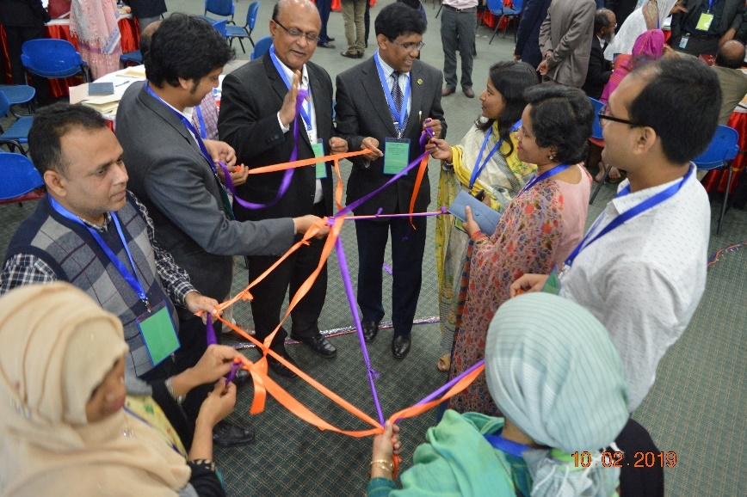 | 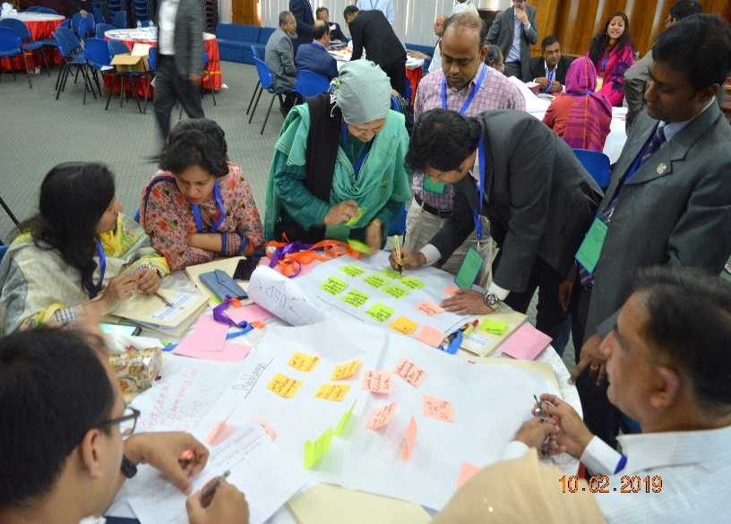
The working groups were facilitated by Mr. Ben Vickers, Regional Programme Officer, FAO, Mr. Arfanuzzman, National Project Feasibility Expert of FAO and Dr. Matieu Henry, Chief Technical Advisor, FAO.
We have organized the 60 participants into 4 groups to identify institutional arrangement and find possible solution for robust data sharing. Participants also provided suggestion on each three components of the project. After the group exercise, each group representative presented the major findings of their discussion. Few groups remarked that institutional data sharing policy is required for the government entities. They propose that MoU and official request letter can be a better solution and remove many problems related to data sharing. All the group urged for an uniform data collection and archiving system. Because in Bangladesh, the data collection and archiving system of different entities are dissimilar which creates problem for GHG inventory preparation. The participants expressed that uniform data collection system will help DoE to easily monitor, compile and report the GHG sectoral data. Most of the group feel that the project should cover all the GHG emission sectors including AFOLU, energy, waste and IPPU for the wider benefits. They also opined to conduct a need assessment before the capacity building activity of the project. In order to enhance the multisectoral coordination, the participants proposed to build a common platform and regularly arrange seminar and workshop to engage the stakeholder.
The component wise summary of the group recommendation is as follows.

Component 1
All the group suggested to include following stakeholders and the activities:
- Increase data generation capacity for livestock and waste sector, suggested stakeholder: Dept. of livestock, NGO, Farmers, poultry & dairy association, Dept of Haor and wetland
- Enhance collaboration among the NDC priority sectors, suggested stakeholder: BWDB, DoE, CEGIS, BMD
- Arrange training and workshop on GHG inventory & MRV process, suggested stakeholder: DoE, Private sector, Data provider
- Increase awareness for data sharing
Group 1 suggested to include following stakeholders and the activities:
- Develop skill and build capacity of the relevant institutions, suggested stakeholder: BFD, DoE, DAE, BRRI, BARI, MoEFCC, BADC, MoA
Group 2 suggested to include following stakeholders and the activities:
- Develop a common platform for data sharing: suggested stakeholder: All the ministries
- Strengthen MRV system in Bangladesh, suggested stakeholder: BFD, MoA, MoEFCC
- Establish modern lab with necessary equipment to strengthen institutional capacity of DoE, suggested stakeholder: DoE
Group 3 suggested to include following stakeholders and the activities:
- Strengthen institutions, and build public awareness about GHG mitigation, suggested stakeholder: DoE, Researcher, Govt officials, All data provider
- Develop a fully operational system for documentation and archiving
Group 4 suggested to include following stakeholders and the activities:
- Arrange regular training & workshop for easing the collaboration and coordination, suggested stakeholder: Researcher, Govt officials

Component 2
Group 2 suggested to include following stakeholders and the activities:
- Recruit necessary human resource in DoE for land use change analysis and reporting
- Purchase modern monitoring system for DoE, suggested stakeholder: DoE & all other related agencies
Group 3 suggested to include following stakeholders and the activities:
- Arrange training, seminar, symposium to strengthen national environmental monitoring system, suggested stakeholder: DoE & all other related agencies
Group 4 suggested to include following stakeholders and the activities:
- Organize need based training to increase the capacity of DoE for land use change analysis and reporting
- Develop open data platform for environmental database

Component 3
Group 2 suggested to include following stakeholders and the activities:
- Develop easily understandable framework for adaptation reporting
Group 3 suggested to include following stakeholders and the activities:
- Organize training, seminar, symposium to assess good practice methodologies, suggested stakeholder: DoE & all other related agencies
- Take necessary measure to document the best practices, suggested stakeholder: DoE & all other related agencies

Group 4 suggested to include following stakeholders and the activities:
- Engage all Govt. entities to adopt adaptation information management system
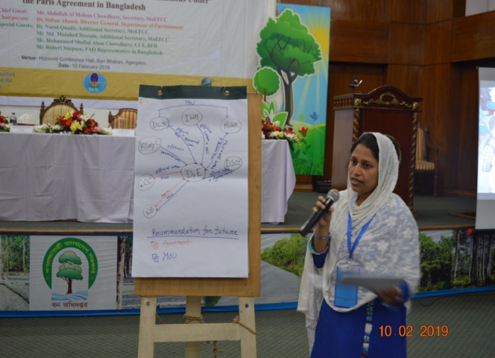 | 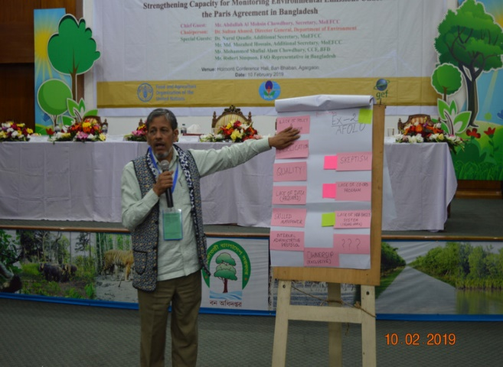
Sharing of key findings of the group exercise
After the group discussion, each group representative presented the major findings of their exercise. Few groups remarked that institutional data sharing policy is required for the government entities. They propose that MoU and official request letter can be a better solution and remove many problem related to data sharing. All the group urged for an uniform data collection and archiving system. Because in Bangladesh, the data collection and archiving system of different entities are dissimilar which creates problem for GHG inventory preparation. The participants suggested that uniform data collection system will help DoE to easily monitor, compile and report the GHG sectoral data. Most of the group feel that the project should cover all the GHG emission sectors including AFOLU, energy, waste and IPPU for the wider benefits. They also opined to conduct a need assessment before the capacity building activity of the project. In order to enhance the multisectoral coordination, the participants proposed to build a common platform and regularly arrange seminar and workshop to engage the stakeholder.
Closing remarks
The closing remarks were given by Mr. Mohmmed Solaiman Haider, Director (Planning), Department of Environment. He appreciated everyone interactive and active participation in the workshop. Todays output will play of substantial role in preparing the proposal. He encouraged everyone to be engaged with the project preparation process. Finally, Mr, Haider requested everyone to fill and share the workshop evaluation form through email
Results of the inception workshop evaluation
Participants were asked to evaluate the validation workshop based on certain questions. Here, 62% of the participants mentioned that the workshop is highly relevant to their organization. Whereas, 19% and 19% of the participants mentioned that the workshop is moderately and less relevant to their organization respectively. 19% of the participants were strongly agreed that the workshop materials (concept note, presentation, group exercise) are adequate and useful and 69%, and 12% of the participants are found to be agreed and neutral correspondingly in this regard. Further, 44% of the participants were strongly agreed that the presentation of information by the resource person was easy to understand and 50%, and 6% of the participants are found to be agreed and neutral correspondingly about this matter. In addition, 63%, and 25% of the participants opined respectively that letter of agreement (LoA) and memorandum of understanding (MoU) are the most appropriate mode of data sharing with DoE. While, rest of the 12% participants mentioned that a single platform can be the most useful mode of data sharing with DoE.

Appendix 15: Validation workshop report

The validation workshop was organized on 18 May 2019 at Ban Bhaban (Forest Department), Agargaon, Dhaka with a view to sharing the draft project proposal with the stakeholders and validate information, and capturing needs and gaps to be considered for the finalization of the project document.
Agenda of the validation workshop
Time | Event
10.30 – 11.00 | Registration
11.00 – 11.25 | Welcome Remarks  and Presentation of the CBIT initiative  Mr. Mirza Shawkat Ali  Director (Climate change & International Convention); Department of Environment
11.25 – 11.30 | Address by Special Guest  Dr. Robert D Simpson, FAO Representative in Bangladesh
11.30– 11.35 | Address by Special Guest  Mr. Md. Mozahed Hossain, Additional Secretary (Development), MoEFCC
11.35– 11.40 | Address by Special Guest  Dr. Nurul Quadir, Additional Secretary (Climate Change), MoEFCC
11.40 – 11.45 | Address by Special Guest  Mr. Mohammed Shafiul Alam Chowdhury  Chief Conservator of Forests, Bangladesh Forest Department
11.45 – 11.55 | Address by Chief Guest  Mr. Abdullah Al Mohsin Chowdhury, Secretary, MoEFCC
11.55– 12.05 | Address by Chairperson  Dr. Sultan Ahmed, Director General, Department of Environment
12.05 – 13:30 | Group Work:  Participants divided in 3 groups  Group A: Component 1 institutional arrangements and capacities to enhance MRV transparency  Group B: Component 2 technical capacity to assess the emissions and removals  Group C: Component 3 capacity to monitor and report adaptation activities
13:30 -14:00 | Prayer break
14.00 – 14.15 | Group Presentation
14:15-14:30 | - Synthesis and next steps  - Mr. Shamshur Rahman Khan, Deputy Secretary (Development), MoEFCC  Mr. Kristofer Johnson, International Consultant, FAO
14.30– 14:40 | - Closing Remarks  Dr. Nurul Quadir, Additional Secretary, MoEFCC
14:40 – 15.00 | Workshop Evaluation and Closing

Summary of the speeches and presentation
Mr. Mirza Shawkat Ali, Director (Climate Change & International Convention), Department of Environment in his opening speech stated that Paris Agreement decided to establish a Capacity-building Initiative for Transparency (CBIT) in order to build institutional and technical capacity of the developing countries in both pre and post-2020. He stated that the CBIT project would enhance institutional arrangements and capacity building, support monitoring mitigation activities and strengthen capacity to monitor and report adaptation activities. He further mentioned that the project will be governed by a Project Steering Committee (PSC), Project Implementation Committee (PIC) and Project Management Unit (PMU) which will ensure the attainment of key benefits such as improved documentation and archiving system, enhanced institutional and multi-sectoral collaboration, one stop platform for data collection sharing and collection and transparent & accountable system for GHG emission and reporting. The Department of Environment as an executing agency of the CBIT project, will directly implement some activities including establishment of collaboration and coordination mechanism among national entities involved in AFOLU, IPPU, energy, and waste sectors, strengthening of multi-sectoral collaboration for data sharing, establishment of national environment database, organization of relevant trainings, workshops and meetings, and support to the Mid-Term Review (MTR) and Terminal Evaluation (MTE) and audit of the project, he added.
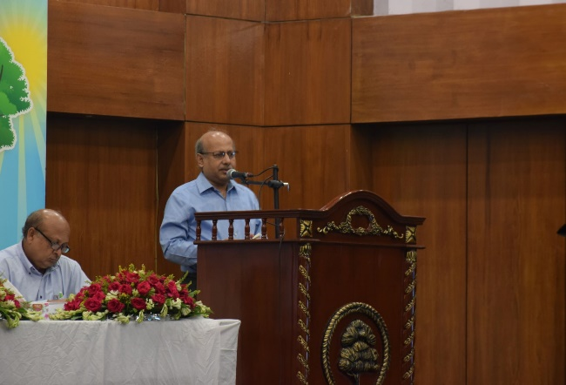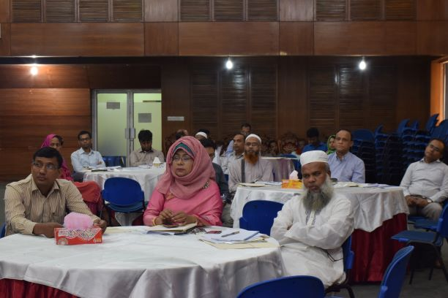
Figure 1: Speech delivered by the Secretary, Ministry of Environment, Forest and Climate Change expressing Ministry’s commitment for the successful implementation of the project
Dr. Nur Ahmed Khondaker, Assistant FAO Representative (Programme) represented FAO in the absence of Mr. Robert Simpson, FAO Representative in Bangladesh. He welcomed all distinguished guests, participants and resource persons to this validation workshop. Dr. Khondaker gratefully appreciated the commitment of the Government and partners and the stakeholder organizations in the project development endeavour which started in May 2018. He termed the project as the first capacity building initiative in Green House Gas (GHG) emission measurement, reporting, and verification and NDC priority adaptation monitoring and reporting in Bangladesh and affirmed that the project proposal would be finalized in close consultation with national stakeholders. Considering the validation workshop as the final stage of the preparation of this capacity building project, he hoped that the participants would contribute to their best to bring improvement to the project document. To conclude, he expressed his satisfaction that FAO could be a part of this capacity building initiative with the MoEFCC and the Department of Environment in sharing its technical expertise and experience.
Mr. Md. Mozahed Hossain, Additional Secretary (Development), Ministry of Environment, Forest and Climate Change in his speech remarked that, addressing the climate change challenge would require a concerted effort at all levels and sectors for which capacity is a crucial prerequisite for GHG emission and adaptation monitoring, reporting and archiving. For the country like Bangladesh, capacity building can play a leading role in tracking and measuring the NDC priority climate change mitigation and adaptation targets, he mentioned. He stressed that the CBIT project would require to be designed to enhance the capacity of the DoE and relevant Govt. entities. Mr. Hossain expected that the CBIT project would strengthen the institutional and individual capacities in Bangladesh to meet the Enhanced Transparency Framework (ETF) of Paris Agreement focusing on AFOLU, energy, industrial processes and product use (IPPU), and waste sectors and track the progress against the NDC priority actions related to these sectors. He concluded that the project would identify capacity gaps of the Department of Environment for meeting the requirements of the ETF and create the opportunities to establish transparent and robust monitoring, reporting and archiving system at DoE.
Mr. Mohammed Shafiul Alam Chowdhury, Chief Conservator of Forests stated that the validation workshop aimed at validating project activities and hearing views of the stakeholders on how this project could be best implemented. He expected that in line with the aspiration of long-term climate action as well as robust adaptation and mitigation, the CBIT project would advance efficient tracking, monitoring, reporting the national climate change adaptation and mitigation in the AFOLU, energy, IPPU and waste sectors. He stressed on the technical capacity enhancement of Bangladesh to estimate the GHG removal and emission. Mr. Chowdhury opined that because of project interventions, the DoE would be well equipped for sectoral GHG data generation, monitoring, reporting and archiving and preparation of biennial update report (BUR), national communication (NC), nationally determined contribution (NDC) under the UNFCCC.
Dr. Nurul Quadir, Additional Secretary (Climate Change), Ministry of Environment, Forest and Climate Change in his speech stressed on strengthening individual and institutional capacities in Bangladesh to meet the Enhanced Transparency Framework (ETF) of Paris Agreement focusing on Agriculture, Forestry and Land Use (AFOLU), Energy, Industrial Processes and Product Use (IPPU), and waste sectors and track the progress against priority actions identified in the NDC. He expressed his satisfaction that the project document had been prepared quite well, the successful implementation of which would enable to advance the integration of the adaptation and mitigation activities at the operational level. Dr. Quadir pointed out that the Government of Bangladesh has initiated several actions at the country level towards climate change mitigation and adaption which have been recognized by the international communities as well. Finally, he wished a successful finalization of the CBIT project document that would eventually lead to the initiation of the required technical capacity for effective monitoring of GHG data, reporting adaptation measures which are crucial to the attain ETF.
Mr. Abdullah Al Mohsin Chowdhury, Secretary, Ministry of Environment, Forest and Climate Change stressed on strengthening the capacities of the Govt. entities to meet the Enhanced Transparency Framework (ETF) of Paris Agreement focusing on Agriculture, Forestry and Other Land Use (AFOLU), energy, Industrial Processes and Product Use (IPPU) and waste sectors and hoped that this could be attained through the appropriate project design and successful implementation of the project. Mr. Chowdhury expressed that the validation workshop with intensive Group Exercise would help representatives of all the stakeholder agencies understand the role and responsibilities they can play in finalization of the project document. He provided some specific recommendations in some sections of the project document such as risk management, PSC membership, cost overrun, and grievance mechanism to further improve the project proposal. He requested the participants to carefully review the project document and provide their important feedbacks. The Chief Guest expected that the project would greatly help developing the capacity of Bangladesh to meet the enhanced transparency framework in relation to climate change mitigation and adaptation for the successful achievement of the target of the Paris Agreement.
Dr. Sultan Ahmed, Director General, Department of Environment appraised the distinguished guests and participants that the project “Strengthening capacity for monitoring environmental emissions under the Paris Agreement in Bangladesh” had reached the finalization stage of its formulation and it had been possible through dedicated efforts of FAO Technical Team with support from the Department of Environment. He mentioned that the success of the Paris Agreement would require setting up new transparency governance structures, developing and implementing measuring and reporting methodologies, and updating, implementing, and integrating new data and information flows with pre-defined periodicity. He hoped that the proposed project would significantly improve the Measurement, Reporting, and Verification (MRV) systems in Bangladesh for Climate Change Mitigation as per the NDC. In his concluding remark, Dr. Ahmed mentioned that the project document would be finalized with incorporation of contributions from the participants of the validation workshop and expressed his hope to submit the project document to the GEF Secretariat by the end of May 2019.

Group discussion
The group discussions involved 40 participants from 22 organizations. For the group exercise, three groups were constituted comprising the experts of AFOLU, energy, IPPU and waste sectors. The participants engaged in different group exercises provided their critical inputs based on their knowledge and experiences.
During the group exercise, participants interacted with representatives of different organizations and they collectively reviewed the project document. In the first exercise, all the groups were asked to review the indicators of different outputs and to provide their suggestions to further improve the indicators. In the second exercise, the participants reviewed the project components, outputs, and activities and recommended some measures for the executing agency to better execute the CBIT project. In the third exercise, participants were requested to identify and to list the institution-wise environmental data availability and to suggest effective data sharing modalities with the Department of Environment.
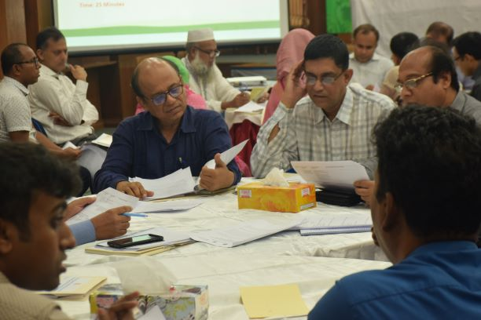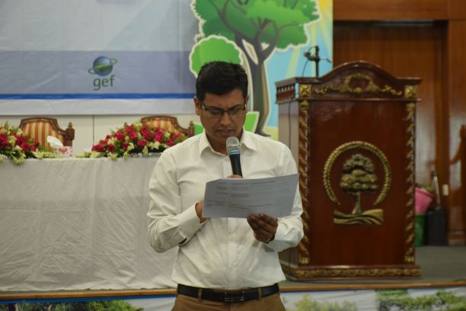
Figure 2: Interactive group exercise and presentation

The summary of the group exercise

The participants were divided into three groups to review the draft project proposal. The summary of the group recommendations on different aspects is as follows:

Feedback on the project components, outcomes and activities
Following recommendations were received from three groups on project component, outcome and activities:
- AFOFU, Energy, Waste and IPPU sectors should be well highlighted in each of the project activities;
- An MRV working group should be established for all GHG emission related sector;
- In project activities and trainings, other relevant stakeholders such as BFRI need to be engaged;
- A common platform for GHG emission data and other information collection needs to be created;
- Separate provision for sector-wise data collection in the platform should be made;
- In output 2.1.1 other sectors (waste, energy, IPPU) along with the land use change analysis should be included;
- Output 3.1.3 needs to be re-written as “Existing information systems upgraded to integrate and analyze adaptation support-related data”;
- A uniform data collection template needs to be shared with all stakeholder/govt. entities; and
- Universities and research centres need to be added in the stakeholder list.

Response on the indicators of the project outputs
Following suggestions were received from three groups on the indicators of the project outputs:
- The indicators of the project output should cover all the sectors such as AFOLU, Energy, Waste and IPPU;
- The indicator (i) of output 2.1.2 should include other sectors along with the land use change analysis;
- In the indicator (ii), the term “number of GHG data” of output 1.1.2 is difficult to understand which need to be clarified; and
- Under output 1.2.2 a separate indicator “No. of exchange program organized” needs to be added.
Suggestion for the project executing agency (DoE) in executing the project
Following recommendations were received from three groups for DoE in executing the project:
- DoE should have dedicated manpower and GHG inventory cell to attain the maximum benefits of the CBIT project;

- DoE should conduct a stakeholder mapping before initiating the stakeholder arrangement process for data collection and sharing;

- DoE should assign a focal point to deal with each sectoral stakeholder for data collection and sharing;
- More ownership and involvement of DoE need to be established in implementing the project;
- DoE must establish in house mechanism to better coordinate the project implementation process;
- An appropriate framework needs to be established in DoE to ensure data validity and homogeneity; and
- DoE should emphasize on continuous capacity building under a team approach drawing participants from other institutions.

Closing remarks
Mr. Shamshur Rahman Khan, Deputy Secretary (Development), MoEFCC, in his closing remarks appreciated all participants for their effective and fruitful contributions in the validation workshop. He expected that these contributions would play a substantial role in the finalization of the project document. He encouraged everyone to be engaged with this project in the days ahead. Mr. Rahman requested everyone to fill and share the workshop evaluation form. Before calling it a day, he conveyed his sincere thanks to all distinguished resource persons and participants for availing themselves to this validation workshop and showing their commitment for capacity building in efficiently dealing with climate change issues.

Workshop evaluation results

Participants were asked to evaluate the validation workshop based on certain questions. Here, 76% of the participants mentioned that the workshop is highly relevant to their organization. Whereas, 14% and 10% of the participants mentioned that the workshop is moderately and less relevant to their organization respectively. 62% of the participants agreed that the workshop materials (concept note, presentation, group exercise) are adequate and useful and 5%, 19%, and 14% of the participants are found to be strongly agreed, neutral and disagreed correspondingly in this regard. Further, 86% of the participants stated that project activities are enough to enhance the capacity of DoE to monitor and report NDC priority adaptation options and vice versa for 14%. However, 81% of the participants agreed that the proposed result framework meets the project objective, and 5% are disagreed and 14% are neutral about this matter. In addition, 43%, 29% and 24% of the participants opined respectively that memorandum of understanding (MoU), official letter of request (OLR), and letter of agreement (LoA) are the most appropriate mode of data sharing with DoE. While rest of the 4% participants mentioned that a single platform can be the most useful mode of data sharing with DoE.

Appendix 16: Response to Project Reviews
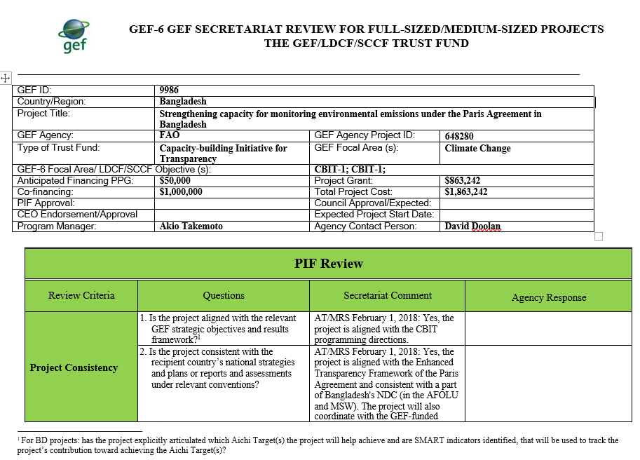
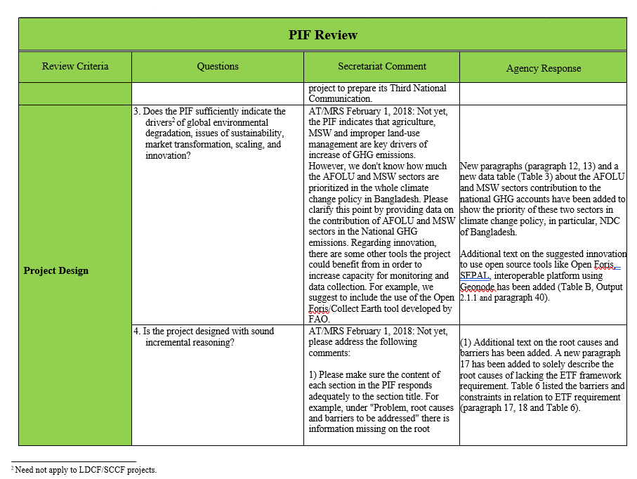

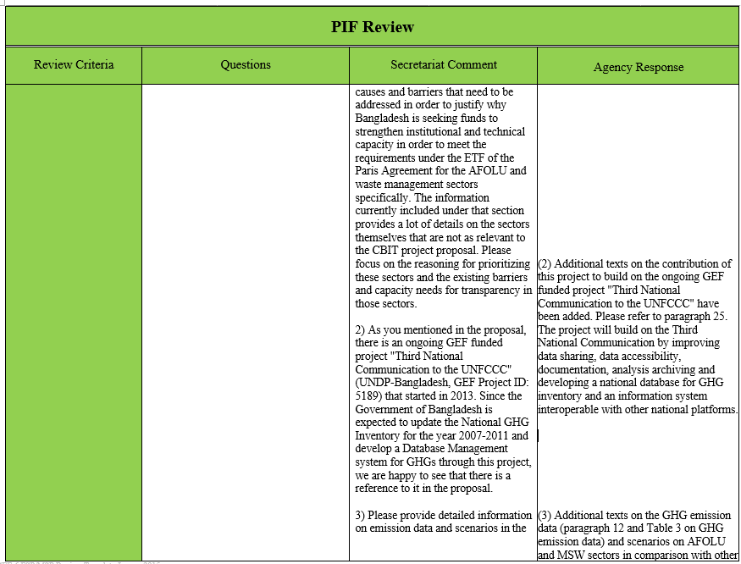


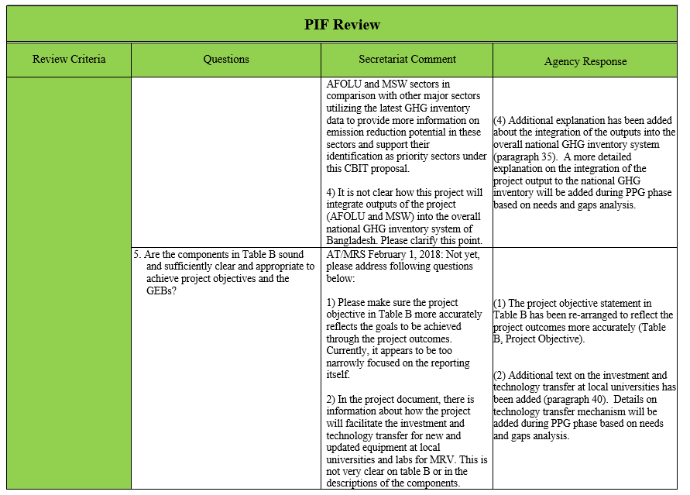

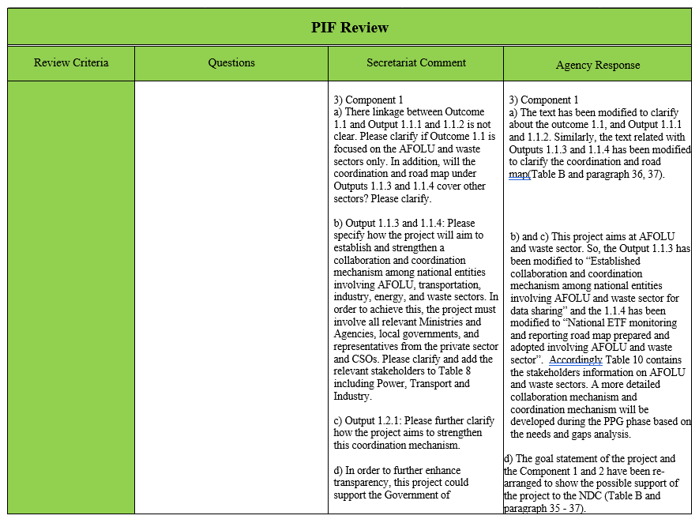
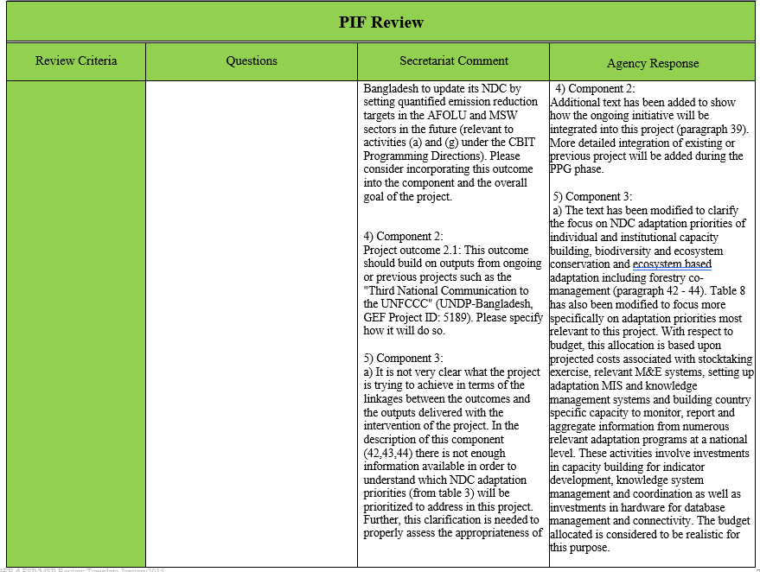

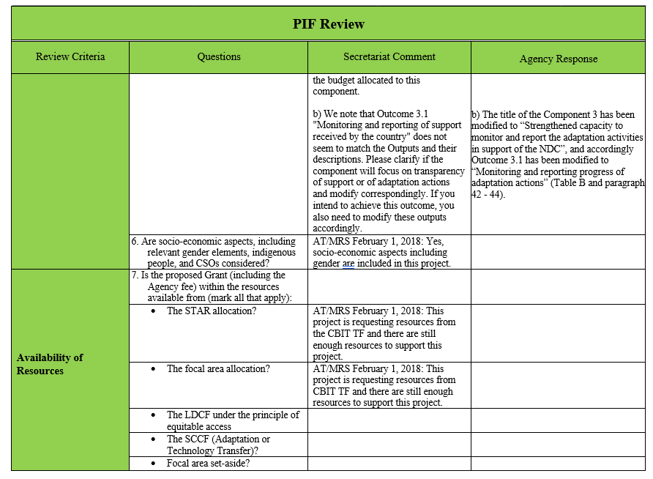

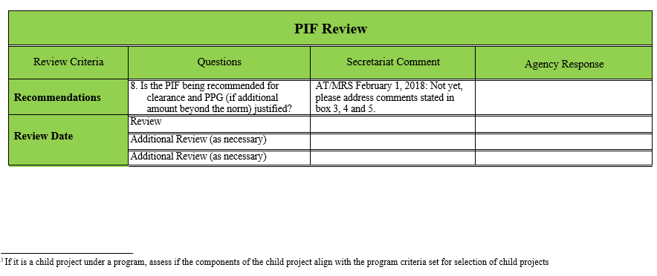

Appendix 17: List of Acronyms

AFOLU: Agriculture, Forestry and Other Land Use
BCCTF: Bangladesh Climate Change Trust Fund
BCCSAP: Bangladesh Climate Change Strategy and Action Plan
BUR: Biennial Update Report
CIP: Country Investment Plan
DoE: Department of Environment
EFCC: Environment, Forestry and Climate Change
FAO: Food and Agriculture Organization of the United Nations
GEF: Global Environment Facility
GHG: Green House Gas
ETF: Enhanced Transparency Framework
GIS: Geographic Information System
LDC: Least Developed Country
LDCF: Least Developed Countries Fund
MoU: Memorandum of Understanding
MoEFCC: Ministry of Environment Forest and Climate Change
MoWCA: Ministry of Women and Children Affairs
MRV: Monitoring, Reporting and Verification
NDC: Nationally Determined Contribution
PMC: Project Management Costs
PMU: Project Management Unit
PSC: Project Steering Committee
SCCF: The Special Climate Change Fund
SDG: Sustainable Development Goal
TACC: Transparency, Accuracy, Consistency, Completeness
UNFCC: United Nations Framework Convention on Climate Change
7FYP: 7th Five Year Plan

The executing entity - also referred to as the Operational Partner in FAO terminology - is required to implement the agreed results of the project in compliance with FAO and relevant requirements on fiduciary, procurement, environmental and social safeguards, and other performance standards. In legal terms, this is ensured through the signature of the Operational partners Agreement with an FAO project document as annex to the Operational partners Agreement which will be signed by the Operational Partner/Executing Entity to govern the use of the funds.
See Guidance Note on Gender Mainstreaming in project identification and formulation
Arfanuzaman, M. Shaheduzzaman, M., Henry, M., Islam, K.M.N 2019. Proceedings of the national workshop on strengthening capacity for monitoring environmental emissions under the Paris Agreement in Bangladesh. 10 February 2019, Dhaka. Bangladesh Forest Department, Food and Agriculture Organization of the United Nations.
MoEF. 2015. Bangladesh’s Intended Nationally Determined Contributions. Dhaka,Bangladesh Ministry of Environment and Forests (MoEF), Government of the People’s Republic of Bangladesh., 15.
United Nations (2015). PARIS AGREEMENT. https://unfccc.int/sites/default/files/english_paris_agreement.pdf
United Nations (2015). Article 4, PARIS AGREEMENT. https://unfccc.int/sites/default/files/english_paris_agreement.pdf
United Nations (2015). Article 13, PARIS AGREEMENT. https://unfccc.int/sites/default/files/english_paris_agreement.pdf
MoEF. 2002. Initial National Communication of Bangladesh to the United Nations Framework on Convention on Climate Change Ministry of Environment and Forests (MoEF), Government of Bangladesh, 170.
MoEF.2012. Second National Communication of Bangladesh to the United Nations Framework on Convention on Climate Change Ministry of Environment and Forests (MoEF), Government of Bangladesh, 242.
MoEF. 2015. Bangladesh’s Intended Nationally Determined Contributions. Dhaka, Bangladesh Ministry of Environment and Forests (MoEF), Government of the People’s Republic of Bangladesh., 15.
Tubiello, Francesco N., Mirella Salvatore, Alessandro F. Ferrara, Jo House, Sandro Federici, Simone Rossi, Riccardo Biancalani et al. "The contribution of agriculture, forestry and other land use activities to global warming, 1990–2012." Global change biology 21, no. 7 (2015): 2655-2660.
MoEF. 2002. Initial National Communication of Bangladesh to the United Nations Framework on Convention on Climate Change Ministry of Environment and Forests (MoEF), Government of Bangladesh, 170.
MoEF.2012. Second National Communication of Bangladesh to the United Nations Framework on Convention on Climate Change Ministry of Environment and Forests (MoEF), Government of Bangladesh, 242.
MoEFCC.2018. Roadmap and Action Plan for Implementing Bangladesh NDC. Ministry of Environment, Forests, and Climate Change (MoEFCC), Government of Bangladesh, 121.
Proceedings of the national workshop on strengthening capacity for monitoring environmental emissions under the Paris Agreement in Bangladesh. 10 February 2019, Dhaka. Bangladesh Forest Department, Food and Agriculture Organization of the United Nations.
MoEF. 2015. Bangladesh’s Intended Nationally Determined Contributions. Dhaka, Bangladesh Ministry of Environment and Forests (MoEF), Government of the People’s Republic of Bangladesh., 15.
MoEF. 2009. Bangladesh Climate Change Strategy and Action Plan (BCCSAP), 2009. Dhaka, Bangladesh Ministry of Environment and Forests (MoEF), Government of the People’s Republic of Bangladesh., 76.
"Govt to rename environment ministry". The Daily Star. 2017-08-06. Retrieved 2018-05-14
MoEF (2009). Bangladesh climate change strategy and action plan 2009. The Ministry of Environment and Forest (MoEF), Government of the People's Republic of Bangladesh. Dhaka, Bangladesh. XVIII+76pp.
MoEF.2012. Second National Communication of Bangladesh to the United Nations Framework on Convention on Climate Change Ministry of Environment and Forests (MoEF), Government of Bangladesh, 242.
MoEF (2015). Bangladesh’s Intended Nationally Determined Contributions. Dhaka, Bangladesh Ministry of Environment and Forests (MoEF), Government of the People’s Republic of Bangladesh: 15.
MoEF. 2017. Bangladesh country investment plan for Environment, Forestry and Climate Change. Ministry of Environment and Forest (MoEF). Dhaka, Bangladesh.: Ministry of Environment and Forest (MoEF), The Government of the People's Republic of Bangladesh. , 210.
MoEFCC.2018. Roadmap and Action Plan for Implementing Bangladesh NDC. Ministry of Environment, Forests, and Climate Change (MoEFCC), Government of Bangladesh, 121.
"Bangladesh Climate change trust, Ministry of Environment and Forests, Bangladesh". bcct.gov.bd. Retrieved 12 January 2019.
GEF. 2018. GEF-7 REPLENISHMENT. PROGRAMMING DIRECTIONS. https://www.thegef.org/sites/default/files/council-meeting-documents/GEF-7%20Programming%20Directions%20-%20GEF_R.7_19.pdf
United Nations (2015). Article 13, PARIS AGREEMENT. https://unfccc.int/sites/default/files/english_paris_agreement.pdf
"Govt to rename environment ministry". The Daily Star. 2017-08-06. Retrieved 2018-05-14
"Bangladesh Climate change trust, Ministry of Environment and Forests, Bangladesh". bcct.gov.bd. Retrieved 12 January 2019.
MoEF. 2017. Bangladesh country investment plan for Environment, Forestry and Climate Change. Ministry of Environment and Forest (MoEF). Dhaka, Bangladesh.: Ministry of Environment and Forest (MoEF), The Government of the People's Republic of Bangladesh. , 210.
MoEF (2009). Bangladesh climate change strategy and action plan 2009. The Ministry of Environment and Forest (MoEF), Government of the People's Republic of Bangladesh. Dhaka, Bangladesh. XVIII+76pp.
MoEF (2015). Bangladesh’s Intended Nationally Determined Contributions. Dhaka, Bangladesh Ministry of Environment and Forests (MoEF), Government of the People’s Republic of Bangladesh: 15.
MoEFCC.2018. Roadmap and Action Plan for Implementing Bangladesh NDC. Ministry of Environment, Forests, and Climate Change (MoEFCC), Government of Bangladesh, 121.
"Bangladesh Climate change trust, Ministry of Environment and Forests, Bangladesh". bcct.gov.bd. Retrieved 12 January 2019.
GED. 2015. 7th Five Year Plan (2016-2020). Dhaka, Bangladesh: General Economics Division (GED),Planning Commission, Government of the People’s Republic of Bangladesh, 736.
MoEF. 2005. Bangladesh National Adaptation programme of Action (NAPA). In Dhaka, Bangladesh. Dhaka, Bangladesh. : Ministry of Environment and Forests (MoEF), Government of Bangladesh., 46.
MoEF. 2009. Bangladesh National Adaptation programme of Action (NAPA). In Dhaka, Bangladesh. Dhaka, Bangladesh. : Ministry of Environment and Forests (MoEF), Government of Bangladesh., 48.
MoEF. 2016. Bangladesh National Consrvation Strategy (NCS) (2016-2031). Ministry of Environment and Forest (MoEF). Dhaka, Bangladesh: Ministry of Environment and Forest (MoEF), The Government of the People's Republic of Bangladesh.
DoE. 2009. National 3R Strategy for Waste Management. Department of Environment (DoE), Government of the People’s Republic of Bangladesh. Dhaka, Bangladesh: Department of Environment (DoE), Ministry of Environment and Forests (MoEF), Government of the People’s Republic of Bangladesh, 36.
GED. 2013. National Sustainable Development Strategy 2010-21 (NSDS). Dhaka, Bangladesh: General Economics Division (GED),Planning Commission, Government of the People’s Republic of Bangladesh, 143.
GED. 2012. Perspective Plan of Bangladesh 2010-2021: Making Vision 2021 A Reality. Dhaka, Bangladesh: General Economics Division (GED),Planning Commission, Government of the People’s Republic of Bangladesh, 100.
MoEF. 2016. Bangladesh National Conservation Strategy (NCS) (2016-2031). Ministry of Environment and Forest (MoEF). Dhaka, Bangladesh: Ministry of Environment and Forest (MoEF), The Government of the People's Republic of Bangladesh.
The election manifesto 2018 of Bangladesh Awami League. https://www.albd.org/category/election-manifesto-2018
MoEFCC. 2018. Roadman and Action Plan for Implementing Bangladesh NDC: Transport, Power and Industry Sectors, Ministry of Environment, Forest and Climate Change, GoB, Dhaka, Bangladesh
MoEF(a). 2009. Bangladesh Climate Change Strategy and Action Plan 2009. Ministry of Environment and Forest, GoB, Dhaka, Bangladesh
See: http://www.fao.org/in-action/micca/resources/tools/en/
Available via: http://www.fao.org/3/a-i4260e.pdf
Avalable via: http://www.fao.org/tc/exact/ex-act-home/en/
The Canadian International Development Agency.
Government of Bangladesh.

