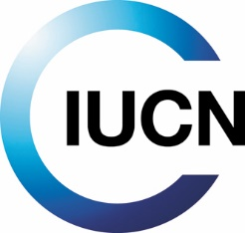

Project Implementation Report (PIR)

01 July 2025– 30 June 2026

EREPA, Solomon Islands

Table of Contents

A. Project Overview 2
B. Overall Ratings (Final – Validated by Regional Portfolio Manager) 4
C. Ratings and Overall Assessments 5
D. Outcomes achievements and outputs delivery 7
E. Challenges: Information on challenges of project implementation activities 9
F. Adjustments 52
G. Implementation Progress 53
H. Critical Risk Management 53
I. Gender 54
J. Implementing the Stakeholder Engagement Plan 56
K. Environmental and Social Safeguards 59
L. Knowledge Management 62
Annex - Ratings definitions 66

Project Overview

Project Information
IUCN Project ID | PO2461
GEF ID | 9846
Title | EREPA – Ensuring Resilient Ecosystems and Representative Protected Areas in the Solomon Islands.
Country(ies) | Solomon Islands
Regional Programme | ORO GEF/GCF
Global Thematic Programme/Regional Thematic Programme (if relevant) | Multilateral Unit HQ
Joint Agency (if relevant)
Executing Agency(ies) | Ministry of Environment Climate Change and Disaster Management, Government of Solomon Islands and SPREP
Project Type | Full Sized Project

Project Description
The proposed GEF -funded project “Ensuring resilient ecosystems and representative protected areas in the Solomon Islands” will be implemented by the Ministry of Environment, Climate Change, Disaster Management and Meteorology (MECDM), in partnership with the Secretariat of the Pacific Regional Environment Program (SPREP) and in close coordination with the International Union for the Conservation of Nature (IUCN). The project’s goal is to “establish an effective network of protected areas to achieve healthy, productive and restored landscapes in Guadalcanal, Malaita, Rennell-Bellona and Temotu provinces”. The project will be implemented in these four provinces of the Solomon Islands.
As part of achieving this goal, the degradation of terrestrial ecosystems will be reduced and there will be a multiplication of co-benefits. The project interventions will lead to improved community livelihoods through the diversification of income-generating sources, increased direct economic value and benefits from natural resources, and increased resilience to the effects associated with climate change. At the national level, baseline information gathered on natural resources and other variables as well as capacity building will contribute to sound and efficient decision making in the Solomon Islands.
The project will contribute to addressing terrestrial biodiversity loss and ecosystem decline through the improved management of natural resources, and the creation of protected and conserved areas within four Key Biodiversity Areas. Biodiversity preservation and ecosystem services will be promoted over at least 50,000 hectares of terrestrial and coastal land. By promoting biodiversity protection, building capacity for the creation and management of protected areas including access to relevant information for land-use planning, and strengthening the policy framework for the creation, management and maintenance of protected areas, the EREPA project will significantly support Solomon Islands in meeting its commitments under multilateral environment agreements.
The design of the project is fully aligned with Solomon Islands’ national priorities and will be implemented within the framework of the Protected Areas Act and other relevant national policies and regulations. The strong political will of participating ministries will be an important factor in sustaining the longevity of the project’s outputs. The strong relationship between government institutions and the executing agency, as well as supporting organizations, will also contribute to sustaining project interventions and outputs.
Project Goals and Objectives
The goal of this project is to establish an effective network of protected areas to achieve healthy, productive and restored landscapes in Guadalcanal, Malaita, Rennell-Bellona and Temotu provinces. The project objective will be achieved through the following interventions as stated in the project document;
I. to support local communities to fulfil the Protected Areas Act’s requirements to formally declare terrestrial protected areas in the four provinces
II. to promote the adoption of improved livelihoods, including improved agricultural practices, based on the sustainable use of natural resources to compensate for the loss of income resulting from the PA creation (stopping detrimental logging or agriculture encroachment);
III. to establish an efficient network of protected areas (knowledge sharing, M&E, incremental national knowledge database, and long-term funding strategy).

Project Outcomes:
Outcome 1. Stakeholders and planning mechanisms recognise the role of ecosystems and ecosystem services for improved management of land, forest and water resources.
Outcome 2. National PA Network, PA Monitoring and Evaluation systems, knowledge management, financing plans developed, and additional protected areas are declared.
Outcome 3. The environmental quality and the livelihood benefits of production landscapes for communities within and adjoining PAs are sustained.

Project Contacts
Task Manager (Implementing Agency) | Vasiti Navuku (Task Manager); Anshuman Saikia (Portfolio Manager)
Global/Regional Thematic Lead (Implementing Agency)
Project Manager (Executing Agency) | Cathy Unga
Project Monitoring and Evaluation Officer (Executing Agency)
Project Safeguards Officer (Executing Agency) | Daniel Hayward
Project Communication Officer (Executing Agency)
GEF Operational Focal Point | Deputy Secretary Technical - Ministry of Environment, Climate Change, Disaster Management and Meteorology

Overall Ratings (Final – Validated by Regional Portfolio Manager)

Overall Development Outcomes Rating | Moderately Satisfactory
Overall Implementation Rating | Moderately Satisfactory
Overall Risk Rating | Substantial risk
Safeguards Risk Rating

^{[1]} This section will use the scale used by the GEF and outlined in Annex L of this document: 1) Highly satisfactory, 2) Satisfactory, 3) Moderately Satisfactory, 4) Moderately Unsatisfactory, 5) Unsatisfactory, 6) Highly Unsatisfactory
^{[1]} Idem
^{[1]} This section will use the scale used by the GEF and outlined in the Annex of this document: 1) High Risk, 2) Substantial Risk, 3) Moderate Risk, 4) Low Risk

Ratings and Overall Assessments
Role | YEAR Development Objective Progress Rating | YEAR Implementation Progress Rating | YEAR Project Risk Rating
Project Management Unit (PMU) | Overall Assessment | Overall Assessment | Overall Assessment
Project Management Unit (PMU) | The Overall assessment for the objectives is satisfactory because of the progress of achieving them in this reporting period | The Overall assessment for the implementation progress is satisfactory because of the progress of each component in this reporting period | The risk is low because they can be managed at the project level.
Project Management Unit (PMU) | Please provide justification for overall assessment | Please provide justification for overall assessment | Please provide justification for overall assessment
Project Management Unit (PMU) | The objective development in the 5th year has shown progress than in the first 4 years of the project. All the 3 objectives of the has made progress:  Objective 1: 44 Protected Area Management Committees established for all the project sites and have demarcated PA boundaries with a total area of 25797 Ha. The signing between tribal groups have been conducted to agree on the boundaries. Also, PA management plans have been developed for Malaita, Renbell and Guadalcanal Provinces.  Objective 2: 35 Community Land Use Based Mapping and Plans have been established that identified agricultural, forestry and conservation interventions. The Screening process of sustainable development project has been developed for communities to apply for project to proposal  Objective3: The project is identifying formal PAs and informal PAs to establish the protected area network. This includes PA exchange learning for an effective network of PAs. Also, the SIPAMET has been developed to determine effective implementation of PA management Plans.  Hence, the progress of project objective development has been rated satisfactory because of its advancement since the commence of the project. | The implementation progress is satisfactory because most of the activities are in progress and in completion stage. The CTA is focusing on all the components in ensuring achieving and meeting the targets. Component 1 is nearly 70% completion; Component 2 is 80 % and component 3 is 70%. Hence the implementation progress is advancing effectively with the support of the key line ministries, provincial government, communities and tribal groups. | The project risk rating is low because most of the risk was being addressed at the project level. The main risk was on operational and financial mitigation plan was carried out that most of the matters has been closed and ongoing. The ongoing risk are closely monitored and just required time for PMU to sit and discuss to address the matter. Hence overall risk is rated low for this reporting period
IUCN Regional/Country Office (IA) | Overall Assessment | Overall Assessment | Overall Assessment
IUCN Regional/Country Office (IA) | Moderately Satisfactory | Moderately Satisfactory | Substantial Risk
IUCN Regional/Country Office (IA) | Please provide justification for overall assessment | Please provide justification for overall assessment | Please provide justification for overall assessment
IUCN Regional/Country Office (IA) | Progress has been made across all components with notable deficiencies, which can be improved during the MTR.  Component 1 is moving closer to meeting its objective with improved management of PAs with the development of 8 training models for PA Management Effectiveness Toolkit. Also noting the 18 EREPA scientists that work collaboratively with the project.  Component 2 noted the result of Learning Exchanges which saw provision of new PAs being declared.  Component 3 focussing on alternative livelihoods saw that sustainable development guidelines and application template was developed to respond to the Community Based Land Use Plans. | Project activity implementation has progressed with minor administrational setbacks. This needs to be managed appropriately to mitigate further delay of activity implementation. The MTR would allow provision to prioritise activities to ensure the intended results. | The delayed MTR may pose further bottlenecks to the progress of the project. Additionally, the non-existent ESMP which would also encompass gender sensitive measures, is a critical document considering the community beneficiaries. These documents are critical to ensure the inclusive and appropriate delivery mechanisms.
IUCN Regional/Global Thematic Lead (as relevant) | Overall Assessment | Overall Assessment | Overall Assessment
IUCN Regional/Global Thematic Lead (as relevant) | Please provide justification for overall assessment | Please provide justification for overall assessment | Please provide justification for overall assessment
IUCN Regional/Global Portfolio Manager | Overall Assessment | Overall Assessment | Overall Assessment
IUCN Regional/Global Portfolio Manager | Moderately Satisfactory | Moderately Satisfactory | Substantial Risk
IUCN Regional/Global Portfolio Manager | Please provide justification for overall assessment | Please provide justification for overall assessment | Please provide justification for overall assessment
IUCN Regional/Global Portfolio Manager | The project has made considerable progress towards achieving its overall development objectives even though there were considerable delays to the start up of the activities. | The projects activity implementation has progressed further including on those related to the step by step establishment of the Protected Area system. However, the project management needs to be more responsive and proactive in managing the project given the changing dynamic context | The overall risk category is rated high due to the project not being compliant with having the safeguard instrument as well as the Mid-Term Review undertaken as scheduled. In addition, given the recent political developments, political instability continues to pose a significant risk.

Outcomes achievements and outputs delivery
- Progress against higher level outcomes since project started
- Outcome 1: Stakeholders and planning mechanisms recognise the role of ecosystems and ecosystem services for improved management of land, forest and water Resources;

The awareness raising campaigns and consultations through different mediums at national, provincial and community levels have informed stakeholders on the importance of establishment of the land use forums and safeguard measures. Also, baseline studies conducted for project sites on ecosystems health and socio-economic analyses have provided baseline information for decision makers to make informed decisions on the protection and management of resources. Similarly, the establishment of the land use forum- will influence decision makers in conservation planning at provincial level to make informed decision that will contribute to sustainable development. Hence, Temotu province has signed the agreement for the establishment of the Provincial Land Use Forum and the recruitment of legal officer which is in the process will develop provincial ordinances to safeguard conservation initiatives at the provincial and community levels.

- Outcome 2: National PA Network, PA Monitoring and Evaluation systems, knowledge management, financing plans developed, and additional protected areas are
declared.

The inventory of existing and upcoming Protected Areas Management committees will inform the development of the protected area network. This inventory report will help conservation partners and stakeholders to collaborate and exchange learning to improve the PA process overtime. Likewise, the development of the data protocol is to ensure PA actors systematically collect, analyse and store information to ensure effective management of protected areas. The data protocol will enable information from the Solomon Islands Protected Area Measuring and Effectiveness Tracking System (SIPAMETS) to made available for PA actors to make inform decisions. The governance and management of PAs determined through using the 38 indicators to measure their performance in the implementation of their Management plans. This will inform the PA groups, provincial and national levels to improve governance of protected areas in Solomon Islands. Hence, these developments will support Protected Areas establishment and conservation efforts to effectively protect and manage their resources through making informed decisions based on strong governance at community, provincial and national levels.

- Outcome 3. The environmental quality and the, livelihood benefits of production landscapes for communities within and adjoining PAs are sustained.
The awareness raising on sustainable agricultural practices, restoration intervention and conservation broaden knowledge of community members to understand importance of Land Use planning. The knowledge obtained help communities identified PA, agriculture and forestry and other land uses within their areas that need to be managed. The land use maps were developed indicating the areas for each land use and building on from this land use maps they make informed decisions on the relevant interventions. They were able to have a 10 years vision and identify interventions to achieve their 10-year visions. Hence Community Based Land Use Management Plans were developed for each PA groups with intervention on sustainable agricultural practices, restoration interventions and conservation initiatives. These will connect planning from community and align with provincial and national plans and policies.

- Overview of Outcome achieved during this reporting period
  - Outcome 1: Stakeholders and planning mechanisms recognise the role of ecosystems and ecosystem services for improved management of land, forest and water Resources;
The baseline report on the ecosystem’s health and services for Malaita and Temotu were providing the health status to help communities make informed decisions. The status of ecosystems helps influence in the development of the protected area management plan and will inform provincial and national government to make informed decisions on policies and plans. The status of ecosystem will determine the types of sustainable agricultural practices, restoration intervention and conservation efforts to help maintain the healthy status of ecosystem to sustain natural resources for future generation. Likewise, the ongoing awareness at the community level is important to influence the resource owners to protect their resources under the protected areas act 2010. Also, awareness at provincial level is important to align with policies and planning and provinces to take ownership in supporting their communities. This will lead to supporting national stakeholders protecting resources from unsustainable development practices.

  - Outcome 2: National PA Network, PA Monitoring and Evaluation systems, knowledge management, financing plans developed, and additional protected areas are declared.
The governance and management of PAs measured through the 38 performance indicators as per the SIPAMETTS and by using this the 7 formal PAs established determined their performances. It is important for PA groups to recognize areas that need improvement and seek support from provincial and national to support improve performance. The governance and management of PAs strengthen through assessing their performances to help them understand their capacity needs. Also, this data of performance contributed to global portal in showing Solomon Islands commitment in protecting their biodiversity. Similarly, majority of the PAs have developed PA Management and Budget Plans and that shows they have completed steps 1-9 and preparing for PA application submission. The commitment to protect the biodiversity is only through PA declaration under the Protected Areas Act 2010. Hence, the alignment of plans and policies at the provincial and national level are possible through community’s commitment to protect their biodiversity in strengthening governance and declaring PAs under the PA Act 2010.

  - Outcome 3. The environmental quality and the, livelihood benefits of production landscapes for communities within and adjoining PAs are sustained.

The development of the sustainable development plans to support funding of the prioritized community livelihood plans based in the Community based land use plans. The project has developed Screening Process guideline for Mini Sustainable Development Project Proposals. The guidelines and eligible criteria are developed to help communities apply for funding under the project. This will be direct benefit for communities to engaged in income livelihood opportunities whilst protecting and managing the natural resources, Also, ongoing agricultural and restoration intervention will help maintain healthy and restored landscapes. Hence, resource owners will make informed decisions based on alternative livelihood opportunities to strengthen establishment of protected areas in Solomon Islands.

Challenges: Information on challenges of project implementation activities
● Challenges encountered since project started
The project has encountered challenges since the commencement of the project, the agreement was signed in September 2021, but PMU was established in April 2022 due to the Covid -19 pandemic. The entire year of 2022 and beginning of 2023 was focusing on inception related activities culminating with inception workshops at National, provincial and community levels. In addition, there was a delay in the recruitment of provincial project coordinators. In addition, the project initiated recruited a CTA in 2023 who did not perform as expected leading to further delays in the implementation of activities. One of the ongoing and major challenges is clearly demonstrating and arguing the long-term benefits of conservation for rural people since they are dependent on natural resources for their livelihoods. The focus is on logging and other unsustainable harvesting of resources for quick cash to meet their immediate needs instead of focusing on the long -term impacts. This has resulted in only a few tribes from the project sites submitting Expression of Interest to participate in the Protected Area step by step process for declaration of protecting their resource under the Protected Area Act 2010. The land resources in Solomon Islands are mostly tribal owned which requires tribal consultation and agreement that causes challenges as it is difficult for certain tribes to achieve consensus among themselves.

● Challenges encountered during this reporting period
In the 4th year of implementation, the major delay is the 4th tranche transfer which took almost 6 months for the transfer to the project account. The financial reports were sent to IUCN ORO at 70% expenditure rate and at that time the IUCN finance officer who reviewed the documents left without notifying PMU and proper handover with IUCN finance team. The activities were on hold since October 2025 which the remain balance is cater for PMU daily operations mainly on salary for staff. This delay for 6 months has impacted on delivering activities and recruitment of consultants. Hence, this reporting period not much of the activities has been implemented which will cause delay of delivering the activities within the timeframe the project is envisioning.

● The solutions applied to mitigate their impact
- The PMU team reached out to IUCN finance team for their support in the absence of the financial officer who is responsible for providing finance support to the project.
- The recruitment of the Multi task GEF/GCF Manager has provided support on following up with IUCN finance team to fast track the process for funds to be made available.
- The long-term benefit of conservation and lengthy process of Protected Area concept has been addressed through ongoing engagement and support and continuous implementation of activities at the community level. Also, community-based land use maps and plans have been developed for each of the proposed PA groups to engage in whilst in the process of PA declaration. The livelihood activities have increased their interest in the project’s objectives as they can now perceive tangible benefits and also willing partners for enhancing biodiversity conservation and improved natural resources management for addressing present and future societal benefits.

Please fill in the table below building on your result framework.
Objective 1: Effective ecosystem management for healthy, complementary networks of protected, productive and restored landscapes in Malaita, Guadalcanal, Rennell-Bellona and Temotu
Outcomes  (Copy and paste outcomes from Result Framework) | Indicators | Baseline | Midterm Target | End of project Target | Periodic Results (01/07/2025-30/06/2026) | Result to Date (from project start) | Progress rating (HS, S,MS,MU,U,SU)
Outcome 1. Stakeholders and planning  mechanisms recognise the role of ecosystems  and ecosystem services for improved  management of land, forest and water  resources | Establishment of land use forums | 0 | 2 | 4 | First provincial and stakeholder consultation to establish Provincial Land Use Forum for Renbel and Guadalcanal Province were convened on 10th and 11th June 2025 at IBS Hotel, Honiara. | The current CTA was recruited in 2024 and leads the activity. All four provinces have had their first Provincial Land Use Forum consultation meetings with project and provincial executives and stakeholders and in principle, all expressed interest to establish PLUFs. So far, Provincial Executives from Temotu Province have successfully signed a Terms of Reference (TOR) governing the establishment of the PLUF and its functions and operation and also a Letter of Agreement (LOA) to guide the key activities under the agreement between parties involved. Malaita, Renbel and Guadalcanal Provinces have requested second consultations to consider the Terms of Reference and Letter of Agreements. | S
 | Number ordinances drafted and submitted for validation | 0 | 2 | 4 | A three-person (Chairman, Secretary and Member) Tender Evaluation Committee (TEC) was formed and evaluated tender applications for Legal Drafting Consultant to draft Provincial Ordinances. The chairman of TEC produced the Tender Evaluation Report based on assessment done by TEC, ready for submission to the Ministrial Tender Board (MTB) to review and approve the recommended applicant. The consultant should be contracted to do four provincial Ordinances for all four provinces in the 3rd quarter of 2026. | Terms of Reference for recruitment of legal drafting consultant was developed by CTA. A budget of $20,000USD was confirmed by PMU for the work of the legal consultant. PMU advertised Consultancy vacancy for 2 weeks in both local newspapers and online platforms and was extended for another week due to limited applicants. Tender Evaluation Committee (TEC) was formed and conducted evaluation of five applicants. The Tender Evaluation Report was prepared by the Chairman of TEC. The report is ready for the consideration of the MinistrIal Tender Board (MTB) to conclude the recruitment process. | MS
Outputs  (Copy and paste outputs from Result Framework) | Indicators | Baseline | Midterm Target | End of project Target | Periodic Result (01/07/2025-30/06/2026) | Result to Date (from project start) | Implementation status (%)
Output 1.1 Provincial level land-use forums  established for decision-making on land use and  resolution of conflicts between natural resource  protection and economic development | Number of cross-sector partnership agreements | 0 | 2 | 4 | Renbel and Guadalcanal Provinces conducted consultations with provincial executives and stakeholders to present the PLUF concept on 10th and 11th June 2025. Malaita Province schedules second PLUF consultation on 16 September and was later cancelled due to other commitments. | 1 x Provincial Land Use Forum was established for Temotu Province based on TOR and LOA signed by Premier of Temotu Province with MECDM and EREPA Project.  3 x Provincial Land Use Forums (Malaita, Guadalcanal and Renbel) completed first consultations and agreed in principle to enter into partnership agreements, but all expressed need for second consultations to agree on the Terms of Reference (TOR) and letter of agreement (LOA) outlining the activities to be implemented under the partnership agreement. | 70%
 | Establishment of land use forums | 0 | 2 | 4 | Renbel and Guadalcanal Provinces conducted consultations with provincial executives and stakeholders to present the PLUF concept on 10th and 11th June 2025. Malaita Province schedules second PLUF consultation on 16 September and was later cancelled due to other commitments. | 1 x Provincial Land Use Forum was established for Temotu Province based on TOR and LOA signed by Premier of Temotu Province with MECDM and EREPA Project.  3 x Provincial Land Use Forums (Malaita, Guadalcanal and Renbel) completed first consultations and agreed in principle to enter into partnership agreements, but all expressed need for second consultations to agree on the Terms of Reference (TOR) and letter of agreement (LOA) outlining the activities to be implemented under the partnership agreement. | 70%
 | Shared Shape file of existing and potential Protected Areas in Solomon Islands | 0 |  | 1 | No activity for this reporting period | Project has been working on 33 proposed PA sites (Temotu 17, Malaita 4, Guadalcanal 11 and Renbel 1). Shape files for all the above proposed PAs have been completed by GIS Expert and received by PMU. Shape files for Malaita and Renbel proposed PAs have been submitted to mandated ministries (Ministry of Forestry, Ministry of Mines and Energy and Ministry of Lands) and already been used to clear proposed PAs as free for conservation use. Shape files for Temotu and Guadalcanal Provinces have been completed but not yet submitted to mandated ministries for clearance of proposed PAs.  Also, SPREP is supporting the project to develop map for existing PAs in Solomon Islands. | 80%
 | Number of people attending land use forums | 0 | 100 | 200 | No activity for this reporting period | 76 Participants participations in the first consultations with provincial governments and NGOs.  The land use forum proper participation is expected to exceed the target. | 40%
 | Land-use forum participants are satisfied with the forum process and outcomes | 0 | 40 | 80 | No activity for this reporting period | 67 Participant which is 89% of the 76 participants were satisfied with the process and outcome. | 83%
Output 1.2: Land and ecosystem characterisation studies (land-tenure, land-use, elevation, geology, hydrography) as well as biodiversity, vegetation and ecosystem health assessments completed to identify priority sites for proposed protected areas in the four priority provinces. | Number of diagnostic assessments completed | 0 | 2 | 4 | 2 x Ecosystem Services and Health Assessment Reports were completed for Malaita and Temotu in October 2025 | The following reports have been produced:  4 x Ecosystem and Socio-Economic Resilience Analysis and Mapping (ESRAM) carried out for all the provinces.  3 x Diagnostic assessment on Ecosystem Services and Health Assessment report has been produced for Renell, Malaita and Temotu. | 100%
 | Number of studies undertaken | 0 | 15 | 30 | 2 x Ecosystem Service and Health Assessment Reports (Temotu and Malaita) were completed in October 2025 | 4 x ESRAM Study Reports  3 x Reports on Socio- Economic Household Reports for Renell and Malaita Province  4 x Reports on Community Based Land Use Management Plan  3 x Reports on Ecosystem Service and Health Assessment  1 x Report on Alignment of Solomon Islands Protected Areas categories with IUCN | 76%
 | Number of local scientists engaged in studies | 0 | 10 | 20 | The following local scientists or technical expertise were engaged in this reporting period:  - Avan Manaseh- Reforestation  - Leah Bently- Agriculture | A total of 18 local scientist engaged with EREPA.  - Dr Kristina Fidali – PAs, HHS, ESH, CBLUP  - Trevor Maeda- PAs  - Fredrick Dotho- PAs  - Geoffery Mauriasi-PAs  - Alister Talua- CBLUP  - Patrick Fiasi- CBLUP  - Paul Hatamane- Reforestation  - Arnold Augwaroa-GIS  - Nelly Kere- ESRAM  - Albert Kwatalae- PAs  - Jeremiah Tabua- PAs  - George Tauika – PAs  - Zena Sauuna – PAs  - Avan Manaseh- Reforestation  - Leah Bently- Agriculture  - Cathy Unga – PAs, HHS, ESH, ESRAM  - Avan Manaseh – Reforestation  - Leah Bently - Agriculture | 90%
Output 1.3 Provincial ordinances developed or updated in partnership with communities in the four targeted provinces to establish a supportive framework for protected and conserved areas and sustainable natural resource management. | Number of ordinances drafted and submitted for validation | 0 | 2 | 4 | The Tender Evaluation Committee has completed evaluation. The Chairman has consolidated and finalised the Tender Evaluation Report based on assessment done by Tender Evaluation Committee, ready for submission to the Ministry Tender Board for review and approval of the recommended applicant. The consultant will be contracted to draft Ordinances for all four provinces in the 3rd quarter of 2026. | Terms of Reference for recruitment of the Legal Drafting Consultant was developed by CTA. A budget of $20,000USD was confirmed by PMU for the work of the Legal Drafting Consultant. PMU advertised the consultancy work for 2 weeks in both local newspapers and online platforms and was extended for another week due to limited applicants. Tender Evaluation Committee was formed and conducted evaluation for five applicants. The Tender Evaluation Report was prepared by the Chairman of the Tender Evaluation Committee. The report is ready for the consideration of the Ministry Tender Board to conclude the recruitment process. | 40%
 | Number of local community members attending consultations | 0 | 100 | 200 | No activity for this reporting period | Advertisement for recruitment of consultant was completed. Evaluation of tender applications completed and recruitment of Legal Drafting Consultant (Lawyer) to draft the Ordinances, near completion. | 40%
 | Community members are satisfied that their views and concerns are heard and addressed | 0 | 40 | 80 | No activity for this reporting period | Advertisement for recruitment of consultant was completed. Evaluation of tender applications completed and recruitment of Legal Drafting Consultant (Lawyer) to draft the Ordinances, near completion. | 20%
Output 1.4 100 government staff at the national and provincial scales, NGO staff and CBO leaders trained in the sustainable management of natural resources including protected areas management, ecosystems restoration and improved agricultural practices. | Number of training kits | 0 | 4 | 8 | 8 Modules/training kits were drafted based on the following topics:  Module 1: Protected Area Establishment Process  Module 2: Development of Protected Area Management Plan  Module 3: Development of Long-Term Funding Opportunities for PAs  Module 4: Soil Management Practices  Module 5: Sustainable Agriculture Practices  Module 6: Community Based Land Use  Module 7: Sustainable Forest Practices  Module 8: Reforestation  These modules to be validated in the 3rd quarter of 2026. | The 8 modules/training kits were drafted in a writeshop in Naghu from 27 to 31 July 2026 and were tested in Guadalcanal, Temotu and Malaita and draft should be finalized by end 3rd quarter. | 50%
 | Number of training sessions | 0 | 32 | 64 | Modules drafted and tested | The modules drafted and trainings are planned for 3rd quarter of 2026 | 10%
 | Number of people trained | 0 | 50 | 100 | Modules drafted and tested | The modules are drafted and trainings are planned for 3rd quarter of 2026 | 10%
 | Capacity of trained individuals increased | 0 | 40 | 80 | Modules drafted and tested | The modules are trainings are planned for 3rd quarter of 2026 | 10%
Output 1.5 Support – including communication, awareness and outreach programmes on the sustainable management of natural resources, ecosystem goods and services and the benefits of protected areas management – delivered in project intervention sites and other ecosystem-based management sites in the country. | Number of broadcasting of radio show documentaries | 0 | 4 | 8 | No activity reporting this period | A total of 3 radio programs were aired since the commence of the project. | 37%
 | Number of broadcasting of video documentaries | 0 | 1 | 3 | No activity reporting this period | In 2024, the declaration of KIRA PA was on live at MMBG Facebook page. | 5%
 | Number of schools with full implementation of Environmental education activities | 0 | 12 | 24 | No activity reporting this period | In 2024, brochures, posters and information sheet were distributed during consultation at community level which schoolteachers were part of the participants. Also, school awareness will be conducted in the 3rd and 4th quarter of 2026. | 15%
 | Increase in awareness among community members (%) | 0 | 38 | 75 | Awareness on PAs and ecosystem services were conducted in Malaita and Temotu provinces. While ongoing awareness on PAs also conducted before every activities’ implementation at sites. | In 2024, more than 70% of men participated in the awareness and consultations and 30% women including young women participated. FPIC was conducted in all the provinces has provided room for improvement in delivering messages which the ongoing consultation has shown increase of understanding in PA and project goals and objectives. The percentage of males is 60% and women and youths are 40% participate in the project awareness and consultations. | 60%
Narrative report
[___________________]
Please develop a qualitative narrative description of the achievements under this objective and how the outputs contributed to these changes during the reporting period (01/07/2025-30/06/2026). Describe evidence for changes in policy, regulation, standards, awareness, capacity, behaviors, and practices.

Policy change:
Progress in outputs 1.1 and 1.3 have strengthened the policy environment for integrated ecosystem services management by increasing stakeholder understanding and acceptance of the Provincial Land Use Forum (PLUF) as a mechanism for coordinated planning that can capture multiple interests in development, conservation, customary ownership and resource management. Through consultations with provincial executives, government agencies, communities and other stakeholders, there is a growing recognition of the needed for cross-sectoral approaches to land use planning that balance environmental sustainability, economic development and community wellbeing. This has fostered greater commitment to collaborative planning processes and laid the foundation for incorporating ecosystem service considerations into provincial development decision-making.

Legal and institutional change:
Although slow, progress has been made towards establishing the legal and institutional arrangements necessary to support integrated land-use governance. The development of Terms of Reference (TOR) and Letters of Agreement (LOAs) has clarified the roles, responsibilities, partnership arrangements among participating stakeholders, strengthening accountability and coordination. At the same time, work towards hiring the Legal Drafting Consultant to draft Provincial Ordinances is creating the legal basis for institutionalising the PLUF and embedding intersectoral planning, intergovernmental collaboration and stakeholder participation within provincial governance systems. These developments are transformative and will provide a more formal and sustainable framework for managing ecosystem services.

Capacity Change:
The project has improved the capacity of government officers, community leaders and practitioners to participate effectively in ecosystem-based planning and management. Diagnostic studies involved 18 local scientists in various capacities from research planning, methodological design, report writing, analysis, communication of data in areas of ecosystem health, socio-economic analysis, ecosystem resilience, biodiversity management and ecosystem service health assessments. Diagnostic studies have enhanced understanding of the status, trends, and risks affecting ecosystem-services, providing stakeholders with the evidence needed for informed decision-making. Capacity building activities have also strengthened technical knowledge, planning skills and leadership capabilities, enabling stakeholders to better design, implement and monitor sustainable land-use and resource management interventions.

Practice and behaviour change:
The project is beginning to influence the way stakeholders work together to manage land and natural resources. Conservation initiatives now considers agriculture, forestry, community livelihoods as integral to practice of conservation. Communities appreciate feedback from the diagnostic studies, giving back stories of their socio-economic status, ecosystem resilience, and ecosystem health for terrestrial forests, garden areas, swamp land, marine ecosystems, mangrove forests, river and streams and soil ecosystems. Increased engagement through the diagnostic studies encouraged greater information sharing, coordination and collective problem solving, across sectors and levels of governance. Stakeholders and project are increasingly drawing on evidence generated through diagnostic studies to inform planning and decision-making, whilst communication and outreach activities have improved public awareness and participation in environmental issues. These changes are contributing to more inclusive, evidence-based and coordinated planning practices that support the long-term sustainability of ecosystem services.

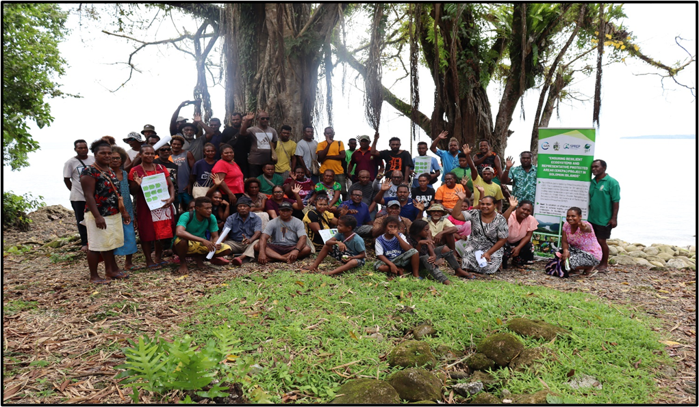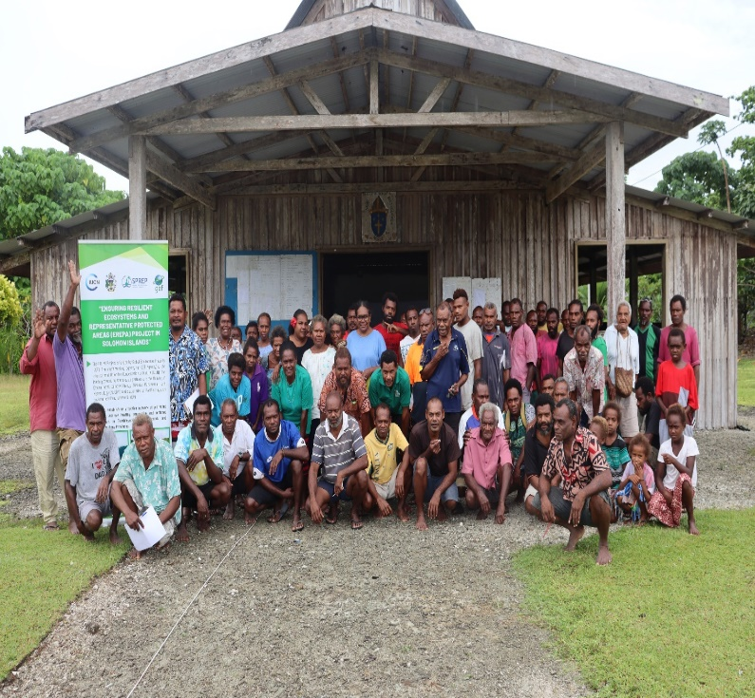
Figure 2: Temotu Ecosystem Services and Health Assessment, Participants Group Photo
Figure 1: Malaita Ecosystem Service Health Assessment, Participants Group Photo

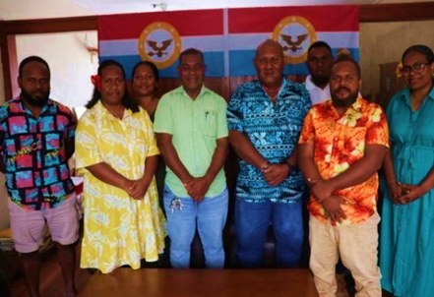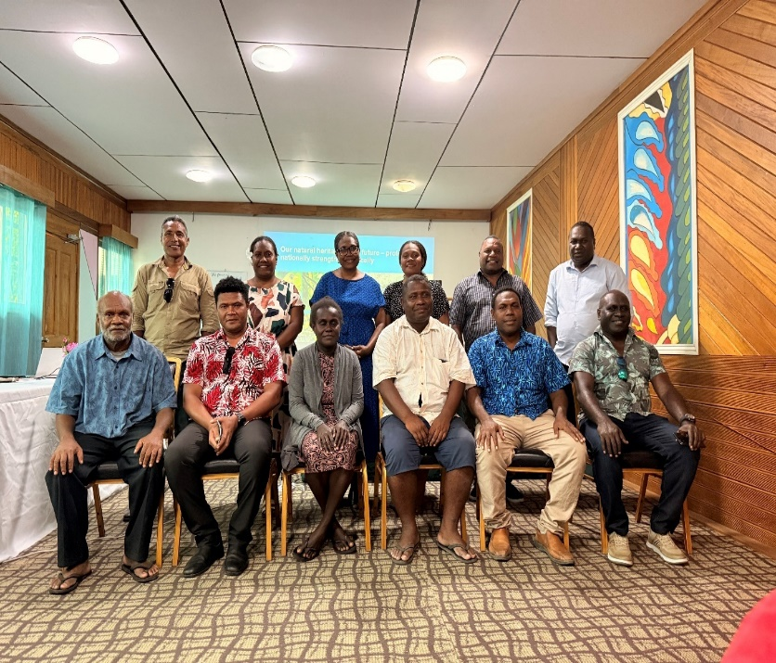
Figure 4: Six Provincial Government Representatives; L-R (Temotu, Rennell-Bellona, Choiseul, Malaita, Guadalcanal and Western Provinces
Figure 3: Courtesy visit to the Malaita Deputy Premier, Provincial Secretary and Treasurer

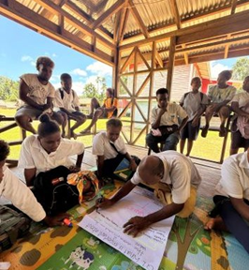
Figure 5: Community High School Students participated in project awareness program

Objective 2:
Outcomes (Copy and paste outcomes from Result Framework) | Indicators | Baseline | Midterm Target | End of project Target | Periodic Result (01/07/2025-30/06/2026) | Result to Date (from project start) | Progress rating (HS, S, MS, MU, U, SU)
Outcome 2. National PA Network, PA  Monitoring and Evaluation systems,  knowledge management, financing plans  developed and additional protected areas are  declared. | Number of national PA learning and exchange networks | 0 |  | 1 | A National PA Learning and Exchange Network Roadmap was developed in a workshop convened from 21st -23rd October 2025 in Honiara. The convening was also a learning exchange for PA members in areas of Governance and Management of PAs. | The National Protected Areas Network Roadmap was developed in 2025 and 50 members of the existing and potential PAs joined both workshop who are members of the PA learning and exchange network. The PA network participants were from Choiseul, Makira, Malaita, Isabel, Guadalcanal, Temotu, Western and Renbel Provinces. | HS
 | Number of operational M&E system established | 0 |  | 1 | No activity for this reporting period. | The national standard monitoring and evaluation for PA in Solomon Islands was developed through a number of consultations and workshops in 2025. The system is referred to as “Solomon Islands Protected Areas Management Effectiveness Tracking System (SIPAMETS). The document is prepared for launching in the last quarter of 2026. | HS
 | Area of new PA’s declared (ha) | 0 |  | 50,000 | Renbel completed steps 7- 9 in PA process;  Malaita completed steps 7-9 in PA process;  Guadalcanal completed steps 7-9 in PA process;  Temotu completed steps 6-7 in PA process  Step 6 – Submit maps to Ministries  Step 7 – Confirm tribal boundaries  Step 8 – Develop Management Plan  Step 9 – Develop Budget |  | MS
Outputs  (Copy and paste outputs from Result Framework) | Indicators | Baseline | Midterm Target | End of project Target | Result to Date (from project start) | Implementation status (%) | Implementation status (%)
Output 2.1 A national Protected Area Network (PAN) including all PA sites and PA actors developed | Number of national PA learning and exchange networks | 0 |  | 1 | A National PA Learning and Exchange Network Roadmap was developed in a workshop convened from 21st -23rd October 2025 in Honiara. The convening was also a learning exchange for PA members in areas of Governance and Management of PAs. | The National Protected Areas Network Roadmap was developed in 2025 and 50 members of the existing and potential PAs joined both workshop who are members of the PA learning and exchange network. The PA network participants were from Choiseul, Makira, Malaita, Isabel, Guadalcanal, Temotu, Western and Renbel Provinces. | 100%
 | Number of road maps to guide the extension of the PAN | 0 |  | 1 | A National PA Learning and Exchange Network Roadmap was developed in a workshop convened from 21st -23rd October 2025 in Honiara. The convening was also a learning exchange for PA members in areas of Governance and Management of PAs | The National Protected Areas Network Roadmap draft was developed in October 2025. The draft shall be launched in the last quarter of 2026. | 50%
 | Number of members of PAN | 0 |  | 40 | The number of members of PAN included the 33 proposed PA under EREPA Project and existing 8 declared sights at the time of reporting, which makes it 41 members in the PAN. | The total number of both existing (8) and new PAs (33) is more than 40. However, once the road map is developed it will expand the number of PAN members. | 50%
Output 2.2: A standardized data repository platform established, information compiled on natural systems and assets, information and its metadata integrated into existing data platforms. | Number of data repository platforms | 0 |  | 1 | The recruitment of the website designer reaches its final stage and awaiting the Ministry Tender Board to meet and approve the selected candidate. | Currently, SPREP has hosted the data for all the declared PAs in the country. The website designer is yet to be recruited to establish the repository platform. | 15%
 | Number of data collection and management protocols | 0 |  | 1 | No activity reporting for this period | The management data protocol was already developed. | 100%
Output 2.3 A standardized monitoring and evaluation system developed and implemented | Number of operational M&E system established | 0 |  | 1 | The SIPAMET was tested in October 2025 through existing PAs and planning for launch scheduled for final quarter of 2026 | A standardised monitoring and evaluation for Protected Areas referred to as Solomon Islands Protected Areas Management Effectiveness Tracking System (SIPAMETS) was developed in 2024 through stakeholder consultations, expert group consultation, provincial consultations and a draft was reviewed in October 2025.  Launch is expected the 4th quarter of 2026. | 90%
Output 2.4 Declarations made for at least 50,000 hectares of protected areas across four (4) provinces – including the development of PA management plans – through supporting consenting communities in the PA Act process. | Number of hectares of terrestrial and marine ecosystems under formal protection and in the process of being formally declared as protected | 0 |  | 30,000 | Renbel completed steps 7- 9 in PA process;  Malaita completed steps 7-9 in PA process;  Guadalcanal completed steps 7-9 in PA process;  Temotu completed steps 6-7 in PA process  Step 6 – Submit maps to Ministries  Step 7 – Confirm tribal boundaries  Step 8 – Develop Management Plan  Step 9 – Prepare Budget | The project adopted the 12-steps in the Protected Areas Toolkit in establishing PAs for declaration under the PA Act (2010). At the Project Inception Meetings in 2022, communities have been invited to submit to PMU, Expression of Interest (EOI) for their communities to be considered for PA establishment. So far, Project has been working with 33 PA sites in the four provinces. These 33 PA sites have been mapped (step 5) and the total area was calculated to be 25, 797 hectares. At the time of reporting the following have been completed:  1) Renbel – Steps 1 to 9 completed  2) Malaita – Steps 1 to 9 completed  3) Guadalcanal – Steps 1-9 completed  4) Temotu – Steps 1-7 completed | 50%
 | Number of hectares of upcoming PAs with management committee established, management plan developed and boundary defined (9 steps fulfilled of 12 for the formal declaration) | 0 |  | 20,000 | Interest from a conservation group in Malaita Province (Kwaio Fadanga PA) was registered for support with their PA work in terms of mapping and developing management plans. | Initial email contacts WITH PMU was received as express of interest (EOI) and request support from Project. The PA area was estimated at 50,000 ha. | 50%
 | Number of rangers working in new protecting areas | 0 |  | 80 | No activity reporting this period | The total of rangers for the proposed 33 protected areas is estimated to be more than 100 rangers. However, the number can be validated after the PAs are declared. | 50%
Output 2.5 Business/operational plans and funding opportunities for the implementation of the PA management plan in each targeted site developed. | Number of business/operational plans developed | 0 |  | 4 | Tender evaluation completed for hiring of business consultant to develop business plans, Tender Evaluation Report compiled and ready for submission to Ministry Tender Board | Terms of Reference for the recruitment of the business consultant was developed by CTA. Advertisement was done for 2 weeks. Tender evaluation completed and tender evaluation report completed and ready to submit to Ministry Tender Board. The recruitment of the consultant reaches final stage where the Ministrial Tender Board (MTB) to meet and approve selected candidate. | 10%
 | Business/operational plans presented to government agencies/private sector actors/potential funders | 0 |  | 4 | Tender evaluation completed for hiring of Business consultant, Tender Evaluation Report compiled and ready for submission to Ministry Tender Board | Terms of Reference for the recruitment of the business consultant was developed by CTA. Advertisement was done for 2 weeks. Tender evaluation completed and tender evaluation report completed and ready to submit to Ministry Tender Board. The recruitment of the consultant reaches final stage where the Ministrial Tender Board (MTB) to meet and approve selected candidate. | 10%
Narrative report
[___________________]
Please develop a qualitative narrative description of the achievements under this objective and how the outputs contributed to these changes during the reporting period (01/07/2025-30/06/2026). Describe evidence for changes in policy, regulation, standards, awareness, capacity, behaviors, and practices.

Component 2 focus on providing support to community or tribal groups through the PA step by step process to declare proposed areas under Protect Areas Act 2010. These includes establishment of national protected area network, developing Monitoring and Evaluation systems, knowledge management, financing plans and protected areas declared. The following changes are described for the reporting period:

1. Policy change:
The development of the National Protected Area Learning and Exchange Network (PALEN) Roadmap has strengthened the policy foundation for a more coordinated and collaborative approach to protected area management in Solomon Islands. The PALEN is a coordinated system of terrestrial and marine protected areas that are legally declared or community-recognized as protected areas. Instead of individual sites working alone, the network approach links them together to represent ecosystems and biodiversity; connect habitats; support local communities and coordinate governance, resources and monitoring at provincial and national level. The learning and exchange workshop brought together PA stakeholders from Western, Choiseul, Isabel, Makira, Temotu, Malaita, Guadalcanal, and Rennell-Bellona, to share experiences and promote common approaches to governance and management, contributing to greater alignment of conservation priorities and management practices across provinces. The expansion of the PALEN to include 41 sites has further strengthen the national framework for coordinated conservation planning and implementation.

2. Legal and institutional change
Progress in the protected area establishment process across Renbel, Malaita, Guadalcanal and Temotu has advanced the formal recognition and governance of protected areas. Activities such as confirming tribal boundaries, submitting maps to mandated ministries., developing management plan and preparing budgets have responded to the legal steps in the process of establishing PAs and therefore strengthened the legal and administrative requirements necessary for protected area declaration and management. Expression of interest received for an additional 50,000 hectares of protected area coverage demonstrate growing institutional support and stakeholder commitment to formal conservation mechanisms. These developments contribute to strengthening the Protected Areas Network and expanding legally recognised conservation areas.

3. Capacity Change:
The project has enhanced the capacity of protected area management committees, rangers, provincial officers and stakeholders to plan, manage and monitor conservation areas effectively. The learning and exchange workshop provided opportunities for peer learning and knowledge sharing on protected area governance and management. In addition, the development and review of the Solomon Islands Protected Areas Management Effectiveness Tracking System (SIPAMETS) has strengthened national capacity to assess, monitor and improve protected area performance using a standardised framework. The procurement process for business planning support will further strengthen the capacity of protected area management committees and rangers to develop sustainable financing and livelihood strategies that support long-term conservation outcomes. The peer learning had the opportunity to test their PA management effectiveness against the SIPAMETS with interesting results showing that existing PAs scored between 57% to approximately 87% in management effectiveness. The SIPAMETS tool will increase the capacity of PA managers and rangers to improve adaptive management of PAs.

4. Enhanced Awareness
Awareness of the benefits and requirements of PA management has increased amongst government agencies, provincial stakeholders, communities and conservation practitioners. Participation in the learning and exchange workshop improved understanding of protected area governance, management effectiveness and the role of the protected area network in supporting national conservation goals such as the 30x30 Aichi Goals and the National Biodiversity National Action Plan (NBSAP). The growing number of sites progressing through the PA establishment process and submission of new expressions of interest indicate increased recognition of PA as an important mechanism for biodiversity conservation, sustainable resource management and community development.

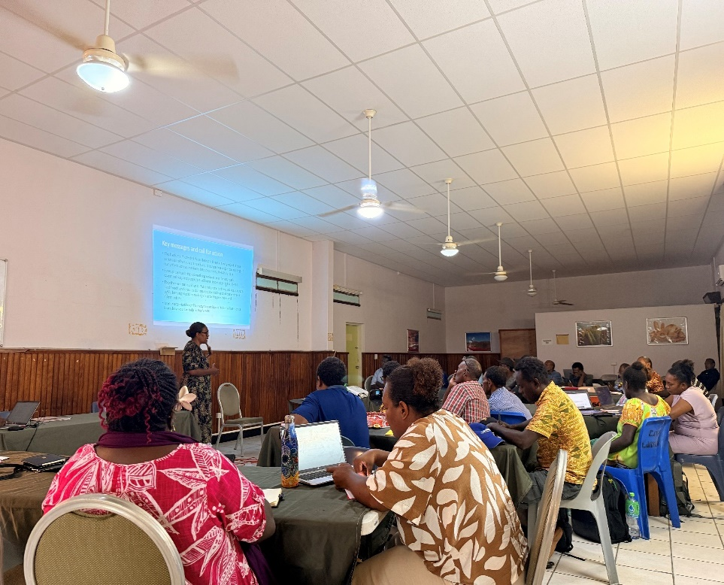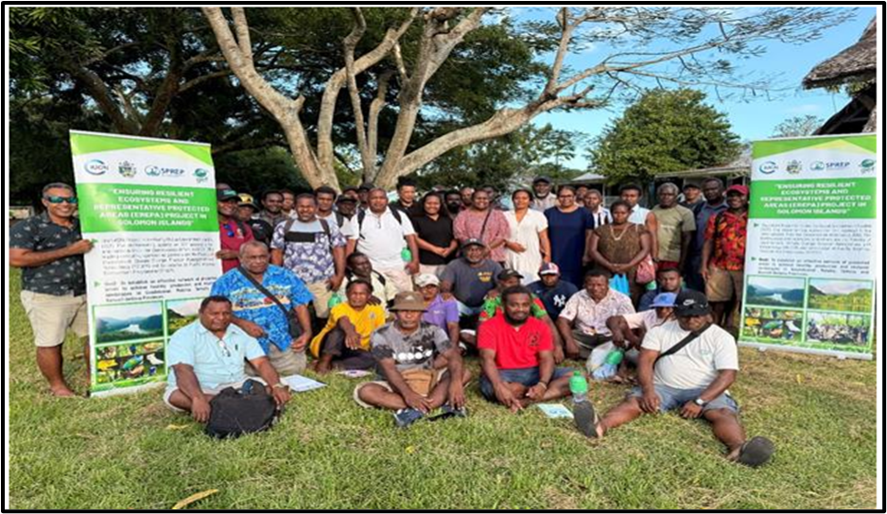
Figure 6: Governance and Management Workshop Participants from all the six provinces
Figure 7: Exchange Learning and PAN Participants from existing and upcoming PA Groups

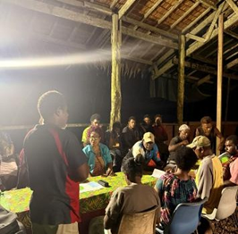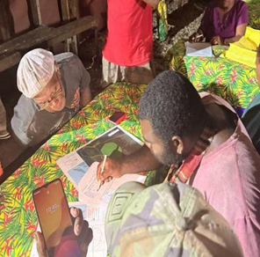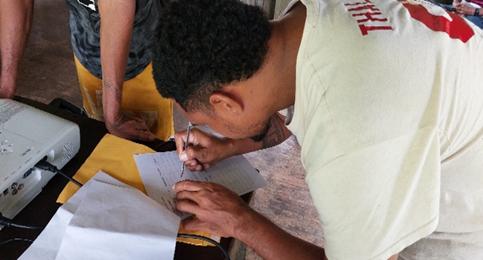
Figure 10: East Rennell tribal group signing MOU with neighbouring tribes
Figure 8: Tribal meeting and signing of MOU with neighbouring tribes
Figure 9: Tribal group verifying boundaries on the map before signing MOU

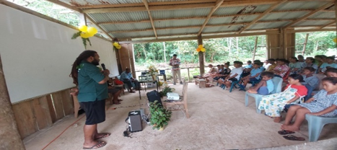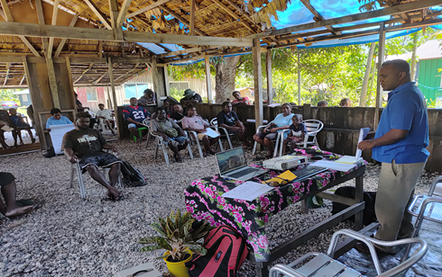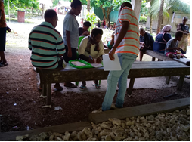
Figure 13: Leaders of Nebio in Temotu Province discussing MOU before signing
Figure 12: Management Planning Workshop in Guadalcanal Province
Figure 11: Management Plan Awareness in East Rennell

Objective 3: [Title]
Outcomes (Copy and paste outcomes from Result Framework) | Indicators | Baseline | Midterm Target | End of project Target | Periodic Result (01/07/2025-30/06/2026) | Result to Date (from project start) | Progress rating (HS, S,MS,MU,U,SU)
Outcome 3. The environmental quality and the  livelihood benefits of production landscapes  for communities within and adjoining PAs are  sustained. | Number of community-based land-use Management Plans | 0 |  | 22 | No activity reporting this period | In year 2024, the baseline studies such as ESRAM, Ecosystem Assessment and Household survey has highlighted conservation, agricultural and forestry challenges. Community consultation was conducted in all the project sites and each of the PA groups have developed 38 CBLUP that integrated Agriculture, Forestry and Conservation activities | HS
 | Number of micro-finance systems developed | 0 |  | 4 | Tender Evaluation Committee (TEC) completed evaluation for hiring of Micro-Finance consultant. Chairman of TEC has prepared Tender Evaluation Report and ready for submission to Ministry Tender Board | Terms of Reference for the recruitment of the Micro-Finance consultant was developed by CTA. Advertisement was done for 2 weeks. Tender evaluation completed and Tender Evaluation Report completed and ready to submit to Ministrial Tender Board (MTB). The recruitment of the consultant reaches final stage where MTB will meet and approve selected candidate. | MS
 | Number of sustainable micro or small enterprises created/strengthened because of microloans | 0 |  | 40 | Sustainable development guidelines and application template was developed.  - Awareness of the process of the application was conducted with Malaita, Guadalcanal and Rennell. | The sustainable micro small enterprises have been identified to respond to the Community based land use plans and Socio-Economic Household Survey Report. . | MS
 | Number of hectares reforested | 0 |  | 100 | Malaita Reforestation Training and Assessment of degraded area. | In year 2024, the Ecosystem assessment conducted has identified degraded areas. In 2025, degraded areas have been mapped for Malaita (36 ha) and Temotu Provinces (200 ha). Restoration intervention plans have been developed for Malaita Province and Temotu Provinces and are starting to be implemented in Malaita Province. Nursey demonstration started in Malaita. | MS
Outputs  (Copy and paste outputs from Result Framework) | Indicators | Baseline | Midterm Target | End of project Target | Periodic Result (01/07/2025-30/06/2026) | Result to Date (from project start) | Implementation status (%)
Output 3.1 Community-based and endorsed land use management plans at the landscape level developed including delineating PAs, sustainable agricultural areas, agroforestry areas, settlement areas, and forest areas, and identifying improved livelihood activities. | Number of community-based land-use Management Plans | 0 | 11 | 22 | No activity reporting for this period | In year 2024, the baseline studies such as ESRAM, Ecosystem Assessment and Household survey has highlighted conservation, agricultural and forestry land uses. Community consultation was conducted in all the project sites and each of the PA groups have developed 38 CBLUP that indicated Agriculture, Forestry and Conservation action plan | 100%
 | Number of peer-to-peer capacity building training sessions | 0 | 60 | 120 | Module 6 in Community-Based Land Use Planning was developed and tested to refine module content | Based on the Module 6 on Community-Based Land Use Planning, peer to peer training can be conducted for communities. | 15%
 | Community members’ feel that their inputs into land-use management plans are taken seriously | 0 | 40 | 80 | No activity reporting for this period | The number of participants involved in CBLUP workshops for each of the provinces is approximately 30 which total number of participants is more than 150 people.  Therefore, the land- use plans were determined by tribal and community members. An evaluation based on communities’ views on the CBLUP will be sought | 50%
Output 3.2 Improved and diversified livelihoods based on the sustainable use of forest and agricultural resources, including income generating and livelihood options for communities, adopted and implemented within and outside protected areas. | Number of priority sustainable development practices and activities supported | 0 | 45 | 90 | The screening process for mini development project was developed and project proposal were sought from communities. Awareness and consultation was conducted in Malaita, Guadalcanal and Renbel Provinces. | The screening process for mini development project was developed and communities encouraged to submit project proposal for funding up to SBD50,000/project. This process was made aware and consultation was conducted in Malaita, Guadalcanal and Renbell provinces. Currently, waiting for PA groups to submit their project proposal. | 20%
 | Number of participants in peer to-peer capacity building sessions | 0 | 250 | 500 | Module 6 in Community-Based Land Use Planning was developed and tested to refine module content | The training modules/kits in Community Based Land Use Planning have been drafted from 27 to 31 July and refined through testing in Malaita, Guadalcanal and Temotu. | 10%
 | Number of participants in peer to-peer capacity building sessions reporting new knowledge or skill | 0 | 150 | 300 | Module 6 in Community-Based Land Use Planning was developed and tested to refine module content | Module 6 on Community Based Land Use Planning have been drafted from 27 to 31 July and refined through testing in Malaita, Guadalcanal and Temotu. | 10%
 | Number of micro-finance systems developed | 0 |  | 1 | The Tender Evaluation Committee (TEC) has completed evaluation for Micro-Finance Consultant. The Chairman has consolidated and finalised the Tender Evaluation Report based on assessment done by TEC, ready for submission to the Ministry Tender Board (MTB) for review and approval of the recommended applicant. The consultant will be contracted to develop micro-finance systems for all four provinces in the 3rd quarter of 2026. | Terms of Reference for recruitment of the Micro-Finance Consultant was developed by CTA for 60 days work spread over 6 months. A budget for hiring was confirmed by PMU for the work of the Micro-Finance Consultant. PMU advertised the consultancy work for 2 weeks in both local newspapers and online platforms and was extended for another week due to limited applicants. Tender Evaluation Committee was formed and conducted evaluation for five applicants. The Tender Evaluation Report was prepared by the Chairman of the Tender Evaluation Committee. The report is ready for the consideration of the MinistrIal Tender Board (MTB) to conclude the recruitment process. | 10%
Output 3.3: Degraded forest areas restored through reforestation activities and natural regeneration interventions | Number of hectares reforested | 0 | 50 | 100 | Reforestation training on nursery of seeds conducted in Malaita. | Reforestation activities are identified for Malaita and Temotu Province due to forest degradation in proposed PA areas. Malaita Province the area identified for reforestation was 36 hectares (Ono PA 15 Ha, Otepaina PA -16 ha, and Ausi PA 5 ha). In Temotu, about 200 ha was identified for reforestation. | 45%
 | Number of managements of invasive species interventions | 0 | 20 | 40 | No activity reporting for this period | Alien Invasive Species (AIS) have been identified as threat for Renbel and Temotu Provinces endemic species due to the presence of AIS. For Renbel Province, a newly developed Invasive Species Plan was developed by BirdLife and the project will not develop another parallel plan but to implement relevant interventions in the BirdLife Plan. | 20%
Narrative report
[___________________]
Please develop a qualitative narrative description of the achievements under this objective and how the outputs contributed to these changes during the reporting period (01/07/2025-30/06/2026). Describe evidence for changes in policy, regulation, standards, awareness, capacity, behaviors, and practices.

Component 3 focuses on improved land management, agricultural practices and restoration interventions in rural production landscapes. Through awareness raising, training and field visit to garden and forest areas. This address the livelihood need for the PA groups whilst engaging in conservation work. The following changes are identified based on the activities completed during this reporting period:
1. Community Planning change
The development of sustainable development guidelines and application templates has strengthened the planning landscape for community-led environment management and livelihood development. These tools provide a more consistent and transparent approach for assessing and supporting community initiatives, helping to align local development activities with sustainable land use, conservation and livelihood objectives. The tools have criteria that also takes into consideration gender considerations, environmental and social safeguards whereby the environment is not left worse off due to the development. The promotion of community-land use planning (CBLUP) approaches is also encouraging the integration of environmental sustainability considerations into local planning and development processes.

- Institutional change
The establishment of screening procedures for mini-projects has strengthened governance and accountability mechanisms for community investments. The development of standardised application, assessment and approval process provides a more structured framework for evaluating proposed activities and ensuring they contribute to sustainable development outcomes. In addition, progress towards engaging Micro-Finance Consultant will support the establishment of institutional mechanisms that improve community access to financial services and livelihood financing opportunities across participating provinces.

- Capacity change
The project has significantly strengthened the capacity of the communities to undertake sustainable land use planning, environmental management and livelihood development. More than 150 participants across the participating provinces attended workshops, enhancing their understanding of participatory planning approaches and sustainable resource management. Restoration training and degraded area assessments in Malaita have further strengthened local technical skills in ecosystem restoration, while the development of peer-to-peer training approaches to be conducted through Module 6, is creating opportunities to share knowledge and build local expertise with management committee and rangers in PA sites.

- Practice and Behaviour Change
Communities are increasingly adopting more participatory and structured approaches to planning and resource management. The implementation of CBLUP workshops has encouraged communities to consider long-term environmental sustainability, land use priorities and livelihood opportunities in their decision-making processes. The introduction of the screening process has also promoted greater accountability and planning discipline in the design of community development initiatives. Interest from communities in submitting project proposals demonstrates increasing willingness to engage with formal planning and development processes, while restoration activities indicate a growing commitment to restoring degraded landscapes and improving environmental care. The forest degraded areas have been identified for Temotu and Malaita during the Ecosystem Health and Service Assessment and interventions has been identified as well in the Community Based Land Use Management Plans. Malaita has taken first initiative through awareness on reforestation intervention and demonstration of nursey at the site level. The PA groups in Malaita will ensure to continue with reforestation intervention on the degraded areas through natural regeneration of forest.

- Enhanced awareness
Awareness of sustainable development principles, land use planning processes and livelihood opportunities has increased across Malaita, Guadalcanal and East Rennell through consultations and trainings. Communities and stakeholders who engaged in the process have a better understanding of integrating conservation and livelihood objectives, and the role of community-based planning in achieving sustainable development outcomes. Awareness activities have also strengthened recognition of the links between healthy ecosystems, resilient livelihoods and long-term community wellbeing, creating greater support for conservation, restoration and sustainable resource management initiatives. The awareness of the screening process and development of proposal was conducted for Malaita, Renell-Bellona and Guadalcanal. Currently, communities and tribal groups are developing their sustainable development plan proposal to access the funding under the EREPA project. This will help communities and PA groups to engage in income generating activities and be able to sustainable manage their resources whilst engaging in conservation initiatives.

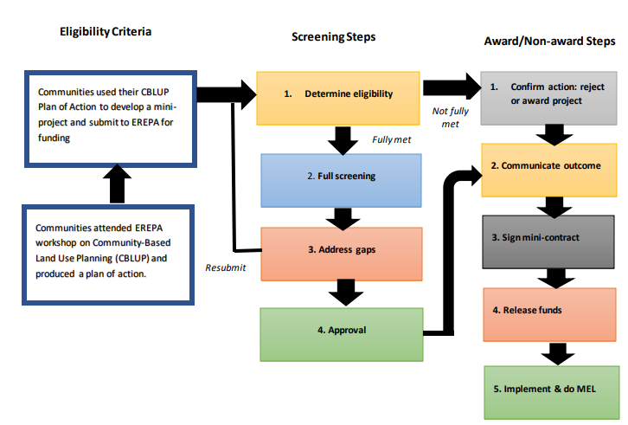
Figure 18, SDP Screening process guidelines for funding of sustainable development plans

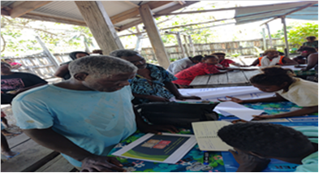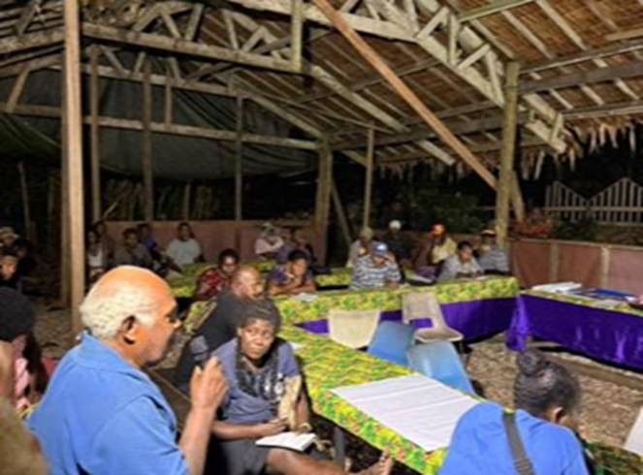
Figure 19, Guadalcanal Participants discuss SDP proposal Figure 20, Malaita Participant discuss SDP proposal

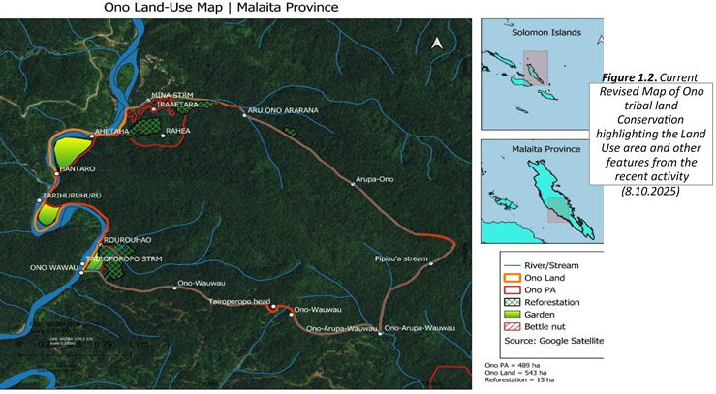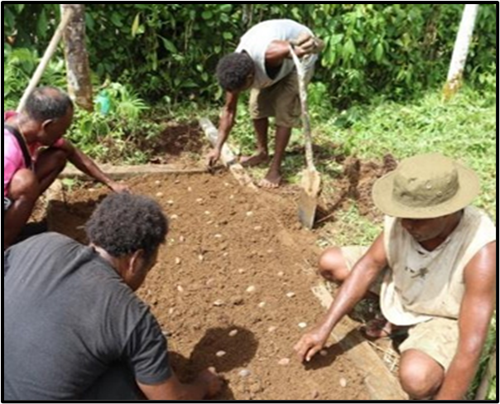
Figure 21 Ono Land Use Map showing reforestation area Figure 22, Ono tribal members engage in nursey demonstration

Objective 4: [Title]
Outcomes (Copy and paste outcomes from Result Framework) | Indicators | Baseline | Midterm Target | End of project Target | Periodic Result (01/07/2025-30/06/2026) | Result to Date (from project start) | Progress rating (HS, S,MS,MU,U,SU)
Project is effectively and efficiently managed |  |  |  |  | Project is effectively implemented with all PMU and CTA on board. | In year 1 and 2 the project has encountered challenges in staff recruitment that affect the implementation schedule. Whereas in year 3 the 2nd CTA was recruited, and staff turnover was low so progress of implementation of the activities. Currently, all project staff are on board with CTA. | HS
Outputs  (Copy and paste outputs from Result Framework) | Indicators | Baseline | Midterm Target | End of project Target | Periodic Result (01/07/2025-30/06/2026) | Result to Date (from project start) | Implementation status (%)
Output 4.1. Project management team established and functional. | Number of project coordinator hired | 0 | 1 | 1 | Project coordinator is providing overall day to day operation of the project implementation. | At the commencement of the project the contract was signed for 1 year. 2nd year the contract was signed for another 2 years.  The project coordinator contract was renewed for 1 based on performance report. | 100%
 | Number of provincial coordinators hired | 0 | 4 | 4 | 4 Provincial Project Coordinators are station and implemented activities at all sites. | The four provincial coordinators have remained in the project and effectively support the progress of implementation of the project activities.
 | Number of administrative and finance officer hired | 0 | 2 | 2 | The PAO and PFO are effectively providing financial and administrative support on daily basis for the progress of the implementation of the project activities. | The admin officer is effectively providing admin support. The former finance officer resigned, and the new finance officer was recruited in October 2024. | 100%
Output 4.2 Project is effectively and efficiently managed | Number of evaluations carried out | 0 | 3 | 6 | No activity this reporting period | The two main evaluation reports – MTR and End of Project Report are supported by internal project evaluation to be conducted by MECDM PMCU to maintain progress towards accomplishing project strategic goals and indicators. | 40%
Output 4.2 Project is effectively and efficiently managed | Number of audits carried out | 0 | 2 | 4 | No activity reporting this period | The first audit has been conducted for the period of September 2021 to December 2022 and the report was submitted. | 25%
Output 4.3 Project knowledge efficiently managed | Number of knowledge management plans developed | 0 | 1 | 1 | No activity reporting this period | The PMU will lead the development of a knowledge management plan for the project. | 50%
Output 4.3 Project knowledge efficiently managed | Knowledge products available on Solomon Islands government websites | 0 |  | 20 | No activity reporting this period | A number of study reports, national standard guidelines, roadmaps and modules will be made available on government website for public | 40%
Narrative report
[___________________]
Please develop a qualitative narrative description of the achievements under this objective and how the outputs contributed to these changes during the reporting period (01/07/2025-30/06/2026). Describe evidence for changes in policy, regulation, standards, awareness, capacity, behaviors, and practices.

Component 4 focus on project management cost that ensuring the project is effectively and efficiently managed. This is through project management team is established and managed, effective monitoring and ensure information about the project is documented and made available. The project team was established and functional that reflects the positive delivery of the outputs during this reporting period. The PMU team has well-coordinated to ensure effective delivery of the daily operation of the project activities. The flow of communication between the finance officer, project admin and national project coordinator is well established and efficiently managed. Moreover, the continuous technical guidance provided by the Chief technical advisor has made the progress in delivering the project outputs and achieving its intended objectives and goals.

The project is effectively monitored through the result-based framework and financial audit to ensure project implementation was adhered to SIG, IUCN and GEF requirements. The technical deliverable was monitored through submission of field reports from the provincial coordinators and CTA and ensure the targets were achieved. The reports have shown that through the implementation of the project activities communities have good understanding in conservation that the PA process has effectively implemented. Also, the project is working closely with provincial government to ensure activities are align with provincial plans, policies and strategies. At the national level, the project is developing monitoring systems and established management and effectiveness tracking tool for protected area. These activities maintained good financial practices that contributed towards an efficient operation at the project level.

The Knowledge management plan was implemented as per the communication plan of action which conducted through meetings, consultations, workshops and field mission. The documentation of the learnings was through field trip reports, press releases and study reports. Also, the continuous distribution of brochures, posters and presentation during workshop has contributed towards increase of knowledge on how agriculture and forestry sector supported sustainable management of natural resources. Hence, the project knowledge was efficiently managed through continuous collaboration and coordination with key stakeholders and knowledge product was made available for all audience to access at national, provincial and community level.

GEF Core Indicators
Please report on GEF core indicators that are relevant to your project using guidance provided by GEF on the implementation of the GEF-8 results measurement framework

Table 1. Eleven GEF Core Program Indicators
Indicator #  As per GEF portal | Indicator | Baseline | Project Target | Progress to date (from project start) | Means of Verification
1 | Terrestrial protected areas created or under improved management  This indicator will be reported as the aggregate total of the following Sub-Indicators.  - Terrestrial protected areas newly created  - Terrestrial protected areas under improved management effectiveness |  | 50,000 ha | All the potential protected areas for all the provincial project sites have been demarcated of an areal extent of 25,797 hectare. This is part of the newly created PAs and will be finalized during declaration stage in step 12 for all proposed PAs. | Mid-term review
2 | Marine protected areas created or under improved management  This indicator will be reported as the aggregate total of the following Sub-Indicators.  - Marine protected areas newly created  - Marine protected areas under improved management effectiveness
3 | Area of land and ecosystems under restoration  This indicator will be reported as the aggregate total of the following Sub-Indicators.  - Area of degraded agricultural lands under restoration  - Area of forest and forest land under restorationArea of natural grass and woodlands under restoration  - Area of wetlands (including estuaries and mangroves) under restoration |  | 100 Hectares | The 38 Community Based Land Use Mapping and Planning (CBLUMP) has identified areas of conservation, agriculture and forest interventions but yet to conduct ground truthing to determine the hectares. | Field visit reports and Evaluation Reports
4 | Area of landscapes under improved practices (excluding protected areas)  This indicator will be reported as the aggregate total of the following Sub-Indicators.  - Area of landscapes under improved management to benefit biodiversity  - Area of landscapes under third-party certification incorporating biodiversity considerations  - Area of landscapes under sustainable land management in production systems  - Area of High Conservation Value or other forest loss avoided  - Terrestrial OECMs supported |  | 90- Priority sustainable development practices and activities. | The screening process for mini development project was developed and project proposal. This process was made aware and consultation was conducted in Malaita, Guadalcanal and Renbell provinces. Currently, waiting for PA groups to submit their project proposal. | Sustainable Development Proposals.
5 | Area of marine habitat under improved practices to benefit biodiversity  This indicator will be reported as the aggregate total of the following Sub-Indicators.  - Fisheries under third-party certification incorporating biodiversity considerations  - Large Marine Ecosystems with reduced pollution and hypoxia  - Marine OECMs supported
6 | Greenhouse gas emissions mitigated  This indicator will be reported through the following Sub-Indicators  - Greenhouse gas emission mitigated in the AFOLU sector  - Greenhouse gas emission mitigated outside of the AFOLU sector  - Carbon sequestered or emissions avoided in the AFOLU sector (Direct)  - Carbon sequestered or emissions avoided in the AFOLU sector (Indirect)  - Emissions avoided outside AFOLU sector (Direct)  - Emissions avoided outside AFOLU sector (Indirect)  - Energy saved  - Increase in installed renewable energy capacity per technology |  |  | The project did not directly address the target of GHG emission but through the reforestation intervention in output 3.3 it will address reduction of carbon emission. The carbon levels will be determined during the mapping exercise using carbon default values under IPPC guidelines. | Field Visits, Mid-term and final evaluation reports
7 | Shared water ecosystems under new or improved cooperative management  This indicator will be reported through the following Sub-Indicators  - Level of Regional Legal Agreements and Regional Management Institutions to support its implementation  - Level of Transboundary Diagnostic Analysis and Strategic Action Program (TDA/SAP) formulation and implementation  - Level of National/Local reforms and active participation of Inter-Ministerial Committees  - Level of engagement in IW:LEARN through participation and delivery of key products |  |  | The provincial ordinance that will be developed in 3rd and 4th quarter will protect shared water ecosystem. Also, PA sites has been mapped and identified as proposed areas for PA. | Shape files, Field Visits, Mid-term and final evaluation reports. Provincial ordinances
8 | Globally over-exploited fisheries moved to more sustainable levels
9 | Chemicals of global concern and their waste reduced  This indicator will be reported through the following Sub-Indicators  - Solid and liquid Persistent Organic Pollutants (POPs) removed or disposed (POPs type)  - Quantity of mercury reduced  - Hydrochlorofluorocarbons reduced/phased out  - Countries with legislation and policy implemented to control chemicals and waste  - Low-chemical/non-chemical systems implemented, particularly in food production, manufacturing and cities  - POPs/Mercury containing materials and products directly avoided  - Highly Hazardous Pesticides eliminated  - Avoided residual plastic waste
10 | Persistent organic pollutants to air reduced  This indicator will be reported through the following Sub-Indicators  - Countries with legislation and policy implemented to control emissions of POPs to air  - Emission control technologies/practices implemented
11 | People benefiting from GEF-financed investments  This indicator will be reported as the aggregate total of the following Sub-Indicators.  - Female  - Male |  |  | The signed attendance sheet of each activities at project site have indicated both male and female benefiting from the project. | Participant List

Adjustments

Please provide comments on delays during this reporting period in achieving any of the following key project milestones: inception workshop, mid-term review, terminal evaluation and/or project closure.

The delay for this reporting period is mainly on the delay of 4th tranche of funds into the project account for 6 months due to staff turnover and proper hand over at IUCN ORO. This has affected the implementation schedule which requires more time before the mid-term review. Hence, affect the mid-term review for the project and implementation of few key milestones of the project.
Project Minor Amendments
Minor amendments are changes to the project design or implementation that do not have significant impact on the project objectives or scope, or an increase of the GEF project financing up to 5% as described in Annex 9 of the Project and Program Cycle Policy Guidelines.
Please tick each category for which a change occurred in the fiscal year of reporting and provide a description of the change that occurred in the textbox. You may attach supporting documents as appropriate within this PIR submission.
 |  | Results framework
 |  | Components and cost
 |  | Institutional and implementation arrangements
 |  | Financial management
 |  | Implementation schedule
 |  | Executing Entity
 |  | Executing Entity Category
 |  | Minor project objective change
 |  | Safeguards
 |  | Risk analysis
 |  | Increase of GEF project financing up to 5%
 |  | Co-financing
 |  | Location of project activity
 |  | Other
Minor amendments |  |  | Change description

Implementation Progress

Please insert graph below showing cumulative disbursements on quarterly and yearly basis since project launch

Cumulative Disbursements
Cumulative general ledger delivery against total approved amount (in Project Document) - % | %
Cumulative general ledger delivery against expected delivery as of this year - % | %
Cumulative disbursement as of 30 June 2026 (note: amount to be updated in later August) | USD

Key Financing Amounts
PPG Amount | USD 150,000.00
GEF Grant Amount | USD 4,918,364
Planned Co-Financing  Co-Financing to date | USD 8,180,000  USD

Key Project Dates
PIF Approval Date | 13 June 2017
CEO Endorsement Date | 21 May 2021
Project Document Signature Date (Project start date) | 09 JUne 2022
Date of Inception workshop (Project launch) | 02 June 2022
Expected date of mid-term review | October 2026
Actual date of mid-term review
Expected date of Terminal Evaluation | April 2027
Original planned closing date | 30 March 2026
Revised Planned closing date | 13 June 2027

Dates of Project Steering Committee / Board Meetings during reporting period (June 2025 to July 2026)
It was planned for the 1st quarter of 2026 but due to limited and delay of funds the board meeting was not able to be organized.

Critical Risk Management

Please complete the table below (Only risk with High or Medium rating / level should be recorded) by using the information in the Project Risk register (excel file provided with PIR templates). If a project risk register has already been completed for the project, please provide any updates for High or Medium risk from this reporting period – e.g. changing in risk rating, risk owners or additional risk identified etc. in the table below.

Risk Category | Risk description | Rating / Level (H, M) | Mitigation measures undertaken in this reporting period | Risk Owner | Updates / Changes
Operational | Delay of field reports | L | Keep in-touch with SIMS (MECDM) weather forecasts. For flights to project sites (e.g. Ren-bell & Temotu) contact Airline Agents for final decisions.  In Tandai Ward area, regular contacts with resource owners to confirm the conditions of roads, rivers and rain falls | Project coordinator/Provincial Project Coordinators | Active / Delayed but still submitted
Information system | Office documentation & filing | L | Responsible staff to produce field reports on time or after field work | PMU and Project Provincial Coordinators | Filing still in progress
Operational | Asset Register & EREPA Properties | L | - Staff to store in desktop filing system (folders) or external drive. (b) Staff to use Arch files and manila folders to keep documents safe and properly stored. (c) Staff to use the office cabinets and shelf to keep documents.  - All EREPA assets must be registered using standard/quality label & IUCN Asset Register | PMU | Asset Register ongoing
Operational | Activities reports are not prepared and submitted after their completion | L | Reports to be compiled after all field works, meetings, workshops etc. And submitted to NPC & PAO | Project coordinator/Provincial Project Coordinators | Delayed but submmitted
Financial | Project funds are delayed causing further delay of project activities, operational and implementation | L | Reports to be compiled after all field works, meetings, workshops etc. And submitted to NPC & PAO | PMU /ICUN ORO | Closed

Project overall risk rating (Low, Moderate, Substantial or High). Please see Annex – Ratings definition for guidance.

2025 rating (H, S, M, L) | 2026rating (H, S, M, L) | Comments/reasons for the rating for 2026 and any changes (positive or negative) in the rating since the previous reporting period
L | L | The project overall risk rating remain low similar to 2025 rating because of the risks has been addressed at the project and national level.

Gender

Progress in advancing Gender equality and women’s empowerment
Please note that all projects approved since GEF 6 are required to carry out a gender analysis and provide gender-responsive and where possible gender transformative measures to address differences, identified impacts and risks, and opportunities through a Gender Action Plan (GAP) or equivalent.

Project activities implemented at community level target women and girls as direct beneficiaries for this project. Women and girls have been included in the development of the PA management plan and the development of sustainable development plans workshop. For example, in Malaita is socially organised around a patrilineal system where men hold the key influence in decision making processes. However, in this project women and girls were included in consultations and the development of management plans.
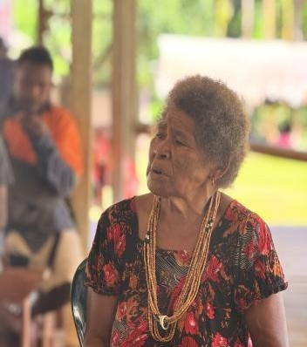
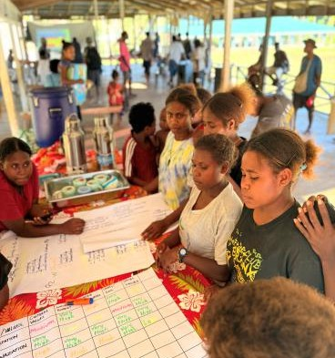

Figure 23 (above left), Elderly women participated in the SDP
Figure 24 (above right), Youth girls participated in the development of PA management plans

In case a gender analysis was not undertaken during project preparation (PPG), has it been carried out in this reporting period? If yes, what were the main findings? If an analysis during project design had been undertaken, but further updates have been carried out during the reporting period, please indicate this below. Please also report on additional site level gender analyses if they were undertaken during this reporting period.

As a GEF-6 project, a specified gender analysis was not a GEF requirement and has not been carried out. Nevertheless, Section 4.11 of the project document (Environmental and Social Safeguards) identifies a series of gender issues, namely access to education, involvement in decision-making, access to land, roles in the household and gender in policy framework. Following these issues, the project has proposed the following approaches:

Employing a gender-sensitive approach, understanding the social context of each project site, including the level of education and skills and women community members.

Conducting targeted focus groups for women, to ensure a safe space to speak but without adding a burden to time availability.

Awareness-raising and provisions of information on women’s access to higher education.

Providing gender-sensitive indicators in the project result framework.

Tailoring sustainable development actions at community level to support the involvement of women as well as men with an aim to achieve equal participation.

Providing financial literacy training and the development of savings groups for women as part of the project micro-finance system, utilising successful experiences elsewhere in the Solomon Islands.

The Protected Area Process, community level-based land use mapping and plans, socio-economic household survey and ecosystem service and health assessments and consultations, interviews and workshops have been tailored to be inclusive for women. Hence, when all the reporting in these areas has been completed then gender analysis can be conducted.

While there is no plan to provide a separate Gender Analysis and Action Plan for the project, the completion of an Environmental and Social Management Plan will contain a chapter on gender, that formalises the above list of employing a gender responsive approach, while linking to any identified risks and mitigation measures under the Risk Area on Adverse gender-related impacts.

Please describe progress in implementing the Gender Action Plan (GAP); you could also add the GAP in form of a GAP progress report as annex. Please also specify results achieved during this reporting period through implementing gender-responsive measures.

Results reported can include site level results working with local communities and municipal/ regional organizations as well as work to integrate gender considerations into national policies, strategies and planning. Please explain how the results reported addressed the different needs of men or women, improved norms, values and power structures, and/or contributed to transforming or challenging gender inequalities and discrimination.
As a GEF-6 project, there is no specified Gender Action Plan available to implement. However, it is possible to report on how the project has incorporated gender-responsive measures in its work. At the community level, the roles and responsibilities of women and men are fundamentally driven by cultural and traditional values. The Community Based Land Use Mapping and Plan workshop indicated the different types of livelihood that will benefit both women and men. The Socio-economic Survey shows that women are skilful in certain types of income-generating activities and are able to manage this income effectively. This indicates that women can contribute to household level needs that support men in providing and managing the family. Hence different types of livelihood activities will be benefiting both women and men.

Please report on gender-responsive indicators and gender-disaggregated targets as established in the results framework of the project including women and girls as direct beneficiaries of the project.
The project has disaggregated data by sex for its participant lists at national, provincial and community level during workshops and consultations. Overall, 40% of participants are women and 60% are men. The disparity in the figures is due to cultural and social obligations. Women tend to be more involved in preparing food for the workshop while men participate in the workshop proceedings. Also, at community level women tend to focus on gardening because this is to ensure food will always be available for the family, the practice obstructing an ability to attend workshops

Implementing the Stakeholder Engagement Plan

The GEF Stakeholder Engagement Policy Guidelines require that Agencies prepare a Stakeholder Engagement Plan to describe how Stakeholders will be engaged in the project specifying means of engagement throughout the project/program cycle. Agencies should include information on progress, challenges and outcomes of stakeholder engagement in the annual PIR.

Please either provide the Stakeholder Engagement Plan and its respective progress report as annex or complete the below table by specifying the engagement strategies and achievements for the most important stakeholder groups. This can include demonstrating how different stakeholders were engaged in decisions on project governance (e.g. as member of the steering group), in the management or monitoring of the project or in specific programmatic activities. Forms of engagement include direct consultation or exchange, or the obtaining of consent prior to carrying out activities, as well as indirect forms such as through media or other communication channels. Where relevant, explain whether further stakeholder mapping and analysis has been carried out. Please also specify how the engagement is documented to provide evidence of such activities.

Please note that the data may be used for reporting to the GEF or IUCN web site, and for other internal and external knowledge and learning efforts. It is critical that the SEP and documentation complies with the IUCN Data Protection Policy

All projects must complete this section. Please enter N/A in cells that are not applicable to your project.

Information on stakeholder engagement strategies, progress, outcomes and challenges
Local governments
The project has actively engaged with the provincial government for each of the project sites. During each field trip a courtesy visit is made to provide implementation progress updates to the provincial government to ensure that activities align with provincial plans and strategies. Also, the establishment of provincial land use forums has shown the commitment of the provincial government in conservation initiatives. Temotu provincial government has signed the Letter of Agreement and established the land use forum whereas the other 3 provinces are still to hold a 2nd consultation on the matter.

Provincial Government:
Provincial Secretaries, Deputy Secretaries, Heads of Division, Provincial Government Executives, Members of Provincial Assemblies (MPAs), Provincial Extension Officers,

Civil society organisations
The project has collaborated with Live and Learn Solomon Islands in Renbell and Guadalcanal Province. Live and Learn has focused on the development of Payment of Ecosystem Services and Carbon Projects in alignment to the Protected Area Act as one of the requirements of their process. Ongoing meetings have been organized to provide updates on activities to avoid any duplication of work.

List of CSOs
NGOs: World Vision, Maimasina Green Belt (Local NGOs), Tandai House of Chiefs, Barana National Park, Live & Learn Solomon Islands (Nakau Program)

Churches: Anglican Church, United Church, Roman Catholic Church, Seventh Day Adventist Church, South Seas Evangelical Church (SSEC), Bahai Faith, REMA.

Local communities (disaggregate where relevant, e.g. by gender, vulnerable groups, etc)
The Provincial Project Coordinators play an important role with active engagement at the community level. The ongoing consultations, meetings and workshops have contributed towards the capacity building of community and tribal groups in conservation work and an understanding of the legal process in establishing the Protected Area. Also, discussions on ecosystem services and health assessments with land uses have broadened the knowledge of community members on identifying threats and how to address it through agriculture and reforestation interventions for the protection of ecosystems. The ongoing participatory approach has contributed increased capacity for both women and men and has encouraged community and tribal groups to work closely with the project and protect their resources.

Local Community Groups:
Chiefs, elders, women group, youth group, men’s group, CBOs, PWD, tribal groups, teachers, students, nurses.
Indigenous Peoples
As customary landowners, local communities, as outlined above, can be regarded as Indigenous Peoples, albeit representing the clear majority population of the Solomon Islands.
Private sector
The partnership with Solomon Water Authority (SWA) is maintained through Nakau programmes and Live & Learn Solomon Islands. Solomon Water has engaged Live and Learn and Nakau to focus on developing the PES mechanism to protect the water source supplying Honiara City. The water source was located within the project area and they are working closely with the project team to manage community expectations. The partnership involves the implementation of activities on the ground, the sharing of data and co-planning of work. The partnership has been maintained since the commencement of the project in 2022.
Other relevant stakeholders as identified in the projects’ stakeholder mapping and analysis
The 3 key government ministries, MECDM, Ministry of Agriculture and Livestock (MAL) and Ministry of Forestry and Research (MoFR) have actively engaged in project activities since the commencement of the project at national, provincial and community levels. During workshops and training, other line ministries (MPGIS, MWYFA, MCT, MMERE, MFRMR) are actively participating. The 3 key ministries involved in the community land use mapping and planning workshops in all the provinces identified agricultural, reforestation and conservation interventions for all proposed Protected Areas. Likewise, the partnership with Nakau and Maimasina has been maintained through meetings, workshops and training.

Other stakeholders
Nakau and Maimasina
Government
Ministry of Environment, Climate Change, Disaster Management and Metereology (MECDM), Ministry of Forestry and Research (MoFR), Ministry of Lands, Housing and Survey (MLHS), Ministry of Agriculture and Livestock (MAL), Ministry of Provincial Government and Institutional Strengthening (MPGIS), Ministry of Women, Youth, Children and Family Affairs (MWYCF)

Environmental and Social Safeguards

This section of the PIR describes the progress made towards implementing the Environmental and Social Management Plans or other safeguard tools, when appropriate. Note that this section only applies to projects classified as moderate or high risk, not to low-risk projects, per the ESMS risk rating in the ESMS screening report.

For reporting progress on the implementation of ESMS plans or tools, please either provide the ESMP Monitoring Table as annex (see ESMP guidance note and template) or complete the below table.

Progress of implementing the Environmental and Social Management Plan (ESMP) or other safeguard tools
Environmental and Social Risks | Risks identified by ESMS Screening or during any update of ESMP since project start | Actions taken during this FY; explainhow you engaged with groups affected by the identified risks and the outcomes achieved |  | Are the measures considered sufficient? Are there any outstanding issues relevant for next FY?
Adverse gender-related impacts |  | Section I of this PIR highlights work being carried out on the topic of gender. There are no specific gender provisions contained within the ESMF, although the production of an ESMP will include a review of activities for the addition of any relevant risks and mitigation measures. |  | Measures remain insufficient and must be addressed in production of ESMP
Risks of affecting vulnerable groups |  | There are no direct provisions afforded to dealing with vulnerable groups in the project screening or ESMF. |  | Updating the ESMF and sub-project screening should contain provisions so that vulnerable groups can be targeted in relation to the impacts of access restrictions and the provision of livelihood support activities.
Risk of undermining human rights |  |  |  | To be reviewed in the production of an ESMP for the project
Community health, safety and security risks |  |  |  | To be reviewed in the production of an ESMP for the project
Labour and working conditions |  |  |  | To be reviewed in the production of an ESMP for the project
Resource efficiency, pollution, wastes, chemicals |  |  |  | To be reviewed in the production of an ESMP for the project
New risks emerged
ESMS Standards | Required management measures/plans (when standard triggered) | Actions taken during this FY – for each safeguard plan, please indicate if actions are on schedule; explainhow you engaged with groups affected by the identified risks and the outcomes achieved |  | Are the measures considered sufficient? Are there any outstanding issues relevant for next FY?
Involuntary Resettlement & Access Restrictions  ☐ yes  ☐ no  ☐ TBD | ☐ Resettlement Action Plan  ☐ Resettlement Policy Framework  ☐ Action Plan to Mitigate Impacts Access Restriction  ☐ Access Restrictions Mitigation Process Framework  ☐ Other: | The project ESMF highlights the key risk of access restrictions resulting from the establishment and expansion of Protected Areas (although it should be noted that PAs will fundamentally be community-driven, sited on customary land). The aim, now that project sites are being finalised, is to screen site-specific sub-projects to confirm whether such restrictions may take place, in which case an Action Plan to Mitigate Impacts on Access Restrictions will be required. This process is yet to take place. |  | An abbreviated ESMP and sub-project screening should, at minimum, be available for the next FY.
Indigenous Peoples  ☐ yes  ☐ no  ☒ TBD | ☐ Indigenous Peoples Plan  ☐ Indigenous Peoples Planning Framework  ☐ Other:
Cultural Heritage  ☐ yes  ☐ no  ☒ TBD | ☐ Chance Find Procedures  ☐ Other:
Biodiversity & Sustainable Use Natural Resources  ☐ yes  ☐ no  ☐ TBD | ☐ Pest Management Plan  ☐ Other: | With small-scale livelihoods support being instigated through a micro-financing scheme, there is a need to screen for any significant risks once the supporting activities are made clear as participating communities. This screening, along with any resultant risks and mitigation measures, is yet to take place. |  | Screening at sub-project level on livelihoods should, at the minimum, have taken place and been documented by the next FY, with ESMPs containing mitigation measures put in place where risks at a moderate rating or higher are found.
ESMS Risk Category (as per ESMS Screening) |  |  | ☐ Low Risk ☐ Moderate Risk ☐ High Risk
Have findings during implementation triggered any changes to the ESMS Risk Category? If yes, explain the issues and justification for the new rating. |  |  | No
List all risk issues that are now rated as high risk
(if any)
Has a list of relevant host country regulations on environmental and social matters been established? What is the status of the project’s compliance with the applicable laws and regulations? |  |  | Section 3.1.3 of the project document contains such a list, but no gap analysis has been carried out.
In case any changes of regulations have occurred since project design, have these changes been reflected in project implementation?

Please indicate whether any grievances as per IUCN ESMS and GEF ESS policies have been received during this reporting period. If yes, please complete the below table. Also include grievances that had been received in earlier reporting periods which have not yet been closed. Note that anonymity and compliance with the IUCN Data Protection Policy (see footnote above) needs to be ensured.

Grievance | Date of receipt | Action taken during this reporting period; has the grievance been addressed (closed)? | If grievance hasn’t been closed: describe actions planned for next FY | Has the grievance led to changes / improvement of project design / activities?
Participation- 1 tribal group in Guadalcanal joined Live and Learn Program because of concerns around the carbon programme | 5th October 2025 | Communicating with Live and Learn for tribal groups to work together in protected the main watershed because Live and Learn is working towards the same goal in protecting the watershed. | The matter has been discussed with Live and Learn and reached agreement that Live and Learn will work together in sharing information to ensure tribal groups protect the watershed under the PA Act 2012. | This has not impacted the project so the matter has been delt with and solved.

Knowledge Management

Knowledge activities / products (when applicable), as outlined in Knowledge Management Approach approved at CEO Endorsement / Approval during this reporting period.

Does the project have a knowledge management strategy? How does the project collect, document and share good practices? Please list relevant good practices from this year that can be learned and shared from the project.

Currently there is no knowledge management strategy for the project but the project collects and documents good practices through field and study reports by provincial coordinators and Chief Technical Advisor deliverables and press releases. Some of the good practices that relate to learning and sharing from the project include;
- Establishment of Land Use Forum within the provincial government to create a platform to make informed decision on conservation planning.
- The establishment of Community Based Land Use Mapping and Plans has involved community and tribal participation in Agriculture, Forestry and Ecosystem awareness. Hence, community and tribal groups were able to identify threats and interventions in Agriculture, forestry and conservation.
- FPIC was conducted in the implementation phase to reaffirm participation of community and tribal groups in the project. This has identified the level of understanding about the project and protected area step by step process. Hence, awareness through presentation, brochures and posters contributed towards increased in knowledge about the project and the PA process.
- The establishment of the Protected Area network is where PA actors exchange learning and information to strengthen governance and share good practices.

Does the project have a communication strategy? Please provide a brief overview of the communications successes and challenges this year.

Based on the Communication Plan of Action, the project continues to provide awareness to all through project presentation in meetings and workshops at community, provincial and national levels. Also, effectively engaging at the community level has made positive impacts that neighbouring tribes and communities requesting for project support in the development of protected areas under the PA step by step process. Since, the project have limited time we include them in trainings and workshop but referring them to MECDM for full support of the PA process. However, the ongoing key challenge is messaging when working in a community that have multiple partners. During field visit, participants always raise questions that need clear explanation to avoid raising expectations and not tarnishing other organizations work. The usual response is reminding them of project intended objectives and the importance to work with partners in terms of capacity building and accessing useful information that will have positive impacts in their conservation efforts. Hence, ongoing awareness at the community, provincial and national level is important to ensure partners and stakeholders understand the project goals and objectives to avoid duplication of activities, same messaging and share lesson learnt to improve conservation efforts.

Communication material
Please provide a list of publications, project website, project page on the IUCN website, any other facebook, twitter, flickr or youtube account related to the project, as well as hyperlinks to any media coverage of the project, for example stories written by an outside source. Please upload any supporting files, including photos, videos, stories, and other documents.
EREPA Project signed Provincial Land Use Forum agreement with Temotu Provincial Government.
https://solomons.gov.sb/erepa-project-signed-provincial-land-use-forum-agreement-with-temotu-provincial-government/

EREPA CONCLUDED THREE DAYS ASSESSMENT AND EVALUATION OF PROTECTED AREAS GOVERNANCE AND MANAGEMENT SYSTEMS WORKSHOP
https://solomons.gov.sb/erepa-concluded-three-days-assessment-and-evaluation-of-protected-areas-governance-and-management-systems-workshop/

EREPA CONCLUDED THREE DAY CONSULTATION WORKSHOP ON THE DEVELOPMENT OF THE NATIONAL PROTECTED AREAS NETWORK (PAN) ROADMAP FOR SOLOMON ISLANDS.
https://solomons.gov.sb/erepa-concluded-three-day-consultation-workshop-on-the-development-of-the-national-protected-areas-network-pan-roadmap-for-solomon-islands/

Lessons learned
Please share any particular lessons learnt in the context of project implementation (e.g. successfully tested tools, unexpected positive or negative impacts) and/or lessons learnt regarding one of your key outcomes
Issue | Background Information | Remedial | Lesson Learnt
Lengthy process of Protected Area Step by step process. | The PA process has 12 steps and is a participatory approach that the 12 steps can take more time than the project time frame. | The PA process cannot be shortened because it requires inclusive consultation to avoid objection at the end of the process. Hence, during the process all tribal or community members must be informed and attend. | Provincial Coordinators (PPCs) and Conservation officers must ensure consultation must be inclusive and all templates filled properly in the field
Communities short term/ urgent needs versus Logging and Mining (Ongoing challenge) | Majority of communities rely on their natural resources for their livelihoods. The urgent needs are school fees, household needs and accessing health and other services. Hence, their view on conservation benefit is long-term. | The ongoing continuous awareness on the long-term benefits to increase knowledge in conservation. Conducting Community Land Use Based Mapping and Planning (CBLUMP) Workshop to prioritize livelihood activities | The project has established 35 CBLUPs and has identified livelihood activities. Based on this PA groups will submit proposal to access project support for an income generating activity.
Unpredictable weather patterns | Weather can affect flights and boats travelling to project sites that delay implementation of project activities. | Plan according to meteorology weather updates and projections. | Include safety wears and adhere to meteorology weather warnings.

Communicating impact
Tell us the story of how the project has helped to improve people’s lives and biodiversity and how it contributed to the target(s) pledged through internal conventions (UNCCD LDN, UNFCCC NDCs, CBD NBSAPs, SDGs, etc) and/or national policies

(The text will be used for IUCN Corporate Communications, the IUCN-GEF web-site, and/or other internal and external knowledge and learning efforts)

Please also note you can share your success story and solution on the IUCN PANORAMA web platform. This will allow for knowledge retention and dissemination of project outcomes and success factors.
The success story for this period is the development of Protected Area Management and Budget Plans and Signing of MoU between neighbouring tribal groups that shared PA boundaries. The PA Management and Budget Plans and signing of MoUs between tribal groups has been completed. The World Heritage Site has been red listed under IUCN because of the threats from logging and mining from west Rennell. The completion of PA steps 1- 9 is a success because they will be compiling the application for PA to be declared under the PA Act 2010. In addition, East Rennell is partnering with Live and Learn for the carbon program which PA is one of its requirements. The successful application means East Rennell will benefit from the carbon incentives and protecting world heritage site from destructive development such as logging and mining and will be removed from the red list under IUCN.

What is the most significant change that has resulted from the project during this reporting period?

Annex - Ratings definitions

Implementation Progress Ratings

Highly Satisfactory (HS): Implementation of all components is in substantial compliance
with the original/formally revised implementation plan for the project. The project can be presented as “good practice”.

Satisfactory (S): Implementation of most components is in substantial compliance with the original/formally revised plan except for only a few that are subject to remedial action.

Moderately Satisfactory (MS): Implementation of some components is in substantial compliance with the original/formally revised plan with some components requiring remedial action.

Moderately Unsatisfactory (MU): Implementation of some components is not in substantial compliance with the original/formally revised plan with most components requiring remedial action.

Unsatisfactory (U): Implementation of most components is not in substantial compliance with the original/formally revised plan.

Highly Unsatisfactory (HU): Implementation of none of the components is in substantial compliance with the original/formally revised plan.

Global Environment Objective/Development Objective Ratings

Highly Satisfactory (HS): Project is expected to achieve or exceed all its major global environmental objectives, and yield substantial global environmental benefits, without major shortcomings. The project can be presented as “good practice”.

Satisfactory (S): Project is expected to achieve most of its major global environmental objectives, and yield satisfactory global environmental benefits, with only minor shortcomings.

Moderately Satisfactory (MS): Project is expected to achieve most of its major relevant objectives, but with either significant shortcomings or modest overall relevance. Project is expected not to achieve some of its major global environmental objectives or yield some of the expected global environment benefits.

Moderately Unsatisfactory (MU): Project is expected to achieve its major global environmental objectives with major shortcomings or is expected to achieve only some of its major global environmental objectives.

Unsatisfactory (U): Project is expected not to achieve most of its major global environment objectives or to yield any satisfactory global environmental benefits

Highly Unsatisfactory (HU): The project has failed to achieve, and is not expected to achieve, any of its major global environment objectives with no worthwhile benefits.

Development/Adaptation Objective Ratings (For LDCF/SCCF/GCF Adaptation)

Highly Satisfactory (HS): Project is expected to achieve or exceed all its major development/adaptation objectives, and yield substantial adaptation benefits, without major shortcomings. The project can be presented as “good practice”.

Satisfactory (S): Project is expected to achieve most of its major development/adaptation objectives, and yield satisfactory adaptation benefits, with only minor shortcomings.

Marginally Satisfactory (MS): Project is expected to achieve most of its major relevant development/adaptation objectives, but with either significant shortcomings or modest overall relevance. Project is expected not to achieve some of its major development objectives or yield some of the expected adaptation benefits.

Marginally Unsatisfactory (MU): Project is expected to achieve its major development/adaptation objectives with major shortcomings or is expected to achieve only some of its major adaptation objectives.

Unsatisfactory (U): Project is expected not to achieve most of its major development/adaptation objectives or to yield any satisfactory adaptation benefits.

Highly Unsatisfactory (HU): The project has failed to achieve, and is not expected to achieve, any of its major development/adaptation objectives with no worthwhile adaptation benefits.

Risk ratings

Risk ratings will assess the overall risk of factors internal or external to the project that may affect implementation or prospects for achieving project objectives. Risks of projects should be rated on the following scale:

High Risk (H): There is a probability of greater than 75% that assumptions may fail to hold or materialize, and/or the project may face high risks.

Substantial Risk (S): There is a probability of between 51% and 75% that assumptions may fail to hold and/or the project may face substantial risks.

Modest Risk (M): There is a probability of between 26% and 50% that assumptions may fail to hold or materialize, and/or the project may face only modest risks.

Low Risk (L): There is a probability of up to 25% that assumptions may fail to hold or materialize, and/or the project may face only modest risks.

The table below illustrates how the risk categories used by GEF and IUCN align with one another.
GEF risk categories | IUCN risk categories
Climate | External
Environment & Social | Part of Environmental and Social Safeguards
Political and Governance | External
Macro-economic | External
Strategies and policies | Strategic
Technical design of project or program | Operational
Institutional capacity for implementation and sustainability | Operational
Fiduciary: financial management and procurement | Finance
Stakeholder engagement | Part of ESMS risk assessment
Other | People management; Legal / Compliance; Information systems
Financial risks for NGI projects | N/A

The table below illustrates how the risk rating/level used by GEF and IUCN align with one another.
GEF risk rating / level | IUCN risk rating / level
High | High
Substantial | High
Moderate | Medium
Low | Low

Safeguard risk ratings (also referred to as ESMS risk category)

The ESMS risk category determines the significance of environmental and/or social (E&S) risks or impacts. The significance is established for each identified E&S risks by combining likelihood and expected impact as demonstrated in table 2. The project ESMS risk category is then that of the highest risk rating. The ESMS Guidance Note on Assessment and Management of Environmental and Social Risks provides further details (including factors influencing the likelihood and impact).

Rating significance of a risk event
Impact | Likelihood of occurrence
Impact | Very unlikely to occur (1) | Low likelihood (2) | Likely – could occur (3) | Known to occur - almost certain (4) | Common occurrence (5)
Severe (5) | Moderate | Moderate | High | High | High
Major (4) | Low | Moderate | Moderate | High | High
Medium (3) | Low | Low | Moderate | Moderate | Moderate
Minor (2) | Low | Low | Low | Moderate | Moderate
Negligible (1) | Low | Low | Low | Low | Low

Annex 1. Ecosystem Health and Services Assessment Reports
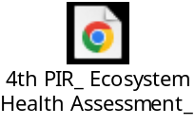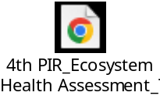
Annex 2. PA Learning Network (PAN)
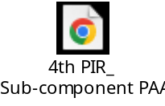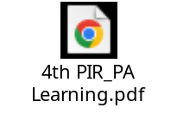

Annex 3. PA Governance and Management
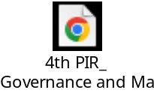
Annex 4. Alignment of IUCN and SI PA Categories
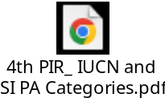
Annex 5. Sample of step 7 : Signed MoU with Neigbouring tribes
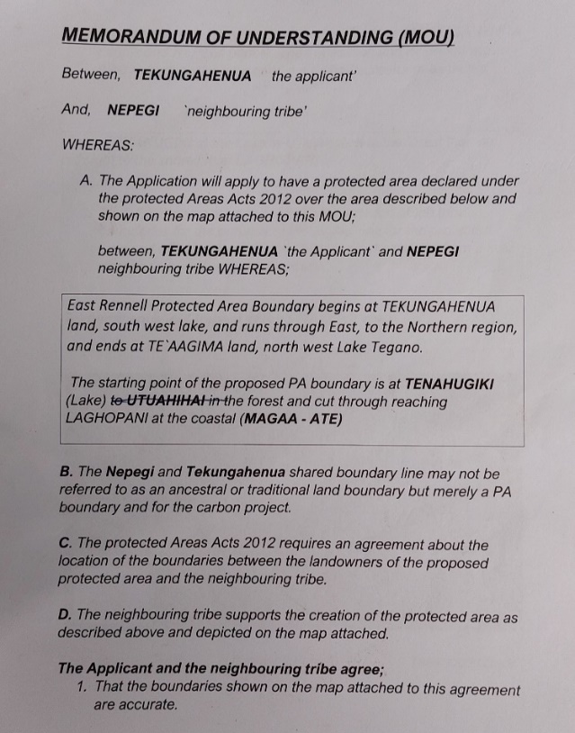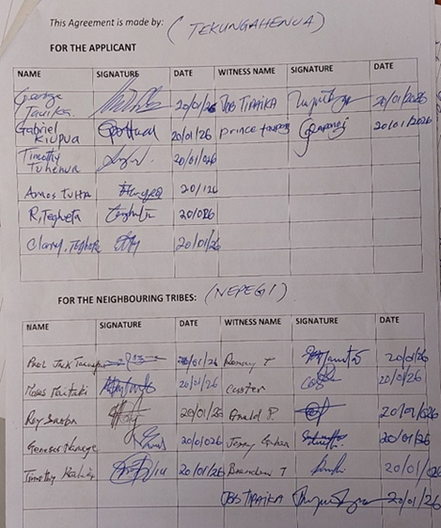
Annex 6. Protected Area Management Plan
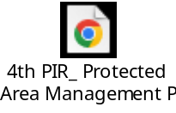
Annex 7. Screening Process Guideline and Application Template for SDPs
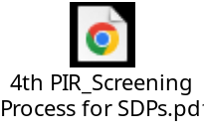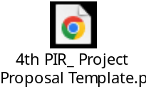
Annex 8. IUCN Project Risk_EREPA
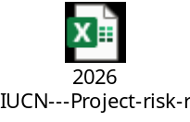

This section will use the scale used by the GEF and outlined in Annex L of this document: 1) Highly satisfactory, 2) Satisfactory, 3) Moderately Satisfactory, 4) Moderately Unsatisfactory, 5) Unsatisfactory, 6) Highly Unsatisfactory
Idem
This section will use the scale used by the GEF and outlined in the Annex of this document: 1) High Risk, 2) Substantial Risk, 3) Moderate Risk, 4) Low Risk
Using the methodology established by the IUCN Environmental and Social Management System (ESMS) - see Annex
This section will use the scale used by the GEF and outlined in Annex of this document: 1) Highly satisfactory, 2) Satisfactory, 3) Moderately Satisfactory, 4) Moderately Unsatisfactory, 5) Unsatisfactory, 6) Highly Unsatisfactory
Idem
Abbreviations are explained in the Annex
IUCN risk categories: Strategic, Financial, People management, Operational, Legal/Compliance, Information systems, External
Stakeholder Engagement Policy Guidelines (SD/GN/01), December 20, 2018
Available at: https://iucn.org/sites/default/files/2022-05/iucn-data-protection-policy_0.pdf.
https://www.iucn.org/sites/dev/files/esms_esmp_guidance_note_and_template.docx
Add n/a if the respective risk issues has neither been identified during the ESMS screening nor in any update of the ESMP.
Please check the respective box to indicate the decision at Screening stage: whether a standards has been triggered or not, or the decision was deferred to the implementation phase. If the latter, please explain the status of this decision.
Please describe the grievance in an anonymized way, e.g type (e.g. gender, participation, violence etc)
Available et: https://iucn.org/sites/default/files/2022-09/iucn_esms_gn-risk-management-clean-22.pdf

